Week 6 Preparing date: October ….., 2023
Period 23 Teaching date: October ….., 2023

Unit 4: My birthday party
Lesson 1 (1, 2, 3)
A. OBJECTIVES:
By the end of the lesson, Ss will be able to:
1. Knowledge:
- understand and correctly repeat the sentences in two communicative contexts focusing on asking and answering questions about birthdays.
- correctly say the words and use When’s your birthday? – It’s in …... to ask and answer questions about someone’s birthday.
- enhance the correct use of When’s your birthday? – It’s in ……... to ask and answer questions about someone’s birthday in a freer context.
- Vocabulary: January, February, March, April, May, June, birthday.
- Skills: speaking and listening
2. Competences:
- Co-operation: ready to help friends in pair work/ group work.
- Sociability: Talk to each other, say good words to others.
3. Attitude/ Qualities:
- Kindness: Help partners to complete learning tasks.
- Honesty: tell the truth about feelings and emotions
B. TEACHING AIDS:
- Teacher: Teacher’s guide Pages 55,56,57 audio Tracks 36,37; website hoclieu.vn, laptop, pictures, textbook, lesson plan, TV or projector.
- Students: Pupil’s book Page 28, notebooks, workbooks, school things.
- PROCEDURES:
Teacher’s and Students’ activities | Content
1.Warm- up: (3’)  Sing: Happy birthday to you  *Aims: to create a friendly and active atmosphere in the class to beginning the lesson  *Procedure:  - Show the song on the screen.  https://www.youtube.com/watch?v=90w2RegGf9w  - Ask pupils to listen, sing the song.  - Ss sing the song  - Say “Open your book page 28” and look at “Unit 4, Lesson 1 (1,2,3)”.  - Ss open their books  - New lesson:  Activity 1. Look, listen and repeat:  *Aims: Ss will be able to understand and correctly repeat the sentences in two communicative contexts focusing on asking and answering questions about birthdays  *Procedure:  - Have Ss look at Pictures a and b and identify the characters in the pictures.  - Play the audio twice (sentence by sentence).  -Ss listen and repeat in chorus (twice)  - Correct their pronunciation where necessary.  - Have Ss to practice the dialogue  -Ss work in pairs to practice  - T invites a few pairs to the front of the class to practice.  -Ss practice the dialogue  - T checks pronunciation for ss.  Activity 2: Listen, point and say.  *Aims: Ss will be able to correctly say the words and use When’s your birthday? – It’s in …… to ask and answer questions about someone’s birthday.  *Procedure:  * Vocabulary.  -T elicits the new words  - T models (3 times).  - Ss listen and repeat  + Choral repetition (3 times).  + Individual repetition (3 ss)  - T writes the words on the board.  - Ss take note  * Model sentences:  - T asks Ss look at picture b and helps Ss know the structure from the dialogue.  - T introduces new structure for Ss.  - T explains, models and gives meaning.  - Have Ss repeat the model sentences.  *Drill pictures  - Have pupils look at the pictures and elicit the names of the months.  - Run through all the pictures.  - Run through model sentences.  - Have Ss to practise:  + T asks the first picture, Ss answer  + Ss asks the second picture, T answers  + Group A asks the third picture, group B answers  + Group B asks the last picture, group A answers.  - Ask Ss to work in pairs.  - T controls and corrects.  - Invite a few pairs to come to the front of the classroom, point at the pictures, and say the questions and answers in front of the class.  - T gives feedbacks.  Activity 3. Let’s talk.  *Aims: Ss will be able to enhance the correct use of When’s your birthday? – It’s in …….. to ask and answer questions about someone’s birthday in a freer context.  *Procedure:  - Have pupils say the names of the months in the picture.  + When’s your birthday? – It’s in ……..  - Elicit the missing words in the speech bubble and write them on the board.  - Have pupils look at the bubbles to understand how the sentence pattern is used.  - Have pupils role-play to practise asking the questions and giving their answers in pairs, using picture cues.  - Make sure pupils understand the structure and say them with the right pronunciation and intonation.  - Invite some pupils to practise asking and answering questions in front of the class.  - Consolidation  *Aims: Ss will be able consolidate and wrap up the content of the lesson.  *Procedure:  - T asks ss to answer the following questions:  + What have you learnt from the lesson today?  - T review the vocabulary and model sentences.  - T praises some Ss who are hardworking / active/ good…. as well as encourage others to try more.  4. Homework.  - Learn the vocabulary and model sentences by heart  - Prepare the new lesson: Unit 4, Lesson 1 (4,5,6). | 1. Look, listen and repeat:  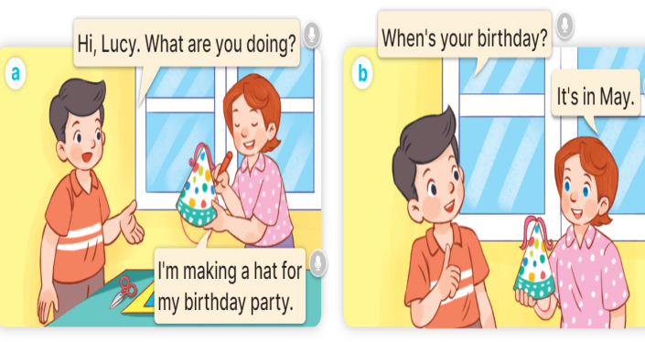  + In picture a:  Nam: Hi, Lucy. What are you doing?  Lucy: I’m making a hat for my birthday party.  + In picture b:  Nam: When’s your birthday?  Lucy: It’s in May.  2. Listen, point and say.  * Vocabulary.  + January :tháng 1  + February :tháng 2  + March :tháng 3  + April :tháng 4  + May :tháng 5  + June :tháng 6  +birthday : ngày sinh, sinh nhật  * Model sentences:  A: When’s your birthday?  B: It’s in May.      3.Let’s talk.  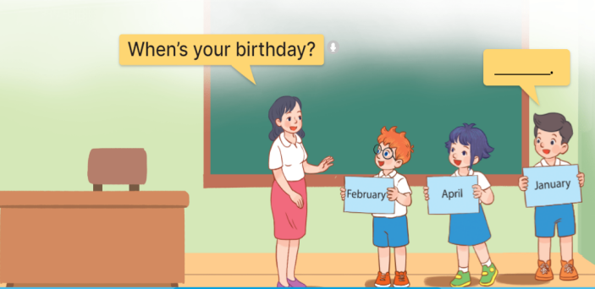  It’s in ……..

D. ADJUSTMENTS (if necessary):
………………………………………………………………………………………….…..……………………………………………………………………………...………………………………………….…..…………………………………………………
------------------------------------------------------
Preparing date: October ….., 2023
Teaching date: October ….., 2023
Period 24 : Unit 4: My birthday party
Lesson 1 (4, 5, 6)
A. OBJECTIVES:
By the end of the lesson, Ss will be able to:
1. Knowledge:
- listen to and understand four communicative contexts in which pupils ask and answer questions about their birthdays and number the correct pictures.
- complete four target gapped exchanges with the help of picture cues.
- sing the song When's your birthday? with the correct pronunciation, rhythm and melody.
- Vocabulary: Review
- Skills: speaking, listening, reading and writing.
2. Competences:
- Co-operation: ready to help friends in pair work/ group work.
- Self-control and independent learning: perform listening tasks.
3. Attitude/ Qualities:
- Kindness: Help partners to complete learning tasks.
- Honesty: tell the truth about feelings and emotions.
- Diligence: complete learning tasks.
B. TEACHING AIDS:
- Teacher: Teacher’s guide Pages 57,58,59,60; audio Tracks 39, 40; website hoclieu.vn, laptop, pictures, textbook, lesson plan, TV or projector.
- Students: Pupil’s book Page 29, notebooks, workbooks, school things.
- PROCEDURES:

Teacher’s and Students’ activities | Content
1.Warm- up: (5’)  Game: Slap the board  *Aims: to create a friendly and active atmosphere in the class to beginning the lesson.  *Procedure:  - Divide class into 2 groups: Tom and Jerry.  - How to play:  + Each group chooses five Ss to play.  + Class will read aloud.  + Look at the picture, listen and slap the picture you heard.  + Who faster will get 1 mark.  + Which group with higher mark is the winner.  - Say “Open your book page 29” and look at “Unit 4, Lesson 1 (4,5,6)”.  - New lesson:  Activity 1. Listen and number:  *Aims: Ss will be able to listen to and understand four communicative contexts in which pupils ask and answer questions about their birthdays and number the correct pictures.  *Procedure:  - Elicit the name of the month in each picture.  - Listen to the tape:  + Play the recording  + Ss listen to the tape and number  + Play the recording again and get Ss to swap books with their partners.  + Ss listen again, number and swap books with their partners.  + Play the recording again to check answers together as a class.  + Ss listen again and check.  + Write the answers on the board for Ss to correct their answers.  + Ss check their answers  - Play the recording, sentence by sentence, for the class to listen and repeat in chorus.  -Ss listen and repeat.  Activity 2. Look, complete and read.  *Aims: Ss will be able to complete four target gapped exchanges with the help of picture cues.  *Procedure:  - Get Ss to look at the pictures and identify the body parts in the pictures.  - Have Ss look at the four incomplete dialogues and elicits the missing words in the sentences.  -Ss look at the picture and say  - T models with picture 1  + Ask Ss what is missing in the sentence.  + Have Ss look at the picture and complete the gap, then read the completed sentence in chorus.  -Ss answer: It’s in March…………  -Have Ss work in groups and complete the picture 2, 3 and 4.  - Ask a few Ss to stand up and read the completed sentences aloud.  -Ss read aloud  -T gives feedbacks.  Activity 3. Let’s sing.  *Aims: Ss will be able to sing the song When's your birthday? with the correct pronunciation, rhythm and melody.  *Procedure:  - Introduce the title and lyrics of the song: “ When's your birthday? ”  - Play the recording for Ss to listen to the whole song.  + Have them repeat the title and lyrics line by line.  + Tell Ss to point at the parts of their body while singing his or her name.  - Play the recording all the way through for Ss to listen to pronunciation and melody of the song.  - Play the recording line by line for Ss to listen, repeat and point to the part of their body  - Play the recording for Ss to sing and do actions.  - Ask Ss to practice singing and doing actions in pairs or groups.  - Invite groups to the front of the classroom to perform the song  -T gives feedback.  - Consolidation  *Aims: Ss will be able consolidate and wrap up the content of the lesson.  *Procedure:  - T asks ss to answer the following questions:  + What have you learnt from the lesson today?  - T praises some Ss who are hardworking / active/ good…. as well as encourage others to try more.  4. Homework. (3’)  - Practice part 5 again.  - Prepare the new lesson: Unit 4, Lesson 2 (1,2,3). | 4.Listen and number:  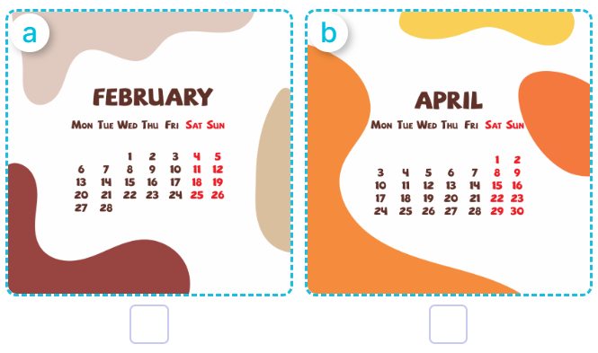  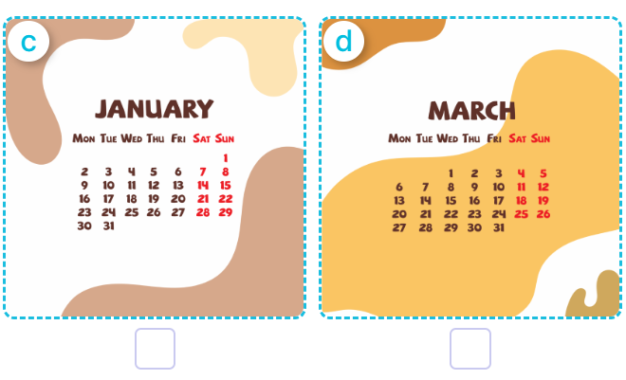  + Picture a: a calendar showing February.  + Picture b: a calendar showing April.  + Picture c: a calendar showing January  + Picture d: a calendar showing March  Key: 1.b 2.a 3.d 4.c  5.Look, complete and read.  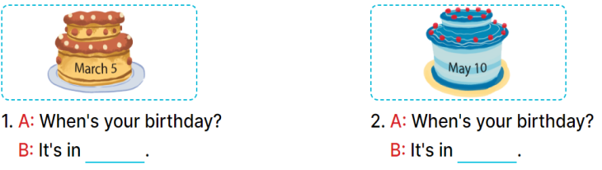  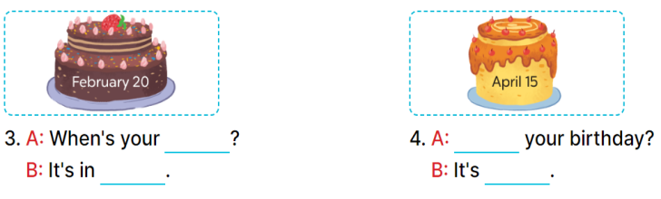  Key: 1. March  2. May  3. birthday; February  4. When’s; in April  6.Let’s sing.  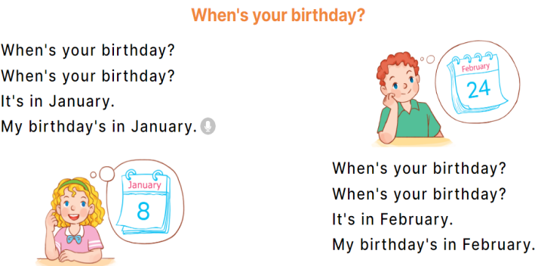
D. ADJUSTMENTS (if necessary):
………………………………………………………………………………………….…..……………………………………………………………………………...…………………………………………
Week 7 Preparing date: October ……. 2023
Period 25 Teaching date: October ……, 2023

Unit 4: My birthday party
Lesson 2 (1, 2, 3)
A. OBJECTIVES:
By the end of the lesson, Ss will be able to:
1. Knowledge:
- understand and correctly repeat the sentences in two communicative
contexts focusing on what someone wants to eat / drink.
- correctly say the phrases and use What do you want to eat / drink? – I want ……….to ask and answer questions about what someone wants to eat / drink.
- enhance the correct use of What do you want to eat / drink? – …….. to ask and answer questions about what someone wants to eat / drink in a freer context.
- Vocabulary: chips, grapes, jam, juice.
- Skills: speaking and listening
2. Competences:
- Oral Communication: speak about names, ask and answer the questions
- Co-operation: ready to help friends in pair work/ group work.
- Sociability: Talk to each other, say good words to others.
3. Attitude/ Qualities:
- Kindness: Help partners to complete learning tasks.
- Honesty: tell the truth about feelings and emotions
- Diligence: complete learning tasks
B. TEACHING AIDS:
- Teacher: Teacher’s guide Pages 59, 60, 61, audio Tracks 40, 41, website hoclieu.vn, laptop, pictures, textbook, lesson plan, TV or projector.
- Students: Pupil’s book Page 30, notebooks, workbooks, school things.
- PROCEDURES:
Teacher’s and Students’ activities | Content
1.Warm- up:  Sing a song  *Aims: to create a friendly and active atmosphere in the class to beginning the lesson.  *Procedure:  - Sing the song When’s your birthday? on page 29.  - Say “Open your book page 30” and look at “Unit 4, Lesson 2 (1,2,3)”.  - New lesson:  Activity 1. Look, listen and repeat:  *Aims: Ss will be able to understand and correctly repeat the sentences in two communicative contexts focusing on what someone wants to eat / drink.  *Procedure:  - Have pupils look at Pictures a and b and identify the characters in the pictures.  + Who is he/ she?  + Where is he/ she?  - Play the audio twice (sentence by sentence). Correct their pronunciation where necessary.  - Have Ss to practice the dialogue  - T invites a few pairs to the front of the class to practice.  - T checks pronunciation for ss.  Activity 2. Listen, point and say.  *Aims: Ss will be able to correctly say the phrases and use What do you want to eat / drink? – I want ……… to ask and answer questions about what someone wants to eat / drink  *Procedure:  * Vocabulary.  -T elicits the new words  - T models (3 times).  - Ss listen and repeat  + Choral repetition (3 times).  + Individual repetition (3 ss)  - T writes the words on the board.  - Ss take note  * Model sentences:  - T asks Ss look at picture a, b and helps Ss know the structure from the dialogue.  - T introduces new structure for Ss.  - T explains, models and gives meaning.  -Have Ss repeat the model sentences.  *Drill pictures  - Have pupils look at the pictures and elicit the names of the food and drinks.  - Run through all the pictures.  - Run through model sentences.  + Run through the questions.  + Run through the answers.  - Have Ss to practise:  + T asks the first – Ss answer (change role).  + Ss – Ss (change role).  - Ask Ss to work in pairs to ask and answer the question What do you want to eat/ drink? I want……  - T controls and corrects.  - Invite a few pairs to point at the pictures and giving the instructions in front of the class.  - Encourage Ss to practise speaking English.  - T gives feedbacks.  Activity 3. Let’s talk.  *Aims: Ss will be able to enhance the correct use of What do you want to eat / drink? – I want ……... to ask and answer questions about what someone wants to eat / drink in a freer context.  *Procedure:  - Have Ss look at the picture and answer the questions:  +Who are they?  + What are they doing?  - Have pupils look at the bubbles to understand how the sentence pattern is used.  - Have pupils role-play to practise asking the questions and giving their answers in pairs, using the picture cue.  - Invite some pupils to practise asking and answering questions in front of the class.  - Have pupils ask and answer questions about what they want to eat / drink at a birthday party, using the structure learnt.  - Consolidation  *Aims: Ss will be able consolidate and wrap up the content of the lesson.  *Procedure:  - T asks ss to answer the following questions:  + What have you learnt from the lesson today?  - T review the vocabulary and model sentences.  - T praises some Ss who are hardworking / active/ good…. as well as encourage others to try more.  4. Homework.  - Learn the vocabulary and model sentences by heart  - Prepare the new lesson: Unit 4, Lesson 2 (4,5,6). | - Look, listen and repeat:  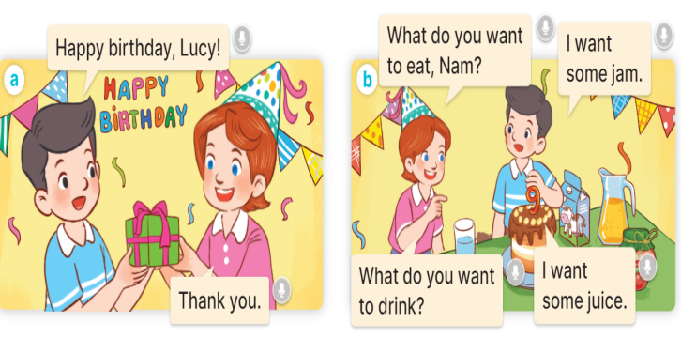  - Listen, point and say.  * Vocabulary.  + chips : khoai tây chiên (realia)  + grapes : quả nho (realia)  +jam :mứt (realia)  + juice : nước ép (realia)  * Model sentences:  A: What do you want to eat/ drink?  B: I want some chips/ milk.  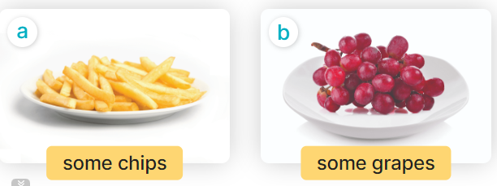  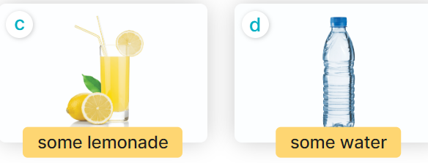  + In picture a:  Nam: Happy birthday, Lucy.  Lucy: Thank you.  + In pucture b:  Lucy: What do you want to eat, Nam?  Nam: I want some jam.  Lucy: What do you want to drink?  Nam: I want some juice.  - Let’s talk.  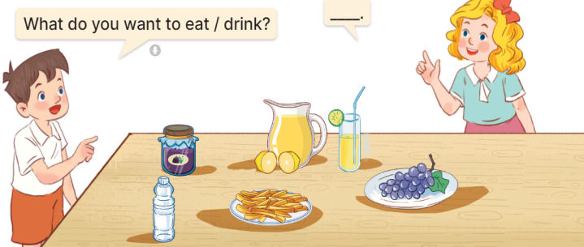  + In picture a: some chips  + In picture b: some grapes  + In picture c: a glass of lemonade  + In picture d: a bottle of water
D. ADJUSTMENTS (if necessary):
………………………………………………………………………………………….…..……………………………………………………………………………...………………………………………….…..……………………………………………………………………………….……………………………………………………………
_______________________________________________
Week 7 Preparing date: October ……. 2023
Period 26 Teaching date: October ……, 2023

Unit 4: My birthday party
Lesson 2 (4, 5, 6)
A. OBJECTIVES:
By the end of the lesson, Ss will be able to:
1. Knowledge:
- listen to and understand two communicative contexts in which pupils ask and answer questions about what they want to eat / drink and tick the correct pictures.
- complete two gapped dialogues with the help of picture cues.
- revise the target vocabulary items through playing the game Board race.
- Vocabulary: Review
- Skills: speaking, listening, reading and writing.
2. Competences:
- Critical Thinking: self-introduce
- Co-operation: ready to help friends in pair work/ group work.
- Self-control and independent learning: perform listening tasks.
3. Attitude/ Qualities:
- Kindness: show kindness in inviting someone to a birthday party and offering them food and drink they want.
- Honesty: tell the truth about feelings and emotions.
- Diligence: complete learning tasks.
B. TEACHING AIDS:
- Teacher: Teacher’s guide Pages 62,63; audio Tracks 42; website hoclieu.vn, posters, laptop, pictures, textbook, lesson plan, TV or projector.
- Students: Pupil’s book Page 31, notebooks, workbooks, school things.
- PROCEDURES:

Teacher’s and Students’ activities | Content
1.Warm- up:  Game: Guessing game  *Aims: to create a friendly and active atmosphere in the class to beginning the lesson.  *Procedure:  - T introduces and explains the game.  - How to play:  + T will show some pictures which is hidden.  + Ss look at the pictures in the screen.  + Ss tell what someone is doing.  - T models. (jam)  - Ss play the game.  - T gives feedback.  - Say “Open your book page 31” and look at “Unit 4, Lesson 2 (4,5,6)”.  - New lesson:  Activity 1. Listen and tick:  *Aims: Ss will be able to listen to and understand two communicative contexts in which pupils ask and answer questions about what they want to eat / drink and tick the correct pictures.  *Procedure:  - Elicit the names of the food and drink items.  - Point at the pictures respectively to explain the context.  - Listen to the tape:  + Play the recording  + Play the recording again and get Ss to swap books with their partners.  + Play the recording again to check answers together as a class.  + Write the answers on the board for Ss to correct their answers. Then checks Ss’ guessing.  - Play the recording, sentence by sentence, for the class to listen and repeat in chorus.  Activity 2. Look, complete and read.  *Aims: Ss will be able to complete two gapped dialogues with the help of picture cues.  *Procedure:  - Have pupils look at the pictures and identify the food and drink items in the pictures.  - Have pupils look at the two incomplete dialogues.  - Model Dialogue 1, ask pupils what is missing in the question (What) and the answer (the food).  - Ask pupils to complete the gap (What do you want to eat, Mary? – I want some grapes.).  - Have pupils complete the dialogues individually.  - Ask a few pairs to read them aloud.  - Correct their pronunciation where necessary, praise the readers, and get the class to clap or cheer if their pronunciation is good  Activity 3. Let’s play.  *Aims: Ss will be able to revise the target vocabulary items through playing the game Board race.  *Procedure:  - Tell pupils the goal of the game and how to play it.  - Divide pupils into two teams. They take turns going to the board and each pupil tries to write one word in the columns Drinks and Food as fast as possible.  - The team that writes the most words in the set time wins.  - Point to the words and have pupils read the words out loud.  - Have pupils play the game using other word sets, ex: months, countries, days of the week.  - Consolidation  *Aims: Ss will be able consolidate and wrap up the content of the lesson.  *Procedure:  - T asks ss to answer the following questions:  + What have you learnt from the lesson today?  - T praises some Ss who are hardworking / active/ good…. as well as encourage others to try more.  4. Homework.  - Practice about the pictures on page 31.  - Prepare the new lesson: Unit 4, Lesson 3 (1,2,3). | - Ex:  1. jam 2. grapes 3. chips  4. milk 5. lemonade 6.chicken  - Listen and tick:  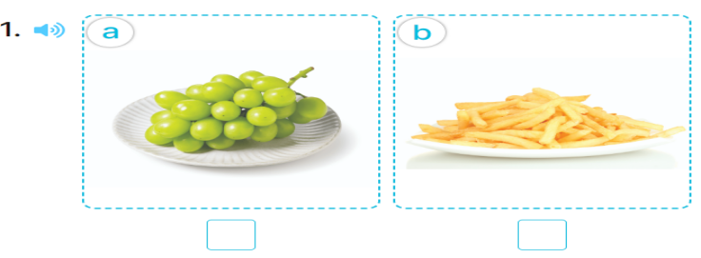  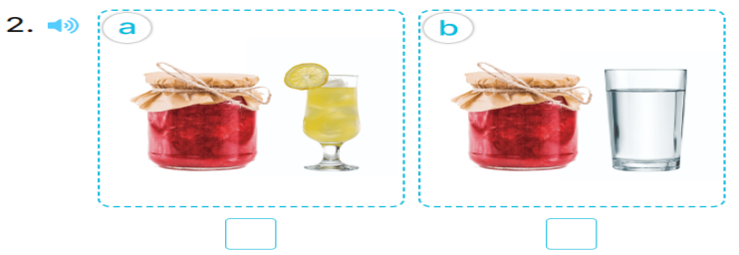  + Picture 1a: grapes  + Picture 1b: chips  + Picture 2a: jam ad lemonade  + Picture 2b: jam and water  Key: 1. a 2.a  5.Look, complete and read.  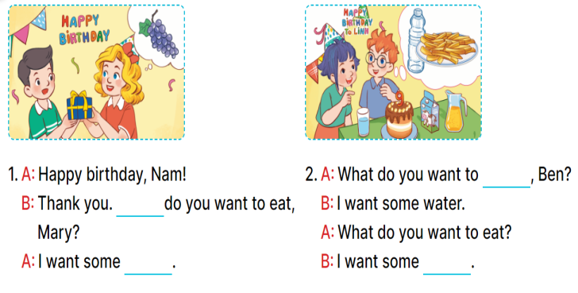  Key: 1. What; grapes 2. drink; chips  - Let’s play.

D. ADJUSTMENTS (if necessary):
………………………………………………………………………………………….…..……………………………………………………………………………...………………………………………….…..…………………………………………………

Week 7 Preparing date: October ……. 2023
Period 27 Teaching date: October ……, 2023

Unit 4: My birthday party
Lesson 3 (1, 2, 3)
A. OBJECTIVES:
By the end of the lesson, Ss will be able to:
1. Knowledge:
- correctly repeat the sounds of the letters j and w in isolation, in the words jam and water, and in the sentences I like jam. and I want some water.
- listen to and demonstrate understanding of simple communicative to identify the target words jam and water while listening.
- say the chant with the correct pronunciation and rhythm.
- Vocabulary: Review
- Skills: speaking, listening, reading and writing.
2. Competences:
- Co-operation: ready to help friends in pair work/ group work.
- Sociability: Talk to each other, say good words to others.
3. Attitude/ Qualities:
- Kindness: show self-respect to what they want and what others want
- Honesty: tell the truth about feelings and emotions
B. TEACHING AIDS:
- Teacher: Teacher’s guide Pages 64,65; audio Tracks 43,44,45; website hoclieu.vn, posters, laptop, pictures, textbook, lesson plan, TV or projector.
- Students: Pupil’s book Page 32, notebooks, workbooks, school things.
- PROCEDURES:
Teacher’s and Students’ activities | Content
1.Warm- up:  Game: Pass the ball  *Aims: to create a friendly and active atmosphere in the class to beginning the lesson.  *Procedure:  - T gives Ss a ball.  - T asks Ss to listen to music and transfer a ball around the class.  - When the music stops, Ss who keep a ball have to answer the question using: What do you want to eat/ drink? and I want some…..  - T gives feedback.  - Say “Open your book page 32” and look at “Unit 4, Lesson 3 (1,2,3)”.  2. New lesson  Activity 1. Listen and repeat:  *Aims: Ss will be able to correctly repeat the sounds of the letters j and w in isolation, in the words jam and water, and in the sentences I like jam. and I want some water.  water.  *Procedure:  - T gives instruction to the letter j and w, in the words jam and water, and in the sentences I like jam. and I want some water.  - Ss recognize the differences about color of letter  - Play the recording for the letter j, w.  - Encourage Ss to point at the letter /word/ sentence while listening.  - Ss listen and point  - Play the recording again and encourage Ss to listen and repeat.  - Ss listen again and repeat  - Do this several times until Ss feel confident.  - Ss listen again and repeat  - T calls some Ss to practice.  - Ss practice  - T gives feedbacks.  Activity 2. Listen and circle.  *Aims: Ss will be able to identify the target words jam and water while listening.  *Procedure:  - Elicit the sentences and the gap-fill options.  - Listen to the tape:  + Play the recording  + Play the recording again and get Ss to swap books with their partners.  + Play the recording again to check answers together as a class.  + Write the answers on the board for Ss to correct their answers. Then checks Ss’ guessing.  - Play the recording, sentence by sentence, for the class to listen and repeat in chorus.  - Invite one or two Ss to stand up and read the completed sentences.  Activity 3. Let’s chant  *Aims: Ss will be able to say the chant with the correct rhythm and pronunciation.  *Procedure:  - Introduce the title and lyrics of the chant.  - Play the recording for Ss to listen to the whole chant.  + Have them repeat the title and lyrics line by line.  + Ask Ss to attend to the sounds of the letters j and w and the words jam and water..  - Play the recording all the way through for Ss to listen to pronunciation and melody.  - Play the recording line by line for Ss to listen and repeat  - Play the recording for Ss to chant and clap along.  - Ask Ss to practice chant and clap along in pairs or groups.  - Invite groups to the front of the classroom to perform the chant  -T gives feedback.  3.Consolidation  *Aims: Ss will be able consolidate and wrap up the content of the lesson.  *Procedure:  - T asks ss to answer the following questions:  + What have you learnt from the lesson today?  - T praises some Ss who are hardworking / active/ good…. as well as encourage others to try more.  4. Homework.  - Practice the chant more.  - Prepare the new lesson: Unit 4, Lesson 3 (4,5,6). | 1. Listen and repeat:  -  2. Listen and circle.  Key: 1.b 2.c  - Let’s chant  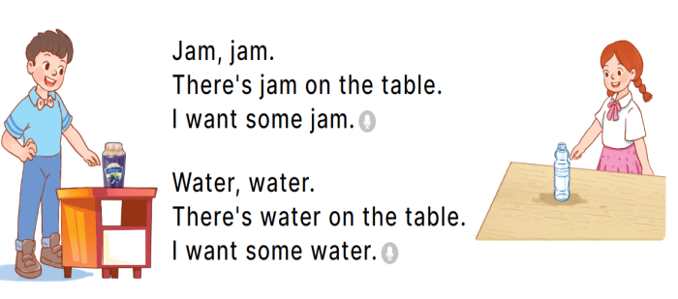
D. ADJUSTMENTS (if necessary):
………………………………………………………………………………………….…..……………………………………………………………………………...………………………………………….…..……………………………………………………………………………….……………………………………………………………

Week 7 Preparing date: October ……. 2023
Period 28 Teaching date: October ……, 2023

Unit 4: My birthday party
Lesson 3 (4, 5, 6)
A. OBJECTIVES:
By the end of the lesson, Ss will be able to:
1. Knowledge:
- read and understand a text (Bill’s letter) and circle the correct answers.
- complete a gapped text using pupils’ personal information.
- make birthday party invitations at home and present them to the class by using the target language.
- Vocabulary: Review
- Skills: speaking, listening, reading and writing.
2. Competences:
- Critical Thinking: self-introduce
- Co-operation: ready to help friends in pair work/ group work.
- Self-control and independent learning: perform listening tasks.
3. Attitude/ Qualities:
- Kindness: Show kindness in inviting someone to a birthday party and offering them food and drink they want.
- Honesty: Show pride in the date of birth of themselves and others’ and respect to their parents for their presence.
B. TEACHING AIDS:
- Teacher: Teacher’s guide Pages 66, 67; website hoclieu.vn, posters, laptop, pictures, textbook, lesson plan, TV or projector.
- Students: Pupil’s book Page 33, notebooks, workbooks, school things.
- PROCEDURES:

Teacher’s and Students’ activities | Content
1.Warm- up:  Game: “Chant”  *Aims: to review the vocabulary and structure about greet and respond to greetings.  *Procedure:  - Ask Ss chant and do the actions in Unit 4, Lesson 3 page 32 in groups.  - Give point for the groups and encourage them.  - Say “Open your book page 33” and look at “Unit 4, Lesson 3 (4, 5, 6)”.  - New lesson:  Activity 1. Read and circle:  *Aims: Ss will be able to read and understand a text (Bill’s letter) and circle the correct answers.  *Procedure:  - Draw pupils’ attention to Bill’s letter and read it together as a class.  - Have pupils pay attention to the gap and the three answer options for each sentence.  - Ask pupils to read the letter again and circle the correct options.  - SS read again and circle  - Tell pupils to swap books with a partner, then check answers together as a class.  - Ss swap books and check  - Call Ss go to the board to write the answers  - Ask pupils to look at the board and check their answers.  -Ss check their answer again.  - Give feed back  Activity 2. Let’s write  *Aims: Ss will be able to complete a gapped text using pupils’ personal information.  *Procedure:  - Tell the class the goal of this activity: to read the text and fill in the gaps using their personal information.  - Write the first sentence on the board.  - Read the sentence as a class. When you reach the gap, point at it and encourage pupils to say their own names.  - Give pupils time to write the answers.  - Repeat the same procedure with the other sentences.  - Invite a few pupils to read the sentences they have completed aloud in front of the class.  Activity 3. Project.  *Aims: Ss will be able to make birthday party invitations at home and present them to the class by using the target language.  *Procedure:  - Tell pupils the goal of this activity.  - Explain that they are going to show the birthday party invitations that they have made at home and tell the class about their birthdays.  - Have pupils work in groups of five.  + Each pupil shows his / her invitation and tells the group about his / her birthday  + Ex: My birthday’s in May.  - Invite some pupils to show their work and talk about their birthdays.  - Have pupils stick their invitations on the wall of the classroom as a display.  - Consolidation  *Aims: Ss will be able consolidate and wrap up the content of the lesson.  *Procedure:  - T asks ss to answer the following questions:  + What have you learnt from the lesson today?  +What are the core values of the lesson? (if the teacher can take from the lesson).  - T praises some Ss who are hardworking / active/ good…. as well as encourage others to try more.  4. Homework.  - Prepare the new lesson: Unit 5, Lesson 1 (1, 2, 3). | 4.Read and circle:  Key: 1. b 2. a 3. a 4. b  5.Let’s write  Ex: My name is Huong. I am from Nghia Lam Village. My birthday is in October. I want some chips, milk and a birthday cake at the party.  6.Project.
D. ADJUSTMENTS (if necessary):
………………………………………………………………………………………….…..……………………………………………………………………………...………

