Week: 3
Class: 4A1, 4A2

Unit 2: Time and daily routines
Lesson 2 (1, 2, 3)
A. OBJECTIVES:
By the end of the lesson, Ss will be able to:
1. Knowledge:
- use the words get up, have breakfast, go to school, go to bed, do homework.
in relation to the topic “daily routines”.
- use What time do you ……..? - I …….at ………… to ask and answer about someone’s daily routines.
- listen to and demonstrate understanding of simple communicative contexts
in relation to the topic “daily routines”.
- Vocabulary: get up, have breakfast, go to school, go to bed, do homework.
- Skills: speaking and listening
2. Competences:
- Communication and collaboration: work in pairs and groups to complete the
learning tasks
- Self-control and independent learning: perform listening tasks
3. Attitude/ Qualities:
- Kindness: Help partners to complete learning tasks.
- Honesty: tell the truth about feelings and emotions
B. TEACHING AIDS:
- Teacher: Teacher’s guide Pages 34, 35, 36, 37, audio Tracks 19,20, website hoclieu.vn, posters, laptop, pictures, textbook, lesson plan, TV or projector.
- Students: Pupil’s book Page 18, notebooks, workbooks, school things.
C. PROCEDURES:
Teacher’s and students’ activities | Content
Activity 1. Warm- up:  - 1.Warm- up: (3’)  Game: Which clocks says…..  - Spend a few minutes revising the previous lesson by having the class play the game Which clock says ...?  - Say “Open your book page 18” and look at “Unit 2, Lesson 2 (1,2,3)”.  - Ss open their books  Activity 2. Look, listen and repeat:  - Have Ss look at Pictures a and b and identify the characters in the pictures.  + Who is he/ she?  + Where is he/ she?  - Play the audio twice (sentence by sentence). Correct their pronunciation where necessary.  - Have Ss to practice the dialogue  - T invites a few pairs to the front of the class to practice.  - T checks pronunciation for ss.  Activity 3. Listen, point and say.  -T elicits the new words:  - T models (3 times).  - T writes the words on the board.  - Checking: Rub out and remember  - T asks Ss look at picture a and helps Ss know the structure from the dialogue.  - T introduces new structure for Ss.  - T explains, models and gives meaning.  - Have Ss repeat the model sentences.  - Elicit and check comprehension the name of each character and countries.  - Run through all the pictures.  - Run through model sentences.  - Have Ss to practise:  + T asks the first picture, Ss answer  + Ss asks the second picture, T answers  + Group A asks the third picture, group B  answers  + Group B asks the last picture, group A  - Ask Ss to work in pairs.  - T controls and corrects.  - Invite a few pairs to come to the front of the classroom, point at the relevant character in each picture, and act out his/her role.  - Encourage Ss to practise speaking English.  - T gives feedbacks.  Activity 4. Let’s talk.  - T asks ss to guess each character and what the children say.  + What can you see in the picture?  +Who are they?  +Where are they?  +What are they saying?  - Elicit the answer in the speech bubble and write it on the board. Get pupils to say the completed sentences.  - Put pupils into pairs to practise the exchanges.  - Invite a few pairs to point at the pictures and ask and answer questions about What time do you……?  - Give feedbacks  Activity 5. Consolidation  - T review the vocabulary and model sentences.  - T praises some Ss who are hardworking / active/ good…. as well as encourage others to try more.  Homework.  - Learn the number by heart  - Prepare the new lesson: Unit 2: Lesson 2 (4,5,6). | Game: Which clocks says…..  1. Look, listen and repeat:  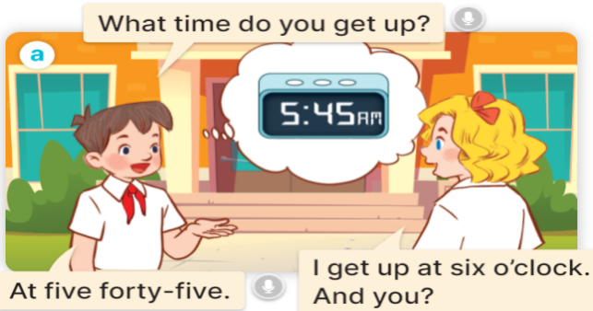  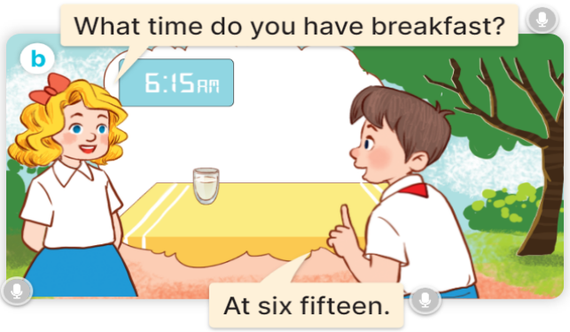  2. Listen, point and say.  * New words  + get up: thức dậy (situation)  + have breakfast : ăn sáng (situation)  + go to school: đi học (picture)  + go to bed : đi ngủ (picture)  + do homework:làm bài tập về nhà (picture)  +wash face: rửa mặt (mime)  + clean teeth : đánh răng (mime)  * Model sentences:  A: What time do you get up?  B: I get up at six o’clock.  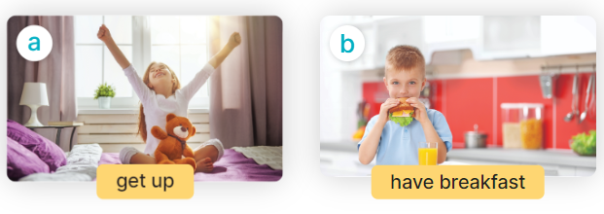  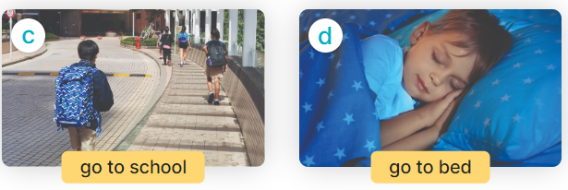  3. Let’s talk.  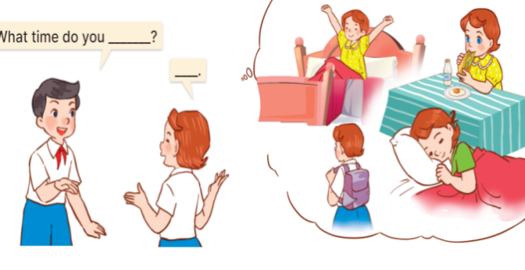  + What can you see in the picture?  +Who are they?  +Where are they?  +What are they saying?
D. ADJUSTMENTS (if necessary):
………………………………………………………………………………………….…..…………………………………………………………………………
--------------------------------------------------
Class: 4A1, 4A2
Unit 2: Time and daily routines
Lesson 2 (4,5,6)
I. Objective
By the end of the lesson, students will be able to:
1. Knowledge:
listen to and understand four communicative contexts in which pupils ask and answer questions about daily routines and number the correct pictures.
- complete four gapped exchanges with the help of picture cues.
- sing the song What time do you go to school?
- Vocabulary: Review
2. Skills: speaking, listening, reading and writing.
3. Competences:
- Critical Thinking: self-introduce
- Co-operation: ready to help friends in pair work/ group work.
- Self-control and independent learning: perform listening tasks.
4. Attitude/ Qualities:
- Kindness: Help partners to complete learning tasks.
- Honesty: Show pride in where they come from and great respect for where someone
comes from by using appropriate gestures and intonation when asking and
answering about nationality
- Diligence: complete learning tasks.
II. Methods: Communicative approach, group Ss and T's activities, play as a character, teaching methods with game, teaching methods by visual, teaching methods by practising, discussion group, technical present....
III. Teaching aids
- Teacher: Teacher’s guide Pages 37,38,39; audio Tracks 21, 22; website hoclieu.vn, posters, laptop, pictures, textbook, lesson plan, TV or projector.
- Students: Pupil’s book Page 19, notebooks, workbooks, school things.
IV. Procedures
Teacher’s and students’ activities | Content
Activity 1. Warm- up:  - Asks Ss to review from, using What time do you …..? – I ……at ………..  - Say “Open your book page 19” and look at “Unit 2, Lesson 2 (4,5,6)”.  - Ss open their books  Activity 2. Listen and number:  - Elicit the names of the characters in the pictures. Point at the pictures respectively to explain the context.  +Who is he/ she?  +Where is he/ she from?  - Look at the pictures and say.  - T ask Ss to guess the answers.  - Ss guess the answers  - T writes Ss’ guessing on the board.  - Listen to the tape:  + Play the recording  + Play the recording again and get Ss to swap books with their partners.  + Play the recording again to check answers together as a class.  + Write the answers on the board for Ss to correct their answers. Then checks Ss’ guessing.  - Invite one pupil to read aloud sentences 1 and 2 and a pair of pupils to act out Exchanges 3 and 4 in front of the class.  Activity 3. Look, complete and read.  - Get Ss to look at the pictures and identify the characters  - Have Ss look at the four incomplete sentences and elicits the missing words in the sentences.  - T models with sentence 1  + Ask Ss what is missing in the sentence.  + Have Ss look at the picture and complete the gap, then read the completed sentence in chorus.  -Have Ss work in groups and complete the sentences 2,3 and 4.  - Ask a few Ss to stand up and read the completed sentences aloud.  -T gives feedbacks.  Activity 4. Let’s sing.  Introduce the title and lyrics of the song: “What time do you go to school?” song.  - Play the recording for Ss to listen to the whole song.  + Have them repeat the title and lyrics line by line.  + Tell Ss to point at the relevant character while singing his or her name.  - Play the recording all the way through for Ss to listen to pronunciation and melody of the song.  - Play the recording line by line for Ss to listen, repeat and point at the relevant character.  - Play the recording for Ss to sing and do actions.  - Ask Ss to practice singing and doing actions in pairs or groups.  - Invite groups to the front of the classroom to perform the song  -T gives feedback.  Activity 5: Consolidation  - T asks ss to answer the following questions:  + What have you learnt from the lesson today?  - T praises some Ss who are hardworking / active/ good…. as well as encourage others to try more.  Homework.  - Learn the song by heart  - Prepare the new lesson: Unit 2, Lesson 3 (1,2,3). | 4. Listen and number  Key: 1. d 2. c 3. a 4. b  5. Look, complete and read  Key:  1. six o’clock  2. six thirty  3. What time; six forty-five  4. go to bed; go to bed; nine fifteen  6. Let’s sing.  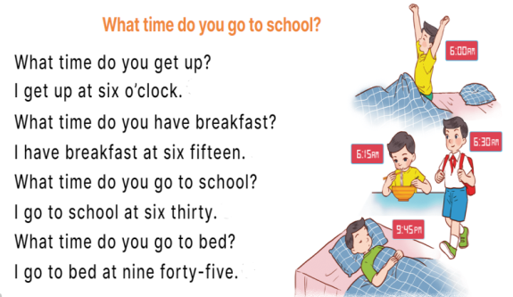
V. Adjustments (if necessary):
………………………………………………………………………………………….…..…………………………………………………………………………
……………………………………………………
Class: 4A1, 4A2
Unit 2: Time and daily routines
Lesson 3 (1, 2, 3)
A. OBJECTIVES:
By the end of the lesson, Ss will be able to:
1. Knowledge:
- correctly repeat the sounds of the letters t and d in isolation, in the words get and bed, and in the questions What time do you get up? and What time do you go to bed?
- identify the sounds of the letters t and d in sentences while listening.
- say the chant with the correct rhythm and pronunciation.
- Vocabulary: Review
- Skills: speaking, listening, reading and writing.
2. Competences:
- Communication and collaboration: work in pairs and groups to complete the
learning tasks.
- Self-control & independent learning: perform listening tasks.
3. Attitude/ Qualities:
- Kindness: Help partners to complete learning tasks.
- Honesty: Show pride in where they come from and great respect for where someone comes from by using appropriate gestures and intonation when asking and answering about nationality.
B. TEACHING AIDS:
- Teacher: Teacher’s guide Pages 39, 40; audio Tracks 23, 24, 25; website hoclieu.vn, posters, laptop, pictures, textbook, lesson plan, TV or projector.
- Students: Pupil’s book Page 20, notebooks, workbooks, school things.
C. PROCEDURES:
Teacher’s and students’ activities | Contents
1.Warm- up: (5’)  Game: Pass the ball  - T gives Ss a ball.  - T asks Ss to listen to music and transfer a ball around the class.  - Ss listen  - When the music stops, Ss who keep a ball have to answer the question using: What time do you …….and I ……..  -Ss listen the rules  - Ss play the game  - T gives feedback.  - Say “Open your book page 20” and look at “Unit 2, Lesson 3 (1,2,3)”.  2. New lesson (30’)  Activity 1. Listen and repeat:  - T gives instruction to the letter t and d, the word get and bed , and the sentences What time do you get up? and What time do you go to bed?  - Play the recording for the letter letter t and d,  - Encourage Ss to point at the letter/ word/ sentence while listening.  - Play the recording again and encourage Ss to listen and repeat in chorus and individually until they feel confident. Correct their pronunciation if necessary.  - Invite a few pupils to listen to and repeat the sound, the word and the sentence in front of the class. Praise them when their pronunciation is good  - Have pupils work in pairs or groups to do this several times until Ss feel confident.  - T calls some Ss to practice.  - T gives feedbacks.  Activity 2. Listen and circle.  - Tell pupils the goal of the activity. Explain that they have to listen to the recording and circle the correct options. Check comprehension.  - Get pupils to read the gapped sentences and guess which option can be chosen to fill in the gaps  - Play the recording, once or twice, for pupils to listen and circle the correct options. Get pupils to swap books with a partner and check their answers before checking as a class.  - Play the recording again for pupils to double-check their answers  - Write the answers on the board for Ss to correct their answers. Then checks Ss’ guessing.  - Play the recording, sentence by sentence, for the class to listen and repeat in chorus.  - Invite one or two Ss to stand up and read the completed sentences.  Activity 3. Let’s chant  - Introduce the title and lyrics of the chant.  - Play the recording for Ss to listen to the whole chant.  + Have them repeat the title and lyrics line by line..  - Play the recording all the way through for Ss to listen to pronunciation and melody.  - Play the recording line by line for Ss to listen and repeat  - Ss listen and repeat line by line without clap their hands  -Ss note the sounds, words  - Play the recording for Ss to chant and clap along.  - Ss chant and clap along.  - Ask Ss to practice chant and clap along in pairs or groups.  - Ss work in groups (two groups) to chant  - Invite groups to the front of the classroom to perform the chant  -Ss perform in front of the class.  -T gives feedback.  4. Homework. (5’)  - Practice the chant more.  - Prepare the new lesson: Unit 2, Lesson 3 (4,5,6). | Play game : Slap the board  1. Listen and repeat  t- get What time do you get up?  d- bed What time do you go to bed?  2. Listen and circle.  Key: 1.c 2.a  3. Let’s chant  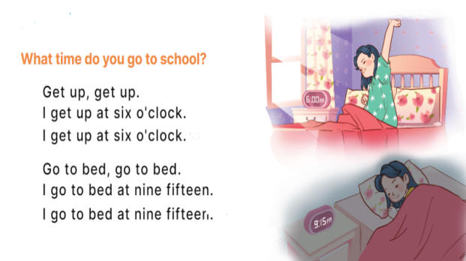
D. ADJUSTMENTS (if necessary):
………………………………………………………………………………………….…..……………………………………………………………………………...………………………………………….…..………………………………

Class: 4A1, 4A2
Unit 2: Time and daily routines
Lesson 3 (4,5,6)
I. Objectives:
By the end of the lesson, pupils will be able to:
- read and match the activities in a paragraph with the clocks showing the corresponding time.
- complete a paragraph about pupils’ daily routines.
- draw pictures of their daily routines at home and present them to the class by using the target language.
- Vocabulary: Review
2. Skills.
- Listening, reading, speaking and writing
3. Attitude/ Quality:
Kindness: help partners to complete learning tasks
Diligence: complete learning tasks
Honesty: tell the truth about feelings and emotions
Responsibility: appreciate kindness
Leadership: collaborate with teachers to enhance language skills
4. Forming competence:
Critical thinking: self-introducing
Communication and collaboration: work in pairs or groups
II. Methods:
- Communicative approach, group Ss and T's activities, play as a character, teaching methods with game, teaching methods by visual, teaching methods by practising, discussion group, technical present....
III. Preparation.
- Teacher: Teacher’s guide Pages 41,42; website hoclieu.vn, posters, laptop, pictures, textbook, lesson plan, TV or projector.
- Students: Pupil’s book Page 21, notebooks, workbooks, school things IV. Procedures.
Teacher’s and student’s activities | Contents
Activity 1. Warm-up and review.(5’)  Game: “Chant”  - Ask Ss chant and do the actions in Unit 2, Lesson 3 page 20 in groups.  - Ss listen and chant  - Give point for the groups and encourage them.  - Say “Open your book page 21” and look at “Unit 2, Lesson 3 (4,5,6)”.  - Ss open their books  Activity 2. Read and match (10’)  - Show the pictures and ask Ss some questions:  + What’s this?  + What time is it?  - Have pupils read the paragraph, the sentences, and the time on the clocks.  - Ss read and match  - Model Sentence 1 (clock d).  - Ss listen  - Set a time limit for pupils to do the activity independently.  -Ss do the activity and match  - Get pupils to swap books with a partner and check their answers before checking as a class.  -Ss swap books and check their answer  - Invite some pupils to stand up to read the paragraph aloud.  -Ss read the paragraph aloud.  -Tgives feedback.  Activity 3. Let’s write.(12’)  - Tell and explain the class the goal of the activity.  Ss listen to the teacher  - Ask pupils what the paragraph is about (daily routines).  -Ss listen and answer  - Set a time limit for pupils to complete the paragraph independently.  Ss complete the paragraph  - Get pupils to swap books and check their answers in pairs or groups before checking as a class.  -Ss swap books and check their answers  - T gives feedback.  Activity 4. Project (10’)  Explain that pupils have to show simple pictures of their daily routines (getting up, having breakfast, etc.)  Ss listen to the teacher  - Invite a pupil to the front of the class to model the presentation.  -Ss pay attention  - Put the key presentation language on the board (ex: I get up at six fifteen.).  -Ss pay attention  - Have pupils repeat the key presentation language a few times to make them feel confident when they present their daily routines before an audience.  - Set a time limit for pupils to work in groups.  Ss work in groups  - Invite a few pupils to the front of the class to present the project.  Ss present the project  Activity 5: Consolidation(2’)  - T asks ss to answer the following questions:  + What have you learnt from the lesson today?  +What are the core values of the lesson? (if the teacher can take from the lesson).  - T praises some Ss who are hardworking / active/ good…. as well as encourage others to try more.  6. Homework. (1’)  - Read again the text.  - Prepare the new lesson: Unit 3, Lesson 1 (1,2,3). | 4 Read and match  Key: 1. d 2. c 3. b 4. a  5. Let’s write.  Key: Pupil’s answer  Ex: I get up at six o’clock. I have breakfast at seven o’clock. I go to school at seven fifteen. What about you? What time do you go to school?  6: Project  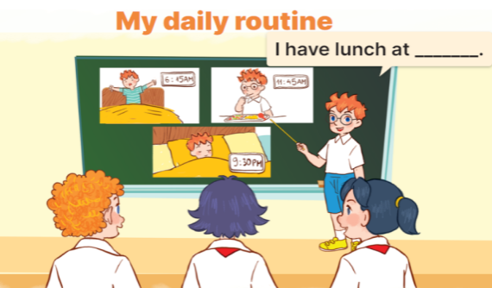  Ex: I get up at six fifteen
D. ADJUSTMENTS (if necessary):
………………………………………………………………………………………….…..…………………………………………………………………………..

