Week 2 Preparing date: September ………, 2023
Teaching date: September …….., 2023

Unit 1: My friends
Lesson 1 (1, 2, 3)
I. Objective
By the end of the lesson, students will be able to:
1. Knowledge:
- use the words America, Australia, Britain and Viet Nam in relation to the topic “My friends”
- use Where are you from? – I’m from _____. to ask and answer questions about where someone comes from
- Vocabulary: America, Australia, Britain and Viet Nam
2. Skills: speaking and listening
3. Competences:
- Co-operation: ready to help friends in pair work/ group work.
- Sociability: Talk to each other, say good words to others.
3. Attitude/ Qualities:
- Kindness: Help partners to complete learning tasks.
- Honesty: Show pride in where they come from and great respect for where someone
comes from by using appropriate gestures and intonation when asking and
answering about nationality.
II. Methods:
Communicative approach, group Ss and T's activities, play as a character, teaching methods with game, teaching methods by visual, teaching methods by practising, discussion group, technical present....
III. Teaching aids
1. Teacher: Teacher’s guide Pages 17, 18, 19, audio Tracks 6,7, website hoclieu.vn, posters, laptop, pictures, textbook, lesson plan, TV or projector.
2. Students: Pupil’s book Page 10, notebooks, workbooks, school things.
IV. Procedures

Teacher’s and students’ activities | Content
Activity 1. Warm- up:  - Elicit that there are many countries around the world.  - Ask pupils to say the name as many countries as they know.  - Say “Open your book page 10” and look at “Unit 1, Lesson 1 (1,2,3)”.  Activity 2. Look, listen and repeat:  - Have Ss look at Pictures a and b and identify the characters in the pictures.  + Who is he/ she?  + Where is he/ she?  - Play the audio twice (sentence by sentence). Correct their pronunciation where necessary.  - Have Ss to practice the dialogue  - T invites a few pairs to the front of the class to practice.  - T checks pronunciation for ss.  Activity 3. Listen, point and say.  -T elicits the new words:  - T models (3 times).  - T writes the words on the board.  - Checking: Rub out and remember  - T asks Ss look at picture a and helps Ss know the structure from the dialogue.  - T introduces new structure for Ss.  - T explains, models and gives meaning.  - Have Ss repeat the model sentences.  - Elicit and check comprehension the name of each character and countries.  - Run through all the pictures.  - Run through model sentences.  - Have Ss to practise:  + T asks the first picture, Ss answer  + Ss asks the second picture, T answers  + Group A asks the third picture, group B  answers  + Group B asks the last picture, group A  - Ask Ss to work in pairs.  - T controls and corrects.  - Invite a few pairs to come to the front of the classroom, point at the relevant character in each picture, and act out his/her role.  - Encourage Ss to practise speaking English.  - T gives feedbacks.  Activity 4. Let’s talk.  - T asks ss to guess each character and what the children say.  + What can you see in the picture?  +Who are they?  +Where are they?  +What are they saying?  - Elicit the answer in the speech bubble and write it on the board. Get pupils to say the completed sentences.  - Put pupils into pairs to practise the exchanges.  - Invite a few pairs to point at the pictures and ask and answer questions about where the pupils are from.  - Give feedbacks  Activity 5. Consolidation  - T review the vocabulary and model sentences.  - T praises some Ss who are hardworking / active/ good…. as well as encourage others to try more.  Homework.  - Learn the number by heart  - Prepare the new lesson: Unit 1: Lesson 1 (4,5,6). | Game: Find the flags  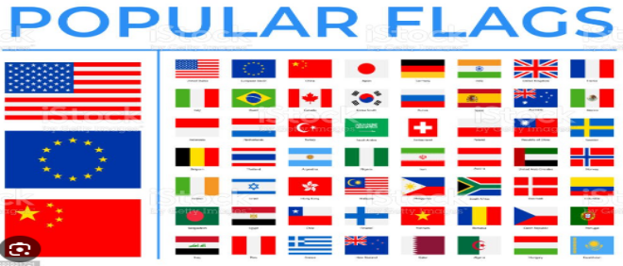  1. Look, listen and repeat:  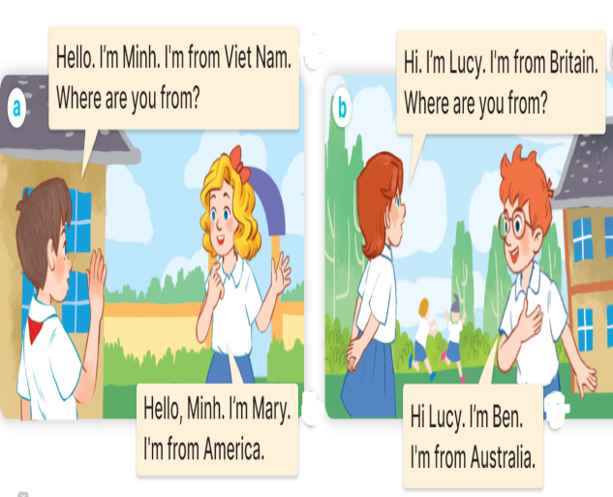  2. Listen, point and say.  * New words  + America : nước Mỹ  + Australia : nước Úc  + Britain: nước Anh  + Viet Nam: nước Việt Nam  * Model sentences:  A: Where are you from?  B: I’m from America.  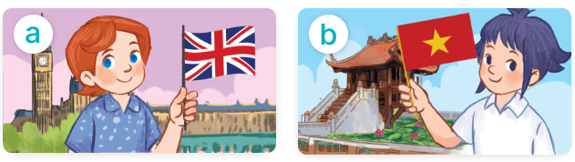    3. Let’s talk.  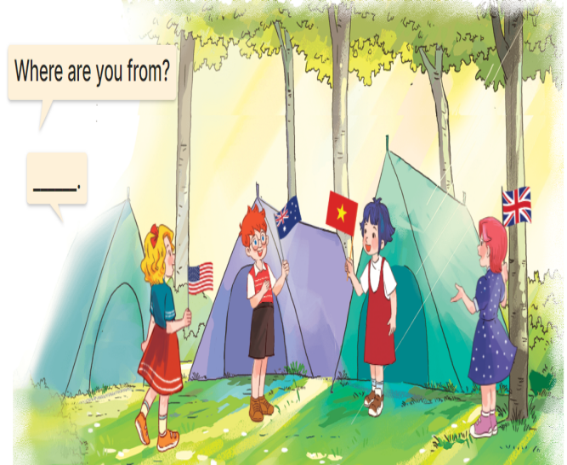
V. Adjustments (if necessary):
………………………………………………………………………………………….…..……………………………………………………………………………...………………………………………….…..………………………………............
---------------------------------------------------------
Preparing date: September …….., 2023
Period 6 Teaching date: September ………., 2023

Unit 1: My friends
Lesson 1 (4,5,6)
I. Objective
By the end of the lesson, students will be able to:
1. Knowledge:
- use the words America, Australia, Britain, and Viet Nam in relation to the topic “My friends”;
- listen to and demonstrate understanding of simple communicative contexts
in relation to the topic “My friends”.
- read and write about where someone comes from.
- Vocabulary: Review
2. Skills: speaking, listening, reading and writing.
3. Competences:
- Critical Thinking: self-introduce
- Co-operation: ready to help friends in pair work/ group work.
- Self-control and independent learning: perform listening tasks.
4. Attitude/ Qualities:
- Kindness: Help partners to complete learning tasks.
- Honesty: Show pride in where they come from and great respect for where someone
comes from by using appropriate gestures and intonation when asking and
answering about nationality
- Diligence: complete learning tasks.
II. Methods: Communicative approach, group Ss and T's activities, play as a character, teaching methods with game, teaching methods by visual, teaching methods by practising, discussion group, technical present....
III. Teaching aids
1.Teacher: Teacher’s guide Pages 20,21; audio Tracks 8, 9; website sachmem.vn, posters, laptop, pictures, textbook, lesson plan, TV or projector.
2. Students: Pupil’s book Page 11, notebooks, workbooks, school things.
IV. Procedures
Teacher’s and students’ activities | Content
Activity 1. Warm- up:  - Divide the class into 3 teams.  - Guides Ss to play the game.  - Gives comments.  - Say “Open your book page 11” and look at “Unit 1, Lesson 1 (4,5,6)”.  - Ss open their books  Activity 2. Listen and number.  - Elicit the names of the characters in the pictures. Point at the pictures respectively to explain the context.  +Who is he/ she?  +Where is he/ she from?  - Look at the pictures and say.  - T ask Ss to guess the answers.  - Ss guess the answers  - T writes Ss’ guessing on the board.  - Listen to the tape:  + Play the recording  + Play the recording again and get Ss to swap books with their partners.  + Play the recording again to check answers together as a class.  + Write the answers on the board for Ss to correct their answers. Then checks Ss’ guessing.  - Invite one pupil to read aloud sentences 1 and 2 and a pair of pupils to act out Exchanges 3 and 4 in front of the class.  Activity 3. Look, complete and read.  - Get Ss to look at the pictures and identify the characters  - Have Ss look at the four incomplete sentences and elicits the missing words in the sentences.  - T models with sentence 1  + Ask Ss what is missing in the sentence.  + Have Ss look at the picture and complete the gap, then read the completed sentence in chorus.  -Have Ss work in groups and complete the sentences 2,3 and 4.  - Ask a few Ss to stand up and read the completed sentences aloud.  -T gives feedbacks.  Activity 4. Let’s sing.  - Introduce the title and lyrics of the song: “Where are you from” song.  - Play the recording for Ss to listen to the whole song.  + Have them repeat the title and lyrics line by line.  + Tell Ss to point at the relevant character while singing his or her name.  - Play the recording all the way through for Ss to listen to pronunciation and melody of the song.  - Play the recording line by line for Ss to listen, repeat and point at the relevant character.  - Play the recording for Ss to sing and do actions.  - Ask Ss to practice singing and doing actions in pairs or groups.  - Invite groups to the front of the classroom to perform the song  -T gives feedback.  Activity 5: Consolidation  - T asks ss to answer the following questions:  + What have you learnt from the lesson today?  - T praises some Ss who are hardworking / active/ good…. as well as encourage others to try more.  Homework.  - Learn the song by heart  - Prepare the new lesson: Unit 1, Lesson 2 (1,2,3). | Game: “Lucky number”  4. Listen and number.  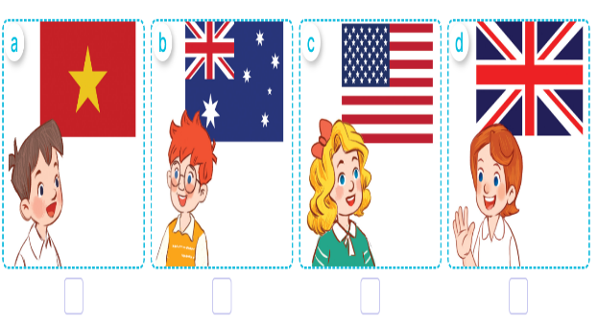  + Picture a: Minh from Viet Nam  + Picture b: Ben from Australia  + Picture c: Mary from America  + Picture d: Lucy from Britain  Key:  1. b 2. d 3. c 4. a  5. Look, complete and read.  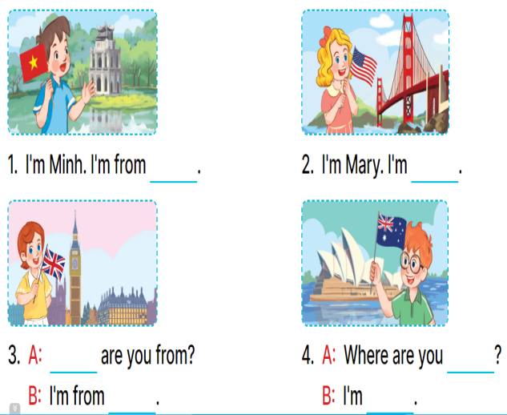  Key:  1. Viet Nam  2. from America  3. Where; Britain  4. from; from Australia  6. Let’s sing.  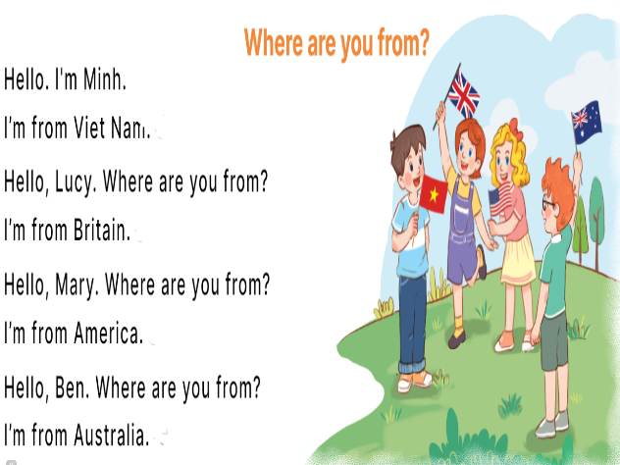
V. Adjustments (if necessary):
………………………………………………………………………………………….…..……………………………………………………………………………...………………………………………….…..………………………………
---------------------------------------------------------

