Week: 33
Teaching date:
UNIT 20: AT THE ZOO
Period: 130- Lesson 1:1,2,3
I. Objectives: By the end of the lesson, Ss will be able to:
1. Knowledge:
- use the words tiger, monkey, horse, peacock in relation to the topic “At the zoo”.
- correctly use What can you see? – I can see …….. to ask and answer questions about what animals someone can see at the zoo.
- Vocabulary: tiger, monkey, horse, peacock, zoo, see
- Model sentences:
A: What can you see?
B: I can see a tiger.
- Skills: speaking and listening
2. Competences:
-Critical Thinking: talk about friends.
- Co-operation: ready to help friends in pair work/ group work.
- Sociability: Talk to each other, say good words to others.
3. Attitude/ Qualities:
- Kindness: Help partners to complete learning tasks.
- Honesty: tell the truth about feelings and emotions
II. TEACHING AIDS:
- Teacher: Teacher’s guide Pages 242, 243, audio Tracks 94, 95, website sachmem.vn, posters, laptop, pictures, textbook, lesson plan, TV or projector.
- Students: Pupil’s book Page 64, notebooks, workbooks, school things.
III. PROCEDURES:
Teacher’s and students’ activities | Contents
Activity 1.Warm- up: sing a song  “ IF YOU’RE HAPPY AND YOU KNOW IT”  - Show the song on the screen.  https://www.youtube.com/watch?v=zyMWcWqmhRc  - Ask Ss to listen, sing and dance the song.  - Say “Open your book page 64” and look at “Unit 20, Lesson 1 (1,2,3)”.  Activity 2. Look, listen and repeat:  - Have pupils look at Pictures a and b and identify the characters in the pictures.  - Play the audio twice (sentence by sentence). Correct their pronunciation where necessary.  - Have Ss to practice the dialogue  - T invites a few pairs to the front of the class to practice.  - T checks pronunciation for ss. Ask sts to link to activity 3:  Activity 3: Listen, point and say..  - T asks Ss look at picture a and helps Ss know the structure from the dialogue.  - T introduces new word and structure for Ss.  - T explains, models and gives meaning.  -Have Ss repeat the model sentences.  - Elicit and check comprehension  - Run through all the pictures. 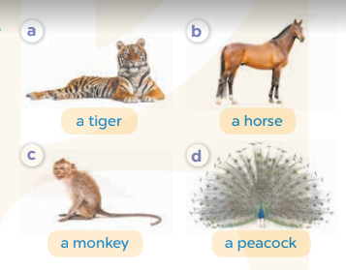  - Run through model sentences.  + Run through the questions.  + Run through the answers.  - Have Ss to practise:  + T asks the first – Ss answer (change role).  + Ss – Ss (change role).  - Ask Ss to work in pairs to ask and answer the question “What can you see?  - I can see a tiger/ a horse/ a monkey/ a peacock.  - T controls and corrects.  - Invite a few pairs to come to the front of the classroom, point at the relevant character in each picture, and act out his/her role.  - Encourage Ss to practice speaking English.  - T gives feedbacks.  Activity 4. Let’s talk.  - Run though the picture 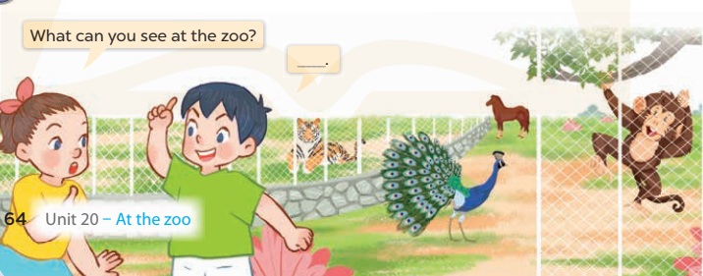  - T asks ss look at the second bubble and ask  +What can you see at the zoo? ______.  - Get Ss to repeat the question and the answer several times in pairs.  - T models: Go around the classroom, pointing to Ss and asking What can you see at the zoo ?  - Ask Ss ask and answer about their hobbies in pairs.  - Call some pairs to practice.  - Give feedbacks  Activity 5. Consolidation  - Summary the lesson  Homelink:  Learn the vocabulary and model sentences by heart  - Prepare the new lesson: Unit 20, Lesson 1: 4,5,6 on page 65. | 1.Look, listen and repeat  see: nhìn, xem  zoo: sở thú  a tiger: 1 con hổ  2.Listen, point and say  A horse: 1 con ngựa  A monkey: 1 con khỉ  A peacock: 1 con công  Structure:  - What can you see?  - I can see a tiger/ a horse/ a monkey/ a peacock.  3.Let’s talk.  What can you see at the zoo? ___ _____________
IV. ADJUSTMENTS (if necessary):
………………………………………………………………………………………….…..……………………………………………………………………………...…===========================
Teaching date: 3A:
Unit 20: AT THE ZOO
Period 131- Lesson 1: 4,5,6
I. OBJECTIVES:
By the end of the lesson, Ss will be able to:
1. Knowledge:
- listen to and understand four communicative contexts in which pupils ask and answer questions about what animals they can see at the zoo and number the correct pictures.
- complete the four gapped exchanges with the help of the picture cues.
- Vocabulary: Review
- Skills: speaking, listening, reading and writing.
2. Competences:
- Critical Thinking: talk about friends
- Co-operation: ready to help friends in pair work/ group work.
- Self-control and independent learning: perform listening tasks.
3. Attitude/ Qualities:
- Kindness: Help partners to complete learning tasks.
- Honesty: tell the truth about feelings and emotions.
- Diligence: complete learning tasks.
II. TEACHING AIDS:
- Teacher: Teacher’s guide Pages 244, 245; audio Tracks 96; website sachmem.vn, posters, laptop, pictures, textbook, lesson plan, TV or projector.
- Students: Pupil’s book Page 65, notebooks, workbooks, school things.
III. PROCEDURES:
Teacher’s and students’ activities | Contents
Activity 1: Warm-up  Game: Simon says  - T is the leader and calls out the actions with “Simon says”.  - Ss must follow the leader and do the action.  - Then teacher has to try and get pupils to do an action without saying “Simon says”. If pupil does the action, he/she is out of the game.  Simon says swim like a fish.  Simon says jump like a monkey.  Simon says run like a horse.  Simon says roar like a tiger.  Dance like a peacock.  Swim like a fish  - Say “Open your book page 65” and look at “Unit 20, Lesson 1 (4,5,6)”.  Activity 2. Listen and number:  - Elicit the animals in those pictures 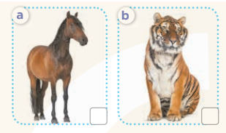  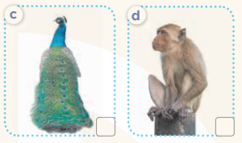  - Point at the pictures respectively to explain the context.  - T asks Ss to guess the answers.  + T writes Ss’ guessing on the board. Sts listen and number.  - Listen to the tape:  + Play the recording  + Play the recording again and get Ss to swap books with their partners.  + Play the recording again to check answers together as a class.  + Write the answers on the board for Ss to correct their answers. Then checks Ss’ guessing.  - Play the recording, sentence by sentence, for the class to listen and repeat in chorus.  Activity 3. Look, complete and read.  - Have Ss look at the pictures and identify the animals.  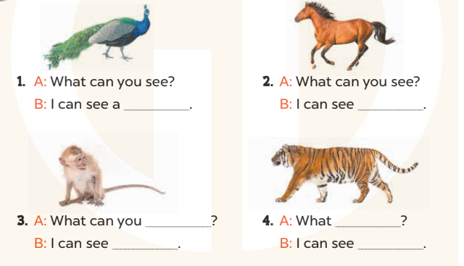  - Have Ss look at the four incomplete sentences and elicits the missing words in the sentences.  - T models with sentence 1  + Ask Ss what is missing in the sentence.  + Have Ss look at the picture and complete the gap, then read the completed sentence in chorus.  -Have Ss work in groups and complete the sentences 2,3 and 4.  - Ask a few Ss to stand up and read the completed sentences aloud.  -T gives feedbacks  Activity 4. Game “ miming game”  - Tell Ss that they are going to revise the target vocabulary items they have learnt in Lesson 1.  - Divide Ss into groups of five and give each group a set of cards.  - Have each player in group 1 in turn look at the card and mime / act out the animal on the card (ex: peacock) without making any sounds or lip movements.  + The other player in the group asks What can you see? The players in group 2 answer (ex:I can see a peacock.).  + If the second group has the correct answer, they get a point.  + If the answer does not match the action, switch the groups and let each player in group 2 mime the animal while the first group gives the answer.  - The game ends when all the cards are gone.  Activity 5. Consolidation  -T asks ss to answer the following questions:  + What have you learnt from the lesson today?  +What are the core values of the lesson? (if the teacher can take from the lesson).  - T praises some Ss who are hardworking / active/ good…. as well as encourage others to try more.  Homelink:  - Ask and answer about the pictures on page 65.  - Prepare the new lesson: Unit 20, Lesson 2:1,2,3 on page 66. | 4. Listen and number  Key:  1. d  2. a  3. b  4. c  5. Look, complete and read  Key:  1. peacock  2. a horse  3. see; a monkey  4. can you see; a tiger  6. Let’s play  Miming game
IV. ADJUSTMENTS (if necessary):
………………………………………………………………………………………….…..……………………………………………………………………………...…======================================
Teaching date:
Unit 20: AT THE ZOO
Period: 132- Lesson 2: 1,2,3
I. OBJECTIVES:
By the end of the lesson, Ss will be able to:
1. Knowledge:
- use What is the ……… doing? – It's ……. to ask and answer questions about what a zoo animal is doing.
-enhance the correct use of What’s the …..doing? – It’s ………to ask and answer questions about what a zoo animal is doing.
- Vocabulary: counting, swinging, climbing
- Model sentences:
A: What’s the elephant doing?
B: It’s dancing.
- Skills: speaking and listening
2. Competences:
- Co-operation: ready to help friends in pair work/ group work.
- Sociability: Talk to each other, say good words to others.
3. Attitude/ Qualities:
- Kindness: Help partners to complete learning tasks.
- Honesty: tell the truth about feelings and emotions
II. TEACHING AIDS:
- Teacher: Teacher’s guide Pages 246, 247; audio Tracks 97, 98, website sachmem.vn, posters, laptop, pictures, textbook, lesson plan, TV or projector.
- Students: Pupil’s book Page 66, notebooks, workbooks, school things.
III. PROCEDURES:
Activity 1. Warm- up:  Game: Matching.  - Teacher divides the class into 2 teams  There are 2 columns. The first column is some pictures about animals such as a peacock, a tiger, a monkey, a horse. The other column is meaning of them. Sts must match the picture in the first column with correctly its meaning in the other column.  - Pupils of each team will get points if their matching is correct.  -T give feedback  - Say “Open your book page 66” and look at “Unit 20, Lesson 2 :1,2,3”.  Activity 2. Look, listen and repeat:  - Have pupils look at Pictures a and b and identify the characters and ask students to guess the content in the pictures such as what’s can you see? Sts can answer I can see “ con voi” if they do not speak “ con voi” in English or T can use Vietnamese to ask sts in picture b to guess content before reading.  - Play the audio twice (sentence by sentence). Correct their pronunciation where necessary.  - Have Ss to practice the dialogue  - T invites some pairs to the front of the class to practice.  - T checks pronunciation for ss.  - T ask sts to write the new words on the board.  Activity 3 Listen, point and say.  - Have Ss look at the pictures and elicit the name of the animal.  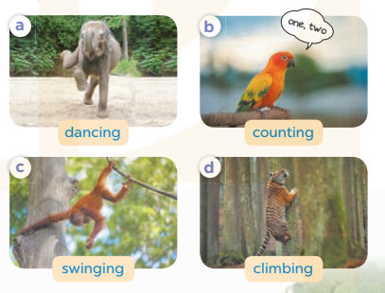  - Run through all the pictures.  - T asks Ss look at picture a and helps Ss know the structure from the dialogue.  - T introduces new words and structure for Ss.  - T explains, models and gives meaning.  -Have Ss repeat the model sentences.  - Have Ss to practise:  + T asks the first – Ss answer (change role).  + Ss – Ss (change role).  - Ask Ss to work in pairs to ask and answer the question What’s the___doing? It’s____  - T controls and corrects.  - Invite a few pairs to come to the front of the classroom  - Encourage Ss to practice speaking English.  - T gives feedbacks.  Activity 4. Let’s talk.  - Have Ss look at the picture and elicit the question and answer: What’s the…… doing? It’s…..  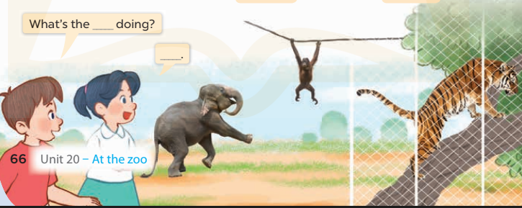  - Ask Ss work in pairs to ask and answer questions about what is the animal doing?  - Invite some pairs to role play in front of the class to point at the activity in the picture cue in their books.  -Check and congratulate.  Activity 5: Consolidation  - Summary the lesson  Homelink  - Learn the vocabulary and model sentences by heart  - Prepare the new lesson: Unit 20, Lesson 2:4,5,6 on page 67 | 1.Look, listen and repeat.  + an elephant: 1 con voi  + dancing: đang múa  2. Listen, point and say.  counting: đang đếm  swinging: đang đu  climbing: đang trèo  Structure  - What the elephant/parrot /monkey doing?  - It’s dancing /counting/ swinging  3. Let’s talk.  What’s the____ doing?  ______.
IV. ADJUSTMENTS (if necessary):
………………………………………………………………………………………….…..……………………………………………………………………………...…======================================
Teaching date: 3A:

Unit 20: AT THE ZOO
Period 133: Lesson 2: 4,5,6
I. OBJECTIVES:
By the end of the lesson, Ss will be able to:
1. Knowledge:
- listen to and demonstrate understanding of simple communicative contexts in relation to the topic “At the zoo”.
- Vocabulary: Review
- Skills: speaking, listening, reading and writing.
2. Competences:
- Co-operation: ready to help friends in pair work/ group work.
- Self-control and independent learning: perform listening tasks.
3. Attitude/ Qualities:
- Kindness: Help partners to complete learning tasks.
- Honesty: tell the truth about feelings and emotions.
- Diligence: complete learning tasks.
II. TEACHING AIDS:
- Teacher: Teacher’s guide Pages 248, 249; audio Tracks 99, 100; website sachmem.vn, posters, laptop, pictures, textbook, lesson plan, TV or projector.
- Students: Pupil’s book Page 67, notebooks, workbooks, school things.
III. PROCEDURES:

Teacher’s and students’ activities | Contents
Activity 1. Warm- up: “ Guessing game”  - Guessing action to review 4 words sts have learned in previous lesson ( counting, dancing, climbing and swing)  - Ask pupils to play in 2 teams.  - T make model  - Monitor and check to find the winner and congratulate.  - Say “Open your book page 67” and look at “Unit 20, Lesson 2 (4,5,6)”.  Activity 2. Listen and tick:  - Have Ss look at the pair of picture and check comprehension  + What can you see?  + What is it doing?  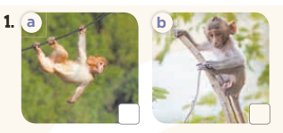  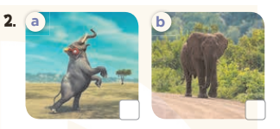  - T ask Ss to guess the answers.  + T writes Ss’guessing on the board.  - Listen to the tape:  + Play the recording  + Play the recording again and get Ss to swap books with their partners.  + Play the recording again to check answers together as a class.  + Write the answers on the board for Ss to correct their answers. Then checks Ss’ guessing.  - Play the recording, sentence by sentence, for the class to listen and repeat in chorus.  Activity 3. Look, complete and read.  - Have Ss look at the pictures and identify the animals in the picture.  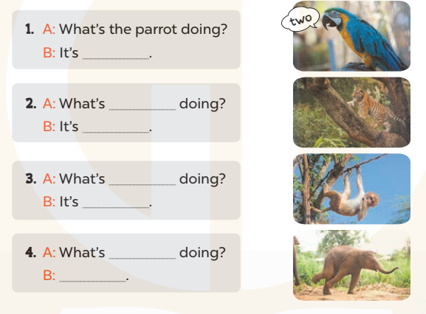  - T models with sentence 1.  + Have Ss look at the sentence.  + Ask them what is missing in the answer (counting).  + Have Ss complete the gap.  + Have Ss read the completed sentence in chorus.  -Have Ss work in pairs and complete the sentences 2, 3 and 4.  - Invite pairs of pupils to stand up and read aloud the sentences.  - T gives feedbacks.  Activity 4. Let’s sing  - Introduce the title and lyrics of the song “At the zoo”  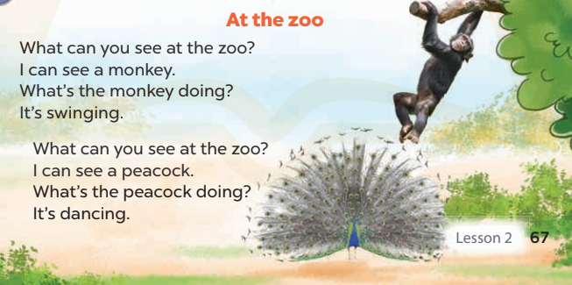  - Play the recording for Ss to listen to the whole song.  + Have them repeat the title and lyrics line by line.  + Tell Ss to point at the pictures  while singing.  - Play the recording all the way through for Ss to listen to pronunciation and melody of the song.  - Play the recording line by line for Ss to listen, repeat and point to the pictures  - Play the recording for Ss to sing and do actions.  - Ask Ss to practice singing and doing actions in pairs or groups.  - Invite groups to the front of the classroom to perform the song  -T gives feedback.  Activity 5: Consolidation  - Summary the lesson  Homelink  - Ask and answer about the pictures on page 67.  - Prepare the new lesson: Unit 20, Lesson 3 (1,2,3) on page 68. | 4. Listen and tick  Key: 1.a 2. a  5. Look, complete and read.  Key:  1. counting  2. the tiger; climbing (the tree)  3. the monkey; swinging  4. the elephant; It's dancing  6.Let’s sing.  “At the zoo”
IV. ADJUSTMENTS (if necessary):
………………………………………………………………………………………….…..…………………………………………………………………………….
---------------------------

Week:
Teaching date:
UNIT 20: AT THE ZOO
Period 134: Lesson 3 (1, 2, 3)
I. OBJECTIVES:
By the end of the lesson, Ss will be able to:
1. Knowledge:
- correctly repeat the sounds of the letters a in isolation, the words parrot and dancing and the sentences I can see a parrot. and The peacock is dancing. with the correct pronunciation and intonation.
- identify the target words parrot and dancing while listening.
- say the chant with the correct rhythm and pronunciation.
- Vocabulary: Review
- Skills: listening, speaking and reading.
2. Competences:
- Co-operation: ready to help friends in pair work/ group work.
- Self-control and independent learning: perform listening tasks.
3. Attitude/ Qualities:
- Kindness: Help partners to complete learning tasks.
- Honesty: tell the truth about feelings and emotions
II. TEACHING AIDS:
- Teacher: Teacher’s guide Pages 250, 251; audio Tracks 101,102,103; website sachmem.vn, posters, laptop, pictures, textbook, lesson plan, TV or projector.
- Students: Pupil’s book Page 68, notebooks, workbooks, school things.
III. PROCEDURES:
Teacher’s and students’ activities | Contents
Activity 1. Game: Brain storming “ Animals”  - Divide class into 2 teams to play this game.  - Give rules, make model  -Monitors  -T checks who’s winner?  - Say “Open your book page 68” and look at “Unit 20, Lesson 3 (1,2,3)”.  Activity 2. Listen and repeat  T gives instruction to the letters a in isolation, the words parrot and dancing and the sentences I can see a parrot. and The peacock is dancing  - Play the recording for the letter pl and fl  - Encourage Ss to point at the letter/ word/ sentence while listening.  - Play the recording again and encourage Ss to listen and repeat.  - Do this several times until Ss feel confident.  - T calls some Ss to practice.  - T gives feedbacks.  Activity 3. Listen and circle.  - Run though 2 sentences and possible answers.  - T ask Ss to guess the answers.  + T writes student s’ guess on the board.  - Listen to the tape:  + Play the recording  + Play the recording again and get Ss to swap books with their partners.  + Play the recording again to check answers together as a class.  + Write the answers on the board for Ss to correct their answers. Then checks Ss’ guessing.  - Play the recording, sentence by sentence, for the class to listen and repeat in chorus.  - Invite some students to read before whole class  Activity 4. Let’s chant.  - Introduce the title and lyrics of the chant.  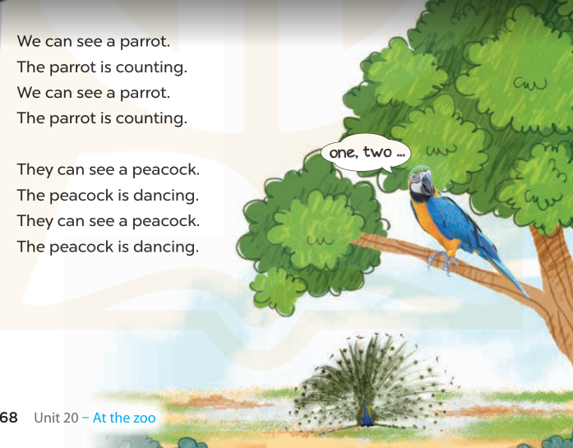  - Play the recording for Ss to listen to the whole chant.  + Have them repeat the title and lyrics line by line.  + Ask Ss to attend to the sounds of the letters a and the words parrot and dancing.  - Play the recording all the way through for Ss to listen to pronunciation and melody.  - Play the recording line by line for Ss to listen and repeat  - Play the recording for Ss to chant and clap along.  - Ask Ss to practice chant and clap along in pairs or groups.  - Invite groups to the front of the classroom to perform the chant  -T gives feedback.  Activity 5: Consolidation  - Summary the lesson  Homelink  - Draw a picture about the favourite animal  - Prepare the new lesson: Unit 20, Lesson 3: 4,5,6 on page 69 | 1.Listen and repeat:  2. Listen and circle.  Key: 1.c 2.a  3. Let’s chant
IV. ADJUSTMENTS (if necessary):
………………………………………………………………………………………….…..……………………………………………………………………………...
========================
Week:
Teaching date:
UNIT 20: AT THE ZOO
Period 135: Lesson 3:4,5,6
I. OBJECTIVES:
By the end of the lesson, Ss will be able to:
1. Knowledge:
- use the target language in real context by reading and writing a gapped text about what pupils can see at the zoo.
- use the target language items they have learnt in a real context by showing the class some photos of animals and saying what animals they can see at home or at the zoo.
- Vocabulary: Review
- Skills: reading, writing and speaking.
2. Competences:
- Co-operation: ready to help friends in pair work/ group work.
- Self-control and independent learning: perform reading tasks.
3. Attitude/ Qualities:
- Kindness: Help partners to complete learning tasks.
- Honesty: tell the truth about feelings and emotions.
- Diligence: complete learning tasks.
II. TEACHING AIDS:
- Teacher: Teacher’s guide Pages 251, 252, website sachmem.vn, posters, laptop, pictures, textbook, lesson plan, TV or projector.
- Students: Pupil’s book Page 69, notebooks, workbooks, school things.
III. PROCEDURES:
Teacher’s and students’ activities | Contents
Activity 1: Warm- up: (5’)Game: Kim game  - Tell Ss that they are going to look at the cards in 60 seconds, memorize the words (tiger, elephant, monkey, peacock,…) then remember as many of the words as possible.  - Divide the class into 2 teams.  - In their teams, Ss try to say as many of the words as they can remember.  - Have the groups say the names of the things aloud.  - For each correct word, give them a star.  - The group with the most stars will be winner.  - Say “Open your book page 69” and look at “Unit 20, Lesson 3 (4,5,6)”.  Activity 2. Read and tick True or False:  - Tell the class the goal of this activity and how to complete the task.  - Have Ss read the sentence and identify where Linh and her mother are. Then have them read the text and find the appropriate information to tick in the True box or False box.  - Set a time limit for Ss to do the activity independently.  - Let Ss swap and check the answers.  - Invite Ss to read the texts aloud  - T gives feedbacks.  Activity 3. Let’s write  - Tell the class the goal of this activity  - Explain that the first gap should be animals, the second gap should be what the monkey is doing, the next gap can be an animal and the last gap can be what the pupils think about the animals at the zoo.  - Give Ss time to complete the text independently.  - In pairs or groups, ask Ss to swap their complete text before checking as a class.  Activity 4. Project.  - Tell pupils about the goal of the activity.  - Explain that they are going to show some photos of animals (at home or at the zoo) which they have found as homework and tell the class about them.  - Have Ss work in groups. Each member shows his / her photos and introduces them, ex: I can see a dog at home. I can see two monkeys at the zoo.  - Invite one or two Ss to show their photos to the class and say what animals they can see at home or / and at the zoo.  Activity 5: Consolidation  - T asks ss to answer the following questions:  + What have you learnt from the lesson today?  +What are the core values of the lesson?  - T praises some Ss who are hardworking / active/ good…. as well as encourage others to try more.  Homelink. (3’)  - Prepare the new lesson: Review 4 on page 70 | 4.Read and tick True or False:  Key: 1. True 2. False  3. True 4. True  5. Let’s write  Key: Pupil’s answer  6. Project.  My favourite animals
IV. ADJUSTMENTS (if necessary):
………………………………………………………………………………………….…..……………………………………………………………………………...

