Week:
Teaching date: / /2023
Unit 18: Playing and doing
Lesson 1:1,2,3
I. OBJECTIVES:
By the end of the lesson, Ss will be able to:
1. Knowledge:
- understand and correctly repeat the sentences in two communicative contexts to talk about an action in progress.
- correctly say the words and use I’m …… to identify an action in progress.
- enhance the correct use of I’m……… to identify an action in progress in a freer context.
- Vocabulary: writing, dancing, singing, reading, song.
- Model sentences:
I’m dancing.
- Skills: speaking and listening
2. Competences:
- Co-operation: ready to help friends in pair work/ group work.
- Sociability: Talk to each other, say good words to others.
3. Attitude/ Qualities:
- Kindness: Help partners to complete learning tasks.
- Honesty: tell the truth about feelings and emotions
II. TEACHING AIDS:
- Teacher: Teacher’s guide Pages 221, 222, audio Tracks 74, 75, website sachmem.vn, posters, laptop, pictures, textbook, lesson plan, TV or projector.
- Students: Pupil’s book Page 52, notebooks, workbooks, school things.
III. PROCEDURES:
Teacher’s and students’ activities | Contents
Activity 1.Warm- up: Sing: Head, shoulders, knees and toes  - Show the song on the screen.  https://www.youtube.com/watch?v=WX8HmogNyCY  - Ask Ss to listen, sing and dance the song.  - Say “Open your book page 52” and look at “Unit 18, Lesson 1 (1,2,3)”.  Activity 2. Look, listen and repeat:  - Have pupils look at Pictures a and b and identify the characters in the pictures.  - Play the audio twice (sentence by sentence). Correct their pronunciation where necessary.  - Have Ss to practice the dialogue  - T invites a few pairs to the front of the class to practice.  - T checks pronunciation for ss. Ask sts to link to activity 2.  Activity 3: Listen, point and say.  - T asks Ss look at picture b and helps Ss know the structure from the dialogue.  - T introduces new structure for Ss.  - T explains, models and gives meaning.  - Have Ss repeat the model sentences.  - Elicit the character and the quantity of toys in each picture.  - Run through all the pictures.  - Run through model sentences.  - Have Ss to practise:  - Ask Ss to work in pairs.  - T controls and corrects.  - Invite a few pairs to come to the front of the classroom and point at the pictures and say the questions and answers in front of the class.  - T gives feedbacks.  Activity 4. Let’s talk.  - Have Ss look at the picture and tell them about the activity.  - Put Ss into groups of four.  - Ask Ss to say using I’m…..  - Invite some Ss to the front of the class to say about the activity.  Activity 5. Consolidation  - Summary the lesson  Homelink:  Learn the vocabulary and model sentences by heart  - Prepare the new lesson: Unit 18, Lesson 1: 4,5,6. | I’m dancing.  1. Look, listen and repeat  + writing : viết  + dancing : nháy múa  + singing :hát  + reading : đọc  + song :bài hát  2. Listen, point and say  I’m dancing.  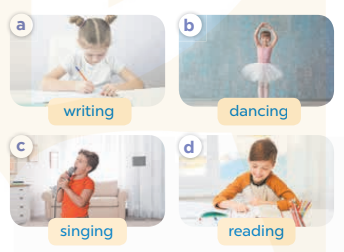  3. Let’s talk.  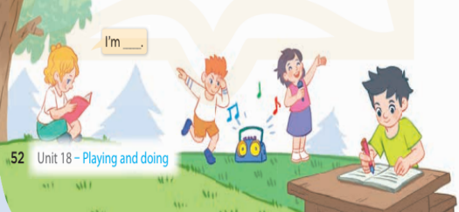  I’m ……..
IV. ADJUSTMENTS (if necessary):
………………………………………………………………………………………….…..……………………………………………………………………………...…===========================
Week:
Teaching date:
Unit 18: Playing and doing
Lesson 1:4,5,6
I. OBJECTIVES:
By the end of the lesson, Ss will be able to:
1. Knowledge:
- listen to and understand two communicative contexts about identifying actions in progress and tick the correct pictures.
- complete the four target sentence patterns with the help of picture cues.
- practise the target vocabulary and sentence patterns by playing the Miming game.
- Vocabulary: Review
- Skills: speaking, listening, reading and writing.
2. Competences:
- Critical Thinking: talk about activity
- Co-operation: ready to help friends in pair work/ group work.
- Self-control and independent learning: perform listening tasks.
3. Attitude/ Qualities:
- Kindness: Help partners to complete learning tasks.
- Honesty: tell the truth about feelings and emotions.
- Diligence: complete learning tasks.
II. TEACHING AIDS:
- Teacher: Teacher’s guide Pages 223, 224; audio Tracks 76, 77; website sachmem.vn, posters, laptop, pictures, textbook, lesson plan, TV or projector.
- Students: Pupil’s book Page 53, notebooks, workbooks, school things.
III. PROCEDURES:
Teacher’s and students’ activities | Contents
Activity 1: Warm-up  Game: A letter to the Santa Claus  - Divide class into 4 teams.  - Set rules: invite 1 pupil to go to the board, look at the picture, then say aloud what toy the boy wants for Christmas. The fastest has one points for his/her team.  (writing, dancing, singing, reading)  - Encourage Ss join in the game.  - Give point for Ss.  - Say “Open your book page 53” and look at “Unit 18, Lesson 1 (4,5,6)”.  Activity 2. Listen and tick:  - Elicit the word for the action in each picture .  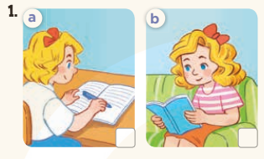  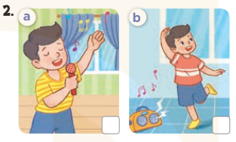  - T ask Ss to guess the answers.  + T writes Ss’guessing on the board.  - Listen to the tape:  + Play the recording  + Play the recording again and get Ss to swap books with their partners.  + Play the recording again to check answers together as a class.  + Write the answers on the board for Ss to correct their answers. Then checks Ss’ guessing.  - Play the recording, sentence by sentence, for the class to listen and repeat in chorus.  Activity 3. Look, complete and read  - Get Ss to look at the pictures and identify the actions in the pictures.  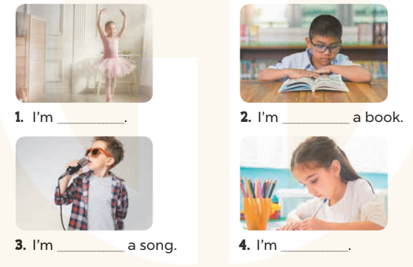  - Have Ss look at the four sentences and the pictures. Elicit and model with picture 1  + Ask Ss to read the sentence 1 in chorus.  + Ask them what is missing in the question (dancing). Then have them complete the gap (I’m dancing.).  -Have Ss work in pairs and complete the dialogue 2, 3, 4.  - Ask a few Ss to stand up and read the sentences aloud.  -T gives feedbacks.  Activity 3. Let’s play  - Introduce the title and lyrics of the song: “Their toys ” song.  - Play the recording for Ss to listen to the whole song.  + Have them repeat the title and lyrics line by line.  + Tell Ss to point at the relevant character while singing his or her name.  - Play the recording all the way through for Ss to listen to pronunciation and melody of the song.  - Play the recording line by line for Ss to listen, repeat and point at the relevant character.  - Play the recording for Ss to sing and do actions.  - Ask Ss to practice singing and doing actions in pairs or groups.  - Invite groups to the front of the classroom to perform the song  -T gives feedback.  Activity 5. Consolidation  -T asks ss to answer the following questions:  + What have you learnt from the lesson today?  +What are the core values of the lesson? (if the teacher can take from the lesson).  - T praises some Ss who are hardworking / active/ good…. as well as encourage others to try more.  Homelink:  - Ask and answer about the pictures on page 47.  - Prepare the new lesson: Unit 18, Lesson 2:1,2,3. | 4. Listen and tick  Key: 1. b 2. b  5. Look, complete and read  Key:  1. dancing 2. reading  3. singing 4. writing  6. Let’s play.  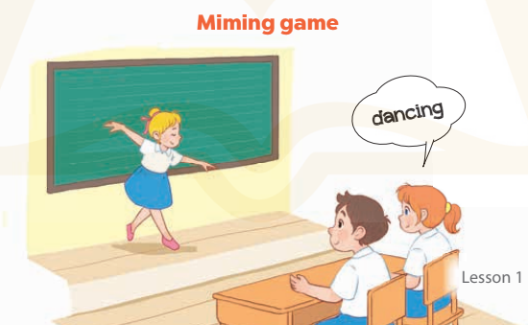
IV. ADJUSTMENTS (if necessary):
………………………………………………………………………………………….…..……………………………………………………………………………...…======================================
Week :
Teaching day:
Unit 18: Playing and doing
Lesson 2:1,2,3
I. OBJECTIVES:
By the end of the lesson, Ss will be able to:
1. Knowledge:
- understand and correctly repeat the sentences in two communicative contexts to ask and answer questions about an action in progress.
- correctly say the words and use What are you doing? – I’m …….. to ask and answer questions about an action in progress.
- enhance the correct use of What are you doing? – I’m …….. to ask and answer questions about an action in progress in a freer context
- Vocabulary: playing basketball, drawing a picture, watching TV, listening to music.
- Model sentences:
A: What are you doing?
B: I’m watching TV.
- Skills: speaking and listening
2. Competences:
- Critical Thinking: talk about activity
- Co-operation: ready to help friends in pair work/ group work.
- Sociability: Talk to each other, say good words to others.
3. Attitude/ Qualities:
- Kindness: Help partners to complete learning tasks.
- Honesty: tell the truth about feelings and emotions
II. TEACHING AIDS:
- Teacher: Teacher’s guide Pages 224, 225; audio Tracks 77, 78, website sachmem.vn, posters, laptop, pictures, textbook, lesson plan, TV or projector.
- Students: Pupil’s book Page 54, notebooks, workbooks, school things.
III. PROCEDURES:
Activity 1. Warm- up:  - Stand up and pass the ball with music.  - When music stops, those who keep the ball must look at a picture on the board and say a sentence. I’m……………  - Say “Open your book page 48” and look at “Unit 18, Lesson 2 (1,2,3)”.  Activity 2. Look, listen and repeat:  - Have pupils look at Pictures a and b and identify the characters and ask students to guess the content in the pictures such as what’s this?  - Play the audio twice (sentence by sentence). Correct their pronunciation where necessary.  - Have Ss to practice the dialogue  - T invites some pairs to the front of the class to practice.  - T checks pronunciation for ss.  - T ask sts to write the new words on the board.  - Checking: Rub out and remember  Activity 3 Listen, point and say.  - T asks Ss look at picture a, b and helps Ss know the structure from the dialogue.  - T introduces new structure for Ss.  - T explains, models and gives meaning.  - Have Ss repeat the model sentences.  What are you doing?  I’m watching TV.  - Have Ss look at the pictures and elicit the actions in progress.  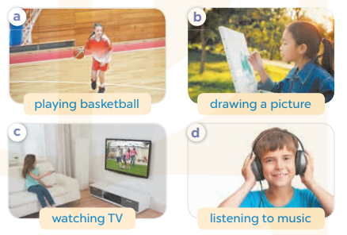  - Run through all the pictures.  - Run through model sentences.  +Run through the question sentences  +Run through the answer sentences  - Have Ss to practise:  + T asks, Ss answer picture a  + Ss ask, T answers picture b  + Group A ask, group B answer picture c  + Group B ask, group A answer picture d  - Ask Ss to work in pairs.  - T controls and corrects.  - Invite a few pairs to come to the front of the classroom, point at the pictures and say in front of the class.  - T gives feedbacks.  Activity 4. Let’s talk.  - Have Ss look at the picture and elicit the answer I’m drawing a picture.  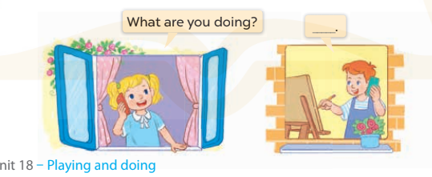  - Have Ss do the action for drawing a picture. Pretend to start a phone call and ask pupils: What are you doing? and elicit the full answer: I’m drawing a picture.  - Have Ss repeat the question a few times, and then the answer  - Have Ss sit back-to-back in pairs. One pupil is doing something while the other calls and asks: What are you doing?  - Invite some pairs to the front of the class to interact with each other, pointing at the activity in the picture cue in their books.  Activity 5: Consolidation  - Summary the lesson  Homelink  - Learn the vocabulary and model sentences by heart  - Prepare the new lesson: Unit 18, Lesson 2:4,5,6 on page 49 | 1.Look, listen and repeat.  + watching TV : xem ti vi  + playing basketball:chơi bóng rổ  + drawing a picture : vẽ tranh  + listening to music: nghe nhạc  2. Listen, point and say.  Structure  A: What are you doing?  B: I’m watching TV.  3. Let’s talk.  What are you doing?  I’m ………………
IV. ADJUSTMENTS (if necessary):
………………………………………………………………………………………….…..……………………………………………………………………………...…======================================
Week:
Teaching date:
Unit 18: Playing and doing
Lesson 2: 4,5,6
I. OBJECTIVES:
By the end of the lesson, Ss will be able to:
1. Knowledge:
- listen to and understand four communicative contexts in which pupils ask and answer questions about an action in progress and number the correct pictures.
- complete four gapped dialogues with the help of picture cues.
- sing the song What are you doing? with the correct pronunciation and melody.
- Vocabulary: Review
- Skills: speaking, listening, reading and writing.
2. Competences:
- Critical Thinking: talk about activity
- Co-operation: ready to help friends in pair work/ group work.
- Self-control and independent learning: perform listening tasks.
3. Attitude/ Qualities:
- Kindness: Help partners to complete learning tasks.
- Honesty: tell the truth about feelings and emotions.
- Diligence: complete learning tasks.
II. TEACHING AIDS:
- Teacher: Teacher’s guide Pages 227, 228; audio Tracks 79, 80; website sachmem.vn, posters, laptop, pictures, textbook, lesson plan, TV or projector.
- Students: Pupil’s book Page 55, notebooks, workbooks, school things.
III. PROCEDURES:
Teacher’s and students’ activities | Contents
Activity 1. Warm- up: Game: Matching pairs  - Divide the class into two teams. (Boys and Girls)  - Ask pupils to choose the matching pairs. (words with pictures)  - Pupils come to the front and choose the pictures in order to match with the words. Who can make it will have points for the team.  Give points to the pupils. Encourage the pupils to join the activity.  - Say “Open your book page 55” and look at “Unit 18, Lesson 2 (4,5,6)”.  Activity 2. Listen and number  - Have Ss look at the four picture cues and elicit the actions in progress.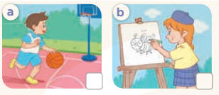  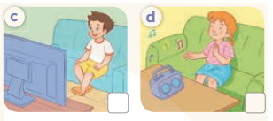  - T ask Ss to guess the answers.  + T writes Ss’guessing on the board.  - Listen to the tape:  + Play the recording  + Play the recording again and get Ss to swap books with their partners.  + Play the recording again to check answers together as a class.  + Write the answers on the board for Ss to correct their answers. Then checks Ss’ guessing.  - Play the recording, sentence by sentence, for the class to listen and repeat in chorus.  Activity 3. Look, complete and read.  - Have Ss look at the pictures and identify the actions in the picture.  - T models with sentence 1.  + Have Ss look at the sentence.  + Ask them what is missing in the answer (listening).  + Have Ss complete the gap.  + Have Ss read the completed sentence in chorus.  -Have Ss work in pairs and complete the sentences 2, 3 and 4.  - Invite pairs of pupils to stand up and read aloud the sentences.  - T gives feedbacks.  Activity 4. Let’s sing  - Introduce the title and lyrics of the song: “What are you doing?”  - Play the recording for Ss to listen to the whole song.  + Have them repeat the title and lyrics line by line.  + Tell Ss to point at the pictures while singing.  - Play the recording all the way through for Ss to listen to pronunciation and melody of the song.  - Play the recording line by line for Ss to listen, repeat and point to the pictures  - Play the recording for Ss to sing and do actions.  - Ask Ss to practice singing and doing actions in pairs or groups.  - Invite groups to the front of the classroom to perform the song  -T gives feedback.  Activity 5: Consolidation  - Summary the lesson  Homelink  - Ask and answer about the pictures on page 49.  - Prepare the new lesson: Unit 18, Lesson 3 (1,2,3). | 4. Listen and number  Key: 1.c 2. b 3.a 4d  5. Look, complete and read.  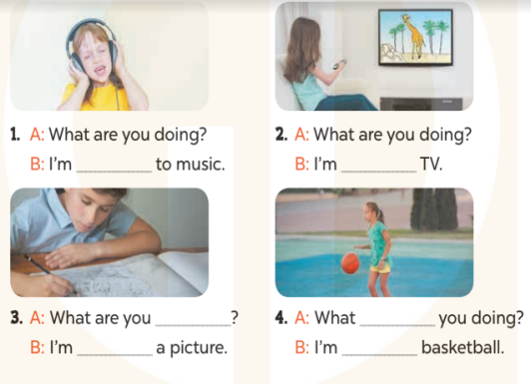  Key: 1. listening 2. Watching  3. doing; drawing 4. are; playing  6.Let’s sing.  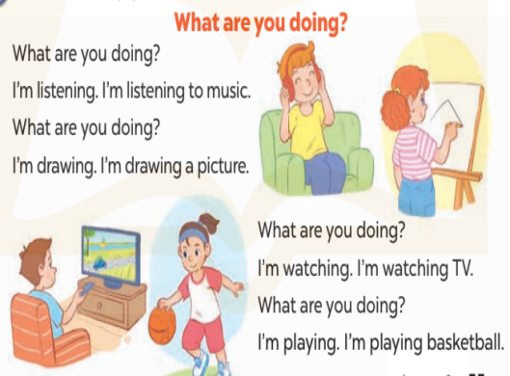
IV. ADJUSTMENTS (if necessary):
………………………………………………………………………………………….…..…………………………………………………………………………….
********************************
Week:
Teaching date:
Unit 18: Playing and doing
Lesson 3 (1, 2, 3)
I. OBJECTIVES:
By the end of the lesson, Ss will be able to:
1. Knowledge:
- correctly repeat the sounds of the letters n and ng in isolation, the words listen and singing and the sentences We listen to music at break time. and I’m singing my favourite song. with the correct pronunciation and intonation.
- identify the target words listen and singing while listening.
- say the chant with the correct rhythm and pronunciation.
- Vocabulary: Review
- Skills: speaking, listening, reading and writing.
2. Competences:
- Co-operation: ready to help friends in pair work/ group work.
- Self-control and independent learning: perform listening tasks.
3. Attitude/ Qualities:
- Kindness: Help partners to complete learning tasks.
- Honesty: tell the truth about feelings and emotions
II. TEACHING AIDS:
- Teacher: Teacher’s guide Pages 228, 229; audio Tracks 81, 82, 83; website sachmem.vn, posters, laptop, pictures, textbook, lesson plan, TV or projector.
- Students: Pupil’s book Page 56, notebooks, workbooks, school things.
III. PROCEDURES:
Teacher’s and students’ activities | Contents
Game: Find and circle the words  - Divide class into 2 groups  - Ask Ss to find and circle the words that they learnt.  - Which groups find the best correct words is winner.  - Give Ss time to play the game.  Rows: listen, train  Columns: singing, reading, ten.  -T checks who’s winner?  - Say “Open your book page 56” and look at “Unit 18, Lesson 3 (1,2,3)”.  Activity 1. Listen and repeat:  - T gives instruction to the letters n and ng in isolation, the words listen and singing and the sentences We listen to music at break time. and I’m singing my favourite song  - Play the recording for the letter n and ng  - Encourage Ss to point at the letter/ word/ sentence while listening.  - Play the recording again and encourage Ss to listen and repeat.  - Do this several times until Ss feel confident.  - T calls some Ss to practice.  - T gives feedbacks.  Activity 2. Listen and circle.  - Elicit the sentences and explain that they have to listen.  - T ask Ss to guess the answers.  + T writes Ss’guessing on the board.  - Listen to the tape:  + Play the recording  + Play the recording again and get Ss to swap books with their partners.  + Play the recording again to check answers together as a class.  + Write the answers on the board for Ss to correct their answers. Then checks Ss’ guessing.  - Play the recording, sentence by sentence, for the class to listen and repeat in chorus.  - Invite one or two Ss to stand up and read the completed sentences.  Activity 3. Let’s chant  - Introduce the title and lyrics of the chant.  - Play the recording for Ss to listen to the whole chant.  + Have them repeat the title and lyrics line by line.  + Ask Ss to attend to the sounds of the letters n and ng and the words listen and singing.  - Play the recording all the way through for Ss to listen to pronunciation and melody.  - Play the recording line by line for Ss to listen and repeat  - Play the recording for Ss to chant and clap along.  - Ask Ss to practice chant and clap along in pairs or groups.  - Invite groups to the front of the classroom to perform the chant  -T gives feedback.  Activity 4: Consolidation  - T asks ss to answer the following questions:  + What have you learnt from the lesson today?  +What are the core values of the lesson? (if the teacher can take from the lesson).  - T praises some Ss who are hardworking / active/ good…. as well as encourage others to try more.  - Practice the chant more.  - Prepare two photos or pictures for the project.  - Prepare the new lesson: Unit 18, Lesson 3 (4,5,6). | 1.Listen and repeat:  2. Listen and circle.  Key: 1. a 2. a  3. Let’s chant  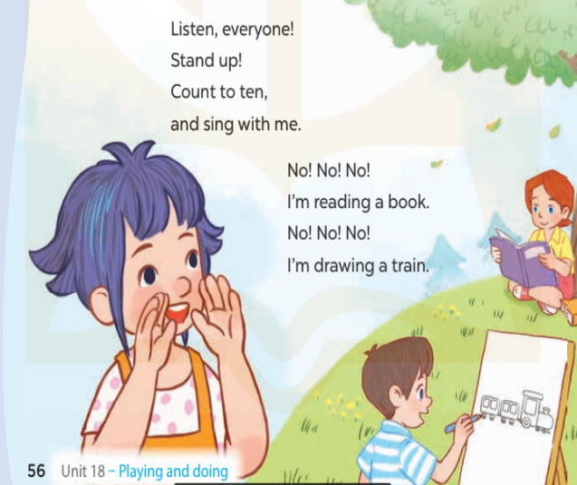
  D | B | K | K | E | P | S | C | R | T
  G | E | S | E | E | D | D | X | E | H
  G | E | I | Y | Y | E | C | Z | A | I
  R | A | N | M | F | C | C | Y | D | N
  T | A | G | N | N | R | L | S | I | K
  G | L | I | S | T | E | N | W | N | B
  S | R | N | W | R | C | V | T | G | H
  M | M | G | K | K | C | S | E | A | Y
  D | P | P | T | R | A | I | N | S | M
  A | C | E | B | F | A | Z | Y | W
IV. ADJUSTMENTS (if necessary):
………………………………………………………………………………………….…..……………………………………………………………………………...
========================
Week:
Teaching date:
Unit 18: Playing and doing
Lesson 3:4,5,6
I. OBJECTIVES:
By the end of the lesson, Ss will be able to:
1. Knowledge:
- read and match the pupils with the activities that they are doing.
- write a paragraph about what they are doing.
- present their photos and tell their friends what they are doing in the photos.
- Vocabulary: Review
- Skills: speaking, listening, reading and writing.
2. Competences:
- Co-operation: ready to help friends in pair work/ group work.
- Self-control and independent learning: perform reading tasks.
3. Attitude/ Qualities:
- Kindness: Help partners to complete learning tasks.
- Honesty: tell the truth about feelings and emotions.
- Diligence: complete learning tasks.
II. TEACHING AIDS:
- Teacher: Teacher’s guide Pages 230, website sachmem.vn, posters, laptop, pictures, textbook, lesson plan, TV or projector.
- Students: Pupil’s book Page 57, notebooks, workbooks, school things.
III. PROCEDURES:
Teacher’s and students’ activities | Contents
Activity 1:Warm- up:  Game: Who’s faster?  - Tell Ss that they are going to look at the cards in 60 seconds, memorise the words (listening to music, singing a song, watching TV, playing football, playing volleyball, drawing a picture) then remember as many of the words as possible.  - Put the cards on a desk or stick them on the board. Then cover them with a piece of cloth.  - Divide the class into 2 or 4 groups. - Remove the cloth and show the cards for 60 seconds. Then cover them again.  - In their groups, Ss try to say as many of the words as they can remember.  - Have the groups say the names of the things aloud.  - For each correct word, give them a star or a point.  - The group with the most stars / points wins.  - Say “Open your book page 57” and look at “Unit 18, Lesson 3 (4,5,6)”.  Activity 2. Read and match:  - Ask Ss to attendto the icons for listening, reading and drawing and elicit the words.  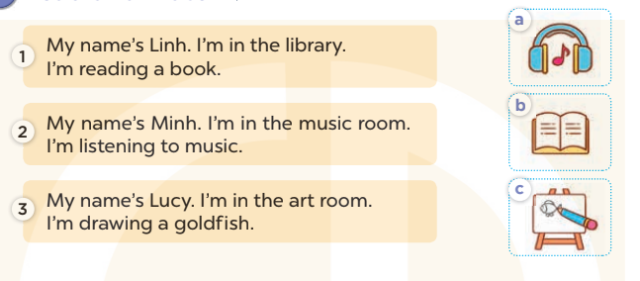  - Tell Ss about the activity. Give Ss time to read and match.  - Get S to swap books with a partner. Then check the answers as a class.  -Write the correct answers on the board for Ss to check and correct their answers.  - Invite Ss to read the texts aloud  -T gives feedbacks.  Activity 3. Let’s write  - Tell the class the goal of this activity  - Have Ss fill in the first gap together as an example.  - Ask Ss to look at the first gap, ask What do you write here? and elicit their names (My name is….).  - Let Ss write down the word in the gap.  - Repeat the same procedure with the other incomplete sentences.  - Give Ss time to write the answers in their notebooks.  - Invite a few Ss to read aloud the paragraph they have completed in front of the class.  Activity 4. Project.  - Point at the prompt drawing and explain what they should do to complete the project.  - Prepare two photos to share with Ss. Take a piece of paper and write the captions for the photos. Point at one photo and say: In this photo, I’m ……. and point at the other photo and say: And in this photo, I’m …….  - Have Ss show the photos or pictures that they have prepared for the project.  - Give the Ss time to practise their presentations by themselves.  - Invite some Ss to present in front of the class.  Activity 5: Consolidation  - T asks ss to answer the following questions:  + What have you learnt from the lesson today?  +What are the core values of the lesson?  - T praises some Ss who are hardworking / active/ good…. as well as encourage others to try more.  Homelink.  - Prepare the new lesson: Unit 19: Lesson 1 (1,2,3) | 4. Read and match:  Key: 1.b 2.a 3.c  5. Let’s write  Key: Pupil’s answer  6. Project.
IV. ADJUSTMENTS (if necessary):
………………………………………………………………………………………….…..……………………………………………………………………………...

