Unit 16: My pets
Lesson 1 (1, 2, 3)
I. Objective
By the end of the lesson, Ss will be able to:
1. Knowledge:
- use the words birds, cats, parrots, rabbits in relation to the topic "Pets".
- use some and many to identify the quantity of pets
- use Do you have any…….? – Yes, I do. / No, I don’t. to ask and answer questions about pets
- listen to and demonstrate understanding of simple communicative contexts in relation to the topic "Pets".
- Vocabulary: bird, cat, dog, parrot, rabbit, pet, any.
- Model sentences:
A: Do you have any cats?
B: Yes, I do. / No, I don’t.
2. Skills: speaking and listening
3. Competences:
- Co-operation: ready to help friends in pair work/ group work.
- Sociability: Talk to each other, say good words to others.
4. Attitude/ Qualities:
- Kindness: Help partners to complete learning tasks.
- Honesty: tell the truth about feelings and emotions
II. Methods: Communicative approach, group Ss and T's activities, play as a character, teaching methods with game, teaching methods by visual, teaching methods by practising, discussion group, technical present....
III. Teaching aids:
1. Teacher: Teacher’s guide Pages 179, 180, audio Tracks 54, 55, website sachmem.vn, posters, laptop, pictures, textbook, lesson plan, TV or projector.
2. Students: Pupil’s book Page 40, notebooks, workbooks, school things.
IV. Procedures
Teacher’s and Students’ activities | Contents
Activity 1. Warm- up:  - Divide class into 4 groups: Tom, Jerry, Miu and Chit.  - Ask Ss look at the pieces of picture.  - Ask Ss go to the board and jigsaw puzzle into the correct picture.  -T checks who’s the winner?  - Say “Open your book page 40” and look at “Unit 16, Lesson 1 (1,2,3).  Activity 2. Look, listen and repeat:  - Have Ss look at Pictures a and b and identify names of the speakers in the pictures.  - Look at the pictures and say  - Play the audio once  - T elicits the new words  + cat : con mèo (picture)  + dog : con chó (picture)  + any : bất cứ (translation)  - Ss listen and repeat new words  + Choral repetition (3 times).  + Individual repetition (3 ss)  - Ss take note  - Play the audio twice (sentence by sentence). Correct their pronunciation where necessary.  - Have Ss to practice the dialogue  - T invites a few pairs to the front of the class to practice.  - T checks pronunciation for ss.  Activity 3. Listen, point and say.  - T asks Ss look at picture a, b and helps Ss know the structure from the dialogue.  - T introduces new structure for Ss.  - T explains, models and gives meaning.  -Have Ss repeat the model sentences.  - Have Ss to practise:  + T asks, Ss answer picture a  + Ss ask, T answers picture b  + Group A ask, group B answer picture c  + Group B ask, group A answer picture d  - Ask Ss to work in pairs.  - T controls and corrects.  - Invite a few pairs to come to the front of the classroom and point at the pictures and say the questions and answers in front of the class.  - T gives feedbacks.  Activity 4. Let’s talk.  - Have Ss look at the picture and elicit the question and the answer in context.  + What can you see in the picture?  + How many pets are there?  - Put Ss into groups of four.  - Tell them to ask and answer questions using Do you have any…..? – Yes, / No,…..  - Invite some Ss to the front of the class to ask and answer questions about their pets.  Activity 5. Consolidation  - T review the vocabulary and model sentences.  - T praises some Ss who are hardworking / active/ good…. as well as encourage others to try more.  Home link  - Learn the vocabulary and model sentences by heart  - Prepare the new lesson: Unit 16, Lesson 1 (4,5,6). | Sing: Jigsaw puzzle  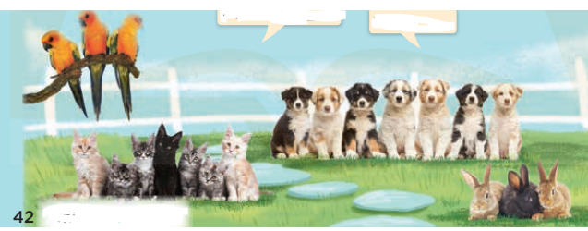  1. Look, listen and repeat:  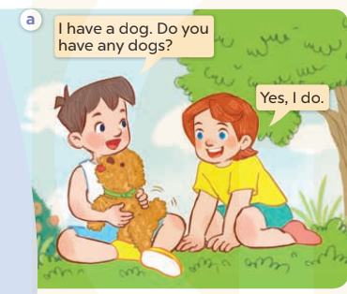  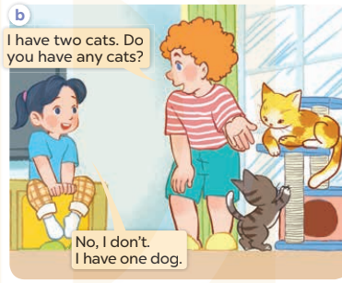  + In picture a: Minh says: I have a dog. Do you have any dogs? Lucy answers: Yes, I do.  + In picture b: Bill: I have two cats. Do you have any cats? Mai answers: No, I don’t. I have one dog.  2. Listen, point and say.  A: Do you have any cats?  B: Yes, I do. / No, I don’t.  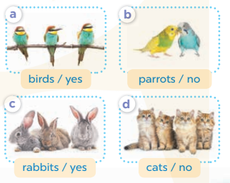  + Picture a: birds / yes  + Picture b: parrots / no  + Picture c: rabbits / yes  + Picture d: cats / no  3. Let’s talk.  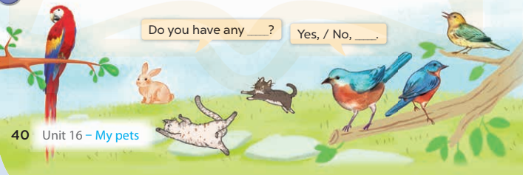
V. Adjustments (if necessary):
………………………………………………………………………………………….…..……………………………………………………………………………...…………
-----------------------------------------------------------
Unit 16: My pets
Lesson 1 (4, 5, 6)
I. Objective
By the end of the lesson, Ss will be able to:
1. Knowledge:
- listen to and understand two communicative contexts in which pupils ask and answer questions about pets and tick the correct pictures.
- read and complete four target gapped dialogues with the help of the picture cues.
- sing the song My pets with the correct pronunciation and melody.
- Vocabulary: Review
2. Skills: speaking, listening, reading and writing.
3. Competences:
- Critical Thinking: talk about names of the pets.
- Co-operation: ready to help friends in pair work/ group work.
- Self-control and independent learning: perform listening tasks.
4. Attitude/ Qualities:
- Kindness: Help partners to complete learning tasks.
- Honesty: tell the truth about feelings and emotions.
- Diligence: complete learning tasks.
II. Methods: Communicative approach, group Ss and T's activities, play as a character, teaching methods with game, teaching methods by visual, teaching methods by practising, discussion group, technical present....
III. Teaching aids:
1. Teacher: Teacher’s guide Pages 201, 202; audio Tracks 56, 57; website sachmem.vn, posters, laptop, pictures, textbook, lesson plan, TV or projector.
2. Students: Pupil’s book Page 41, notebooks, workbooks, school things.
IV. Procedures
Teacher’s and Students’ activities | Contents
Activity 1. Warm- up:  - Divide class into 3 teams.  - Each team has 1 sticky ball.  - Play the music, students in each team take turn to pass the ball. After the music ends, 3 Ss have the ball – stand up and say the name, using the sentence model.  - Say “Open your book page 41” and look at “Unit 16, Lesson 1 (4,5,6)”.  Activity 2: Listen and tick:  - Elicit the word for the pets in each picture  - Point at the pictures respectively to explain the context.  - Look at the pictures and say:  - T ask Ss to guess the answers.  + T writes Ss’ guessing on the board.  - Listen to the tape:  + Play the recording  + Play the recording again and get Ss to swap books with their partners.  + Play the recording again to check answers together as a class.  + Write the answers on the board for Ss to correct their answers. Then checks Ss’ guessing.  - Play the recording, sentence by sentence, for the class to listen and repeat in chorus.  Activity 2. Look, complete and read  - Get Ss to look at the pictures and identify the pets in the pictures.  - Have Ss look at the four dialogue and the pictures. Elicit and model with picture 1  + Ask Ss to read the sentence 1 in chorus.  + Ask them what is missing in the question (cats). Then have them complete the gap (Do you have any cats?).  -Have Ss work in pairs and complete the dialogue 2, 3, 4.  - Ask a few Ss to stand up and read the sentences aloud.  -T gives feedbacks.  Activity 3. Let’s sing  - Introduce the title and lyrics of the song: “My pets”  - Play the recording for Ss to listen to the whole song.  + Have them repeat the title and lyrics line by line.  + Tell Ss to point at the pictures while singing.  - Play the recording all the way through for Ss to listen to pronunciation and melody of the song.  - Play the recording line by line for Ss to listen, repeat and point to the pictures  - Play the recording for Ss to sing and do actions.  - Ask Ss to practice singing and doing actions in pairs or groups.  - Invite groups to the front of the classroom to perform the song  -T gives feedback.  Activity 5: Consolidation  - T praises some Ss who are hardworking / active/ good…. as well as encourage others to try more.  Home link  - Practice part 5 again.  - Prepare the new lesson: Unit 16, Lesson 2 (1,2,3). | Game: Pass the ball  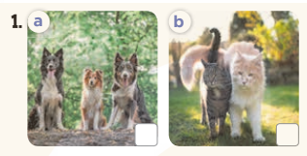  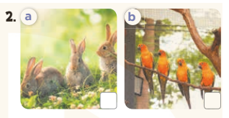  + Picture 1a: three dogs  + Picture 1b: two cats  + Picture 2a: three rabbits  + Picture 2b: four parrots  Key: 1. b 2. a  5. Look, complete and read  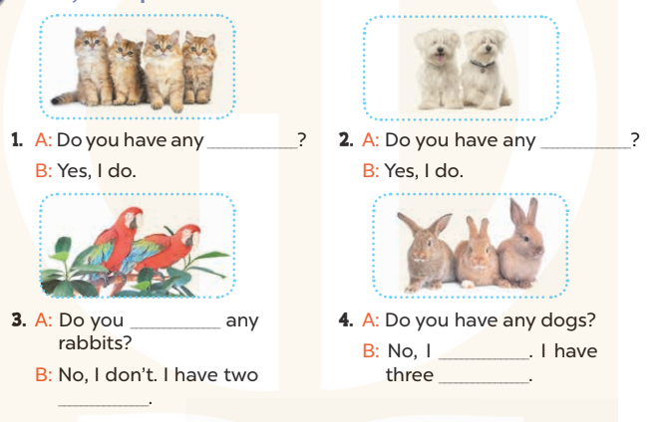  Key:  1. cats 2. dogs 3. have; parrots  4. don’t; rabbits  6. Let’s sing  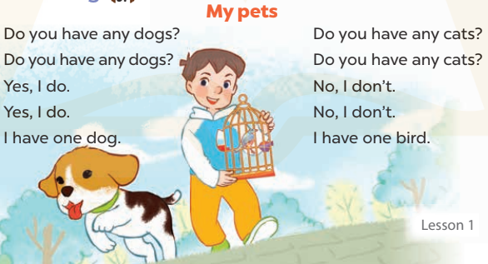
V. Adjustments (if necessary):
………………………………………………………………………………………….…..……………………………………………………………………………...…………
-----------------------------------------------------------
Unit 16: My pets
Period 108 : Lesson 2 (1, 2, 3)
I. Objective
By the end of the lesson, Ss will be able to:
1. Knowledge:
- use some and many to identify the quantity of pets
- use How many…..do you have? – I have………. to ask and answer questions about the quantity of pets
- Vocabulary: goldfish, some, many, how many
- Model sentences:
A: How many cats do you have?
B: I have some
2. Skills: speaking and listening
3. Competences:
- Critical Thinking: talk about someone’s pets
- Co-operation: ready to help friends in pair work/ group work.
- Sociability: Talk to each other, say good words to others.
4. Attitude/ Qualities:
- Kindness: Help partners to complete learning tasks.
- Honesty: tell the truth about feelings and emotions
II. Methods: Communicative approach, group Ss and T's activities, play as a character, teaching methods with game, teaching methods by visual, teaching methods by practising, discussion group, technical present....
III. Teaching aids:
1. Teacher: Teacher’s guide Pages 203, 204; audio Tracks 58, 59, website sachmem.vn, posters, laptop, pictures, textbook, lesson plan, TV or projector.
2. Students: Pupil’s book Page 42, notebooks, workbooks, school things.
IV. Procedures
Teacher’s and Students’ activities | Contents
Activity 1. Warm- up:  - T shows 4 pictures of places and calls 4 Ss to come to the board and choose.  - The Ss on the board will get the same points as the numbers of Ss raising their hands.  - Say “Open your book page 42” and look at “Unit 16, Lesson 2 (1,2,3)”.  Activity 2. Look, listen and repeat:  - Have Ss look at Pictures a and b and identify the characters in the pictures.  T elicits the new words  + goldfish : con cá vàng (picture)  + some: một vài (example)  + many : nhiều (example)  + how many : bao nhiêu (translation)  - T models (3 times).  - T writes the words on the board.  - Play the audio twice (sentence by sentence). Correct their pronunciation where necessary.  - Have Ss to practice the diaguage  - T invites a few pairs to the front of the class to practice.  - T checks pronunciation for ss.  Activity 3. Listen, point and say.  - T asks Ss look at picture a, b and helps Ss know the structure from the dialogue.  - T introduces new structure for Ss.  - T explains, models and gives meaning.  - Have Ss repeat the model sentences.  *Drill pictures  - Have Ss look at the pictures and elicit the names of the pets  - Run through all the pictures.  - Run through model sentences.  +Run through the question sentences  +Run through the answer sentences  - Have Ss to practise:  + T asks, Ss answer picture a  + Ss ask, T answers picture b  + Group A ask, group B answer picture c  + Group B ask, group A answer picture d  - Ask Ss to work in pairs.  - T controls and corrects.  - Invite a few pairs to come to the front of the classroom, point at the pictures and say the questions and answers in front of the class.  - T gives feedbacks.  Activity 4. Let’s talk.  - Tell Ss about the activity  + What can you see in the picture?  +Let’s count the pets.  +Where are the pets?  - Put Ss into pairs and encourage them to ask and answer questions using How many……? − I have……  - Invite some pairs to stand up to perform their exchanges.  Activity 5: Consolidation  - T review the vocabulary and model sentences.  - T praises some Ss who are hardworking / active/ good…. as well as encourage others to try more.  Home link  - Learn the vocabulary and model sentences by heart  - Prepare the new lesson: Unit 16, Lesson 2 (4,5,6). | Game: Guessing and Choosing  1. Look, listen and repeat:  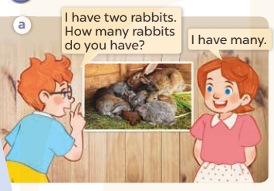  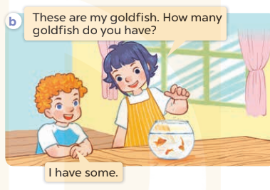  2. Listen, point and say.  A: How many cats do you have?  B: I have some  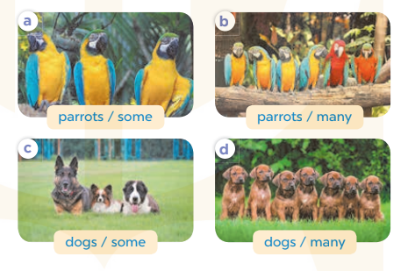  +Picture a: three parrots (some)  +Picture b. six parrots (many)  +Picture c. three dogs (some)  +Picture d. seven dogs (many)  3. Let’s talk.  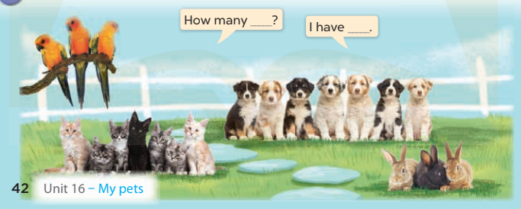  Three parrots, seven cats, three rabbits and seven puppies are in the garden.
V. Adjustments (if necessary):
………………………………………………………………………………………….…..……………………………………………………………………………...…………
-----------------------------------------------------------
Period 109 Teaching date: March…………, 2023

Unit 16: My pets
Lesson 2 (4, 5, 6)
I. Objective
By the end of the lesson, Ss will be able to:
1. Knowledge:
- listen to and demonstrate understanding of simple communicative contexts in relation to the topic "Pets"
- complete the four gapped exchanges with the help of picture cues.
- play the game How many ...? to review vocabulary and structure words related to the topic “Pets”
- Vocabulary: Review
2. Skills: speaking, listening, reading and writing.
3. Competences:
- Critical Thinking: talk about someone’s pets
- Co-operation: ready to help friends in pair work/ group work.
- Self-control and independent learning: perform listening tasks.
4. Attitude/ Qualities:
- Kindness: Help partners to complete learning tasks.
- Honesty: tell the truth about feelings and emotions.
- Diligence: complete learning tasks.
II. Methods: Communicative approach, group Ss and T's activities, play as a character, teaching methods with game, teaching methods by visual, teaching methods by practising, discussion group, technical present....
III. Teaching aids:
1. Teacher: Teacher’s guide Pages 205, 206; audio Tracks 60; website sachmem.vn, posters, laptop, pictures, textbook, lesson plan, TV or projector.
2. Students: Pupil’s book Page 43, notebooks, workbooks, school things.
IV. Procedures
Teacher’s and Students’ activities | Contents
Activity 1. Warm- up:  Sing a song: “throw the ball”  - Encourage Ss to take part in the game.  - Give points for Ss.  - Say “Open your book page 43” and look at “Unit 16, Lesson 2 (4,5,6)”.  Activity 2. Listen and number:  - Have Ss look at the pictures and ask them some questions such as What pets? and How many…?  - T ask Ss to guess the answers.  + T writes Ss’guessing on the board.  - Listen to the tape:  + Play the recording  + Play the recording again and get Ss to swap books with their partners.  + Play the recording again to check answers together as a class.  + Write the answers on the board for Ss to correct their answers. Then checks Ss’ guessing.  - Play the recording, sentence by sentence, for the class to listen and repeat in chorus.  Activity 3. Look, complete and read.  - Have Ss look at the pictures and ask identify pets in the pictures.  - T models with sentence 1.  + Have Ss look at the sentence.  + Ask them what is missing in the answer ( one).  + Have Ss complete the gap.  + Have Ss read the completed sentence in chorus.  -Have Ss work in pairs and complete the sentences 2, 3 and 4.  - Invite pairs of pupils to stand up and read aloud the sentences.  -T gives feedbacks.  Activity 4. Let’s play.  - Ask Ss to look at the picture carefully, then listen to the questions to find the right answers.  - Invite a group of four to the front of the class to demonstrate the game. - Two Ss compete as a pair in one round.  + A teacher asks the question How many_________do you have? and the player who first correctly answers I have________. wins one point for his / her group.  - Give Ss time to play the game in groups of four.  Activity 5. Consolidation  - T praises some Ss who are hardworking / active/ good…. as well as encourage others to try more.  Home link  - Prepare the new lesson: Unit 16, Lesson 3 (1,2,3). | 4. Listen and number:  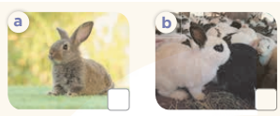  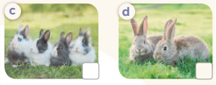  Key: 1.b 2. c 3. d 4. a  5. Look, complete and read.  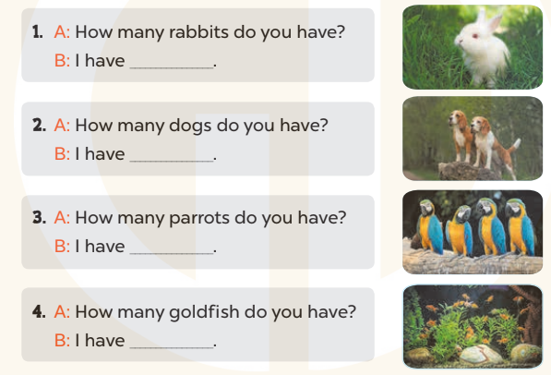  Key: 1. one 2. two 3. some 4. many  6. Let’s play.

V. Adjustments (if necessary):
………………………………………………………………………………………….…..……………………………………………………………………………...…………
-----------------------------------------------------------
Unit 16: My pets
Lesson 3 (1, 2, 3)
I. Objective
By the end of the lesson, Ss will be able to:
1. Knowledge:
- correctly repeat the sounds of the letters o in isolation, the words dog and goldfish and the sentences Do you have any dogs? and How many goldfish do you have? with the correct pronunciation and intonation.
- identify the target words dog and goldfish while listening.
- say the chant with the correct rhythm and pronunciation.
- Vocabulary: Review
2. Skills: speaking, listening, reading and writing.
3. Competences:
- Co-operation: ready to help friends in pair work/ group work.
- Self-control and independent learning: perform listening tasks.
4. Attitude/ Qualities:
- Kindness: Help partners to complete learning tasks.
- Honesty: tell the truth about feelings and emotions
II. Methods: Communicative approach, group Ss and T's activities, play as a character, teaching methods with game, teaching methods by visual, teaching methods by practising, discussion group, technical present....
III. Teaching aids:
1. Teacher: Teacher’s guide Pages 207, 208; audio Tracks 61, 62, 63; website sachmem.vn, posters, laptop, pictures, textbook, lesson plan, TV or projector.
2.Students: Pupil’s book Page 44, notebooks, workbooks, school things.
IV. Procedures
Teacher’s and Students’ activities | Contents
Activity 1: Warm up  - Divide class into 2 groups  - Give Ss time to play the game.  Rows: goldfish  Columns: dog, door, parrot  -T checks who’s winner?  - Say “Open your book page 44” and look at “Unit 16, Lesson 3 (1,2,3)”.  Activity 2. Listen and repeat:  - T gives instruction to the letters o in isolation, the words dog and goldfish and the sentences Do you have any dogs? and How many goldfish do you have?  - Play the recording for the letter o  - Encourage Ss to point at the letter/ word/ sentence while listening.  - Play the recording again and encourage Ss to listen and repeat.  - Do this several times until Ss feel confident.  - T calls some Ss to practice.  - T gives feedbacks.  Activity 2. Listen and circle.  - Elicit the sentences and explain that they have to listen.  - T ask Ss to guess the answers.  + T writes Ss’ guessing on the board.  - Listen to the tape:  + Play the recording  + Play the recording again and get Ss to swap books with their partners.  + Play the recording again to check answers together as a class.  + Write the answers on the board for Ss to correct their answers. Then checks Ss’ guessing.  - Play the recording, sentence by sentence, for the class to listen and repeat in chorus.  - Invite one or two Ss to stand up and read the completed sentences.  Activity 3. Let’s chant  - Introduce the title and lyrics of the chant.  - Play the recording for Ss to listen to the whole chant.  + Have them repeat the title and lyrics line by line.  + Ask Ss to attend to the sounds of the letters o and the words dog and goldfish.  - Play the recording all the way through for Ss to listen to pronunciation and melody.  - Play the recording line by line for Ss to listen and repeat  - Play the recording for Ss to chant and clap along.  - Ask Ss to practice chant and clap along in pairs or groups.  - Invite groups to the front of the classroom to perform the chant  -T gives feedback.  Activity 5. Consolidation  - T praises some Ss who are hardworking / active/ good…. as well as encourage others to try more.  Home link  - Practice the chant more.  - Prepare the new lesson: Unit 16, Lesson 3 (4,5,6). | Game: Find and circle the words  1. Listen and repeat:  2. Listen and circle.  Key: 1.b 2.a  3. Let’s chant  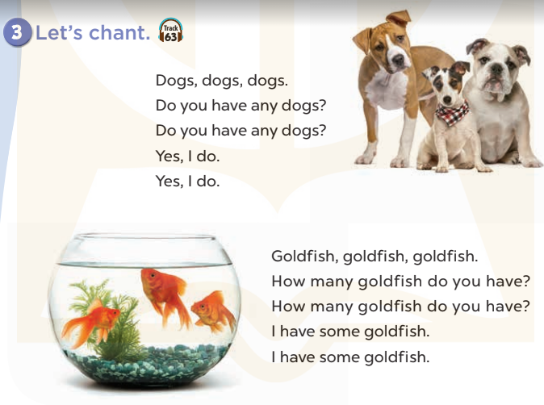
  D | B | K | K | E | P | S | C | P | T
  O | E | T | E | E | D | D | C | A | H
  G | E | U | A | A | E | C | O | R | I
  R | A | M | M | F | C | C | S | R | N
  T | A | B | N | N | N | L | S | O | K
  G | O | L | D | F | I | S | H | T | B
  S | R | O | O | R | C | V | T | A | H
  M | M | T | O | H | R | S | T | A | Y
  D | P | P | R | E | S | E | R | S | M
  A | C | E | B | F | A | Z | Y | W | A
V. Adjustments (if necessary):
………………………………………………………………………………………….…..……………………………………………………………………………...…………
-----------------------------------------------------------

Unit 16: My pets
Lesson 3 (4, 5, 6)
I. Objective
By the end of the lesson, Ss will be able to:
1. Knowledge:
- listen to and demonstrate understanding of simple communicative contexts in relation to the topic "Pets"
- read and write about pets.
- use the target language items they have learnt in a real context by showing the photos of their pets and telling the class about them.
- Vocabulary: Review
2. Skills: speaking, listening, reading and writing.
3. Competences:
- Co-operation: ready to help friends in pair work/ group work.
- Self-control and independent learning: perform reading tasks.
4. Attitude/ Qualities:
- Kindness: Help partners to complete learning tasks.
- Honesty: tell the truth about feelings and emotions.
- Diligence: complete learning tasks.
II. Methods: Communicative approach, group Ss and T's activities, play as a character, teaching methods with game, teaching methods by visual, teaching methods by practising, discussion group, technical present....
III. Teaching aids:
1. Teacher: Teacher’s guide Pages 208, 209, website sachmem.vn, posters, laptop, pictures, textbook, lesson plan, TV or projector.
2. Students: Pupil’s book Page 45, notebooks, workbooks, school things.
IV. Procedures
Teacher’s and Students’ activities | Contents
Activity 1. Warm- up:  - Divide the class into four groups.  - Each group chooses one pupil to be the 'runner'. The runners go to the teacher's desk and read the category.  - Say “Open your book page 45” and look at “Unit 16, Lesson 3 (4, 5, 6)”.  Activity 2. Read and complete:  - Tell Ss how to complete the task.  - Point at the words provided in the box and the five gaps in the passage - Ask Ss attend to the blank in number 1 and find the missing word.  - Write the missing word on the board and get the class to read the completeed sentence together.  - Have Ss work in pairs and complete  - Tell Ss to swap books with a partner, then check answers together as a class.  - Write the correct answers on the board for pupils to correct their answers.  - Invite Ss to read the complete text aloud  -T gives feedbacks.  Activity 3. Let’s write  - Explain to the class the goal of this activity.  - Ask Ss to read each gapped sentence, look at the picture and fill in the gap.  - Give Ss time to write their answers  - Ask Ss to swap and correct their answers in pairs.  - Check the answers as a class.  Activity 4. Project.  - Point at the prompt picture and explain what they should do to complete the project.  - Prepare two photos to share with pupils. Point at one photo and say: I have some…. and point at the other photo and say: I have some ….  - Have Ss work in groups. Each pupil shares his / her photos and says what pets he / she has in the photos.  - Give the class time to complete the project.  - Invite some Ss to the front of the class to present the photos.  Activity 5. Consolidation  - T praises some Ss who are hardworking / active/ good…. as well as encourage others to try more.  Home link  - Prepare the new lesson: Unit 17- Lesson 1 (1,2,3). | Game: Brainstorming  4. Read and complete:  Key: 1. many 2. have 3. and 4. Do  5. Let’s write  Key: Pupils’ own answers  6. Project.  My name………I love pets. I have a cat. It is big. I have….  It is ……………..Do you have  any……….?
V. Adjustments (if necessary):
………………………………………………………………………………………….…..……………………………………………………………………………...…………
-----------------------------------------------------------

