UNIT 14: MY BEDROOM
Period 91 : Lesson 1 (1, 2, 3)
A. OBJECTIVES:
By the end of the lesson, Ss will be able to:
1. Knowledge:
– Understand and correctly repeat the sentences in two communicative contexts (pictures) focusing on quantities of things in a room
- Correctly say the words and use There’s / There are……… in the room. to talk about quantities of things in a room;
-Enhance the correct use of There’s / There are…….. in the room. to talk about quantities of things in a room in a free context.
- Vocabulary: desk, bed, door, window
- Model sentences:
There’s a desk in the room.
There are two doors in the room.
- Skills: speaking and listening
2. Competences:
- Critical Thinking: talk about things in bedroom.
- Co-operation: ready to help friends in pair work/ group work.
- Sociability: Talk to each other, say good words to others.
3. Attitude/ Qualities:
- Kindness: Help partners to complete learning tasks.
- Honesty: tell the truth about feelings and emotions
B. TEACHING AIDS:
- Teacher: Teacher’s guide Pages 172, 173, audio Tracks 32, 33, website sachmem.vn, laptop, pictures, textbook, lesson plan, TV or projector.
- Students: Pupil’s book Page 24, notebooks, workbooks, school things.
C. PROCEDURES:

Teacher’s and Students’s activities | Content
1.Warm- up:  *Aims: to create a friendly and active atmosphere in the class to beginning the lesson.  *Procedure:  - Show the song on the screen.  - Ask pupils to listen, sing and dance the song.  - Say “Open your book page 24” and look at “Unit 14, Lesson 1 (1,2,3)”.  2. New lesson:  Activity 1.  *Aims: Ss will be able to understand and correctly repeat the sentences in two communicative contexts (pictures) focusing on quantities of things in a room.  *Procedure:  - Have Ss look at Pictures a and b and identify names of the speakers in the pictures.  - Set the scene to give the dialogue.  - Ask Ss to listen to the conversation  - Tell them to listen and repeat in chorus.  - Play the audio twice (sentence by sentence).  - Play the recording again for pupils to repeat the lines.  - Divice class in to two groups to role play.  - Ask them to work in pair to practise reading the conversation.  - Call 2 pairs to role play.  - T checks pronunciation for Ss.  Activity 2  *Aims: Ss will be able to correctly say the words desk, bed, door, window and use There’s / There are ……. in the room. to talk about quantities of things in a room.  *Procedure:  * New words:  - Use photos of things in room to teach vocabulary.  + Show each picture and ask Ss to repeat in chorus, then call 3 Ss to repeat.  + Do the same with other pictures.  * Model sentences:  - T asks Ss look at picture a , b and helps Ss know the model sentences from the dialogue.  - T introduces model sentences for Ss.  - T explains, models and gives meaning.  - Have Ss repeat the model sentences.  - Elicit and check comprehension the name of the rooms.  - Run through all the pictures.  - Run through model sentences.  - Have Ss to practise:  + T and Ss practice speaking (change role).  + Ss – Ss practice speaking (change role).  - Ask Ss to work in pairs.  - T controls and corrects.  - Invite a few pairs to come to the front of the classroom, point at the relevant character in each picture, and act out his/her role.  - T gives feedbacks.  Activity 3  *Aims: Ss will be able to enhance the correct use of There’s / There are ……… in the room. to talk about quantities of things in a room in a freer context.  *Procedure:  - T asks ss to look at the things in the bedroom and elicit their names  + What can you see in the picture?  - T fills the gaps and writes the sentences on the board.  - T models  - T asks Ss to work in pairs to to practise speaking  - Invite some pupils to the front of the class to present their exchanges.  - Give feedbacks  3. Consolidation  *Aims: Ss will be able consolidate and wrap up the content of the lesson.  *Procedure:  - T asks ss to answer the following questions:  + What have you learnt from the lesson today?  - T review the vocabulary and model sentences.  - T praises some Ss who are hardworking / active/ good…. as well as encourage others to try more.  5. Homework.  - Learn the model sentence and new words by heart.  - Prepare the new lesson: Unit 14, Lesson 1 (4,5,6). | Sing a song: “If you happy and you know it”  - Show the song on the screen.  https://www.youtube.com/watch?v=zyMWcWqmhRc  1. Look, listen and repeat.  2.Listen, point and say  * New word  + desk : cái bàn học sinh (realia)  + bed : cái giường (picture)  + door : cửa ra vào (realia)  + window : cửa sổ (realia)  * Model sentences:  There’s a desk in the room.  There are two doors in the room  There’s ……… in the room.  There are ……. in the room  *Drill pictures  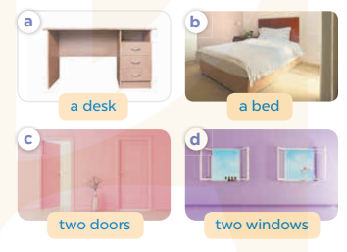  3. Let’s talk.  There’s……………  There are………….  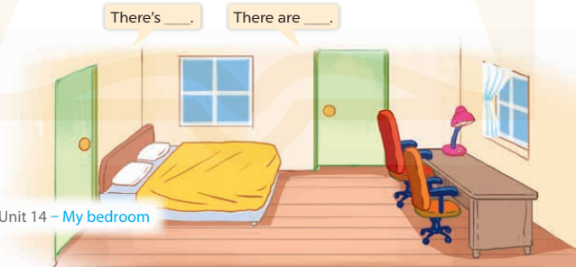
D. ADJUSTMENTS (if necessary):
………………………………………………………………………………………….…..……………………………………………………………………………...……
__________________________________________________
Preparing date: 16/02/2023
Teaching date: 3A1: 24/ 02/2023 3A2: 23/ 02/2023
UNIT 14: MY BEDROOM
Period 92: Lesson 1 (4, 5, 6)
A. OBJECTIVES:
By the end of the lesson, Ss will be able to:
1. Knowledge:
- Listen to and understand two communicative contexts in which pupils describe things in the bedroom and tick the correct pictures.
- Complete the four gapped sentence patterns with the help of picture cues.
- Revise the target vocabulary items through the game Memory game.
- Vocabulary: Review
- Skills: speaking, listening, reading and writing.
2. Competences:
- Co-operation: ready to help friends in pair work/ group work.
- Self-control and independent learning: perform listening tasks.
3. Attitude/ Qualities:
- Kindness: Help partners to complete learning tasks.
- Honesty: tell the truth about feelings and emotions.
- Diligence: complete learning tasks.
B. TEACHING AIDS:
- Teacher: Teacher’s guide Pages 174; audio Tracks 34; website sachmem.vn, posters, laptop, pictures, textbook, lesson plan, TV or projector.
- Students: Pupil’s book Page 25, notebooks, workbooks, school things.
C. PROCEDURES:

Teacher’s and Students’ activities | Content
1.Warm- up:  Game: “Passing the ball”  *Aims: to create a friendly and active atmosphere in the class to beginning the lesson.  *Procedure:  - Play the music, Ss take turn to pass the ball.  - After the music ends, ss have the ball – stand up and say the quantities of things in a room, using the sentence model.  - T praises some Ss who are active/ good…. as well as encourage others to try more.  - Say “Open your book page 25” and look at “Unit 14, Lesson 1 (4,5,6)”.  2. New lesson:  Activity 1.  *Aims: Ss will be able to listen to and understand two communicative contexts in which pupils describe things in the bedroom and tick the correct pictures.  *Procedure:  - Elicit the name of the things in the room in each picture  + Picture 1a: a bed in the bedroom  + Picture 1b: a desk in the bedroom  + Picture 2a: two doors in the bedroom  + Picture 2b: two windows in the bedroom  - Listen to the tape:  + Play the recording twice.  + Ask Ss exchange their answers with their partners.  + Call Ss go to the board and write down their answers.  + Play the recording again to check answers together as a class.  - Play the recording, sentence by sentence, for the class to listen and repeat in chorus.  Activity 2.  *Aims: Ss will be able to complete the four gapped sentence patterns with the help of picture cues.  *Procedure:  - Have Ss look at the pictures and identify things in the rooms  - Have Ss look at the four incomplete sentences and elicits the missing words in the sentences.  - T models with sentence 1  + Ask Ss what is missing in the sentence.  + Have Ss look at the picture and complete the gap, then read the completed sentence in chorus.  - Have Ss work in groups and complete the sentences 2,3 and 4.  - Ask a few Ss to stand up and read the completed sentences aloud.  -T gives feedbacks.  Activity 3.  *Aims: Ss will be able to revise the target vocabulary items through the game Memory game.  *Procedure:  - Explain how the game is played.  - Tell Ss that they are going to look at the cards for 60 seconds, memorise the words, then remember as many of the words as possible.  - Put the cards on a desk or stick them on the board. Then cover them with a piece of cloth  - Divide the class into groups. Remove the cloth and show the cards for 60 seconds. Then cover them again.  - Have the groups say the names of the things aloud. For each correct word, give them a star or a point.  - The group with the most stars / points wins.  3. Consolidation  *Aims: Ss will be able consolidate and wrap up the content of the lesson.  *Procedure:  - T asks ss to answer the following questions:  + What have you learnt from the lesson today?  - T praises some Ss who are hardworking / active/ good…. as well as encourage others to try more.  4. Home work  - Prepare the new lesson: Unit 14, Lesson 2 (1,2,3). | 1.Listen and tick:  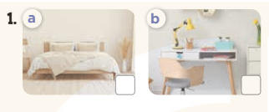  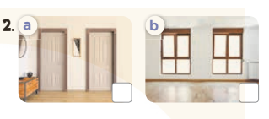  Key: 1.a 2.b  2.Look, complete and read.  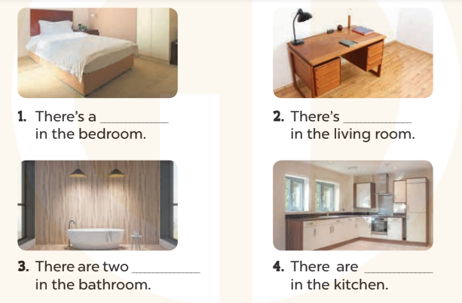  Key:  1. bed 2. a desk  3. lamps 4. two windows  3.Let’s play
D. ADJUSTMENTS (if necessary):
………………………………………………………………………………………….…..……………………………………………………………………………...……
_____________________________________________
UNIT 14: MY BEDROOM
Period 93:Lesson 2 (1, 2, 3)
A. OBJECTIVES:
By the end of the lesson, Ss will be able to:
1. Knowledge:
- Understand and correctly repeat the sentences in two communicative contexts (pictures) to describe things in the room.
- Correctly say the words and use The …….. is ……. / The …… are …….. to describe things in the room.
- Enhance the correct use of The ……..is ……….. / The ……..are ……….to describe things in the room in a freer context.
- Vocabulary: big, small, old, new
- Model sentences:
The door is big.
The chairs are new.
- Skills: speaking and listening
2. Competences:
- Co-operation: ready to help friends in pair work/ group work.
- Oral Communication: speak about someone, ask and answer the questions
3. Attitude/ Qualities:
- Kindness: Help partners to complete learning tasks.
- Honesty: tell the truth about feelings and emotions
B. TEACHING AIDS:
- Teacher: Teacher’s guide Pages 176, 177; audio Tracks 35,36, website sachmem.vn, posters, laptop, pictures, textbook, lesson plan, TV or projector.
- Students: Pupil’s book Page 26, notebooks, workbooks, school things.
C. PROCEDURES:
Teacher’s and Students’s activities | Content
1.Warm- up:  *Aims: to create a friendly and active atmosphere in the class to beginning the lesson.  *Procedure:  - Sing a song.  - Say “Open your book page 26” and look at “Unit 14, Lesson 2 (1,2,3)”.  2. New lesson:  Activity 1. Look, listen and repeat  *Aims: Ss will be able to understand and correctly repeat the sentences in two communicative contexts (pictures) to describe things in the room.  *Procedure:  - Have Ss look at Pictures a and b and identify the characters in the pictures.  - Play the audio twice (sentence by sentence). Correct their pronunciation where necessary.  - Have Ss to practice the diaguage  - T invites some pairs to the front of the class to practice.  - T checks pronunciation for ss.  Activity 2. Listen, point and say.  *Aims: Ss will be able to correctly say the words big, small, new, old and use The …. is …... / The …….are ……. to describe things in the room.  *Procedure:  -T elicits the new words  - Use photos of thing in the room to teach Ss vocabulary.  + Show each picture and ask Ss to repeat in chorus, then call 3 Ss to repeat.  + Do the same with other pictures.  - T writes the words on the board.  - Checking: Rub out and remember  * Model sentences:  - T asks Ss look at picture a, b and helps Ss know the model sentences from the dialogue.  - T introduces model sentences for Ss.  - T explains, model sentences and gives meaning.  - Have Ss repeat the model sentences.  - Run through all the pictures.  - Run through model sentences.  - Have Ss to practise  - Ask Ss to work in pairs.  - T controls and corrects.  - Invite a few pairs to come to the front of the classroom, point at the relevant character in each picture, and act out his/her role.  - T gives feedbacks.  Activity 3. Let’s talk  *Aims: Ss will be able to enhance the correct use of The …… is ……. / The……. are ……..to describe things in the room in a freer context.  *Procedure:  - Have Ss look at the things in a bedroom and say their names.  + What can you see in the picture?  +What are they?  - T fills the gaps and writes the sentences on the board.  - T models  - T asks Ss use of The bed is new. The chair are new. to introduce the things in the room.  - Invite some groups to perform.  - Give feedbacks  3. Consolidation  *Aims: Ss will be able consolidate and wrap up the content of the lesson.  *Procedure:  - T asks ss to answer the following questions:  + What have you learnt from the lesson today?  - T review the vocabulary and model sentences.  - T praises some Ss who are hardworking / active/ good…. as well as encourage others to try more.  4. Homework.  - Learn the number by heart  - Prepare the new lesson: Unit 14, Lesson 2 (4,5,6). | - Look, listen and repeat  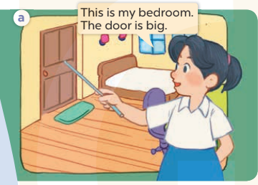  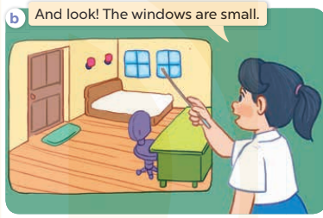  2. Listen, point and say.  * New word  + big : to, lớn (picture)  + small : nhỏ, bé (picture)  + new : mới (picture)  + old : cũ (picture)  * Model sentences:  The door is big.  The chairs are new  The …is .….  The …. are …..  *Drill pictures  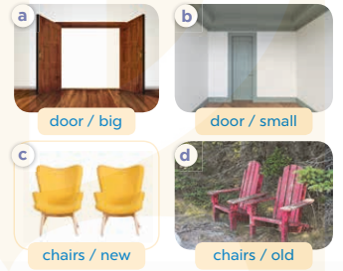  3.Let’s talk  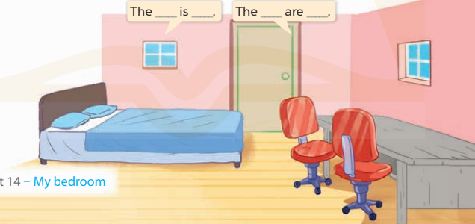
D. ADJUSTMENTS (if necessary):
………………………………………………………………………………………….…..……………………………………………………………………………...……
__________________________________________________
UNIT 14: MY BEDROOM
Period 94: Lesson 2 (4, 5, 6)
A. OBJECTIVES:
By the end of the lesson, Ss will be able to:
1. Knowledge:
- Listen to and understand four communicative contexts in which characters introduce and describe things in a bedroom and number the correct pictures.
- Complete four gapped sentences with the help of picture cues.
- Sing the song My bedroom with the correct pronunciation, rhythm and melody.- Vocabulary: Review
- Skills: speaking, listening, reading and writing.
2. Competences:
- Co-operation: ready to help friends in pair work/ group work.
- Self-control and independent learning: perform listening tasks.
3. Attitude/ Qualities:
- Kindness: Help partners to complete learning tasks.
- Honesty: tell the truth about feelings and emotions.
- Diligence: complete learning tasks.
B. TEACHING AIDS:
- Teacher: Teacher’s guide Pages 178, 179; audio Tracks 37, 38; website sachmem.vn, posters, laptop, pictures, textbook, lesson plan, TV or projector.
- Students: Pupil’s book Page 27, notebooks, workbooks, school things.
C. PROCEDURES:
Teacher’s and Students’ activities | Content
1.Warm- up:  Sing a song: “throw the ball”  *Aims: to create a friendly and active atmosphere in the class to beginning the lesson.  *Procedure:  - Divide the class into 2 teams.  - Stick the pictures of things in the room on the board.  + T says a word, a pupil from each team has to point/throw the ball to the right picture and says the word three times.  + The one says faster will get points.  - Encourage Ss to take part in the game.  - Give points for Ss.  - Say “Open your book page 27” and look at “Unit 14, Lesson 2 (4,5,6)”.  2. New lesson:  Activity 1. Listen and number:  *Aims: Ss will be able to listen to and understand four communicative contexts in which characters introduce and describe things in a bedroom and number the correct pictures  *Procedure:  - Have Ss look at the pictures and ask them some questions such as What is this? and What are these?  - Listen to the tape:  + Play the recording twice.  + Ask Ss exchange their answers with their partners.  + Call Ss go to the board and write down their answers.  + Play the recording again to check answers together as a class.  - Play the recording, sentence by sentence, for the class to listen and repeat in chorus.  Activity 2.  *Aims: Ss will be able to complete four gapped dialogues with the help of picture cues.  *Procedure:  - Have Ss look at the pictures and ask identify things in the room in the pictures.  - T models with sentence 1.  + Have Ss look at the sentence.  + Ask them what is missing in the answer ( bed ).  + Have Ss complete the gap.  + Have Ss read the completed sentence in chorus.  - Have Ss work in pairs and complete the sentences 2, 3 and 4.  - Invite pupils to stand up and read aloud the sentences.  -T gives feedbacks.  Activity 3.  *Aims: Ss will be able to sing the song My bedroom with the correct pronunciation, rhythm and melody *Procedure:  - Introduce the title and lyrics of the song: “My bedroom? ” song.  - Play the recording for Ss to listen to the whole song.  + Have them repeat the title and lyrics line by line.  + Tell Ss to point at the relevant character while singing his or her name.  - Play the recording all the way through for Ss to listen to pronunciation and melody of the song.  - Play the recording line by line for Ss to listen, repeat and point at the relevant character.  - Play the recording for Ss to sing.  - Ask Ss to practice singing in pairs or groups.  - Invite groups to the front of the classroom to perform the song  -T gives feedback.  3. Consolidation  *Aims: Ss will be able consolidate and wrap up the content of the lesson.  *Procedure:  - T asks ss to answer the following questions:  + What have you learnt from the lesson today?  +What are the core values of the lesson? (if the teacher can take from the lesson).  - T praises some Ss who are hardworking / active/ good…. as well as encourage others to try more.  4. Homework.  - Prepare the new lesson: Unit 14, Lesson 3 (1,2,3). | 4. Listen and number:  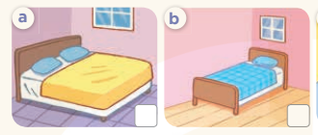  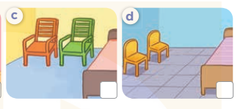  Key: 1.b 2. a 3. c 4. d  2. Look, complete and read.  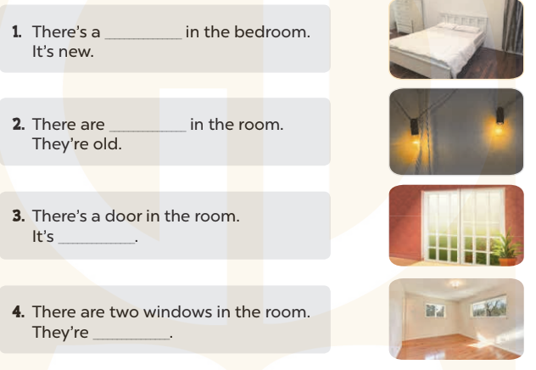  Key: 1. bed 2. two lamps 3. big 4. small  3. Let’s sing.  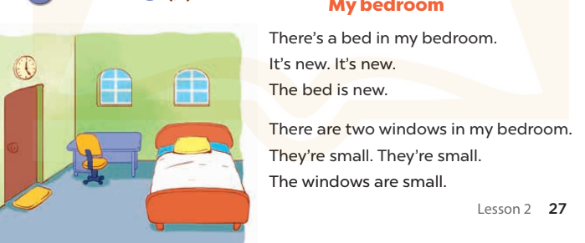
D. ADJUSTMENTS (if necessary):
………………………………………………………………………………………….…..……………………………………………………………………………...……

UNIT 14: MY BEDROOM
Period 95: Lesson 3 (1, 2, 3)
A. OBJECTIVES:
By the end of the lesson, Ss will be able to:
1. Knowledge:
- correctly repeat the sounds of the letters oo in isolation, the words room and door and the sentences There’s the bed in the room and The doors are big. with the correct pronunciation and intonation.
- identify the target words room and door while listening.
- say the chant with the correct rhythm and pronunciation.
- Vocabulary: Review
- Skills: speaking, listening, reading and writing.
2. Competences:
- Co-operation: ready to help friends in pair work/ group work.
- Self-control and independent learning: perform listening tasks.
3. Attitude/ Qualities:
- Kindness: Help partners to complete learning tasks.
- Honesty: tell the truth about feelings and emotions
B. TEACHING AIDS:
- Teacher: Teacher’s guide Pages 179, 180; audio Tracks 39, 40, 41; website sachmem.vn, posters, laptop, pictures, textbook, lesson plan, TV or projector.
- Students: Pupil’s book Page 28, notebooks, workbooks, school things.
C. PROCEDURES:
Teacher’s and Students’s activities | Content
1.Warm- up:  *Aims: to create a friendly and active atmosphere in the class to beginning the lesson.  *Procedure:  - Sing a song and do actions.  - Say “Open your book page 17” and look at “Unit 14, Lesson 3 (1,2,3)”.  2. New lesson:  Activity 1.  *Aims: Ss will be able to correctly pronounce the sounds of the letters oo in isolation, in the words room and door, and in the sentences There’s the bed in the room. and The doors are big with correct pronunciation and intonation.  *Procedure:  - T gives instruction to the letters oo in isolation, in the words room and door, and in the sentences There’s the bed in the room. and The doors are big.  - Let Ss pay attention to the letters coloured differently.  - Have Ss learn to produce the sound of the letters “ oo”  -Play the CD for the Ss listen once to get the main ideas.  -Play the CD again for the SS listen and repeat.  - Encourage Ss to point at the letter/ word/ sentence while listening.  - Play the recording again and encourage Ss to listen and repeat.  - Do this several times until Ss feel confident.  - T calls some Ss to practice.  - T gives feedbacks.  Activity 2.  *Aims: Ss will be able to identify the target words room and door while listening.  *Procedure:  - Elicit the sentences and explain that they have to listen.  - Give them a few seconds to read the words in silence .  - Have pupils listen to the recording and circle the words.  - Have them swap their answers before checking as a class.  - Call some Ss to give their answers. Other comment  - Play the recording again pupils check their answers.  - Play the recording, sentence by sentence, for the class to listen and repeat in chorus.  - Invite one or two Ss to stand up and read the completed sentences.  Activity 3.  *Aims: Ss will be able to say the chant with the correct rhythm and pronunciation.  *Procedure:  - Introduce the title and lyrics of the chant.  - Play the recording for Ss to listen to the whole chant.  + Have them repeat the title and lyrics line by line.  + Ask Ss to attend to the sounds of the letters oo and the words room and door.  - Play the recording all the way through for Ss to listen to pronunciation and melody.  - Play the recording line by line for Ss to listen and repeat  - Play the recording for Ss to chant and clap along.  - Ask Ss to practice chant and clap along in pairs or groups.  - Invite groups to the front of the classroom to perform the chant  -T gives feedback.  3. Consolidation  *Aims: Ss will be able consolidate and wrap up the content of the lesson.  *Procedure:  - T asks ss to answer the following questions:  + What have you learnt from the lesson today?  - T praises some Ss who are hardworking / active/ good…. as well as encourage others to try more.  4. Home work:  - Practice the chant more.  - Find a photo of a bedroom in a newspaper or a magazine.  - Prepare the new lesson: Unit 14, Lesson 3 (4,5,6). | 1.Listen and repeat  2.Listen and circle.  + Number 1: The….is there  + Number 2: The…..is big.  Key: 1.b 2.c  3.Let’s chant  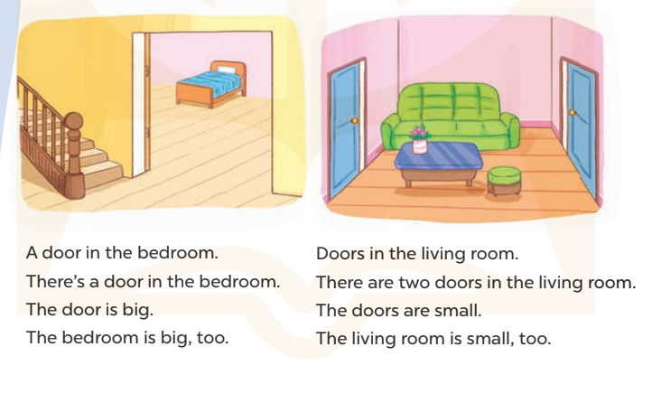
D. ADJUSTMENTS (if necessary):
………………………………………………………………………………………….…..……………………………………………………………………………...……
_______________________________________________
UNIT 14: MY BEDROOM
Period 96: Lesson 3 (4, 5, 6)
A. OBJECTIVES:
By the end of the lesson, Ss will be able to:
1. Knowledge:
- Read the text and complete the gapped sentences.
- Read the text and complete the gapped sentences.
- Complete a gapped paragraph with the help of the picture cue.
- Vocabulary: Review
- Skills: speaking, listening, reading and writing.
2. Competences:
- Co-operation: ready to help friends in pair work/ group work.
- Self-control and independent learning: perform reading tasks.
3. Attitude/ Qualities:
- Kindness: Help partners to complete learning tasks.
- Honesty: tell the truth about feelings and emotions.
- Diligence: complete learning tasks.
B. TEACHING AIDS:
- Teacher: Teacher’s guide Pages 181, 182, website sachmem.vn, posters, laptop, pictures, textbook, lesson plan, TV or projector.
- Students: Pupil’s book Page 29, notebooks, workbooks, school things.
C. PROCEDURES:
Teacher’s and Students’s activities | Content
1.Warm- up:  Game: Brainstorming  *Aims: to review the vocabulary and structure about greet and respond to greetings.  *Procedure:  - Divide the class into 2 groups.  - Each group chooses one pupil to be the 'runner'. The runners go to the teacher's desk and read the category.  Ex: Find objects/things in your bedroom/living room.  - The runners then go back to their group and tell their group members the category. Their group brainstorm words from that category  - The first group to finish shouts 'stop' and then calls out their answers. If their answers are correct, they score one point for each word in the category.  - The group with the highest score at the end of the game wins.  - Say “Open your book page 29” and look at “Unit 14, Lesson 3 (4, 5, 6)”.  2. New lesson:  Activity 1.  *Aims: Ss will be able to read the text and complete the gapped sentences  *Procedure:  - Tell Ss how to do the task.  - Point at the table and elicit the type of information they need to find in the texts.  - Ask Ss attend to the blank in number 1 and find the missing word.  - Write the missing word on the board and get the class to read the completed sentence together.  - Have Ss work in individual and complete  - Tell Ss to swap books with a partner, then check answers together as a class.  - Calls Ss go to the board and write down their answers  - Write the correct answers on the board for pupils to correct their answers.  - Invite Ss to read the complete text aloud  - T gives feedbacks.  Activity 2.  *Aims: Ss will be able to complete a gapped paragraph with the help of the picture cue.  *Procedure:  - Explain to the class the goal of this activity.  - Ask Ss to read each gapped sentence, look at the picture and fill in the gap.  - Give Ss time to write their answers  - Ask Ss to swap and correct their answers in pairs.  - Check the answers as a class.  Activity 3.  *Aims: Ss will be able to find a picture of a bedroom and tell the class about things in the room.  *Procedure:  - Tell Ss to find a photo of a bedroom in a newspaper or a magazine as homework. They should bring their photos to class.  - Have Ss work in groups. Each member introduces the picture of the bedroom using the structures they have learnt in the unit.  - Invite one or two Ss to show their photos and describe them in front of the class.  - Create a class display of the projects and organise a vote to find the most beautiful ones.  3. Consolidation  *Aims: Ss will be able consolidate and wrap up the content of the lesson.  *Procedure:  - T asks ss to answer the following questions:  + What have you learnt from the lesson today?  - T praises some Ss who are hardworking / active/ good…. as well as encourage others to try more.  4. Home work:  - Prepare the new lesson: Unit 15: Lesson 1 (1,2,3). | 1. Read and complete  - There is a bed and there is a…….  - There are two……and two windows.  - The bed is…….  - The windows are…….  Key: 1. desk 2. Chairs  3. big 4. small  2. Let’s write  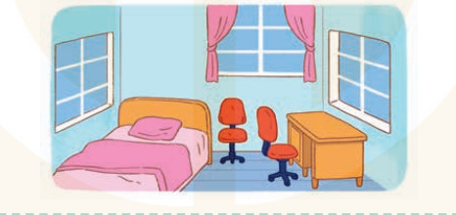  This is my bedroom. It is……..  There is a…………………….  It is……..There are two……….  They are……………………..  Key: first gap: small  second gap: bed / desk  third gap: small / old  fourth gap: chairs  fifth gap: old / new  3.Project.  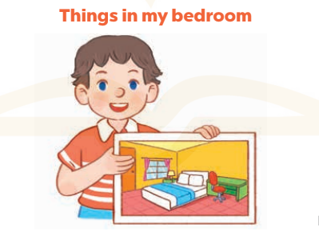  +Example: Hello, everyone. My name’s Huong. I’m nine years old. This is my bedroom. There is a bed. It is bag. There are two windows. They are new.
D. ADJUSTMENTS (if necessary):
………………………………………………………………………………………….…..……………………………………………………………………………...……

