Week:
Teaching date: / /2023
Unit 13: My house
Period: 85- Lesson 1:1,2,3
I. Objectives: By the end of the lesson Ps will be able to:
–use the words living room, bedroom, kitchen, bathroom, here, there
–use Where’s the……….? – It’s here/ there. to ask and answer questions about the location of a room in a house
- Vocabulary: living room, bedroom, kitchen, bathroom, here, there
- Model sentences:
A: Where’s the……….?
B: It’s here/ there.
- Skills: speaking and listening
2. Competences:
- Critical Thinking: talk about house
- Co-operation: ready to help friends in pair work/ group work.
- Sociability: Talk to each other, say good words to others.
3. Attitude/ Qualities:
- Kindness: Help partners to complete learning tasks.
- Honesty: tell the truth about feelings and emotions
II. TEACHING AIDS:
- Teacher: Teacher’s guide Pages 161, 162, audio Tracks 22, 23, website sachmem.vn, posters, laptop, pictures, textbook, lesson plan, TV or projector.
- Students: Pupil’s book Page 18, notebooks, workbooks, school things.
III. PROCEDURES:
Teacher’s and students’ activities | Contents
Activity 1.Warm- up: Let’s chant  -Chant and do activities (Unit 12, Lesson 3).  - Ask pupils to chant and do the actions in Unit 13 in groups.  - Give points to the groups and encourage them.  - Say “Open your book page 18” and look at “Unit 13, Lesson 1: 1,2,3.  Activity 2. Look, listen and repeat:  - Have pupils look at Pictures a and b and identify the characters in the pictures.  - Play the audio twice (sentence by sentence). Correct their pronunciation where necessary.  - Have Ss to practice the dialogue  - T invites a few pairs to the front of the class to practice.  - T checks pronunciation for ss. Ask sts to link to activity 3:  Activity 3: Listen, point and say..  - T asks Ss look at picture a and helps Ss know the structure from the dialogue.  - T introduces new word and structure for Ss.  - T explains, models and gives meaning.  -Have Ss repeat the model sentences.  - Elicit and check comprehension the name of each character.  - Run through all the pictures.  - Run through model sentences.  + Run through the questions.  + Run through the answers.  - Have Ss to practise:  + T asks the first – Ss answer (change role).  + Ss – Ss (change role).  - Ask Ss to work in pairs to ask and answer the question Where’s the___? It’s here/there.  - T controls and corrects.  - Invite a few pairs to come to the front of the classroom, point at the relevant character in each picture, and act out his/her role.  - Encourage Ss to practice speaking English.  - T gives feedbacks.  Activity 4. Let’s talk.  - T asks ss look at the second bubble and ask  +Where’s___? It’s______.  - Get Ss to repeat the question and the answer several times in pairs.  - T models: Go around the classroom, pointing to Ss and asking Where’s___?  - Ask Ss ask and answer about their hobbies in pairs.  - Call some pairs to practice.  - Give feedbacks  Activity 5. Consolidation  - Summary the lesson  Homelink:  Learn the vocabulary and model sentences by heart  - Prepare the new lesson: Unit 13, Lesson 1: 4,5,6 on page 19. | - Look, listen and repeat  House: ngôi nhà  Bedroom: phòng ngủ  - Listen, point and say  Where: ở đâu  Kitchen: bếp  Bathroom: phòng tắm  Living room: phòng khách  - Let’s talk.  Where’s___?  It’s______.
IV. ADJUSTMENTS (if necessary):
………………………………………………………………………………………….…..……………………………………………………………………………...…===========================
Week:
Teaching date:
Unit 13: My house
Period 86- Lesson 1: 4,5,6
I. OBJECTIVES:
By the end of the lesson, Ss will be able to:
1. Knowledge:
- listen to and understand simple exchanges in relation to the topic “My house”
- read and write about the location of rooms in a house and things in a room.
- Vocabulary: Review
- Skills: Listening, reading and writing.
2. Competences:
- Co-operation: ready to help friends in pair work/ group work.
- Self-control and independent learning: perform listening tasks.
3. Attitude/ Qualities:
- Kindness: Help partners to complete learning tasks.
- Honesty: tell the truth about feelings and emotions.
- Diligence: complete learning tasks.
II. TEACHING AIDS:
- Teacher: Teacher’s guide Pages 163, 164; audio Tracks 24, 25; website sachmem.vn, posters, laptop, pictures, textbook, lesson plan, TV or projector.
- Students: Pupil’s book Page 19, notebooks, workbooks, school things.
III. PROCEDURES:
Teacher’s and students’ activities | Contents
Activity 1: Warm-up  Game: Brain storming  -Divide 2 teams to go to the board and write the words about topic “ my house”. In 1 minute the team has the more right words and quickly is the winner.  -Monitor, check, find the winner and congratulate.  - Say “Open your book page 19” and look at “Unit 13, Lesson 1:4,5,6”.  Activity 2. Listen and circle:  - Elicit the rooms of the house in the pictures.  - Point at the pictures respectively to explain the context.  - T asks Ss to guess the answers.  + T writes Ss’ guessing on the board. Sts listen and circle.  - Listen to the tape:  + Play the recording  + Play the recording again and get Ss to swap books with their partners.  + Play the recording again to check answers together as a class.  + Write the answers on the board for Ss to correct their answers. Then checks Ss’ guessing.  - Play the recording, sentence by sentence, for the class to listen and repeat in chorus.  Activity 3. Look, complete and read.  - Have Ss look at the pictures and identify the rooms (a living room, a kitchen, a bathroom and a bedroom).  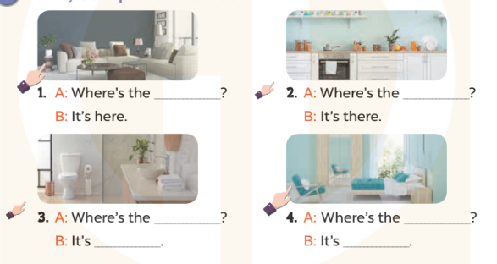  - Have Ss look at the four incomplete sentences and elicits the missing words in the sentences.  - T models with sentence 1  + Ask Ss what is missing in the sentence.  + Have Ss look at the picture and complete the gap, then read the completed sentence in chorus.  -Have Ss work in groups and complete the sentences 2,3 and 4.  - Ask a few Ss to stand up and read the completed sentences aloud.  -T gives feedbacks  Activity 3. Let’s sing.  - Introduce the title and lyrics of the song: “Where is it? ” song.  - Play the recording for Ss to listen to the whole song.  + Have them repeat the title and lyrics line by line.  + Tell Ss to point at the relevant character while singing his or her name.  - Play the recording all the way through for Ss to listen to pronunciation and melody of the song.  - Play the recording line by line for Ss to listen, repeat and point at the relevant character.  - Play the recording for Ss to sing and do actions.  - Ask Ss to practice singing and doing actions in pairs or groups.  - Invite groups to the front of the classroom to perform the song  -T gives feedback.  Activity 5. Consolidation  -T asks ss to answer the following questions:  + What have you learnt from the lesson today?  +What are the core values of the lesson? (if the teacher can take from the lesson).  - T praises some Ss who are hardworking / active/ good…. as well as encourage others to try more.  Homelink:  - Ask and answer about the pictures on page 19.  - Prepare the new lesson: Unit 13, Lesson 2:1,2,3 on page 20. | 4. Listen and circle  Key: 1.a 2.b  5. Look, complete and read  Key:  1. living room  2. kitchen  3. bathroom; there  4. bedroom; here  6. Let’s sing.  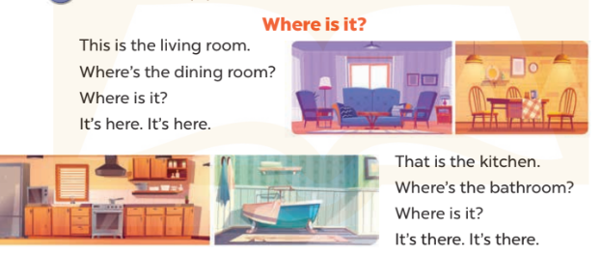
IV. ADJUSTMENTS (if necessary):
………………………………………………………………………………………….…..……………………………………………………………………………...…======================================
Teaching day:
Unit 13: My house
Period: 87- Lesson 2 – 1,2,3
I. OBJECTIVES:
By the end of the lesson, Ss will be able to:
1. Knowledge:
- use the words table, chair, book, lamp, in and on in the target sentence patterns
- use Where are the…..? – They’re……. to ask and answer questions about the locations of things in a room
- Vocabulary: table, chair, book, lamp, in, on
- Model sentences:
A: Where are the tables?
B: They’re in the living room.
- Skills: speaking and listening
2. Competences:
- Critical Thinking: talk about house
- Co-operation: ready to help friends in pair work/ group work.
- Oral Communication: speak about someone, ask and answer the questions
3. Attitude/ Qualities:
- Kindness: Help partners to complete learning tasks.
- Honesty: tell the truth about feelings and emotions
II. TEACHING AIDS:
- Teacher: Teacher’s guide Pages 165, 166; audio Tracks 26,27, website sachmem.vn, posters, laptop, pictures, textbook, lesson plan, TV or projector.
- Students: Pupil’s book Page 20, notebooks, workbooks, school things.
III. PROCEDURES:
Activity 1. Warm- up:  Game: Matching.  - Teacher divides the class into 2 teams  There are 2 columns. The first column is some pictures about places such as kitchen, bathroom  living room, bedroom, house. The other column is meaning of them. Sts must match the picture in the first column with correctly its meaning in the other column.  - Pupils of each team will get points if their matching is correct.  -T give feedback  - Say “Open your book page 20” and look at “Unit 13, Lesson 2 :1,2,3”.  Activity 2. Look, listen and repeat:  - Have pupils look at Pictures a and b and identify the characters and ask students to guess the content in the pictures such as what’s this? Sts say This is the living room,…  - Play the audio twice (sentence by sentence). Correct their pronunciation where necessary.  - Have Ss to practice the dialogue  - T invites some pairs to the front of the class to practice.  - T checks pronunciation for ss.  - T ask sts to write the new words on the board.  - Checking: Rub out and remember  Activity 3 Listen, point and say.  - T asks Ss look at picture a and helps Ss know the structure from the dialogue.  - T introduces new words and structure for Ss.  - T explains, models and gives meaning.  -Have Ss repeat the model sentences.  - Have Ss to practise:  + T asks the first – Ss answer (change role).  + Ss – Ss (change role).  - Ask Ss to work in pairs to ask and answer the question Where are the___? They’re____  - T controls and corrects.  - Invite a few pairs to come to the front of the classroom, point at the relevant location of things in each picture, and act out his/her role.  - Encourage Ss to practice speaking English.  - T gives feedbacks.  Activity 4. Let’s talk.  - Have Ss look at the picture and explain the picture. Tell sts say about location of things.  - T asks Ss look at the first speech bubble and ask Where are ___?  - Get Ss to repeat the question and the answer several times in pairs.  - T models: Go around the classroom, pointing to Ss and asking Where are____?  - Ask Ss ask and answer about their hobbies in pairs.  - Invite some groups to perform in front of the class.  - Give feedbacks  Activity 5: Consolidation  - Summary the lesson  Homelink  - Learn the vocabulary and model sentences by heart  - Prepare the new lesson: Unit 13, Lesson 2:4,5,6 on page 21 | 1.Look, listen and repeat.  + chairs: những cái ghế  + in: ở trong  2. Listen, point and say.  Tables: những cái bàn  Lamps: những đèn ngủ  On: ở trên  Structure  1.Where are the tables/books/..?  2: They’re in the living room/ on the table,..?  3. Let’s talk.  Where are____?  They’re___________.
IV. ADJUSTMENTS (if necessary):
………………………………………………………………………………………….…..……………………………………………………………………………...…======================================
Week:
Teaching date:
Unit 13: My house
Period 88: Lesson 2: 4,5,6
I. OBJECTIVES:
By the end of the lesson, Ss will be able to:
1. Knowledge:
- listen to and understand simple exchanges in relation to the topic “My house”
- read and write about the location of rooms in a house and things in a room.
- Vocabulary: Review
- Skills: speaking, listening, reading and writing.
2. Competences:
- Critical Thinking: talk about rooms in a house and things in a room.
- Co-operation: ready to help friends in pair work/ group work.
- Self-control and independent learning: perform listening tasks.
3. Attitude/ Qualities:
- Kindness: Help partners to complete learning tasks.
- Honesty: tell the truth about feelings and emotions.
- Diligence: complete learning tasks.
II. TEACHING AIDS:
- Teacher: Teacher’s guide Pages 167, 168; audio Tracks 28; website sachmem.vn, posters, laptop, pictures, textbook, lesson plan, TV or projector.
- Students: Pupil’s book Page 21, notebooks, workbooks, school things.
III. PROCEDURES:

Teacher’s and students’ activities | Contents
Activity 1. Warm- up: sing a song  - Show the song on the screen.  https://www.youtube.com/watch?v=qZyJPZxsmZk  - Ask pupils to listen, sing and dance the song.  - Say “Open your book page 21” and look at “Unit 13, Lesson 2 (4,5,6)”.  Activity 2. Listen and number:  - Run through 4 pictures and elicit and ask students about things of rooms in these pictures  - Ss to guess the answers.  + T writes Students’ guessing on the board.  -Sts listen and number  - Sts listen to the tape.  + Play the recording  + Play the recording again and get Ss to swap books with their partners.  + Play the recording again to check answers together as a class.  + Write the answers on the board for Ss to correct their answers. Then checks Ss’ guessing.  - Play the recording, sentence by sentence, for the class to listen and repeat in chorus.  Activity 3. Look, circle and read.  - Have Ss look at the pictures and identify the rooms and things in the pictures.  - T models with sentence 1.  + Have Ss look at the sentence.  + Ask them what is missing in the answer (tables).  + Have Ss circle the correct options  + Have Ss read the completed sentence in chorus.  -Have Ss work in pairs and circle the sentences 2, 3 and 4.  - Invite pairs of pupils to stand up and read aloud the sentences.  -T gives feedbacks.  Activity 4. Let’s play.  - Explain how to play the game:  + Draw a 3 x 3 Bingo grid on the board and a list of the vocabulary words for reviewing.  + Get Ss to copy the grid onto a paper sheet and fill their grids with the vocabulary words.  + Ss need to listen carefully for the words that you’ll be calling out from the list on the board. If they have a word that is called out, then they need to cross it out on their grids.  + Eventually, one pupil will have crossed out all of his or her words and should out “Bingo!” to show that he / she has finished.  - Give Ss time to play the game in pairs or groups.  - When time runs out, invite a few pairs to stand up and take turns asking and answering questions using the sentence patterns Where’s …….? − It’s here / there. and Where are …….? – They’re…….  Activity 5: Consolidation  - Summary the lesson  Homelink  - Ask and answer about the pictures on page 21.  - Prepare the new lesson: Unit 13, Lesson 3 (1,2,3) on page 22. | 4. Listen and number  Key:  1.c 2. d 3. a 4. b  5. Look, circle and read. 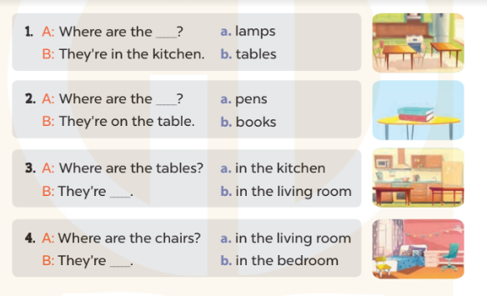  Key: 1. b 2. b 3. a 4. b  6.Let’s play. 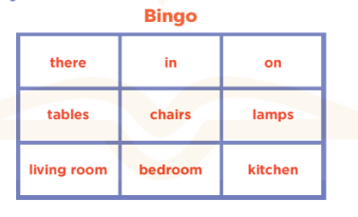
IV. ADJUSTMENTS (if necessary):
………………………………………………………………………………………….…..…………………………………………………………………………….
Week:
Teaching date:
Unit 13: My house
Period 89: Lesson 3 (1, 2, 3)
I. OBJECTIVES:
By the end of the lesson, Ss will be able to:
1. Knowledge:
- correctly repeat the sounds of the letters ou and ow in isolation, the words house and brown and the sentences Wow, it’s a big house! and Wow, it’s a brown house! with the correct pronunciation and intonation.
- identify the target words house and brown while listening.
- say the chant with the correct rhythm and pronunciation.
- Vocabulary: Review
- Skills: speaking, listening, reading and writing.
2. Competences:
- Co-operation: ready to help friends in pair work/ group work.
- Self-control and independent learning: perform listening tasks.
3. Attitude/ Qualities:
- Kindness: Help partners to complete learning tasks.
- Honesty: tell the truth about feelings and emotions
II. TEACHING AIDS:
- Teacher: Teacher’s guide Pages 169, 170; audio Tracks 29, 30, 31; website sachmem.vn, posters, laptop, pictures, textbook, lesson plan, TV or projector.
- Students: Pupil’s book Page 22, notebooks, workbooks, school things.
III. PROCEDURES:
Teacher’s and students’ activities | Contents
Activity 1.Warm- up: Game: Find and circle the words  H B K K E P M C F T  O C T H S N O W F H  U L U A A E U O T I  S E L N F C S S T N  E A W K R I E S E K  R C O O R C I S R B  S R O E M C V T A H  B R O W N R S T A Y  D T S S R S O R S M  A C E B K N W O W  - Divide class into 2 groups  - Ask Ss to find and circle the words that they learnt.  - Which groups find the best correct words is winner.  - Give Ss time to play the game.  Rows: brown, snow, wow  Columns: house, mouse  -T checks who’s winner?  - Say “Open your book page 22” and look at “Unit 13, Lesson 3 (1,2,3)”.  Activity 2. Listen and repeat:  - Play the recording for the letter ou, ow  - Encourage Ss to point at the letter/ word/ sentence while listening.  - Play the recording again and encourage Ss to listen and repeat.  - Do this several times until Ss feel confident.  - T calls some Ss to practice.  - T gives feedbacks.  Activity 3. Listen and circle.  - T ask Ss to guess the answers.  + T writes student s’ guess on the board.  - Listen to the tape:  + Play the recording  + Play the recording again and get Ss to swap books with their partners.  + Play the recording again to check answers together as a class.  + Write the answers on the board for Ss to correct their answers. Then checks Ss’ guessing.  - Play the recording, sentence by sentence, for the class to listen and repeat in chorus.  - Invite some students to read before whole class  Activity 4. Let’s chant.  - Introduce the title and lyrics of the chant.  - Play the recording for Ss to listen to the whole chant.  + Have them repeat the title and lyrics line by line.  + Ask Ss to attend to the sounds of the letters ou and ow and the words house and brown.  - Play the recording all the way through for Ss to listen to pronunciation and melody.  - Play the recording line by line for Ss to listen and repeat  - Play the recording for Ss to chant and clap along.  - Ask Ss to practice chant and clap along in pairs or groups.  - Invite groups to the front of the classroom to perform the chant  -T gives feedback.  Activity 5: Consolidation  - Summary the lesson  Homelink  - Draw a picture about the doll’s houses  - Prepare the new lesson: Unit 13, Lesson 3: (4,5,6) on page 23 | 1.Listen and repeat:  2. Listen and circle.  Key: 1. b 2. b  3. Let’s chant
IV. ADJUSTMENTS (if necessary):
………………………………………………………………………………………….…..……………………………………………………………………………...
========================
Week:
Teaching date:
Unit 13: My house
Period 90: Lesson 3:4,5,6
I. OBJECTIVES:
By the end of the lesson, Ss will be able to:
1. Knowledge:
- read a paragraph and complete sentences with the words from the paragraph
- read, understand and complete a gapped text using the information from a picture cue
- make a model house and tell the class about it.
- Vocabulary: Review
- Skills: speaking, listening, reading and writing.
2. Competences:
- Critical Thinking: talk about things in the house.
- Co-operation: ready to help friends in pair work/ group work.
- Self-control and independent learning: perform reading tasks.
3. Attitude/ Qualities:
- Kindness: Help partners to complete learning tasks.
- Honesty: tell the truth about feelings and emotions.
- Diligence: complete learning tasks.
II. TEACHING AIDS:
- Teacher: Teacher’s guide Pages 170, 171, website sachmem.vn, posters, laptop, pictures, textbook, lesson plan, TV or projector.
- Students: Pupil’s book Page 23, notebooks, workbooks, school things.
III. PROCEDURES:

Teacher’s and students’ activities | Contents
Activity 1: 1.Warm- up: (5’)  Game: Guessing  - Divide the class into 3 teams.  - Look at the cards (1-8), there are pictures behind them.  + Let Ss guess the pictures then say aloud the rooms and things in the house.  + Who can make it will have points for the team. (Spin the lucky wheel to get the points)  - Encourage Ss to take part in the game and practice speaking English.  - Give points for Ss.  - Say “Open your book page 23” and look at “Unit 13, Lesson 3 (4, 5, 6)”.  Activity 2. Read and complete:  - Tell Ss about this activity.  - Get Ss to scan the paragraph and find the missing words.  - Ask Ss attend to the blank in sentence 1 and find the missing word.  - Write the missing word on the board and get the class to read the completed sentence together.  - Have Ss work in pairs and complete  - Tell Ss to swap books with a partner, then check answers together as a class.  - Write the correct answers on the board for pupils to correct their answers.  - Invite Ss to read the complete sentences aloud  -T gives feedbacks.  Activity 3. Let’s write  - Explain to the class the goal of this activity.  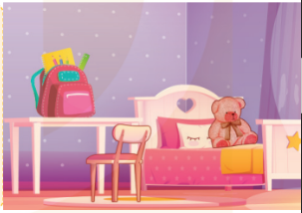  - Ask Ss to read each gapped sentence, guess the missing information and complete the sentence with their own personal information.  - Give Ss time to write their answers  - Ask Ss to swap and correct their answers in pairs.  - Check the answers as a class.  Activity 4. Project.  - Tell Ss about this activity. Check their doll’s houses.  - Show a sample of a doll’s house on the board and write the presentation language under it.  -Give Ss repeat the sentences until they can say them by themselves.  - Give Ss time to practise their presentations by themselves.  - Invite a student to the front of the classroom to model the presentation.  - Give Ss work in individually to present their doll’s houses.  - Invite a few SS to present in front of the classroom.  -Give Ss display of doll’s houses and vote for the best picture.  Activity 5: Consolidation  - T asks ss to answer the following questions:  + What have you learnt from the lesson today?  +What are the core values of the lesson?  - T praises some Ss who are hardworking / active/ good…. as well as encourage others to try more.  Homelink. (3’)  - Prepare the new lesson: Unit 14: Lesson 1 (1,2,3) on page 24 | 4.Read and complete  Key:  1.the bedroom  2. the kitchen  3. the kitchen  4. the table  5. Let’s write  Key: Pupil’s answer  6. Project. 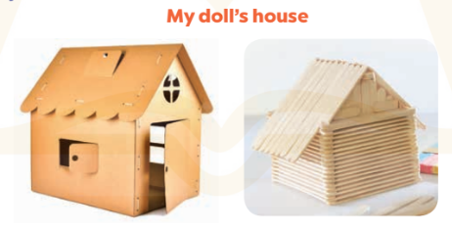
IV. ADJUSTMENTS (if necessary):
………………………………………………………………………………………….…..……………………………………………………………………………...

