Date of preparation: ……….
Date of teaching: ………..
Class:
UNIT 10: BREAK TIME ACTIVITIES
Lesson 1 (1, 2, 3)
I. OBJECTIVES:
By the end of the lesson, Ss will be able to:
1. Knowledge:
- understand and correctly repeat the sentences in two communicative contexts about school break time activities.
- correctly say the words and use I ______ at break time. to identify school break time activities.
- enhance the correct use of I ______ at break time. to identify school break time activities.
- Vocabulary: play volleyball, play basketball, play chess, play badminton
- Skills: speaking and listening
2. Competences:
- Self-control and independent learning: perform listening tasks.
- Communication and collaboration: work in pairs or groups.
- Sociability: talk to each other, say good words to others.
3. Attitude/ Qualities:
- Kindness: Help partners to complete learning tasks.
- Honesty: tell the truth about feelings and emotions
II. TEACHING AIDS:
- Teacher: Teacher’s guide Pages 122, 123, 124, audio Tracks 97, 98, website sachmem.vn, posters, laptop, pictures, textbook, lesson plan, TV or projector.
- Students: Pupil’s book Page 68, notebooks, workbooks, school things.
III. PROCEDURES:
Teacher’s and Students’ activities | Content
1. Warm-up: 5’  Jigsaw puzzle  *Procedure:  - Divide class into 4 groups: Tom, Jerry, Miu and Chit.  - Ask Ss look at the pieces of picture.  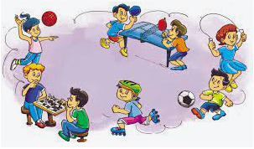  - Ask Ss go to the board and jigsaw puzzle into the correct picture.  -T checks who’s the winner?  - Say “Open your book page 68” and -Ss open their books look at “Unit 10, Lesson 1 (1,2,3)”.  2. New lesson  Activity 1. Look, listen and repeat (10’)  *Procedure:  - Have pupils look at Pictures a and b and identify the characters in the pictures.  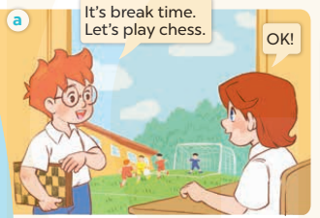  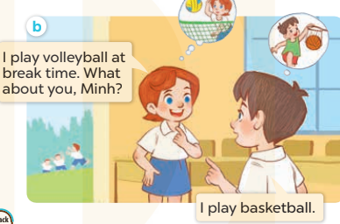  - Play the audio twice (sentence by sentence). Correct their pronunciation where necessary.  -Ask Ss take note the newwords  - Have Ss to practice the dialogue  - T invites a few pairs to the front of the class to practice.  - T checks pronunciation for ss.  -T elicits the new words  - Ss listen and repeat  + Choral repetition (3 times).  + Individual repetition (3 ss)  - Ss take note  - T models (3 times).  - T writes the words on the board.  - Checking: Rub out and remember  Activity 2: Listen, point and say(8’)  *Procedure:  - T asks Ss look at picture b and helps Ss know the structure from the dialogue.  - T introduces new structure for Ss.  -Ss listen and repeat in chorus (twice)  - T explains, models and gives meaning.  -Have Ss repeat the model sentences.  - Have Ss look at the pictures and identify the names of the school things in the pictures  - Run through all the pictures.  - Run through model sentences.  +Run through question sentence  +Run through answer sentence  - Have Ss to practise:  + T asks, Ss answer picture a  + Ss asks, T answers picture b  + Group A ask, group B answer picture c  + Group B ask, group A answer picture d  - Ask Ss to work in pairs.  -Ss work in pairs to practice  - T controls and corrects.  - Invite a few pupils to stand up, point at each school thing in the picture and say the sentence aloud.  -Ss point and say  - T gives feedbacks.  Activity 3. Let’s talk (7’)  *Procedure:  - Have Ss look at the picture and elicit the question and the answer in context.  + Who are they?  + Where are they?  + What are they doing?  - Have Ss look at the picture and say the activities  - Have Ss look at the first speech bubble and read I play badminton at break time.  - Then have them point to the pupils playing badminton and complete the gapped answer in the second bubble (Ex: I play badminton at break time) After that, let them say aloud.  - Give Ss time to practise say the sentence I play ……at break time.  - Invite some Ss to practise talking about school break time activities in front of the class.  3.Consolidation (3’)  - T asks ss to answer the following questions:  + What have you learnt from the lesson today?  +What are the core values of the lesson? (if the teacher can take from the lesson).  - T review the vocabulary and model sentences.  - T praises some Ss who are hardworking / active/ good…. as well as encourage others to try more.  4.Homelink(2’)  - Learn the vocabulary and model sentences by heart  - Prepare the new lesson: Unit 10, Lesson 1 (4,5,6).  -Ss listen and take note | 1.Look, listen and reppeat.  + chess : cờ (visual)  + volleyball: bóng chuyền (picture)  + basketball :bóng rổ (picture)  + badminton :cầu lông (visual)  + play: chơi (translation)  + break time: giờ giải lao (situation)  -  2. Listen, point and say  I play volleyball at break time.  .  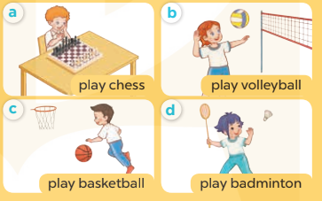  + Picture a: a boy playing chess  + Picture b: a girl playing volleyball  + Picture c: a boy playing basketball  + Picture d: a girl playing badminton  3.Let’s talk  I play ……at break time.  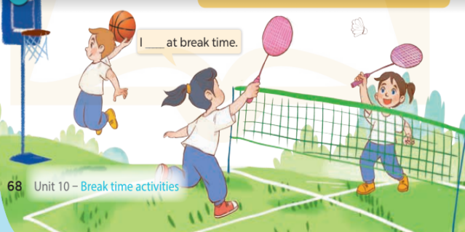
ADJUSTMENTS (if necessary):
………………………………………………………………………………………….…..…………………………………………………………………………
UNIT 10: BREAK TIME ACTIVITIES
Lesson 1 (4, 5, 6)
I. OBJECTIVES:
By the end of the lesson, Ss will be able to:
1. Knowledge:
- listen to and understand two communicative contexts in which pupils talk about what they do at break time.
- complete four target sentence patterns with the help of the picture cues.
- sing the song “It’s break time” with the correct pronunciation and melody.
- Vocabulary: Review
- Skills: speaking, listening, reading and writing.
2. Competences:
- Written Communication: complete the sentences.
- Self-control and independent learning: perform listening tasks.
- Communication and collaboration: work in pairs or groups.
3. Attitude/ Qualities:
- Kindness: Help partners to complete learning tasks.
- Honesty: tell the truth about feelings and emotions.
- Diligence: complete learning tasks.
II. TEACHING AIDS:
- Teacher: Teacher’s guide Pages 124, 125; audio Tracks 99, 100, website sachmem.vn, posters, laptop, pictures, textbook, lesson plan, TV or projector.
- Students: Pupil’s book Page 69, notebooks, workbooks, school things.
III. PROCEDURES:
Teacher’s and Students’ activities | Contents
1.Warm-up(5’)  Slap the board  *Procedure:  - Divide class into 2 groups: Tom and Jerry.  - How to play:  + Each group chooses five Ss to play.  + Class will read aloud.  + Look at the picture, listen and slap the picture you heard.  + Who faster will get 1 mark.  + Which group with higher mark is the winner.  - Ss listen and play  - T gives feedback.  - - Say “Open your book page 69” and look at “Unit 10, Lesson 1 (4,5,6)”.  - Ss open their books  2.New lesson (23’)  Activity 1. Listen and tick:  *Procedure:  - Elicit the name of the school thing in each picture.  -Ss look at the pictures and say  - Check comprehension the difference between the two pictures.  - T ask Ss to guess the answers.  -Ss guess the answers  + T writes Ss’guessing on the board.  - Listen to the tape:  + Play the recording  + Play the recording again and get Ss to swap books with their partners.  - Ss listen to the tape and tick  + Play the recording again to check answers together as a class.  - Ss listen again, tick and swap books with their partners.  + Write the answers on the board for Ss to correct their answers. Then checks Ss’ guessing.  - Play the recording, sentence by sentence, for the class to listen and repeat in chorus.  Activity 2. Look, complete and read  *Procedure:  - Have Ss look at the picture cues and identify the activity of the character.  - Have Ss look at the four incomplete sentences. Elicit and model with picture 1  + Ask Ss to read the sentence 1 in chorus.  + Ask Ss what word is missing in the gap (play volleyball). Then have them complete the sentence (I play volleyball at break time).  -Have Ss work in pairs and complete the sentences 2, 3, 4.  - Ask a few Ss to stand up and read the sentences aloud.  -T gives feedbacks.  Activity 3. Let’s sing  *Procedure:  - Introduce the title and lyrics of the song and check comprehension.  + What is the song about?  + What are they doing?  - Play the recording for Ss to listen to the whole song.  + Have them repeat the title and lyrics line by line.  + Tell Ss to point at the pictures while singing.  - Play the recording all the way through for Ss to listen to pronunciation and melody of the song.  - Play the recording line by line for Ss to listen, repeat and point to the pictures  - Play the recording for Ss to sing and do actions.  - Ask Ss to practice singing and doing actions in pairs or groups.  - Invite groups to the front of the classroom to perform the song  -T gives feedback.  3.Consolidation (5’)  *Procedure:  - T asks ss to answer the following questions:  + What have you learnt from the lesson today?  +What are the core values of the lesson? (if the teacher can take from the lesson).  -Ss answer the questions  - T praises some Ss who are hardworking / active/ good…. as well as encourage others to try more.  -Ss listen and clap their hands  4.Homelink (2’)  - Practice part 5 again.  - Prepare the new lesson: Unit 10, Lesson 2 (1,2,3).  -Ss listen and take note | 4.Listen and tick  + Picture 1a: Linh is playing chess.  + Picture1 b: Linh is playing volleyball.  + Picture 2a: Ben is playing basketball.  + Picture 2b: Ben is playing badminton.  Key: 1. b 2. a  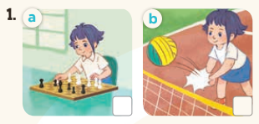  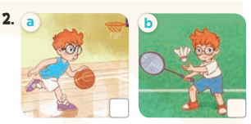  5. Look, complete and read  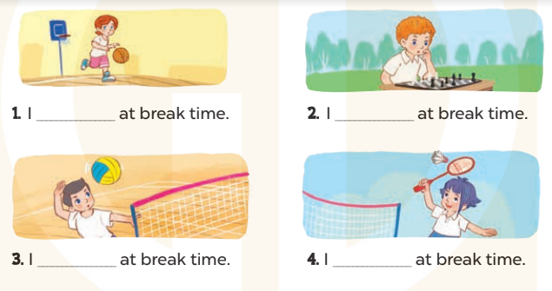  Key:  1.play basketball  2. play chess  3. play volleyball  4. Play badminton  6.Let’s sing  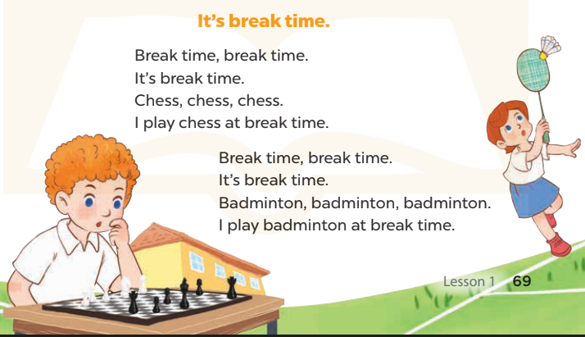
ADJUSTMENTS (if necessary):
………………………………………………………………………………………….…..…………………………………………………………………………
UNIT 10: BREAK TIME ACTIVITIES
Lesson 2 (1, 2, 3)
I. OBJECTIVES:
By the end of the lesson, Ss will be able to:
1. Knowledge:
- use the words football, table tennis, chat, word puzzle related to the topic school break time activities
- use What do you do at break time? – I……… to ask and answer questions about school break time activites.
- Vocabulary: football, table tennis, chat, word puzzle
- Skills: speaking and listening
2. Competences:
- Self-control and independent learning: perform listening tasks.
- Communication and collaboration: work in pairs or groups.
- Sociability: talk to each other, say good words to others.
3. Attitude/ Qualities:
- Kindness: Help partners to complete learning tasks.
- Honesty: tell the truth about feelings and emotions
II. TEACHING AIDS:
- Teacher: Teacher’s guide Pages 126, 127, audio Tracks 101, 102, website sachmem.vn, posters, laptop, pictures, textbook, lesson plan, TV or projector.
- Students: Pupil’s book Page 70, notebooks, workbooks, school things.
III. PROCEDURES:
Teacher’s and Students’ activities | Contents
1.Warm-up(5’) Game: Act and Guess  *Procedure:  - Divide the class into 2 teams (boys and girls).  - 1 pupil of each team comes to the board and does actions for their team to guess the names of break time activities and sticks the right pictures.  -The first Team to stick 4 correct pictures with right order is the winner.  - Say “Open your book page 70” and look at “Unit 10, Lesson 2 (1, 2, 3)”.  -Ss open their books  2.New lesson (25’)  Activity 1. Look, listen and repeat:  *Procedure:  - Have Ss look at Pictures a and b and identify the characters (Bill and Mai) in the pictures.  -Ss listen and answer  + In picture a: Mai asks Bill if What do you do at break time? Bill says that I play football.  + In picture b: Bill asks Mai: What do you do at break time?  Mai answers: I play badminton 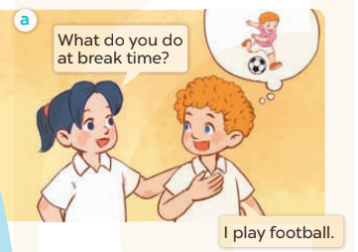  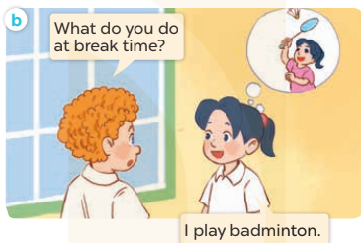  - Play the audio twice (sentence by sentence). Correct their pronunciation where necessary.  - Ss listen and repeat  - Have Ss to practice the dialogue  - Ss work in pairs to practice  - T invites a few pairs to the front of the class to practice.  - T checks pronunciation for ss.  -T elicits the new words  - T models (3 times).  - Ss listen and repeat  - T writes the words on the board.  + Choral repetition (3 times).  + Individual repetition (3 ss)  - Ss take note  - Ss look, remember and write  - Checking: Rub out and remember  Activity 2: Listen, point and say.  *Procedure:  - T asks Ss look at picture a and helps Ss know the structure from the dialogue.  -Ss look at the picture and answer.  - T introduces new structure for Ss.  - T explains, models and gives meaning.  -Have Ss repeat the model sentences.  -Ss listen and repeat  - Have Ss look at the pictures and identify the action of the characters in the pictures.  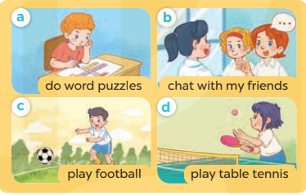  - Ss look, listen and answer  - Run through all the pictures.  - Run through model sentences.  +Run through question sentence  +Run through answer sentence  - Have Ss to practise:  -Ss practice in chorus, individuals.  + T asks, Ss answer picture a  + Ss asks, T answers picture b  + Group A ask, group B answer picture c  + Group B ask, group A answer picture d  - Ask Ss to work in pairs.  - T controls and corrects.  - Invite a few pupils to stand up, point at each school thing in the picture and say the sentence aloud.  -Ss point and say  - T gives feedbacks  Activity 3. Let’s talk.  *Procedure:  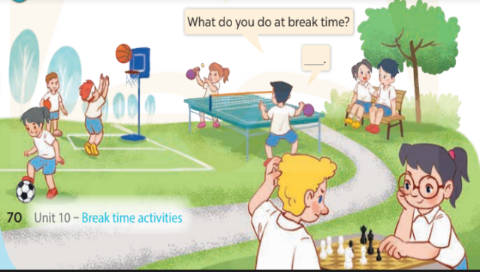  - Have Ss look at the picture and elicit the question and the answer in context.  + What are they?  + Where are they?  + What are they doing?  -Ss look at the picture and answer  + pupils playing different games and sports at break time.  - Have Ss look at the picture and say the break time activites.  - Have Ss look at the first speech bubble and read What do you do at break time?  - Have Ss point the activities, ask and answer the questions about break time activities  - Give Ss time to practise asking and answering the question What do you do at break time? – ……. in pairs.  - Invite a few pairs to practise asking and answering questions about break time activites in front of the class.  3.Consolidation(3’)  - T asks ss to answer the following questions:  + What have you learnt from the lesson today?  +What are the core values of the lesson? (if the teacher can take from the lesson).  - T review the vocabulary and model sentences.  - T praises some Ss who are hardworking / active/ good…. as well as encourage others to try more.  4. Home link(2’)  - Learn the vocabulary and model sentences by heart  - Prepare the new lesson: Unit 10, Lesson 2 (4,5,6).  -Ss listen and take note | Game: Act and Guess  1.Look, listen and repeat:  + football : bóng đá (visual)  + word puzzle : trò chơi ô chữ  (visual)  + chat :trò chuyện (translation)  + table tennis : bóng bàn (visual)  -  2.Listen, point and say.  * Model sentences:  A: What do you do at break time?  B: I play football.  + Picture a: a boy doing word puzzle.  + Picture b: a girl chatting with her friends  + Picture c: a boy playing football  + Picture d: a girl playing table tennis  3. Let’s talk.  What do you do at break time?  I ……………………
ADJUSTMENTS (if necessary):
………………………………………………………………………………………….…..…………………………………………………………………………

UNIT 10: BREAK TIME ACTIVITIES
Lesson 2 (4, 5, 6)
I. OBJECTIVES:
By the end of the lesson, Ss will be able to:
1. Knowledge:
- listen to and understand four comunicative context in which Ss ask and answer question about school break time activities
- read and match four target sentences with four pictures
- practice the target language by playing Miming game.
- Vocabulary: Review
- Skills: speaking, listening, reading and writing.
2. Competences:
- Critical Thinking: look, complete and read
- Co-operation: ready to help friends in pair work/ group work.
- Self-control and independent learning: perform listening tasks.
3. Attitude/ Qualities:
- Kindness: Help partners to complete learning tasks.
- Honesty: tell the truth about feelings and emotions.
- Diligence: complete learning tasks.
II. TEACHING AIDS:
- Teacher: Teacher’s guide Pages 128, 129; audio Tracks 103; website sachmem.vn, posters, laptop, pictures, textbook, lesson plan, TV or projector.
- Students: Pupil’s book Page 71, notebooks, workbooks, school things.
III. PROCEDURES:
Teacher’s and Students’ activities | Contents
1. Warm-up (5’)  *Procedure:  - Hold a school break time activities card, then reveal it slowly.  - Ask What do you do at break time?  - Ask the Ss guess the answer as fast as possible.  - Then have Ss do the same with the rest.  - This can be played in groups to make it more interesting.  - Say “Open your book page 72” and look at “Unit 10, Lesson 2 (4,5,6)”.  - Ss open their books  2. New lesson (25’)  Activity 1. Listen and number:  *Procedure:  - Elicit the action of the character in each picture.  + Who are they?  + What are they doing?  -Ss look at the pictures and say:  + Picture a: a girl play table tennis  + Picture b: a boy playing football  + Picture c: a girl doing word puzzle  + Picture d: a boy chatting with his friends  - T ask Ss to guess the answers.  + T writes Ss’guessing on the board.  - Listen to the tape:  + Play the recording  + Play the recording again and get Ss to swap books with their partners.  + Play the recording again to check answers together as a class.  + Write the answers on the board for Ss to correct their answers. Then checks Ss’ guessing.  - Ss listen again, write and swap books with their partners.  - Play the recording, sentence by sentence, for the class to listen and repeat in chorus.  -Ss listen and repeat.  Activity 2. Read and match  *Procedure:  - Get Ss to look at the pictures and elicit the characteres’ actions.  - Have Ss look at the first sentence and the pictures. Elicit and model with number 1: I play table tennis  + Ask Ss read and find the correct picture on the right to match.  + When Ss answer picture b, tell Ss draw a line to match the sentence and the picture  -Have Ss work in pairs and match the sentences 2, 3, 4.  - Ask a few Ss to stand up and read the sentences aloud.  -T gives feedbacks.  Activity 3. Let’s play  *Procedure:  -Elicit the language that Ss need to talk about break time activities (play football, play chess, play volleyball, do word puzzles, chat with friends, play tble tennis…)  -Explain how the game is played:  +One Ss mimes the action of doing an activity.  +Other Ss look at him/ her, guess the action and what it is, ex: play football.  -Model the game with two Ss  -Divide class into four groups, each group, choose a pupil to do the actions while the resr guesses the words.  +Ss get one point for each correct answer.  -The group with most point wins  3.Consolidation (3’)  *Procedure:  - T asks ss to answer the following questions:  + What have you learnt from the lesson today?  +What are the core values of the lesson? (if the teacher can take from the lesson).  - T praises some Ss who are hardworking / active/ good…. as well as encourage others to try more.  -Ss listen and clap their hands  4.Home link (2’)  - Practice part 5 again.  - Prepare the new lesson: Unit 10, Lesson 3 (1,2,3).  -Ss listen and take note | Game: Who says fast?  4. Listen and number:  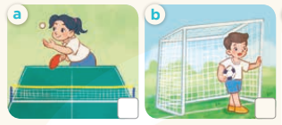  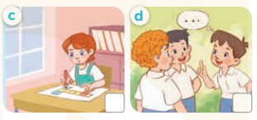  Key: 1. b 2. a 3. d 4. c  5. Read and match  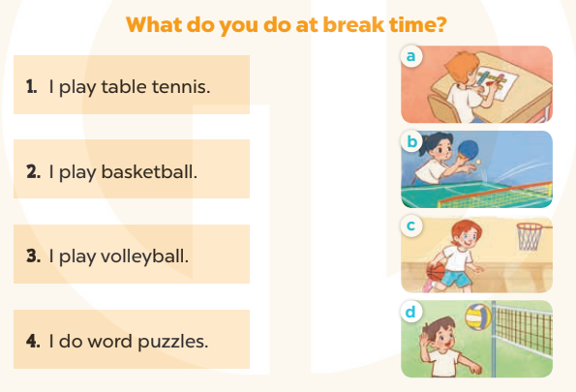  Key:  1. b 2. c 3. d 4. a  6. Let’s play  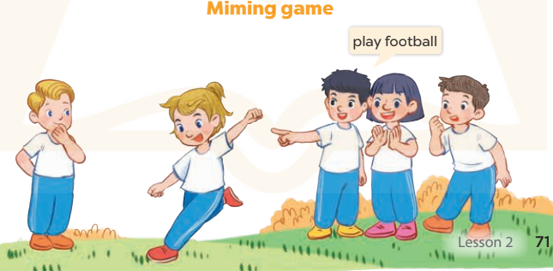
ADJUSTMENTS (if necessary):
………………………………………………………………………………………….…..………………………………………………………………………….

UNIT 10: BREAK TIME ACTIVITIES
Lesson 3 (1, 2, 3)
I. OBJECTIVES:
By the end of the lesson, Ss will be able to:
1. Knowledge:
- correctly repeat the sounds of the letter f and letter v in isolation, in the words football and volleyball, and in the sentences I play football at break time. and I play volleyball at break time. with correct pronunciation and intonation.
- identify the target words football and volleyball while listening.
- say the chant with the correct rhythm and pronunciation.
- Vocabulary: Review
- Skills: speaking, listening, reading and writing.
2. Competences:
- Co-operation: ready to help friends in pair work/ group work.
- Sociability: Talk to each other, say good words to others.
3. Attitude/ Qualities:
- Kindness: Help partners to complete learning tasks.
- Honesty: tell the truth about feelings and emotions
II. TEACHING AIDS:
- Teacher: Teacher’s guide Pages 130, 131; audio Tracks 104, 105, 106; website sachmem.vn, posters, laptop, pictures, textbook, lesson plan, TV or projector.
- Students: Pupil’s book Page 72, notebooks, workbooks, school things.
III. PROCEDURES:
Teacher’s and Students’ activities | Contents
- Warm-up (5’)  Game: Find and circle the words  *Procedure:  - Divide class into 2 groups  - Ask Ss to find and circle the words that they learnt.  - Which groups find the best correct words is winner.  - Give Ss time to play the game.  -Ss play game  -T checks who’s winner?  - Say “Open your book page 72” and look at “Unit 10, Lesson 3 (1,2,3)”.  - Ss open their books  2.New lesson (25’)  Activity 1. Listen and repeat:  *Procedure:  - T gives instruction to the letter letter f and v, football and volleyball, and in the sentences I play football at break time. and I play volleyball at break time.  - Ss recognize the differences about color of letter  - Play the recording for the letter f, v.  - Encourage Ss to point at the letter/ word/ sentence while listening.  - Play the recording again and encourage Ss to listen and repeat.  - Ss listen again and repeat  - Do this several times until Ss feel confident.  - T calls some Ss to practice.  - T gives feedbacks.  Activity 2. Listen and circle.  *Procedure:  - Elicit the sentences and the gap-fill options.  - T ask Ss to guess the answers.  -Ss guess the answers  + T writes Ss’guessing on the board.  - Listen to the tape:  + Play the recording  + Play the recording again and get Ss to swap books with their partners.  + Play the recording again to check answers together as a class.  + Write the answers on the board for Ss to correct their answers. Then checks Ss’ guessing.  - Ss listen again, circle and swap books with their partners.  - Play the recording, sentence by sentence, for the class to listen and repeat in chorus.  - Invite one or two Ss to stand up and read the completed sentences.  -Ss read the sentences  - T gives feedbacks  Activity 3. Let’s chant  *Procedure:  - Introduce the title and lyrics of the chant.  - Play the recording for Ss to listen to the whole chant.  -Ss listen to the chant  + Have them repeat the title and lyrics line by line.  - Ss listen and repeat line by line without clap their hands  + Ask Ss to attend to the sounds of the letters f and v and the words football and volleyball.  -Ss listen to melody of the chant  - Play the recording all the way through for Ss to listen to pronunciation and melody.  - Play the recording line by line for Ss to listen and repeat  - Play the recording for Ss to chant and clap along.  - Ask Ss to practice chant and clap along in pairs or groups.  - Ss work in groups (two groups) to chant  - Invite groups to the front of the classroom to perform the chant  -Ss perform in front of the class  -T gives feedback.  3.Consolidation  - T asks ss to answer the following questions:  + What have you learnt from the lesson today?  +What are the core values of the lesson? (if the teacher can take from the lesson).  - T praises some Ss who are hardworking / active/ good…. as well as encourage others to try more.  4.Home link (2’)  - Practice the chant more.  - Collect three school things  - Prepare the new lesson: Unit 10, Lesson 3 (4, 5, 6).  -Ss listen and take note | F M V C E P S V B  O C T H N E B O B  O L U E A V X L O  T E L S N N T L X  B B S S M K K E V  A C D K O K K Y E  L R O E E C V B A  L H B B W W N A A  D F O O T S O L S  V O B L Y Y Z L W  Rows: foot  Columns: football, volleyball, chess  - Listen and repeat:  f football I play football at break time.  v volleyball I play volleyball at break time.  - Listen and circle.  Key: 1.a 2.b  -  - Let’s chant  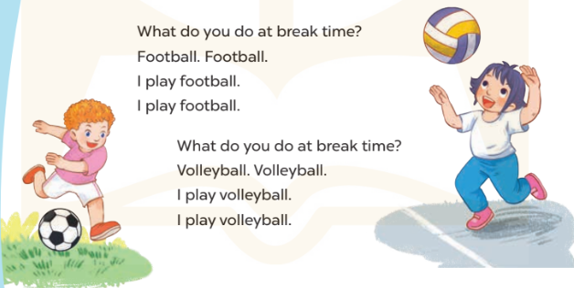
ADJUSTMENTS (if necessary):
………………………………………………………………………………………….…..…………………………………………………………………………

UNIT 10: BREAK TIME ACTIVITIES
Lesson 3 (4, 5, 6)
I. OBJECTIVES:
By the end of the lesson, Ss will be able to:
1. Knowledge:
- read the exchange and tick the correct boxes in the table bout Mary’s, Lucy’s, Bill’s and Minh’s break time activities
- use the target language in a real context by completing a gapped text about their school break time activities
- revise the target by asking and answering questions about school break time activities and talking about them to the class.
- Vocabulary: Review
- Skills: speaking, listening, reading and writing.
2. Competences:
- Written communication: write about the colours of school things
- Critical thinking: complete a task in reading a text.
- Co-operation: ready to help friends in pair work/ group work.
- Self-control and independent learning: perform listening tasks.
3. Attitude/ Qualities:
- Kindness: Help partners to complete learning tasks.
- Honesty: tell the truth about feelings and emotions.
- Diligence: complete learning tasks.
II. TEACHING AIDS:
- Teacher: Teacher’s guide Pages 132 133; website sachmem.vn, posters, laptop, pictures, textbook, lesson plan, TV or projector.
- Students: Pupil’s book Page 73, notebooks, workbooks, school things.
III. PROCEDURES:
Teacher’s and Students’ activities | Contents
1. Warm –up (5’): “Chant”  *Procedure:  - Ask Ss chant and do the actions in Unit 10 , Lesson 3 page 66 in groups.  - Ss listen and chant  - Give point for the groups and encourage them.  - Say “Open your book page 67” and look at “Unit 10, Lesson 3 (4, 5, 6)”.  - Ss open their books  2. New lesson (25’)  Activity 1. Read and tick:  *Procedure:  - Explain how to complete the task: read the dialogue and tick the correct break time activities in the table.  - Ask Ss to read the list of the break time activities in the first column of the table.  - Ask Ss look at the name on the right side of the table.  - Ask Ss read the text and tick the correct activities  - Let Ss swap and check answers.  - Check the answers  - Ask some Ss to read the text aloud.  Activity 2. Let’s write  *Procedure:  - Check comprehension and elicit to Ss read the gapped text and fill in the gaps.  - Let Ss read the gapped text and fill in the gaps.  - Have Ss complete the first gap together as an example: I am in the school …….  - Ask Ss to look at the gap and ask them what is missing. Then let them identify the playground. After that, let them write down the suitable word in the gap.  - Give Ss time to complete the text independently.  - In pairs or groups, ask Ss to swap their complete texts before checking as a class.  - Invite some Ss to come to the board and read the answer.  Activity 3. Project.  *Procedure:  - Elicit the language needed to do the task: What do yo do at break time? –I…………..Write it on the board.  - Model with one Ss, asking: What do you do at break time? And the Ss answer: I play football. Put a tick in the column football in the table.  - Ask Ss to work in groups of six.  - Invite some Ss to report on their work using the language leanrt.  - Have Ss tick their notes on the walls of the classroom as a display.  3.Consolidation  *Procedure:  - T asks ss to answer the following questions:  + What have you learnt from the lesson today?  +What are the core values of the lesson? (if the teacher can take from the lesson).  - T praises some Ss who are hardworking / active/ good…. as well as encourage others to try more.  4. Home link (2’)  - Prepare the new lesson: Review 2 (1, 2, 3).  -Ss listen and take note | 4.Read and tick:  Key:  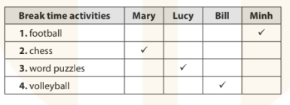  5.Let’s write  It’s break time. I am in the school……..…I play……….…..  I like playing………….  6.Project.  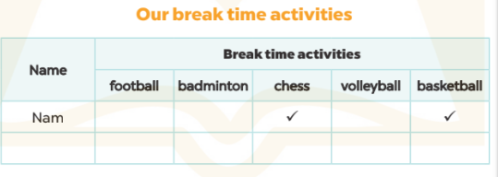
ADJUSTMENTS (if necessary):
………………………………………………………………………………………….…..…………………………………………………………………………

