Week 13 – Grade 3
Teaching date: /11/2022 – class 3A1, 3A2

Unit 8: MY SCHOOL THINGS
Lesson 1:1,2,3
I. Objectives:
1. Knowledge:
By the end of the lesson, pupils will be able to:
- use the words pen, ruler, book, school bag in relation to the topic “School things”;
- use I have _____. to talk about having a school thing;
- understand and correctly repeat the sentences in two communicative contexts (pictures) to talk about having a school thing.
2. Skills.
- Listening and speaking.
3. Attitude/ Qualities:
Kindness: help partners to complete learning tasks
Diligence: complete learning tasks
Honesty: tell the truth about feelings and emotions
Responsibility: appreciate kindness
4. Forming competence:
- Listening: listen and recognize the characters, then repeat
- Critical Thinking: self-introduce
- Self-control & independent learning: perform listening tasks
- Communication and collaboration: work in pairs or groups
II. Methods:
Communicative approach, group Ss and T's activities, play as a character, teaching methods with game, teaching methods by visual, teaching methods by practising, discussion group, technical present....
III. Preparation.
- Teacher: Teacher’s guide , audio Tracks , laptop, pictures, textbook, projector/TV
- Students: Pupil’s book, notebooks, workbooks.
IV. Procedures.
Activity 1.Warm- up: Game: polite  Option 3: Game: Listen and choose  Review the previous lesson by having the class play the game polite with the classroom instructions in Unit 7: Stand up, sit down, close your book, open your book.  Activity 2. Look, listen and repeat:  *Aim: Understand and correctly repeat the sentences in two communicative contexts (pictures) to talk about having a school thing  * Procedure:  - Have pupils look at Pictures a and b and identify the characters (Linh and Ben) in the pictures.  - Play the audio twice (sentence by sentence). Correct their pronunciation where necessary.  - Have Ss to practice the dialogue  - T invites some pairs to the front of the class to practice.  - T checks pronunciation for ss. Ask sts to link to activity 3  Activity 3: Listen, point and say.  *Aim : Correctly say the words and use: I have _____. to talk about having a school thing  * Procedure:  - T asks Ss look at picture a and helps Ss know the structure from the dialogue.  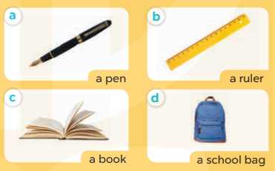  - T introduces new word and structure for Ss.  - T explains, models and gives meaning.  -Have Ss repeat the model sentences.  - Elicit and check comprehension the name of each character.  - Run through all the pictures.  - Run through model sentences.  + Run through the questions.  + Run through the answers.  - Have Ss to practise:  + T asks the first – Ss answer (change role).  + Ss – Ss (change role).  - Ask Ss to work in pairs to talk about having a school thing use I have a_________  - T controls and corrects.  - Invite a few pairs to come to the front of the classroom, point at the relevant character in each picture, and act out his/her role.  - Encourage Ss to practice speaking English.  - T gives feedbacks.  Activity 4. Let’s talk.  * Aim: Enhance the correct use of I have _____. to talk about having a school thing  * Procedure:  - T asks ss look at the second bubble and ask  +What’s your hobby?  - Have pupils identify the school things in the picture (as in Input). Point at each school thing, elicit the missing words in the bubble (I have a book /ruler / etc.). Complete the sentence. Get pupils to say the completed sentence.  - T models: Go around the classroom, pointing to Ss and asking What’s your hobby?  - Ask Ss ask and answer about their hobbies in pairs.  - Call some pairs to practice.  - Give feedbacks  Activity 5. Consolidation  - Summary the lesson  Homelink:  Learn the vocabulary and model sentences by heart  - Prepare the new lesson | 1. Look, listen and repeat:  + have : có  + pen : bút mực  + ruler : thước kẻ  + like : thích  2. Listen, point and say.  School bag: cặp sách  book  Structure:  1.I have a + tên đồ dùng HT  3. Let’s talk.  I have a_________
ADJUSTMENTS (if necessary):
………………………………………………………………………………………….…..…………………………………………………………………………….....
============================
Teaching date: /11/2022 – class 3A1, 3A2

Unit 8: MY SCHOOL THINGS
Lesson 1:4,5,6
I. Objectives:
- By the end of the lesson Ps will be able to:
1. Knowledge:
- listen to and understand two communicative contexts in which pupils talk about the school things they have.
- read and complete the four gapped sentences with the help of the picture cues.
- sing the song School things with the correct pronunciation and melody. - Vocabulary: Review
- Sentences pattern: Review
2. Skills.
- Listening, reading and speaking .
3. Attitude/ Qualities:
Kindness: help partners to complete learning tasks
Diligence: complete learning tasks
Honesty: tell the truth about feelings and emotions
Responsibility: appreciate kindness
Leadership: collaborate with teachers to enhance language skills
4. Forming competence:
Listening: listen and recognize the characters, then repeat
Critical Thinking: self-introducing
Self-control & independent learning: perform listening tasks
Communication and collaboration: work in pairs or groups
II. Methods:
- Communicative approach, group Ss and T's activities, play as a character, teaching methods with game, teaching methods by visual, teaching methods by practising, discussion group, technical present....
III. Preparation.
1. Teacher’s preparation: Audio, Teacher’s guide, Student’s book, TV/ Projector
2. Student’s preparation: Students’ aids: books, notebooks,..
IV. Procedures.
Teacher’s and student’s activities | Contents
Activity 1: Warm-up  Game: Sentence Puzzle  - Divide the class into groups of four.  - Give each group a sentence that is broken/cut into pieces. Ask them to arrange the words to make a complete sentence, then read it aloud. The group that makes it first will be the winner.  Activity 2. Listen and tick  *Aim: listen to and understand two communicative contexts in which pupils talk about the school things they have  * Procedure:  - Run through 4 pictures and elicit and ask students about the school things they have in these pictures  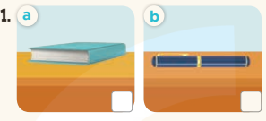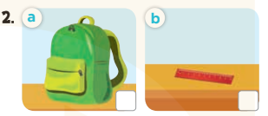  - Ss to guess the answers.  + T writes Ss’guessing on the board.  - Listen to the tape:  + Play the recording  + Play the recording again and get Ss to swap books with their partners.  + Play the recording again to check answers together as a class.  + Write the answers on the board for Ss to correct their answers. Then checks Ss’ guessing.  - Play the recording, sentence by sentence, for the class to listen and repeat in chorus.  Activity 3. Look, complete and read.  *Aim: - To read and complete the four gapped sentences with the help of the picture cues  *Procedure:  -Have pupils look at the pictures. Have them identify the school things in the pictures.  -Have pupils look at the four incomplete sentences. Draw their attention to the missing words in the sentences.  -Model with Picture 1. Have pupils look at the sentence. Ask them what is missing in the answer (pen). Then have them look at the picture and identify the school things. Then have them complete the gap (I have a______)  -Follow the same procedure with Pictures 2, 3 and 4.  -Have Ss work in pairs to complete the sentence 2, 3,4.  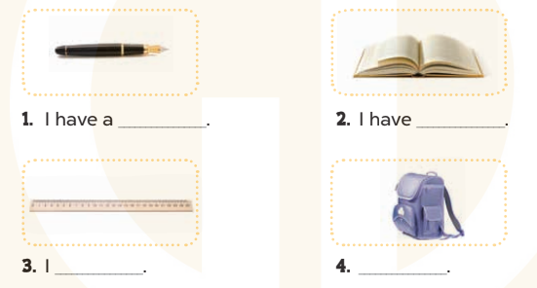  - Call some pairs to check  -T gives feedbacks.  Activity 4. Let’s sing  *Aim: sing the song School things with the correct pronunciation and melody  * Procedure:  - Introduce the title and lyrics of the song: “School things”  - Play the recording for Ss to listen to the whole song.  + Have them repeat the title and lyrics line by line.  - Play the recording all the way through for Ss to listen to pronunciation and melody of the song.  - Play the recording line by line for Ss to listen, repeat  - Play the recording for Ss to sing and do actions.  - Ask Ss to practice singing and doing actions in groups.  - Invite groups to the front of the classroom to perform the song  -T gives feedback.  Activity 5. Consolidation  - Summary the lesson  Homelink:  - Prepare the new lesson | 4. Listen and tick  Key:  1. b 2. a  5. Look, complete and read.  Key: 1. pen  2. a book  3. have a ruler  4. I have a school bag  6. Let’s sing  The song: School things
ADJUSTMENTS (if necessary):
………………………………………………………………………………………….…..…………………………………………………………………………….....
---------------------------------------------------------
Teaching date: /11/2022 – class 3A1, /11/2022 - 3A2

Unit 8: MY SCHOOL THINGS
Lesson 2 – 1,2,3
I. Objectives:
- By the end of the lesson Ps will be able to:
1. Knowledge: By the end of the lesson, pupils will be able to:
- understand and correctly repeat the sentences in two communicative contexts (pictures) focusing on the questions and answers about having a school thing.
- correctly say the words and use Do you have _____? − Yes, I do. / No, I don’t. to ask and answer questions about having a school thing.
- enhance the correct use of Do you have _____? − Yes, I do. / No, I don’t. to ask and answer questions about having a school thing.
- Vocabulary: a, an, pencil case, eraser, notebook

- Sentece pattern: Do you have _____? − Yes, I do. / No, I don’t
2. Skills.
- Listening and speaking.
3. Attitude/ Qualities:
Kindness: help partners to complete learning tasks
Diligence: complete learning tasks
Honesty: tell the truth about feelings and emotions
Responsibility: appreciate kindness
Leadership: collaborate with teachers to enhance language skills
4. Forming competence:
- Listening: listen and recognize the characters, then repeat
- Critical Thinking: self-introduce
- Self-control & independent learning: perform listening tasks
- Communication and collaboration: work in pairs or groups
II. Methods:
- Communicative approach, group Ss and T's activities, play as a character, teaching methods with game, teaching methods by visual, teaching methods by practising, discussion group, technical present....
III. Preparation.
1. Teacher’s preparation: CDs player, book page 36, TV/Projector,…
2. Student’s preparation: books, notebooks,..
IV. Procedures.
Teacher’s and student’s activities | Contents
Activity 1. Warm- up:  Game: pass the ball  - Play ‘pass the ball’ game. Students stand up and  pass the ball with the music played. When music stops, those who keep the ball must say a sentence with the structure I have a ….  Activity 2. Look, listen and repeat:  - Have pupils look at Pictures a and b and identify the characters in the pictures.  - Play the audio twice (sentence by sentence). Correct their pronunciation where necessary.  - Have Ss to practice the dialogue  - T invites some pairs to the front of the class to practice.  - T checks pronunciation for ss.  - T writes the words on the board.  - Checking: Rub out and remember  Activity 3 Listen, point and say.  - T asks Ss look at picture a and helps Ss know the structure from the dialogue.  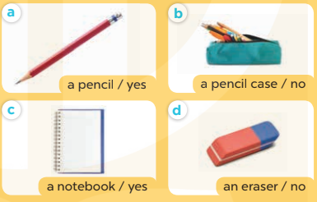  - T introduces new words and structure for Ss.  - T explains, models and gives meaning.  -Have Ss repeat the model sentences.  - Have Ss to practise:  + T asks the first – Ss answer (change role).  + Ss – Ss (change role).  - Ask Ss to work in pairs to ask and answer the question Do you have _____? − Yes, I do. / No, I don’t.  - T controls and corrects.  - Invite a few pairs to come to the front of the classroom, point at the relevant school things in each picture, and act out his/her role.  - Encourage Ss to practice speaking English.  - T gives feedbacks.  Activity 4. Let’s talk.  - Draw pupils’ attention to the pictures. Elicit the context (see Input) and the missing words. Write them on the board. Complete the question and relevant answer. Invite two pupils to take turns to ask and answer with yes. Correct their pronunciation where necessary. Repeat the procedure, but with no answers.  - Put pupils into pairs to do the task. Go around the classroom to offer support where necessary.  - Get Ss to repeat the question and the answer several times in pairs.  - Ask Ss ask and answer about the school things in pairs.  - Invite some groups to perform in front of the class.  - Give feedbacks  Activity 5: Consolidation  - Summary the lesson  Homelink  - Learn the vocabulary and model sentences by heart  - Prepare the new lesson | 1.Look, listen and repeat.  2. Listen, point and say.  A: 1  An: 1  Pencil case  Eraser  notebook  Structure  Do you have a/an_____?  − Yes. I do. /No, I don't.  3. Let’s talk.  Do you have a/an_____?  − Yes. I do. /No, I don't.
ADJUSTMENTS (if necessary):
………………………………………………………………………………………….…..…………………………………………………………………………….....
======================================
Teaching date: /11/2022 – class 3A1, /11/2022 - 3A2

Unit 8: MY SCHOOL THINGS
Lesson 2 – 4,5,6
By the end of the lesson, pupils will be able to:
1. Knowledge:
- listen to and understand four communicative contexts in which pupils ask and answer questions about having a school thing.
- read and match four simple exchanges with the correct pictures
- review vocabulary words for school things and use them in the sentence patterns Do you have _____? and Yes, I do. / No, I don’t. by playing the matching game or Pelmanism.
- Vocabulary: Review
- Sentence pattern: Review
2. Skills: Listening, reading ,writing .
- Critical Thinking: self-introduce
- Co-operation: ready to help friends in pair work/ group work.
- Self-control and independent learning: perform listening tasks.
3. Attitude/ Qualities:
- Kindness: Help partners to complete learning tasks.
- Honesty: tell the truth about feelings and emotions.
- Diligence: complete learning tasks.
4. Forming Competences:
- Co-operation: ready to help friends in pair work/ group work.
- Sociability: Talk to each other, say good words to others.
III. TEACHING AIDS:
- Teacher: Teacher’s guide Pages 105, 106, 107; audio Tracks 83; website sachmem.vn, posters, laptop, pictures, textbook, lesson plan, TV or projector.
- Students: Pupil’s book Page 59, notebooks, workbooks, school things.
IV. Procedures.
Teacher’s and student’s activities | Contents
Activity 1. Warm- up:  * Game: Pass the school things.  Review the previous lesson by having the class pass the school things around while playing the music. When the music stops, those who have school things have to say the sentence: I have a …  Activity 2. Listen and tick:  - Run through 4 pictures and elicit and ask students about school in eachpictures  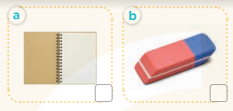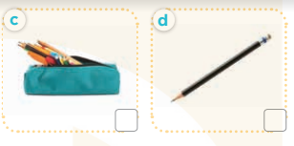  - Ss to guess the answers.  + T writes Ss’guessing on the board.  - Listen to the tape:  + Play the recording  + Play the recording again and get Ss to swap books with their partners.  + Play the recording again to check answers together as a class.  + Write the answers on the board for Ss to correct their answers. Then checks Ss’ guessing.  - Play the recording, sentence by sentence, for the class to listen and repeat in chorus.  Activity 3. Read and match  -Have pupils look at the pictures. Have them identify the school things in the pictures.  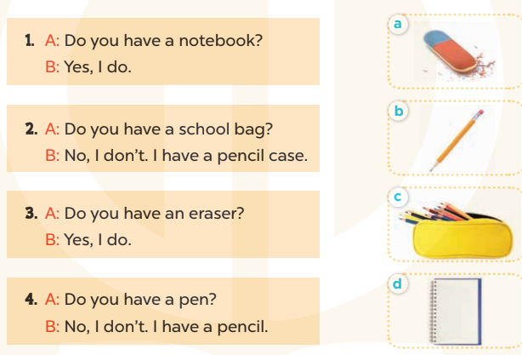  - Have Ss look at the four dialogues and the pictures. Elicit and model with number 1  + Get Ss to read number 1 in chorus. + Ask them what A and B are talking about.  + Write the word notebook on the board.  + Tell Ss to identify the picture of a notebook (Picture d).  + Then match number 1 with Picture d.  -Have Ss work in pairs and match the sentences 2, 3, 4.  - Go around the classroom to offer support where necessary.  - Tell pupils to swap books with a partner, then check answers together as a class. Write the correct answers on the board for pupils to correct their answers.  - Ask a few Ss to stand up and read the sentences aloud.  -T gives feedbacks.  Activity 4. Let’s play  - Explain how to play the game:  + Players take turns to flip over two matching cards.  + A picture matches with the name of the object in the picture.  For example, a picture of a pen matches with the word pen.  + If two cards match, they are left turned face up and the player scores one point.  + If they do not match, they are returned to their face down layout and play passes to the next player.  + Players that successfully match cards get to take another turn and try to match two more cards.  + This continues until that player fails to match a pair.  + The player with the most points is the winner.  - Set a time limit for Ss to play the game in pairs.  - When time runs out, show the cards one by one and invite a few pairs to ask and answer questions using the sentence patterns Do you have ………? And Yes, I do. / No, I don’t.  Activity 5: Consolidation  - Summary the lesson  Homelink  - Prepare the new lesson | 4. Listen and tick  Key: 1. b 2. b  5. Look, complete and read.  Key:  1. swimming  2. singing  3. cooking  4. painting  6. Let’s play  Game: matching game or Pelmanism
ADJUSTMENTS (if necessary):
………………………………………………………………………………………….…..…………………………………………………………………………….....
------------------------------------------------------
Teaching date: /12/2022 – class 3A1, /12/2022 - 3A2
Unit 8: MY SCHOOL THINGS
Lesson 3 – 1,2,3
A. Objectives :
By the end of the lesson, Ss will be able to:
1. Knowledge:
- correctly repeat the sounds of the letter cluster oo and letter a in isolation, in the words book and eraser, and in the sentences I have a book. and Do you have an eraser? with correct pronunciation and intonation.
- identify the target words book and eraser while listening.
- say the chant with the correct rhythm and pronunciation.
- Vocabulary: Review
2. Skills: speaking, listening, reading and writing.
3. Attitude/ Qualities:
- Kindness: Help partners to complete learning tasks.
- Honesty: tell the truth about feelings and emotions
4. Forming Competences:
- Co-operation: ready to help friends in pair work/ group work.
- Sociability: Talk to each other, say good words to others.
III. TEACHING AIDS:
- Teacher: Teacher’s guide Pages 107, 108; audio Tracks 84, 85, 86; website sachmem.vn, posters, laptop, pictures, textbook, lesson plan, TV or projector.
- Students: Pupil’s book Page 60, notebooks, workbooks, school things.
IV. Procedures
Teacher and Students’s activities | Contents
Activity 1.Warm- up:  Spend a few minutes revising the previous lesson by dividing the class into two groups.  - Show a few picture cards of school things, one by one. Each group takes turns to ask and answer questions using the sentence patterns Do you have _____? and Yes, I do. / No, I don’t.  - Get pupils to open their books on page 60 and look at Lesson 3, Activity 1. Tell them what they will learn in this lesson.  Activity 2. Listen and repeat:  - T gives instruction to the letter , words and in the sentences  - Ss recognize the differences about color of letter  - Play the recording for the letter oo , a.  - Encourage Ss to point at the letter/ word/ sentence while listening.  - Play the recording again and encourage Ss to listen and repeat  - Do this several times until Ss feel confident.  - T calls some Ss to practice.  - Ss practice  - T gives feedbacks.  Activity 3. Listen and circle.  - Elicit the sentences and the gap-fill options.  - T ask Ss to guess the answers.  - Ss guess the answers  + T writes Ss’guessing on the board.  - Listen to the tape:  + Play the recording  - Ss listen to the tape and circle  + Play the recording again and get Ss to swap books with their partners.  - Ss listen again, circle and swap books with their partners  + Play the recording again to check answers together as a class.  + Write the answers on the board for Ss to correct their answers. Then checks Ss’ guessing.  - Play the recording, sentence by sentence, for the class to listen and repeat in chorus.  - Invite one or two Ss to stand up and read the completed sentences.  Activity 4. Let’s chant  - Introduce the title and lyrics of the chant.  - Play the recording for Ss to listen to the whole chant.  + Have them repeat the title and lyrics line by line.  - Ss listen and repeat line by line without clap their hands  + Ask Ss to attend to the sounds of the letters oo and a and the words book and eraser.  - Play the recording all the way through for Ss to listen to pronunciation and melody.  - Play the recording line by line for Ss to listen and repeat  - Ss listen and chant line by line.  - Play the recording for Ss to chant and clap along.  - Ask Ss to practice chant and clap along in pairs or groups.  - Ss work in groups (two groups) to chant  - Invite groups to the front of the classroom to perform the chant  -Ss perform in front of the class  -T gives feedback.  Activity 5: Consolidation  - Summary the lesson  Homelink  - Practice the chant more.  - Collect three school things  - Prepare the new lesson | 1. Listen and repeat:  oo- book - I have a book.  a- eraser – Do you have an eraser?  2. Listen and circle.  Key: 1.b 2.c  3. Let’s chant

ADJUSTMENTS (if necessary):
………………………………………………………………………………………….…..…………………………………………………………………………….....
****************************************************
Teaching date: /12/2022 – class 3A1, /12/2022 - 3A2

Unit 8: MY SCHOOL THINGS
Lesson 3 – 4,5,6
A. Objectives:
By the end of the lesson, Ss will be able to:
1. Knowledge:
- read and complete a gapped paragraph with the words provided.
- read, understand and complete the writing frame with Ss’ information.
- collect three school things from home and bring them to the classroom to present to their classmates
- Vocabulary: Review
2. Skills: speaking, listening, reading and writing.
3. Attitude/ Qualities:
- Kindness: Help partners to complete learning tasks.
- Honesty: tell the truth about feelings and emotions.
- Diligence: complete learning tasks.
4. Forming Competences:
- Listening: Listen to the teacher and classmates in communicating.
- Critical Thinking: complete a task in reading a text.
- Co-operation: ready to help friends in pair work/ group work.
- Self-control and independent learning: perform listening tasks.
III. TEACHING AIDS:
- Teacher: Teacher’s guide Pages 109, 110; website sachmem.vn, posters, laptop, pictures, textbook, lesson plan, TV or projector.
- Students: Pupil’s book Page 61, notebooks, workbooks, school things.
IV. Procedures.:
Teacher and Students’s activities | Contents
Activity 1: Warm up  Game: “Chant”  - Ask Ss chant and do the actions in Unit 8, Lesson 3 page 60 in groups.  - Give point for the groups and encourage them.  - Say “Open your book page 61” and look at “Unit 8, Lesson 3 (4, 5, 6)”.  Activity 2. Read and complete:  - Elicit and introduce the paragraph to complete  - Ss look at the pictures and answer  - Elicit the missing word for the first gap (have)  -Ss read and complete the first sentence  - Then tell Ss to pay attention to the article a / an to select appropriate nouns in the box for the next two gaps  - Give Ss time to do the rest individually or in pairs.  - Tell Ss to swap their answers with a partner.  - Check answers as a class. Write the correct answers on the board for Ss to correct their answers.  - Have Ss read the text aloud.  Activity 3. Let’s write  - Write the writing frame on the board.  - Ss look and listen  - Have Ss read the sentences in chorus.  - When you reach the first gap, point to it and tell Ss to complete it with their name.  -Ss write  - Then read the next line and tell them to complete each gap with the school things they have.  - Give Ss time to do the task.  - Invite a few Ss to stand up and read their writing aloud.  Activity 3. Project.  Tell Ss about the activity.  - Check their school things.  - Draw a school thing on the board and write the presentation language under it.  - Ss look and note  - Check comprehension and give feedback.  - Have Ss repeat the sentences until they can say them by themselves.  - Invite a pupil to the front of the class to model the presentation.  -Watch and offer your support with the language.  - Put Ss into groups to rehearse their presentation.  - Invite a few Ss from different groups to show and talk about their school things in front of the class.  - Create a class display of school things and vote for the best presentation.  Activity 5: Consolidation  - Summary the lesson  Homelink  - Prepare the new lesson | 4. Read and complete:  Key: 1. have 2. pen 3. eraser 4. my  5. Let’s write  My name is…….Look at my school things. I have……..  and……….  Key: Pupils’ answer  6. Project
ADJUSTMENTS (if necessary):
………………………………………………………………………………………….…..…………………………………………………………………………….....

