UNIT 7: CLASSROOM INSTRUCTIONS
Period 44 : Lesson 1 (1, 2, 3)
I. OBJECTIVES:
By the end of the lesson, Ss will be able to:
1. Knowledge:
- Use the words open, close, stand up, sit down and please in relation to the topic “Classroom instructions”
- Use …………. please! to give instructions;
- Vocabulary: open, close, stand up, sit down, please
- Skills: speaking and listening
2. Competences:
- Critical Thinking: self-introduce
- Co-operation: ready to help friends in pair work/ group work.
- Sociability: Talk to each other, say good words to others.
3. Attitude/ Qualities:
- Kindness: Help partners to complete learning tasks.
- Honesty: tell the truth about feelings and emotions
II. TEACHING AIDS:
- Teacher: Teacher’s guide Pages 50, website sachmem.vn, laptop, pictures, textbook, lesson plan
- Students: Pupil’s book Page 50, notebooks, workbooks, school things.
III. PROCEDURES:
Teacher’s and Students’ activities | Contents
1. Warm up: Sing: Baby shark  *Aims: to create a friendly and active atmosphere in the class to beginning the lesson.  *Procedure:  - Show the song on the screen.  https://www.youtube.com/watch?v=XqZsoesa55w  - Ask Ss to listen, sing and dance the song.  - Say “Open your book page 50” and look at “Unit 7, Lesson 1 (1,2,3)”.  2. New lesson:  Activity 1  *Aims:  - Ss will be able to understand and correctly repeat the sentences in two communicative contexts (pictures) focusing on classroom instructions.  *Procedure:  - Have Ss look at Pictures a and b and identify names of the speakers in the pictures.  - Look at the pictures and say  + In picture a:  Class says: Good morning, Ms Hoa. Lucy answers: Hello, class. Sit down, please!  + In picture b:  Ms Hoa says: Open your books, please!  - Play the audio twice (sentence by sentence). Correct their pronunciation where necessary.  - Have Ss to practice the dialogue  - T invites a few pairs to the front of the class to practice.  - T checks pronunciation for ss.  Activity 2  *Aims:  - Ss will be able to correctly say the words and use ……. , please! to give instructions.  - Ss will be able to know the vocabulary before starting the new lesson.  *Procedure:  -T elicits the new words  - - T models (3 times).  - - T writes the words on the board.  - Checking: Rub out and remember  - T asks Ss look at picture a and helps Ss know the structure from the dialogue.  - T introduces new structure for Ss.  - T explains, models and gives meaning.  - Have Ss repeat the model sentences.  - Elicit the school thing and the character in each picture.  - Have S point at Picture a, listen to the recording and repeat the phrase  (open your book).  - Follow the same procedure with the other three pictures.  - Point at the bubble and Picture a and have Ss listen and repeat after the recording  (Open your book, please!).  - Have pairs practise saying ______, please! with Pictures b, c and d.  - Invite a few pairs to point at the pictures and give instructions for the class to act out  Activity 3.  *Aims: Ss will be able to enhance the correct use of ………., please! to give instructions  *Procedure:  - Have Ss look at the picture and elicit the question and the answer in context.  - Put Ss work in pairs to give and respond to instructions. Go around the classroom to offer support while they are acting out the instructions.  - Invite some pairs of Ss to the front of the class to act out the instructions.  3. Consolidation  *Aims: Ss will be able consolidate and wrap up the content of the lesson.  *Procedure:  - T asks ss to answer the following questions:  + What have you learnt from the lesson today?  - T review the vocabulary and model sentences.  - T praises some Ss who are hardworking / active/ good…. as well as encourage others to try more.  4. Homewwork:  - Learn the vocabulary and model sentences by heart  - Prepare the new lesson: Unit 7, Lesson 1 (4,5,6). | 1. Look, listen and repeat  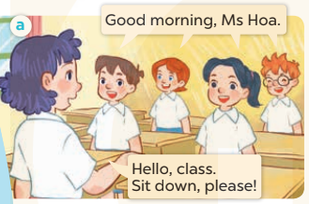  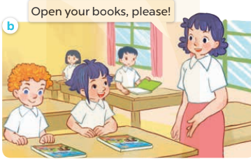  - Listen, point and say.  * New words  + open : mở  + close : đóng  + stand up : đứng lên  + sit down : ngồi xuống  * Model sentences:  Sit down, please!  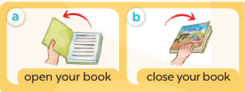  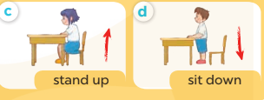  - Let’s talk.  + What can you see in the picture?  + A picture of a classroom in which pupils are asking the teacher for her permission to (open the book / close the book / stand up / sit down)

____________________________________________

UNIT 7: CLASSROOM INSTRUCTIONS
Period 45 : Lesson 1 (4, 5, 6)
I. OBJECTIVES:
By the end of the lesson, Ss will be able to:
1. Knowledge:
- listen to and understand two communicative contexts in which pupils introduce someone and respond to the introduction.
- read and complete the sentences correctly.
- recognise target words while listening and acting out the classroom instructions by playing the game Sit down, please!
- Vocabulary: Review
- Skills: speaking, listening, reading and writing.
2. Competences:
- Critical Thinking: self-introduce
- Co-operation: ready to help friends in pair work/ group work.
- Self-control and independent learning: perform listening tasks.
3. Attitude/ Qualities:
- Kindness: Help partners to complete learning tasks.
- Honesty: tell the truth about feelings and emotions.
- Diligence: complete learning tasks.
II. TEACHING AIDS:
- Teacher: Teacher’s guide Pages 51, website sachmem.vn, laptop, pictures, textbook, lesson plan
- Students: Pupil’s book Page 51, notebooks, workbooks, school things.
III. PROCEDURES:
Teacher’s and Students’ activities | Contents
1. Warm up: Game: Simon says  *Aims: to create a friendly and active atmosphere in the class to beginning the lesson.  *Procedure:  - T is the “Simon” and calls out the actions. Every student must follow and do the action, but only when they hear “Simon says ...”.  - If teacher leaves out “Simon says” before giving instruction, anyone who does the action is out.  - Then, teacher can choose one or more students as the leader to continue a game.  - Say “Open your book page 51” and look at “Unit 7, Lesson 1 (4,5,6)”.  2. New lesson:  Activity 1  *Aims: Ss will be able to listen to and understand two communicative contexts in which Ms Hoa gives pupils two instructions.  *Procedure:  - Elicit the instruction used in each picture.  - Point at the pictures respectively to explain the context.  - T ask Ss to guess the answers.  + T writes Ss’guessing on the board.  - Listen to the tape:  + Play the recording  + Play the recording again and get Ss to swap books with their partners.  + Play the recording again to check answers together as a class.  + Write the answers on the board for Ss to correct their answers. Then checks Ss’ guessing.  - Play the recording, sentence by sentence, for the class to listen and repeat in chorus.  Activity 2  *Aims: Ss will be able to complete the four target sentence patterns with the help of the picture cues.  *Procedure:  - Get Ss to look at the pictures and identify the instruction used in each picture.  - Have Ss look at the four incomplete sentences. Elicit and model with picture 1  + Ask Ss to read the sentence 1 in chorus.  + Ask Ss what word is missing in the gap (Open). Then have them complete the sentence (Open your book, please!).  -Have Ss work in pairs and complete the sentences 2, 3, 4.  - Ask a few Ss to stand up and read the sentences aloud.  -T gives feedbacks.  Activity 3.  *Aims: Ss will be able to recognise target words while listening and acting out the classroom instructions by playing the game Sit down, please!  *Procedure:  - Put Ss into groups of 5 or 6. Choose one pupil from each group as aperson who gives instructions for the rest of the group to act out.  - Model by saying: Stand up, please! Ss respond to this instruction by  standing up.  - Have groups play the game. One pupil in each group gives instructions for his / her group to act out.  + Ss perform the wrong action are out of the game.  - The winning group is the one that has the highest number of members left at the end of the game.  3. Consolidation  *Aims: Ss will be able consolidate and wrap up the content of the lesson.  *Procedure:  - T asks ss to answer the following questions:  + What have you learnt from the lesson today?  - T praises some Ss who are hardworking / active/ good…. as well as encourage others to try more.  4. Homewwork:  - Practice part 5 again.  - Prepare the new lesson: Unit 7, Lesson 2 (1,2,3). | 4. Listen and tick  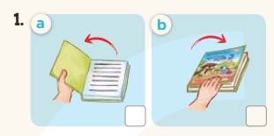  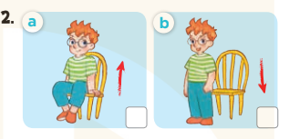  *Key: 1. a 2. a  -  5.Look, complete and read  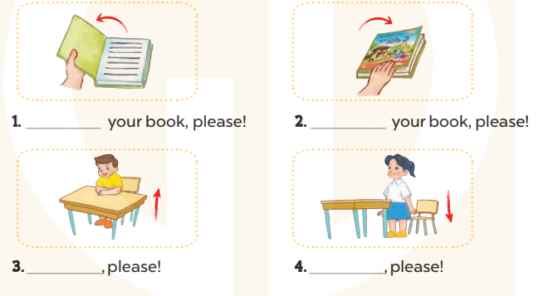  * Key  - Open your book, please!  - Close your book, please!  - Stand up, please!  - Sit down, please!  6.Let’s play  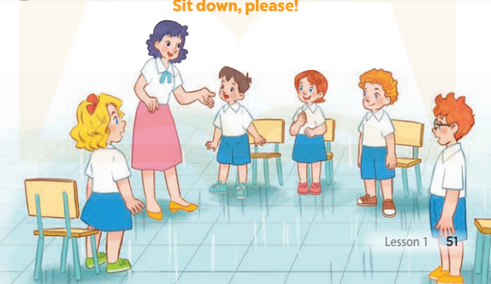

_____________________________________________

Period 46 : UNIT 7: CLASSROOM INSTRUCTIONS.
Lesson 2: Part 1, 2, 3

I. OBJECTIVES:
By the end of the lesson, Ss will be able to:
1. Knowledge:
- Use the words open, close, stand up, sit down, go out, come in, speak, English, Vietnamese and please in relation to the topic “Classroom instructions”.
- Use May I ____? – Yes, you can. / No, you can’t. to ask for and give permission.
- Listen to and demonstrate understanding of communicative contexts in asking for and giving permission.
- Ask for and give permission correctly and confidently.
- Vocabulary: Come in, go out, speak.
- Skills: Speaking and listening
2. Competences:
- Oral Communication: Practice asking for and giving permission.
- Self-control & independent learning: Perform listening & speaking tasks.
- Communication and collaboration: Work in pairs or groups.
- Sociability: Talk to each other, say good words to others.
3. Attitude/ Qualities:
- Diligence: Complete learning tasks.
- Leadership: Collaborate with teachers to enhance language skills.
II. TEACHING AIDS:
- Teacher: Teacher’s guide Pages 93, audio tracks 70, 71, website sachmem.vn,laptop, pictures, textbook, lesson plan, projector.
- Students: Pupil’s book Page 52, notebooks, school things.
III. PROCEDURES:
Teacher’s and Students’ activities | Content
1.Warm- up.  Game: Sit down, stand up.  *Aims: To create a friendly and active atmosphere in the class to beginning the lesson.  *Procedure:  - Ask pupils to give instructions for his / her group to act out.  - Ss listen  - Give points for the groups and encourage them.  - Ss play the game in group.  - Ask Ss open the book Unit 7, Lesson 2 (1,2,3) page 52.  2. New lesson.  Activity 1.  *Aims: Help Ss to find out new words; understand the context of the dialogue and role play the dialogue about greeting and self- introduction.  *Procedure:  - Ask Ss look at pictures a and b and identify the characters in the pictures.  - Ss look at the pictures and say.  - Play the audio twice (sentence by sentence). Correct their pronunciation where necessary.  -Ss listen and repeat in chorus (twice)  - Have Ss to practice the dialogue.  - T invites a few pairs to the front of the class to practice.  -Ss work in pairs to practice  -Ss practice the dialogue.  - T checks pronunciation for Ss.  Activity 2:  *Aims: Ss will be able to correctly say the words and use May I ____ ? and Yes, you can. / No, you can’t. To ask for and give permission.  *Procedure:  - Have Ss look at Pictures a,b,c and d and identify names of the speakers in the pictures.  -Ss look at the picture and answer.  -T elicits the new words.  - T models (3 times).  - Ss listen and repeat.  + Choral repetition (3 times).  + Individual repetition (3 ss).  - T asks Ss look at picture a and helps Ss know the structure from the dialogue.  - T introduces new structure for Ss.  - T explains, models and gives meaning.  - Have Ss repeat the model sentences.  *Drill pictures  - Look at the pictures and get to know the characters in the pictures.  - Elicit and check comprehension the name of each character.  - Run through all the pictures.  - Run through model sentences.  + Run through the self-introduce.  + Run through respond to greetings.  - Have Ss to practise:  + T says the first – Ss respond to greetings (change role).  + Ss – Ss (change role).  - Ask Ss to work in pairs.  - T controls and corrects.  - Invite a few pairs to come to the front of the classroom, point at the relevant character in each picture, and act out his/her role.  - Encourage Ss to practise speaking English.  - T gives feed backs.  Activity 3.  *Aims: Ss will be able to enhance the correct use of “May I....... ? and Yes, you can. / No, you can’t.” to ask for and give permission.  *Procedure:  - Have Ss look at the picture and elicit the question and the answer in context.  +Who are they?  +Where are they?  +What are they doing?  - T fills the gaps and writes the sentences on the board.  - Ss look, listen and repeat.  - T models.  -Ss practice in chorus.  - T asks Ss to greet, self-introduce and respond to greetings (groups of four).  -Ss work in pairs to practice.  - Invite some groups to perform.  -Ss point and say.  - T give feedbacks  -Ss listen.  3.Consolidation.  *Aims: Ss will be able consolidate and wrap up the content of the lesson.  *Procedure:  - T asks ss to answer the following questions:  + What have you learn from the lesson today?  - T review the vocabulary and model sentences.  - T praises some Ss who are hardworking / active/ good…. as well as encourage others to try more.  4. Homewwork.  - Learn the vocabulary and model sentences by heart.  - Prepare the new lesson: Unit 7, Lesson 2 (4,5,6).  - Ss listen and take note. | Game: Sit down, stand up.  Sit down, stand up, open your book, close your book.  1. Look, listen and repeat.  + In picture a: Ben asks: May I open the book? Mr Long says: No, you can’t.  + In picture b: Mai asks: May I go out? Mr Long says: Yes, you can  2. Listen, point and say.  +Picture a: A boy asks Mr Long for his permission to go out.  +Picture b. A boy asks Mr Long for his permission to speak Vietnamese.  +Picture c. A girl asks the teacher for her permission to open her book.  +Picture d. A boy asks Ms Hoa for his permission to sit down.  New words:  + go out : đi ra  + come in : đi vào  + speak :nói  + Vietnamese: tiếng Việt  + English : tiếng Anh  Model sentences:  A: May I go out?  B: Yes, you can.  No, You can’t.  3.Let’s talk.  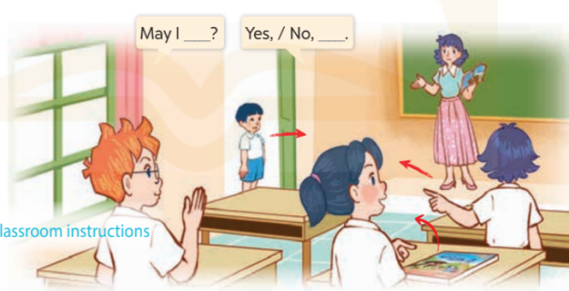  + Ben asks for Ms Hoa’s permission to open his book.  + Linh asks for Ms Hoa’s permission to go out.

*********************************************
Period 47 : UNIT 7: CLASSROOM INSTRUCTIONS.
Lesson 2: Part 4, 5, 6

I. OBJECTIVES:
By the end of the lesson, Ss will be able to:
1. Knowledge:
- Listen to and understand four communicative contexts and number the correct pictures.
- Complete six gaped sentences with the help of picture cues.
- Sing the song May I come in and sit down? with the correct pronunciation, rhythm and melody.
- Vocabulary: Review
- Skills: Speaking, listening, reading and writing.
2. Competences:
- Critical Thinking: Self-introduce
- Co-operation: Ready to help friends in pair work/ group work.
- Self-control and independent learning: Perform listening tasks.
3. Attitude/ Qualities:
- Kindness: Help partners to complete learning tasks.
- Honesty: Tell the truth about feelings and emotions.
- Diligence: Complete learning tasks.
II. TEACHING AIDS:
- Teacher: Teacher’s guide pages 95; audio tracks 72, website sachmem.vn, posters, laptop, pictures, textbook, lesson plan, projector.
- Students: Pupil’s book page 53, notebooks, school things.
III. PROCEDURES:

Teacher’s and Students’ activities | Content
1.Warm- up. Game: Slap the board  *Aims: to create a friendly and active atmosphere in the class to beginning the lesson.  *Procedure:  - Divide class into 2 groups  - How to play:  + Each group chooses five Ss to play.  + Class will read aloud.  + Look at the picture, listen and slap the picture you heard.  + Who faster will get 1 mark.  + Which group with higher mark is the winner.  - Ss listen to teacher.  - Ss play game  - T gives feedback.  - Ask Ss open your book Unit 7, Lesson 2 (4,5,6) page 53.  - New lesson.  Activity 1.  *Aims: Ss will be able to listen to and understand two communicative contexts in which pupils discuss different actions.  *Procedure:  - Elicit the questions to ask for permission used in the pictures.  - Look at the pictures and say.  - Point at the pictures respectively to explain the context.  - T ask Ss to guess the answers.  - Ss guess the answers.  + T writes Ss’ guessing on the board.  - Listen to the tape:  + Play the recording  + Play the recording again and get Ss to swap books with their partners.  + Ss listen to the tape and write number.  + Ss listen again and swap books with their partners.  + Play the recording again to check answers together as a class.  + Write the answers on the board for Ss to correct their answers. Then checks Ss’ guessing.  - Ss check their answers and guessing.  - T give correct answer.  Activity 2.  *Aims: Ss will be able to complete the six target sentence patterns in the dialogues with the help of the picture cues.  *Procedure:  - Get Ss to look at the pictures and identify what the characters in the pictures are asking for.  - Ask Ss look and answer.  - Have Ss look at the four dialogues and the pictures. Elicit and model with picture 1.  + Ask Ss to read the sentence 1 in chorus.  + Ask them what word is missing in the answer (can’t). Then have them complete the answer (No, you can’t.).  - Work individually to do task.  - Have Ss work in pairs and complete the sentences 2, 3, 4.  - Call some pairs go to the board and write down.  - T checks  - Ask a few Ss to stand up and read the sentences aloud.  -T gives feed backs.  Activity 3.  *Aims: Ss will be able to sing the song May I come in and sit down? with the correct pronunciation and melody .  *Procedure:  - Introduce the title and lyrics of the song: “May I come in and sit down? ”  - Ss listen.  - Play the recording for Ss to listen to the whole song.  + Ss listen to the song.  + Have them repeat the title and lyrics line by line.  - Ss listen and repeat line by line without the action.  + Tell Ss to point at the pictures while singing.  + Ss point to the pictures while singing.  - Play the recording all the way through for Ss to listen to pronunciation and melody of the song.  - Play the recording line by line for Ss to listen, repeat and point to the pictures  - Play the recording for Ss to sing and do actions.  - Ss sing and do actions.  - Ask Ss to practice singing and doing actions in pairs or groups.  + Ss work in groups (two groups) to sing.  - Invite groups to the front of the classroom to perform the song  -T gives feedback.  - Consolidation.  *Aims: Ss will be able consolidate and wrap up the content of the lesson.  *Procedure:  - T asks ss to answer the following questions:  + What have you learnt from the lesson today?  - T praises some Ss who are hardworking / active/ good…. as well as encourage others to try more.  - Homework.  - Practice part 5 again.  - Prepare the new lesson: Unit 7, Lesson 3 (1,2,3).  - Ss listen and take note | Game: Slap the board  speak, go out, open, close, sit down, stand up.  4.Listen and number:  a. Minh asks for Ms Hoa’s permission to speak Vietnamese.  b. Nam asks for Ms Hoa’s permission to open a book.  c. Linh asks for Ms Hoa’s permission to leave the classroom.  d. Bill asks for Ms Hoa’s permission to sit down.  Key: 1. b 2. a 3. d 4. c  5.Look, complete and read.  Key: 1. can’t 2. Yes 3. go out; No 4. sit down; can.  6.Let’s sing.  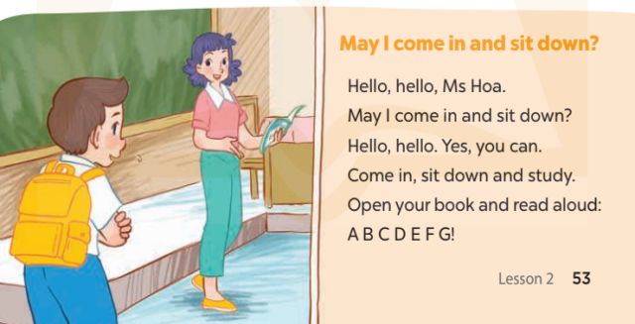

*********************************************
Period 48 : UNIT 7: CLASSROOM INSTRUCTIONS.
Lesson 3: Part 1, 2, 3
I. OBJECTIVES:
By the end of the lesson, Ss will be able to:
- Knowledge:
- Repeat and pronounce the sounds of the consonant clusters sp and st in isolation, in the words speak and stand and in the sentences Speak English, please! and May I stand up? with the correct pronunciation and intonation;
- Identify the target words speak and stand and the sentences Speak English, please! and May I stand up? while listening.
- Vocabulary: Review
- Skills: speaking, listening, reading and writing.
2. Competences:
- Co-operation: ready to help friends in pair work/ group work.
- Sociability: Talk to each other, say good words to others.
3. Attitude/ Qualities:
- Kindness: Help partners to complete learning tasks.
- Honesty: tell the truth about feelings and emotions
II. TEACHING AIDS:
- Teacher: Teacher’s guide pages 97; audio tracks 74, 75, 76; website sachmem.vn, laptop, pictures,lesson plan, projector.
- Students: Pupil’s book page 54, notebooks, school things.
III.PROCEDURES:
Teacher’s and Students’ activities | Content
1.Warm- up. Game: Pass the ball  *Aims: to create a friendly and active atmosphere in the class to beginning the lesson.  *Procedure:  - Divide the class into 3 teams.  - Each team has 1 sticky ball.  - Play the music, Ss in each team take turns to pass the ball.  + After the music ends, 3 Ss have the ball – stand up and say the name, using the sentence model.  - Ss listen to teacher.  - Ss play game  - T gives feedback.  - Ask Ss open your book Unit 7, Lesson 3 (1,2,3)” page 54.  2.New lesson.  Activity 1.  *Aims: Ss will be able to correctly repeat the sounds of the consonant clusters sp and st in isolation, in the words speak and stand and in the sentences Speak English, please! and May I stand up? with the correct pronunciation and intonation.  *Procedure:  - T gives instruction to the letter and in the sentences.  - Ss listen to teacher.  - Play the recording for the letter sp, st.  - Encourage Ss to point at the letter/ word/ sentence while listening.  - Play the recording again and encourage Ss to listen and repeat.  - Ss listen again and repeat.  - Do this several times until Ss feel confident.  - T calls some Ss to practice.  - T gives feed backs.  Activity 2.  *Aims: Ss will be able to identify the target words speak and stand while listening.  *Procedure:  - Elicit the sentences and the gap-fill options.  -Ss listen and say.  - T ask Ss to guess the answers.  - Ss guess the answers. T writes Ss’guessing on the board.  - Listen to the tape:  + Play the recording.  - Ss listen to the tape and tick.  + Play the recording again and get Ss to swap books with their partners.  - Ss listen again, tick and swap books with their partners.  + Play the recording again to check answers together as a class.  - Ss check their answers and guessing.  + Write the answers on the board for Ss to correct their answers. Then checks Ss’ guessing.  - Play the recording, sentence by sentence, for the class to listen and repeat in chorus.  - Invite one or two Ss to stand up and read the completed sentences.  - Ss read the sentences.  -T gives feed backs.  Activity 3.  *Aims: Ss will be able to say the chant with the correct rhythm and pronunciation.  *Procedure:  - Introduce the title and lyrics of the chant.  - Ss look and listen.  - Play the recording for Ss to listen to the whole chant.  + Have them repeat the title and lyrics line by line.  - Ss listen and repeat line by line without clap their hands.  - Play the recording all the way through for Ss to listen to pronunciation and melody.  - Play the recording line by line for Ss to listen and repeat.  - Ss listen and chant line by line.  - Play the recording for Ss to chant and clap along.  - Ss chant and clap along.  - Ask Ss to practice chant and clap along in pairs or groups.  - Ss work in groups (two groups) to chant.  - Invite groups to the front of the classroom to perform the chant.  -Ss perform in front of the class.  -T gives feedback.  3.Consolidation.  *Aims: Ss will be able consolidate and wrap up the content of the lesson.  *Procedure:  - T asks ss to answer the following questions:  + What have you learnt from the lesson today?  - T praises some Ss who are hardworking / active/ good…. as well as encourage others to try more.  4.Homework.  - Practice the chant more.  - Prepare the new lesson: Unit 7, Lesson 3 (4,5,6).  - Ss listen and take note. | Game: Pass the ball  speak, go out, open, close, sit down, stand up.  1.Listen and repeat.  sp and st,  speak and stand,  Speak English, please!  May I stand up?  2.Listen and tick.  + Number 1: …..., please.  + Number 2: May I stand up ……?  Key: 1.b 2.a  3.Let’s chant.  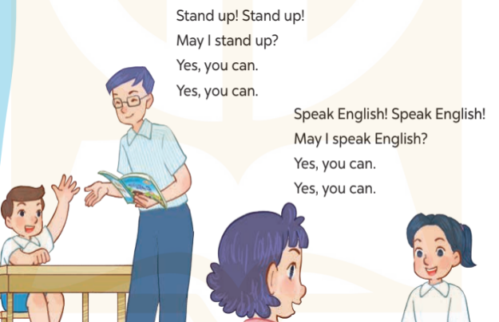

_________________________________________

Period 49 : UNIT 7: CLASSROOM INSTRUCTIONS.
Lesson 3: Part 4, 5, 6

I. OBJECTIVES:
By the end of the lesson, Ss will be able to:
1. Knowledge:
- Read and match two sentences and two dialogues with four pictures.
- Read, understand and complete the incomplete sentences by writing the correct words in the gaps.
- Make classroom instructions, choose one from the box and read it to the classmates to act out.
- Vocabulary: Review
- Skills: Speaking, listening, reading and writing.
2. Competences:
- Critical Thinking: self-introduce
- Co-operation: ready to help friends in pair work/ group work.
- Self-control and independent learning: perform listening tasks.
3. Attitude/ Qualities:
- Kindness: Help partners to complete learning tasks.
- Honesty: tell the truth about feelings and emotions.
- Diligence: complete learning tasks.
II. TEACHING AIDS:
- Teacher: Teacher’s guide pages 98, 99, website sachmem.vn,laptop, pictures, textbook, lesson plan.
- Students: Pupil’s book page 55, notebooks, school things.
III. PROCEDURES:
Teacher’s and Students’ activities | Content
1.Warm- up. Chant  *Aims: To review the vocabulary and structure about greet and respond to greetings.  *Procedure:  - Ask Ss chant and do the actions in groups.  - Give point for the groups and encourage them.  - Ask Ss open the book Unit 7, Lesson 3 (4,5,6) page 55.  2. New lesson.  Activity 1.  *Aims: Ss will be able to read and match two sentences and two dialogues with four pictures.  *Procedure:  - Elicit and introduce four picture cues, two sentences and two dialogues to match.  - Ss look at the pictures and answer.  - Have Ss read the first sentence in chorus  - Model by drawing a line to match it with Picture d and make sure that Ss know how to do the task.  -Ss read the first sentence and match.  - Check the answers as a class.  - t give correct answer.  - Have Ss read the text aloud.  Activity 2:  *Aims: Ss will be able to read, understand and complete the incomplete sentences by writing the correct words in the gaps.  *Procedure:  -Write the first incomplete sentence on the board: 1. Open your.., please!  - Read the incomplete sentence as a class.  + Elicit the word Ss have to write in the first gap and encourage them to say it.  - Give Ss time to write down the answer 2, 3, 4.  - Invite Ss to go to the board and write down their answers .  - T gives feed backs.  Activity 3.  *Aims: Ss will be able to make classroom instructions, choose one from the box and read it to the classmates to act out.  *Procedure:  - Put Ss into groups or ask the whole class to work together.  - Tell Ss to write instructions on their sheets of paper, then fold and put them in a box (each pupil writes just one instruction).  - Ss write instructions.  - Get each Ss to choose one instruction in the box then read it to the group/ whole class to act out.  -Ss choose instruction and read it.  - Give Ss enough time to complete each step.  -Ss do the task.  - Create a class display using the pictures and vote for the most creative.  -Ss vote for the most creative.  3.Consolidation.  *Aims: Ss will be able consolidate and wrap up the content of the lesson.  *Procedure:  - T asks ss to answer the following questions:  + What have you learn from the lesson today?  - T review the vocabulary and model sentences.  - T praises some Ss who are hardworking / active/ good…. as well as encourage others to try more.  4. Homewwork.  - Prepare the new lesson: Unit 8, Lesson 1 (1, 2, 3).  - Ss listen and take note. | 4. Read and match.  Key: 1. d 2. c 3. a 4. b  5. Let’s write.  Key: 1. book(s) 2. Stand  3. come; Yes 4. speak; can’t  6. Project.  + Example: Stand up / Sit down, please!  Close / Open your book(s), please!  Go to the board, please! Go there / Come here, please!  Tell me / Spell your name, please!

