Week13:
Teaching date: 4A: / /2023; 4B: / /2023
Unit 8: My favourite subjects
Period 50: Lesson 1 (1, 2, 3)
I. OBJECTIVES:
By the end of the lesson, Ss will be able to:
1. Knowledge:
- use the words and phrases Art, music, PE, IT in relation to the topic “My favourite subjects”.
- use What’s your favourite subject? – It’s …..to ask and answer questions about someone’s favourite subject;
- listen to and demonstrate understanding of simple communicative contexts in relation to the topic “My favourite subjects”.
- Vocabulary: Art, music, PE, IT
- Skills: speaking and listening
2. Competences:
- Self-control and independent learning: perform listening tasks.
- Communication and collaboration: work in pairs or groups.
- Sociability: talk to each other, say good words to others.
3. Attitude/ Qualities:
- Show pride in what they can do and great respect for other people’s abilities by using appropriate gesture and intonation when asking and answering about abilities.
II. TEACHING AIDS:
- Teacher: Teacher’s guide Pages 112, 113, audio Tracks 77, 78, website hoclieu.vn, posters, laptop, pictures, textbook, lesson plan, TV or projector.
- Students: Pupil’s book Page 56, notebooks, workbooks, school things.
III. PROCEDURES:
Teacher’s activities and students’ activities | Contents
Warm- up:  Game: Who says faster  - Hold some flashcards about subjects, then reveal it slowly.  - Ask What is it?  - Ask the Ss guess the answer as fast as possible.  - Then have Ss do the same with the rest.  - This can be played in groups to make it more interesting  - Say “Open your book page 56” and look at “Unit 8, Lesson 1 (1,2,3)”. Sts open the book.  Activity 1. Look, listen and repeat:  - Have Ss look at Pictures a and b and identify the characters (Linh and Ben) in the pictures  - Play the audio twice (sentence by sentence). Correct their pronunciation where necessary.  -T elicits and ask sts to give the new words  - T models (3 times).  - T writes the words on the board.  - Checking: Rub out and remember  - Have Ss to practice the dialogue  - T invites a few pairs to the front of the class to practice  - T checks pronunciation for ss.  Activity 2 . Listen, point and say.  - Run through 4 pictures to teach vocabularies  T elicits the new words  - T models (3 times).  -Ss listen and repeat in chorus ( 3 times)  + Individual repetition (3 ss)  - T writes the words on the board.  - Checking: Slap the board  - Ss take note  - T asks Ss look at picture a and helps Ss know the structure from the dialogue.  - T introduces new structure for Ss.  - T explains, models and gives meaning.  -Have Ss repeat the model sentences.  - Have Ss look at the pictures and elicit the subjects.  - Run through all the pictures.  - Run through model sentences.  - Have Ss to practise:  +Tell Ss to point the subjects in the picture when they are repeating the sentence  - T controls and corrects.  - Invite a few pupils to stand up, point the picture and say the sentence aloud.  - T gives feedbacks.  Activity 3. Let’s talk.  - Draw pupils’ attention to the two speech bubbles.  - Ask them to look at the girl’s speech bubble to identify what the answer should be. ex: It’s IT.  - Get pupils to repeat the question and answer several times.  - Have pupils to work in pairs, point at the different books, ask and answer questions about their favourite subjects using What’s your favourite subject? – …..  - Invite some pairs to take turns asking and answering questions about their favourite subjects in front of the class.  *Consolidation  - T asks ss to answer the following questions:  + What have you learnt from the lesson today?  +What are the core values of the lesson? (if the teacher can take from the lesson).  - T review the vocabulary and model sentences.  - T praises some Ss who are hardworking / active/ good…. as well as encourage others to try more.  Homework.  - Learn the vocabulary and model sentences by heart  - Prepare the new lesson: Unit 8, Lesson 1 (4,5,6). | 1.Look,listen and repeat  + favourite subject : môn học ưu thích (situation)  + PE= Physical Education: môn thể dục  (realia)  + English: môn Tiếng Anh ( realia)  +Science: Môn khoa học ( visual)  + Maths: Môn Toán ( realia)  2. Listen, point and say.  Art: môn Mĩ Thuật  Music: Môn Âm nhạc  IT: Môn Tin học  1: What’s your favourite subject? 2: It’s Art  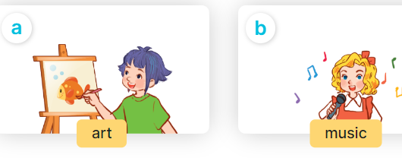  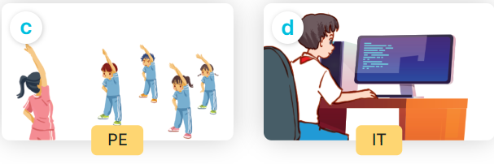  3. Let’s talk 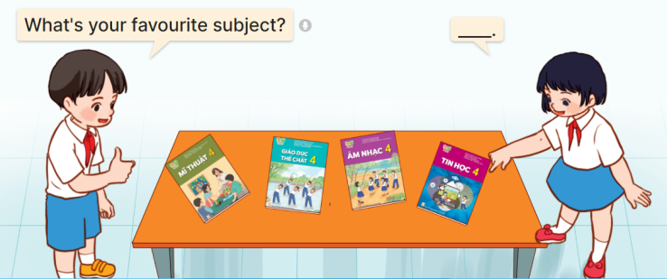
IV. ADJUSTMENTS (if necessary):
………………………………………………………………………………………….…..……………………………………………………………………………...…

------------------------------------
Teaching date: 4A: / /2023; 4B: / /2023
Unit 8: My favourite subjects
Period 51: Lesson 1 (4, 5, 6)
I. OBJECTIVES:
By the end of the lesson, Ss will be able to:
1. Knowledge:
- use the words and phrases Art, music, PE, IT in relation to the topic “My favourite subjects”.
– use What’s your favourite subject? – It’s ……... to ask and answer questions about someone’s favourite subject.
– listen to and demonstrate understanding of simple communicative contexts in relation to the topic “My favourite subjects”.
– read and write about someone’s favourite subject.
- Vocabulary: Review
- Skills: speaking, listening, reading and writing.
2. Competences:
- Written Communication: complete the sentences.
- Self-control and independent learning: perform listening tasks.
- Communication and collaboration: work in pairs or groups.
3. Attitude/ Qualities:
- Kindness: Help partners to complete learning tasks.
- Diligence: complete learning tasks.
II. TEACHING AIDS:
- Teacher: Teacher’s guide Pages 114, 115,116; audio Tracks 83; website hoclieu.vn, posters, laptop, pictures, textbook, lesson plan, TV or projector.
- Students: Pupil’s book Page 57, notebooks, workbooks, school things.
III. PROCEDURES:
Teacher’s activities and students’ activities | Contents
Warm- up: Guessing pictures  - Divide the class into 2 teams  - Give instructions of this game  - Make model, monitor and check  - Find the winner and congratulate  Sts play game in teams  - Say “Open your book page 57” and look at “Unit 8, Lesson 1 (4,5,6)”. Sts listen an open the book.  Activity 1. Listen and tick or cross:  - Elicit the subjects in each picture.  Sts look at the pictures and say:  + Picture 1: An IT textbook  + Picture 2: A PE textbook  + Picture 3: A music textbook  + Picture 4: . An art textbook  - T ask Ss to guess the answers.  + T writes Ss’guessing on the board.  - Listen to the tape:  + Play the recording  + Play the recording again and get Ss to swap books with their partners  - Ss listen to the tape and tick/ cross  + Play the recording again to check answers together as a class.  Ss listen again, tick/ cross and swap books with their partners.  + Write the answers on the board for Ss to correct their answers. Then checks Ss’ guessing.  - Play the recording, sentence by sentence, for the class to listen and repeat in chorus.  Activity 2. Look, complete and read  - Ask pupils to look at the pictures and identify the subjects.  - Have Ss look at the four incomplete sentences. Elicit and model with picture 1  + Ask Ss to read the sentence 1 in chorus.  + Ask Ss what word is missing in the gap (music). Then have them complete the sentence (It’s music).  -Have Ss work in pairs and complete the sentences 2, 3, 4.  - Ask a few Ss to stand up and read the sentences aloud.  -T gives feedbacks.  Activity 3. Let’s sing  - Have pupils read the song to familiarize themselves with the lyrics  - Play the recording for Ss to listen to the whole song.  + Have them repeat the title and lyrics line by line.  + Tell Ss to point at the pictures while singing.  - Play the recording all the way through for Ss to listen to pronunciation and melody of the song.  - Play the recording line by line for Ss to listen, repeat and point to the pictures  - Play the recording for Ss to sing and do actions.  - Ask Ss to practice singing and doing actions in pairs or groups.  - Invite groups to the front of the classroom to perform the song  -T gives feedback.  *Consolidation  - T asks ss to answer the following questions:  + What have you learnt from the lesson today?  +What are the core values of the lesson? (if the teacher can take from the lesson).  - T praises some Ss who are hardworking / active/ good…. as well as encourage others to try more.  Homework  - Practice part 5 again.  - Prepare the new lesson: Unit 8, Lesson 2 (1,2,3).Sts listen and take note | 4. Listen and tick or cross: 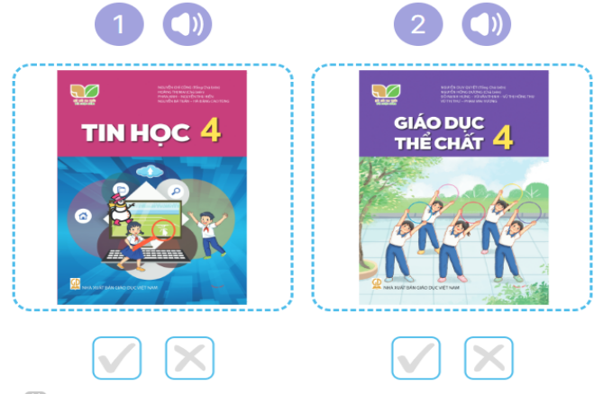  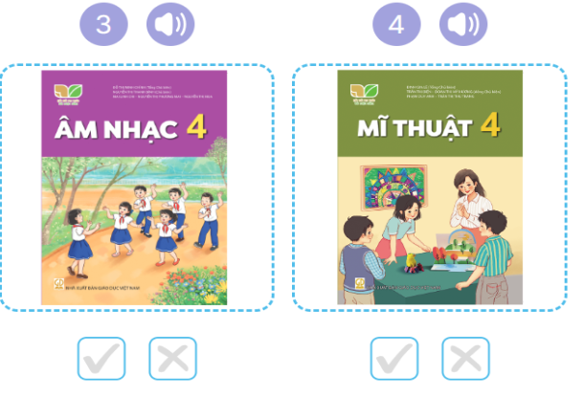  Key: 1. v 2. x 3.v 4.x  5. Look, complete and read  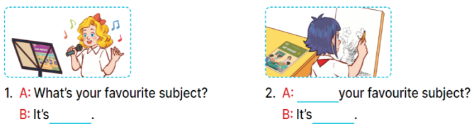  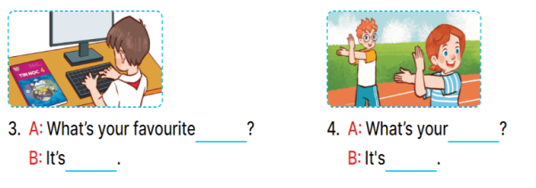  Key:  1. music  2. What’s; Art  3. subject; IT  4. favourite subject; PE  6. Let’s sing  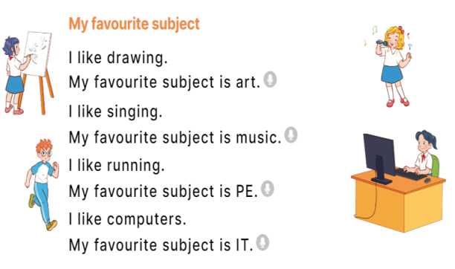
IV. ADJUSTMENTS (if necessary):
………………………………………………………………………………………….…..……………………………………………………………………………...…

Teaching date: 4A: / /2023; 4B: / /2023
Unit 8: My favourite subjects
Period 52: Lesson 2 (1, 2, 3)
I. OBJECTIVES:
By the end of the lesson, Ss will be able to:
1. Knowledge:
- – use the words and phrases art, music, PE, IT, an English teacher, a Maths teacher, a painter and a singer in relation to the topic “My favourite subjects”.
– use Why do you like ……..? – Because I want to be ……... to ask for and give reasons for liking a school subject.
– listen to and demonstrate understanding of simple communicative contexts in relation to the topic “My favourite subjects”.
- Vocabulary: English teacher, Maths teacher, painter
- Skills: speaking and listening
2. Competences:
- Critical Thinking: self-introduce
- Co-operation: ready to help friends in pair work/ group work.
- Sociability: Talk to each other, say good words to others.
3. Attitude/ Qualities:
- Kindness: Help partners to complete learning tasks.
- Honesty: tell the truth about feelings and emotions
II. TEACHING AIDS:
- Teacher: Teacher’s guide Pages 116, 117, 118, audio Tracks 81, 82, website hoclieu.vn, posters, laptop, pictures, textbook, lesson plan, TV or projector.
- Students: Pupil’s book Page 58, notebooks, workbooks, school things.
III. PROCEDURES:
Teacher’s activities and students’ activities | Contents
Warm- up:  Pass the subjects  - Review the previous lesson by having the class pass the school things with the music.  - When the music stops, who have subjects have to say the sentence: I like music.  - Ss play game  Say “Open your book page 52” and look at “Unit 8, Lesson 2 (1, 2, 3)”.  -Ss open their books  Activity 1 Look, listen and repeat:  - Have Ss look at Pictures a and b and identify the characters and the reason why Nam likes English.  -Look at the pictures and say  + In picture a:  Mary: What’s your favourite subject, Nam?  Nam: It’s English  + In picture b:  Mary: Why do you like English?  Nam: Because I want to be an English teacher.  - Play the audio twice (sentence by sentence). Correct their pronunciation where necessary.  T elicits and ask sts to give the new words  - T models (3 times).  - T writes the words on the board.  - Checking: Rub out and remember  - Ss listen and repeat  + Choral repetition (3 times).  + Individual repetition (3 ss)  - Ss take note  - Ss look, remember and write  - Have Ss to practice the dialogue  - T invites a few pairs to the front of the class to practice.  - T checks pronunciation for ss.  Activity 3 Listen, point and say.  Vocabs: Teach vocabularies using pictures.  Sts listen, repeat( choral, individual repetition)  - Check vocabs: Slap the board.  - T asks Ss look at picture b and helps Ss know the structure from the dialogue.  - T introduces new structure for Ss.  - T explains, models and gives meaning.  -Have Ss repeat the model sentences.  *Drill pictures  - Have Ss look at the pictures and elicit the reason why each pupil likes his / her favourite subject.  - Run through all the pictures.  - Run through model sentences.  +Run through question sentence  +Run through answer sentence  - Have Ss to practise:  + T asks, Ss answer picture a  + Ss asks, T answers picture b  + Group A ask, group B answer picture c  + Group B ask, group A answer picture d  - Ask Ss to work in pairs.  - T controls and corrects.  - Invite a few pairs to come to the front of the classroom and point at the pictures and say the questions and answers in front of the class.  - T gives feedbacks.  Activity 4. Let’s talk  - Have pupils look at the picture and explain that a group of four pupils are in the playground  - Ask pupils to look at the first girl with black hair with the art textbook and ask pupils to identify her favourite subject (Art) and what she want to be in the future (painter).  - Divide the class into two groups to role-play the girls/ boys and an interviewer.  - Have pupils work in pairs to practise asking and answering the question  Why do you like……? – ……...  - Invite pairs of pupils to the front of the classroom to take turns asking for and giving reasons why they like the subject.  *Consolidation  - T asks ss to answer the following questions:  + What have you learnt from the lesson today?  +What are the core values of the lesson? (if the teacher can take from the lesson).  - T review the vocabulary and model sentences.  - T praises some Ss who are hardworking / active/ good…. as well as encourage others to try more.  Homework  - Learn the vocabulary and model sentences by heart  - Prepare the new lesson: Unit 8, Lesson 2 (4,5,6). | 1 . Look, listen and repeat:  -  Why? Tại sao (situation)  Because: bởi vì ( situation)  want to be: muốn là.. ( translation)  an English teacher: giáo viên Tiếng Anh( visual)  2. Listen, point and say.  a singer: ca sĩ  a painter: họa sĩ  a Maths teacher: giáo viên Toán  1: Why do you like English.?  2. Because I want to be an English teacher  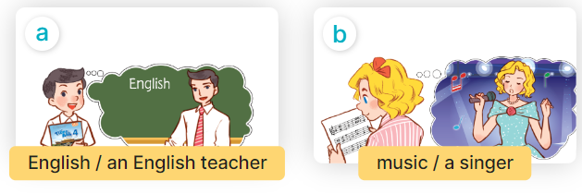  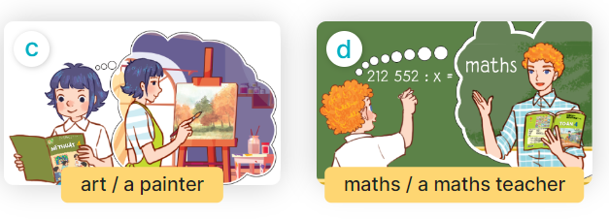  3. Let’s talk.  Why do you like____?  _________.
IV. ADJUSTMENTS (if necessary):
………………………………………………………………………………………….…..……………………………………………………………………………...
========================

Week 14
Teaching date: 4A: / /2023; 4B: / /2023
Unit 8: My favourite subjects
Period 53: Lesson 2: 4,5,6
I. OBJECTIVES:
By the end of the lesson, Ss will be able to:
1. Knowledge:
- use the words and phrases art, music, PE, IT, an English teacher, a Maths teacher, a painter and a singer in relation to the topic “My favourite subjects”.
– listen to and demonstrate understanding of simple communicative contexts in relation to the topic “My favourite subjects”.
- Vocabulary: Review
- Skills: speaking, listening, reading and writing.
2. Competences:
- Critical Thinking: self-introduce
- Co-operation: ready to help friends in pair work/ group work.
- Self-control and independent learning: perform listening tasks.
3. Attitude/ Qualities:
- Kindness: Help partners to complete learning tasks.
- Diligence: complete learning tasks.
II. TEACHING AIDS:
- Teacher: Teacher’s guide Pages 119, 120, 121; audio Tracks 83; website hoclieu.vn, posters, laptop, pictures, textbook, lesson plan, TV or projector.
- Students: Pupil’s book Page 59, notebooks, workbooks, school things.
III. PROCEDURES:
Teacher’s activities and students’ activities | Contents
Warm- up: (5’)  Game: Pass the ball  - T gives Ss a ball.  - T asks Ss to listen to music and transfer a ball around the class.  - When the music stops, Ss who keep a ball have to answer the question using: Why do you like……? and Because I……  - T gives feedback.  - Say “Open your book page 59” and look at “Unit 8, Lesson 2 (4,5,6)”.  Activity 1. Listen and number:  - Elicit the favourite subject and the reason for liking it.  Sts look at the pictures and say:  + Picture a: A male singer singing  + Picture b: A female painter working  + Picture c: An English teacher writing  + Picture d: A maths teacher writing  - T ask Ss to guess the answers.  + T writes Ss’guessing on the board.  - Listen to the tape:  + Play the recording  + Play the recording again and get Ss to swap books with their partners.  + Play the recording again to check answers together as a class.  + Write the answers on the board for Ss to correct their answers. Then checks Ss’ guessing.  - Play the recording, sentence by sentence, for the class to listen and repeat in chorus.  Activity 2. Look, complete and read  - Get Ss to look at the pictures and ask them what the girl and the boy are doing  - Model and elicit the missing words from the Exchange 1 (Why, painter).  -Have pupils to do the task individually.  - Get pupils swap books with their partners and check the answers before checking as a class.  - Invite a few pairs to stand up and read the sentences aloud.  Activity 3. Let’s play  Sentence making  - Tell pupils the goal of the game and how to play it.  - How to play the game:  + When the teacher circles or says one of the words on the board, the groups make as many sentence as possible.  + The group that gives the correct sentences more quickly gets one point or one star for one correct sentence.  + The group with more points or stars is the winner.  - Divide the class into groups of three or four pupils to play.  Sts play in groups  *Consolidation  - T asks ss to answer the following questions  + What have you learnt from the lesson today?  +What are the core values of the lesson? (if the teacher can take from the lesson).  - T praises some Ss who are hardworking / active/ good…. as well as encourage others to try more  Homework.  - Practice part 5 again.  - Prepare the new lesson: Unit 8, Lesson 3 (1,2,3).: | 4.Listen and number  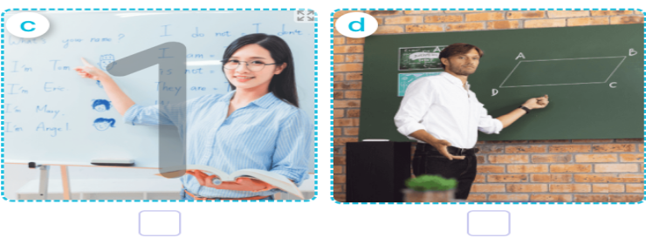    Key: 1. b 2. d 3. a 4. c  5. Look, complete and read 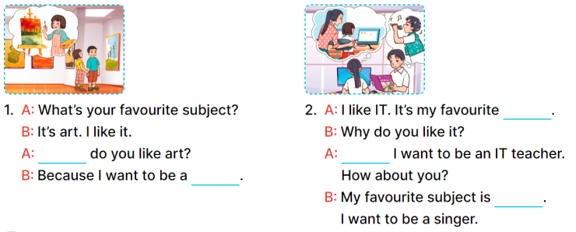  Key:  - Why/ painter  - Subject; because; music  6. Let’s play  Sentence making  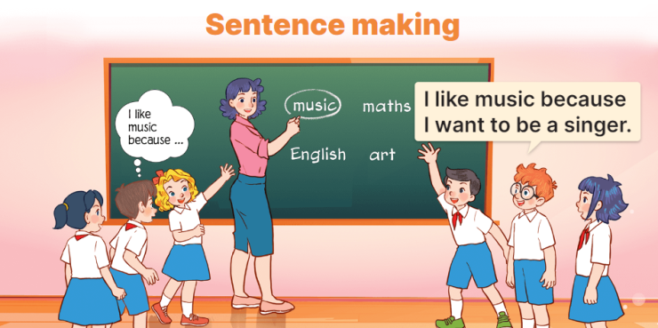

IV. ADJUSTMENTS (if necessary):
………………………………………………………………………………………….…..……………………………………………………………………………...…

--------------------------------------------------
Teaching date: 4A: / /2023; 4B: / /2023
Unit 8: My favourite subjects
Period 54 :Lesson 3 (1, 2, 3)
I. OBJECTIVES:
By the end of the lesson, Ss will be able to:
1. Knowledge:
- correctly pronounce the sounds of the letters ke and te in isolation, in the words like and write, and in the sentences I like English. and Let's write.
– use the words and phrases art, music, PE, IT, an English teacher, a maths teacher, a painter and a singer in relation to the topic “My favourite subjects”
– use Why do you like …….? – Because I want to be …….. to ask for and give reasons for liking a school subject
– listen to and demonstrate understanding of simple communicative contexts in relation to the topic “My favourite subjects”
- Vocabulary: Review
- Skills: speaking, listening, reading and writing.
2. Competences:
- Co-operation: ready to help friends in pair work/ group work.
- Sociability: Talk to each other, say good words to others.
3. Attitude/ Qualities:
- Kindness: Help partners to complete learning tasks.
- Honesty: tell the truth about feelings and emotions
II. TEACHING AIDS:
- Teacher: Teacher’s guide Pages 121,122; audio Tracks 84, 85, 86; website hoclieu.vn, posters, laptop, pictures, textbook, lesson plan, TV or projector.
- Students: Pupil’s book Page 60, notebooks, workbooks, school things.
III. PROCEDURES:
Teacher’s activities and students’ activities | Contents
1.Warm- up: (5’)  Game: Find and circle the words  L I K E E W S C M T  H C T H N R H C A H  C L U A A I A O K I  L E L N N T T S E N  A A W K E E O E E K  A C D E G H O S V B  F A V O U R I T E H  B I K E I A S D A Y  D T S S R S N O T E  A C E B F E Z Y W  - Divide class into 2 groups  - Ask Ss to find and circle the words that they learnt.  - Which groups find the best correct words is winner.  - Give Ss time to play the game.  Rows: like, bike, note, favourite  Columns: write, make  -T checks who’s winner?  - Say “Open your book page 60” and look at “Unit 8, Lesson 3 (1,2,3)”.  Activity 1. Listen and repeat:  - T gives instruction to the letter ke and te, like and write, and in the sentences I like English. and Let’s write.  - Play the recording for the letter ke, te.  - Encourage Ss to point at the letter/ word/ sentence while listening.  - Play the recording again and encourage Ss to listen and repeat.  - Do this several times until Ss feel confident.  - T calls some Ss to practice.  - T gives feedbacks.  Activity 2. Listen and circle.  - Elicit the sentences and the gap-fill options.  - T ask Ss to guess the answers.  + T writes Ss’guessing on the board.  - Listen to the tape:  + Play the recording  + Play the recording again and get Ss to swap books with their partners.  + Play the recording again to check answers together as a class.  + Write the answers on the board for Ss to correct their answers. Then checks Ss’ guessing.  - Play the recording, sentence by sentence, for the class to listen and repeat in chorus.  - Invite one or two Ss to stand up and read the completed sentences.  Activity 3. Let’s chant  - Introduce the title and lyrics of the chant.  - Play the recording for Ss to listen to the whole chant.  + Have them repeat the title and lyrics line by line.  + Ask Ss to attend to the sounds of the letters ke and te and the words like and write.  - Play the recording all the way through for Ss to listen to pronunciation and melody.  - Play the recording line by line for Ss to listen and repeat  - Play the recording for Ss to chant and clap along.  - Ask Ss to practice chant and clap along in pairs or groups.  - Invite groups to the front of the classroom to perform the chant  -T gives feedback.  *Consolidation  - T asks ss to answer the following questions:  + What have you learnt from the lesson today?  +What are the core values of the lesson? (if the teacher can take from the lesson).  - T praises some Ss who are hardworking / active/ good…. as well as encourage others to try more.  Homework.  - Practice the chant more.  - Collect three school things  - Prepare the new lesson: Unit 8, Lesson 3 (4, 5, 6). Sts listen and remember | - Listen and repeat:  ke like I like English  te write Let’s write  2.Listen and circle  Key: 1.a 2.b  3.Let’s chants  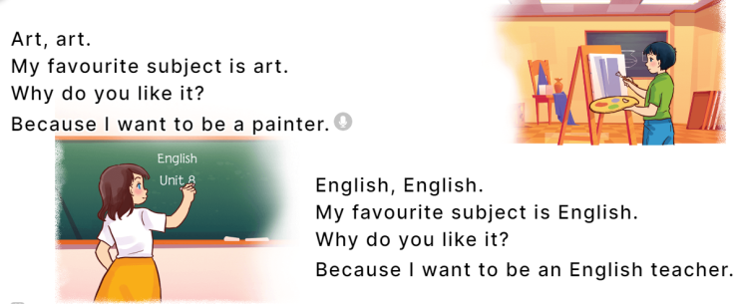
IV. ADJUSTMENTS (if necessary):
………………………………………………………………………………………….…..……………………………………………………………………………...…
=============================

Teaching date: 4A: / /2023; 4B: / /2023
Unit 8: My favourite subjects
Period 55: Lesson 3 (4, 5, 6)
I. OBJECTIVES:
By the end of the lesson, Ss will be able to:
1. Knowledge:
- read and write about someone’s favourite subject.
- do a survey on their classmates’ favourite subjects and the reasons why they like these subjects and present it to their classmates at Project time.
- Vocabulary: Review
- Skills: speaking, listening, reading and writing.
2. Competences:
- Critical Thinking: complete a task in reading a text.
- Co-operation: ready to help friends in pair work/ group work.
- Self-control and independent learning: perform listening tasks.
3. Attitude/ Qualities:
- Kindness: Help partners to complete learning tasks.
- Diligence: complete learning tasks.
II. TEACHING AIDS:
- Teacher: Teacher’s guide Pages 123, 124, 125; website hoclieu.vn, posters, laptop, pictures, textbook, lesson plan, TV or projector.
- Students: Pupil’s book Page 61, notebooks, workbooks, school things.
III. PROCEDURES:
Teacher’s activities and students activities | Contents
Warm- up:  Game: “Chant”  - Ask Ss chant and do the actions in Unit 8, Lesson 3 page 60 in groups.  - Give point for the groups and encourage them.  - Say “Open your book page 61” and look at “Unit 8, Lesson 3 (4, 5, 6)”.  Activity 1. Read and tick True or False  - Have pupils read all the sentences under the paragraph.  - Have pupil read Sentence 1 and pay attention to the keywords name and Peter, then scan the paragraph for the information.  + If it is the same, they should put a tick in the True box.  + If the information is not the same, they should put a tick in the False box.  -Ask pupils to do the activity independently.  - Get pupils to swap books with their partners and check their answers before checking as a class.  - Invite some pupils to stand up and read the paragraph aloud.  Activity 2. Let’s write  - Tell pupils what they are going to do.  - Then get them to read the incomplete paragraph.  - Elicit what the paragraph is about (someone’s favourite subject and the reason why he / she likes it).  - Get pupils to fill the first gap with their name as an example.  -Have pupils to complete the paragraph independently.  - Get pupils to swap books with their partners and check the answers in pairs or groups.  - Have a few pupils to stand up and read their writing aloud.  - Invite a few pupils to read their completed texts in front of the class.  Activity 3. Project.  - Tell Ss about the activity.  - Get pupils to work in groups to show their surveys on their classmates’ favourite subjects and the reasons why they like these subjects which they have prepared at home as homework.  - Invite a pupil to the front of the class to model the presentation.  - Have the pupils repeat the language a few times to help them feel confident when they present.  - Have pupils to present the project in their groups.  - Invite a few pupils to the front of the class to present their projects.  *Consolidation  - T asks ss to answer the following questions:  + What have you learnt from the lesson today?  +What are the core values of the lesson? (if the teacher can take from the lesson).  - T praises some Ss who are hardworking / active/ good…. as well as encourage others to try more.  Homework  - Prepare the new lesson: Unit 9, Lesson 1 (1, 2, 3).  Sts listen and remember | 4.Read and tick True or False  Key:  1. True  2. False  3. True  4. False  5. Let’s write  Key: Pupils’ answer  Ex: My name is Huong. I have English, Art and Maths today. My favorite subject is English. I like it because I want to be an English teacher. What is your favorite subject?  6.Project.  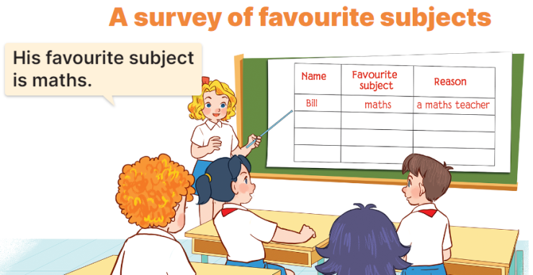  Ex: Look at Bill. His favourite subject is Maths. He likes it because he wants to be a Maths teacher.
IV. ADJUSTMENTS (if necessary):
………………………………………………………………………………………….…..……………………………………………………………………………...

