Week 11 Preparing date: November ….., 2023
Period 44 Teaching date: November ….., 2023

Unit 7: Our timetables
Lesson 1 (1, 2, 3)
I. Objectives:
By the end of the lesson, Ss will be able to:
1. Knowledge:
- use the words English, maths, science, Vietnamese in relation to the topic “Our timetable”
- use What subjects do you have today? – I have ……. to ask and answer questions about school subjects
- Vocabulary: English, maths, science, Vietnamese, subject
2. Skills: speaking, listening, reading and writing.
3. Competences:
- Self-control and independent learning: perform listening tasks.
- Communication and collaboration: work in pairs or groups.
4. Attitude/ Qualities:
- Kindness: Help partners to complete learning tasks.
- Honesty: tell the truth about feelings and emotions
II. Methods: Communicative approach, group Ss and T's activities, play as a character, teaching methods with game, teaching methods by visual, teaching methods by practising, discussion group, technical present....
III. Teaching aids:
- Teacher: Teacher’s guide Pages 100, 101, audio Tracks 67, 68, website hoclieu.vn, posters, laptop, pictures, textbook, lesson plan, TV or projector.
- Students: Pupil’s book Page 50, notebooks, workbooks, school things.
IV. Procedures:
Teacher’s and Students’ activities | Contents
Activity 1.Warm- up: (3’)  Sing: Baby shark  - Show the song on the screen.  https://www.youtube.com/watch?v=XqZsoesa55w  - Ask Ss to listen, sing and dance the song.  - Ss sing and dance the song  - Say “Open your book page 50” and look at “Unit 7, Lesson 1 (1,2,3)”.  Activity 2. Look, listen and repeat:  - Have Ss look at Pictures a and b and identify names of the speakers in the pictures.  - Play the audio twice (sentence by sentence). Correct their pronunciation where necessary.  - Have Ss to practice the dialogue  - T invites a few pairs to the front of the class to practice.  - T checks pronunciation for ss.  Activity 3 Listen, point and say.  T elicits the new words  - T models (3 times).  - - Ss listen and repeat  + Choral repetition (3 times).  + Individual repetition (3 ss)  - T writes the words on the board.  - Checking: Rub out and remember  - T asks Ss look at picture b and helps Ss know the structure from the dialogue.  - T introduces new structure for Ss.  - T explains, models and gives meaning.  -Have Ss repeat the model sentences.  - Ask pupils to look at Pictures a, b, c and d and identify the names of the subjects.  - Play the recording for pupils to listen to and repeat the words under the pictures in chorus and individually.  - Play the recording for pupils to listen to and repeat the sentences in both bubbles a few times.  - Have Ss to practise:  + T asks the first picture, Ss answer  + Ss asks the second picture, T answers  + Group A asks the third picture, group B  answers  + Group B asks the last picture, group A  - Ask Ss to work in pairs.  - T controls and corrects.  - Let pupils practise asking and answering questions in pairs.  - Invite a few pairs to point at the pictures and ask and answer questions about what subject they have today.  Activity 4. Let’s talk.  - Ask questions to help them identify the context  -Ss look at the picture and answer  - Elicit the missing words in the speech bubble and write them on the board.  - Get pupils to say the completed sentences.  - Put pupils into pairs to practice the exchanges.  - Invite a few pairs to point at the pictures and ask and answer questions about school subjects.  Activity 5. Consolidation  - T asks ss to answer the following questions:  + What have you learnt from the lesson today?  +What are the core values of the lesson? (if the teacher can take from the lesson).  - T review the vocabulary and model sentences.  - T praises some Ss who are hardworking / active/ good…. as well as encourage others to try more.  * Homework.  - Learn the vocabulary and model sentences by heart  - Prepare the new lesson: Unit 7, Lesson 1 (4,5,6). | Sing: Baby shark  1. Look, listen and repeat:  + English : môn tiếng anh (realia)  + Maths :môn toán  + subject : môn học (translation)  2. Listen, point and say.  + Vietnamese : môn tiếng việt (realia)  + Science : môn khoa học (realia)  A: What subjects do you have today?  B: I have English.  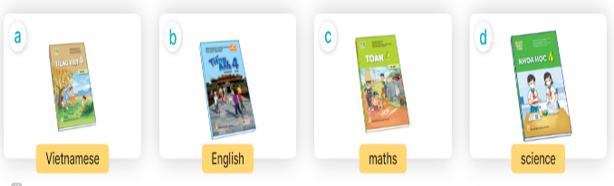+ Picture a: A Vietnamese textbook  + Picture b: An English textbook  + Picture c: A maths textbook  + Picture d: A science textbook  3. Let’s talk.  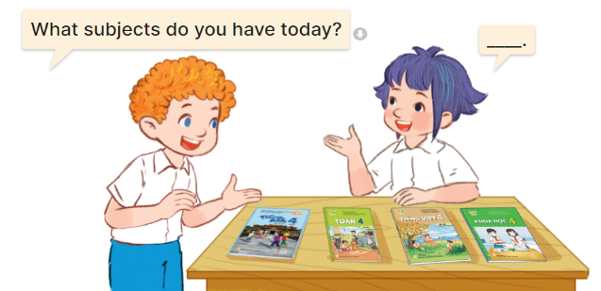  + a boy and a girl talking about school subjects with four textbooks (Vietnamese, English, maths, science) on a desk  * What subjects do you have today?  – I have…………..  -  .
V. ADJUSTMENTS (if necessary):
………………………………………………………………………………………….…..……………………………………………………………………………...………………………………………….…..……………………………………………………………………………….……………………………………………………………………...

Week 12 Preparing date: November ….., 2023
Period 45 Teaching date: November ….., 2023

Unit 7: Our timetables
Lesson 1(4, 5, 6)
I. Objectives:
By the end of the lesson, Ss will be able to:
1. Knowledge:
- Identity specific information by listen to conversation related to topic school subjects.
- Fill in the gaps using given picture cues.
- Recall some vocabularies related to topic school subject by doing the puzzle.
- Vocabulary: Review
2. Skills: speaking, listening, reading and writing.
3. Competences:
- Self-control and independent learning: perform listening tasks.
- Communication and collaboration: work in pairs or groups.
4. Attitude/ Qualities:
- Kindness: Help partners to complete learning tasks.
- Honesty: tell the truth about feelings and emotions
II. Methods: Communicative approach, group Ss and T's activities, play as a character, teaching methods with game, teaching methods by visual, teaching methods by practising, discussion group, technical present....
III. Teaching aids:
- Teacher: Teacher’s guide Pages 102,103,104; audio Tracks 69; website hoclieu.vn, posters, laptop, pictures, textbook, lesson plan, TV or projector.
- Students: Pupil’s book Page 51, notebooks, workbooks, school things.
IV. Procedures :
Teacher’s and students’ activities | Contents
Activity 1.Warm- up:  Game: Slap the board  - Divide class into 2 groups: Tom and Jerry.  - How to play:  + Each group chooses five Ss to play.  + Class will read aloud.  + Look at the picture, listen and slap the picture you heard.  + Who faster will get 1 mark.  + Which group with higher mark is the winner.  - Say “Open your book page 51” and look at “Unit 7, Lesson 1 (4,5,6)”.  Activity 2. Listen and tick or cross:  - Draw pupils’ attention to the pictures and ask questions: What subject is it?  - Look at the pictures and say  - Remind them to look at the book covers of the subjects and tick or cross the boxes while listening.  - Play the recording all the way through.  - Play the recording for pupils to listen and tick or cross the boxes.  - Get pupils to swap books with a partner to check their answers.  - Ss listen to the tape and tick or cross  - Ss listen again, tick and swap books with their partners.  - Check the answer together.  - Play the recording, sentence by sentence, for pupils to listen and repeat in chorus.  Activity 3. Look, complete and read  - Get Ss to look at the pictures and identify the subjects in each picture.  -Ss look at the picture and say  - Have Ss look at the four incomplete sentences. Elicit and model with picture 1  + Ask Ss to read the sentence 1 in chorus.  + Ask Ss what word is missing in the gap (Vietnamese). Then have them complete the sentence (I have Vietnamese).  - Have Ss work in pairs and complete the sentences 2, 3, 4.  - Ss say and write  -Ss work in pairs and complete  - Ask a few Ss to stand up and read the sentences aloud.  -T gives feedbacks.  Activity 4 Let’s play  - Tell pupils the goal of the puzzle and how to play it. Then have them look at the spaces in the puzzle and given letters as well as picture cues to find appropriate lettersto complete the words.  - Give pupils a time limit to do the puzzle individually.  - Have pupils work in pairs. One points at the completed words or the clues and asks What subjects do you have today? and their partner answers I have ………  - Invite a few pairs to the front of the classroom to ask and answer questions about what subjects they have today.  Activity 5. Consolidation  - T asks ss to answer the following questions:  + What have you learnt from the lesson today?  +What are the core values of the lesson? (if the teacher can take from the lesson).  - T praises some Ss who are hardworking / active/ good…. as well as encourage others to try more.  * Homework.  - Practice part 5 again.  - Prepare the new lesson: Unit 7, Lesson 2 (1,2,3). | Game: Slap the board  - Ss listen  -  1. Listen and tick or cross  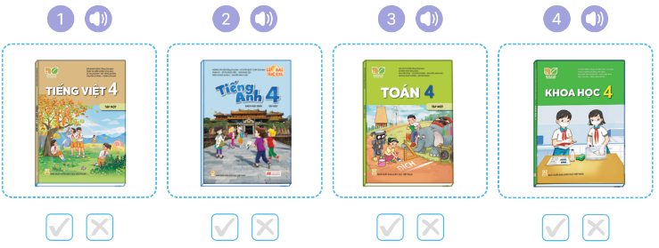  + Picture 1: A Vietnamese textbook  + Picture2: An English textbook  + Picture 3: A maths textbook  + Picture 4: A science textbook  Key: 1. v 2. x 3. v 4. x  .  5. Look, complete and read  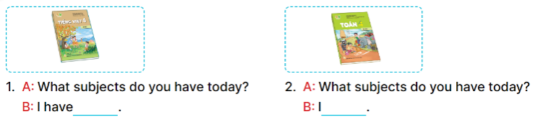  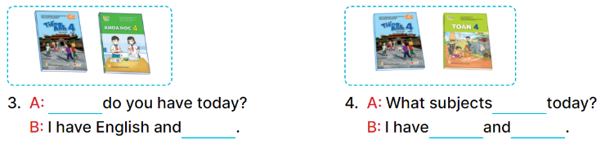  Key:  1. Vietnamese 2. have maths  3. What subjects; science  4. do you have; English; maths  6. Let’s play  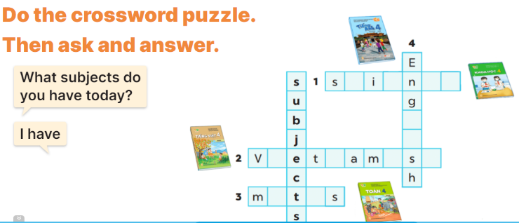  Key: 1. science 2. Vietnamese 3. maths 4. English.
V. ADJUSTMENTS (if necessary):
………………………………………………………………………………………….…..……………………………………………………………………………...………………………………………….…..……………………………………………………………………………….……………………………………………………………………...

Week 12 Preparing date: November ….., 2023
Period 46 Teaching date: November ….., 2023

Unit 7: Our timetables
Lesson 2 (1, 2, 3)
I. Objectives:
By the end of the lesson, Ss will be able to:
1. Knowledge:
- Identify the situation between Nam and Lucy (setting, participants, topic).
- Use the word “art, music, science” in relation to topic “school subjects” to talk about school timetable.
- Use sentence pattern “When do you have….? I have it on……..” to ask and answer about school timetable.
- Vocabulary: art, music, history and geography.
2. Skills: speaking, listening, reading and writing.
3. Competences:
- Self-control and independent learning: perform listening tasks.
- Communication and collaboration: work in pairs or groups.
4. Attitude/ Qualities:
- Kindness: Help partners to complete learning tasks.
- Honesty: tell the truth about feelings and emotions
II. Methods: Communicative approach, group Ss and T's activities, play as a character, teaching methods with game, teaching methods by visual, teaching methods by practising, discussion group, technical present....
III. Teaching aids:
- Teacher: Teacher’s guide Pages 104,105, audio Tracks 71, 72, website hoclieu.vn, posters, laptop, pictures, textbook, lesson plan, TV or projector.
- Students: Pupil’s book Page 52, notebooks, workbooks, school things.
IV. Procedures:
Teacher’s and students’ activities | Contents
Activity 1.Warm- up:  Matching game  - Using pictures and flashcards, get 3 pupils hold the pictures and 3 more hold the sentences.  - Ask them to find and match. Praise the ones who finish the matching.  - Then ask the class to look and say aloud.  - Say “Open your book page 52” and look at “Unit 7, Lesson 2 (1,2,3)”.  Activity 2. Look, listen and repeat:  - Ask pupils to look at Pictures a and b and identify the characters.  - Play the audio twice (sentence by sentence). Correct their pronunciation where necessary.  -Ss listen and repeat in chorus (twice)  - Have Ss to practice the dialogue  -Ss work in pairs to practice  -Ss practice the dialogue  - T invites a few pairs to the front of the class to practice.  - T checks pronunciation for ss.  Activity 3 Listen, point and say.  -T elicits the new words  - T models (3 times).  - Ss listen and repeat  + Choral repetition (3 times).  + Individual repetition (3 ss)  - T writes the words on the board.  - Checking: Rub out and remember  - T asks Ss look at picture b and helps Ss know the structure from the dialogue.  - T introduces new structure for Ss.  - T explains, models and gives meaning.  - Have Ss repeat the model sentences.  - Have Ss look at the pictures and identify the subjects and days of week  - Run through all the pictures.  - Run through model sentences.  - Have Ss to practise:  + T asks, Ss answer picture a  + Ss ask, T answers picture b  + Group A ask, group B answer picture c  + Group B ask, group A answer picture d  - Ask Ss to work in pairs.  - T controls and corrects.  - Invite a few pairs to come to the front of the classroom and point at the pictures and say the questions and answers in front of the class.  - T gives feedbacks.  Activity 4. Let’s talk.  - Have Ss look at the picture and elicit the question and the answer in context.  + Who are they?  + What are they talking about?  - Elicit the missing words and write them on the board. Get pupils to say the completed sentences.  - Put Ss work in pairs to give and respond to instructions.  - Invite some pairs of Ss to the front of the class to ask and answer.  Activity 5. Consolidation  - T asks ss to answer the following questions:  + What have you learnt from the lesson today?  +What are the core values of the lesson? (if the teacher can take from the lesson).  - T review the vocabulary and model sentences.  - T praises some Ss who are hardworking / active/ good…. as well as encourage others to try more.  * Homework.  - Learn the vocabulary and model sentences by heart  - Prepare the new lesson: Unit 7, Lesson 2 (4,5,6). | Game: Matching game  1. Look, listen and repeat:  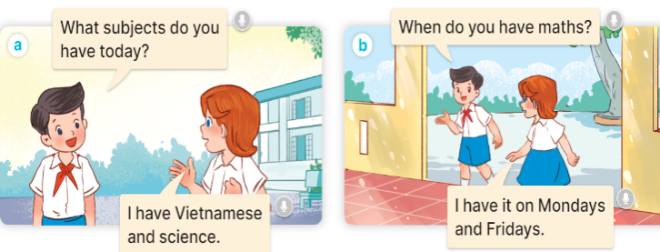  2. Listen, point and say.  + art : môn Mĩ thuật (realia)  + music : môn Âm nhạc (realia)  + history and geography :môn lịch sử và địa lý (realia)  A: When do you have Art?  B:I have it on Monday.  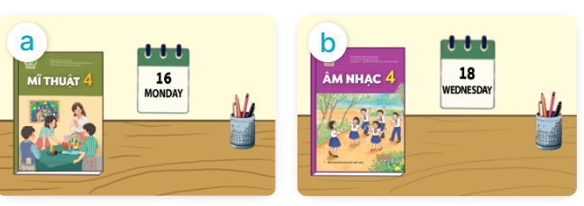  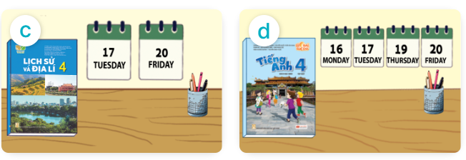  + Picture a: An art textbook and a calendar displaying Monday  + Picture b: A music textbook and a calendar displaying Wednesday.  + Picture c: A science textbook and two calendars displaying Tuesday and Friday.  + Picture d: An English textbook and three calendars displaying Monday, Tuesday and Thursday  3. Let’s talk.  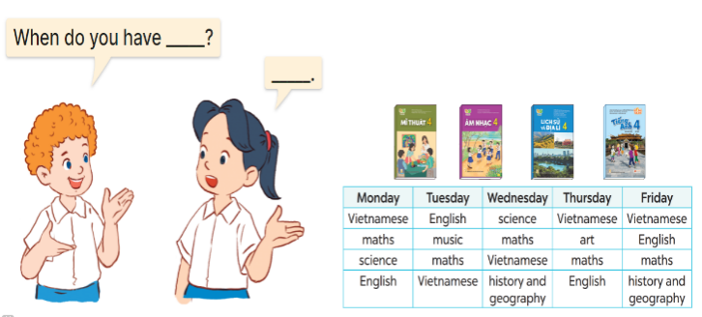  + a boy and a girl talking about a timetable  * Structures.  A: When do you have Art?  B:I have it on……………..
V. ADJUSTMENTS (if necessary):
………………………………………………………………………………………….…..……………………………………………………………………………...………………………………………….…..……………………………………………………………………………….……………………………………………………………………...
Week 12 Preparing date: November ….., 2023
Period 47 Teaching date: November ….., 2023

Unit 7: Our timetables
Lesson 2 (4, 5, 6)
I. Objectives:
By the end of the lesson, Ss will be able to:
1. Knowledge:
- Identify the specific information by listening 2 conversations about school timetable to tick the correct pictures.
- Using clue pictures to complete the gaps;
- Perform the song “What subjects do you have today?” in interesting ways, using appropriate and meaningful gestures.
- Vocabulary: Review
2. Skills: speaking, listening, reading and writing.
3. Competences:
- Self-control and independent learning: perform listening tasks.
- Communication and collaboration: work in pairs or groups.
4. Attitude/ Qualities:
- Kindness: Help partners to complete learning tasks.
- Honesty: tell the truth about feelings and emotions
II. Methods: Communicative approach, group Ss and T's activities, play as a character, teaching methods with game, teaching methods by visual, teaching methods by practising, discussion group, technical present....
III. Teaching aids:
- Teacher: Teacher’s guide Pages 106,107; audio Tracks 72; website hoclieu.vn, posters, laptop, pictures, textbook, lesson plan, TV or projector.
- Students: Pupil’s book Page 53, notebooks, workbooks, school things.
IV.Procedures:
Teacher’s and students’ activities | Contents
Activity 1.Warm- up:  Game: Slap the board  - Divide class into 2 groups  - How to play:  + Each group chooses five Ss to play.  + Class will read aloud.  + Look at the picture, listen and slap the picture you heard.  + Who faster will get 1 mark.  + Which group with higher mark is the winner.  - T gives feedback.  - Say “Open your book page 53” and look at “Unit 7, Lesson 2 (4,5,6)”.  Activity 2. Listen and tick:  - Ask pupils to look at Pictures 1a and 1b and identify a part of the timetables and the subject.  -Look at the pictures and say:  - T ask Ss to guess the answers.  + T writes Ss’guessing on the board.  - Listen to the tape:  + Play the recording  - Ss listen to the tape and tick  + Play the recording again and get Ss to swap books with their partners.  - Ss listen again, tick and swap books with their partners.  -SS listen again and check  + Play the recording again to check answers together as a class.  + Write the answers on the board for Ss to correct their answers. Then checks Ss’ guessing.  - Play the recording, sentence by sentence, for the class to listen and repeat in chorus.  Activity 3. Look, complete and read  - Have pupils read the sentences and guess the missing words  - Model the first gapped exchange.  - Elicit the names of the subjects that can be used to fill in the gaps (What, Vietnamese and maths).  - Give pupils look at the picture and fill in the gaps independently.  -Ss say and fill in the gaps  - Get pupils to swap books with a partner and check their answers before checking as a class.  -Ss work in pairs and swap books and check  - Invite one pupil to write the answers on the board.  - Invite four pairs of pupils to act out the complete exchanges in front of the class.  Activity 4. Let’s sing  - Introduce the title and lyrics of the song: “  - Play the recording for Ss to listen to the whole song.  + Have them repeat the title and lyrics line by line.  + Tell Ss to point at the pictures while singing.  - Play the recording all the way through for Ss to listen to pronunciation and melody of the song.  - Play the recording line by line for Ss to listen, repeat and point to the pictures  - Ss listen and repeat line by line without the action.  - Play the recording for Ss to sing and do actions.  - Ss sing and do actions.  - Ask Ss to practice singing and doing actions in pairs or groups.  + Ss work in groups (two groups) to sing.  - Invite groups to the front of the classroom to perform the song  -Ss perform in front of the class.  -T gives feedback.  Activity 5. Consolidation  - T asks ss to answer the following questions:  + What have you learnt from the lesson today?  +What are the core values of the lesson? (if the teacher can take from the lesson).  - T praises some Ss who are hardworking / active/ good…. as well as encourage others to try more.  *Homework.  - Prepare the new lesson: Unit 7, Lesson 3 (1,2,3). | Game: Slap the board  4. Listen and tick:  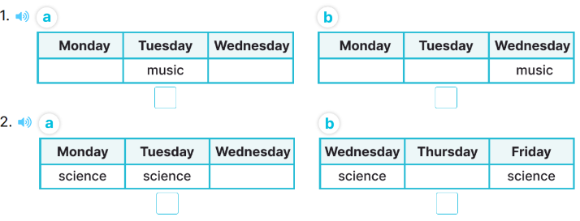  + Picture 1a. A part of the timetable in which music is taught on Tuesdays  + Picture 1b. A part of the timetable in which music is taught on Wednesdays  + Picture 2a. A part of the timetable in which science is taught on Wednesdays and Thursdays  + Picture 2b. A part of the timetable in which science is taught on Wednesdays and Fridays  Key: 1. a 2. B  5. Look, complete and read  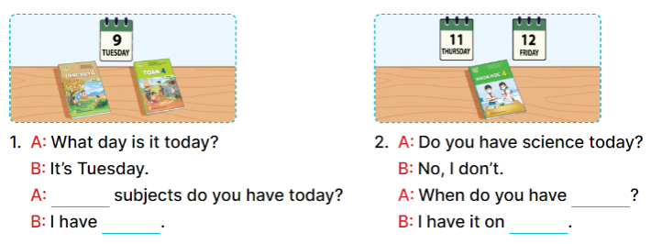  Key:  1. What, Vietnamese and maths  2. science, Thursday and Friday  6. Let’s sing  The song “What subjects do you have today?”  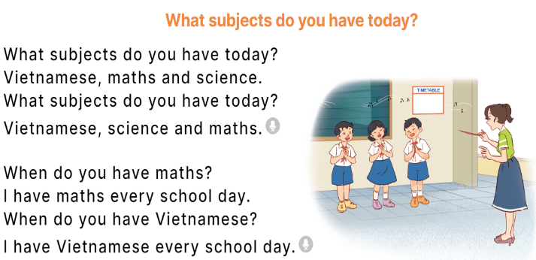  -
V. ADJUSTMENTS (if necessary):
…………………………………………………………………………………………………………………………………………………………………………………….……

Week 12 Preparing date: November ….., 2023
Period 48 Teaching date: November ….., 2023

Unit 7: Our timetables
Lesson 3 (1, 2, 3)
I.Objectives:
By the end of the lesson, Ss will be able to:
1. Knowledge:
- Correctly pronounce the sound of the letters se and ce in isolation, in the words Vietnamese and science and in the correct sentences “When do you have Vietnamese” and “We have science today”
- Identify the specific information by listening 2 sentences to identify the target word;
- Perform the chant in interesting ways, using appropriate and meaningful gestures
- Vocabulary: Review
2. Skills: speaking, listening, reading and writing.
3. Competences:
- Self-control and independent learning: perform listening tasks.
- Communication and collaboration: work in pairs or groups.
4. Attitude/ Qualities:
- Kindness: Help partners to complete learning tasks.
- Honesty: tell the truth about feelings and emotions
II. Methods: Communicative approach, group Ss and T's activities, play as a character, teaching methods with game, teaching methods by visual, teaching methods by practising, discussion group, technical present....
III. Teaching aids:
- Teacher: Teacher’s guide Pages 104,105; audio Tracks 74, 75, 76; website hoclieu.vn, posters, laptop, pictures, textbook, lesson plan, TV or projector.
- Students: Pupil’s book Page 54, notebooks, workbooks, school things.
IV.Procedures :
Teacher’s and students’ activities | Contents
Activity 1.Warm- up:  Game: Pass the ball  - Divide the class into 3 teams.  - Each team has 1 sticky ball.  - Play the music, Ss in each team take turns to pass the ball.  + After the music ends, 3 Ss have the ball – stand up and say the name, using the sentence model.  - Say “Open your book page 54” and look at “Unit 7, Lesson 3 (1,2,3)”.  Activity 2. Listen and repeat:  - T gives instruction to the letter se and ce, Vietnamese and science and in the sentences When do you have Vietnamese” and “We have science today”  - Ss recognize the differences about color of letter  - Play the recording for the letter se, ce.  - Encourage Ss to point at the letter/ word/ sentence while listening.  - Play the recording again and encourage Ss to listen and repeat.  -Ss listen again and repeat  -Ss practice  - Do this several times until Ss feel confident.  - T calls some Ss to practice.  - T gives feedbacks.  Activity 3. Listen and circle  - Elicit the sentences and the gap-fill options.  - T ask Ss to guess the answers.  -Ss guess the answers  + T writes Ss’guessing on the board.  - Listen to the tape:  + Play the recording  - Ss listen to the tape and circle  + Play the recording again and get Ss to swap books with their partners.  - Ss listen again, circle and swap books with their partners.  + Play the recording again to check answers together as a class.  + Write the answers on the board for Ss to correct their answers. Then checks Ss’ guessing.  - Play the recording, sentence by sentence, for the class to listen and repeat in chorus.  - Invite one or two Ss to stand up and read the completed sentences.  Activity 4. Let’s chant  - Introduce the title and lyrics of the chant.  - Play the recording for Ss to listen to the whole chant.  + Have them repeat the title and lyrics line by line.  - Ss listen and repeat line by line without clap their hands  + Ask Ss to attend to the sounds of the letters se and ce and the words Vietnamese and science.  - Play the recording all the way through for Ss to listen to pronunciation and melody.  -Ss listen to melody of the chant  - Play the recording line by line for Ss to listen and repeat  - Play the recording for Ss to chant and clap along.  - Ss chant and clap along.  - Ask Ss to practice chant and clap along in pairs or groups.  - Ss work in groups (two groups) to chant  - Invite groups to the front of the classroom to perform the chant  -T gives feedback.  Activity 5. Consolidation  - T asks ss to answer the following questions:  - T praises some Ss who are hardworking / active/ good…. as well as encourage others to try more.  * Homework.  - Practice the chant more.  - Prepare the new lesson: Unit 7, Lesson 3 (4,5,6).  - Prepare a school timetable at home and present about it. | Game: Pass the ball  1. Listen and repeat:  se- Vietnamese - When do you have Vietnamese”  ce- science-“We have science today  2. Listen and circle  + Number 1: When do you have …….?  + Number 2: They have ….today.  Key: 1.b 2.a  3. Let’s chant  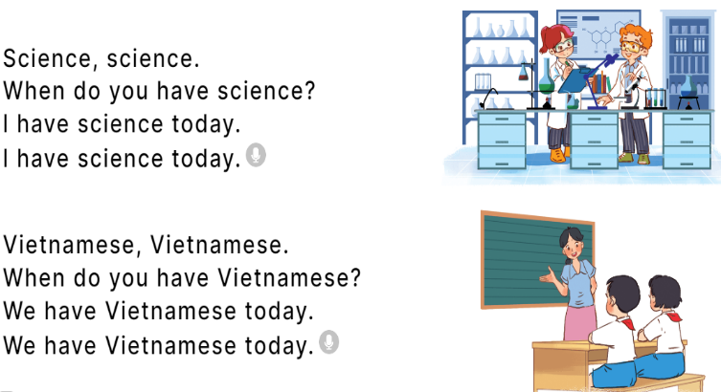
V. ADJUSTMENTS (if necessary):
………………………………………………………………………………………….…..……………………………………………………………………………...………………………………………….…..……………………………………………………………………………….……………………………………………………………………...

Week 13 Preparing date: December ….., 2023
Period 49 Teaching date: December ….., 2023

Unit 7: Our timetables
Lesson 3 (4, 5, 6)
I.Objectives:
By the end of the lesson, Ss will be able to:
1. Knowledge:
- Identify the specific information by scanning the text about Minh and circle the correct answers.
- Write about pupil’s school subjects.
- Present their timetable to the class at the Project time
- Vocabulary: Review
2. Skills: speaking, listening, reading and writing.
3. Competences:
- Self-control and independent learning: perform listening tasks.
- Communication and collaboration: work in pairs or groups.
4. Attitude/ Qualities:
- Kindness: Help partners to complete learning tasks.
- Honesty: tell the truth about feelings and emotions
II. Methods: Communicative approach, group Ss and T's activities, play as a character, teaching methods with game, teaching methods by visual, teaching methods by practising, discussion group, technical present....
III. Teaching aids:
- Teacher: Teacher’s guide Pages 110, 111; website hoclieu.vn, posters, laptop, pictures, textbook, lesson plan, TV or projector.
- Students: Pupil’s book Page 55, notebooks, workbooks, school things.
IV.Procedures:
Teacher’s and Students’ activities | Contents
Activity 1.Warm- up:  Game: “Chant”  - Ask Ss chant and do the actions in Unit 7, Lesson 3 page 54 in groups.  - Give point for the groups and encourage them.  - Say “Open your book page 55” and look at “Unit 7, Lesson 3 (4, 5, 6)”.  Activity 2. Read and circle:  - Tell pupils the goal of the activity and explain that they should read the sentences and choose the correct options.  - Ss look at the passage and listen  - Model number 1: have pupils read the sentence and guess the missing words. Then have them read the text and choose the correct option.  -Ss read and guess the missing words  - Have pupils to do the task independently.  -Ss do the task  - Get pupils to swap their books with a partner and check their answers before checking as a class.  -Ssswap books and check their answer  - Invite one or two pupils to read the text and the completed sentences in front of the class.  Activity 3. Let’s write  - Explain that the gaps in the text focus on their names and their timetables.  - Model the first gap and have pupils do the first gapped sentence together as an example.  - Give pupils time to complete the text independently.  - Ss read and fill  - Invite one or two pupils to read their completed texts in front of the class.  - Ss read the complete texts  Activity 4. Project.  - Explain that they must show the timetables that they have prepared at home and present them to the class.  - Have pupils work in groups of three.  + Each pupil shows his / her timetable and tells the group about it  - Invite a few pupils to show their timetables and tell the class about them.  -Ss perform in front of the class  Activity 5. Consolidation  - T asks ss to answer the following questions:  + What have you learnt from the lesson today?  +What are the core values of the lesson? (if the teacher can take from the lesson).  - T praises some Ss who are hardworking / active/ good…. as well as encourage others to try more.  * Homework.  - Prepare the new lesson: Unit 8, Lesson 1 (1, 2, 3). | Game: “Chant”  4. Read and circle:  Key: . b 2. a 3. b 4. b  5. Let’s write  Ex: My name is Huong. I go to school from Mondays to Fridays. I have Vietnamese and maths today. I have English on Mondays, Thursdays and Fridays. I have science on Wednesdays and Thursdays. I have music on Tuesdays. I like music very much.  6. Project.  My timetable  Monday Tuesday Wednesday Thusday Friday  music ……….  ……… …….  ……..  ex: Look at the timetable. I have Vietnamese and maths every day. I have English on Mondays, Wednesdays, and Fridays. I have music on Thursdays.
V. ADJUSTMENTS (if necessary):
………………………………………………………………………………………….…..……………………………………………………………………………...…………

