Week 10
Preparing date: October ….., 2023
Teaching date: October ….., 2023

Unit 6: Our school facilities
Lesson 1 (1, 2, 3)
A. OBJECTIVES:
By the end of the lesson, Ss will be able to:
1. Knowledge:
- understand and correctly repeat the sentences in two communicative contexts (pictures) in which pupils ask and answer questions about the location of a school.
- correctly say the phrases and use Where’s your school? – It’s in the ………….. to ask and answer questions about the location of a school.
- listen to and demonstrate understanding of simple communicative contexts in relation to the topic “Our school facilities”
- Vocabulary: city, mountains, village, town.
- Skills: speaking and listening
2. Competences:
- Critical Thinking: self-introduce
- Co-operation: ready to help friends in pair work/ group work.
- Sociability: Talk to each other, say good words to others.
3. Attitude/ Qualities:
- Kindness: Help partners to complete learning tasks.
- Show pride in what they can do and great respect for other people’s abilities by using appropriate gestures and intonation when asking and answering about abilities.
B. TEACHING AIDS:
- Teacher: Teacher’s guide Pages 87,88,89, audio Tracks 58,59, website hoclieu.vn, posters, laptop, pictures, textbook, lesson plan, TV or projector.
- Students: Pupil’s book Page 44, notebooks, workbooks, school things.
C. PROCEDURES:
Teacher’s and Students’ activities | Contents
1.Warm- up: (3’)  - Show the song on the screen.  https://www.youtube.com/results?sp=mAEB&search_query=hello+hello+how+are+you+song  - Ask Ss to listen, sing and dance the song.  - Ss sing and dance the song  - Say “Open your book page 44” and look at “Unit 6, Lesson 1 (1,2,3)”.  - Ss open their books  2. Presentation(16’)  Activity 1. 1. Look, listen and repeat:  *Procedure:  - Have Ss look at Pictures a and b and identify the characters in the pictures.  -Ss listen and answer  - Play the audio twice (sentence by sentence). Correct their pronunciation where necessary.  - Ss read sentence by senence  - Have Ss to practice the dialogue  - T invites a few pairs to the front of the class to practice.  - Ss practice before class  - T checks pronunciation for ss.  Activity 2: 2. Listen, point and say.  *Procedure:  T elicits the new words  - T models (3 times).  -Ss listen and repeat in chorus ( 3 times)  + Individual repetition (3 ss)  - T writes the words on the board.  - Checking: Slap the board  - Ss take note  - Ss look, remember and match  * Model sentences:  - T asks Ss look at picture a and helps Ss know the structure from the dialogue.  -Ss look at the picture and answer.  - T introduces new structure for Ss.  -Ss listen  - T explains, models and gives meaning.  - Have Ss repeat the model sentences.  -Ss repeat to the the sentences  3.Practice: (7’)  - Elicit and check comprehension the name of each character.  - Run through all the pictures.  - Run through model sentences.  - Ss look, listen and answer  - Have Ss to practise:  + T asks, Ss answer picture a  + Ss ask, T answers picture b  + Group A ask, group B answer picture c  + Group B ask, group A answer picture d  - Ask Ss to work in pairs.  -Ss work in pairs to practice  - T controls and corrects.  - Invite a few pairs to come to the front of the classroom and point at the pictures and say the questions and answers in front of the class.  -Ss point and say, some pairs practice before class  - T gives feedbacks.  4.Production: (7’)  Activity 3. 3.Let’s talk.  *Procedure:  - T asks ss to guess each character and what the children say.  + What can you see in the picture?  + How many places are there?  -Ss look at the picture and answer  - T fills the gaps and writes the sentences on the board.  - T models  Where’s your school? – It’s in the ………  - T asks Ss to ask and answer questions using new form.  - Ss say the completed sentences.  - Invite some pairs to perform.  -Ss perform in front of the class.  - Give feedbacks  *Consolidation  *Procedure:  - T asks ss to answer the following questions:  + What have you learnt from the lesson today?  +What are the core values of the lesson? (if the teacher can take from the lesson).  -Ss answer the questions  - T review the vocabulary and model sentences.  - Ss listen  - T praises some Ss who are hardworking / active/ good…. as well as encourage others to try more.  -Ss listen and clap their hands  5. Homework. (2’)  - Learn the vocabulary and model sentences by heart  - Prepare the new lesson: Unit 6, Lesson 1 (4,5,6).  -Ss listen and take note | Sing: Hello, how are you? Song.  1.Look, listen and repeat:  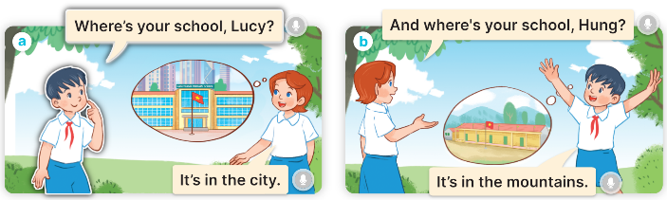  + In picture a:  Hung: Where’s your school, Lucy?  Lucy: It’s in the city  + In picture b:  Lucy: And where’s your school, Hung?  Hung: It’s in the mountains  2. Listen, point and say  New words:  + city : thành phố (picture)  + mountain : vùng núi (picture)  + town :thị trấn (picture)  + village : ngôi làng (picture)  * Model sentences:  A: Where is your school?  B: It’s in the village.  .  *Drill pictures  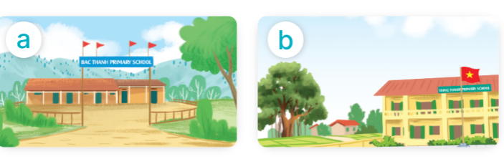  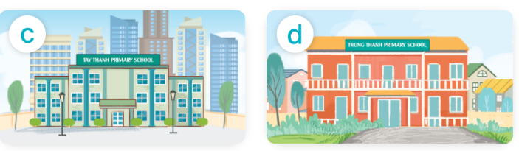  + Picture a. a school in the mountains  + Picture b. a school in the village  + Picture c. a school in the city  + Picture d. a school in the town  horse  3. Let’s talk.  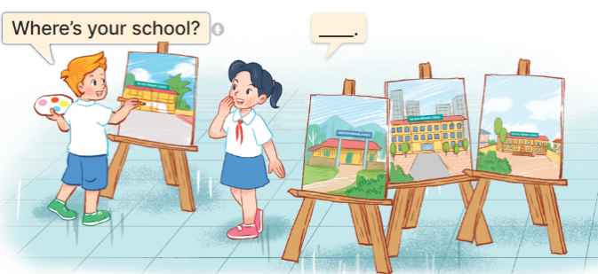  -Ss listen and take note
D. ADJUSTMENTS (if necessary):
………………………………………………………………………………………….…..………………………………………………………………………
Week ____
Preparing date: October ….., 2023
Teaching date: October ….., 2023

Unit 6: Our school facilities
Lesson 1 (4, 5, 6)
A. OBJECTIVES:
By the end of the lesson, Ss will be able to:
1. Knowledge:
- listen to and understand two communicative contexts in which pupils ask and answer questions about the location of a school;
- complete four gapped exchanges with the help of picture cues.
- practise the target vocabulary and sentence patterns by playing the game Matching.
- Vocabulary: Review
- Skills: speaking, listening, reading and writing.
2. Competences:
- Critical Thinking: self-introduce
- Co-operation: ready to help friends in pair work/ group work.
- Self-control and independent learning: perform listening tasks.
3. Attitude/ Qualities:
- Kindness: Help partners to complete learning tasks.
- Honesty: tell the truth about feelings and emotions.
- Diligence: complete learning tasks.
B. TEACHING AIDS:
- Teacher: Teacher’s guide Pages 80,81,82; audio Tracks 60; website hoclieu.vn, posters, laptop, pictures, textbook, lesson plan, TV or projector.
- Students: Pupil’s book Page 45, notebooks, workbooks, school things.
C. PROCEDURES:
Teacher’s and Students’ activities | Contents
1.Warm- up: (5’)  *Procedure:  - Divide the class into 3 teams.  - Ss read the words.  - Pupils from each team choose a letter, then answer the question  - Ss play game  - Pupils answer correctly get some points corresponding to the number of pies.  - Say “Open your book page 45” and look at “Unit 6, Lesson 1 (4,5,6)”.  - Ss open their books  2.Practice: (27’)  Activity 1. Listen and number:  *Procedure:  - Elicit the names of the characters in the pictures.  -Ss guess the answers  - Point at the pictures respectively to explain the context.  - T ask Ss to guess the answers.  + T writes Ss’guessing on the board.  - Listen to the tape:  + Play the recording  + Play the recording again and get Ss to swap books with their partners.  - Ss listen to the tape and write number.  + Play the recording again to check answers together as a class.  - Ss listen again, write number and swap books with their partners.  + Write the answers on the board for Ss to correct their answers. Then checks Ss’ guessing.  -Ss write the correct answer  - Play the recording, sentence by sentence, for the class to listen and repeat in chorus.  -Ss listen and repeat.  Activity 2. Look, complete and read.  *Procedure:  - Have pupils read the exchange and guess the missing words in the answer.  -Ss look at the picture and say  - Have Ss look at the four sentences and the pictures. Elicit with picture 1  - Give pupils time to do the task independently.  -Ss look and answer and do the task  - Get pupils to swap books with a partner and check their answers before checking as a class.  -Ss work in pairs and swap books  - Nominate a pupil to write the answers on the board.  - Invite four pairs of pupils to act out four complete exchanges in front of the class.  -Ss write the answer on the board  -Ss act out  Activity 3. Let’s play  *Procedure:  - Invite two groups, each with six pupils, to play the game.  -Tell pupils the goal of the game and how to play it.  + Each group has two minutes to play.  + The teacher holds up a picture about school, the first pair looks at the picture, one pupil asks (How many______are there at your school?) and another pupil replies as quickly as possible.  - Ss listen  +Check with the whole class if the question is correct or not, and ask the group to demonstrate the action.  + The pair who has played goes to the end of the line.  + The second pair moves up and continues with the next flash card.  + For each pair, the group gets three stars, one star for the question, one for the answer and one for the group action.  - Ss listen and play game  - Play the game with other groups in the class. The group with the most stars is the winner.  *Consolidation  *Procedure:  - T asks ss to answer the following questions:  + What have you learnt from the lesson today?  +What are the core values of the lesson? (if the teacher can take from the lesson).  -Ss answer the questions  - T praises some Ss who are hardworking / active/ good…. as well as encourage others to try more.  -Ss listen and clap their hands  3. Homework. (3’)  - Practice part 5 again.  - Prepare the new lesson: Unit 6, Lesson 2 (1,2,3).  -Ss listen and take note | Game: Doraemon Game ( ppt)  4. Listen and number:  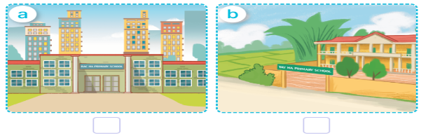  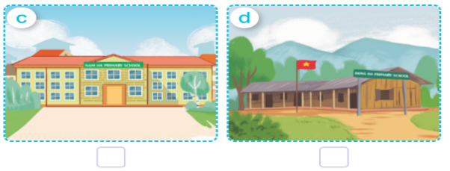  -Look at the pictures and say:  + Picture a. a school in the city  + Picture b. a school in the village  + Picture c. a school in the town  + Picture d. a school in the mountains  Key: 1. c 2. d 3.a 4.b  5. Look, complete and read.  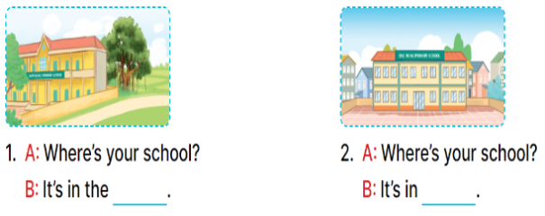  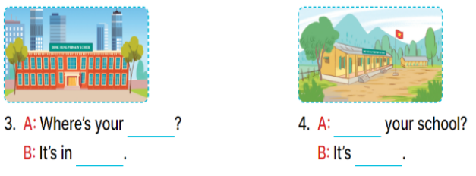  Key:  1. village 2. the town  3. school, the city  4. Where’s, in the mountains  6. Let’s play
D. ADJUSTMENTS (if necessary):
………………………………………………………………………………………….…..………………………………………………………………………….
Week __________
Preparing date: October ….., 2023
Teaching date: October ….., 2023

Unit 6: Our school facilities
Lesson 2 (1, 2, 3)
A. OBJECTIVES:
By the end of the lesson, Ss will be able to:
1. Knowledge:
- understand and correctly repeat the sentences in two communicative contexts (pictures) in which the characters talk about abilities and lack of abilities.
- correctly say the words and use How many ….. are there at your school? – There is ….. / There are …… to ask and answer questions about the quantity of school facilities.
- enhance the correct use of How many ….. are there at your school? – There is ….. / There are …… to talk about abilities and lack of abilities in a freer context.
- Vocabulary: roller skate
- Skills: speaking and listening
2. Competences:
- Critical Thinking: self-introduce
- Co-operation: ready to help friends in pair work/ group work.
- Sociability: Talk to each other, say good words to others.
3. Attitude/ Qualities:
- Kindness: Help partners to complete learning tasks.
- Honesty: tell the truth about feelings and emotions
B. TEACHING AIDS:
- Teacher: Teacher’s guide Pages 82, 83, 84; audio Tracks 61, 62, website hoclieu.vn, posters, laptop, pictures, textbook, lesson plan, TV or projector.
- Students: Pupil’s book Page 46, notebooks, workbooks, school things.
C. PROCEDURES:
Teacher’s and Students’ activities | Contents
1.Warm- up: (3’)  *Procedure:  - Divide the class into 3 teams.  - Ss listen  - Pupils take turns to answer the questions.  - They look at the objects and guess what activity they can do with the objects.  - Ss play the game  - If they have the correct answers, they get the points for their teams. If the answer is not correct, another team answers  - Say “Open your book page 46” and look at “Unit 6, Lesson 2 (1,2,3)”.  - Ss open their books  2. Presentation (16’)  Activity 1. 1. Look, listen and repeat:  *Procedure:  - Have Ss look at Pictures a and b and identify the characters and predict about the quantity of school facilities.  -Look at the pictures and get to know the characters in the pictures.  - Play the audio twice (sentence by sentence). Correct their pronunciation where necessary.  -Ss listen and repeat in chorus (twice)  - Have Ss to practice the diaguage  -Ss work in pairs to practice  - T invites a few pairs to the front of the class to practice.  -Ss practice the diaguage  - T checks pronunciation for ss.  Activity 2. 2. Listen, point and say.  *Procedure:  -T elicits the new words  - T models (3 times).  - - Ss listen and repeat  + Choral repetition (3 times).  + Individual repetition (3 ss)  - T writes the words on the board.  - Ss take note  - Ss look, remember and slap  * Model sentences:  - T asks Ss look at picture a and helps Ss know the structure from the dialogue.  -Ss look at the picture and answer.  - T introduces new structure for Ss.  - T explains, models and gives meaning.  - Have Ss repeat the model sentences.  -Ss listen and repeat  3.Practice: (7’)  *Drill pictures  - Have Ss look at the pictures and elicit the activities.  - Ss look, listen and repeat  - Run through all the pictures.  - Run through model sentences.  + Run through the questions  + Run through the answers  - Have Ss to practise:  + T asks – Ss answer (change role).  + Ss – Ss (change role).  - Ss practice in chorus  - Ask Ss to work in pairs.  -Ss work in pairs to practice  - T controls and corrects.  - Invite a few pairs to come to the front of the classroom, point at the pictures and say the questions and answers in front of the class.  -Ss go to the board and point and say  - T gives feedbacks.  -Ss listen  4.Production: (7’)  Activity 3. 3. Let’s talk.  *Procedure:  - T asks ss to guess each character and what the children say.  + What can you see in the picture?  -Ss look at the picture and answer  - Put Ss into pairs and encourage them to ask and answer questions using How many…… are there at your school? and There is …….. / There are ………  - Ss work in pairs  - Elicit the missing words in the speech bubbles and write them on the board. Get pupils to say the completed sentences.  -Ss listen and answer  - Have pairs of pupils practise asking and answering the questions about the quantity of school facilities in the picture.  -Ss work in pairs and ask, answer  - Invite some pairs to practise asking and answering questions about the quantity of school facilities in front of the class.  -Ss perform in font of the class.  *Consolidation  *Procedure:  - T asks ss to answer the following questions:  + What have you learnt from the lesson today?  +What are the core values of the lesson? (if the teacher can take from the lesson).  -Ss answer the questions  - T review the vocabulary and model sentences.  - T praises some Ss who are hardworking / active/ good…. as well as encourage others to try more.  -Ss listen and clap their hands  5. Homework. (2’)  - Learn the vocabulary and model sentences by heart  - Prepare the new lesson: Unit 6, Lesson 2 (4,5,6).  -Ss listen and take note | Game: Guessing game  1. Look, listen and repeat:  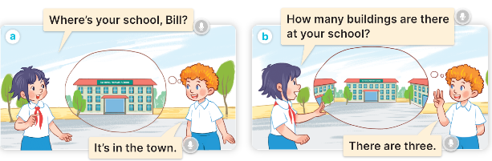  + In picture a:  Linh: Where’s your school, Bill?  Bill: It’s in the town.  – In picture b:  Linh: How many buildings are there at your school?  Bill: There are three.  New words  + building : tòa nhà (picture)  + garden : khu vườn (picture)  A: How many buildings are there at your school?  B: – There is one. / There are two.  +Picture a: one playground  +Picture b: two computer rooms  +Picture c: one garden  +Picture d: three buildings  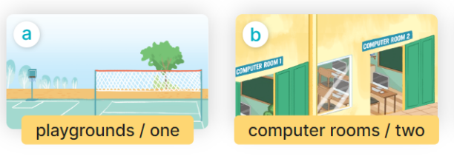  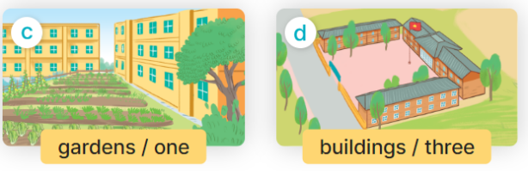  3. Let’s talk.  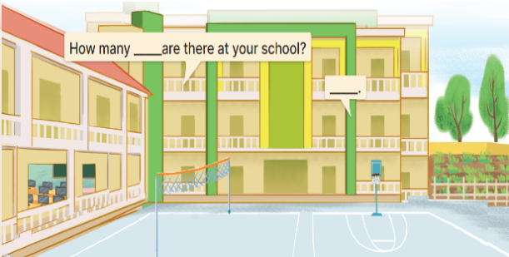  + a school with two buildings, a playground, a computer room and a garden
D. ADJUSTMENTS (if necessary):
………………………………………………………………………………………….…..………………………………………………………………………….
Week 8
Preparing date: October ….., 2023
Teaching date: October ….., 2023

Unit 6: Our school facilities
Lesson 2 (4, 5, 6)
A. OBJECTIVES:
By the end of the lesson, Ss will be able to:
1. Knowledge:
- Use How many …. are there at your school? – There is ……. / There are …..to ask and answer questions about the quantity of school facilities.
- listen to and demonstrate understanding of simple communicative contexts in relation to the topic “Our school facilities”.
- complete four gapped exchanges with the help of picture cues.
- sing the song Gardens and buildings at my school with the correct pronunciation, rhythm and melody.
- Vocabulary: Review
- Skills: speaking, listening, reading and writing.
2. Competences:
- Critical Thinking: self-introduce
- Co-operation: ready to help friends in pair work/ group work.
- Self-control and independent learning: perform listening tasks.
3. Attitude/ Qualities:
- Kindness: Help partners to complete learning tasks.
- Honesty: tell the truth about feelings and emotions.
- Diligence: complete learning tasks.
B. TEACHING AIDS:
- Teacher: Teacher’s guide Pages 94,95; audio Tracks 62,63; website hoclieu.vn, posters, laptop, pictures, textbook, lesson plan, TV or projector.
- Students: Pupil’s book Page 47, notebooks, workbooks, school things.
C. PROCEDURES:
Teacher’s and Students’ activities | Contents
1.Warm- up: (5’)  *Procedure:  - Divide class into 2 groups  - Ss read the words  - How to play:  + Each group chooses five Ss to play.  + Class will read aloud.  - Ss play game  + Look at the picture, listen and slap the picture you heard.  + Who faster will get 1 mark.  + Which group with higher mark is the winner.  - T gives feedback.  - Say “Open your book page 47” and look at “Unit 6, Lesson 2 (4,5,6)”.  - Ss open their books  2.Practice: (27’)  Activity 1. 4. Listen and tick:  *Procedure:  - Elicit the activities in the pictures and tick the boxes while listening.  - T ask Ss to guess the answers.  - Ss Look at the pictures and say  -Ss guess the answers  + T writes Ss’guessing on the board.  - Listen to the tape:  + Play the recording  - Ss listen to the tape and tick  + Play the recording again and get Ss to swap books with their partners.  - Ss listen again, tick and swap books with their partners.  + Play the recording again to check answers together as a class.  + Write the answers on the board for Ss to correct their answers. Then checks Ss’ guessing.  - Ss check their answers and guessing  - Play the recording, sentence by sentence, for the class to listen and repeat in chorus.  -Ss listen and repeat.  Activity 2. 5. Look, complete and read  *Procedure:  - Draw pupils’ attention to the picture and elicit the words to complete the sentence.  - Have Ss look at the four incomplete sentences and elicits the missing words in the sentences.  -Ss look at the picture and say  - T models with picture 1  + Ask Ss what is missing in the sentence.  -Ss answer: mountains  + Have Ss look at the picture and complete the gap, then read the completed sentence in chorus.  -Ss look, complete and read the completed sentence in chorus.  -Have Ss work in groups and complete the picture 2  -Ss complete the sentence  - Ask a few Ss to stand up and read the completed sentences aloud.  -Ss read aloud  -T gives feedbacks.  Activity 3. 6. Let’s sing.  *Procedure:  - Introduce the title and lyrics of the song: “ Gardens and buildings at my school ”  - Play the recording for Ss to listen to the whole song.  -Ss listen to the song  + Have them repeat the title and lyrics line by line.  - Ss listen and repeat line by line without the action.  + Tell Ss to point at the pictures while singing.  -Ss point to the pictures while singing  - Play the recording all the way through for Ss to listen to pronunciation and melody of the song.  -Ss listen to melody of the song  - Play the recording line by line for Ss to listen, repeat and point to the pictures  - Ss listen and sing line by line.  - Play the recording for Ss to sing and do actions.  - Ss sing and do actions.  - Ask Ss to practice singing and doing actions in pairs or groups.  - Invite groups to the front of the classroom to perform the song  + Ss work in groups (two groups) to sing.  -Ss perform in front of the class.  -T gives feedback.  *Consolidation  *Procedure:  - T asks ss to answer the following questions:  + What have you learnt from the lesson today?  +What are the core values of the lesson? (if the teacher can take from the lesson).  -Ss answer the questions  - T praises some Ss who are hardworking / active/ good…. as well as encourage others to try more.  -Ss listen and clap their hands  3. Homework. (3’)  - Practice part 5 again.  - Prepare the new lesson: Unit 6, Lesson 3 (1,2,3). | Play game: Slap the board  4. Listen and tick:  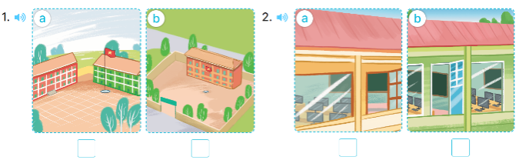  + Picture 1a. a school with a red building and a green building  + Picture 1b. a school with three buildings  + Picture 2a. a school with a computer room  + Picture 2b. a school with two computer rooms  Key: 1. a 2. a  5. Look, complete and read  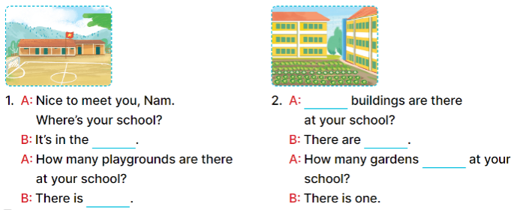  Key:  - mountains, one  - How many, two, are there  6. Let’s sing.  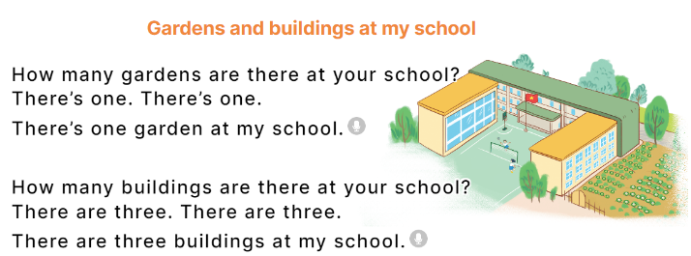

D. ADJUSTMENTS (if necessary):
………………………………………………………………………………………….…..…………………………………………………………………………
Week
Preparing date: November ……. 2023
Teaching date: November ……, 2023

Unit 6: Our school facilities
Lesson 3 (1, 2, 3)
A. OBJECTIVES:
By the end of the lesson, Ss will be able to:
1. Knowledge:
- correctly pronounce the sounds of the letters s and es as final consonants in the words mountains and villages, and in the sentences My school is in the mountains. and There are three villages near my school.
-listen to and demonstrate understanding of simple communicative contexts in relation to the topic “Our school facilities”.
-read about school locations and describe the surrounding
- Vocabulary: Review
- Skills: speaking, listening, reading and writing.
2. Competences:
- Co-operation: ready to help friends in pair work/ group work.
- Sociability: Talk to each other, say good words to others.
3. Attitude/ Qualities:
- Kindness: Help partners to complete learning tasks.
- Honesty: tell the truth about feelings and emotions
B. TEACHING AIDS:
- Teacher: Teacher’s guide Pages 96,97; audio Tracks 64, 65, 66; website hoclieu.vn, posters, laptop, pictures, textbook, lesson plan, TV or projector.
- Students: Pupil’s book Page 48, notebooks, workbooks, school things.
C. PROCEDURES:
Teacher’s and Students’ activities | Contents
1.Warm- up: (5’)  *Procedure: Sing a song: Gardens and buildings at my school.  - Show the song on the screen.  - Ask Ss to listen, sing and dance the song.  - Ss sing and dance the song  - Say “Open your book page 48” and look at “Unit 6, Lesson 3 (1,2,3)”.  - Ss open their books  2. Presentation (9’)  Activity 1. 1.Listen and repeat:  *Procedure:  - T gives instruction to the letter s and es in isolation, in the words mountains and villages, and in the sentences My school is in the mountains. and There are three villages near my school  - Play the recording for the letter s, es  - Ss recognize the differences about color of letter  - Encourage Ss to point at the letter/ word/ sentence while listening.  - Ss listen and point  - Play the recording again and encourage Ss to listen and repeat.  - Ss listen again and repeat  - Do this several times until Ss feel confident.  - T calls some Ss to practice.  -Ss practice  - T gives feedbacks.  3.Practice: (19’)  Activity 2. 2. Listen and circle..  *Procedure:  - Elicit the sentences and the gap-fill options.  -Ss listen and say:  + Number 1: Our school is near two ……  + Number 2: There are two ……. not far from my school.  - T ask Ss to guess the answers.  -Ss guess the answers  + T writes Ss’guessing on the board.  - Listen to the tape:  + Play the recording  - Ss listen to the tape and circle  + Play the recording again and get Ss to swap books with their partners.  - Ss listen again, circle and swap books with their partners.  + Play the recording again to check answers together as a class.  - Ss check their answers and guessing  + Write the answers on the board for Ss to correct their answers. Then checks Ss’ guessing.  - Play the recording, sentence by sentence, for the class to listen and repeat in chorus.  -Ss listen and repeat.  -Ss read the sentences  - Invite one or two Ss to stand up and read the completed sentences.  Activity 3. 3. Let’s chant  *Procedure:  - Introduce the title and lyrics of the chant.  - Play the recording for Ss to listen to the whole chant.  -Ss listen to the chant  + Have them repeat the title and lyrics line by line.  - Ss listen and repeat line by line without clap their hands  + Ask Ss to attend to the sounds of the letters s and es and the words mountains and villages.  -Ss note the sounds, words  - Play the recording all the way through for Ss to listen to pronunciation and melody.  -Ss listen to melody of the chant  - Play the recording line by line for Ss to listen and repeat  - Ss listen and chant line by line.  - Play the recording for Ss to chant and clap along.  - Ss chant and clap along.  - Ask Ss to practice chant and clap along in pairs or groups.  - Ss work in groups (two groups) to chant  - Invite groups to the front of the classroom to perform the chant  -Ss perform in front of the class.  -T gives feedback.  *Consolidation  *Procedure:  - T asks ss to answer the following questions:  + What have you learnt from the lesson today?  +What are the core values of the lesson? (if the teacher can take from the lesson).  -Ss answer the questions  - T praises some Ss who are hardworking / active/ good…. as well as encourage others to try more.  -Ss listen and clap their hands  4. Homework. (2’)  - Practice the chant more.  - Prepare a poster about their school in order to introduce their school to a new pupil.  - Prepare the new lesson: Unit 6, Lesson 3 (4,5,6). | 1.Listen and repeat:  s- mountains, es- villages  My school is in the mountains.  There are three villages near my school  2. Listen and circle..  Key: 1.b 2.c  3. Let’s chant  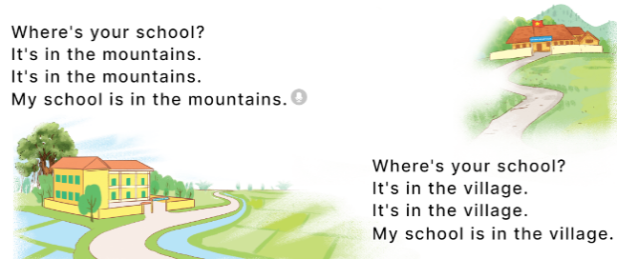
D. ADJUSTMENTS (if necessary):
………………………………………………………………………………………….…..…………………………………………………………………………
Week
Preparing date: November ……. 2023
Teaching date: November ……, 2023
Unit 6: Our school facilities
Lesson 3 (4, 5, 6)
A. OBJECTIVES:
By the end of the lesson, Ss will be able to:
1. Knowledge:
- use the words city, mountains, town, village in relation to the topic "Our school facilities".
- use Where’s your school? – It’s in the …... to ask and answer questions about the location of a school;
- read and demonstrate understanding of simple communicative contexts in relation to the topic “Our school facilities”.
- write and draw about school locations and describe the surrounding.
- Vocabulary: Review
- Skills: speaking, listening, reading and writing.
2. Competences:
- Critical Thinking: self-introduce
- Co-operation: ready to help friends in pair work/ group work.
- Self-control and independent learning: perform listening tasks.
3. Attitude/ Qualities:
- Kindness: Help partners to complete learning tasks.
- Honesty: tell the truth about feelings and emotions.
- Diligence: complete learning tasks.
B. TEACHING AIDS:
- Teacher: Teacher’s guide Pages 98, 99; website hoclieu.vn, posters, laptop, pictures, textbook, lesson plan, TV or projector.
- Students: Pupil’s book Page 49, notebooks, workbooks, school things.
C. PROCEDURES:
Teacher’s and Students’ activities | Contents
1.Warm- up: (5’) Chant  *Procedure:  - Ask Ss chant and do the actions in Unit 6, Lesson 3 page 48 in groups.  - Ss listen and chant  - Give point for the groups and encourage them.  - Say “Open your book page 49” and look at “Unit 6, Lesson 3 (4, 5, 6)”.  - Ss open their books  2.Practice: (8’)  Activity 1. 4. Read and complete:  *Procedure:  - Elicit and introduce the context.  - Ss listen and answer  - Have Ss read aloud the words to fill in.  -Ss read the words and fill  - Model the first blank with Ss to make sure that they know how to do the task.  -Ss complete the text  - Give Ss enough time to complete the text.  - Check the answers as a class.  -Ss check their answer  - Have Ss read the text aloud.  3.Production: (19’)  Activity 2. 5. Let’s write  *Procedure:  - Explain that they should read the gapped text and fill in the gaps using the picture cues and with their own information.  -Ss listen and pay attention  -Ss write the first gapped sentence.  - Have pupils do the first gapped sentence together as an example.  -Ss read and complete the sentence  + Ask them to read the sentence, look at the picture and complete the sentence.  -Ss read the completes texts.  + Have them write the answer in the gap.  - Give pupils time to complete the text independently.  - Get pupils to swap their books with a partner and check their answers before checking as a class.  -Ss swap books and check their answers  - Invite one or two pupils to read their completed texts in front of the class.  -Ss listen and pay attention.  Activity 3. 6. Project.  *Procedure:  - Point at the sample drawing and explain that pupils are going to talk about the drawings of their schools including its location and some of its facilities.  - Have pupils show their drawings that they have prepared for the project.  -Ss present in front of the class  - Give pupils time to practise their presentations by themselves.  -Ss comments, and give corrections  - Give pupils some time to use their drawings to practise presenting in groups.  - Select a few pupils to give their presentations in front of the class.  - Get other pupils to give comments, and give corrections and feedback as necessary.  - Invite a few groups to present their surveys to the class.  *Consolidation  *Procedure:  - T asks ss to answer the following questions:  + What have you learnt from the lesson today?  +What are the core values of the lesson?  - T praises some Ss who are hardworking / active/ good…. as well as encourage others to try more.  -Ss listen and clap their hands  4. Homework. (3’)  - Prepare the new lesson: Unit 7, Lesson 1 (1, 2, 3).  -Ss listen and take note | Game: Chant  4. Read and complete :  Key: 1. village 2. three  3. garden 4. big playground  5. Let’s write  Key: Pupils’ answer  Ex: My school is big. There are three buildings at my school. There is a big garden. My school has a playground. We can play football, badminton and volleyball there. I love my school!  6. Project.  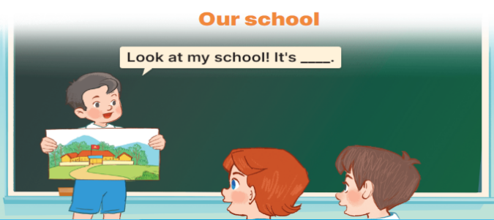
D. ADJUSTMENTS (if necessary):
………………………………………………………………………………………….…..…………………………………………………………………………

