Planning date: 15/11/2025
UNIT 4: MY NEIGHBOURHOOD
I. OBJECTIVES: By the end of the lesson, students will be able to:
1. Knowledge
* Vocabulary:
- Memorize the words related to the topic “My neighbourhood” and understand the context for introductory text.
- Use the vocabulary to talk about My neighbourhood.
* Pronunciation:
- Distinguish how to pronounce the vowel sounds /ɪ/ and /i:/ in words and sentences correctly.
* Grammar:
– Use comparative adjectives.
* Skills:
– Read for specific information about a neighbourhood.
– Talk about a neighbourhood.
– Listen for specific information about a neighbourhood.
– Write a paragraph to describe a neighbourhood.
* Everyday English:
- Asking for and giving directions.
2. Competences
- Develop communication skills and creativity.
- Be collaborative and supportive in pair work and teamwork.
- Actively join in class activities.
* Gifted students: Use the structures "Let's/shall we" to make sentences; use special comparative adjectives (good, bad, narrow, clever, simple; write about 70- 80 words about your neighbourhood; make sentences with comparative adj, may be use special comparative form to make sentences.
3. Personal qualities
- Be positive toward the teacher’s lesson; Respect for teachers and classmates.
- Love of the neighbourhood, the hometown and the country.
II. MATERIALS
- Grade 6 textbook; hoclieu.vn
- Computer connected to the Internet
- Smart TV
III. PROCEDURES

6A:25 / 11/ 2025 6B:25 / 11/ 2025 6C: 24 / 11/ 2025

PERIOD 34: Looking back and project
* Checking the attendance (1’)
6A: ………….6B: ………..6C……………

Teacher’s & Student’s activities | Content
1.Warm up: (4’)  Aim: To revise the vocabularies and structure about comparative related to the topic.  - T calls some SS go to the board to check the old knowledge.  - Ss go to the board to make a sentence with a comparative adjective  - T feedbacks and gives marks. Then leads in the new lesson.  2. New lesson:  Acyivity 1(7’):  Aim: To help Ss revise the vocabulary items and grammar they have learnt in the unit.  - Have Ss do this activity individually  Acyivity 2 (15’)  Aim: To help Ss revise the form and use of comparative adjectives.  - Have Ss do this activity by themselves and write their answers in their notebooks.  - Ss check their answers with a partner before discussing the answers as a class.  - Observe and help when and where necessary, and correct Ss'pronunciation and intonation.  - Invite some Ss to give answer.  - Check and confirm the correct answers  Acyivity 3 (7’)  Aim: To help Ss to write their comparative forms in the table  - Have Ss do this activity by themselves and write their answers in their notebooks.  - Ss check their answers with a partner before discussing the answers as a class.  - Observe and help when and where necessary, and correct Ss'pronunciation  and intonation.  - Invite some Ss to give answer.  - Check and confirm the correct answers  Acyivity 4 (7’)  Aim:To help Ss complete the sentences comparing the pictures  - Have Ss do this activity by themselves and write their answers in their notebooks.  - Have Ss check their answers with a partner before discussing the answers as a class.  - Observe and help when and where necessary, and correct Ss'pronunciation and intonation.  - Invite some Ss to give answer.  - Check and confirm the correct answers  3. Feedback and homework (4’):  - Teacher asks students to rewrite their writing in their books.  - Teacher asks students to prepare the new lesson. | I. Vocabulary.  1. Write the name for each picture.  *Keys:  1. temple 2. railway station  3. square 4. art gallery  5. cathedral.  II. Grammar:  2. Put the following adjective in the correct column.  *Keys:  1. syllable: fast/ hot/ large/ quiet  2. syllables: heavy/ noisy  3. syllables: expensive/ beautiful/ exciting  3. Now write their comparative forms in the table below.  *Keys:  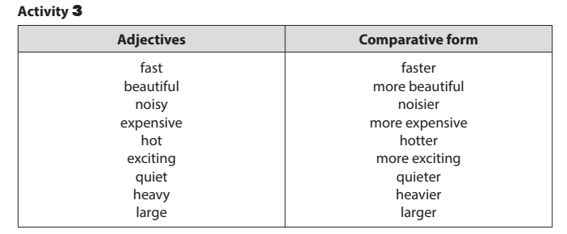  4. Complete the sentences comparing the pictures. Use the comparative  forms of the adjectives below.  Keys:  1. noisier 2. more modern  3. more expensive 4. more peaceful  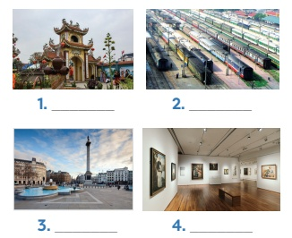  .  * Homework  - Review all the grammar and vocabulary in the lesson  - Do project at home  - Prepare for the next lesson: Unit 5 (Getting started)

**********************************************

UNIT 5: NATURAL WONDERS OF VIET NAM

I. OBJECTIVES:
By the end of this unit, students will be able to:
1. Knowledge
* Vocabulary:
- Memorize the words related to the topic “Natural wonders of Viet Nam” and understand the context for introductory text.
- Use the vocabulary to talk about Natural wonders of Viet Nam.
* Pronunciation:
- Distinguish how to pronounce the sounds /t/ and /d/ in words and sentences correctly.
* Grammar:
– Use countable and uncountable nouns; the modal verb must / mustn’t to give orders.
* Skills:
– Read for specific information about natural wonders;
– Talk about famous places, and what you must / mustn’t do there;
– Listen for specific information about a natural wonder;
– Write a paragraph about a natural wonder.
* Everyday English:
– Making and accepting appointments.
2. Competences
- Develop communication skills and creativity
- Be collaborative and supportive in pair work and teamwork
- Actively join in class activities
* Gifted students:
Students can flexibly use a wide range of vocabulary and complex structures to describe, compare, and give detailed information about natural wonders. They can communicate confidently in extended speaking and writing Activity s, showing creativity and cultural awareness.
3. Personal qualities
- Be positive toward the teacher’s lesson; Respect for teachers and classmates.
- Be willing and actively participate in natural wonders of Viet Nam.
II. MATERIALS
- Teacher’s aids: Grade 6 textbook, Unit 5, Getting started, Pictures and maps, sachmem.vn
- Students’ aids: Text books, notebooks. posters, ….
III. PROCEDURE:
6A:26 / 11/ 2025 6B:27/ 11/ 2025 6C:25 / 11/ 2025

Period 35: Getting started – Geography club
* Checking the attendance (1’)
6A: …………..…….. 6B: ………..……….6C: ………..……….

Teacher’s and students’ activities | Content
1. Warm-up (5’)  Aim: To set the context for the listening and reading text.  To introduce the topic of natural wonders of Viet Nam.  - Teacher shows the colorful boxes on the screen, asks students to look closely, raise their hand to say what they can see behind the boxes aloud.  - Teacher removes the boxes one by one and asks students to guess what is behind the boxes after each box has been removed until students can tell the teacher what it is.  - Sts answer in group  - T checks and lead in the topic of natural wonders of Viet Nam. | Guess what's behind the boxes.  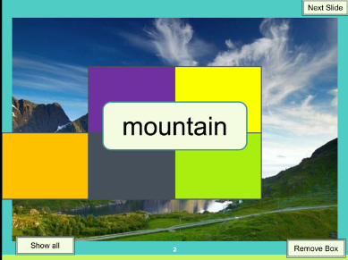  - Who are they?  - What are they looking at?  - What are they talking about?  Suggested answers:  - They are Alice, Elena and Nick.  - They are looking at some photos/ pictures.  3. They are talking about attractive places in Viet Nam.
2. New lesson ( 35’)  Activity 1 (5’)  Aim: To practice the targeted language and the background knowledge of things in nature.  - T introduces the topic of the unit by using some questions about the picture page 8, 9 (textbook) then plays the recording for Ss to listen and read along, underline the words that are related to the unit topic and guess the meaning in context. (Use hoclieu.vn)  - Sts work individually (use their preparations to understand the new words then practice the conversation in pairs.  - T asks some pairs of Ss to read the conversation aloud.-  - T gives feedback, writes the new words on the board and ask sts to take notes) | - Listen and read  new word:  - scenery (noun): [picture]  - natural (adj): [antonym] man-made  - wonders (noun): [picture]  - amazing (adj): [synonym] very good  - island (noun): [picture]    scenery  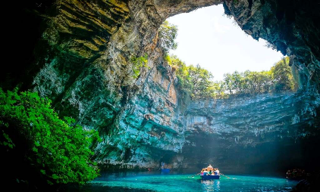  Wonder    island
Activity 2 (18’)  Aim: To help students identify the location of the places mentioned in the conversation.  - Teacher tells students to read the text again in order to find the words to complete the sentences independently.  - Sts work individually to fill  - Teacher allows students to share their answers before discussing as a class.  - Teacher nominates students to give answers and corrects them if necessary.  Activity 3 (7’)  Aim: To help students focus on the use of lexical items to describe the places.  - Teacher asks students to look at the words in the box, listen and repeat.  - Teacher has students match the pictures with the appropriate words independently.  - Teacher allows students to share their answers before discussing as a class.  - Teacher asks students to give answers and corrects them if necessary. | 2.Complete the following sentences with the words from the box. (p. 49)  +What places can you recognize from the photos on their tables?  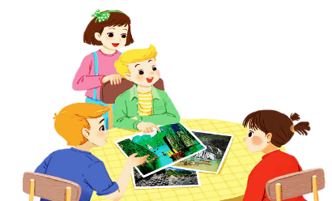  + Why are they attractive? etc.  Answer key:  - amazing  - islands  - scenery  - natural  - wonders  3.Listen and repeat the words, then label the pictures. (p. 4  Answer key:  a. desert  b. island  c. cave  d. river  e. waterfall  f. mountain  g. forest  h. beach
Activity 4 (5’)  Aim: To give students a fun time revising what they have learnt so far in the lesson and more quickly response the questions about natural wonders.  - Teacher divides the class into groups of four or five and provides each group with a set of A and B signs.  - Then, teacher lets students randomly select a number on the screen to choose the question.  - Students raise the correct signs of A or B choose the answer and say the answer aloud.  - The quickest group gets 5 points for each correct answer.  At the end of the activity, 3 groups having the high points are the winners. | 4. Work in groups. Choose the correct answer to each of the questions. (p. 49)  1. Which is an island in Viet Nam?  - A. Con Dao.  2. Where is Mount Fansipan?  - A. In Lao Cai.  3. Which of the following is a national park?  - B. Cat Tien Park.  4. Which of the following wonders is a cave?  - B. Phong Nha.  5. Which is a natural wonder in Australia?  – B. The Great Barrier Reef.
3. Feedback and homework (5’)  - Repeat the main content of the lesson.  - Give out homework and guide Sts to prepare for the new lesson.  - Remind Sts to follow the traffic rules. | *Homework:  - Go to the Internet and search for the information on your favourite natural wonder in Viet Nam and prepare a small talk between 1-2 minutes about it.  - Learn by heart all the new words. Read the dialogue again.  - Prepare lesson 2 ( A closer look 1).

6A:27 / 11/ 2025 6B:28 / 11/ 2025 6C:28 / 11/ 2025

Period 36: A closer look 1
* Checking the attendance (1’)
6A: …………….. 6B: ……………….6C: ……………….

Teacher’s and students’ activities | Content
1. Warm-up (4’)  Aim: To activate students’ prior knowledge and vocabulary related to the topic, the targeted vocabulary and its pronunciation.  -The teacher asks students to work in groups of six and sets the context: “Next week, we are going camping in the forest. What should we bring?”  -Students work in groups. Each group has three minutes to write down as many items as possible. The teacher goes around to provide help if necessary.  - Each group presents their list to the class.  - The teacher checks the answers, gives feedback, and announces the winner (the group with the most correct items | * Names the things needed for going camping:  Suggested answer:  tent  sleeping bag  compass  suncream  mobile phone  food  water  …
2. New lesson ( 35’)  Activity 1 ( 8’)  Aim: To teach students some adjectives describing a city.  - Teacher introduces the vocabulary by:  Providing the pictures of the words: Teacher asks students to write the suitable word under each picture in 2 minutes.  - Students do the Activity .  - Teacher calls some students to give their answers.  - Teacher gives feedback and corrections (if necessary). | I.VOCABULARY  1.Write a word under each picture. Practise saying the words. (p. 50)  - plaster (n): [picture]  - sleeping bag (nph): [picture]  - backpack (n): [picture]  - compass (n): [picture]  - suncream (n): [picture]  - scissors (n): [picture]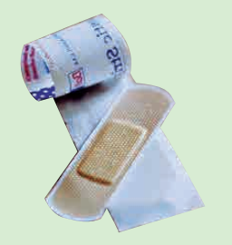  plaster    Suncream    scissors    sleeping bag  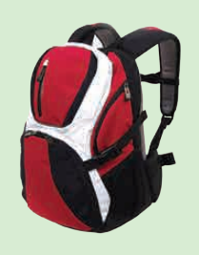  Backpack  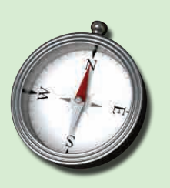  compass
Activity 2 (5’)  Aim: To help students use the adjectives in Activity 1 in a context.  - Teacher asks students to work in pairs and use the words in Activity 1 to complete the sentences.  - Students work in pairs and do the Activity .  - Teacher calls some pairs to share their answers with the whole class.  - Teacher gives feedback and corrections (if necessary).  Activity 3 (7’)  Aim: To teach students some words/ phrases related to a city.  - Teacher asks students to work in groups of three.  - Teacher gives students 3 minutes to discuss and put the item in the order of usefulness.  - Teacher asks students to share their answers as a whole class.  - Teacher gives corrections (if necessary). | 2.Complete the sentences with the words in Activity 1. (p. 50)  Answer key:  - plaster  - suncream  - sleeping bag  - scissors  - backpack  - compass  3.Now put the items in order of usefulness. Number 1 is the most useful, number 6 is the least useful on holiday. (p. 50)  Answer key:  - compass  - suncream  - sleeping bag  - backpack  - plaster
Activity 4: (10’)  Aim: To help students to identify how to pronounce the sounds /t/ and /d/.  - Teacher introduces 2 sounds /t/ and /d/ to students and lets them watch a video about how to pronounce these two sounds.  - Teacher asks students to give some words they know containing these sounds.  - Students listen and repeat the words for the second time.  - T corrrects | II.PRONUNCIATION  4. Listen and repeat the words. (p. 51)  Suggested answers:  - /t/: plaster, tower, letter, desert, want  - /d/: need, island, guide, holiday, pagoda
  /t/ | /d/
  mountain  waterfall  desert  plaster | wonder  island  guide  holiday
Activity 5 (5’)  Aim: To help students practice the sounds /t/ and /d/ in sentences.  - Teacher plays the recording for students to listen and asks students to repeat the sentences after they listen.  - Teacher calls some students randomly to read the sentences and gives correction (if necessary).  - Some students practice reading  - T checks | 5. Listen and repeat. Pay attention to the bold-typed parts of the words. (p. 51)  1- Where's my hat? - Oh, it's on your head.  2. Where do they stay on their holiday?  3. I need some meat for my cat.  4. The Sahara is a very hot desert.  5. I want to explore the island by boat.
3. Feedback and homework (5’)  - Repeat the main content of the lesson.  - Give out homework and guide Sts to prepare for the new lesson.  - Remind Sts to follow the traffic rules. | Homework  Find 5 more words with the sound /t/ and 5 more words with the sound /d/. Write them down and practice pronouncing the words.  - Learn by heart all the new words.  - Find 5 more words with the sound /t/ and 5 more words with the sound /d/.  - Prepare lesson 3 ( A closer look 2).

DUYỆT CỦA TCM

Date of planning: 26/ 11/ 2025

UNIT 5: NATURAL WONDERS OF VIET NAM

I. OBJECTIVES:
By the end of this unit, students will be able to:
1. Knowledge
* Vocabulary:
- Memorize the words related to the topic “Natural wonders of Viet Nam” and understand the context for introductory text.
- Use the vocabulary to talk about Natural wonders of Viet Nam.
* Pronunciation:
- Distinguish how to pronounce the sounds /t/ and /d/ in words and sentences correctly.
* Grammar:
– Use countable and uncountable nouns; the modal verb must / mustn’t to give orders.
* Skills:
– Read for specific information about natural wonders;
– Talk about famous places, and what you must / mustn’t do there;
– Listen for specific information about a natural wonder;
– Write a paragraph about a natural wonder.
* Everyday English:
– Making and accepting appointments.
2. Competences
- Develop communication skills and creativity
- Be collaborative and supportive in pair work and teamwork
- Actively join in class activities
* Gifted students:
Students can flexibly use a wide range of vocabulary and complex structures to describe, compare, and give detailed information about natural wonders. They can communicate confidently in extended speaking and writing Activity s, showing creativity and cultural awareness.
3. Personal qualities
- Be positive toward the teacher’s lesson; Respect for teachers and classmates.
- Be willing and actively participate in natural wonders of Viet Nam.
II. MATERIALS
- Teacher’s aids: Grade 6 textbook, Unit 5, Getting started, Pictures and maps, sachmem.vn
- Students’ aids: Text books, notebooks. posters, ….
III. PROCEDURE:

6A:01 / 12/ 2025 6B:02/ 12/ 2025 6C:02 / 12/ 2025

Period 37: A closer look 2

* Checking the attendance (1’)

6A: …………..…….. 6B: ………..……….6C: ………..……….

Teacher’s and students’ activities | Content
1. Warm-up (4’)  Aim: To put students into English mode;attentive, interested and ready to participate and prime the class for a new topic.  - Teacher divides the class into groups of 3-6 students.  - Teacher delivers a set of unscrambled words which are some countable and uncountable nouns to each group.  - Students will have to work in groups to solve the quiz.  - The group with more correct sentences will be the winner. | * Game: Unscrambled words  Answer key:
  1. cream  2. rock  3. island  4. rice | 5. juice  6. butter  7. backpack  8. plaster
2. New lesson (35’)  Activity 1 (8’)  Aims: To help students remember what countable and uncountabe noun is.  - Teacher introduces about contable and uncountable nouns then has students complete the underlined activity individually.  - Teacher then asks students to swap their textbooks to check their classmates’ answers.  - Teacher draws students’ attention to the underlined words and confirm the use of countable and uncountable nouns.  - Teacher then asks students to give some more examples of uncountable nouns that they know.  - Teacher reminds students to the “definition of countable nouns”  Activity 2 ( 7’)  Aims: To help students know about some, many, much , a few, a little  - Teacher asks students to read the sentences and choose the correct option (A, B, C, or D).  - Students work individually, then compare answers in pairs or groups.  - Students share their answers; teacher writes them on the board.  -Teacher checks answers with the class, gives feedback, and corrects mistakes.  Activity 3 (7’)  Aims: Help students distinguish the usage of the quantifiers a, any, some, much, and many.  Teacher asks students to read the sentences and choose the correct option (A, B, C, or D).  - Students work individually, then compare answers in pairs or groups.  - Students share their answers; teacher writes them on the board.  -Teacher checks answers with the class, gives feedback, and corrects mistakes. | I. Countable and Uncountable nouns:  1. Is this underlined noun countable or uncountable ?  Answer key:  1 – C  2 – U  3 – U  4 – C  5 – U  “Countable nouns are for the people and things we can count using numbers. Countable nouns can be singular."  “Uncountable nouns are for the things that we cannot count with numbers. They usually do not have a plural form.”  “Countable nouns are for the people and things we can count using numbers”. Some English uncountable nouns are countable in Vietnamese. (E.g. rice)  2.Choose the correct option for each sentence  Key:  1-A  2-B  3-A  4-B  5-A  3.Fill in the blank with a,any,some,much or many  Key:  1-many  2-any  3-much  4-a  5-some
Activity 4 (7’)  Aim: To give written consolidation of the grammar and to use the grammar correctly.  - Teacher has students work on the exercise individually before they compare answers with each other.  - Students worl individualy to complete  - Some pairs report their answer  - Teacher gives feedback as a class discussion. | II. Modal verb: must/mustn’t  4: Fill each blank with must or mustn’t. (p. 52)  Answer key:  - must  - musn’t  - must  - mustn’t  - must
Activity 5 (7’)  Aim: To give students speaking practice to use correctly grammar with must and mustn’t to make a set of rules to follow in school.  - Teacher divides the class into groups of 6 students then Teacher assigns the roles for each member by asking quetions:  - Teacher asks students to work in group and make at least 3 classroom rules in 3 minutes.  - The other teams listen and give comments on their friends’ ideas.  - Teacher gives complement or good mark to the group with suitable rules after getting suggestions/ comments from the class. | 5. Write some more rules for you and your classmates at school.  - We must_______  - We mustn’t______
3. Feedback and homework (5’)  - Repeat the main content of the lesson.  - Give out homework and guide Sts to prepare for the new lesson.  - Remind Sts to follow the traffic rules. | * Homework  Do Exercise 3, write the answers on your notebooks.  - Do exercises in the workbook.  - Prepare lesson 4 (communication)

*************************************************

6A:02/ 12/ 2025 6B:04/ 12/ 2025 6C:03/ 12/ 2025

Period 38 : Communication
* Checking the attendance (1’)

6A: …………..…….. 6B: ………..……….6C: ………..……….

Teacher’s and students’ activities | Content
1. Warm-up (5’)  Aim: To review must and mustn’t.  - Have Ss work in pairs.  - Ask and answer: Look at this sign, what must we do?  - Ss make a sentence with must/ mustn’t.  - T checks |   Ex: We mustn’t turn right.  We must go straight ahead
2. New lesson ( 35’)  Aim: To introduce make and accept appointments.  Activity 1 (7’)  - Teacher asks students listen and read the short conversation, paying attention to the highlighted parts. Teacher writes down highlighted parts on the board and asks students what they are used to, which is used to make appointments and which is used to accepting appointments.  - Students works in pairs  - Teacher calls some students to share their opinions.  - Teacher gives more explanations and elicit the form. | I.Making and accepting appointment  1: Listen and read the short conversation, paying attention to the highlighted parts.  * Making and accepting appointments  - Let’s go for a picnic  - That’s fine  - How about 9 o’clock?  - Sure.  * Making appointments:  Let’s + V.  How about …?  * Accepting appointments:  That’s fine.  Sure.
Activity 2 (7’)  Aim: To practice making and accepting appointments.  - Teacher asks students to work in pairs and make a short conversation, following the example. Teacher models with a volunteer.  - Students do the Activity in pairs.  - Teacher calls some pairs to make a conversation in front of the class.  - Teacher gives feedback and corrections (if necessary). | 2.Work in pairs. Make a short conversation, following the example in 1  - Example:  Huy: Nam, let's go to the supermarket this Sunday morning.  Nam: That's great. What time can we meet?  Huy: How about 8 o'clock?  Nam: Sure, I'll meet you at that time.
Activity 3 (7’)  Aim: To help students have knowledge about a travel guide.  -Teacher asks students to read the travel guide entry to check their guess and sets the time limit for reading Activity for 2 minutes.  - Sts work inđividualy  - T calls some students practice reading  - T correct  Activity 4 (7’)  Aims: Practice using must and mustn’t. than Build vocabulary about travel items.  - Teacher asks students to make a list of things they must bring to the Himalayas and things they mustn’t bring.  - Students work individually or in groups to write their lists.  -Students share their lists with the class; teacher writes some ideas on the board.  - Teacher checks, gives feedback, and highlights correct use of must and mustn’t. | II. A Travel guides  3: Read the travel guide entry. (p. 53)  4. Make a list of the things you must bring to the Himalayas. Then add things you mustn’t bring. (p. 53)
  MUST | MUSTN’T
  - compass  - sleeping bag  - plaster  - packback  - waterproof coat | - bicycle  - shorts  - T-shirt
Activity 5 ( 7’)  Aim: To help students talk about what to prepare for a trip.  - Teacher divide the class into 2 main group. One is a tour guide and one is a tourist.  - The tourist prepares the questions and the tour guide prepare the information in 2 minutes.  - Students work in pair. Make a conversation.  - Teacher calls some pairs to talk in front of the class.  - Peer check and then teacher gives feedback. | 5: Role-play being a tour guide and a tourist. Tell your partner what to prepare for their trip to the Himalayas, and give reasons.  Example:  A: I'd like to go to the Himalayas next month.  B: OK. I think you must bring a waterproof coat. It's cold and rainy there!  A: Yes. Anything else?  B: You must bring a sleeping bag so that you can stay here overnight. You must also bring a compass in case you are lost.  A: Is there anything I mustn’t bring?  B: Well, you mustn’t bring bicycle because you can’t ride it here and it’s very cold, so you mustn’t bring shorts or T- shirt.  A: Thanks a lot.
3. Feedback and homework (5’)  - Repeat the main content of the lesson.  - Give out homework and guide Sts to prepare for the new lesson.  - Remind Sts to follow the traffic rules. | Homework  - Choose a natural attraction in your city and find out the information about it (interesting things about the place as well as what they must and mustn’t do there).  - Learn by heart the structures about making and accepting appointments.  - To prepare for the next lesson: Unit 4 My neighbourhood / Skills 1.

6A:03/ 12/ 2025 6B:05/ 12/ 2025 6C:05/ 12/ 2025

Period 39: Skill 1
* Checking the attendance (1’)
6A: …………..…….. 6B: ………..……….6C: ………..……….

Teacher’s and students’ activities | Content
1. Warm-up (5’)  Aim: To introduce the topic of reading.  - Teacher sets the scene: “Next month, I am going travelling. Guess where I will visit.”  - Let’s students guess the places by opening the boxes one by one. The pictures are hidden behind the boxes.  - Teacher shows the pictures on the screen.  - Teacher leads in the lesson by asking questions: | * Set the scene  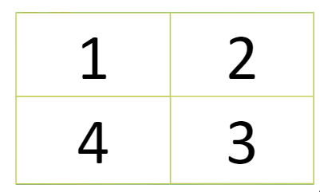  “Have you ever been to these places?”  “Today, let’s see what do they have.”
2.New lesson (35’)  Activity 1 (8’)  Aims: Practice making predictions and Prepare for understanding the reading text.  -Teacher introduce new words asks students to look at the pictures on page 54.  - Students work in pairs or groups to make predictions about the reading.  -Students share their predictions with the class.  -Teacher checks, gives feedback, and connects to the reading text.  . | I/Reading  1. Look at the pictures and make predictions about the reading. (p. 54)  * VOCABULARY  1. tourist attraction (n): a place that people visit for pleasure and interest, usually while they are on holiday  2. popular (adj) =  well-known, common  3. wonder (n): kỳ quan  * Discussing:  1. What is the reading about ?  2. What do you know about these places?    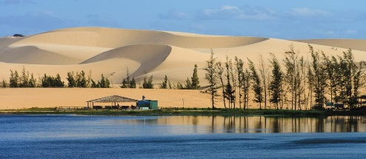
2. Activity 2 (8’)  Aim: To check students understanding of using correct lexical items about the topic.  - Teacher guides students to do  - Sts work individually, in 3 minutes.  - After 3 minutes, teacher lets students swap their answers with their partner.  - Check the answers. | 2. Complete the sentences , using the words from box  Answer key:  1. islands  2. wonder  3. desert  4. Remember  5. visit
Activity 3 (7’0  Aim: To develop reading skill for general and specific information.  - Teacher asks students to go through the questions (1 – 5) to make sure that they understand them and know what information is being asked.  - Students underline the key word(s) in each question to locate the answer in the reading text.  - Teacher asks students to work individually to answer the questions.  - Teacher checks the answers. | 3: Read the text and answer the following questions. (p. 54)  Answer key:  - Ha Long Bay is in Quang Ninh.  - You can enjoy great seafood and join in exciting activities.  - No, there isn’t. It’s like a desert, not a real desert.  - You can have a picnic in Mui Ne by the beach.  - The best time to visit the Mui Ne Sand Dunes is early morning or late afternoon.
Activity 4 (7’)  Aim: To check students’ reading comprehension and prepare for the next part.  - Teacher asks students to work in groups of 3 and make notes about one place in the reading.  - Compare the notes with other groups.  - Teacher asks students to tell their partner about the place by looking at the notes.  - Teacher goes around and offers help if needed.  Students share their ideas with the whole class. | II/Speaking  4: Work in pairs. Make notes about one of the places in the reading. You can add your own ideas. (p. 54)  * Example:  Ha Long Bay has a lot of interesting islands. It also has many caves and beautiful beaches. You can enjoy great seafood here and take part in exciting activities
  Ha Long Bay | Mui Ne
  - interesting islands  - many islands and caves  - beautiful beaches  - great seafood  - exciting activities | - a beautiful places  - amazing landscapes  - different colour  - like a desert  - many activities
Activity 5 (7’)  Aim: To help students form the ideas for their speaking.  - Teacher asks students to choose a famous place in their city or area.then asks students to discuss and make notes of the information they want to share with the class.  - Students refer to the questions as suggestions for their notes or they can do it in their own way and work in groups of 6.  - Teacher goes around and offers help if needed. | 5: Some foreign visitors are visiting your city/ town/ area. You are their tour guide. Tell them some interesting things about the place as well as what they must and mustn’t do there.  * Example:  - You must wear sun scream when you're in My Khe beach  - You must go to the My Khe beach in late afternoon  - You mustn't litter on the beach.  - You mustn't swim alone
6. While-Speaking (5’)
Aim: To help students use what they have learnt so far to talk about a famous place.
- Teacher asks students to practice presenting in their groups.
- Teacher makes sure that students speak in full sentences.
- Then, teacher invites some groups to go to the board and share their preparation with the whole class.
3. Feedback and homework (5’)  - Repeat the main content of the lesson.  - Give out homework and guide Sts to prepare for the new lesson.  - Remind Sts to follow the traffic rules. | Homework  - search for information about Phu Quoc Island.  - Do Ex in workbook.  - Practice speaking a place you like.  - Prepare: Skills 2

DUYỆT CỦA TCM

Date of planning: 04/ 12/ 2025

UNIT 5: NATURAL WONDERS OF VIET NAM

I. OBJECTIVES:
By the end of this unit, students will be able to:
1. Knowledge
* Vocabulary:
- Memorize the words related to the topic “Natural wonders of Viet Nam” and understand the context for introductory text.
- Use the vocabulary to talk about Natural wonders of Viet Nam.
* Pronunciation:
- Distinguish how to pronounce the sounds /t/ and /d/ in words and sentences correctly.
* Grammar:
– Use countable and uncountable nouns; the modal verb must / mustn’t to give orders.
* Skills:
– Read for specific information about natural wonders;
– Talk about famous places, and what you must / mustn’t do there;
– Listen for specific information about a natural wonder;
– Write a paragraph about a natural wonder.
* Everyday English:
– Making and accepting appointments.
2. Competences
- Develop communication skills and creativity
- Be collaborative and supportive in pair work and teamwork
- Actively join in class activities
* Gifted students:
Students can flexibly use a wide range of vocabulary and complex structures to describe, compare, and give detailed information about natural wonders. They can communicate confidently in extended speaking and writing Activity s, showing creativity and cultural awareness.
3. Personal qualities
- Be positive toward the teacher’s lesson; Respect for teachers and classmates.
- Be willing and actively participate in natural wonders of Viet Nam.
II. MATERIALS
- Teacher’s aids: Grade 6 textbook, Unit 5, Getting started, Pictures and maps, sachmem.vn
- Students’ aids: Text books, notebooks. posters, ….
III. PROCEDURE:

6A:08 / 12/ 2025 6B:09/ 12/ 2025 6C:09 / 12/ 2025

Period 40: Skill 2
* Checking the attendance (1’)
6A: …………..…….. 6B: ………..……….6C: ………..……….

Teacher’s and students’ activities | Content
1. Warm-up (5’)  Aim: To introduce about the destination in the talk.  -Teacher asks students to look at the pictures carefully.  - Students work individually or in pairs to name the places in the pictures.  - Students share their answers with the class; teacher writes them on the board.  - Teacher checks, corrects if necessary, and gives feedback. | Look at the pictures and name the places in the pictures  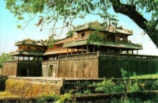      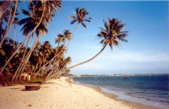  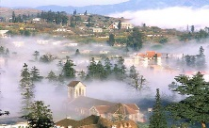    * Answer key:  1. Ha Long Bay 2. Hue  3. Ha Noi 4. Mui Ne 5. Vung tau 6. Sa Pa  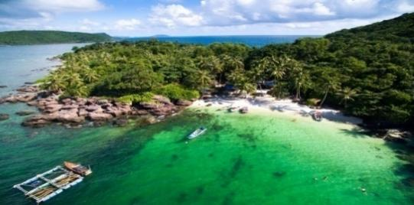  Phu Quoc Island
2. New lesson ( 35’)  Activity 1 (5’)  Aim: To help students brainstorm about destination in the talk.  - Teacher asks students to work in groups of four to answer the question:  “What do you know about Phu Quoc Island?”  2. Teacher asks students to talk in Vietnamese (sometimes) if they do not have enough vocabulary in English.  3- Students share what they have discussed to see what they know about Phu Quoc Island in group  -T calls some groups share  -T checks | I/Listening  1: Work in groups. Discuss and answer the question. (p. 55)  Suggested answers:  - Phu Quoc is a beautiful island in Viet Nam.  - Tourists can enjoy many entertaining activities such as visiting the night market, sightseeing, visiting the Safari,...  - The food in here is delicious and unique.
Activity 2 (7’)  Aim: To help students develop listening skill for specific information (T / F).  - Teacher asks students to read the statements (1–5), underline key words, and make predictions (True/False).  - Students listen to the recording once or twice and tick their answers.  - Students compare their answers with their previous predictions in pairs or groups.  -Teacher invites some students to report, corrects the false ones, and checks answers with the whole class. | 2: Listen and tick True or False. (p. 55)  * Listen and decide True or False:  Answer key:  1. T  2. F (It has beautiful beaches and green forest.)  3. T  4. F (Sailing and fishing are popular water sports.)  5. T
Activity 3: (7’)  Aim: To help students talk about a travel attraction they know and collect information for their later writing.  - Teacher models the activity by summarizing information of a talk with a student using the questions in the network (p.55).  - Students choose a travel attraction they know and brainstorm individually using the network; teacher goes around to help if needed.  - Students work in groups of four to introduce their chosen places using the filled network.  - 1–2 students present their places to the class; teacher gives comments and feedback. | 3. Fill each blank in the network with the information about a travel attraction you know. (p. 55)  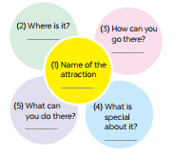  Suggested answers:  Teacher: What is the name of the attraction?  Student: It’s Phu Quoc island  Teacher: Where is it?  Student: It’s in Kien Giang  Teacher: How can you go there?  Student: You can fly to the island because it has an international airport.  Teacher: What can you do there?  Student: I can visit the fishing villages, the national parks, beautiful beaches, temples, pagodas, etc. I can enjoy some water sports like Sailing and fishing or buy interesting things at the night market.  Teacher: What is special about it?  Student: It’s one of the most famous natural wonders of Viet Nam and thousands of tourists visit it every year.
Activity 4 (8’)  Aim: To teach students how to write a paragraph about 50 words about a travel attraction they know.  - Teacher shows the picture in Activity 4 and explains to students that they should begin the paragraph with a topic sentence for Teacher asks students to use ideas they have brainstormed to write a paragraph about 50 words about a travel attraction they know.  - Teacher asks students to refer to the Reading passages in Skills 1 if needed.  - Teacher goes round and help if needed. | 4.Write a paragraph about 50 words about a travel attraction you know. (p. 55)  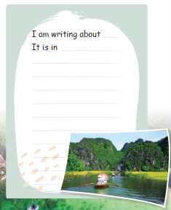  * Example:  I am writing about Ly Son island. It is a beautiful island in Quang Ngai province. And it’s not far from here . You can go there by ship . It is a pristine island with exotic seafood. Ly Son island is famous for its friendliness, long beautiful beaches, and being “the kingdom of garlic.” There you can enjoy great Vietnamese seafood; Especially King crab. You can go diving and swimming. You can join exciting activities. I think, you should have a visit to Ly Son.
3. Feedback and homework (5’)  - Repeat the main content of the lesson.  - Give out homework and guide Sts to prepare for the new lesson.  - Remind Sts to follow the traffic rules. | Homework  - Rewrite the paraghraph in your notebook.  - Rewrite the writing in the notebook.  - Prepare “ Looking back and project”

6A:09 / 12/ 2025 6B:11/ 12/ 2025 6C:10 / 12/ 2025

Period 41: Looking back and project

* Checking the attendance (1’)
6A: …………..…….. 6B: ………..……….6C: ………..……….

Teacher’s and students’ activities | Content
1. Warm-up (5’)  Aim: To revise the vocabulary related to the topic and lead in the next part of the lesson.  - Teacher divides the class into 2 big teams A and B.  - Then, teacher asks students to work in groups of 6.  - One team (team A) finds all the words related to things in nature. Another team (team B) finds all  the travel items they know.  - Teacher asks students to make a web map in 2 minutes, try to add as  many words as possible. The fastest group with the most correct answers is the winner. | * Brainstorming:  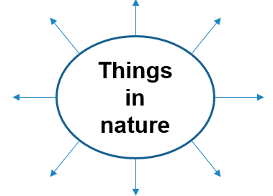  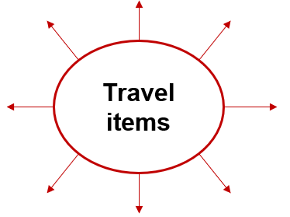  Suggested answers:  - Things in nature: desert,  forest, mountain, lake,  river, valley, cave, island,  beach,…  - Travel items: lighter,  scissors, sleeping bag,  compass, plastic,  backpack,….
Activity 1 (7’)  Aim: To help students revise the vocabulary items they have learnt in the unit.  - Teacher encourages students to complete the Activity individually.  - Teacher asks students to swap their books with their partners.  - T asks student share  - Teacher shows the answer and check.  Activity 2 (7’)  Aims: Practice matching vocabulary related to natural wonders and Help students recognize and understand words describing natural features  - Teacher asks students to work in pairs.Teacher monitors the activity lets them do it in.  -Students works in pairs  - Teacher lets each pair answer.  - Teacher checks the answers with the whole class.  Activity 3 (7’)  - Teacher asks students to do this exercise individually.  - Teacher lets students compare their answers in pairs  - Some pairs share answer  - T checks  Activity (7’)  - Teacher asks students to work independently.  - Teacher asks students to read the sentences carefully and correct the  mistakes.  - Students complete the Activity and discuss about the answers.  - Teacher gives feedback as a class discussion.  Activity (7’)  Aim: To help students revise the use of must/ mustn’t in context.  - Teacher lets students to work in pairs and complete the activity.  - Students stand up and make a role play.  - Teacher checks the answers with the whole class. | I/Vocabulary  1. Write the name for each picture. (p. 56)  Answer key:  1. waterfall  2. cave  3. desert  4. lake  5. beach  6. island  2. Match the name of a natural wonder on column A with a word indicating it in column B.  Answer key:  1. d  2. c  3. a  4. e  5. f  6. b  3. Write the words under the pictures. (p. 56)  Answer key:  1. scissors  2. sleeping bag  3. compass  4. backpack  5. plaster  II/Grammar  4: Find the mistake in  each sentence and correct  it. (p. 56)  Answer key:  1. is -> are  2. are -> is  3. instrument ->  instruments  4. are -> is  5. luggages -> luggage  5: Complete the dialogue, using must / mustn’t. (p. 56)  Answer key:  1. must  2. must  3. mustn’t  4. must  5. mustn’t
Activity 6. (6’)  Aim: To allow students to apply what they have learnt (vocabulary and grammar) into practice through a project.  - Teacher sets the context:  + Teacher will be a tourist who is looking for a dream destination to go on holiday.  + Students will be the travel agents who have to suggest the tourist by providing their travel brochure (poster).  - Teacher divides the class into groups of 6. Each group will act as a travel agency.  - Students summarise the information and design A0 size posters about the places they would like to promote.  - Teacher gives comments and feedback to all groups and awards special prize the group which has the most votes. | 3. Project  1. In groups, make a poster about a natural wonder you would like to visit. In the poster, draw / print a picture of the place. Then give some information about the place:  - what the natural wonder is  - where it is  - how you can go there  - what it is special about  - what you can do there  …  2. Introduce the attraction to your class  
3. Feedback and homework (5’)  - Repeat the main content of the lesson.  - Give out homework and guide Sts to prepare for the new lesson.  - Remind Sts to follow the traffic rules. | Homework  - Complete the project  - Prepare for the next lesson: Unit 6 ( Getting started)

UNIT 6: OUR TET HOLIDAY

I. OBJECTIVES:
By the end of this review, students will be able:
1. Knowledge
* Vocabulary:
- Memorize the words related to the topic “Our Tet Holiday” and understand the context for introductory text.
- Use the vocabulary to talk about Our Tet Holiday
* Pronunciation:
- Distinguish how to pronounce the sounds /s/ and /∫/ in words and sentences correctly.
* Grammar:
– Use should / shouldn’t for advice; some / any for amount;
* Skills:
– Read for specific information about New Year’s practices;
– Talk about what children should / shouldn’t do at Tet;
– Listen for general and specific information about preparations for Tet;
– Write an email about what children should / shouldn’t do at Tet.
* Everyday English:
– Saying New Year’s wishes.
2. Competences
- Develop communication skills and creativity
- Be collaborative and supportive in pair work and teamwork
- Actively join in class activities
# Disabled students: Identify some vocabulary about the topic Our Tet Holiday.
* Gifted students:
Students can flexibly use a wide range of vocabulary and complex structures to describe, compare, and give detailed information about Tet customs. They can communicate confidently in extended speaking and writing tasks, showing creativity and cultural appreciation.
3. Personal qualities
- Be positive toward the teacher’s lesson; Respect for teachers and classmates.
- Be willing and actively participate in Tet holiday.
II. TEACHING AIDS:
- Teacher’s aids: Grade 6 textbook, Unit 6, Getting started; Pictures; CD disk, cassette; sachmem.vn
- Students’ aids: Text books, notebooks. posters, ….
III. PROCEDURE:
6A:10 / 12/ 2025 6B:12/ 12/ 2025 6C:12 / 12/ 2025

Period 42: Getting started – Happy New Year!

* Checking the attendance (1’)

6A: …………..…….. 6B: ………..……….6C: ………..……….

Teacher’s and students’ activities | Content
1. Warm-up (5’)  Aim: To set the context for the listening and reading text. To introduce the topic of the unit.  - Teacher writes the word TET on the board and ask students to give any words relating to the topic.  - Teacher may allow students to give a Vietnamese word and asks other students in the class if they know the equivalent in English.  - Teacher writes on the corner of the board a list of the words which students cannot translate into English and asks them to keep a record for later reference when the unit finishes.  - Teacher lets students open their books and starts the lesson. | + What are there in the picture?  + What do you think about when talking about Tet?  Suggested answers:  1. There is a peach blossom / cherry blossom tree with red envelopes.  2. Lucky money, new clothes,…  - decorate houses  - eat special food  - new clothes  - get lucky money  - visit relatives
2.New lesson (35’)\  Aim: To help students get the main idea of the text.  To help students scan the text for the information to fill the blanks.  - Teacher introduces the vocabulary by:  + showing the pictures illustrating the words;  + + providing the synonym or antonym of the words.  + + providing the definition of the words  - Teacher asks students to look at the title and the picture, then gives brainstorming questions to elicit ideas without confirming answers.  - Teacher plays the recording twice while students listen, read along, and underline words related to the topic.  - Students work in pairs to read the dialogue aloud.  - Teacher asks students to say words related to Tet, writes them on the board, and gives feedback. | 1.listen and read  * VOCABULARY:  - celebrate (v): [definition] [picture]  - decorate (v): [definition] [picture]  - family gathering  (N. phr.): [definition] [picture]  - lucky money (N. phr.): [picture]    Decorate celebrate   family gathering lucky money    - peach flowers (n) : hoa đào
Activity 2 ( 3’)  Aim: To develop students’ knowledge of the vocabulary of things relating to Tet.  - Teacher asks students what exactly Phong and Linda are talking about.  - Teacher lets them read the three options carefully and see the difference among them.  - Some students anwer  - Teacher confirms the correct answer. (They are talking about Tet in Viet Nam.)  Activity 3 ( 8’)  Aims: Practice completing sentences using information from a conversation. Help students understand details about Tet. Develop reading comprehension and writing skills.  - Teacher asks students to work independently to fill each blank with the word(s) from the conversation. Teacher may instruct them how to do the exercise and model with the first sentence.  - Students work independently to fill each blank with the word(s)  - Some students share  - T checks  Activity 4 ( 7’)  Aims: Practice matching vocabulary with pictures.Help students recognize and remember words/phrases related to Tet.  - Teacher lets students look at the pictures first to see if they know the English words for them.  - Teacher then allows students to read the words / phrases in the box and do the matching.  - Teacher checks the answers as a class. | 2. What are Linda and Phong talking about? (p. 59)  1. What do you think they are talking about?  2. When is Tet?  3. Is it a holiday?  4. What do we do at Tet?  Suggested answers:  1. They are talking about Tet/ New Year.  2. It’s in January/ February.  Yes, it is. We clean our houses, decorate them, meet relatives,…  3: Complete the sentences about Tet with the information from the conversation in 1. (p. 59)  1.January  2.house  3.gathering  4.lucky money  5.break  4.Match the words/ phrases in the box with the pictures.  (p. 59)  Answer key:  1. b 2. a 3. c 4. d
Activity 5 ( 6’)  Aim: To allow students’ opportunities to recognize what is related to Tet through a fun game.  - Teacher asks students to read the instructions and example, then demonstrates the game by saying a word/phrase and asking if it’s about Tet.  - Students write down two things/activities related to Tet; teacher goes around to help if needed.  - Teacher divides the class into 2–4 teams and explains the competition rules.  - Teams compete; the team with the most correct words wins, and teacher gives feedback. | 5: Game – Is it about Tet? (p. 59)  Example 1:  Student: banh chung 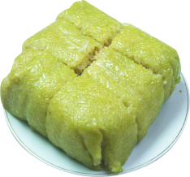  Class: It’s about Tet.  Student: flying a kite.  Class: It’s not about Tet.
3. Feedback and Homework (5’)  Aim: To prepare vocabulary for the next lesson: A closer look 1.  - Teacher lists out 10 words/ phrases you can think of when talking about Tet.  - The students can use the words from the Warm-up activity and look up the words they don’t know in English. | Homework  - Learn by heart all the new words.  - Read the dialogue again.  - Prepare lesson 2 ( A closer look 1).

DUYỆT CỦA TCM

