WEEK 3 ( CLASS: 2a4 )
Preparing date: September 20th, 2024
Teaching date: September 25th, 2024
UNIT 2: IN THE BACKYARD
Lesson 2
A.OBJECTIVES:
1. Knowledge:
- Sound /k/
- Vocabulary: review
- Sentence pattern: He’s/ She’s ________(V-ing)
- Skills: Integrated skills (speaking and listening)
2. Competences:
- Pronounce correctly pronounce the name of letter K/k and the sound /k/ in isolation.
- Correctly pronounce the words kite, kitten, bike and say the sentence pattern:
He’s/ She’s ________(V-ing) in a chant.
3. Attitude/ Qualities:
-Actively participate in activities with their classmates in pairs, groups or class. Educate Ss to become studious and obedient students, love activities, love learning
English
B. METHODS:
- Work in pairs, work in groups, ask and answer.
- Communicative approach, teaching methods with game, teaching methods by visual, teaching methods by practicing, prediction.
C. TEACHING AIDS:
- Teacher: Posters, laptop, pictures, textbook, lesson plan, TV or projector.
- Students: Textbooks, notebooks, workbooks, school things.
D. PROCEDURES:
Teacher’s activities | Students’ activities
1.Warm- up: Check-up:  *Aims: to help ss remember the words that they have learn in lesson 1.  *Procedure:  -T asks ss to say the letter and the sound they learnt in lesson 1(K/ k, /k/)  Say “Open your book page 7 and look at lesson 2”  2. New lesson  Activity 1. 3. Listen and chant:  *Aims: to correctly pronounce the words kite, kitten, bike and say the sentence pattern: He’s/ She’s ________(V-ing) in a chant.  *Procedure:  - Have ss look at the chant on p. 10 in their books and draw ss’ attention to the first line and explain its meaning. Ask them to pay attention to the letter K/ k and the words: kite, kitten, bike.Check comprehension.  - Play the recording of the first verse for Ss to listen and to get familiarized with the tune.  - Play the recording again, ask ss to listen and repeat the first line. Then play the recording for them to listen and repeat until they feel confident.  - Play the recording all the way through. Ask ss to listen and repeat the chant individually and in chorus. Give further support to those ss who find it difficult to do the task.  - Select some ss to the front of the class to chant and clap their hands. The rest of the class may sing the chant along and clap their hands.  Activity 2 4. Listen and circle:  *Aims: to recognize the words kite, kitten, bike  and the sentence pattern: He’s/ She’s ________(V-ing)  *Procedure:  -Have Ss look at two pictures and say what they can see. Draw ss’ attention to the boxes next to the letters a and b. Check comprehension.  -Encourage some ss to point to the pictures and say the words in front of the class. E.g. 1a: kite, 1b: bike  - Play the recording for ss to listen and tick the box.  - Let ss to listen again and check.  -T gets feedback.  Keys: 1.b / 2.a  Activity 3. 5. Look and write:  *Aims: to write the letter K/ k and complete the words: kite, kitten, bike  *Procedure:  - Have Ss look at the letter K (upper case) and k (lower case).  - Tell ss to trace the letter K/ k. T can demonstrate by air tracing or tracing the broken lines of the letter K/ k on the board.  -Then let ss write the letter. Then find out the missing letter to complete the correct word.  - Check the results of ss’ tracing and give feedback. Ask ss to work in pairs and swap their answers. Give ss time to work. Go around and offer help, if necessary.  - Ask some ss to show what they have done.  3. Homework:  - Practice more at home.  - Prepare for the next lesson. | - SS say the letter and the sound.  -SS open their book.  -Look at the picture and listen.  -Ss listen.  -Ss listen and repeat.  -SS listen and chant.  -SS chant in front of the class.  -Look at the picture and describe.  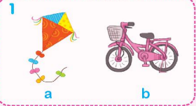  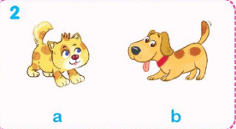  -Point and say  -SS listen and do the task.  -Ss look and listen.  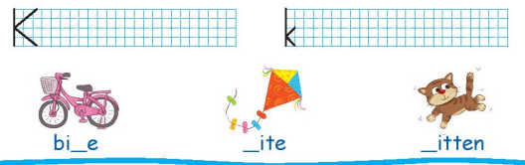  -Ss listen  -SS do the task.  -Check in pairs.  -Ss show their work.  -Ss listen.

Preparing date: September 22nd, 2024
Teaching date: September 27th, 2024
UNIT 2: IN THE BACKYARD
Lesson 3
A. OBJECTIVES:
1. Knowledge:
- Vocabulary: review
- Sentence pattern: Is she/he_______?-> Yes, she /he is. / No, she/he isn’t.
- Skills: Integrated skills (speaking and listening)
2. Competences:
- Use: Is she/he_______?-> Yes, she /he is. / No, she/he isn’t to ask and answer about actions in progress.
- Sing a song about playing in the backyard.
3. Attitude/ Qualities:
-Actively participate in activities with their classmates in pairs, groups or class. Educate Ss to become studious and obedient students, love activities, love learning English
B. METHODS:
- Work in pairs, work in groups, ask and answer.
- Communicative approach, teaching methods with game, teaching methods by visual, teaching methods by practicing, prediction.
C. TEACHING AIDS:
- Teacher: Posters, laptop, pictures, textbook, lesson plan, TV or projector.
- Students: Textbooks, notebooks, workbooks, school things.
D. PROCEDURES:
Teacher’s activities | Students’ activities
1.Warm- up: Game: Slap the board  *Aims: to help ss review some vocabulary that they learnt.  *Procedure:  -Write the words on the board  - Call 2 Ss to go to the board and ask them to slap the word when T says one word aloud.  - After finishing the game, the student slaps more correct words will be the winner.  - Say “Open your book and look at lesson 3”  2. New lesson  Activity 1. 6. Listen and repeat:  *Aims: to use: Is she/he_______? - Yes, she /he is. / No, she/he isn’t to ask and answer about actions in progress.  *Procedure:  - Have Ss look at the first picture. Play the recording for ss to listen and repeat,  - Have ss look at the sentence: Is he flying a kite? Explain the meaning of the sentence and how it is used. Check comprehension.  -Play the recording several times for ss to listen and repeat the sentence. Give more support to those ss who find it difficult to do the task.  - Invite some ss to say the sentences in front of the class.  - T checks and corrects.  Activity 2 7. Let’s talk:  *Aims: to use : Is she/he_______?-> Yes, she /he is. / No, she/he isn’t to ask and answer about actions in progress.  *Procedure:  - Have ss look at the first picture. Point to the pictures and ask them What are they doing? Tell them about actions in progress.  - Ask ss to work in pairs to practise asking and answering about actions in progress. Offer help, if necessary.  - Have ss look at the second picture. And practise in pairs.  - Ask a few pairs of ss to practise in front of the class. Offer help, if necessary.  - T gets feedback.  Activity 3. 8. Let’s sing:  *Aims: to Sing a song about playing in the backyard.  *Procedure:  - Have pupils look at the song and ask them to pay attention to the letter K/k and the word kite.  - Play the recording of the first line for pupils to listen and to get familiarized with the tune.  - Play the recording again, ask pupils to listen and repeat the first line. Then play the recording for them to listen and repeat until they feel confident.  - Follow the same procedure with the other lines. Show pupils how to chant and clap their hands.  - Play the recording all the way through. Ask pupils to listen and repeat the song individually and in chorus.  - Select some pupils to the front of the class to sing and clap their hands.  - If they sing the song well, praise them, saying Well done! or Very good.  3. Homework:  - Practice more at home.  - Prepare for Funtime1 – Part 1,2. | - Ss listen and play game  -SS open their book.  -Look at the picture and listen and repeat.  -Ss listen.  -Ss listen and repeat.  -SS say.  -Look at the picture and describe.  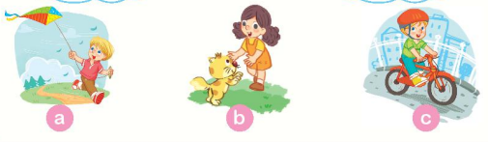  -Point and say  -SS practice in pairs.  -SS practice in front of the class.  -Ss look and listen.  -Ss listen and sing the first line  -Ss listen, sing the first line  -Ss listen, sing the other lines and clap their hands  -Ss listen and sing all the song  -Ss sing in front of the class  -SS listen.

