WEEK 3 ( From 23/9/2024 to 27/9/2024 )
( CLASS: 5a4 )
Preparing date: September 24th, 2024
Teaching date: September 25th, 2024
Unit 1: All about me!
Lesson 3 (1, 2, 3)
A. OBJECTIVES:
By the end of the lesson, Ss will be able to:
1. Knowledge:
- correctly pronounce the two-syllable words with the stress on the first syllable as ‘dolphin and ‘tennis in isolation and as in the sentences I like ‘dolphins. and He plays ‘tennis on Sundays.
- say the chant with the correct pronunciation, word stress and rhythm.
- Vocabulary: Review
- Skills: speaking, listening, reading and writing.
2. Competences:
- Communication and collaboration: work in pairs and groups to complete the learning tasks.
- Self-control and independent learning: perform pronunciation and listening tasks.
3. Attitude/ Qualities:
- Show their love and interest in sports, colours, animals and food.
B. TEACHING AIDS:
- Teacher: Teacher’s guide Pages 29, 30; audio Tracks 12, 13, 14; website hoclieu.vn, posters, laptop, pictures, textbook, lesson plan, TV or projector.
- Students: Students’ book Page 14, notebooks, workbooks, school things.
C. PROCEDURES:
Teacher’s activities | Students’ activities
1.Warm- up and review: (5’)  Game: Who is faster?  *Aims: to revise the words about countries, sports and animals.  *Procedure:  - Tell Ss they are going to look at the picture and choose the correct answer a, b or c.  - Divide the class into two teams.  - Have each team look at the picture and choose the correct answer a, b or c to fill in the blank.  - If they choose the correct answer, they get points for their team. The team with more points is the winner.  - Have pairs of pupils read the questions and answers aloud.  - Say “Open your book page 14” and look at “Unit 1, Lesson 3 (1,2,3)”.  2. Presentation (9’)  Activity 1. Listen and repeat:  *Aims: Ss will be able to correctly pronounce the two-syllable words with the stress on the first syllable as ‘dolphin and ‘tennis in isolation and in the sentences I like ‘dolphins. and He plays ‘tennis on Sundays. with the correct pronunciation and intonation.  *Procedure:  - T gives instruction to the word ‘dolphin and ‘tennis, in the sentences as I like ‘dolphins. and He plays ‘tennis on Sundays.  - Play the recording and encourage Ss to point to the word and sentence while listening  - Play the recording again and encourage Ss to listen and repeat.  - Have Ss work in pairs or groups to do this several times until Ss feel confident.  - T invites some Ss to practice.  3.Practice: (17’)  Activity 2. Circle, listen and check.  *Aims: Ss will be able to identify the stress on some two-syllable words and circle the word with a different stress pattern from the other two words.  *Procedure:  - Draw Ss’ attention to the three sets or two-syllable words.  - Tell Ss to look at the words, read them aloud and circle the word that has the stress on the first syllable.  - Tell Ss to swap books with a partner, then check the answers as a class. Write the correct answers on the board.  - Play the recording again for Ss to listen and check their answers again.  - Invite one or two Ss to stand up, listen to and repeat the words.  Key: 1.a 2.c 3.a  Activity 3. Let’s chant  *Aims: Ss will be able to say the chant with the correct pronunciation, word stress and rhythm.  *Procedure:  - Introduce the title and lyrics of the chant.  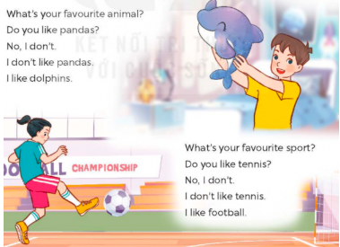  - Play the recording for Ss to listen to the whole chant.  + Have them repeat the title and lyrics line by line.  + Ask Ss to attend to two-syllable words with the stress on the first syllable in the chant, pandas, dolphins, tennis and football.  - Play the recording all the way through for Ss to listen to pronunciation and melody.  - Play the recording line by line for Ss to listen and repeat  - Play the recording for Ss to chant and clap along.  - Ask Ss to practice chant and clap along in pairs or groups.  - Invite groups to the front of the classroom to perform the chant  3. Fun corner and wrap- up (4’)  Game: Put the sentences in the correct order  - Ask the Ss to work in four groups.  - Give each group a different set of sentences and ask them to make a meaningful conversation.  - Give them enough time to do the task.  - Invite each group to present their conversation. Have the class vote the best presentation. Praise the winner. | - Ss listen  -Ss listen the rules  - Ss play the game  -Ss ask and answer  - Ss open their books  - - Ss pay attention  - Ss listen and point  - Ss listen again and repeat  -Ss work in pairs and practice  -Ss say the language in front of the class  - Ss pay attention  - Ss look at the words, read them aloud and circle the word  - Ss swap books and check the answers  - Ss listen again and check the answers again.  -Ss listen and repeat.  - Ss look and listen.  - Ss listen to the chant  - Ss listen and repeat line by line without clap their hands  - Ss note the rhythm and pronunciation.  -Ss listen to melody of the chant  - Ss listen and chant line by line.  - Ss chant and clap along.  - Ss work in groups (two groups) to chant  -Ss perform in front of the class.  -Ss listen  -Ss play the game  Ex:  Nam: Do you like pandas?  Mai: No, I don’t.  Nam: What’s your favourite animal?  Mai: It’s a dolphin.

Preparing date: September 24th, 2024
Teaching date: September 25th, 2024
Unit 1: All about me!
Lesson 3 (4, 5, 6)
A. OBJECTIVES:
By the end of the lesson, Ss will be able to:
1. Knowledge:
- read two paragraphs and circle the correct options.
- make questions and answers about personal information and favourite things.
- revise the target language by making a poster and presenting it to the class.
- Vocabulary: Review
- Skills: speaking, listening, reading and writing.
2. Competences:
- Communication and collaboration: work in pairs and groups to complete the learning tasks.
- Self-control and independent learning: perform reading and writing tasks.
3. Attitude/ Qualities:
- Show their love and interest in sports, colours, animals and food.
B. TEACHING AIDS:
- Teacher: Teacher’s guide Pages 31, 32; website hoclieu.vn, posters, laptop, pictures, textbook, lesson plan, TV or projector.
- Students: Student’s book Page 15, notebooks, workbooks, school things.
C. PROCEDURES:
Teacher’s activities | Students’ activities
1.Warm- up and review: (5’)  Game: “Jumping”  *Aims: to review the leart vocabulary *Procedure  - Stick the flash cards (football, table tennis, Japan, England, dolphin, giraffe) on the board.  - Tell Ss they are going to play the game “Jumping”.  + If the teacher reads a word that is the same as a flash card on the board, Ss jump.  + If it is not, they keep still. Ask them to say the word on the flash card.  - Ask Ss to stand at their desks.  - Hold up a flash card from the vocabulary set and say a word. Have Ss play the game.  - Afterwards, raise all the flash cards for Ss to say the words.  - Say “Open your book page 15” and look at “Unit 1, Lesson 3 (4,5,6)”.  2.Practice: (8’)  Activity 1. Read and circle:  *Aims: Ss will be able to read two paragraphs and circle the correct options.  *Procedure:  - Draw Ss’ attention to the two paragraphs and read them as a class.     - Draw Ss’ attention to the incomplete sentences and answer options.  + Have Ss pay attention to the sentences about personal information of Tom and Lan. + Have Ss read the text again and circle the correct answers.  - Tell Ss to swap books with a partner, then check answers as a class. Write the correct answers on the board.  - Get Ss to look at the board and check their answers again.  + If time allows, ask Ss to read the paragraph aloud in front of the class.  Key: 1. b 2. c, 3. b, 4. a  3.Production: (18’)  Activity 2. Let’s write  *Aims: Ss will be able to complete a paragraph with students’ personal information and favourite things  *Procedure:  - Tell Ss the goal of this activity  - Write the sentence with the first gap on the board: My name is ____, ask Ss to identify the information needed to complete the gap (their names) and encourage Ss to say the whole sentence (ex: My name is Huong.).  - Give Ss time to complete the sentences.  - If time allows, invite a few Ss to read the sentences they have completed in front of the class.  Key: Pupil’s answer  Ex: My name is Huong. I live in the countryside. I am in Class 5D. My favourite sport is running. My favourite food is fish and vegetables. My favourite colour is yellow. My favourite animal is a rabbit.  What about you? What are your favourite things?  Activity 3. Project.  *Aims: Ss will be able to revise the target language by making a poster about favourite things and presenting it to the class.  *Procedure:  - Tell Ss the goal of this activity.  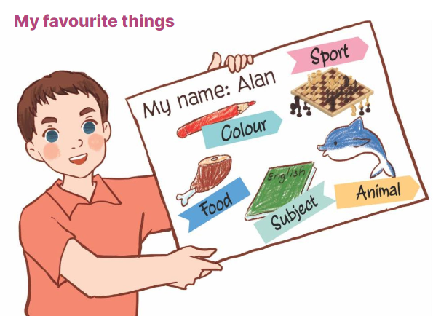  - Have Ss work in groups of five.  + Each student shows his / her poster that he / she has made at home and tells the group about their favourite things, ex: My favourite sport is chess. My favourite food is chicken.  - Invite some Ss to show their work and talk about their favourite things in front of the class.  4. Fun corner and wrap- up (4’)  Game: Number race  - Divide the class into two groups.  - Give each student in one group a number so that each group has equal numbers.  - Ask the questions, ex: What’s your favourite animal, and allow time for Ss to think.  + Then call out a number, have Ss with that number from each group stand up and say the answers, ex: It’s a monkey. Ss are not allowed to give the same answers as their friends.  - Praise and give points for the groups.  - The group with more points wins the game. | - Ss listen  - Ss listen to the rules  -Ss play game  Ex: if the word “England” is the same as the flash card “the flag of England”, ss jump. If it isn’t, they keep still.  - Ss open their books  - Ss pay attention to the two paragraphs and read them as a class.  - Ss look at the incomplete sentences and answer options.  - Ss read the text again and circle the correct answers.  - Ss swap books with a partner, then check answers as a class.  - Ss look at the board and check their answers again.  -Ss read the paragraph aloud  -Ss listen and pay attention  - Ss read the sentence and identify the information needed to complete.  - Ss complete the other sentences.  - A few Ss read the sentences they have completed in front of the class.  - Ss listen  - Ss work in groups of five.  + Ss show his / her poster and tells the group about their favourite things.  - Ss show their work and talk about their favourite things in front of the class.  -Ss listen to the teacher  -Ss play the game  -Ss congratulate the winner

Preparing date: September 24th 2024
Teaching date: September 27th, 2024
Unit 2: Our homes
Lesson 1 (1, 2, 3)
A. OBJECTIVES:
By the end of the lesson, Ss will be able to:
1. Knowledge:

- use the words building, flat, house, tower and the numbers 23, 38, 93, and 116 in relation to the topic “Our homes”

- correctly say the words and use Do you live in this / that……...? – Yes, I do. / No, I don’t. to ask and answer questions about someone’s home

- use Do you live in ____? – Yes, / No, ____. in a freer context.
- Vocabulary: flat, tower.
- Structures:
A: Do you live in this / that building?
B: Yes, I do. / No, I don’t
- Skills: speaking and listening
2. Competences:
- Critical thinking and creativity: learn how to ask and answer questions about personal information correctly and fluently.
- Self-control and independent learning: perform pronunciation and speaking tasks.
3. Attitude/ Qualities:
- Show their pride in their personal information and where they live.
B. TEACHING AIDS:
- Teacher: Teacher’s guide Pages 33, 34 35, audio Tracks 15, 16, website hoclieu.vn, posters, laptop, pictures, textbook, lesson plan, TV or projector.
- Students: Students’ book Page 16, notebooks, workbooks, school things.
C. PROCEDURES:
Teacher’s activities | Students’ activities
1.Warm- up and review: (3’)  Sing a song: Where do you live?*Aims: to create a friendly and active atmosphere in the class to beginning the lesson.  *Procedure:  - Show the song on the screen.  https://www.youtube.com/watch?v=GlYJKcbpVdw  - Ask Ss to listen, sing and dance the song  - Say “Open your book page 16” and look at “Unit 2, Lesson 1 (1,2,3)”.  2. Presentation (15’)  Activity 1. Vocabulary.  *Aims: Ss will be able to know the vocabulary in the new lesson.  *Procedure:  -T elicits the new words  + flat : căn hộ (picture)  + tower : tòa tháp (picture)  - T models (3 times).  - T writes the words on the board.  - Checking: Rub out and remember  Activity 2. Look, listen and repeat:  *Aims: Ss will be able to understand and correctly repeat the sentences in two communicative contexts focusing on greetings, and asking and answering questions about someone’s home.  *Procedure:  - Have Ss look at Pictures a and b and identify the characters in the pictures.  + Who is he/ she?  + Where is he/ she?  + What are they talking about?  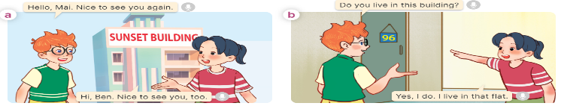  - Play the audio twice (sentence by sentence). Correct their pronunciation where necessary.  - Have Ss to practice the dialogue  - T invites a few pairs to the front of the class to practice.  - T checks pronunciation for ss.  Activity 3 Listen, point and say.  *Aims: Ss will be able to correctly say the words and use Do you live in this / that...? – Yes, I do. / No, I don’t. to ask and answer questions about someone’s home.  *Procedure:  * Structures:  - T asks Ss look at picture b in activity 1 and helps Ss know the structure from the dialogue.  - T introduces new structures for Ss.  - T explains, models and gives meaning.  - Have Ss repeat the model sentences.  A: Do you live in this / that building?  B: Yes, I do. / No, I don’t  3.Practice: (7’)  *Drill pictures  - Have Ss look at the pictures and say what they can see in the pictures.  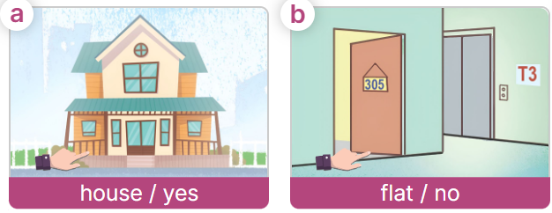  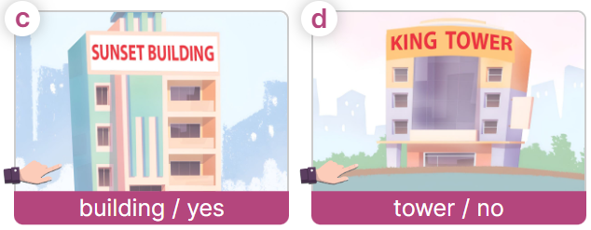  - Have Ss point at pictures, listen and run through all the pictures.  - Have Ss point at the bubbles, listen and run through model sentences.  - Have Ss to practise:  + T asks the first picture, Ss answer  + Ss asks the second picture, T answers  + Group A asks the third picture, group B  answers  + Group B asks the last picture, group A  - Ask Ss to work in pairs to practise asking and answering the question Do you live in this / that ……….?- Yes, I do. / No, I don’t  - T controls and corrects.  - Invite a few pairs to point at the pictures and say the questions and answers in front of the class.  4. Production: (6’)  Activity 4. Let’s talk.  *Aims: Ss will be able to use Do you live in this / that …..?- Yes, I do. / No, I don’t in a freer context.  *Procedure:  - Draw Ss’ attention to the picture  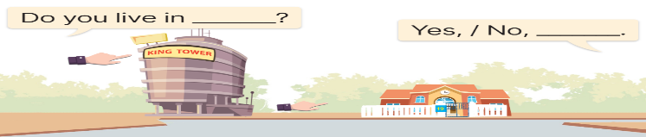  - Elicit the answer in the speech bubble and write it on the board. Get Ss to say the completed sentences.  - Have Ss role-play to practise asking the questions and giving their answers in pairs, using the picture cue.  - Invite a few pairs to point at the pictures and ask and answer questions.  5. Fun corner and wrap- up (4’)  Game: Lucky Letter  - Divide the class into 2 teams.  - Each team takes turns to choose a letter, then asks and answers using the clues shown on the screen and gets points for their teams. | - Sing and dance the song together.  - Ss listen and open their books  -Ss listen and answer  - - Ss listen and repeat  + Choral repetition (3 times).  + Individual repetition (3 ss)  - Ss take note  - Ss look, remember and write  -Look at the pictures and say.  + In picture a:  Ben: Hello, Mai. Nice to see you again.  Mai: Hi, Ben. Nice to see you, too.  + In picture b:  Ben: Do you live in this building?  Mai: Yes, I do. I live in that flat.  -Ss listen and repeat in chorus (twice)  -Ss work in pairs to practice  -Ss come to the front of the classroom to practice.  -Ss listen  - Ss look at the picture and answer.  -Ss listen  -Ss listen and repeat  -Ss repeat to the structures  - Ss look, listen and repeat  +Picture a: a ﬁnger pointing to a nearby house  + Picture b: a ﬁnger pointing to a nearby ﬂat.  + Picture c: a ﬁnger pointing to a building far away  + Picture d: a ﬁnger pointing to a tower far away  -Ss point at pictures, listen and repeat  -Ss point at the bubbles, listen and repeat  -Ss practice in chorus  -Ss practice in chorus  -Ss work in pairs to practise asking and answering the questios  - Pairs of Ss point at the pictures and say in front of the class  -Ss look at the picture and say  + Types of homes: a tower and a house  - Ss say the completed sentences.  -Ss work in pairs to ask and answer  A: (points at King Tower)  Do you live in this tower?  B: No, I don’t. I live in a house in the countryside.  A: (points at the house)  Do you live in that house?  B: Yes, I do. It’s my house.  -Ss perform in front of the class.  - Ss listen  -Ss listen and play the game

Preparing date: September 24th, 2024
Teaching date: September 27th, 2024
Unit 2: Our homes
Lesson 1 (4, 5, 6)
A. OBJECTIVES:
By the end of the lesson, Ss will be able to:
1. Knowledge:
- listen to and understand four communicative contexts in which speakers ask and answer questions about their homes and number the pictures
- complete four gapped exchanges with the help of picture cues
- reinforce understanding of the words and sentences related to the topic “Our homes” by playing Guessing game.
- Vocabulary: Review
- Skills: speaking, listening, reading and writing.
2. Competences:
- Communication and collaboration: work in pairs and groups to complete the learning tasks.
- Self-control and independent learning: perform listening and reading tasks.
3. Attitude/ Qualities:
- Show their pride in their personal home and address.
B. TEACHING AIDS:
- Teacher: Teacher’s guide Pages 36, 37; audio Tracks 17; website hoclieu.vn, posters, laptop, pictures, textbook, lesson plan, TV or projector.
- Students: Student’s book Page 17, notebooks, workbooks, school things.
C. PROCEDURES:
Teacher’s activities | Students’ activities
1.Warm- up and review: (5’)  Game: “Pass the teddy bears”  *Aims: to revise the learned sentence structures.  *Procedure:  - Give two different colored teddy bears to two Ss, a black teddy bear (ask the question) and a white teddy bear (answer the question).  - Ask Ss to listen to music and pass the teddy bears.  - Stop music suddenly. Have the student with a black teddy bear make a question. Have the student with a white teddy bear answer the question.  - Repeat the game several times.  - Say “Open your book page 17” and look at “Unit 2, Lesson 1 (4,5,6)”.  2.Practice: (25’)  Activity 1. Listen and number:  *Aims: Ss will be able to listen to and understand four communicative contexts in which speakers ask and answer questions about their homes and number the pictures.  *Procedure:  - Elicit and ask questions to elicit the home in the pictures  + What can you see in this picture?  + Is it a house?  + Is it a tower?  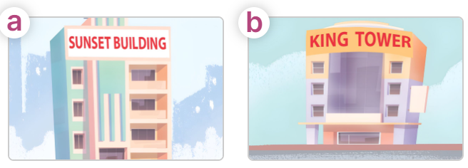  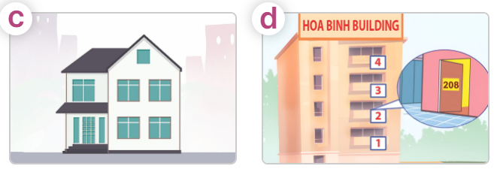  - T ask Ss to guess the answers.  + T writes Ss’guessing on the board.  - Listen to the tape:  + Play the recording  + Play the recording again for pupils to do the task.  + Play the recording a third time for pupils to check their answers.  - Get Ss to swap books with their partner, then check answers as a class.  + Write the answers on the board for Ss to correct their answers. Then checks Ss’ guessing.  - If time allows, play the recording, sentence by sentence, for Ss to listen and repeat individually and in chorus Key: 1. c 2. d 3. b 4. a  Activity 2. Read and complete.  *Aims: Ss will be able to read and complete four gapped exchanges with the help of picture cues.  *Procedure:  - Have Ss read the question and answer, and guess the missing word in the question.  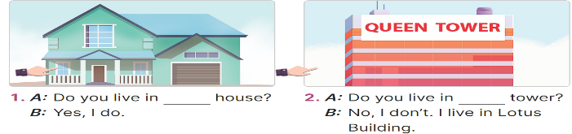  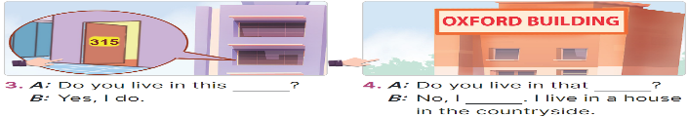  - Have Ss look at the four incomplete exchanges and elicits the missing words in the sentences.  - T models with sentence 1  + Have Ss look at the picture and identify the needed information (this).  - Have Ss work in groups and complete the exchanges 2, 3 and 4.  - Get Ss to swap books with a partner and check their answers before checking as a class.  - Invite four pairs of Ss to act out the four completed exchanges in front of the class  Key: 1. this 2. that 3. flat  4. building; don’t  Activity 3. Let’s play.  *Aims: Ss will be able to play a guessing game to reinforce the words and sentences related to the topic. *Procedure:  - Introduce and explain how to play the game.  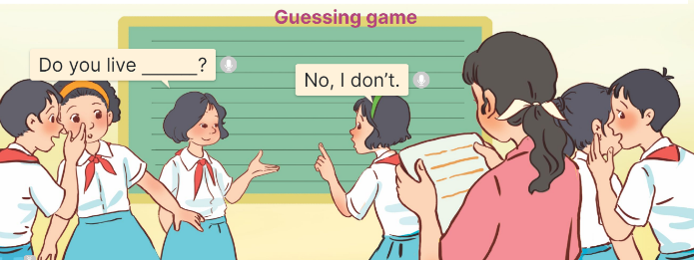  + The class is divided into groups A and B. Each member in Group A and B writes a question to guess the home type that his / her counterpart in the other group lives in. Their work should be written on paper slips and handed to the teacher when the time limit is over.  + After that, the teacher invites two groups at random to interact using the questions and answers.  - Give Ss a time limit for the class to prepare for the game.  - When the time is over, nominate a pair from different groups to check their interaction. Have the counterpart group stand up at their places, make the guesses, and encourage the rest of pupils to cheer up whenever the guess is correct.  3. Fun corner and wrap- up (5’)  Game: Slap the board  - Ask Ss if they remember the words and sentence structures to ask and answer questions about someone’s homes.  - Show the questions and answer choices on the screen.  - If the screen is not big enough, teachers write A, B, C on the board. | - Ss listen  - Ss play the game  - Ask and answer the question  Ex: A: Do you live in this house?  B: Yes, I do.  - Continue playing the game.  - Ss open their books  -Look at the pictures and say:  + Picture a: Sunset Building  + Picture b: King Tower  + Picture c: a two-floor private house  + Picture d: Hoa Binh Building  -Ss guess the answers  - Ss listen to the tape  - Ss listen again and do the task.  - Ss listen and check their answers  - Ss swap books with their partner, then check answers as a class  -Ss check their guesing  -Ss listen and repeat  -Ss look at the picture and identify personal information in each picture.  -Ss look and follow the teacher demonstrating the exchange 1.  -Ss answer: (Do you live in this house?)  -Ss complete the sentences  -Ss swap books with a partner and check their answers before checking as a class.  -Ss read the completed exchanges aloud.  - Ss listen and pay attention  - Ss work into groups A and B.  - Ss follow the teacher’s instructions.  - Ss prepare for the game.  - Ss play the game.  - Ss cheer up whenever the guess is correct.  - Ss say the words and sentence structures.  - Ss look at the questions, read and slap the correct answers.  - Ss continue playing the game.

