Period | Class | Date of teaching
17 | 11A | 08/10/2024
 | 11B | 07/10/2024
 | 11C | 03/10/2024

UNIT 2: GENERATION GAP
Lesson 3.2 – Speaking & Writing, page 23
1. Objectives
By the end of this lesson, students will be able to…
1.1. Language knowledge/ skills
- practice giving supporting evidence in body paragraphs.
- write an essay to show what generations can show each other.
- talk about what generations can show each other.
1.2. Competences
- improve Ss’ communication, collaboration, analytical, and critical thinking skills.
1.3. Attributes
- develop their sense of responsibility
2. Teaching aids and materials
- Teacher’s aids: Teacher’s aids: Student’s book and Teacher’s book, class CDs, DCR– Phần mềm tương tác trực quan, DHA – Ứng dụng trò chơi tương tác, projector / interactive whiteboard /TV (if any), PowerPoint slides.
- Students’ aids: Student’s book, Workbook, Notebook.
3. Assessment Evidence
Performance Tasks | Performance Products | Assessment Tools
- Read the essay again and underline the extra supporting details and circle the examples in each body sentence  - Read the sentences and write D for details, E for examples, and O for opinions.  - Talk about what different generations can learn from each other.  - Write an essay about what skills and knowledge different generations  have or could share with each other. | - Ss’ answers.  - Ss’ answers.  - Ss’ answers.  - Ss’ answers. | - Observation.  - Observation.  - Feedback  - Checking.
4. Procedures
A. Warm-up: 3’
a. Objective: to review lesson 3.1 and lead in the new lesson.
b. Content: ordering sentences activity.
c. Expected outcomes: Ss can put the sentences of a passage in a logical order.
d. Organization
Teacher’s activities | Students’ activities
Ordering sentences  - Ask Ss to work in pairs, putting the sentences below in the correct order:  a. My neighbor could teach me how to fish using a spear, which I think would be a really cool thing to learn.  b. I think I would really enjoy learning how to do it, as well as learning a lot of other useful skills from people with more life experience than me.  c. Older generations could teach me lots of skills, such as teaching me interesting and useful outdoor and survival skills.  - Call some pairs to give their answers.  - Give feedback. | -Work in pairs, putting the sentences below in the correct order.  -Give answers.  Answer keys:  1.c 2.a 3.c
B. New lesson (37’)
1. Pre-writing: 20’
a. Objectives: to help Ss know the structure of body paragraphs and get ideas for the writing task.
b. Content: writing skills: tasks a & b; speaking: tasks a & b.
c. Expected outcomes: Ss can give supporting evidence correctly.
d. Organization
Teacher’s activities | Students’ activities
Writing skills:  Task a: Read about giving supporting evidence in body paragraphs. Then, read the essay again and underline the extra supporting details and circle the examples in each body sentence.  - Ask Ss to read about giving supporting evidence in body paragraphs and answer the questions:  a) How many parts are there in a paragraph?  b) What’s the function of each part?  - Elicit answers from Ss.  - Give feedback.  Read the essay again and underline the extra supporting details and circle the examples in each body sentence.  -Have Ss read the essay again and underline the extra supporting details and circle the examples in each body sentence.  - Pick some Ss to go to the board and do the task.  - Give feedback. | - Work in pairs to make a list of festivals in Vietnam and their activities as well as traditional food  - Give answers.  Answer keys:  1) Three parts: topic sentence, supporting evidence, and closing sentence.  2) Topic sentence: tells the reader the key point of the paragraph  Supporting evidence: First, give extra details and examples to support your main point. Then, give your opinion about it.  Closing sentence: restates the topic sentence using different words and gives a final thought on the main point.  -Read the essay again and underline the extra supporting details and circle the examples in each body sentence.  - Go to the board and do the task.  - Check answers.  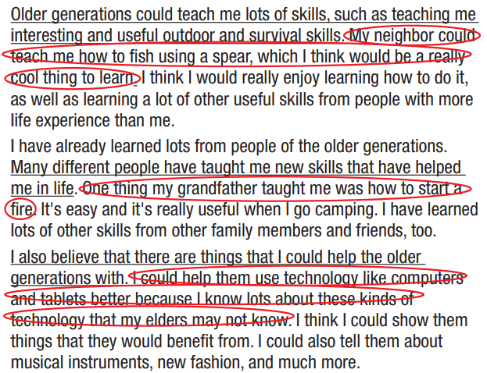
Task b: Read the sentences and write D for details, E for examples, and O for opinions.  1. I think I would really enjoy learning to change a tire. ______  2. My father taught me how to play chess. __  3. I could learn how to put up a tent. ______  4. I can show the older generations how to use social media. ______  5. I showed my grandmother how to put on make-up. ______  - Have Ss read the sentences and write D for details, E for examples, and O for opinions.  - Pick some Ss to give their answers.  - Give feedback. | - Read the sentences and write D for details, E for examples, and O for opinions.  - Give their answers.  - Check answers.  Answer keys:  1–O 2–E 3–D 4–D 5–E
Speaking  Task a. In pairs: You're discussing what different generations can learn from each other. First, talk about some things you have learned or could learn from older people. Then, talk about some things you have shown or could show older people.  - Have Ss work with their partners to do the task.  - Pick some pairs to share their ideas.  - Give feedback.  Task b. Choose and note 2–3 things you have or could learn from the older generations, and at least one thing you could or have helped them with. Give examples or extra opinions for each idea.  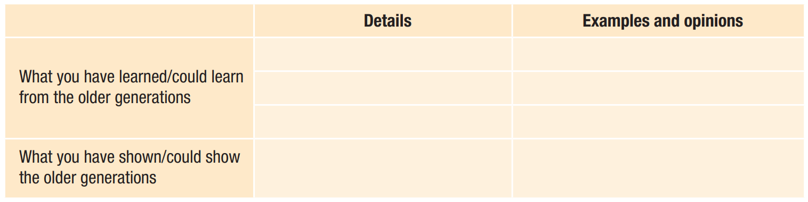  - Have Ss work with their partners to complete the table.  - Pick some pairs to share their ideas.  - Give feedback. | - Work with their partners to do the task.  - Share their ideas.  - Work with their partners to complete the table.  - Share their ideas.
2. While-writing: 15 minutes
a. Objectives: to help Ss to practice writing an essay about what skills and knowledge different generations have or could share with each other.
b. Content: Let’s write.
c. Expected outcomes: Ss can produce an essay.
d. Organization
Teacher’s activities | Students’ activities
Let’s write: Now, write the announcement  for the festival you planned in Speaking. Use the Writing Skill box and your speaking notes to help you. Write 80 to 100 words.  - Assign the task.  - Give Ss some time to write.  - Monitor the class and help them if necessary. | - Write an essay.
3. Post-writing
a. Objectives: To help Ss check their essay.
b. Content: peer check and teacher’s correction.
c. Expected outcomes: Ss can help check the essay.
d. Organization
Teacher’s activities | Students’ activities
-Have Ss exchange their essay.  -Ask Ss to check their friends’ essays by underlining spelling or grammar mistakes.  -Have Ss return their friends’ essays for correction.  - Pick some Ss to show their writing and give feedback.  - Show sample essay. | -Exchange their essay  -Check their friends’ essays by underlining spelling or grammar mistakes.  - Correct their essay.  - Show their writing.  Sample passage:  Older and younger generations can teach each other a lot. We both know things that the other doesn’t.  I could learn a lot from the older generations. They could show me how to plan effectively. My uncle ran a business for many years, so he knows how to plan well. I would find it really useful. I think there’s much more they could  teach me as well.  I have learned from the older generation already. My grandpa has taught me a lot. He showed me how to fix a flat tire on a motorbike. I think it is a really useful skill that will help me in the future. I have learned lots of other skills, too.  I could also teach the older generation. I know a lot about social media. I could show them how to set up their own accounts. I think they would like to communicate more. There’s much more I could teach them, too.  I should spend more time with the older generations. We all have a lot to learn.

C. Consolidation and homework assignments: 5’
* Consolidation
- Review the structure of a paragraph.
* Homework
- Do exercises in the workbook on page 13.
- Play the consolidation games in Tiếng Anh 11 i-Learn Smart World DHA App on www.eduhome.com.vn
- Prepare the next lesson: Unit 3 – Lesson 1.1 - Vocab. & Listening (pages 24 & 25).
5. Reflection

a. What I liked most about this lesson today:
…………………………………………………………………………………………
b. What I learned from this lesson today:
…………………………………………………………………………………………
c. What I should improve for this lesson next time:
…………………………………………………………………………………………

