Planning date:21/9/2025
Teaching date: 25/9/2025

UNIT 2: CITY LIFE
PERIOD 9 Lesson 1: Getting started – How is your city?

I. OBJECTIVES
By the end of this lesson, Ss will be able to:
1. Knowledge
- Gain an overview about the topic City life
- Gain vocabulary to talk about life in the city
2. Competences
- Develop communication skills
- Be collaborative and supportive in pair work and teamwork
3. Personal qualities
- Actively participate in class
- Develop self-study skills
II. MATERIALS
- Grade 9 textbook, Unit 2, Getting started
- Computer connected to the Internet
- Projector / TV
- hoclieu.vn
III. PROCEDURES
Activity 1: WARM-UP (5’)
a. Aims:
- To set the context for the introductory dialogue;
- To introduce the topic of the unit.
b. Content:
- Students play a game: Debate (Write about City advantages and disadvantages.)
c. Expected outcomes:
- Students know to topic of the unit and be ready for the conversation.
d. Organisation :
Teacher’s and Ss’activities | Content
Game:  - Divide the class into Advantages team and Disadvantages team.  - Give them time (2 minutes) to research and prepare arguments supporting their assigned stance before engaging in a structured debate.  - They have two minutes to debate. After that, T gives feedback and leads into the new lesson: City Life. | Game: Debate  - You have 2 minutes think about City advantages and disadvantages.
  Advantages team | Disadvantages team.
  - a lot of fashionable shops | - traffic jams/ traffic congestion
Activity 2: PRESENTATION (10’)
a. Aims:
- To provide students with vocabulary;
- To help students be well-prepared for the listening and reading tasks.
- To help Ss read for specific information about How is your city?;
b. Content:
- Vocabulary pre-teaching
- Task 1: Listen and read.
c. Expected outcomes:
- Students can identify some new words about city.
d. Organisation:
*Vocabulary pre-teaching
Teacher’s and Ss’activities | Content
- Teacher explains the meaning of the new vocabulary by pictures.  - Students guess the meaning of words.  - Teacher reveals that the words corresponding to the pictures will appear in the reading text and asks students to open their textbook to find these words.  - Teacher introduces the vocabulary.  - Teacher checks students’ understanding with the “Rub out and remember” technique.  - Teacher checks students’ pronunciation and gives feedback. | * New words:  1. traffic jam (n): kẹt xe  2. congested (adj): tắc nghẽn (giao thông)  3. construction site (n): công trường xây dựng  4. grand (adj): hoành tráng  5. pricey (adj): đắt đỏ  6. underground (n): hệ thống tàu ngầm  7. unreliable (adj): không dáng tin  8. itchy (adj): ngứa, gây ngứa  9. downtown (n): khu trung tam thành phố
Task 1
Teacher’s and Ss’activities | Content
Task 1  - Ask Ss to look at the pictures on page 18 and answer the questions below:  - Look at the pictures and answer the questions.  - Elicit answers from Ss.  - Ask Ss to read the first exchange in the introductory dialogue. Elicit from Ss that Trang and Ben are living in different cities, and Ben is in London.  -Tell Ss that they will listen to and read the dialogue. Play the recording twice for Ss to listen and read along. The second time, have Ss underline the words that are related to the topic of the unit.  - Ss listen to the recording.  - Ss underline the words that are related to the topic.  - Invite some pairs of Ss to read the conversation aloud.  - Have Ss say the words in the text that they think are related to the topic City life. | * Questions:  1. What do you see in each picture?  2. Are the things in the pictures common in your hometown?  * Possible answers:  traffic jam / traffic congestion, …..  Task 1: Listen and read:  The dialogue on page 19.  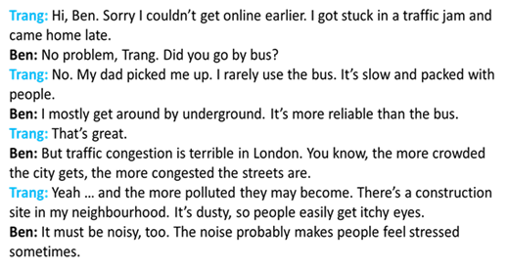
Activity 3: PRACTICE (20’)
a. Aims:
- To help Ss read for specific information about How is your city?;
- To help Ss learn words and phrases related to How is your city?;
- To help Ss use the words in context.
b. Content:
- Task 2: Read the conversation again and tick T (True) or F (False).
- Task 3: Match the words/ phrases with their pictures.
- Task 4: Choose the correct answer A, B, C, or D
c. Expected outcomes:
- Students understand the conversation and topic of the lesson and can complete the tasks successfully.
d. Organisation:
Teacher’s and Ss’activities | Content
Task 2  - Tell Ss to read the conversation again and work independently to find the answers. Remind Ss to underline the information and correct the false statements.  - Ss compare their answers in pairs before checking as the whole class.  - Call on some Ss to give the answers.  - T gives feedbacks | Task 2: Read the conversation again and tick T (True) or F (False).  * Answer key:  1. T  2. F  3. T  4. F  5. T
Task 3  - Have Ss work individually to match the phrases with the appropriate pictures.  - Ss work individually to do exercise.  - Have them compare their answers with a partner.  - Invite some Ss to go to the board and write their answers.  - Confirm the correct answers.  - Choose some good students to make sentences with the words/ phrases. | Task 3: Match the words/phrases with their pictures.  * Answer key:  1. b  2. c  3. a  4. e  5. d
Task 4  - Ask Ss to complete the task with a partner.  - SS complete the task in pairs.  - Check answers as a class. Confirm the correct answers. Explain or ask Ss to explain the correct choices. | Task 4: Choose the correct answer A, B, C, or D  * Answer key:  1. A  2. C  3. B  4. C  5. D
Activity 4: PRODUCTION (5’)
a. Aims:
- To help Ss identify some common differences between living in a city and in a village;
- To check students’ vocabulary and improve group work skills.
b. Content:
- Task 5: Complete a quiz to guess which type of life suits more, city life or village life.
c. Expected outcomes:
- Students can know which type of life suits them more, city life or village life.
d. Organisation:
Teacher’s and Ss’activities | Content
Task 5  - Have Ss compare their choices with their friends. They can ask each other to guess which type of life suits them more, city life or village life.  - Tell Ss that in general, options A in all sentences describe common things in a city while options B are more often related to life in a village.  - Take a show of hands to see which option is most popular.  - Ss work in groups and talk about the differences between living in the city and living in the countryside. | Task 5: Quiz: A lifestyle survey: City life or Village life?  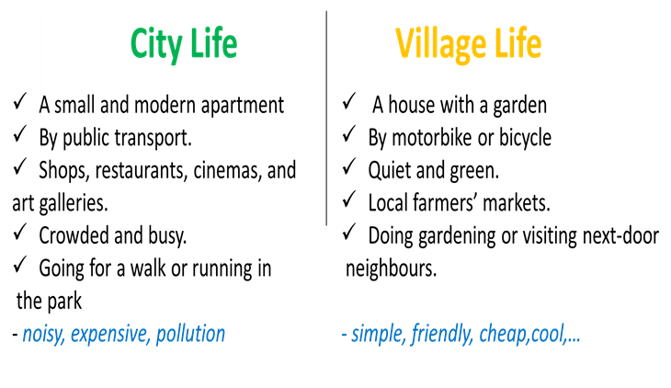
Activity 5: Consolidation (3’)
a. Aims: To consolidate what students have learnt in the lesson.
b. Content: Talk about what they have learnt in the lesson
c. Expected outcomes: Say aloud some words they remember from the lesson.
d. Organisation:
Teacher’s and Ss’activities | Content
- Ask one or two Ss to tell the class what they have learnt.  - Ask Ss to say aloud some words and phrases they remember from the lesson | Understand the conversation and know the vocabulary related to the topic.
* Homework (2’)
a. Aims: To revise the lesson and prepare for the next lesson.
b. Content: Review the lesson and prepare for the next lesson and do exersie in the workbbook
c. Expected outcomes: Students’ textbook and workbook
d. Organisation:
Teacher’s and Ss’ activities | Content
- Teacher asks students to talk about what they have learnt in the lesson.  - Ss work indepently | - Learn by heart all the new words.  - Read the dialogue again.  - Prepare the vocabulary for the next lesson: A closer look 1.  - Start preparing for the Project of the unit.
*******************************************************************
Planning date:
Teaching date:

UNIT 2: CITY LIFE
PERIOD 10 Lesson 2: A closer look 1

I. OBJECTIVES
By the end of this lesson, Ss will be able to:
1. Knowledge
- Use the lexical items related to the topic City life
- Pronounce the diphthong sounds /aʊ/, /əʊ/, and /eə/ in words and sentences correctly
2. Competences
- Be collaborative and supportive in pair work and teamwork
- Access and consolidate information from a variety of sources
3. Personal qualities
- Actively participate in class and school activities
- Develop self-study skills
II. MATERIALS
- Grade 9 textbook, Unit 2, A closer look 1
- Computer connected to the Internet
- Projector / TV
- hoclieu.vn
III. PROCEDURES
Activity 1: Warm-up (5’)
a. Aims:
- To create an active atmosphere in the class before the lesson.
- To lead into the new lesson.
b. Content:
- Game: Emoji / pictures Quiz
c. Expected outcomes:
- Students get some vocabulary from the lesson and be ready for the lesson.
d. Organisation:
Teacher’s and Ss’activities | Content
Game: Emoji / pictures Quiz  - Divide class into teams.  - Ss work in teams and follow the teacher's instruction to play the game.  - Each round, one student from each team stands up.  - You will show some emojis one by one.  - Their goal is to try to guess the secret word from the emojis and make a sentence using that word.  - Once a student answers correctly, he /she gets a point for their team.  - The team with the most points at the end of the game wins. | Game: Emoji / pictures Quiz  * Words:  1. bus driver  2. underground  3. itchy eye  4. downtown  5. traffic jam  6. construction site
Activity 2: PRESENTATION
* Pre teach vocabulary (8 ’)
a. Aims:
- To provide students new vocabulary;
b. Content:
- Vocabulary pre-teaching
c. Expected outcomes:
- Students can identify some vocabulary about City life and use them in different contexts.
d. Organisation:
Teacher’s and Ss’activities | Content
- Introduce the vocabulary by:  + providing explanations of the words  + showing pictures illustrating the words.  - Guess the meaning of words.  -Teacher checks students’ understanding with the “Rub out and remember” technique.  - Teacher checks students’ pronunciation and gives feedback. | * New words:  1. concrete jungle (n): rừng bê tông  2. metro (n): hệ thống tàu điện ngầm  3. public amenities: tiện ích công cộng  4. commuter (n): người đi làm  5. pickpocketing (n): móc túi  6. suburb (n): ngoại ô  7. bustling (adj): hối hả, nhộn nhịp  8. liveable (adj): một cách đáng sống
Activity 3: PRACTICE (17’)
Task 1,2,3
a. Aims:
- To revise some vocabulary related to City Life.
- Use the lexical items related to the topic City life;
b. Content:
- Task 1: Match the words / phrases with their explanations.
- Task 2: Choose the correct answer A, B, C, or D to complete each sentence.
- Task 3: Complete the texts, using the words and phrases from the box.
c. Expected outcomes:
- Students can identify some vocabulary about City life and use them in different contexts.
d. Organisation:
Teacher’s and Ss’activities | Content
Task 1  - Tell Ss to work in pairs and match the words / phrases with their explanations.  - Ss work in pairs to do task 1 p.20  - Check and confirm the correct answers.  - Have the whole class read aloud the words/phrases again. | Task 1: Match the words / phrases with their explanations.  * Answer key:  1. c  2. b  3. e  4. a  5. d
Task 2  - Tell Ss to do this exercise individually. Tell them to read all the sentences carefully to make sure they understand the sentences and choose the correct option.  - Ss do exercise individually  - Have them compare their answers with a partner.  - Invite some Ss to give the answers and confirm the correct ones. Explain the options that might be challenging to Ss. | Task 2: Choose the correct answer A, B, C, or D to complete each sentence  *Answer key:  1. A  2. D  3. B  4. A  5. C
Task 3  -Tell them to work in pairs and choose the appropriate words to complete the texts.  - Ss work in pairs to do the exercise.  - Invite two Ss to write their answers on the board.  - Confirm the correct answers. Ask Ss to explain their choices. For example, blank 1 should be metro because the sentence mentions public transport, and metro, like bus, is a type of public transport.  - Ask Ss who they agree with, John or Jenny, and explain why.  - Check and give feedback.  - Choose some good students and ask them to choose one or two words / phrases and make sentences with them | Task 3: Complete the texts, using the words and phrases from the box.  * Answer key:  1. metro  2. public amenities  3. liveable  4. downtown  5. concrete jungles  6. safe  (Example answer:  + I agree with John. I think that life in the city is great. There are many good public amenities. The public transport system is convenient, too.  + I agree with Jenny. City life is terrible. Cities are often too crowded. They don’t have much green space. They are not liveable.)
Activity 4 * PRONUNCIATION (10’)
Task 4, 5
a. Aims:
- To help students identify how to pronounce the diphthong sounds /aʊ/, /əʊ/, and /eə/;
- To help students practise pronouncing these sounds correctly in words and in sentences.
b. Content:
- Task 4: Put the words in the correct column. Then listen and check.
- Task 5: Read the sentences. Circle the words with /aʊ/, underline those with /əʊ/, and put a tick (√) next to those with /eə/. Then listen, check, and practise the sentences.
c. Expected outcomes:
- Students can pronounce the diphthong sounds /aʊ/, /əʊ/, and /eə/ in words and in sentences correctly.
d. Organisation:
Teacher’s and Ss’activities | Content
- Have SS watch video clip about how to pronounce the diphthong sounds /aʊ/, /əʊ/, and /eə/ to students.  - Ss listen and follow the instruction.  - Tell Ss to do the same with the other words. Then play the recording for them to listen and check.  - Have Ss read aloud the words by column. Correct pronunciation mistakes if any.  - Remind Ss of the common spelling for each sound (e.g. “ow” is often pronounced /aʊ/). Also, notice them that there are exceptions.  - Have the class say the words again in chorus, and then invite some Ss to say them.  - Invite some Ss to say some words they know that have diphthong sounds /aʊ/, /əʊ/, and /eə/. | * Video about how to pronounce the diphthong sounds /aʊ/, /əʊ/, and /eə/;  Task 4: Put the words in the correct column. Then listen and check.  * Script: Listen and check    /aʊ/ /əʊ/ /eə/
- Tell Ss circle the words with /aʊ/, underline those with /əʊ/, and put a tick next to those with /eə/. Do sentence 1 with the whole class as an example.  - Set a time limit for Ss to do this exercise individually. Then, they compare their answers in pairs.  - Do exercise individually and compare their answers in pairs.  - Play the recording for Ss to check. Show them the correct answers.  - Have Ss practise the sentences in pairs. Invite some pairs to read the sentences aloud. Comment on their pronunciation of the sounds. | Task 5: Read the sentences. Circle the words with /aʊ/, underline those with /əʊ/, and put a tick (√) next to those with /eə/. Then listen, check, and practise the sentences.  * Keys:  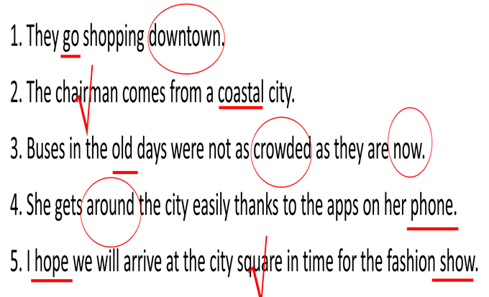
Activity 5: Consolidation (3’)
a. Aims: To consolidate what students have learnt in the lesson.
b. Content: Talk about what they have learnt in the lesson
c. Expected outcomes: Say aloud some words they remember from the lesson.
d. Organisation:
Teacher’s and Ss’ activities | Content
- Teacher asks students to talk about what they have learnt in the lesson | - Use the lexical items related to the topic City life  - Pronounce the diphthong sounds /aʊ/, /əʊ/, and /eə/ in words and sentences correctly
* Homework (2’)
a. Aims: To revise the lesson and prepare for the next lesson.
b. Content: Review the lesson and prepare for the next lesson and do exersie in the workbbook
c. Expected outcomes: Students’ textbook and workbook
d. Organisation:
Teacher’s and Ss’ activities | Content
- T reminds Ss to do homework and prepare the new lesson. | - Learn by heart all the new words.  - Do exercises in the workbook.  - Prepare lesson 3 ( A closer look 2)..
*******************************************************************
Planning date:
Teaching date:

UNIT 2: CITY LIFE
Period 11 Lesson 3: A closer look 2

I. OBJECTIVES:
By the end of this lesson, Ss will be able to:
1. Knowledge
- Recognise and use double comparatives and some phrasal verbs.
2. Competences
- Develop communication skills
- Be collaborative and supportive in pair work and teamwork
3. Personal qualities
- Compare living place
- Develop self-study skills
- Actively join in class activities
II. MATERIALS
- Grade 9 textbook, Unit 2, A closer look 2
- Computer connected to the Internet
- Projector / TV
- hoclieu.vn
III. PROCEDURES
Activity 1: WARM - UP (5’)
a. Aims:
- To activate students’ prior knowledge related to the targeted grammar of double comparative;
- To enhance students’ skills of cooperating with teammates.
b. Content: Game - Brainstorming
c. Expected outcomes:
- Students can answer teacher’s questions using double comparatives.
d. Organisation:
Teacher’s and Ss’activities |  |  | Content
Game: Brainstorming  - Teacher asks Ss to work in 2 groups and think of some Adjectives related the cities and city life.  - Ss (one by one) go to the board and write adjectives that they know.  - Teacher checks Ss’ results.  - The group with more correct adj becomes the winner.  →Teacher leads in the lesson by giving an example . |  |  | Game: Brainstorming  * Suggested answers.  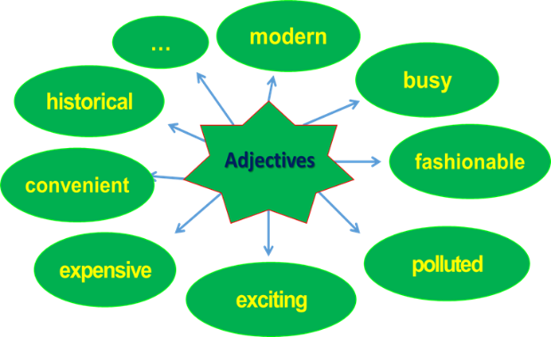  Eg: The more developed the city is, the more crowded it becomes.
Activity 2: PRESENTATION (10’)
Grammar 1: DOUBLE COMPARATIVES
a. Aims:
- To help students get to know about double comparatives.
b. Content:
- Grammar explanation
c. Expected outcomes:
- Students know how to use double comparatives.
d. Organisation:
Teacher’s and Ss’activities |  | Content
Grammar teaching:  -T writes the sentence on the board:  - Underline “the more expensive” and “the fewer”. Check if they understand the sentence.  - T explains the usage :  + we can use “the” with comparative adjectives to emphasise that one thing depends on another.  + we must use “the” before the comparative form of adjective  - Ss listen carefully and write down.  - T asks Ss to read the Remember! box . Use the given examples to reinforce the grammar point |  | * Grammar: DOUBLE COMPARATIVES  Eg:  “The more expensive the rent in the city is, the fewer people can afford to live there”.  * Form: The + comparative adjective 1 + clause 1, the + comparative adjective 2 + clause  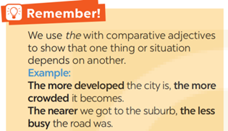
* PRACTICE (15’)
Task 1 +2
a. Aims:
- To help students get to know about double comparatives and do some exercises.
b. Content:
- Task 1: Choose the correct option to complete each sentence.
- Task 2: Find a mistake in the underlined parts in each sentence below and correct it.
c. Expected outcomes:
- Students know how to use double comparatives.
d. Organisation:
Teacher’s and Ss’activities |  | Content
Task 1  - T tells Ss to complete Task 1 individually, then check their answers with another pair.  - Ss do Task 1 individually.  - Invite some Ss to share their answers.  - T confirms the correct answers. Explain or elicit explanations from Ss. |  | Task 1: Choose the correct option to complete each sentence.  * Key:  1. later  2. more comfortable  3. the higher  4. more famous  5. the more difficult
Task 2  -Tell Ss to find a mistake in each sentence and correct it. Tell them to read the sentence carefully and pay attention to the meaning of each sentence.  -Ss listen and follow instructions.  - Ask Ss to do this exercise in pairs.  - Invite one or two Ss to write the mistakes and their corrections on the board. |  | Task 2: Find a mistake in the underlined parts in each sentence below and correct it.  * Key:  1. B (The hotter)  2. C (more tired)  3. A (more modern)  4. D (the more polluted)  5. B (uglier)
Activity 3: Grammar 2: PHRASAL VERBS
a. Aims:
- To present five phrasal verbs;
- To help Ss practise using phrasal verbs learnt in Activity 3 in sentences.
b. Content:
- Task 3: Match a phrasal verb in column A with a suitable word / phrase in column B.
- Task 4: Complete each sentence with a phrasal verb in 3. You can change the form of the verb when necessary.
c. Expected outcomes:
- Students understand some phrasal verbs.
d. Organisation:
Teacher’s and Ss’activities |  | Content
- Ask Ss to recall the phrasal verbs in Unit 1. Tell them that they will learn five more phrasal verbs in  this lesson.  - Ss write some phrasal verbs on the board. |  | Grammar 2: PHRASAL VERBS  * Students’ answers  Eg:  - Take care of  - find out: thực hiện  - come back  - hang down  - get on with
Task 3  - Ask Ss to do Activity 3 individually. Tell them that they can guess if they are not sure.  - Check the answers as a class. Write the correct matches on the board.  - Elicit the meaning of each phrasal verb .  - Check Ss’ comprehension by asking them some questions, tell them to translate the phrases into Vietnamese, |  | Task 3: Match a phrasal verb in column A with a suitable word / phrase in column B.  * Answer key:  1. D  2. C  3. E  4. B  5. A
Task 4  -Tell Ss that they will work in pairs and complete Task 4.  - Ss work in pairs and complete Task 4.  - Set a time limit for them. Then call on one or two Ss to write the answers on the board.  - Check the answers. Elicit explanations from Ss. |  | Task 4: Complete each sentence with a phrasal verb in 3. You can change the form of the verb when necessary  * Answer key:  1. coming down with  2. cut down on  3. get around  4. hang out with  5. carrying out
Activity 4 : PRODUCTION (5’)
Task 5
a. Aims:
- To give Ss speaking practice with the comparison of adjectives.
b. Content:
- Task 5: Work in pairs. Tell each other whether you agree or disagree with the following ideas.
c. Expected outcomes:
- Students can apply the grammar they have learnt in practical situations.
d. Organisation:
Teacher’s and Ss’activities |  | Content
Task 5  - Ask Ss to work in pairs. Each person chooses a sentence and says whether they agree or disagree with it. Encourage them to provide an example, a reason and / or an explanation for their viewpoint.  - Ss listen and follow instructions  - Invite some Ss to share their opinions in front of class. Others listen and give feedback  - Teacher gives corrections and feedback. |  | Task 5: Work in pairs. Tell each other whether you agree or disagree with the following ideas.  * Suggested answers:  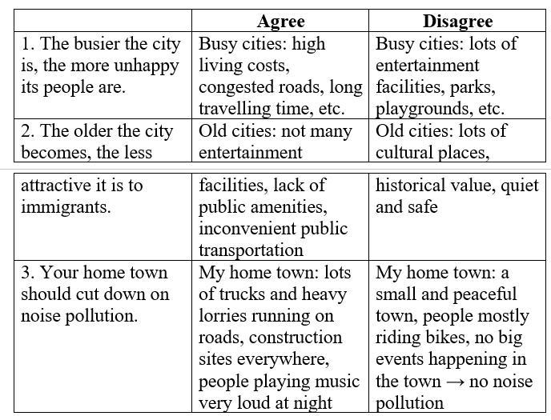
Activity 5: CONSOLIDATION(3’)
a. Aims: To consolidate what students have learnt in the lesson.
b. Content: Talk about what they have learnt in the lesson
c. Expected outcomes: Say aloud some words they remember from the lesson.
d. Organisation:
Teacher’s and Ss’activities | Content
- Ss summarise the main points of the lesson.  - Ask Ss to make sentences about themselves, using double comparatives. | - Recognise and use double comparatives and some phrasal verbs
*HOMEWORK (2’)
a. Aims: To revise the lesson and prepare for the next lesson.
b. Content: Review the lesson and prepare for the next lesson and do exersie in the workbbook
c. Expected outcomes: Students’ textbook and workbook
d. Organisation:
Teacher’s and Ss’activities | Content
- T reminds Ss to do homework and prepare the new lesson. | - Do exercises in the workbook.  - Prepare lesson 4 ( communication)
*******************************************************************
Planning date:
Teaching date:

UNIT 2: CITY LIFE
Period : 12 Lesson 4 : Communication
I. OBJECTIVES
By the end of this lesson, Ss will be able to:
1. Knowledge
- Offer help and respond to an offer;
- Talk about means of transport that they use.
2. Competences
- Develop communication skills and creativity
- Be collaborative and supportive in pair work and teamwork
3. Personal qualities
- Be ready and confident in real life conversations
- Know about means of transport
- Actively join in class activities
II. MATERIALS
- Grade 9 textbook, Unit 2, Communication
- Computer connected to the Internet
- Projector / TV
- hoclieu.vn
III. PROCEDURES
Activity 1: Warm-up (5’)
a Aims:
- To introduce the topic;
- To enhance students’ skills of cooperating with team mates.
b. Content:
- Game: Pelmanism (Pictures of means of transport.)
c. Expected outcomes:
- Students can use their background knowledge to answer the questions.
d. Organisation:
Teacher’s and Ss’activities | Content
* Game : Pelmanism  - Teacher divides the class into 2 teams and asks them to play game.  - Ss listen and follow instructions  - In 2 minutes, each member from each team has to take turns to turn over one card and try to find a card that matches it.  - If the two cards match each other, the team gets one point.  - If the two cards are different, put them back in the same places, facing down.  - The team with more points will win the game.  →Teacher leads in the lesson. | * Game : Pelmanism  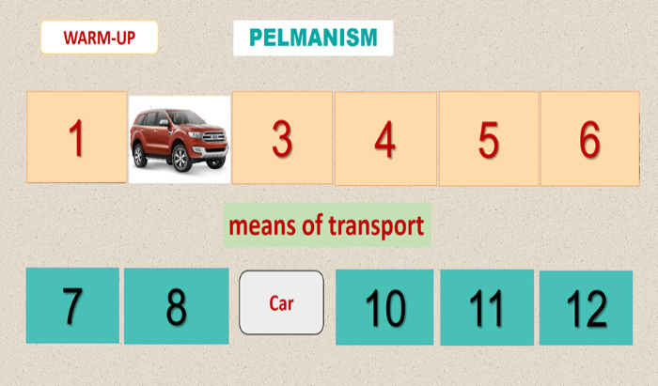
Activity 2: EVERYDAY ENGLISH (10’)
Vocabulary pre-teaching + Task 1, 2
a. Aims:
- To introduce ways of offering help and responding.
b. Content:
- Vocabulary pre-teaching
- Task 1: Listen and read the conversations below. Pay attention to the highlighted parts.
- Task 2: Work in pairs. Make similar conversations with the following situations.
c. Expected outcomes:
- Students can use the structures to offer help and respond.
d. Organisation:
Teacher’s and Ss’activities | Content
Vocabulary pre-teaching  - Introduce the vocabulary by:  + giving a situation;  + giving an explanation  - Ss listen to the explanation of the words.  - Write the new words in their notebooks. | * New words:  1. rush hour (n): Giờ cao điểm  2. tram (n) : Xe điện
Task 1  - Tell Ss a situation: “Duong’s best friend is going to Singapore to study there. Duong’s dad knows that Duong wants to go to the airport to see him off. What will Duong’s dad do?”  - Encourage Ss to make some guesses. Possible guesses might be Duong’s dad will take him to the airport; Duong’s dad will catch a taxi for him to the airport, etc.  - Present the slice for students to see  - Play the recording for Ss to listen and read the conversations. Ask Ss to pay attention to the highlighted language. Tell them that these are two common ways to offer help.  - Ask Ss what Duong and Hoang say to accept the offers.  - Have Ss read aloud the conversations as a class first, then practise them in pairs. Call on some pairs to act the conversations in front of the class. | Task 1: Listen and read the conversations below. Pay attention to the highlighted parts.  * Audio script:  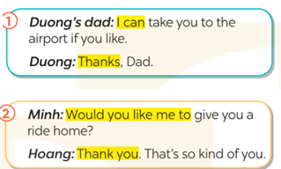  * Structures:  Offering help and responding  + Two common ways to offer help.  I can…….  Would you like……?  Thanks/ Thank you
Task 2  - Ask Ss to work in pairs to make similar dialogues, using the language they have learnt.  - Ss work in pairs to make similar dialogues.  - Move around to observe and provide help. Call on some pairs to practise in front of the class. Comment on their performance | Task 2: Work in groups. Make similar conversations with the following situations.  * Suggested dialogues:  Situation 1:  You: I can show you how to use the library smart card if you like.  Friend: Thanks. That’s so kind of you.  Situation 2  You: Would you like me to write a note for Ms Hoa?  Friend: Thank you. That’s so kind of you.
Transition from Everyday English to Transport in the city.
Teacher’s and Ss’activities | Content
- Choose two good Ss (A & B) in the class. Tell them to imagine B is new to the city and he/she doesn’t know how to use the public transport system. - Tell A to offer help to B and B to respond to A’s offer.  - Ss listen and follow the instruction.  - Tell Ss they are going to read the opinions of some students about their favourite means of transport in the city. | * Possible offers may include  to get to the train station, to buy a bus ticket, to use the sky train system.
Activity 3: TRANSPORT IN THE CITY (20 mins)
a. Aims:
- To provide students with information about three means of transport in the city;
- To give students an example of the structure for their talk;
- To help students plan their talk about their familiar means of transport;
b. Content:
- Task 3: Work in pairs. Read the descriptions of three teenagers about their favourite
means of transport. Then complete the table below.
- Task 4: Make notes about a means of transport you are using.
c. Expected outcomes:
- Students get some information about means of transport.
- Students can talk about their familiar means of transport.
d. Organisation:
Teacher’s and Ss’activities | Content
Task 3  - Have Ss work in pairs. Assign one description for each pair to read and complete the gaps in the table.  - Ss work in pairs to read and complete the table.  - Invite some pairs to share their answers. Confirm the correct answers.  - Put three pairs who read different descriptions together. In their group, they tell each other about the description of the transport that they have read. | Task 3: Work in pairs. Read the descriptions of three teenagers about their favourite means of transport. Then complete the table below.  * Key:  1. traffic jams  2. sky train  3. crowded  4. tram  5. discount
Task 4  - Tell Ss to make notes about the means of transport they are using, following the given outline. They can look at the table in Activity 3 for an example.  - Ss make notes about the means of transport they are using.  - Monitor and provide support when needed.  - When they finish their outline, tell them to talk to a friend using the notes they have prepared. | Task 4: Make notes about a means of transport you are using.  * Suggested answers:  +Means of transport: bus  + Advantages: near house and school, clean, on time, air conditioning  + Drawbacks: crowded at rush hour
Activity 4: PRODUCTION (5’)
a. Aims:
- To provide students with a chance to talk about their familiar means of transport.
b. Content:
- Task 5: Work in groups. Talk to your friends about the means of transport that you
use. Use your notes in 4.
c. Expected outcomes:
- Students can talk about their familiar means of transport.
d. Organisation:
Teacher’s and Ss’activities | Content
Task 5  - Groups take turns to talk, using their notes in 4.  - Ss present in front of the class, using notes in 4 in groups.  - Monitor and provide support when needed.  - Comment on Ss’ talks.  - Teacher gives corrections and feedback. | Task 5: Work in groups. Talk to your friends about the means of transport that you use. Use your notes in 4.  * Suggested talk  I go to school by bus every day. It is convenient because there are bus stops near my house and my school. The bus is clean and on time. It is very crowded at rush hour, but it has air conditioning, so it is cool. That’s why I choose to use it.
Activity 5: CONSOLIDATION (3’)
a. Aims: To consolidate what students have learnt in the lesson.
b. Content: Talk about what they have learnt in the lesson
c. Expected outcomes: Say aloud some words they remember from the lesson.
d. Organisation:
Teacher’s and Ss’activities | Content
Teacher asks students to talk about what they have learnt in the lesson. | - Offer help and respond to an offer;  - Talk about means of transport that they use.
* HOMEWORK (2’)
a. Aims: To revise the lesson and prepare for the next lesson.
b. Content: Review the lesson and prepare for the next lesson and do exersie in the workbbook
c. Expected outcomes: Students’ textbook and workbook
d. Organisation:
Teacher’s and Ss’activities | Content
- T reminds Ss to do homework and prepare the new lesson. | - Do exercises in the workbook  - Prepare lesson 5 ( skills 1)

*******************************************************************
Planning date:
Teaching date:

UNIT 2: CITY LIFE
Period 13 Lesson 5 : Skills 1

I. OBJECTIVES
By the end of this lesson, Ss will be able to:
1. Knowledge
- Read for main idea and specific information in an article about a competition to find solutions to city problems
- Talk about city problems and their solutions
2. Competences
- Develop communication skills and creativity
- Be collaborative and supportive in pair work and teamwork
- Develop presentation skills
3. Personal qualities
- Understand more about city problems and their solutions
- Actively join in class activities
II. MATERIALS
- Grade 9 textbook, Unit 2, Skills 1
- Computer connected to the Internet
- Projector / TV
- hoclieu.vn
III. PROCEDURES
Activity 1: Warm-up (5’)
a. Aims:
- To help Ss understand and activate their knowledge of the topic.
b. Content:
- Mind map: “City problems”
- Survey, using some Qs
c. Expected outcomes:
- Students gain knowledge about their school.
d. Organisation:
Teacher’s and Ss’activities | Content
Game: Mind map  - Make a mind map with “City problems” in the centre. Ask Ss to list some problems of living in the city. Write their ideas in the mind map and keep it there throughout the lesson.  - Ss listen and follow the teacher's instruction.  - Tell Ss that they are going to read and speak about some problems of city life and their solutions.  - Introduce the objectives of the lesson. Write the objectives in the left corner of the board.  - T can ask Ss some Qs about some problems of living in the city.  - Ss answer individually | * Game: Mind map  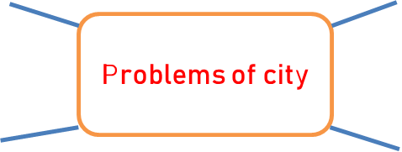  * Suggested answers:  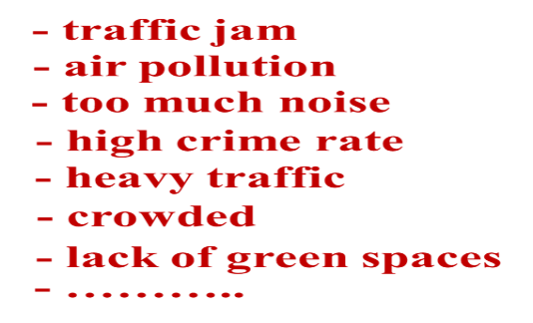  * Questions:  “What is the biggest problem in your city?”  “How does it affect you or your family?”
Activity 2: PRESENTATION (8’)
* Pre –teach vocab + Task 1
a. Aims:
- To help Ss learn new vocabulary in the reading text.
-b. Content:
- Vocabulary teaching
- Task 1: Work in pairs. Match the words / phrases with their pictures.
c. Expected outcomes:
- Students identify some new words and how to use the target vocabulary.
d. Organisation:
Teacher’s and Ss’activities | Content
- Ask Ss to get the meaning of the words in context.  - SS say the meaning of the words.  Task 1  - Have Ss work in pairs and match the given words/phrases with the pictures.  - Ss do exercise in pairs.  - Check the answers as a class.  - Tell Ss to find these words and phrases in the reading text and highlight them. | *New words:  1. leftover (n)  2. biogas (n)  Task 1: Work in pairs. Match the words / phrases with their pictures.  * Keys:  1. a  2. c  3. b  4. d
Activity 3: PRACTICE (READING) 12’
a. Aims:
- To help Ss learn new vocabulary in the reading text.
- To improve Ss’ skill of reading for details (scanning).
b. Content:
- Task 2: Read part of an announcement about the Teenovator competition. Match the topics in the competition with their winners. There is one extra topic.
- Task 3: Read the announcement again. Choose the correct answer.
c. Expected outcomes:
- Students identify some new words and how to use the target vocabulary.
d. Organisation:
Teacher’s and Ss’activities | Content
Task 2  - Ask them to skim the announcement and name the winners (Central School, Bookworm Team, Helena Wilson).  - Ss skim the announcement and name the winners, after that underline the city problem.  - Ask Ss if these problems are solved, how the city will be like (less food waste, teen-friendly library, safety in front of school gates).  - Tell Ss that they will now match a topic in the competition with the winner. Let Ss do the exercise individually.  - Ss match the topic in the competition with the winner.  - Check answers as a class. | Task 2: Read part of an announcement about the Teenovator competition. Match the topics in the competition with their winners.  Teenovator competition  * Keys:  1. C (The food-smart city)  2. B (The teen-friendly city)  3. A (The street-safe city)
Task 3  - Ask Ss to read the questions, underline the keywords in each question, locate the keywords in the text and find the information to answer the question.  - Ask Ss to do the exercise individually and then check their answers in pairs.  - Ss listen and follow the instruction.  - Invite a student to write their answers on the board. Have other Ss explain their answers. Confirm the correct answers. | Task 3: Read the announcement again. Choose the correct answer.  * Keys:  1. A  2. D  3. B  4. C  5. A
Transition from Reading to Speaking
- Ask Ss to add more ideas about city problems and solutions from the article to the mind map.  - Ss discuss in groups and then give ideas in front of the class. | Eg:  + Problem 1: food waste  →Solution: a farm comes and takes leftovers at school canteens. They process them into biogas.  + Problem 2: not teen-friendly city library  → Solution: design lively learning spaces; add teen’s favourite desserts in the cafeteria’s menu.  + Problem 3: too many vehicles around school gates  → Solution: not allow cars at school gates at special hours; no motorbike parking on the pavement near school gates
Activity 4: PRACTICE (SPEAKING) 12’
Task 4 + 5
a. Aims:
- To help students use what they have learnt so far to talk about city problems and solutions;
- To practise public speaking.
b. Content:
- Task 4: Make a list of city problems and some solutions to them.
- Task 5: Work in pairs. Talk to your friends about the city problems and suggest solutions to them. You can use the ideas in 4.
c. Expected outcomes:
- Students can talk about the city problems and suggest solutions to them in front of other people.
d. Organisation:
Teacher’s and Ss’activities | Content
Task 4  - Ask Ss to work in pairs and add as many details of problems of city life and solutions in the mind map as possible. Alternatively, Ss can use problems given in the textbook and think of solutions to them.  - Ss work in pairs to add details of problems of city life and solutions in the mind map.  - Ask pairs to share their answers with the class.  - Ss listen and check. | Task 4: Make a list of city problems and some solutions to them.  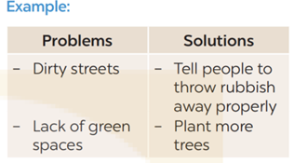
Task 5  - Have Ss work in groups. Tell them that they will talk to each other about problems of city life and solutions. They could use their notes when talking.  - Remind them that they can use the given template in the book in their talk.  - Ss talk about problems of city life and solutions in groups by using their notes.  - Set a time limit for pair work. Go around, monitor and support when necessary.  - Invite some Ss to share their discussion to the class.  - Ask other pairs to listen and give comments. Comment on Ss’ answers. | Task 5: Work in pairs. Talk to your friends about the city problems and suggest solutions to them. You can use the ideas in 4.  * Suggested answer:  We think that there are several problems in our city. First, some streets are dirty. Many people put rubbish on the pavements or near the walls. Second, the city looks like a concrete jungle. It lacks green space and the air is not fresh. To solve these problems, the city authority should instruct people to throw rubbish properly. Another solution is to plant more trees even on the roof of high buildings. By doing so, the city can be a more liveable place.
Activity 5: Consolidation (3’)
a. Aims: To consolidate what students have learnt in the lesson.
b. Content: Talk about what they have learnt in the lesson
c. Expected outcomes: Say aloud some words they remember from the lesson.
d. Organisation:
Teacher’s and Ss’activities | Content
- Teacher asks students to talk about what they have learnt in the lesson. | - Read for main idea and specific information in an article about a competition to find solutions to city problems  - Talk about city problems and their solutions
* Homework (2’)
a. Aims: To revise the lesson and prepare for the next lesson.
b. Content: Review the lesson and prepare for the next lesson and do exersie in the workbbook
c. Expected outcomes: Students’ textbook and workbook
d. Organisation:
Teacher’s and Ss’activities | Content
- Teacher asks students to prepare the new lesson | - Do exercises in the workbook.  - Prepare for the next lesson: Unit 2-Skills 2.
***********************************************************
Planning date:
Teaching date:

UNIT 2: CITY LIFE
Period 14 Lesson 6: Skills 2

I. OBJECTIVES : By the end of this lesson, Ss will be able to:
By the end of this lesson, Ss will be able to:
1. Knowledge
- Listen for specific information in an interview about life in the city
- Write a paragraph on what they like or dislike about city life
2. Competences
- Develop communication skills and creativity
- Be collaborative and supportive in pair work and teamwork
3. Personal qualities
- Be encouraged to express opinion about city life
- Actively join in class activities
II. MATERIALS
- Grade 9 textbook, Unit 2, Skills 2
- Computer connected to the Internet
- Projector / TV
- hoclieu.vn
III. PROCEDURES
Activity 1: Warm –up (5’)
a. Aims:
- To create an active atmosphere in the class before the lesson;
- To lead into the new lesson.
b. Content:
- watch a video clip and write the names of 10 big cities in Vietnam
c. Expected outcomes:
- Students can answer the questions related to school.
d. Organisation:
Teacher’s and Ss’activities | Content
Game: watch a video clip  - Have Ss watch a video and asks them try to remember and write the names of 10 big cities in Vietnam  - Ss work in groups and then write the answers on the board.  - T gives feedback and The group has more the correct answers is winner  → Lead to the new lesson.  Questions:  - Which city do you want to live in? Why? | Game: Watch a video clip and write the names of 10 big cities in Vietnam  
Activity 2: LISTENING (15’)
- To help Ss develop their skill of listening for specific information about city life
b. Content:
- Task 1: Work in pairs. Tick (√) the things that you want in your hometown. Add more ideas if you have any.
- Task 2: Listen to an interview with three teenagers about life in their cities. Decide if the statements are true (T) or false (F).
- Task 3: Listen again. Choose the correct answer A, B, or C.
c. Expected outcomes:
- Ss can listen for general and specific information to do the learning tasks.
d. Organisation:
Teacher’s and Ss’activities |  | Content
Task 1  - Tell Ss to look at the given phrases and ask them to tick the things they want in a city.  - Ss listen and work in pairs.  - Invite answers from Ss.  - Tell Ss that these phrases will appear in the listening, so they should pay attention to them. |  | Task 1:Work in pairs. Tick (√) the things that you want in your home town. Add more ideas if you have any.  * Suggested answers:  a. Nice parks  b. Modern cinemas  c. Air-conditioned buses  d. Free sports facilities  e. Convenient food stalls  f. Wide roads
Task 2  - Tell Ss that they are going to listen to three teenagers talking about what they like and dislike about their city.  - Have Ss look at the statements. Elicit from them the keywords in each statement. Remind them that they need to listen attentively.  - Ss listen to the instruction.  - Play the recording and ask Ss to listen and decide if the information is true or false according to the recording.  - Ask one or two Ss to go to the board and write their answers. Have other Ss work in pairs to compare their answers.  - Confirm the correct answers. Play part of the recording again when needed. |  | Task 2: Listen to an interview with three teenagers about life in their cities. Decide if the statements are true (T) or false (F).  * Answer key:  1. T  2. F  3. F  4. T  * Explaination  1. It has good parks, libraries, and cinemas.  2. The only place teens can find entertainment is a shopping mall but it's very costly, so I don't like  3. There are food stalls at almost all street corners  4. Many teens like street food and are too lazy to cook on their own.
Task 3  - Have Ss read the questions and underline the keywords in each question.  - Ss listen and do the exercise.  - Play the recording and ask Ss to listen again and choose the correct answer. Then Ss work in pairs to compare their answers with each other.  - Check the answers to 3 with the whole class. Ask Ss to explain their choices. Confirm the correct answers. |  | Task 3: Listen again. Choose the correct answer A, B, or C.  * Answer key:  1. A  2. A  3. B  4. C
* Transition from Listening to Writing
Teacher’s and Ss’activities | Content
- Ask Ss to work in pairs and recall information about Tom, Elena and Chi. Note down the answers to the questions.  - Ss work in pairs. Note down the answers. | - What does each person like about life in their city?  - What does each person dislike about life in their city?  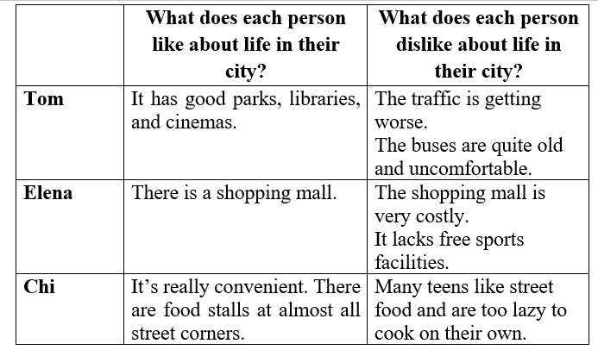
Activity 3: WRITING (15’)
a. Aims:
- To help Ss practise writing a paragraph about what they like or dislike about living in a city.
b. Content:
- Task 4: Work in pairs. Put the phrases from the box in the correct column.
- Task 5: Write a paragraph (about 100 words) about what you like or dislike about living in a city. You can use the ideas in 4 or your own ideas.
c. Expected outcomes:
- Students can use learned vocabulary and grammar to write a paragraph about what they like or dislike about living in a city.
d. Organisation:
Teacher’s and Ss’activities | Content
Task 4  - Have Ss work in pairs to put the phrases in the correct column.  - Ss work in pairs to do the exercise.  - Have some Ss present their answers or write their answers on the board. Confirm the correct answers. | Task 4:Work in pairs. Put the phrases from the box in the correct column.  * Suggested answers:  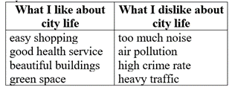
Task 5  - Tell Ss to look at the outline in 5. Tell them that they should follow this structure when writing this paragraph.  - Ask Ss to write their paragraph individually based on the table in 4. Remind them that they do not need to use all suggested ideas, and that they can add their own ideas.  - Ss write their paragraph individually based on the table in 4.  - When Ss have finished, if time permits, check one writing in class. Otherwise, collect some writings to correct at home. | Task 5: Write a paragraph (about 100 words) about what you like or dislike about living in a city. You can use the ideas in 4 or your own ideas.  * Sample paragraph:  I love city life. First, it is very convenient to live in the city. The public transport system reaches almost all areas of the city, so it is easy for me to get around. In addition, there are many shops that sell all kinds of goods, so I can buy almost everything I need. Second, the city often has many good schools and hospitals. Therefore, people here can enjoy quality education and healthcare. Finally, city life is exciting. There are many entertainment places for me and my friends. For example, we can hang out at shopping malls, watch movies at the cinema, and visit beautiful parks downtown. In conclusion, I find the city a liveable place for me.
Activity 4: POST - WRITING (5’)
a. Aim: To peer check, cross check and final check students’ writing.
b. Content: Ss’ writing about what you like or dislike about living in a city.
c. Products: Some Ss show their writing in front of the class.
* Organization of implementation:
Teacher’s and Ss’ activities | Content
- Teacher asks Ss to share their writing with their partners. Then, call on some Ss to show their writing in front of the class.  - Teacher checks ideas, grammar, vocabulary and gives comments. | * Ss’ writing
Activity 5: Consolidation (3’)
a. Aims: To consolidate what students have learnt in the lesson.
b. Content: Talk about what they have learnt in the lesson
c. Expected outcomes: Say aloud some words they remember from the lesson.
d. Organisation:
Teacher’s and Ss’activities | Content
- Teacher asks students to summarise the main points of the lesson. | - Listen for specific information in an interview about life in the city  - Write a paragraph on what they like or dislike about city life
* Homework (2)
a. Aims: To revise the lesson and prepare for the next lesson.
b. Content: Review the lesson and prepare for the next lesson and do exersie in the workbbook
c. Expected outcomes: Students’ textbook and workbook
d. Organisation:
Teacher’s and Ss’activities | Content
Teacher asks students to write down the email in their books.  - Teacher asks students to prepare the new lesson. | Rewrite the passage on the notebook.  - Prepare “ Looking back and project”
****************************************************************

Planning date:
Teaching date:

UNIT 2: CITY LIFE
PRIOD 15 LESSON 7: LOOKING BACK

I. OBJECTIVES
By the end of this lesson, Ss will be able to:
1. Knowledge
- Review the vocabulary and grammar of Unit 2
- Apply what they have learnt (vocabulary and grammar) into practice through a project
2. Competences
- Develop communication skills and creativity
- Develop presentation skill
- Be collaborative and supportive in pair work and teamwork
3. Personal qualities
- Be encouraged to attend school activities
- Actively join in class activities
II. MATERIALS
- Grade 9 textbook, Unit 2, Looking back and Project
- Computer connected to the Internet
- Projector / TV
- hoclieu.vn
III. PROCEDURES
Activity 1: Warm-up (5’)
a. Aims:
- To create an active atmosphere in the class before the lesson.
b. Content:
- Brainstorming
c. Expected outcomes:
- Ss can list as many school things as possible.
d. Organisation:
Teacher’s and Ss’activities |  | Content
Game:Brainstorming  - Teacher divides the board, and divides the class into teams.  - Ss work in teams to play the games.  - Members of each team take turns to write as many adjectives about City as possible in 2 minutes.  - The group having more correct answers is the winner. |  | Game: - Brainstorming  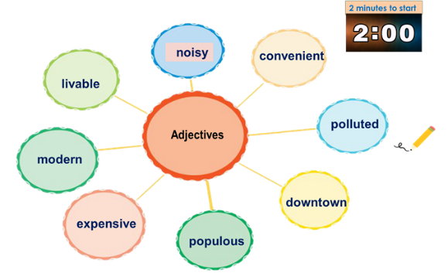
Activity 2: VOCABULARY (10’)
a. Aims:
- To help Ss review the vocabulary of Unit 2.
b. Content:
- Task 1: Choose the correct answer to complete each sentence below.
- Task 2: Fill in each gap with a word from the box to complete the passage.
c. Expected outcomes:
- Students can use the knowledge they have learnt in this unit to complete the tasks successfully.
d. Organisation:
Teacher’s and Ss’activities | Content
Task 1  - Have Ss do this activity individually then compare their answers with their partners.  - Ss do the activity individually.  - Ask for Ss’ answers or ask one student to write his / her answer on the board.  - Confirm the correct answers. | Task 1: Choose the correct answer to complete each sentence below.  * Answer key:  1. suburbs  2. metro  3. concrete jungle  4. lively  5. bustling
Task 2  - Have Ss read the passage and complete the blanks with the given words.  - Ss do the task individually.  - Ask them to share their answers with a classmate.  - Invite some Ss to write the answers on the board. Confirm the correct answers.  - Ask Ss if they like or dislike Mia’s town. | Task 2: Fill in each gap with a word from the box to complete the passage.  * Answer key:  1. peaceful  2. safe  3.congestion  4. itchy  5. liveable
Activity 3: GRAMMAR ( 15’)
a. Aims:
- To help Ss revise the double comparatives and some phrasal verbs.
b. Content:
- Task 3: Complete the sentences with the particles in the box.
- Task 4: Find a grammar mistake in each sentence and correct it.
c. Expected outcomes:
- Recall the uses of the grammar that they have learnt in this unit (phrasal verbs and double comparatives).
d. Organisation:
Teacher’s and Ss’activities |  | Content
Task 3  - Ask Ss to list phrasal verbs they have learnt in the unit.  - Ss do this exercise individually then compare their answers with a partner.  - Ss exchange their textbooks and give feedback to each other.  - Call on some Ss to give the answers. Confirm the correct answers and write them on the board. |  | Task 3: Complete the sentences with the particles in the box.  * Answer key:  1. away  2. out  3. down on  4. out  5. down with
Task 4  - Recall the structure of double comparatives Ss learnt in this unit.  - Ss listen and review double comparatives.  - Tell them that they need to identify a grammar mistake in each sentence and correct it.  - Have Ss do this exercise individually then compare their answers with a partner.  - Invite some Ss to read their answers aloud. Confirm the answer |  | Task 4: Find a grammar mistake in each sentence and correct it.  * Answer key:  1. more difficult → the more difficult  2. get up → get around*  3. Nearer → The nearer  4. came up with → came down with  5. more slow → slower  *Note:  go around = turn round in a circle  go around (to) = visit sb / a place that is near  get around = to go to a lot of different places
Activity 4: PRODUCTION: PROJECT(10’)
a. Aims:
- To help Ss improve their creativity and teamwork;
- To improve their speaking and presentation skills.
b. Content:
- Poster presentation
c. Expected outcomes:
- Students are able to present their posters about a city in the future.
d. Organisation:
Teacher’s and Ss’activities |  | Content
- As Ss have prepared for the project throughout the unit, the focus of this lesson should be on the final product, which is a poster presentation of future city.  - Have Ss work in their groups. Give them a few minutes to prepare for the presentation.  - Give Ss checklists for peer and self-assessment. Explain that they will have to tick appropriate items while listening to their classmates’ presentations and write comments if they have any.  - The presenters should complete their self-assessment checklists after completing their presentation.  - Invite the assigned groups to give their presentations. Encourage the rest of the class to ask questions at the end.  - Give praise and feedback after each presentation. T can summarise the feedback given by other Ss and add any other comments. T can also give Ss marks for their presentation as part of their continuous assessment. |  | PROJECT  A city in the future  1. Imagine a future city you would like to live in. Complete the table.  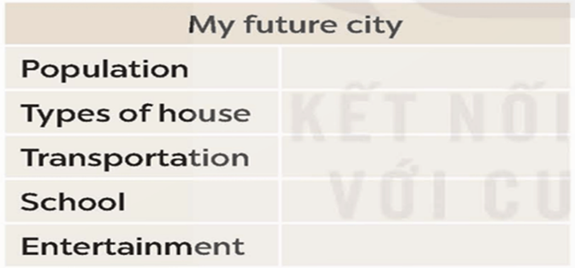  2.Prepare a poster presentation on your future city. Use the information from your table in 1  3. Present your poster of the future city to your class.
Activity 5: Consolidation (3’)
a. Aims: To consolidate what students have learnt in the lesson.
b. Content: Talk about what they have learnt in the lesson
c. Expected outcomes: Say aloud some words they remember from the lesson.
d. Organisation:
Teacher’s and Ss’activities |  | Content
Teacher asks students to talk about what they have learnt in the lesson. |  | - revise vocabulary in unit 2  - revise the double comparatives and some phrasal verbs.  - do a project.
* Homework (2’)
a. Aims: To revise the lesson and prepare for the next lesson.
b. Content: Review the lesson and prepare for the next lesson and do exersie in the workbbook
c. Expected outcomes: Students’ textbook and workbook
d. Organisation:
Teacher’s and Ss’activities |  | Content
Teacher asks students to revise old lesson and to do exercise in workbook.  - Teacher asks students to complete the project and prepare the new lesson. |  | - Complete the project  - Prepare for the next lesson: Unit 3 –Lesson 1. Getting started.
*****************************************************************

