Week 27 Preparing date: March 17th, 2025
Period 105 Teaching date: 24/3 (4B, 4A)

Extension activities
I. OBJECTIVES:
By the end of the lesson, Ss will be able to:
1. Knowledge:
- take part in extension activities to apply their language knowledge and competences.
- Vocabulary: Review
- Skills: speaking, writing and listening
2. Competences:
- Co-operation: ready to help friends in pair work/ group work.
- Sociability: Talk to each other, say good words to others.
3. Attitude/ Qualities:
- Kindness: Help partners to complete learning tasks.
- Honesty: tell the truth about feelings and emotions
II. TEACHING AIDS:
- Teacher: Teacher’s guide Pages 226, 227; website hoclieu.vn, posters, laptop, pictures, textbook, lesson plan, TV or projector.
- Students: Pupil’s book Page 38, 39, notebooks, workbooks, school things.
III. PROCEDURES:
Teacher’s activities | Students’ activities
1.Warm- up: (3’)  Game: Review game (ppt)  *Aims: to create a friendly and active atmosphere in the class to beginning the lesson.  *Procedure:  - T reminds Ss of 4 topics (Jobs, Appearance, Daily activities, My family’s weekend) they will review in this lesson.  - T calls 1 pupil from each team choose a topic and the points they want to get.  - Have Ss to answer the questions.  - If the Ss answers correctly, they will get the chosen points for that question.  - After 16 numbers, the team with the most points is the winner.  - Say “Open your book page 38” and look at “Extension activities”.  2. Practice(30’)  Activity 1. Work in pairs. Take turns to describe and draw a family member  *Aims: Ss will be able to correctly describe the appearance of a family member for a partner to draw  *Procedure:  - Have Ss look at the picture and ask: What is the girl / boy doing? 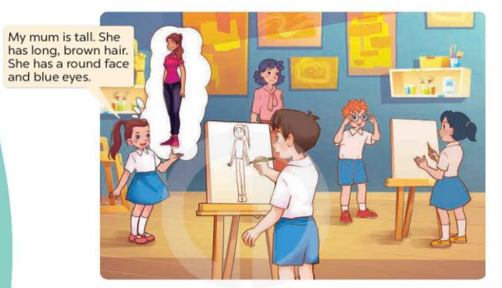  - Write the following prompts on the board: tall or short?, hair?, face?, eyes?  - Tell Ss to choose a family member and think about how he or she looks.  - Have Ss work in pairs and describe a family member for their partner to draw.  - When all the ss have had a turn, tell them to swap their drawings with their partners.  Activity 2. Tell the class about your partner’s family  *Aims: Ss will be able to correctly describe the appearance of someone’s family member.  *Procedure:  - Have Ss look at the picture and answer the question:  +What is the boy doing?  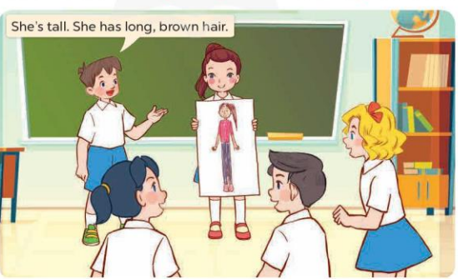  - Invite a few pairs to come to the front of the class and share their drawings and descriptions with the class.  Activity 3. Read and match. Then say what the animals are  *Aims: Ss will be able to read and match four descriptions with four pictures of animals, then say what the animals in the pictures are.  *Procedure:  - Explain any new words and check comprehension.  - Ask Ss to look at the pictures on the right and elicit the answer. Get them to read the sentences in Description 1 again and draw a line to match it to the correct picture (Picture c)  - Have Ss time to do the task  - Get Ss to swap books with a partner, then check answers as a class.  - Write the correct answers on the board for Ss to correct their answers.  - Have Ss say the names of the animals in the pictures by asking them questions, ex: What is it? or What can you see in the picture?  Key: 1. c 2. d 3. a 4. b  1. It’s an elephant. 2. It’s a parrot.  3. It’s a monkey. 4. It’s a fish  *Consolidation  *Aims: Ss will be able consolidate and wrap up the content of the lesson.  *Procedure:  - T asks ss to answer the following questions:  + What have you learnt from the lesson today?  - T praises some Ss who are hardworking / active/ good…. as well as encourage others to try more.  3. Homework. (2’)  - Prepare the new lesson: Unit 16, Lesson 1 (1,2,3). | - Ss listen  - Ss play the game  - Open their books  - Ss look at the picture and answer  + The girl is describing her mum.  + The boy is drawing the girl’s mum  - - Ss note  - Ss choose the family member and think  - Ss work in pairs and describe to draw  - Ss swap their drawing with the partner  - Ss look at the picture and answer  + He is describing the girl’s mum.  - Ss come to the front of the class and share their drawings and descriptions.  - Ss pay attention and answer  - Ss look at the picture, the description and match  - Ss do the task  - Ss swap books and check answers  - Ss write the answer  - Ss say the names os the animals  - Ss answer the questions  - Ss listen and clap their hands  - Ss listen and take note
IV. ADJUSTMENTS (if necessary):
………………………………………………………………………………………….…..……………………………………………………………………………...………………………………………….…..…………………………………………………

Week 27 Preparing date: March 17th, 2025
Period 106 Teaching date: 24/3 (4A), 25/3 (4B)

Unit 16: Weather
Lesson 1 (1, 2, 3)
I. OBJECTIVES:
By the end of the lesson, Ss will be able to:
1. Knowledge:
- use What was the weather like yesterday / last weekend? – It was ……. to ask and answer questions about the weather in the past.
- listen to and demonstrate understanding of simple communicative contexts in relation to the topic “Weather”
- Vocabulary: rainy, sunny, cloudy, windy, weather.
- Model sentences:
A: What was the weather like last weekend?
B: It was sunny.
- Skills: speaking and listening
2. Competences:
- Co-operation: ready to help friends in pair work/ group work.
- Sociability: Talk to each other, say good words to others.
3. Attitude/ Qualities:
- Kindness: Help partners to complete learning tasks.
- Honesty: tell the truth about feelings and emotions
II. TEACHING AIDS:
- Teacher: Teacher’s guide Pages 228, 229, audio Tracks 52,53, website hoclieu.vn, posters, laptop, pictures, textbook, lesson plan, TV or projector.
- Students: Pupil’s book Page 40, notebooks, workbooks, school things.
III. PROCEDURES:
Teacher’s activities | Students’ activities
1.Warm-up: (3’)  Sing: How’s the weather?  *Aims: to create a friendly and active atmosphere in the class to beginning the lesson.  *Procedure:  https://www.youtube.com/watch?v=rD6FRDd9Hew  - Show the video on the screen and ask Ss sing and dance together.  - Say “Open your book page 40” and look at “Unit 16, Lesson 1 (1,2,3)”.  2. Presentation(16’)  Activity 1. Vocabulary.  *Aims: Ss will be able to know the vocabulary in the new lesson.  *Procedure:  - T elicits the new words  + rainy : có mưa (mime)  + sunny : có nắng (picture)  + cloudy :có mây (picture)  + windy : có gió (picture)  + weather : thời tiết (translation)  - T models (3 times).  - T writes the words on the board.  - Checking: Matching  Activity 2. Look, listen and repeat:  *Aims: Ss will be able to understand and correctly repeat the sentences in two communicative contexts focusing on asking and answering questions about the weather in the past.  *Procedure:  - Have Ss look at Pictures a and b and identify names of the speakers in the pictures.  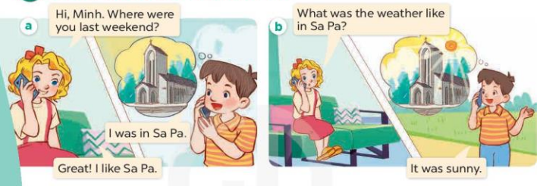  - Play the audio twice (sentence by sentence). Correct their pronunciation where necessary.  - Have Ss to practice the dialogue  - T invites a few pairs to the front of the class to practice.  - T checks pronunciation for ss.  Activity 3. Listen, point and say.  *Aims: Ss will be able to correctly say the words and use What was the weather like last weekend? – It was …to ask and answer questions about the weather in the past.  *Procedure:  * Model sentences:  - T asks Ss look at picture b and helps Ss know the structure from the dialogue.  - T introduces new structure for Ss.  - T explains, models and gives meaning.  - Have Ss repeat the model sentences.  A: What was the weather like last weekend?  B: It was sunny.  3. Practice: (7’)  *Drill pictures  - Have pupils look at the pictures and elicit the weather in each picture.  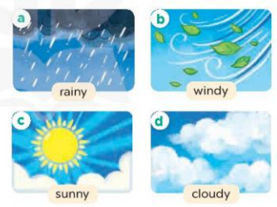  - Run through all the pictures.  - Run through model sentences.  +Run through the question sentences  +Run through the answer sentences  - Have Ss to practise:  + T asks, Ss answer picture a  + Ss ask, T answers picture b  + Group A ask, group B answer picture c  + Group B ask, group A answer picture d  - Ask Ss to work in pairs.  - T controls and corrects.  - Invite a few pairs to come to the front of the classroom and point at the pictures and say the questions and answers in front of the class.  4. Production: (7’)  Activity 4. Let’s talk.  *Aims: Ss will be able to enhance the correct use of What was the weather like yesterday? – It was ….. to ask and answer questions about the weather in a freer context.  *Procedure:  - Have them look at the weather icons and identify the weather in each place.  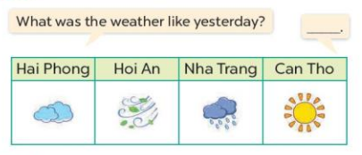  - Put Ss into groups of four.  - Tell them to ask and answer questions using What was the weather like yesterday? – It was …..  - Invite some Ss to the front of the class to ask and answer questions.  *Consolidation  *Aims: Ss will be able consolidate and wrap up the content of the lesson.  *Procedure:  - T asks ss to answer the following questions:  + What have you learnt from the lesson today?  - T review the vocabulary and model sentences.  5. Homework. (2’)  - Learn the vocabulary and model sentences by heart  - Prepare the new lesson: Unit 16, Lesson 1 (4,5,6). | - Ss listen, sing and dance  - Ss open their books  - Ss listen and answer  - - Ss listen and repeat  + Choral repetition (3 times).  + Individual repetition (3 ss)  - Ss take note  - Ss look, remember and match  - Look at the pictures and say  + In picture a:  Mary: Hi, Minh. Where were you last weekend?  Minh: I was in Sa Pa.  Mary: Great! I like Sa Pa.  + In picture b:  Mary: What was the weather like in Sa Pa?  Minh: It was sunny.  - Ss listen and repeat in chorus (twice)  - Ss work in pairs to practice  - Ss practice the dialogue  - Ss listen  - Ss look at the picture and answer.  - Ss listen  - Ss listen and repeat  - Ss repeat  - Ss look, listen and answer  + Picture a: a rainy weather icon  + Picture b: a windy weather icon  + Picture c: a sunny weather icon  + Picture d: a cloudy weather icon  - Ss listen and repeat  - Ss practice in chorus  - Ss practice in chorus  - Ss work in pairs to practice  - Ss point and say  - Ss listen.  - Ss look at the picture and answer  - Ss work in groups to ask and answer the questions  - Ss perform in front of the class.  - Ss answer the questions  - Ss listen  - Ss listen and take note
IV. ADJUSTMENTS (if necessary):
………………………………………………………………………………………….…..……………………………………………………………………………...………

Week 27 Preparing date: March 17th, 2025
Period 107 Teaching date: 25/3 (4B), 28/3 (4A)

Unit 16: Weather
Lesson 1 (4, 5, 6)
I. OBJECTIVES:
By the end of the lesson, Ss will be able to:
1. Knowledge:
- use What was the weather like yesterday / last weekend? – It was …….. to ask and answer questions about the weather in the past.
– listen to and demonstrate understanding of simple communicative contexts in relation to the topic “Weather”
- Vocabulary: Review
- Skills: speaking, listening, reading and writing.
2. Competences:
- Co-operation: ready to help friends in pair work/ group work.
- Self-control and independent learning: perform listening tasks.
3. Attitude/ Qualities:
- Kindness: Help partners to complete learning tasks.
- Honesty: tell the truth about feelings and emotions.
- Diligence: complete learning tasks.
II. TEACHING AIDS:
- Teacher: Teacher’s guide Pages 230, 231; audio Tracks 54, 55; website hoclieu.vn, posters, laptop, pictures, textbook, lesson plan, TV or projector.
- Students: Pupil’s book Page 41, notebooks, workbooks, school things.
III. PROCEDURES:
Teacher’s activities | Students’ activities
1.Warm- up: (5’)  Game: Miming game  *Aims: to create a friendly and active atmosphere in the class to beginning the lesson.  *Procedure:  - Divide S into groups  - One pupil acts to show his favourite weather, he/she is not allowed to say or write but acts or uses body language.  - Groups get more answers win and get stickers  - Change and give the miming pupil cues if necessary.  - Say “Open your book page 41” and look at “Unit 16, Lesson 1 (4,5,6)”.  2.Practice: (27’)  Activity 1. Listen and number:  *Aims: Ss will be able to listen to and understand four communicative contexts in which pupils ask and answer questions about the weather and number the correct pictures.  *Procedure:  - Elicit the weather in each picture.    - T ask Ss to guess the answers.  + T writes Ss’guessing on the board.  - Listen to the tape:  + Play the recording  + Play the recording again and get Ss to swap books with their partners.  + Play the recording again to check answers together as a class.  + Write the answers on the board for Ss to correct their answers. Then checks Ss’ guessing.  - Play the recording, sentence by sentence, for the class to listen and repeat in chorus.  Key: 1. d 2. a 3.c 4.b  Activity 2. Look, complete and read  *Aims: Ss will be able to complete four gapped exchanges with the help of picture cues.  *Procedure:  - Get Ss to look at the pictures and identify the weather in the pictures.  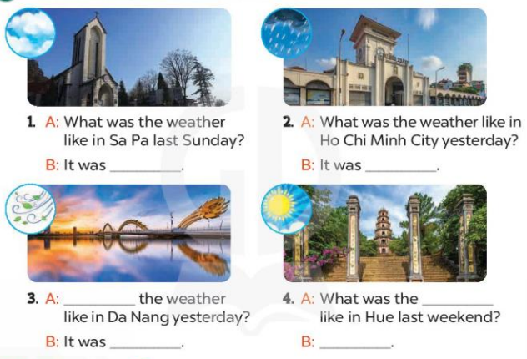  - Have Ss look at the four dialogue and the pictures. Elicit and model with picture 1  + Ask Ss to read the sentence 1 in chorus.  + Ask them what is missing in the question (cloudy). Then have them complete the gap (It was cloudy.).  - Have Ss work in pairs and complete the dialogue 2, 3, 4.  - Ask a few Ss to stand up and read the sentences aloud.  - T gives feedbacks.  Key:  1. cloudy 2. rainy 3. What was; windy  4. weather; It was sunny  Activity 3. Let’s sing  *Aims: Ss will be able to sing the song What was the weather like yesterday? with the correct pronunciation and melody.  *Procedure:  - Introduce the title and lyrics of the song: “ What was the weather like yesterday? ”  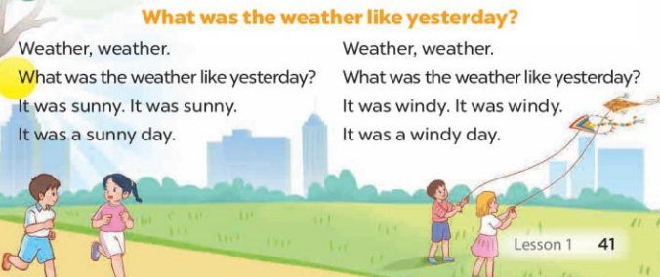  - Play the recording for Ss to listen to the whole song.  + Have them repeat the title and lyrics line by line.  + Tell Ss to point at the pictures while singing.  - Play the recording all the way through for Ss to listen to pronunciation and melody of the song.  - Play the recording line by line for Ss to listen, repeat and point to the pictures  - Play the recording for Ss to sing and do actions.  - Ask Ss to practice singing and doing actions in pairs or groups.  - Invite groups to the front of the classroom to perform the song  - T gives feedback.  *Consolidation  *Aims: Ss will be able consolidate and wrap up the content of the lesson.  *Procedure:  - T asks ss to answer the following questions:  + What have you learnt from the lesson today?  +What are the core values of the lesson? (if the teacher can take from the lesson).  - T praises some Ss who are hardworking / active/ good…. as well as encourage others to try more.  3. Homework. (3’)  - Practice part 5 again.  - Prepare the new lesson: Unit 16, Lesson 2 (1,2,3) | - SS listen  - Ss play the game  - Ss open their books  - Look at the pictures and say:  + Picture 1: a rainy weather icon  + Picture 2: a sunny weather icon  + Picture 3: a cloudy weather icon  + Picture 4: a windy weather icon  - Ss guess the answers  - Ss listen to the tape and write number  - Ss listen again, write and swap books with their partners.  - Ss check their answers and guessing  - Ss write the correct answer  - Ss listen and repeat.  - Ss look at the picture and say  - Ss look and answer  - Ss read  - Ss say and complete  - Ss work in pairs and complete  - Ss read the sentences aloud  - Ss listen  - Ss listen to the song  - Ss listen and repeat line by line without the action.  - Ss point to the pictures while singing  - Ss listen to melody of the song  - Ss listen and sing line by line.  - Ss sing and do actions.  + Ss work in groups (two groups) to sing.  - Ss perform in front of the class.  - Ss listen  - Ss answer the questions  - Ss listen and clap their hands  - Ss listen and take note
IV. ADJUSTMENTS (if necessary):
………………………………………………………………………………………….…..……………………………………………………………………………...………………………………………….…..……………………………………………………………………………….……………………………………………………………

Week 27 Preparing date: March 17th, 2025
Period 108 Teaching date: 26/3 (4B), 28/3 (4A)

Unit 16: Weather
Lesson 2 (1, 2, 3)
I. OBJECTIVES:
By the end of the lesson, Ss will be able to:
1. Knowledge:
- use the words bakery, bookshop, food stall, supermarket and water park in relation to the topic “Weather”.
- use Do you want to go to the ……..? – Great! Let’s go./ Sorry, I can’t. to make suggestions to go somewhere and respond
- Vocabulary: bakery, bookshop, food stall, supermarket and water park.
- Model sentences:
A: Do you want to go to the water park?
B: Great! Let’s go./ Sorry, I can’t.
- Skills: speaking and listening
2. Competences:
- Co-operation: ready to help friends in pair work/ group work.
- Sociability: Talk to each other, say good words to others.
3. Attitude/ Qualities:
- Kindness: Help partners to complete learning tasks.
- Honesty: tell the truth about feelings and emotions
II. TEACHING AIDS:
- Teacher: Teacher’s guide Pages 232, 233; audio Tracks 56, 57, website hoclieu.vn, posters, laptop, pictures, textbook, lesson plan, TV or projector.
- Students: Pupil’s book Page 42, notebooks, workbooks, school things.
III. PROCEDURES:
Teacher’s activities | Students’ activities
1.Warm- up: (3’)  Game: Who says faster  *Aims: to create a friendly and active atmosphere in the class to beginning the lesson.  *Procedure:  - Hold a weather card, then reveal it slowly.  - Ask What’s the weather?  - Ask the Ss guess the answer as fast as possible.  - Then have Ss do the same with the rest.  - This can be played in groups to make it more interesting.  - Say “Open your book page 42” and look at “Unit 16, Lesson 2 (1,2,3)”.  2. Presentation(16’)  Activity 1. Vocabulary.  *Aims: Ss will be able to know the vocabulary the new lesson.  *Procedure:  - T elicits the new words  + food stall : cửa hàng thực phẩm (picture)  + bookshop : hiệu sách (example)  + supermarket : siêu thị (example)  + bakery : tiệm bánh mì (translation)  + water park : công viên nước (picture)  - T models (3 times).  - T writes the words on the board.  - Checking: What and where  Activity 2. Look, listen and repeat:  *Aims: Ss will be able to understand and correctly repeat the sentences in two communicative contexts focusing on making suggestions to go somewhere and responding. *Procedure:  - Have Ss look at Pictures a and b and identify the characters in the pictures.  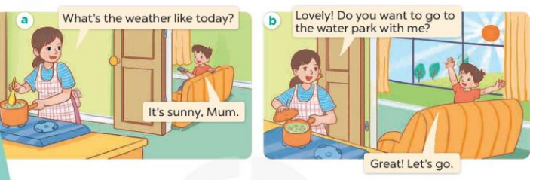  - Play the audio twice (sentence by sentence). Correct their pronunciation where necessary.  - Have Ss to practice the diaguage  - T invites a few pairs to the front of the class to practice.  - T checks pronunciation for ss.  Activity 3. Listen, point and say.  *Aims: Ss will be able to correctly say the words and use Do you want to go to the …….? – Great! Let’s go. / Sorry, I can’t. to make suggestions to go somewhere and respond.  *Procedure:  * Model sentences:  - T asks Ss look at picture b and helps Ss know the structure from the dialogue.  - T introduces new structure for Ss.  - T explains, models and gives meaning.  - Have Ss repeat the model sentences.  A: Do you want to go to the water park?  B: Great! Let’s go./ Sorry, I can’t.  3.Practice: (7’)  *Drill pictures  - Have Ss look at the pictures and elicit the names of the places.  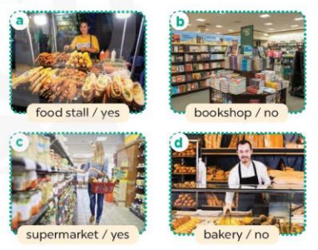  - Run through all the pictures.  - Run through model sentences.  +Run through the question sentences  +Run through the answer sentences  - Have Ss to practise:  + T asks, Ss answer picture a  + Ss ask, T answers picture b  + Group A ask, group B answer picture c  + Group B ask, group A answer picture d  - Ask Ss to work in pairs.  - T controls and corrects.  - Invite a few pairs to come to the front of the classroom, point at the pictures and say the questions and answers in front of the class.  - T gives feedbacks.  4. Production: (7’)  Activity 4. Let’s talk.  *Aims: Ss will be able to enhance the correct use of Do you want to go to the ……? – Great! Let’s go. / Sorry, I can’t. to make suggestions to go somewhere and respond in a freer context.  *Procedure:  - Have Ss look at the picture and say the names of the places in the picture.  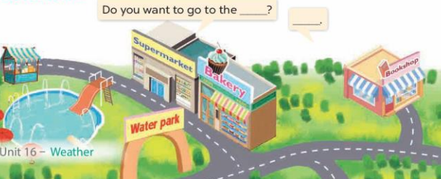  - Put Ss into pairs and encourage them to ask and answer questions using Do you want to go to the……? − …….  - Invite some pairs to stand up to perform their exchanges.  *Consolidation  *Aims: Ss will be able consolidate and wrap up the content of the lesson.  *Procedure:  - T asks ss to answer the following questions:  + What have you learnt from the lesson today?  - T review the vocabulary and model sentences.  - T praises some Ss who are hardworking / active/ good…. as well as encourage others to try more.  5. Homework. (2’)  - Learn the vocabulary and model sentences by heart  - Prepare the new lesson: Unit 16, Lesson 2 (4,5,6). | - Ss listen  - Ss play the game  - Ss open their books  - Ss listen and answer  - - Ss listen and repeat  + Choral repetition (3 times).  + Individual repetition (3 ss)  - Ss take note  - Ss look, remember and write  - Look at the pictures and get to know the characters in the pictures.  + In picture a:  Minh’s mother: What’s the weather like today?  Minh: It’s sunny, Mum  – In picture b:  Minh’s mother: Lovely! Do you want to go to the water park with me?  Minh: Great! Let’s go.  - Ss listen and repeat in chorus (twice)  - Ss work in pairs to practice  - Ss practice the diaguage  - Ss listen  - Ss look at the picture and answer.  - Ss listen  - Ss listen and repeat  - Ss repeat  - Ss listen and answer  +Picture a: a food stall  +Picture b. a bookshop  +Picture c. a supermarket  +Picture d. a bakery  - Ss look, listen and repeat  - Ss practice in chorus  - Ss practice in chorus  - Ss work in pairs to practice  - Ss listen  - Ss go to the board and point and say  - Ss listen  - Ss look at the picture and answer  + a map of an area with a supermarket, bakery, water park, bookshop and food stall.  - Ss work in pairs to ask and answer the question  - Ss perform in front of the class  - Ss answer the questions  - Ss listen  - Ss listen and clap their hands  - Ss listen and take note
IV. ADJUSTMENTS (if necessary):
………………………………………………………………………………………….…..……………………………………………………………………………...………

NHẬN XÉT CỦA TỔ CHUYÊN MÔN
- Xây dựng KHBD đầy đủ, đúng chương trình thời khoá biểu.
- KHBD cơ bản đã bám theo công văn 2345
ĐÃ KIỂM TRA
TP:

Chu Thị Mỹ Linh

XÁC NHẬN CỦA BGH



