Period…: UNIT 1 : LEISURE TIME
Lesson 5 : SKILLS 1/ Reading and speaking

I. OBJECTIVES: * By the end of this lesson, Ss will be able to gain the following:
1. Knowledge:
- Read about leisure activities with family;
- Talk about leisure activities with family;
+ Vocabulary: The lexical items related to Leisure time.
+ Pronounce the sounds /ʊ/ and /u:/ correctly in words and sentences;
* New words:
+ Grammar: Use verbs of liking / disliking followed by gerunds and / or to-infinitives to talk about likes and dislikes;
2. Competence:
- Students will be able to know some new words and learn how to use them.
- Develop communication skills and creativity.
- Be cooperative and supportive in pair work and teamwork. Be actively join in class activities.
3. Qualities:
- Love reading and talking about activities in leisure time
- Develop self-study skills.
II. TEACHING AIDS:
- Teacher: Grade 8 text book, laptop, projector / TV.....
- Students : Text books, workbook…
- Sach mem.vn.
III. PROCEDURE:

1. WARM UP & INTRODUCTION ( 3’- 5’)
* Objectives:
- To create an active atmosphere in the class before the lesson;
- To lead into the new lesson.
* Content: To have some warm-up activities to create a friendly and relaxed atmosphere to inspire Ss to warm up to the subject and new lesson.
* Product: Having a chance to speak English.
* Organisation : Teacher’s instructions …

Teacher’s Student’s activities | Content
+ Greeting  + Teacher (T) asks Ss some questions about the previous lessons,  - T may introduce some warm-up activities to create a friendly and relaxed atmosphere to inspire Ss to warm up to the subject and new class…  - T encourages Ss to talk in English as much as possible  - Ask some Ss what leisure activities they usually do and who in the family they do the activities with.  - Ask them about the good things of doing these activities with family members. Elicit answers from ss.  - Lead into the new lesson: Reading and Speaking about leisure activities that can be done with family members.  - Introduce the objectives of the lesson. Write the objectives in the left corner of the board. | + Greeting  - T_Ss.  + Students (Ss) listen and learn how to do the tasks.  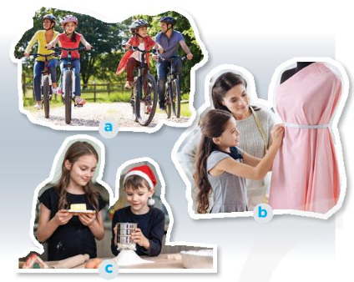  - Open the book and write the tittle of the lesson.
2. PRESENTATION/ NEW LESSON ( 12’- 15’)
A. READING
* Pre-reading
* Objectives:
- To activate Ss' knowledge of the topic of the reading text
* Content: Learn some new words . Look at the pictures. Answer questions.
* Product: Knowing more new words. Answer the questions .
- Students know how to use the target vocabulary.
* Organisation : Teacher’s instructions.
Teacher’s Student’s activities | Content
ACTIVITY 1: Look at the pictures. What activities can you see?

* Teach vocabulary:  + Teacher uses different techniques to teach vocab (situation, realia, translation.)  + Teacher introduces the vocabulary by:  - providing the pictures  - eliciting the definition of the words  + Teacher do the “Rub out and remember” checking technique.  * Have Ss look at the pictures in the book or show the pictures on a slide. Ask ss what activity is shown in each picture. If time allows, ask ss to describe the pictures (who they can see and what the people are doing).  - Tell Ss that they are going to read a text about leisure activities that Ann does with her family members. | - T_Ss  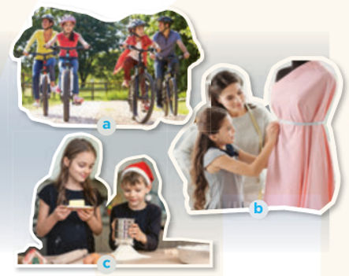  *Vocabulary  1. connect (v) kết nối  2. recipe (n) công thức  3. ingredient (n) nguyên liệu  4. costume (n) trang phục  * Key :  Picture a: riding bikes / cycling  Picture b: making a dress  Picture c: cooking
3. WHILE READING ( 15’)
* Objectives:
2. To help Ss develop the skill of finding the main idea and guessing the meaning of new words in context
3. To help Ss develop the skill of reading for specific information (scanning).
* Content: Read and choose the correct answer; Read the text again and answer the questions.
* Product: To Improve the skill of reading for specific information. To get more information of the text.
* Organisation :
Teacher’s Student’s activities | Content
ACTIVITY 2: Read about Trang’s leisure activities. Choose the correct answer.

- Tell Ss what they are going to do.  - Ask Ss to do the exercise individually and then check their answer in pairs.  - Invite some ss to share their answers. Confirm the correct answers. | - T_Ss  - Work individually.  * Key: 1. C 2. B
ACTIVITY 3: Read the text again and answer the questions.
- Ask Ss what they are going to do.  - Have Ss share how to do this exercise.  - Briefly tell them the steps: Read the questions, underline the key words in each question, locate the keywords in the text and find the information to answer the question.  - Ask Ss to repeat the steps if necessary.  - Ask Ss to do the exercise individually and then check their answers in pairs.  - Invite some Ss to share their answers. Have them explain their answers. Confirm the correct answers.  - Ask some Ss to tell the class about Trang's leisure activities. | - T_ Ss  - Ss to work individually.  * Key:  1. She goes for a bike ride, cooks and does DIY.  2. Her brother does.  3. No, it isn't.  4. She loves doing DIV projects with her mum the most.  5. Her mum teaches her to make her own dresses and doll clothes.  6. She won first prize in a costume contest at her school

EXTRA ACTIVITY
Materials: One A4 sheet of paper per student
+ Put Ss into groups of three.
- Ss reread the text and write two statements about the information in the text. One statement should be true and the other false.
- Each group member passes their paper to another group member who reads the two statements and decide which one is true and which one is false.

- The papers are given to a third group member who reads the statements and says if they agree or disagree with the previous group members' decision and find the clues in the text to support their idea.

4 . SPEAKING
* Objectives:
4. To help Ss prepare ideas to talk about the leisure activities they do with their family members.
5. To give Ss a chance to report their group's answers about leisure activities they do with their family members.
* Content: Asking and answering the questions; Report the answers to the class.
* Product: Students can ask and answer the questions correctly; Report what activities are the most common.
* Organisation :
Teacher’s Student’s activities | Content
ACTIVITY 4 : Work in groups. Take turns to ask and answer the questions. Record the friends’ answers in the table .
- Tell Ss that they are going to work in groups to answer the questions in the book. Model the answers to the questions yourself.  - Have Ss work in groups of four to ask and answer the three questions in the book. Ask them to draw a similar table on a sheet of paper to record their group members' answers.  - Ask Ss to practise reporting the group's answers within the group.  - Move around to observe and offer help if needed. | - T_ Ss.  - Ss- Ss  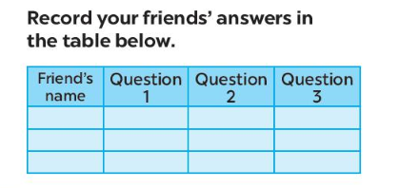
ACTIVITY 5: Report your group members’ answers to the class. What activities are the most common?

- Invite some Ss to share their group's answers to the class.  - Ask other groups to listen and give comments.  - Comment on Ss' answers.  * Teacher gives corrections and feedback | - Ss _ Ss  * Example:  - Some teenagers enjoy spending free time with their friends.  - Some of them prefer spending time with theeir family .  - I love going for a bike ride. ….
5. WRAP-UP & HOME WORK (2’)

- Ask Ss to summarise what they have learnt in the lesson.
- Have Ss look at the objectives written on the board at the beginning of the lesson and tick the objectives they have learnt.
* HOME WORK:
- Do more exercises in workbook.
- Prepare new lesson: Lesson 6 : A SKILLS _2.
IV. EVALUATION
+Lesson plan : -full form
+Content: - exactly
+Teacher’s activities : -clear instruction
+Students’activities: - effective activities
+Time : -shortage of time

