REVIEW 1 (UNITS 1+2+3)

Period:24 Lesson 2: Skills

I. OBJECTIVES:
By the end of this review, students will be able to revise the language they have learnt and the skills they have practised in Units 1-2-3.
1. Knowledge:
* Vocabulary: Review vocabulary, Pronunciation in Units 1-3
* Grammar: Grammar in Units 1 - 3
2. Attitude: To teach Ss life skills and love their school, friends,…
3. Competences: Ss can join teamwork or social activities; Talking about activities friends often do together.
II. TEACHING AIDS:
- Grade 6 textbook, Review (language)
- Projector/ pictures and cards
sachmem.vn
  - III. PROCEDURES:
* Warm-up (5’)
* Aim: To increase students’ interest and lead them into the lesson.
* Content: Ask some questions about pen pal.
* Products: Students’ correct answers
* Organization of implementation:
Teacher’s and Ss’ activities |  |  | Content
* Warm up (Team work)  - T -Ss  - Teacher asks students some questions to lead them into the lesson:  - Teacher lead in the reading part of the lesson. |  |  | * Chatting  1. Do you have any pen pals?  2. How do you communicate with your pen pal?  3. Do you often write emails to your pen pal?
* Practice (35’)
I. READING

Task 1
* Aim: To help students practise reading for specific information.
* Content: Choose A, B, or C for each blank in the email below.
* Products: The correct answers from Ss.
* Organization of implementation:
Teacher’s and Ss’ activities | Content
- T –Ss :  - Students do these exercises individually.  -Students check their answers with their partners before they give the answers to teacher.  - Teacher confirms the correct answers | Task 1: Choose A, B, or C for each blank in the email below.  - .  Answer key:  1. A  2. C  3. C  4. B  5. B
Task 2:
* Aims: To help students practise reading for general information.
* Content: Read the text and answer the questions.
* Products: The correct answers from Ss. ( individual work)
* Organization of implementation:
Teacher’s and Ss’ activities |  | Content
- T –Ss ; Ss – Ss  - Students do these exercises individually.  - Students check their answers with their partners before they give the answers to teacher.  - Teacher confirms the correct answers |  | Task 2: Read the text and answer the questions.  - .  *Answer key:  1. It’s in a quiet place not far from the city centre.  2. They are hard-working and kind.  3. They are helpful and friendly.  4. There are five clubs.  5. Because it’s a good school.
II. SPEAKING
Task 3
* Aims: To help students practise asking and answering about what they like and dislike about their school
and the reasons why.
* Content: Interview two of your classmates about what they like and dislike about your school. Report their answers.
* Products: students’ ideas in groups
* Organization of implementation:
Teacher’s and Ss’ activities |  | Content
Task 3: T - Ss, Ss – Ss  - Teacher has students work in groups of three. One interviews the other two about what they like and dislike about their school and the reasons why.  - Teacher tells students to write their group members’ answers in their notebooks and report them to the class.  - Teacher summarizes students’ ideas. |  | Task 3: Interview two of your classmates about what they like and dislike about your school. Report their answers.  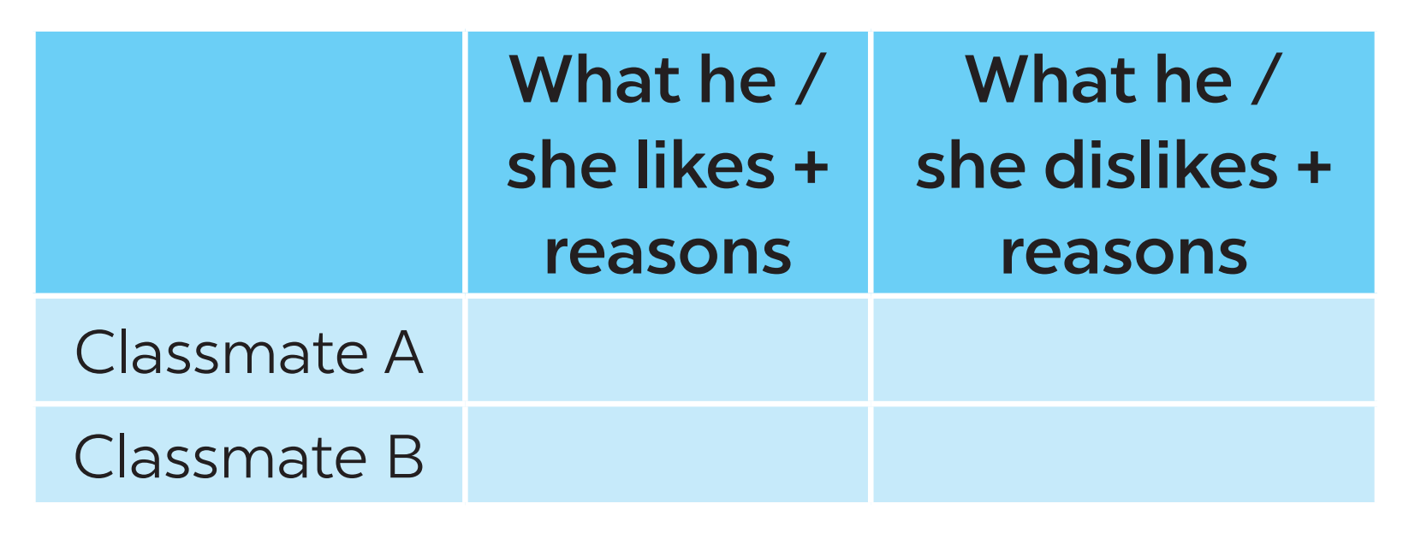  - Example:  Nam:  + He likes the friendly teachers and helpful friends. + They help him a lot with school work.  - The school yard is quite small, so he can’t play many games with friends.
III. LISTENING
Task 4.
* Aims: To help students review listening for specific information.
* Content: Listen and fill each blank with one word.
* Products: students’ correct answers .
* Organization of implementation:
Teacher’s and Ss’ activities |  | Content
Task 4: T - Ss, Ss – Ss  - Teacher has students read the sentences.  -Teacher plays the recording for the first time.  -Teacher asks students to listen and complete the sentences. Ask for their answers and writes them on the board.  -Teacher plays the recording the second time for students to check their answers.  -Teacher checks students’ answers.  -Teacher plays the recording the last time if necessary, stopping at diﬀerent places where students got the wrong answers. |  | Task 4: An and Mi are talking on the phone. Listen and fill each blank with one word.  Answer key:  1. home  2. plants  3. living  4. sleeping  5. TV  * Audio script:  An: Why is it so quiet, Mi? Are you home alone?  Mi: No. Everybody is here, but they are in diﬀerent rooms.  An: Where’s your mum? Is she cooking in the kitchen?
IV. WRITING
Task 5
* Aims: To help students complete a guided paragraph of 40-45 words about a student’s family member.
* Content: Write an email of about 50 words to your friend. Tell him/ her about a family member.
* Products: Students’ perfect writing.
* Organization of implementation:

Teacher’s and Ss’ activities |  | Content
Task 5: T - Ss, Ss – Ss  - Teacher elicits the parts of an email.  - Teacher asks students to discuss and answer the questions in pairs.  - Teacher then has them write their emails individually.  - Teacher asks one student to write the email on the board.  - Other students and teacher comment on  the email on the board.  - Teacher then collects some emails to give feedback at home. |  | Task 5: Write an email of about 50 words to your friend. Tell him/ her about a family member. Use these questions as cues.  Example:  1. My mom.  2. She is 40 years old.  3. She's tall and beautiful with long black hair.  4. She is caring because she always takes good care of me. She prepares food and uniform for me to go to school every morning. She's also kind because she usually helps the neighbours whenever they get trouble.  Hi Hoa,  Thanks for your email. Now I’ll tell you about my mother. She is 40 years old. She's tall and beautiful with long black hair. She is caring because she always takes good care of me. She prepares food and uniform for me to go to school every morning. She's also kind because she usually helps the neighbours whenever they get trouble.  Write me soon and tell me about a member in your family.  Best,
* Consolidation (3’)
* Aim: To consolidate what students have learnt in the lesson.
* Content: Summarize the content of the lesson.
* Products: A student says the lesson’s content aloud.
* Organization of implementation:
Teacher’s and Ss’ activities |  | Content
- Teacher asks students to talk about what they have learnt in the lesson. |  | - - 4 skills
* Homework (2’)
Aim: To revise the knowledge that students have gained in the lesson and To prepare for the next lesson
* Content: Review the lesson and prepare for the next lesson and do exercise in the workbook
* Products: Students’ textbook and workbook.
* Organization of implementation:

Teacher’s and Ss’ activities |  | Content
- Teacher asks students to revise old lesson and to do exercise in workbook.  - Teacher asks students to complete the project and prepare the new lesson. |  | - revise the old lesson.  - Do exercise in workbook.  - Prepare for the next lesson: Unit 4 – lesson1

