Period : 23 REVIEW 1

Lesson 1: Language

I. OBJECTIVES:
By the end of this review, students will be able to revise the language they have learnt and the skills they have practised in Units 1-2-3.
1. Knowledge:
* Vocabulary: Review vocabulary, Pronunciation in Units 1-3
* Grammar: Grammar in Units 1 - 3
2. Attitude: To teach Ss life skills and love their school, friends,…
3. Competences: Ss can join teamwork or social activities; Talking about activities friends often do together.
II. TEACHING AIDS:
- Grade 6 textbook, Review (language)
- Projector/ pictures and cards
sachmem.vn
  - III. PROCEDURES:
1.Warm-up (5’)
* Aim: To revise the language that students have learnt in Units 1+2+3.
* Content: Memory game: finish chart which summarizes the language that students have learnt in Units 1, 2, 3
* Products: Students’ correct answer key on the board.
* Organization of implementation:
Teacher’s and Ss’ activities |  |  | Content
* Warm up (Team work)  - T -Ss  - Teacher draws/sticks an unfinished chart which summarizes the language that students have learnt in Units 1, 2, 3 on the board.  - Teacher divides the class into 2 teams and asks students to run in a relay to complete the chart:  - The team with the most correct answers will be the winner. |  |  | * Game: Memory game  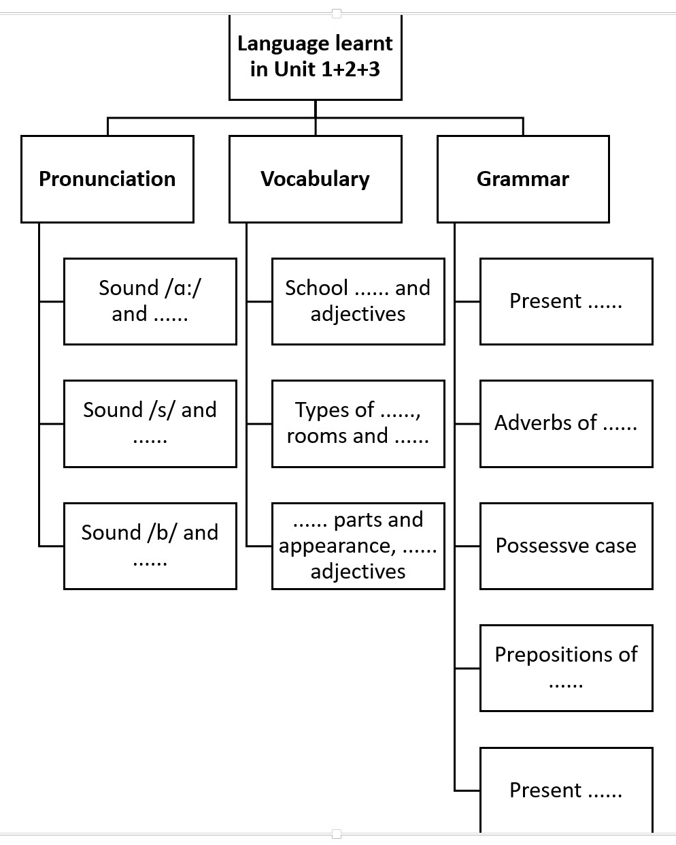  * Suggested answer:  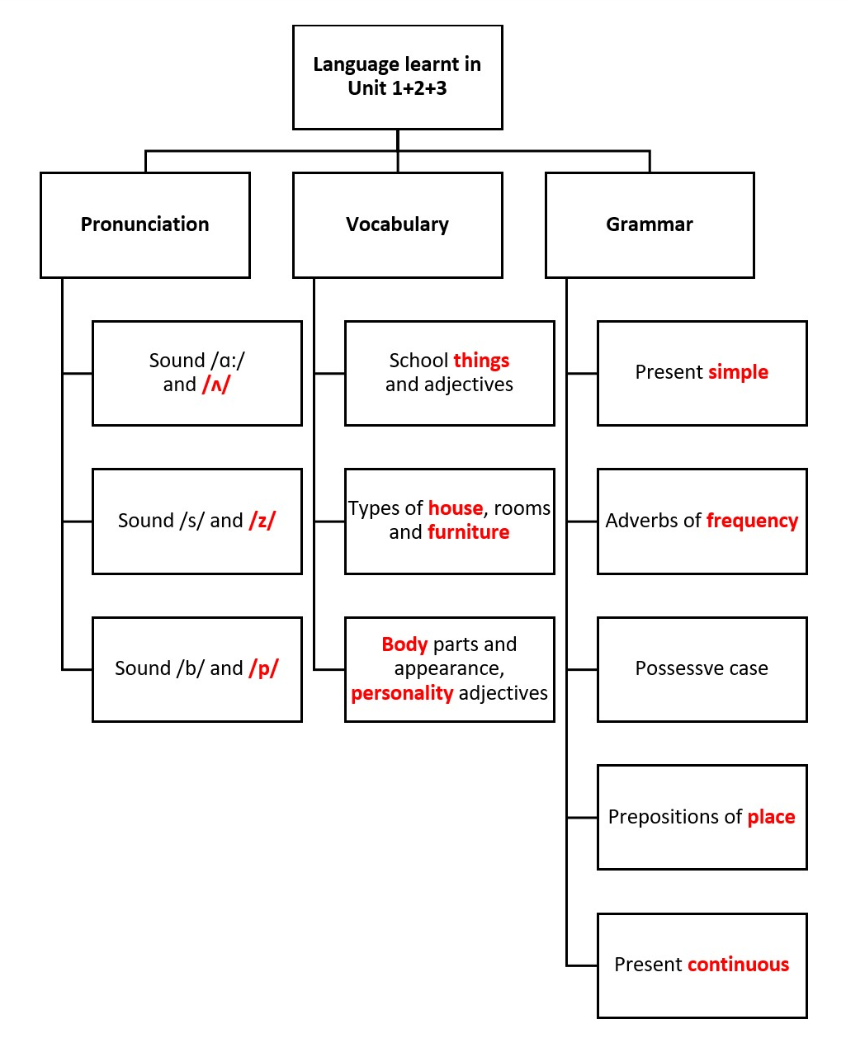
* Practice (35’)
PRONUNCIATION

Task 1
* Aim: To help students review the pronunciation of the sounds learnt in Units 1-2-3: /ɑ:/ and /ʌ/; /s/ and /z/ correctly.
* Content: Choose the word whose underlined part is pronounced diﬀerently
* Products: Students say the correct answer key.
* Organization of implementation:
Teacher’s and Ss’ activities | Content
- T –Ss :  - Teacher elicits the rules of pronouncing final -s if needed.  - Students do this exercise individually then share their answers with their partners.  - Teacher gives feedback and confirms the answers | Task 1: Choose the word whose underlined part is pronounced diﬀerently.  .  * Answer key:  1. C  2. A  3. B  4. A  5. B
Task 2: (5’)

* Aims: To help students review the pronunciation of the sounds /b/ and /p/ in words.
* Content: Write the names of school things and furniture in the house which begin with /b/ and /p/.
* Products: The correct words on the board
* Organization of implementation:
Teacher’s and Ss’ activities |  | Content
- T –Ss ; Ss – Ss  - Teacher organizes this task as a game.  - Students do this task in pairs. The pair that finds the most words will go to the board and write their answers.  - Other pairs may want to add more words. Write other words on the board.  - Teacher gives feedback and confirms the answers. |  | Task 2: Write the names of school things and furniture in the house which begin with /b/ and /p/.  * Suggested answers:  /b/  book, bag, bed…  /p/  pen, pencil, picture, poste…
Task 3.
VOCABULARY
* Aims: To help students review the word groups used with “play, have, do” and “study”.
* Content: Complete the words.
* Products: The correct words on the board (individual work)
* Organization of implementation:
Teacher’s and Ss’ activities |  | Content
Task 3: T - Ss, Ss – Ss  - Teacher has students do this task individually and then share their answers with their partners.  - Teacher calls one or two students to write their answers on the board.  - Teacher checks and confirms the correct ones. |  | Task 3: Complete the words.  * Answer key:  1. English 2. homework  3. lunch 4. sports  5. badminton  🡪 play: sports, badminton  🡪 have: lunch  🡪 do: homework  🡪 study: English
Task 4.
* Aims: To help students review the personality adjectives, the words related to body parts, rooms and types of house.
* Content: Solve the crossword puzzle.
* Products: Say the correct answer aloud. (team work)
* Organization of implementation:
Teacher’s and Ss’ activities |  | Content
Task 4: T - Ss, Ss – Ss  - Teacher sticks the crossword puzzle on the board.  Giaoandethitienganh.info  - Teacher divides the class into 2 teams and asks students to run in a relay to complete the crossword puzzle.  - The team with the most correct answers will be the winner. |  | Task 4: Solve the crossword puzzle.  * Answer key:  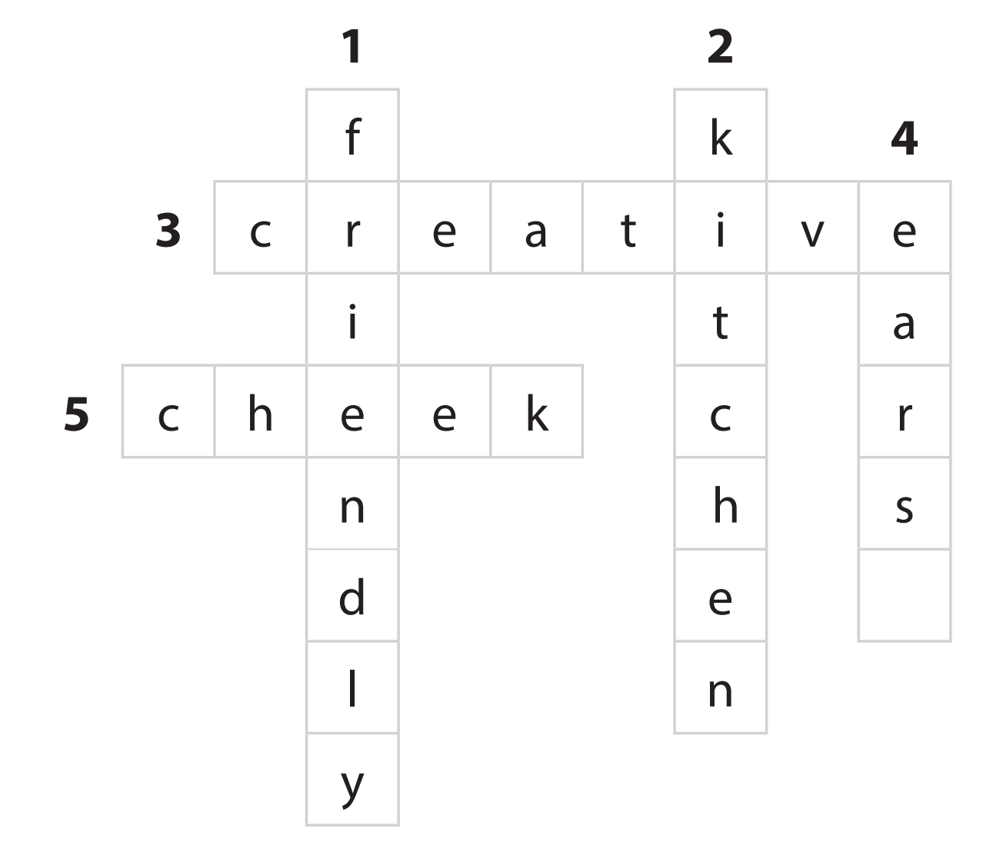
Task 5
* GRAMMAR
* Aims: To help students review grammar elements taught in Units 1-2-3: prepositions of place, possessive case and present continuous.
* Content: : Look at the picture of a classroom. Choose the best answer A, B, or C.
* Products: Students’ correct choice.
* Organization of implementation:

Teacher’s and Ss’ activities |  | Content
Task 5: T - Ss, Ss – Ss  - Teacher has students look at the picture of a classroom and complete the sentences.  - Students compare their answers with a classmate.  - Teacher checks and confirms the correct answers. |  | Task 5: Look at the picture of a classroom. Choose the best answer A, B, or C.  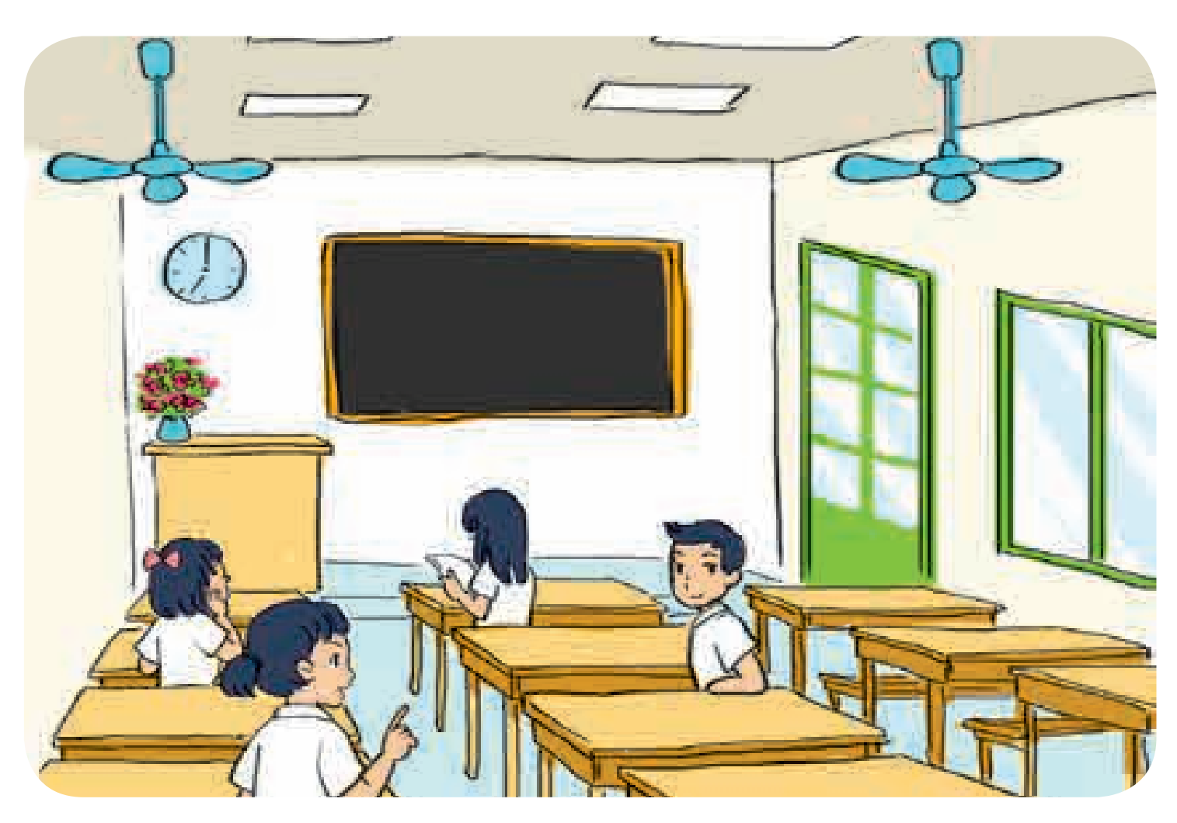  * Answer key:  1. B 2. A 3. A 4. B 5. C
Task 6:
* Aims: To help Ss review the use of the present simple and the present continuous.
* Content: : Complete the sentences with the present simple or the present continuous form of the verbs in brackets.
* Products: Write the answers correctly on the board./ say the answers aloud
* Organization of implementation:

Teacher’s and Ss’ activities |  | Content
Task 6: T - Ss, Ss – Ss  - Teacher elicits form and usage of the present simple and the present continuous.  - Teacher asks students to do the exercise individually before calling one or two students to write their answers on the board.  - Teacher checks students’ answers and asks them for explanation if necessary |  | Task 6: Complete the sentences with the present simple or the present continuous form of the verbs in brackets.  Answer key:  1. is / ’s raining  2. do you have  3. Is she studying  4. likes  5. is not / isn’t cooking;  is reading
* Consolidation (3’)
* Aim: To consolidate what students have learnt in the lesson.
* Content: summarize the content of the lesson.
* Products: A student says the lesson’s content aloud.
* Organization of implementation:

Teacher’s and Ss’ activities |  | Content
- Teacher asks students to talk about what they have learnt in the lesson. |  | - - vocabulary and grammar in the lesson
* Homework (2’)
Aim: To revise the knowledge that students have gained in the lesson and To prepare for the next lesson
* Content: Review the lesson and prepare for the next lesson and do exercise in the workbook
* Products: Students’ textbook and workbook.
* Organization of implementation:

Teacher’s and Ss’ activities |  | Content
- Teacher asks students to revise old lesson and to do exercise in workbook.  - Teacher asks students to complete the project and prepare the new lesson. |  | - Do exercise in workbook.  - Prepare for the next lesson: Review (SKILLS).

