**Khanh Mau Secondary School Teacher: Dinh Thi Thu Huong Social science group**

**WEEK 31**

**Period: 91 UNIT 9: GETTING AROUND**

**Lesson 9.7: WRITING: An invitation**

**STAGE I. DESIRED OBJECTIVES:**

**A. Objectives:** By the end of the lesson, Ss will be able to:

**1. Cognition/ knowledge:** Identify the topic of this unit and lesson through the part 1, 2, 3, 4 and 5. Recognize the lexical items related to the topic “ Getting around…”. Use phrases and expressions to write an invitation email.

**2. Competences:**

- *General competences:* Develop groupwork and independent working, pair work, linguistic competence, cooperative learning, and communicative competence.

*- Specific competences*: Write an invitation email.

**3. Attributes/ personal qualities:** Show their good attitude when writing an ivitation email. Be responsible for the invitation.

**B. LANGUAGE FOCUS**

**Key terms/ Vocabulary:**

- Text languages, meeting arrangements.

- Past simple, *be going to* for plans, suggestions, present continuous for arrangements.

**C. INSTRUCTIONAL RESOURCES:**

- textbooks, hand-out, active teach

- TV (Projector), loudspeaker….

**STAGE II. ASSESSMENT EVIDENCE.**

|  |  |  |
| --- | --- | --- |
| **Performance Tasks** | **Performance Products** | **Assessment Tools** |
| 1. Discussion: Talk about the last good news you celebrated. | Ss’ oral answers in 1-min short conversation | T’s observation. |
| 2. In pairs, read the email quickly and answer the questions. | Ss’discussion  Ss’ written answers in sentences. | T’s observation  Peer’s correction  T’s feedback. |
| 3. Find examples of the phrases in Eva’s email. | Students’ discussion  Ss’ written answers in 2 sentence | T’ observation  Peer’s correction  T’s feedback |
| 4. Read the advert and complete the sentences with no more than 3 words. | Ss’ written answers in words and numbers. | T’s observation.  Peer’s correction  T’s feedback |
| 5. Write an email inviting a friend to come to your birthday this Saturday. | Ss’ written answers in email. | T’ observation  T’s feedback |

**STAGE III: TEACHING PROCEDURE/ LEARNING EXPERIENCES**

***Activity 1: Warm-up***

**- Step 1:** T divides the class into 2 groups and asks Ss to play a game.

**- Step 2:** T shows pictures of celebrations one by one and asks Ss to guess: What celebration is this?

**- Step 3:** Ss have to put their hands up to answer. The first group to put their hands up and to give the correct answer wins a point.

**- Step 4:** The winning group is the one that has won the most points.

**Answer:**

* Birthday
* New year
* Halloween
* Thanksgiving
* Christmas

***Activity 2: Pre-writing***

*Exercise 1: In pairs, talk about the last good news you celebrated. How did you celebrate it?*

**- Step 1:** T checks that Ss understand the difference between celebrate (verb) and celebration (noun).

**- Step 2:** T sets a time limit for the pairs to discuss their story of the last good news.

**- Step 3:** T invites pairs to share their stories with the rest of the class.

**- Step 4:** T feedbacks

***Activity 3: Practice***

*Exercise 2: In pairs, read the email quickly and answer the questions.*

**- Step 1:** T asks students to read the email quickly and answer the questions in pairs.

**- Step 2:** T elicits the answers.

**- Step 3:** T asks Ss to look in the email again and find an example of something that happened in the past, a future plan, a suggestion, and text language.

**- Step 4:** T asks students to work in groups of 4 to share their ideas.

**- Step 5:** T calls some volunteers to share with the whole class.

**Answers:**

1. Eva
2. Max passed his audition.
3. Sol, Lily, and Max's dad.
4. At a quarter to six, on Friday.
5. A card.

* **In the past:** Max passed his audition.
* **Future plan:** I’m going to invite Lily and Max’s dad.
* **A suggestion:** Let’s meet under the bus station clock.

**Text language:** BTW – which means by the way.

***Activitie 4: Presentation of the Writing box.***

*Exercise 3: Find examples of the phrases in Eva’s email.*

**- Step 1:** T asks Ss to find examples of phrases in Eva’s mail and elicits the answers.

**- Step 2:** T gives an unfinished table about the structure of an invitation email.

**- Step 3:** T divides the class into groups of six and asks Ss to complete the task.

**- Step 4:** Teacher gives feedback, the first group to have the correct answers wins the game.

**Possible answer**:

|  |  |  |
| --- | --- | --- |
| Information | Tense/ Structure | Part |
| To giving recent news | Past simple | Greeting/News |
| To say what is happening now | Present continuous | Invitation |
| To talk about plans | Be going to | Invitation/ Other plans |
| To talk about arrangements | Present continuous | Meeting arrangements |
| To make suggestions | Let’s | Meeting arrangements |
| To invite | Would you like | Invitation |

***Activity 5: While writing***

*Exercise 4: Read the advert and complete the sentences. Write no more than three words in each gap.*

**- Step 1:** T shows the photo in Exercise 4 and discusses the photo with the class. T asks Ss if anyone has been karting.

**- Step 2:** T asks students to read the text quickly and complete the sentences.

**- Step 3:** T elicits the answers and checks that Ss understand the differences between *minimum* and *maximum.*

**- Step 4:** T confirms the answers.

**Answers:**

1. 10 a.m
2. Thirteen
3. 2.30
4. Food or drink

***Activitiy 6: Practice writing an invitation email.***

*Exercise 5: You’r celebrating your birthday this Saturday. Write an email inviting a friend to come. Use Eva’s email and the inviting box.*

**- Step 1:** T elicits ideas for possible news that they could include at the start of their email.

**- Step 2:** T sets a time limit for Ss to write their email.

**- Step 3:** T puts Ss in pairs and asks them to swap emails. Ss should read their partner’s email and ask if it was written specifically to them.

**- Step 4:** The pairs take turns to thank each other and say whether they can come.

*\* Minimum*: used after amounts to show that the amount is the lowest possible

*\* Maximum:*used after amounts to show that the amount is the highest possible

***Activity 7: Post writing( Wrap up ) and Assignment***

**\*Wrap up:** T gives students the writing rubric to check their writings themselves, then give comments.

Writing rubric:

1. Does your writing follow the right format of an invitation email?
2. Do you use correct punctuation?
3. Do you use the correct forms of the verbs?

Do you have a greeting and closing?

**\* Assignment**

- Do exercises on Workbook page 85.

- Prepare Unit 9 Lesson 8 Pronunciation and Revision.

**Period: 92 +93**

**UNIT 9: GETTING AROUND**

**Lesson 9.8: PRONUNCIATION AND REVISION**

**STAGE I. DESIRED OBJECTIVES:**

**A. OBJECTIVES**

*By the end of the lesson, students will be able to:*

**1. Cognition/ knowledge**: Identify the topic of this unit and lesson through the part 4, 5( p 98), 2, 5, 6, 8 ( p99). Recognize the lexical items related to the topic “Getting around”.

**2. Competences:**

*- General competences*: Develop communication and collaboration skills by sharing their answers with their partners by writing, listening and speaking.

*- Specific competences:* Listen to how we pronunce the /ei/ and /a:/ sounds, write the correct word for each definition, match the picture with words from the wordlist, do exercises to improve their knowledge they have leanred on the topic Getting around.

**3. Attributes/ personal qualities:** Show their love for their interests through group work, pair work, individual work .

**B. LANGUAGE FOCUS**

**Key terms/ Vocabulary:**

**- Pronunciation:** /ei/ and /a:/ sound.

- **Vocabulary:** review transport, travel, holiday activities, the weather.

**- Grammar:** Present Continuous for future arrangements, “be going to” for plans

**C. INSTRUCTIONAL RESOURCES:**

- Grade 6 textbook, Unit 9 (SB p. 98-99)

- Computer connected to the Internet

- Projector / TV/ PPT slides / loud speaker

**STAGE II. ASSESSMENT EVIDENCE.**

|  |  |  |
| --- | --- | --- |
| **Performance Tasks** | **Performance Products** | **Assessment Tools** |
| 1.(4/98). Listen how we pronounce the /ei/ and /a:/ sounds. | Students’ discussion  Ss’ written and oral answers in 40-second short conversation | T’s observation  Peer’s correction  T’s feedback. |
| 2. (5/98). In pairs, say the sentences. Listen, check and repeat. | Students’ oral answers in 1 sentence. | T’s observation.  Peer’s correction. |
| 3.(2/99). In pairs, explain the words below. Choose the two activities that you like best. | Students’ oral answer. | T’s observation.  T’s feedback. |
| 4.(5/99). Look at the table and write sentences about Phong and Chi’s arrangements. Use the present continuous. | Sts’ written answers. | T’s observation  T’s feedback. |
| 5.(6/99). Look at the list of what Phong and Chi want to do in Ha noi. Write about their plan. Use “going to”. | - sts’ written answers.  Students’ discussion  Ss’ oral answers in 1,5 min short dialogue | T’s observation  Peer’s correction  T’s feedback.edback. |
| 6.(8/99). In pairs, ask for and give direction**s.** | - Students’ discussion  - sts’written answers  - sts’ oral answers. | T’s observation  Peer’s correction  T’s feedback |

**STAGE 3: LEARNING PLAN/ LEARNING EXPRIENCES**

***Activity 1: Warm-up***

**- Step 1:** T divides the class into groups of 4.

**- Step 2:** T says a word and Ss have to race to find that word in the worksheet. When a group has found the word, they should raise their hands.

**- Step 3:**T calls the first raising group to go to the board and shows the word on the board.

**- Step 4:** The first team to find the correct answer gets a point. Which group gets more points will be the winner.

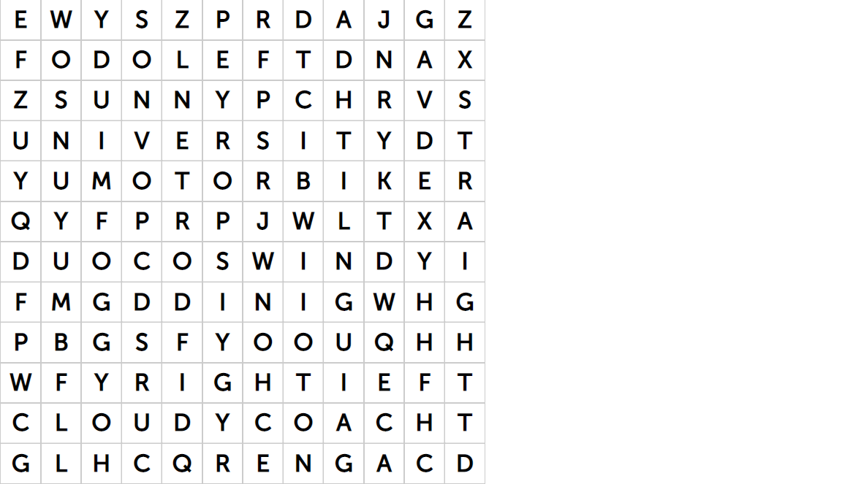

|  |  |
| --- | --- |
| 1. Foggy 2. Windy 3. Sunny 4. Cloudy 5. University | 1. Coach 2. Right 3. Left 4. Straight 5. Motorbike |

***Activity 2: Presentation of the /ei/ and /a:/ sound****.*

**- Step 1:** T introduces two sounds to Ss and lets them listen and repeat words in Exercise 4. T stops the recording to let Ss repeat each word.

**- Step 2:** T asks Ss to work in pairs to write the words in the correct column.

**- Step 3:** T ask Ss to practice the words in pairs in 1 minute.

**- Step 4:** T calls some pairs to practice the sounds and the words and give feedback.

**Answer:**

/ei/: accommodation, bike lane, celebrate, dangerous, make, place, rainy.

/a:/: car, car park, past.

***Activity 3: Practice***

**- Step 1:** T asks Ss to say the sentences in pairs.

**- Step 2:** T plays the audio track 9.14 and asks Ss to listen and check.

- **Step 3:** T calls some Ss to stand up and say sentences.

**- Step 4:** T correct their mistakes and give comments.

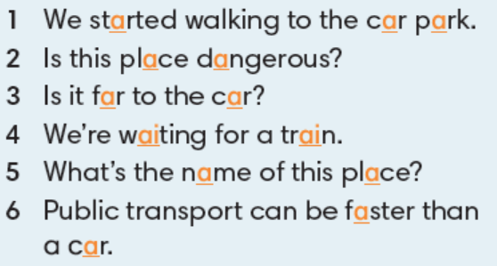

**Game: “Up and down”**

* T explains the rules: *T says 1-15 words containing the sound /ei/ and /a:/. Ss stand up for the words with the /ei/ sound sit down for ones with /a:/ sound.*

Ss plays on groups.

1. Accommodation
2. Bike lane
3. Rainy
4. Dangerous
5. Car
6. Make
7. Park
8. Place
9. Past
10. Celebrate
11. Train
12. Fast
13. Far
14. Start
15. Wait

***Activity 4: Review***

*Exercise 2(p99): In pairs, explain the words below. Choose the two activities you like best.*

**- Step 1:** T asks Ss to work in pairs to explain the words in English.

**- Step 2:** T checks by asking Ss to match the words with their definitions.

**- Step 3:** T calls some Ss to give their ideas.

**- Step 4:** T confirms the answers by showing images and giving explaination.

**Answers:**

* Hiking: the activity of going for long walks in the country for pleasure.
* Shopping: the activity of going to shops and buying things or ordering them online
* Sightseeing: the activity of visiting interesting buildings and places as a tourist
* Skiing: the sport or activity of moving over snow on skis
* Sunbathing: to sit or lie in the sun, especially to go brown

*Exercise 5( p99): Look at the table and write about their arrangements.*

**Game: Writing race**

**-Step 1:** T reviews the meaning, usage, and form of Present Continuous.

* Meaning: to talk about future arrangements.
* Usage: I am + V ing

He/She/It + is + Ving

You/We/They + are + Ving

* Form:

(+) S + to be + Ving .

(-) S + tobe + not + Ving.

(?) Tobe + S + Ving?

(?) Wh-question + tobe + S + Ving?

**- Step 2**: T asks Ss to look at Exercise 5.

**- Step 3:** T asks Ss to work in pairs, use the table and words to write about their arrangements.

**- Step 4:** T asks some Ss to read aloud their answers.

**Answers:**

1. At 7 a.m they’re taking a taxi to Niem Nghia bus station.
2. At 7.30 a.m they’re getting the coach to Ha Noi.
3. At 5 p.m they’re leaving Ha Noi.

At 8 p.m they’re arriving back in Hai Phong.

*Exercise 6: Look at the list of what Phong and Chi want to do in Hanoi. Write about their plans.*

**Game: Lucky number**

**- Step 1:** T divides the class into 2 groups.

**- Step 2:** T asks Ss to choose numbers and answer the questions quickly in 3 seconds.

**- Step 3:**If Ss choose the lucky number, they don’t have to answer.

|  |  |  |
| --- | --- | --- |
| 1 | 2 | 3 |
| 4 | 5 | 6 |

**Answers:**

They’re going to visit Ho Chi Minh Mausoleum. Then they’re going to meet Tom’s brother for lunch. Then they’re going to visit Thu Le zoo. They’re going to go walking around Hoan Kiem lake.

***Activity 5:* Further practice**

**- Step 1:** T has each Ss draw a map of their neighbourhood with the name of at least 4 places on their map. (school, town centre, bus/train station)

**- Step 2:** T may have Ss prepare their map at home.

**- Step 3:** T asks Ss to work in pairs, taking turns to ask for and give directions to the places on their maps.

**- Step 4:** T goes around and offers help if necessary.

If there is time, have some pairs practise in front of the whole class.

***Activity 6: Wrap up and Assignments***

**\*) Wrap up:** T sums up some main points, focus on pronunciation, key terms and grammatical structures.

**\*) Asignments:**

- Do Self – check on Workbook page 14.

- Prepare Unit 10, lesson 10.1.

**BGH KÝ DUYỆT**