Period :88

UNIT 13: APPEARANCE
Lesson 2 - Activity 4, 5, 6

I. OBJECTIVES:
By the end of the lesson, students will be able to:
- Listen to and understand four communicative contexts in which characters ask and answer questions about someone’s appearance, and number the correct pictures.
- Complete the target sentence patterns in two exchanges about appearance with the help of picture cues.
- Review vocabulary about family members and appearance by playing the game Tic-tac-toe.
1. Knowledge/ Language focus:
- Vocabulary: review
- Sentence patterns: review
2. Skills:
- Listening, reading and speaking
3. Quality /Attitude:
-Actively participate in activities with their classmates in pairs, groups or class. Educate Ss to show pride in how we look and show great respect for other people’s appearance by using appropriate gestures and intonation when asking and answering about appearance.
Kindness: help partners to complete learning tasks
Diligence: complete learning tasks
Leadership: collaborate with teachers to enhance language skills
4. Competences:
SS can develop some competences:
- Communication and collaboration: work in pairs and groups to complete the learning tasks
- Self-control & independent learning: perform listening tasks
II. TEACHING AIDS / MATERIALS:
- Pictures, textbook, computer, projector, flashcards, recording…
III. PROCEDURE:

Teacher’s activities | Students’ activities
1.Warm- up: 5’  Game: Angry birds  *Aims: to help ss to be happy and play game  *Procedure:  -T asks ss to tell about the appearance that they have learnt.  -Ask ss to read again those words  -Say “Open your book page 20 and look at lesson 2 – Activity 4, 5, 6”  2. New lesson  Activity 1. - 4. Listen and number :9’  *Aims: to listen to and understand four communicative contexts in which characters ask and answer questions about someone’s appearance, and number the correct pictures.  *Procedure:  -Draw student’s attention to the sentences 1and 2. Tell them about the activity. Elicit the names of the characters and flag in each picture. Point at the pictures respectively to explain the context.  - Play the recording for ss to do the task.  - Get Ss to swap with a partner.  -Play the recording again to check answers together as a class.  -Ask ss to write their answers on the board and correct their answers.  - T gets feedback.  * Key: 1. d 2. a 3. c 4. b  *Outcome: Ss can listen to and understand four communicative contexts in which characters ask and answer questions about someone’s appearance, and number the correct pictures.  Activity 2 - 5. Look, complete and read :9’  *Aims: to complete the target sentence patterns in two exchanges about appearance with the help of picture cues.  *Procedure:  - Get Ss to look at the pictures. Get them to identify the characters.  - Have Ss look at the four incomplete sentences and guess the missing word. Then draw Ss’ attention to the picture and elicit the apperance that can be used to fill in the gap (big).  - Model with a sentence.  - Have Ss complete the sentences individually. Go around the classroom to offer support where necessary.  -Ask ss to write their answers on the board and correct their answers.  -Ask a few Ss to read the correct answers in front of the class.  -T gets feedback.  * Key: 1. big, face 2. look like, long hair  *Outcome: Ss can complete the target sentence patterns in two exchanges about appearance with the help of picture cues.  Activity 3. - 6. Let’s play :7’  *Aims: to review vocabulary about family members and appearance by playing the game Tic-tac-toe.  *Procedure:  -Tell Ss that they are going to play the game Tic-tac-toe. Two Ss play at a time. One student is X, and the other is O. The Ss take turns choosing a square by saying a word and putting their mark in the corresponding square. The first student to write three marks in a vertical, horizontal or diagonal line is the winner.  - Invite two Ss to play at a time.  - Change the words in the grid and let Ss play the game several times if there is enough time.  *Outcome: Ss can review vocabulary about family members and appearance by playing the game Tic-tac-toe.  3. Consolidation :3’  *Aims: to consolidate and wrap up the content of the lesson.  - T tells Ss about the main content of the lesson.  -T tells Ss about the educational aims of the lessons.  4. Homelink .2’  - Practice more at home.  - Prepare for the next lesson. | - SS listen and do the task.  -SS open their book.  -Look at the picture, listen and answer.  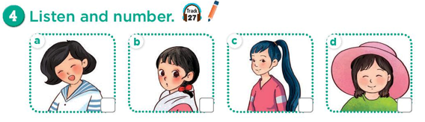  -Ss listen and do the task  -Ss swap.  -Ss listen and check.  -SS write their answers  -Look at the picture and identify.  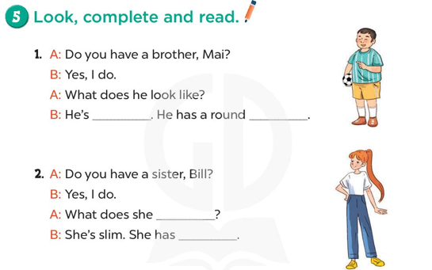  -SS do the task.  -Ss write their answers  -SS read in front of the class.  -Ss look and listen.  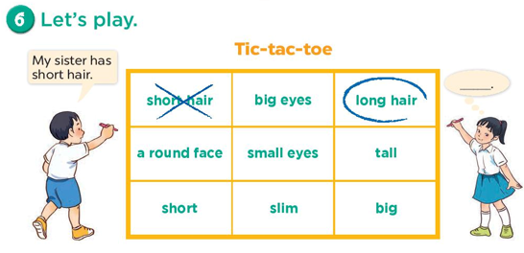  -Ss play game.  -SS listen.  -SS listen.

IV. Assignments of teacher one’s self after the teaching lesson :
...............................................................................................................................................................................................................................................................................................................................................................................................................................................

