UBND XÃ NHO QUAN  TRƯỜNG TH&THCS LẠNG PHONG | BÀI KIỂM TRA ĐỊNH KỲ CUỐI HỌC KỲ 1  NĂM HỌC 2025 - 2026  MÔN TIẾNG ANH LỚP 5  ( Thời gian làm bài 40 phút )
Họ và tên học sinh:…………………………………………Lớp 5… ……..
Họ tên giáo viên coi kiểm tra |  |  | Họ tên giáo viên chấm bài kiểm tra
…………………………………………  ………………………………………… |  |  | …………………………………………  …………………………………………
Mark | Listening | Reading | Writing | Speaking | Total
Comment | ………………………………………………………………………...  …………………………………………………………………………

PART I: LISTENING (2,5pts)

Question 1. Listen and circle the best answer A, B or C. (1pt)

- A. | B. | C. 
- A. | B. | C.
- A | B.  | C.
3. A. | B. | C. 
- A. | B.  | C.

Question 2. Listen and match to the correct picture. (1pt)
A. | B | C | D | 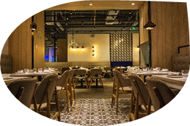  E.
0 | 1 | 2 | 3 | 4

Question 3. Listen to the questions and circle the correct answers. (0,5pt)

0. ________________?  A. No, thanks.  B. Yes, you can.  C. Yes, go ahead. | 9. ________________?  A. Yes, she is.  B. I am good at swimming.  C. He can swim. | 10. ________________?  A. No, they aren’t.  B. We ride the roller coaster today.  C. No, we can’t.

PART II: READING (2,5 pts)

Question 4: Read and circle the best answer A, B, C or D. (1,25đ)

11.What is she good at?
A.She’s good at swim in the sea. B. She good at swimming.
C. She’s good at swimmer D. She’s good at swimming.
12. My brother ………….on a picnic with his friends on his last birthday.
A. to B. went C. go D. going
13. ………………… did you go on last Christmas?
- I went to the church with my family.
A. Where B. When C. What D. How
14. There are ………………oranges in the box.
A. much B. many C. a lot D. too
15.What do parents often do in their free time? - They often……………….ice skate in their free time.
A. goes B. went C. go D. going

Question 5: Read and tick True or False.(1,25đ)

This is my friend, Alex. He usually gets up at 6.00 in the morning.He always has breakfast with his mum and dad. His mum drives him to school. Alex finishes school at 4 p.m. He sometimes visits grandparents in the afternoon. In the evening, Alex usyally does his homework.Then he often play volleyball with his dad. He goes to bed at 10.30 at night.
 | T | F
- Alex is my friend. | V
- 16. He always gets up at 6:5 in the morning
- 17. He always has breakfast with his parents
- 18. He goes to school by bus.
- 19. Alex finishes school at 4.00 p.m.
- 20. He often plays volleyball with his dad

PART III: WRITING (2,5 pts)

Question 6: Look, read and write the words. (1,25pts)
Hello everyone, my name is Linda. I’m 11 years old. I live in Ha Noi with my parents and my brother Ann. He’s 7 years old. I’m good at (0)  s

swimming. And ít’s my favourite activity. I often go swimming in the (21) 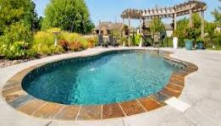 ………. …. with my mum at the weekend.Sometimes when my mum busy. I (22) 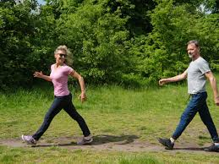 ……………..to the park with my brother, Danie. My brother is quiet young so he often stays at (23) ………………He can (24) …………….TV or play (25) ………….. ……...

with my dad.We often have dinner together. I love my family very much.

Question 7: Reorder the words to make sentences.(1,25 pts)

0 . many/ room/ There/ toys/ are/ in/ the/ of/ middle/ the/. (10 words)
⇨ There are many toys in the middle of the room.
26. / Both my sister/ are kind./ and my brother/
⇨ Both……………………………………………………………………………
27. food/ My favourte / is/ / beef./
⇨ My ……………………………………….……................…………...................
28. three boxes/ There are /under the table./
⇨ There …………………………………….……................………….......................
29. When /her sister was / was a doll. / seven, / her/ favourite toy/
⇨ When …………………………………………………………………………
30. Alex’s/ birthday party / yesterday./ . I went to
⇨ I …………………………................…………................…………........................

PART III: SPEAKING (2,5 pts)

31. What are you good at/ crazy about?
32. What time do you go to school/ go to bed?
33. What do you often do during Tet holiday/ Mid-Autumn Festival?
34. How many computers/ people are there in your class?
35. Where is the clock/ schoolbag/ map?

