Date of planning: October 3 ^{rd} 2025
Date of teaching: October 10 ^{th} 2025.(3D,3C,3A,3B)

Period 20 - Unit 3: Our friends
Lesson 2 (4, 5, 6)

A. OBJECTIVES:
By the end of the lesson, Ss will be able to:
1. Knowledge:
- listen to and understand communicative in contexts.
- look, complete and read the dialogues with the help of picture cues
- Vocabulary: Review
- Skills: speaking, listening, reading and writing.
2. Competences:
- Critical Thinking: self-introduce
- Co-operation: ready to help friends in pair work/ group work.
- Self-control and independent learning: perform listening tasks.
3. Attitude/ Qualities:
- Kindness: Help partners to complete learning tasks.
- Honesty: tell the truth about feelings and emotions.
- Diligence: complete learning tasks.
B. TEACHING AIDS:
- Teacher: Teacher’s guide Pages 45, 46; audio Tracks 31; website sachmem.vn, posters, laptop, pictures, textbook, lesson plan, TV or projector.
- Students: Pupil’s book Page 25, notebooks, workbooks, school things.
C. PROCEDURES:
Teacher’s activities | Students’ activities
1.Warm- up: (5’)  Sing a song: Hello  *Aims: to create a friendly and active atmosphere in the class to beginning the lesson.  *Procedure:  - Show the song on the screen.  https://www.youtube.com/watch?v=O13gITUS5t4  - Ask pupils to listen, sing and dance the song.  - Say “Open your book page 13” and look at “Unit 3, Lesson 2 (4,5,6)”.  2.Practice: (27’)  Activity 1. Listen and number:  *Aims: Ss will be able to listen to and understand four communicative contexts in which pupils ask and answer questions about someone.  *Procedure:  - Elicit the names of the characters in the pictures.  - Point at the pictures respectively to explain the context.  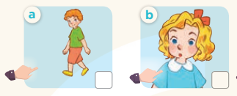  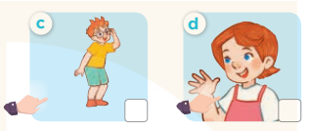  - T ask Ss to guess the answers.  + T writes Ss’guessing on the board.  - Listen to the tape:  + Play the recording  + Play the recording again and get Ss to swap books with their partners.  + Play the recording again to check answers together as a class.  + Write the answers on the board for Ss to correct their answers. Then checks Ss’ guessing.  - Play the recording, sentence by sentence, for the class to listen and repeat in chorus.  Key: 1. b 2. a 3. d 4. c  Activity 2. Look, complete and read  *Aims: Ss will be able to look, complete and read four target sentence patterns in four dialogues with the help of picture cues.  *Procedure:  - Elicit the context and check comprehension  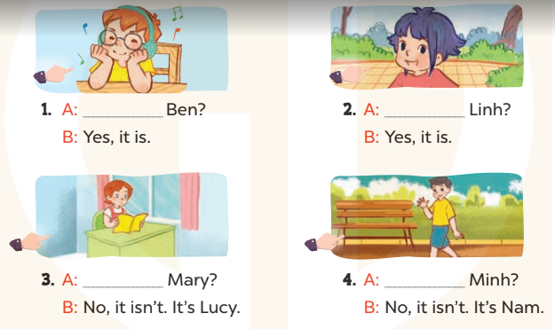  - Have Ss look at the four incomplete dialogue and elicits the missing words in the sentences.  - T models with picture 1  + Ask Ss what is missing in the sentence.  + Have Ss look at the picture and complete the gap, then read the completed sentence in chorus.  -Have Ss work in groups and complete the picture 2, 3 and 4.  - Ask a few Ss to stand up and read the completed sentences aloud.  -T gives feedbacks.  Key: 1. Is this 2. Is this 3. Is that 4. Is that  Activity 3. Let’s play.  *Aims: Ss will be able to recognise target words while looking at pictures of the characters and circle six names in a letter table and use them to ask and answer questions.  *Procedure:  - Tell pupils to work in pairs.  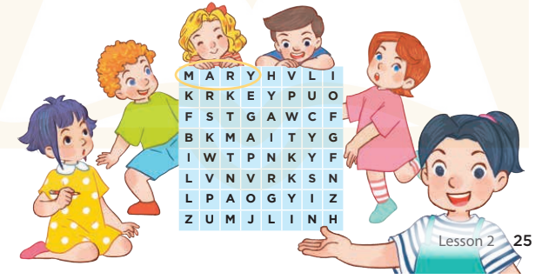  - Model the activity by identifying the picture of Mary first, draw Ss' attention to the word Mary in the table.  - Point to the picture of Mary and ask: “Is this Mary?” Ask a ss to answer the question: “Yes, it is.”  - Have pupils play the game. Explain that after identifying six characters in the pictures and circling  - Give Ss time to play the game.  - Invite a few pairs to perform the game in front of the class.  - Give feedbacks  Key:  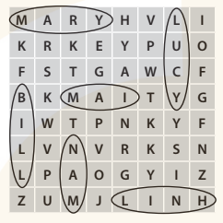  *Consolidation  *Aims: Ss will be able consolidate and wrap up the content of the lesson.  *Procedure:  - T asks ss to answer the following questions:  + What have you learnt from the lesson today?  +What are the core values of the lesson? (if the teacher can take from the lesson).  - T praises some Ss who are hardworking / active/ good…. as well as encourage others to try more.  3. Homelink. (3’)  - Practice part 5 again.  - Prepare the new lesson: Unit 3, Lesson 3 (1,2,3). | - Sing and dance the song in chorus.  - Ss open their books  -Look at the pictures and say:  + Picture a: Bill  + Picture b: Mary  + Picture c: Ben  + Picture d: Lucy  -Ss guess the answers  - Ss listen to the tape and write number  - Ss listen again, write number and swap books with their partners.  - Ss check their answers and guessing  -Ss listen and repeat.  -Ss look and answer  -Ss answer: Is this Ben?  -Ss look, complete and read the completed sentence in chorus.  -Ss complete the sentence  -Ss read aloud  - Ss listen  -Ss play game  -Ss answer the questions  - Ss listen  -Ss listen and clap their hands  -Ss listen

D. ADJUSTMENTS (if necessary):
………………………………………………………………………………………
………………………………………………………………………………………
………………………………………………………………………………………
………………………………………………………………………………………

