KẾ HOẠCH BÀI DẠY
THI GIÁO VIÊN GIỎI CẤP TRƯỜNG
Năm học 2025-2026

Preparing date: 21/10/2025
Teaching date: 25/10/2025
Teacher: Chu Thi Thuy Minh
Class:5b
______________________________________________________________________

SUBJECT: ENGLISH
UNIT 4: OUR FREE- TIME ACTIVITIES
Lesson 2 (4,5,6)
A. OBJECTIVES:
By the end of the lesson, Ss will be able to:
- listen to and understand two communicative contexts about what someone does at the weekend and tick the correct pictures
- complete two gapped exchanges with the help of picture cues
- listen to and complete the song What do you like doing in your free time? and to sing it with the correct pronunciation, rhythm and melody.
- Vocabulary: Review
- Skills: speaking, listening, reading and writing.
- Communication and collaboration: work in pairs and groups to complete the learning tasks.
- Explore new interests and develop healthier and balanced lifestyle, then improve general well-being.
B. TEACHING AIDS:
- Teacher: Teacher’s guide Pages 69, 70; audio Tracks 40, 41; website hoclieu.vn, posters, laptop, pictures, textbook, lesson plan, TV or projector.
- Students: Student’s book Page 31, notebooks, workbooks, school things.
C. PROCEDURES:
Teacher’s activities | Students’ activities
1.Warm- up and review: (5’)  Game: Lucky number  *Aims: to revise the learned words *Procedure:  - Divide the class into three teams.  - Have Ss take turns to choose a number.  - Ask Ss to look at the picture and say the activity.  - If the answer is correct, Teacher clicks the picture to open the hidden points.  - The team that gets more points wins. Praise the winner.  - Say “Open your book page 31” and look at “Unit 4, Lesson 2 (4,5,6)”.  2.Practice: (25’)  Activity 1. Listen and tick:  *Aims: Ss will be able to listen to and understand two communicative contexts about what someone does at the weekend and tick the correct pictures.  *Procedure:  - Ask questions to help Ss identify the characters and their free-time activities.  + What’s he/she doing?  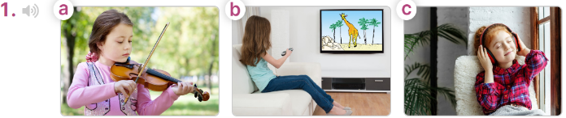  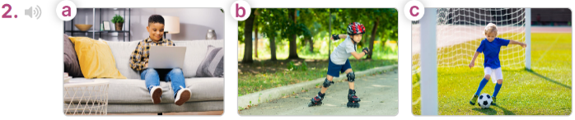  - T ask Ss to guess the answers.  + T writes Ss’guessing on the board.  - Listen to the tape:  + Play the recording  + Play the recording again for pupils to do the task.  + Play the recording a third time for pupils to check their answers.  - Get Ss to swap books with their partner, then check answers as a class.  + Write the answers on the board for Ss to correct their answers. Then checks Ss’ guessing.  - If time allows, play the recording, sentence by sentence, for Ss to listen and repeat individually and in chorus  Key: 1. b 2. a  Activity 2. Read and complete  *Aims: Ss will be able to complete two gapped exchanges with the help of picture cues.  *Procedure:  - Have Ss look at the pictures and identify the activities of the characters in the pictures.  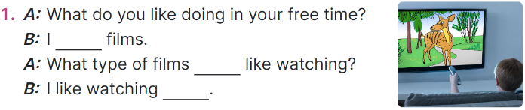  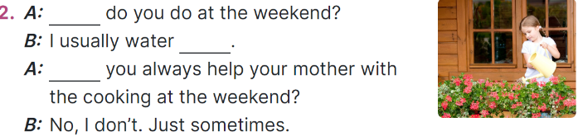  -Model sentences: have Ss read the question and ask what words are missing (like watching)  - Give Ss a time limit to read the gapped dialogues, look at the pictures and do the task independently.  - Get Ss to swap books with a partner and check their answers before checking as a class.  + Invite one student to write the answers on the board.  - Invite two pairs of Ss to act out the completed dialogues.  Key: 1. like watching; do you; cartoons  2. What; the flowers; Do  Activity 3. Listen, complete and sing  *Aims: Ss will be able to listen to and complete the song What do you like doing in your free time? and to sing it with the correct pronunciation, rhythm and melody.  *Procedure:  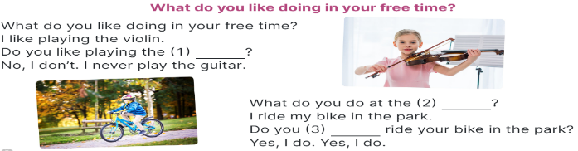  - Draw Ss’ attention to the gapped sentences.  - Play the recording the whole song.  + Then play the recording again to fill in the gaps with missing words.  - Check answers as a class.  + Play the recording line by line for Ss to listen and repeat.  - Play the recording all the way through for Ss to sing along and clap along with the recording.  3. Fun corner and wrap- up (5’)  Game: The football game  - Divide the class into 3 teams.  - Tell Ss that they are going to play football.  - Ss take turns to choose a number, read the question and say the answer.  - If the answer is correct, they will get points for their teams.  - If not, move to another team.  - The group with more points wins the game. | -Ss listen to the teacher  -Ss play the game  - Ss open their books  -Look at the pictures and say:  + Picture 1a: a girl playing the violin + Picture 1b: a girl watching a cartoon on TV  + Picture 1c: a girl listening to music + Picture 2a: a boy surfing the net  + Picture 2b: a boy roller skating in the park  + Picture 2c: a boy playing football  -Ss guess the answers  - Ss listen to the tape  - Ss listen again and do the task.  - Ss listen and check their answers  - Ss swap books with their partner, then check answers as a class and guessing  -Ss write the answer on the board  -Ss listen and repeat  -Ss look at the picture and say  -Ss follow the teacher  - Ss do the task independently.  - Ss swap books with a partner and check their answers.  - Ss write the answers on the board  - Pairs of Ss read the completed dialogues aloud  - Ss guess the missing words  - Ss listen all the way through carefully to the rhythm and pronunciation.  - Ss listen again and fill in the gaps  - Ss listen to the recording, line by line, and repeat.  - Ss listen and sing along  -Ss listen to the teacher  - Ss play the game.  - Ss praise the winner.
D. ADJUSTMENTS (if necessary):
………………………………………………………………………….……………….…..……………………………………………………….…………….……..................
________________________________________________________________

A. OBJECTIVES:
By the end of the lesson, Ss will be able to:

- understand and correctly repeat the sentences in two communicative contexts focusing on asking and answering questions about personal information

- correctly say the words and use What do you like doing in your free time? – I like _____. to ask and answer questions about hobbies

- enhance the correct use of What do you like doing in your free time? – I like _____ . to ask and answer questions about hobbies in freer contexts

- Vocabulary: play the violin, surf the Internet, go for a walk, water the flower.

- Structures:
A: What do you like doing in your free time?
B: I like playing the violin.
- Skills: speaking and listening
- Critical thinking and creativity: learn how to ask and answer questions about personal information correctly and fluently.
- Self-control and independent learning: perform speaking tasks.
- Show their pride in their personal information and what they like doing in their free time.
B. TEACHING AIDS:
- Teacher: Teacher’s guide Pages 61, 62, 63, 64, audio Tracks 35, 36, website hoclieu.vn, posters, laptop, pictures, textbook, lesson plan, TV or projector.
- Students: Students’ book Page 28, notebooks, workbooks, school things.
C. PROCEDURES:
Content | Teacher’s activities | Students’ activities
1.Warm- up and review: (3’)  2. Presentation (15’)  Activity 1. Look, listen and repeat:  *Aims: Ss will be able to understand and correctly repeat the sentences in two communicative contexts in which characters ask and answer questions about what someone likes doing in their free time.  *Procedure:  Activity 2 Listen, point and say.  *Aims: Ss will be able to correctly say the words and use What do you like doing in your free time? – I like _____. to ask and answer questions about what someone likes doing in their free time.  *Procedure:  * Structures:  - T asks Ss look at picture b in activity 1 and helps Ss know the structure from the dialogue.  - T introduces new structures for Ss.  - T explains, models and gives meaning.  - Have Ss repeat the structures  3.Practice: (7’)  *Drill pictures  4. Production: (6’)  Activity 4. Let’s talk.  *Aims: Ss will be able to correctly use What do you like doing in your free time? - ____. to ask and answer questions about what someone likes doing in their free time in a freer context.  *Procedure:  5. Fun corner and wrap- up (4’)  Game: Racing car | Greet the class  Sing a song  - Then have pupils sing along the song My friends and clap their hands.  - Ask pupils the lead-in questions:  + Do you go to school in the  evenings or at the weekends?  + What do you do when you are  free?  - Write the title Our free-time  activities on the board and model it  for the class to repeat a few times.  - Tell pupils what they will learn in this lesson  - Say “Open your book page 28” and look at “Unit 4, Lesson 1 (1,2,3)”.  - Have Ss look at Pictures a and b and identify the characters and their activities.  + Who is he/ she?  + Where is he/ she?  + What is he/ she doing in the picture?  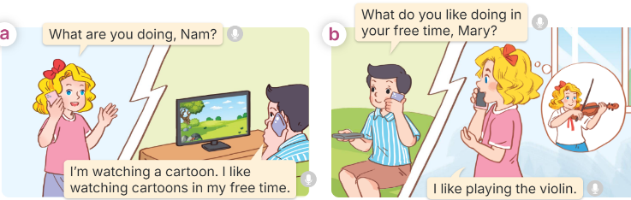  - Play the audio twice (sentence by sentence). Correct their pronunciation where necessary.  - Have Ss to practice the dialogue  - T invites a few pairs to the front of the class to practice.  - T checks pronunciation for ss.  - T asks Ss look at picture b in activity 1 and helps Ss know the structure from the dialogue.  - T introduces new structures for Ss.  - T explains, models and gives meaning.  - Have Ss repeat the structures  A: What do you like doing in your free time?  B: I like playing the violin.  - Have Ss look at the pictures and identify the characters and their activities. 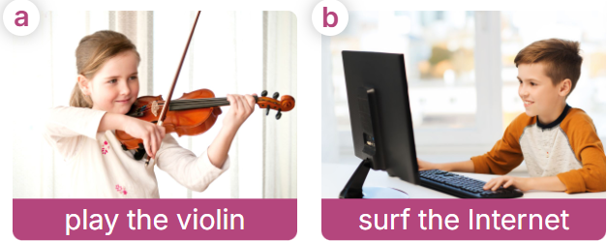  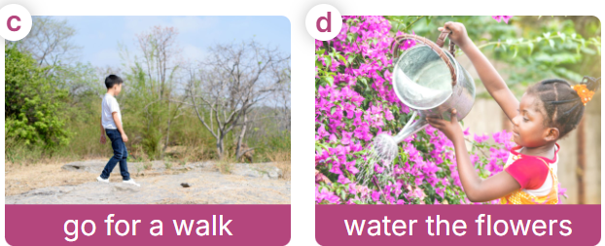  - Have Ss point at pictures, listen and run through all the pictures.  - Have Ss point at the bubbles, listen and run through model sentences.  - Have Ss to practise:  + T asks the first picture, Ss answer  + Ss asks the second picture, T answers  + Group A asks the third picture, group B  answers  + Group B asks the last picture, group A  - Ask Ss to work in pairs to practise asking and answering the What do you like doing in your free time? - I like _____.  - T controls and corrects.  - Invite a few pairs to point at the pictures and say the questions and answers in front of the class.  - Ask Ss to look at the pictures and elicit the context  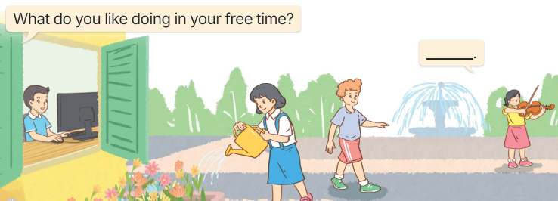  - Point at the ﬁrst building and elicit the question in the ﬁrst speech bubble What do you like doing in your free time? and the answer in the second speech bubble I like……… as an example.  - Give Ss time to work in pairs and take turns pointing at each picture to ask and answer using What do you like doing in your free time? - ………..  - Invite a few pairs to come to the front of the classroom and act out the exchanges.  - The teacher divides the class into two teams.  - Each team takes turns choosing the number and answering the question.  -The team that drives the car to the finish line first is the winner. | - Pupils sing the song.  - Pupils listen and answer  the questions.  - Pupils listen and repeat  - Ss listen to the teacher  - Ss listen and open their books  -Ss listen and answer  - - Ss listen and repeat  + Choral repetition (3 times).  + Individual repetition (3 ss)  - Ss take note  - Ss look and match  -Look at the pictures and say.  -Ss listen and repeat in chorus (twice)  -Ss work in pairs to practice  -Ss come to the front of the classroom to practice.  -Ss listen  - Ss look at the picture and answer.  -Ss listen  -Ss listen and repeat  -Ss repeat to the structures  - Ss look, listen and repeat  +Picture a: a girl playing the violin  + Picture b: a boy surfing the Internet  + Picture c: a boy going for a walk + Picture d: a girl watering the flowers  -Ss point at pictures, listen and repeat  -Ss point at the bubbles, listen and repeat  -Ss practice in chorus  -Ss practice in chorus  -Ss work in pairs to practise asking and answering the question  - Pairs of Ss point at the pictures and say in front of the class  -Ss look at the picture and say  - Ss look at the first building and elicit the missing words in speech bubbles and say the completed sentences.  - Ss role-play to practise asking and answering questions  - Ss practise asking and answering questions in front of the class.  -Ss listen to the teacher  -Ss play the game  -Ss congratulate the winner
D. ADJUSTMENTS (if necessary):
………………………………………………………………………….……………….…..……………………………………………………….…………….……..................
..………………………………………………………..…………………….…….........
________________________________________________________________
Tổ trưởng ký duyệt

