KẾ HOẠCH BÀI DẠY CHUYÊN ĐỀ CẤP TRƯỜNG HÈ NĂM 2025
MÔN TIẾNG ANH LỚP 5
Ngày thực hiện: 20/8/2025
GV thực hiện: Nguyễn Thị Hương Trà
STARTER
A. Back to school
A. OBJECTIVES:
By the end of the lesson, Ss will be able to:
1. Knowledge:
- sing the song Back to school with correct pronunciation, rhythm and melody.
- review the vocabulary and structure items related to months of the year and someone’s birthday.
- complete three gapped sentences in My goal tree about their learning goals and share them with their friends.
- Vocabulary: Review
- Skills: speaking, listening and writing.
2. Competences:
- Critical thinking and creativity: learn how to ask and answer questions about personal information correctly and fluently.
- Communication and collaboration: work in pairs and groups to complete the learning tasks.
- Self-control and independent learning: perform speaking and writing tasks.
3. Attitude/ Qualities:
- Show pride in the time back to school.
- Show their love and interest in learning and playing.
B. TEACHING AIDS:
- Teacher: Teacher’s guide Pages 12-13, audio Tracks 1, website hoclieu.vn, posters, pictures, computer, textbook, lesson plan, TV or projector.
- Students: Student’s book Page 7, notebooks, workbooks, school things.
C. PROCEDURES:
Teacher’s activities | Students’ activities
1.Warm- up: (5’)  Sing a song: Hello song  *Aims: to create a friendly and lively atmosphere in the classroom.  *Procedure:  - Show the song on the screen.  https://www.youtube.com/watch?v=tVlcKp3bWH8  - Ask Ss to listen, sing and dance the song.  - Say “Open your book page 7” and look at “Starter, Back to school”  2. Practice (25’)  Activity 1. Let’s sing  *Aims: Ss will be able to sing the song Back to school with correct pronunciation, rhythm and melody.  *Procedure:  - Draw Ss’ attention to the lyric of the song.  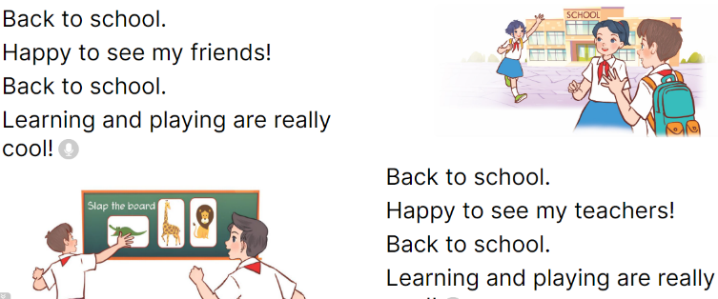  - Have Ss read and listen to the song, drawing their attention to the pronunciation, rhythm and melody.  - Play the recording again and let them listen to and practise singing the song, line by line, while doing actions or clapping their hands.  - Ask Ss to listen to and sing the whole song while doing actions or clapping their hands.  - Invite a few groups to the front of the class to sing the song.  Activity 2. Let’s play  *Aims: Ss will be able to review the vocabulary and structure items related to months of the year and someone’s birthday.  *Procedure:  - Invite two teams of six pupils to play. Tell Ss how to play the game. Ss say their birthday months and line up, starting with January.  - The faster team will win the game.  - Invite other teams to play the game.  Activity 3. Write and share.  *Aims: Ss will be able to complete three gapped sentences in My goal tree about their learning goals and share them with their friends.  *Procedure:  - Tell the class the goal of the activity and explain that they should write three sentences about their learning goals. Check comprehension. 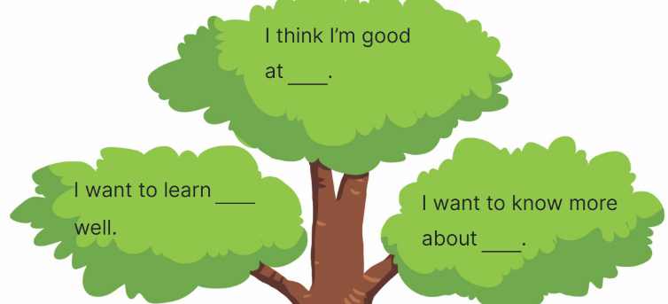  - Ask Ss to read the sentence and elicit possible answers. Then have them write their answers in the gap.  - Give Ss time to complete the sentences independently.  - Get pupils to work in pairs to share their learning goals  - Invite one or two Ss to read their learning goals aloud.  3. Fun corner and wrap- up (5’)  Game: Bingo (ppt)  - Prepare word cards about months of the year.  - Give each Ss a bingo grid with four squares.  - Ask Ss to choose four words and write in a bingo grid.  - Explain that when you call out a word, Ss should search for that word on their bingo card. If they have the word, they should cross it out. The first pupil to cross out all their words wins.  - Play the game. Praise the winner. | - Sing and dance the song in chorus.  - Ss listen and open their books.  - Ss pay attention to the title and lyrics of the song.  - Ss read and listen to the song.  - Ss listen to the recording and practise singing the song, line by line, while doing actions or clapping their hands.  - Ss listen to and sing the whole song while doing actions or clapping their hands.  - Ss come to the front of the class to sing the song.  - Ss work in two teams of six. Ss listen to the instructions and play the game.  - Ss praise the winner.  - Ss play the game.  - Ss listen to the teacher’s explanation.  - Ss read the sentence and elicit possible answers and write their answers in the gap.  - Ss complete the sentences  - Ss work in pairs to share their learning goals.  - Ss read their learning goals aloud.  - Ss listen  - Ss play the game  -Ss praise the winner
D. ADJUSTMENTS (if necessary):
………………………………………………………………………………………….…..……………………………………………………………………………...……..

GV thực hiện Hiệu phó chuyên môn

Nguyễn Thị Hương Trà Phạm Thị Tấm

