WEEK 8
Preparing date: 26/10/2025
Teaching date: 28/10/2025
PERIOD 29
UNIT 5: MY FUTURE JOB
LESSON 1 (1, 2, 3)

I. OBJECTIVES
By the end of this lesson, pupils will be able to:
1. Knowledge and skills
- Use the words firefighter, reporter, gardener and writer and the sentence patterns What would you like to be in the future? and I’d like to be a ________. to ask and answer questions about someone’s future job.
2. Competences
- Critical thinking and creativity: learn how to ask and answer questions about someone’s future jobs correctly and fluently.
- Communication and collaboration: work in pairs and groups to complete the learning tasks.
- Self-control & independent learning: perform pronunciation and speaking tasks.
3. Attributes
- Show their love and interest in a certain job in the future.
4. The disabled: Practice reading vocab.
II. MATERIALS
- Pupil’s book: Page 34
- Audio tracks 45, 46
- Teacher’s guide: Pages 75, 76, 77
- Website hoclieu.vn
- Flash cards/ pictures and posters (Unit 5)
- Computer, projector, …
III. PROCEDURES
Teacher’s activities | Student’s activities
- Warm up (5’)  - Objectives  - Sing a song:Hello!What do you do?  - To revise the previous lesson by playing a game.  b. Content  - Let’s play the Quiz game.  c. Expected outcomes  - Pupils can say the jobs correctly based on the given cues.  d. Organisation  - There is a female AI character named Mary who asks a few questions to test the whole class:  1-She works at school. She teaches pupil. Who is she?  a. actor b.teacher  2-She takes care of sick people. Who is she?  a. doctor b. farmer  3-He can sing very well.Who is he?  a. student b. singer  - The AI praised someone  2. Presentation  Activity 1-1. Look, listen and repeat. (10’)  a. Objectives  - To understand and correctly repeat the sentences in two communicative contexts focusing on asking and answering questions about someone’s future job.  b. Content  - Activity 1. Look, listen and repeat.  c. Expected outcomes  - Pupils can understand and correctly repeat the sentences in two communicative contexts focusing on asking and answering questions about someone’s future job.  d. Organisation  Step 1: Ask pupils to look at Pictures a and b, and identify the characters and other details.  -Who are they in the picture a and b?  -What are they talking about?  Step 2: Ask pupils to focus on Picture a. Play the recording for them to listen to the entire conversation several times.  Step 3: Play the recording again, sentence by sentence, for pupils to listen and repeat individually and in chorus. Correct their pronunciation where necessary. Repeat the same procedure with Picture b.  Step 4: Invite a few pairs to stand up, listen and repeat the sentences in the recording. Check their pronunciation, provide corrections and offer feedback where necessary.  Step 5: Direct pupils’ attention to the question What would you like to be in the future? and the answer I’d like to be a doctor. Explain that this is about someone’s future job.  – Context a:  Linh and Bill in Linh’s  living room. A photo of Linh’s parents  on the wall  Linh: That’s my father.  Bill: What’s his job?  Linh: He’s a doctor.  Bill: Cool!  – Context b:  Linh and Bill talking about future jobs. Link thinking of being a doctor in  the future  Bill: What would you like to be in the future?  Linh: I’d like to be a doctor, too.  Activity 2-2. Listen, point and say. (7’)  a. Objectives  - To correctly say the words firefighter, reporter, gardener and writer and use sentence patterns What would you like to be in the future? – I’d like to be a _______ . to ask and answer questions about someone’s future job.  b. Content  Activity 2. Listen, point and say.  c. Expected outcomes  - Pupils can correctly say the given words and use sentence patterns What would you like to be in the future? and I’d like to be a _______. to ask and answer questions about someone’s future job.  d. Organisation  Step 1: Have pupils point at Picture a, listen to the recording and repeat the word firefighter. Repeat the same procedure with Pictures b, c and d. Have the class repeat the words a few times:  -T elicits the new words  + firefighter : lính cứu hỏa (picture)  + reporter : phóng viên (picture)  + gardener : người làm vườn (picture)  + writer : nhà văn (picture)  - T models (3 times).  - T writes the words on the board  Step 2: Point at the question pattern What would you like to be in the future? Read it aloud and have pupils repeat it several times. Repeat the procedure with the answer pattern I’d like to be a _______.  - Sentence partern:  A: What would you like to be in the future?  B: I’d like to be a -----------------._______.  Step 3: Point at Picture a and have pupils listen and repeat after the recording What would you like to be in the future? – I’d like to be a firefighter. Repeat the same procedure with Pictures b, c and d.  Step 4: Divide the class into two groups to take turns repeating the question and the answer in Picture a until they feel confident. Repeat the same procedure with Pictures b, c and d.  Step 5: Put pupils in pairs and have pairs practise asking and answering questions using the pictures. Invite a few pairs to point at the pictures and say the questions and answers in front of the class. Give corrections and feedback where necessary.  – Picture and word cues:  - a firefighter saving a person from a fire and the word firefighter underneath  - a reporter reporting the news in the street and the word reporter underneath  - a gardener working in a garden and the word gardener underneath  - a writer working at his desk and the word writer underneath  – Speech bubbles:  What would you like to be in the future? I’d like to be a .  Audio script:  a. firefighter b. reporter  c. gardener d. writer  a.  A: What would you like to be in the future?  B: I’d like to be a firefighter.  b.  A: What would you like to be in the future?  B: I’d like to be a reporter.  c.  A: What would you like to be in the future?  B: I’d like to be a gardener.  d.  A: What would you like to be in the future?  B: I’d like to be a writer.  3. Practice  Activity 3-3. Let’s talk. (7’)  a. Objectives  - To correctly use the words for jobs in Act 2 and sentence patterns What would you like to be in the future? and I’d like to be a _______. to ask and answer questions about someone’s future job in a freer context.  b. Content  - Activity 3. Let’s talk.  c. Expected outcomes  - Pupils can correctly use the words for jobs and sentence patterns What would you like to be in the future? and I’d like to be a _______. to ask and answer questions about someone’s future job in a freer context.  d. Organisation  Step 1: Direct pupils’ attention to the phrase Job fair in the picture. Have them guess the meaning of the phrase. Ask them what jobs they can find in the picture.  Step 2: Read the question in the speech bubble aloud and ask pupils to repeat it. Ask pupils to look at the second bubble and guess what the answer should be. Give an example answer, e.g. I’d like to be a doctor. Get pupils to repeat the question and answer several times.  Step 3: Have some pairs practise asking and answering questions about the jobs in the picture. Go around the classroom to observe and provide help.  Step 4: Invite some pairs to practise asking the question and giving the answer in front of the class. Give corrections and feedback where necessary. Encourage them to talk about the jobs that they know and would like to do in the future.  – Picture cue: A job fair at a school where the pupils are wearing the uniforms and accessories of different jobs.  – Speech bubbles:  What would you like to be in the future?  _______.  Suggested answers:  What would you like to be in the future? – I’d like to be a taxi driver / a firefighter / a reporter / a doctor.  - Production (5’)  * Option 1: Game: Pass the balls (ppt)  - Give two different colored balls to two pupils, one ball (ask the question) and another one (answer the question).  - Ask pupils to listen to music and pass the balls.  - Stop music suddenly. Have one pupil ask, the other answers the question.  - Repeat the game several times.  .  5. Fun corner and wrap- up (1’)  - Practice reading vocab and structure at home.  - Prepare the new lesson: Lesson 2 (4,5,6) of Unit 5.  * Preparation for the project: Ask pupils to prepare for the project on page 39 by doing a survey about the future jobs that their classmates would like to be in the future and the reasons why they would like to do the job. Ask pupils to do the survey during the time they learn Unit 5 so that they can present a report at Project time. | -Sing a song.(Whole class)  - Listen to the teacher’s instructions.  - Listen and raise your hands to get the chance to answer:  1- teacher  2- doctor  3- singer  -Clab their hands  - Pupils look at Pictures a and b and identify the characters in the pictures.  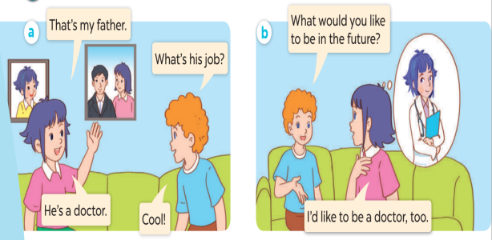  -They are Linh and Bill.  -They are talking about jobs.  - Pupils look at Picture a and listen to the recording.  - Pupils listen to the recording again and repeat individually and/ or in chorus sentence by sentence.  - Pairs of pupils come to the front of the classroom to listen to and repeat the sentences in the recording.  - Pupils pay attention to the question and the answer. Pupils listen to the teacher’s explanation.  - Pupils point at Picture a, listen to the recording and repeat the word. Pupils follow the teacher’s instructions with the other three pictures. Pupils repeat the words a few times.  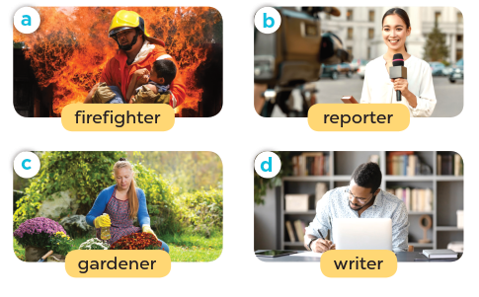  - Pupils listen and repeat after the recording. Pupils look at Picture a and listen and repeat after the recording. Pupils follow the teacher’s instructions with the other three pictures.  - Pupils work in two groups to take turns repeating the question and the answer in Picture a until they feel confident. Pupils follow the teacher’s instructions with the other three pictures.  - Pupils work in pairs to practise asking and answering the question, using speech bubbles and Pictures a, b, c and d.  - Pairs of pupils point at the pictures and say the Questions & Answers in front of the class.  - Pupils look at the phrase Job fair in the picture and guess the meaning of the phrase. Pupils answer what jobs they can find in the picture.  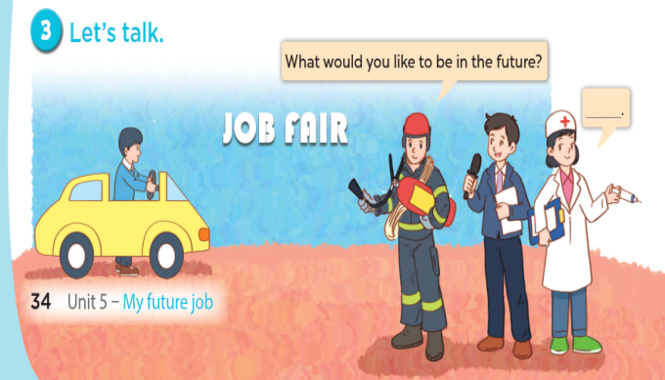  - Pupils look at the bubbles to understand how the sentence pattern is used.  - Pupils role-play to practise asking the questions and giving their answers in pairs, using the picture cue.  - Pairs of pupils practise asking and answering questions in front of the class.  - Play game (whole class).  -Listen
IV. ADJUSTMENTS (if necessary):
…………………………………………………………………………………………………………………………………………………………………………………………

