BỘ LAO ĐỘNG THƯƠNG BINH & XÃ HỘI
TRƯỜNG CĐN KỸ THUẬT CÔNG NGHỆ



GIÁO TRÌNH
TIẾNG ANH CHUYÊN NGÀNH KẾ TOÁN DOANH NGHIỆP
ENGLISH FOR ACCOUNTING
MÃ SỐ MÔN HỌC: MH 11
TRÌNH ĐỘ: TRUNG CẤP
Ban hành kèm thao Quyết định số…../QĐ …. Ngày…..tháng ……năm của Hiệu trưởng Trường CĐN Kỹ thuật Công Nghệ)



Hà nội, 2021

LỜI NÓI ĐẦU
Giáo trình “TIẾNG ANH CHUYÊN NGÀNH KẾ TOÁN ” được biên soạn theo chương trình đào tạo nghề kế toán của tổng cục nghề, giảng dạy cho sinh viên hệ Cao trung cấp của trường Cao đẳng Nghề Kỹ thuật Công nghệ. Tuy nhiên, giáo trình này có những ưu điểm nổi bật sau:
Có tính cập nhật mới nhất.
Các thông tin và thông số đưa ra có tính khoa học và độ tin cậy cao. Có bố cục hợp lý, logic, khoa học.
Có nhiều hoạt động thảo luận cặp, nhóm thông qua các đọa hội thoại. Các chủ đề bài học có tranh ảnh minh họa, được thiết kế một cách cụ thể, thiết thực và gắn liền với thực tế.
Vốn từ vựng phong phú.
Vốn kiến thức phù hợp với trình độ chung cho đối tượng học sinh trường nghề.
Để đáp ứng yêu cầu trên các bài trong giáo trình vừa tuân theo chương trình vừa có những chủ đề gần gũi với sinh viên ngành kế toán. Khi các em học đến phần tiếng Anh chuyên ngành thì các em cũng đã có những kiến thức nhất định về nghề cũng như có một số kiến thức tiếng Anh cơ bản, do đó mục tiêu của giáo trình là:
- Phát triển những kỹ năng như: đọc hiểu, dịch các tài liệu tiếng Anh chuyên ngành kế toán.
- Phát triển các kỹ năng theo một hệ thống các chủ điểm gắn liền với các hoạt động chuyên ngành kế toán, đặc biệt phát triển kỹ năng đọc, dịch hiểu;
- Xây dựng và rèn luyện các kỹ năng học tập ngoại ngữ đồng thời hình thành và phát triển khả năng độc lập suy nghĩ và sáng tạo trong giao tiếp bằng tiếng Anh cho sinh viên;
- Đây là giáo trình mang tính chuyên ngành nên tranh ảnh nhiều, chúng tôi đề nghị giáo trình được in mầu để sinh viên dễ dàng hơn trong việc hiểu các khái niệm chuyên ngành bằng tiếng Anh thông qua hình ảnh.
Để hoàn thành việc biên soạn giáo trình, chúng tôi luôn được sự giúp đỡ của các giáo viên trong trường. Chúng tôi xin chân thành cám ơn các giáo viên tổ môn Tiếng Anh và Kinh Tế của nhà trường đã nhiệt tình giúp đỡ chúng tôi trong quá trình biên soạn.
Chắc chắn giáo trình không tránh khỏi thiếu sót. Chúng tôi mong nhận được ý kiến đóng góp để giáo trình được chỉnh sửa và ngày càng hoàn thiện hơn.
Xin trân trọng cám ơn
Hà Nội,ngày 10 tháng 5 năm 2021 Tham gia biên soạn giáo trình
Chủ biên:

Tuyên bố bản quyền

Tài liệu này là loại giáo trình nội bộ dùng trong nhà trường với mục đích làm tài liệu giảng dạy cho giáo viên và học sinh, sinh viên nên các nguồn thông tin có thể được tham khảo.
Tài liệu phải do trường Cao đẳng nghề Kỹ thuật Công nghệ in ấn và phát hành.
Việc sử dụng tài liệu này với mục đích thương mại hoặc khác với mục đích trên đều bị nghiêm cấm và bị coi là vi phạm bản quyền.
Trường Cao đẳng nghề Kỹ thuật Công nghệ xin chân thành cảm ơn các thông tin giúp cho nhà trường bảo vệ bản quyền của mình.
Địa chỉ liên hệ:
Trường Cao đẳng nghề Kỹ thuật Công nghệ. Tổ 27, Thị trấn Đông Anh, Hà Nội.
Điện thoại: (024) 38821104

Website: www.httc.edu.vn

CONTENTS

CONTENTS |  | PAGE
MAIN CONTENTS
Lời nói đầu |  | 2
Unit 1: Market Economy |  | 7
Unit 2: Macroeconomics and Microeconomics |  | 13
Unit 3: Supply and Demand |  | 19
Unit 4: Money and its functions |  | 23
Unit 5: Bank and business |  | 28
Unit 6: Marketing and Analysis of market opportunities |  | 36
Unit 7: Pricing |  | 43
Unit 8: Finance |  | 51
Unit 9: Taxation |  | 68
Unit 10: Insurance |  | 73
Unit 11: Management of Working capital |  | 76
Unit 12: Accounting – the Balance sheet |  | 80
Unit 13: The Stock Exchange |  | 85
Unit 14: The role of Auditor |  | 90
APPENDIX
Appendix 1 |  | 93
Appendix 2 |  | 94
Appendix 3 |  | 96
Appendix 4 |  | 98
Appendix 5 | 100
Appendix 6 | 101
Appendix 7 | 103
Appendix 8 | 107
Appendix 9 | 109
Appendix 10 | 110
Appendix 11 | 112
Appendix 12 | 114
Appendix 13 | 117
Appendix 14 | 119
Appendix 15 | 122
REFERENCE | 125

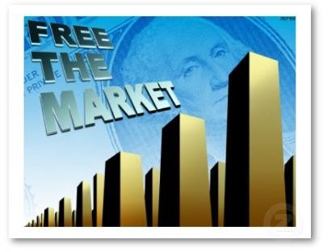
UNIT 1: THE MARKET ECONOMY
- READING COMPREHENSION
Planned economy: A system whereby the structure of the market is deliberately planned by the state, in which production and consumption quotas are fixed beforehand and where there is no real competition between industrial or commercial organizations. In the Soviet model, for instance, all the means of production and the channels are state controlled. Private ownership does not exist in this field.
In practice, there is wide gap between the theoretical model and economy realities: the so- called market economies rely more and more on Government planning and intervention, whereas in planned economies, such capitalistic notions as profit tend to be reintroduced.
Free market economy: An economic system in which the market – that is the relation between producers and consumers, buyers and sellers, investors and workers, management and labour – is supposed to be regulated by the law of supply and demand. Business firms are supposed to complete freely, and any attempt at hindering free competition (‘restrictive practices’) is punishable by law.
Direct government intervention is theoretically ruled out although the government will influence the economic situation through its fiscal and budgetary policies.
Mixed economy: An economic system in which some goods and services are produced by the government and some by private enterprise. It
lies between a command economy and a complete laissez- faire economy. In practice, most economies are mixed: the significant feature is whether an economy is moving towards or away from a more laissez – faire situation.

VOCABULARY

Free market economy: inventor(n)/investor: management (n): manage to do smt labour ;labor ['leibə] (n) suppose (v):  supply (n):  supply smt for smb demand (n): attempt (v):  hinder (v): restrictive (adj): intervention(n): fiscal (adj): budgetary (adj): planned economy: deliberately(adj): quotas (n): beforehand (adv): commercial (adj): ownership (n): reality [ri:'æliti] (n): so- called (adj):  rely (v): ( + on, upon)  notion ['nou∫n] (n): mixed economy (n): enterprise (n):  laissez- faire (n): | Free market economy  người phát minh, người sáng chế sự trông nom, sự quản lý  cố gắng làm gì lao động.  cho là; tin rằng; nghĩ rằng  sự cung cấp; sự được cung cấp  sự đòi hỏi, sự yêu cầu; nhu cầu nỗ lực làm cái gì; thử làm cái gì cản trở, gây trở ngại  hạn chế, giới hạn  sự xen vào, sự can thiệp  (thuộc) công khố; (thuộc) tài chính (thuộc) ngân sách  nền kinh tế có kế hoạch tập trung có suy nghĩ cân nhắc; thận trọng phần, chỉ tiêu  sẵn sàng; trước; sớm hơn  thuộc về hoặc dành cho thương mại quyền sở hữu  sự thực; thực tế; thực tại; cái có thật cái gọi là  tin vào, tin cậy vào, tin tưởng vào ý niệm, khái niệm  hệ thống kinh tế hợp doanh  (từ Mỹ,nghĩa Mỹ) tổ chức kinh doanh, hãng, xí nghiệp  chính sách để mặc tư nhân kinh  doanh; chính sách tự do kinh

doanh; sự không can thiệp vào việc người khác

COMPREHENSION
Using the information in the text, answer the questions below:
1. What is market economy?
2. What is planned economy?
3. What are differences between Market economy and Planned economy? What is mixed economy?

IV. WORD-STUDY
Work with your friends; find out all the words in the picture below and research their meaning. Then compare your results to other groups.
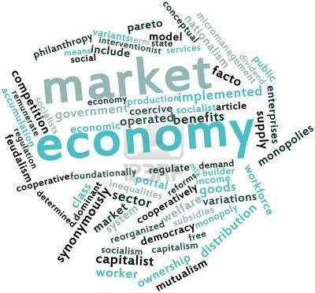
Fill each of the numbered blanks in the following passage. Use only one word from the box in each space:

Principlethe
anything
both
what
for
issues
training
how
at
Economy is ……………… (1) study of how individuals and nations make choices about how to use scare resources to fill their needs and wants. A resource is ………….. (2) that people can use to make or obtain
…………..(3) they need or want. You may be asking yourself …………..
(4) this point how economics will help you, a student. Also, you may be wandering how a scare resource is a problem ……………(5) a nation like the United State that has such abundant resources.
It may surprise you to know that many of the decisions you will face as a citizen deal with ……………. (6) the United States should use its resources. Learning economic ………(7) can help you make decisions about candidates for political office, political social………………(8), and the goals the United States should set for itself, such as how to spend government revenues. Many people are familiar with the benefits of government programs such as job (9) and Medicare, but how many
people are aware of the costs of this programs? Economics can help you to understand (10) costs and benefits and, therefore, help you to make
better decisions.

FURTHER READING
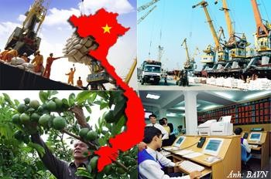
- “ĐỔI MỚI” – REFORM PERIOD
The economy of Vietnam is a developing planned economy and market economy. Since the mid-1980s, through the "Đổi Mới" reform period, Vietnam has made a shift from a highly-centralized planned economy to a socialist-oriented market economy which use both directive and indicative planning (see Five-Year Plans of Vietnam). Over
that period, the economy has experienced rapid growth. Nowadays, Vietnam is in a period of being integrated into the global economy. Almost all Vietnamese enterprises are SMEs. Vietnam has become a leading agricultural exporter and served as an attractive destination for foreign investment in Southeast Asia.
In 2011, the nominal GDP reached $121.6 billion, with nominal GDP per capita of $1328.60. According to a forecast in December 2005 by Goldman Sachs, Vietnamese economy will become the 35th largest economy in the world with nominal GDP of $ 436 billion and nominal GDP per capita of 4,357 USD by 2025. According to a forecast by the PricewaterhouseCoopers in 2008, Vietnam may be the fastest growing of emerging economies by 2025, with a potential annual growth rate of about 10% in real dollar terms, which would increase the size of the economy to 70% of the size of the UK economy by 2050.
- CHARACTERISTICS OF A MARKET ECONOMY PRIVATE PROPERTY
Labor resources, natural resources, capital resources (e.g., equipment and buildings), and the goods and services produced in the economy are largely owned by private individuals and private institutions rather than by government. This private ownership combined with the freedom to negotiate legally binding contracts permits people, within very broad limits, to obtain and use resources as they choose.
FREEDOM OF ENTERPRISE AND CHOICE
Private entrepreneurs are free to obtain and organize resources in the production of goods and services and to sell them in markets of their choices. Consumers are at liberty to buy that collection of goods and services that best satisfies their economic wants. Workers are free to seek any jobs for which they are qualified.
MOTIVE OF SELF-INTEREST
The "Invisible Hand" that is the driving force in a market economy is each individual promoting his or her self-interest. Consumers aim to get the greatest satisfaction from their budgets; entrepreneurs try to achieve the highest profits for their firms; workers want the highest possible wages and
salaries; and owners of property resources attempt to get the highest possible prices from the rent and sale of their resources.
COMPETITION
Economic rivalry means that buyers and sellers are free to enter or leave any market and that there are buyers and sellers acting independently in the marketplace. It is competition, not government regulation, that diffuses economic power and limits the potential abuse of that power by one economic unit against another as each attempts to further its own self- interest.
SYSTEM OF MARKETS AND PRICES
Markets are the basic coordinating mechanisms in our type of economy, not central planning by government. A market brings buyers and sellers of a particular good or service into contact with one another. The preferences of sellers and buyers are registered on the supply and demand sides of various markets, and the outcome of these choices is a system of product and resource prices. These prices are guideposts on which participants in markets make and revise their free choices in furthering their self-interests. LIMITED GOVERNMENT
A competitive market economy promotes the efficient use of its resources. As a self-regulating and self-adjusting economy, no significant economic role for government is necessary. However, a number of limitations and undesirable outcomes associated with the market system result in an active, but limited economic role for government.

UNIT 2: MACROECONOMICS AND MICROECONOMICS

- READING
  - What is economic?
The Economist's Dictionary of Economics defines economics as "The study of the production, distribution and consumption of wealth in human society."
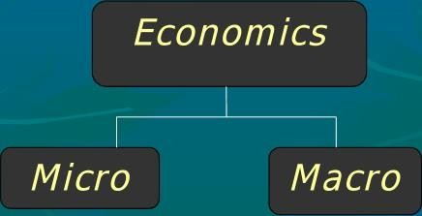
  - What is macroeconomic?
The field of economics that studies the behavior of the aggregate economy. Macroeconomics examines economy-wide phenomena such as changes in unemployment, national income, rate of growth, gross domestic product, inflation and price levels.
  - What is microeconomic?
The branch of economics that analyzes the market behavior of individual consumers and firms in an attempt to understand the decision- making process of firms and households. It is concerned with the interaction between individual buyers and sellers and the factors that influence the choices made by buyers and sellers. In particular, microeconomics focuses on patterns of supply and demand and the determination of price and output in individual markets (e.g. coffee industry).
THE RELATIONSHIP
BETWEEN MACROECONOMICS & MICROECONOMICS
Microeconomics

Those who have studied Latin know that the prefix “micro-“ means “small,” so it shouldn’t be surprising that microeconomics is the study of small economic units. The field of microeconomics is concerned with things like:
Consumer decision making and utility maximization Firm production and profit maximization
Individual market equilibrium
Effects of government regulation on individual markets Externalities and other market side effects
Macroeconomics
Macroeconomics can be thought of as the “big picture” version of economics. Rather than analyzing individual markets, macroeconomics focuses on aggregate production and consumption in an economy. Some topics that macroeconomists study are:
The effects of general taxes such as income and sales taxes on output and prices
The causes of economic upswings and downturns
The effects of monetary and fiscal policy on economic health How interest rates are determined
Why some economies grow faster than others
The Relationship between Microeconomics and Macroeconomics
There is an obvious relationship between microeconomics and macroeconomics in that aggregate production and consumption levels are the result of choices made by individual households and firms, and some macroeconomic models explicitly make this connection.
Most of the economic topics covered on television and in newspapers are of the macroeconomic variety, but it’s important to remember that economics is about more than just trying to figure out when the economy is going to improve and what the Fed is doing with interest rates.

VOCABULARY
Resource (n): nguồn lực, tài nguyên
Factor (n): nhân tố, yếu tố
Aggregate (n): tập hợp lại, kết hợp lại, gộp lại Phenomenon (n): hiện tượng
Unemployment (n): tình trạng thất nghiệp National income: thu nhập quốc gia Rate of growth: tỷ lệ tăng trưởng
Inflation (n): sự lạm phát
Price level: mức giá
Analyze (v): phân tích
Behavior (human behavior, market behavior…) (n): hành vi Individual (adj) cá nhân, cá thể, đơn lẻ
Interaction (n): tính tương tác, sự tương tác Influence (n): ảnh hưởng
Seller (n): người bán
Buyer (n): người mua
Nation wide: trên phạm vi toàn quốc Individual market: thị trường riêng lẻ Supply and demand: cung và cầu

COMPREHENSION
Use the knowledge you have studied to answer the following questions
Macroeconomic:
  - What is the importance of macroeconomics?
  - What does macroeconomics study?
  - What does fiscal policy deal with?
  - What are 4 main areas that macroeconomics focuses on?
  - What are 4 tools of macroeconomics policy? Microeconomic:
- What does microeconomics deal with?
- What does microeconomics focus on?
- Does microeconomics analyze what influences the prices of particular goods?
- In microeconomics what are supply and demand analyses considered to be?
- The instructions are available in Appendix 1.

WORD STUDY
- Work with your partners and use your knowledge to explain the cause and effect story in the following picture
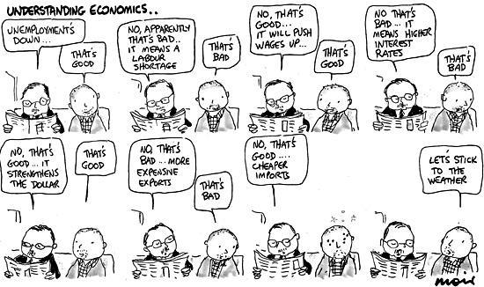
- Choose the best answer to fill in the blank
- Inflation that's out of control = inflation runaway
renegade rebel
- Barack Obama said that the United States has a plan to bring the deficit
(= decrease the deficit) once the economic crisis has been resolved.
lower down
downward
- (= very high) deficits could spark (= cause) inflation or a sudden drop in the value of the U.S. dollar.
Soaring Flying
Cruising
- Most analysts believe the U.S. is (= ready, just about) to make steady progress on this issue.
standing
poised almost
- to the whole system = to put the whole system at risk jettison
germinate
jeopardize
- to stimulate economic growth = to economic growth stifle
stretch
spur
- He doesn't think that current economic conditions will continue to . (= he thinks that the current economic conditions will change)
prevail lag on drag out
- The worst that can possibly happen = the worst case study
case scenario
take on things
- You can't keep taking these things . (= you can't keep assuming that these things will always be there)
by decree
in transit for granted
- The new regulations should prevent banks from . (= from going bankrupt)
failing falling
keeping afloat

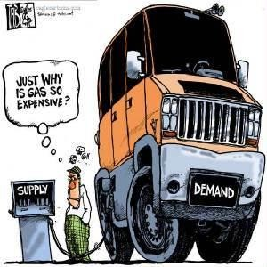
UNIT 3: SUPPLY AND DEMAND
- READING
  - Definition of 'Supply'
A fundamental economic concept that describes the total amount of a specific good or service that is available to consumers. Supply can relate to the amount available at a specific price or the amount available across a range of prices if displayed on a graph. This relates closely to the demand for a good or service at a specific price; all else being equal, the supply provided by producers will rise if the price rises because all firms look to maximize profits.
  - Definition of 'Demand'
An economic principle that describes a consumer’s desire and willingness to pay a price for a specific good or service. Holding all other factors constant, the price of a good or service increases as its demand increases and vice versa.
  - The relationship between supply and demand
We have known about price and demand, price and supply as though they were separate. But in the real world, they operate together. As the price of a good goes down, the quantity demanded rises, and the quantity supplied falls. As the price goes up, the quantity demanded falls, and the quantity supplied rises.
Is the price at which the quantity demanded and the quantity supplied meet? Yes, this level is called the equilibrium price. It means that the price of any good or service will find the level at which the quantity demanded and the quantity supplied are balanced. In other words, at the equilibrium price the plans of the buyers and the plans of the sellers are the same. Suppliers provide the amount that is demanded by consumers.
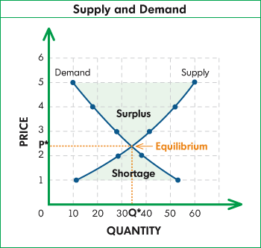
Whenever the market price of a good falls below the equilibrium price, we say that a shortage has developed. Shortages occur when at the going price the quantity demanded is greater than the supply available. If the market is free, without government regulations or other restrictions, shortages put pressure on price to rise.
When the market price is higher than the equilibrium price, a surplus develops. At the price above the equilibrium price, suppliers produce more than consumer’s demand in the marketplace. As surpluses occur, suppliers end up with large inventories of goods and this and other forces put pressure on the price to drop to the equilibrium price.

VOCABULARY
Demand (n): cầu, nhu cầu
Supply (n): cung, nguồn cung
Separate (v): tách biệt, riêng biệt
Real (adj): thực, tính thực tế Equilibrium (adj): tính cân bằng Shortage (n) thiếu hụt
Surplus (n): thặng dư, dư thừa
Pressure on (v): áp lực
Force (n): lực lượng
Balance (v): cân đối.
Quantity (n): số lượng
Price (n): giá cả
Curve (n): đường cong
Reflect (v): phản chiếu, phản ánh
Certain price: giá cố định
Upward slope: đường dốc lên Downward slope: đường dốc xuống Illustrate (v): minh họa
Negative relationship: mối quan hệ tỉ lệ nghịch Opportunity cost: chi phí cơ hội
Forgo (v): thôi, bỏ, kiêng
Increase (v): tăng lên
Decrease (v): giảm xuống
Revenue (n): thu nhập, doanh thu
Chart (n): đồ thị, biểu đồ
Desire (n): sự mong muốn, sự khao khát Willingness (n): sự bằng lòng, sẵn sàng, sốt sắng

COMPREHENSION
  - How do supply and demand operate together?
  - What is an equilibrium price of a good?
  - When do shortages occur?
  - When do surpluses occur?

LANGUAGE FOCUS
Using adverb clauses to show the time relationships: when, while, since, as, whenever, after, until, before, once…
When = at that time While/as = during that time Whenever = every time
Since = from that time to the present Until = to that time and then no longer

Exercises
Look at the following sentences taken from the reading passage. “As the price of good goes down, the quantity demanded rises…”
“Whenever the market price of good falls below the equilibrium price, we say that a shortage has developed.”
“When the market price is higher than the equilibrium price, a surplus develops.”
Fill in the blanks with a suitable of the following adverb clauses: as, after, when, since, until, whenever, once, before.
  - She will get a job ………, she graduates.
  - it stops raining, we will leave soon.
  - We stay there we finished our work.
  - I was walking home, it began to rain.
  - They will leave he comes.
  - …………….. I see her, I say “hello”
  - I haven’t seen him he left this morning.

WORD STUDY
  - Look at the paragraph 1 and say what words have the opposite meaning to:
Fall
Rise
  - Look at the paragraph 2 and say what words have the same meaning to:
Customer Fair price
  - Look at the paragraph 3 and explain what the following mean:
Shortage Regulation
  - Look at the paragraph 4 and explain what the following mean:
Surplus Drop
Read and discuss about questions in Appendix 2.

UNIT 4: MONEY AND ITS FUNCTIONS
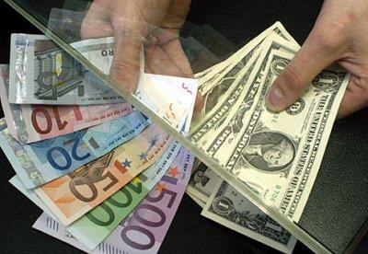
- READING
MONEY AND FUNCTIONS OF MONEY
  - Money
What is money? Money is any good that is widely used and accepted in transactions involving the transfer of goods and services from one person to another. Economists differentiate among three different types of money: commodity money, fiat money, and bank money. Commodity money is a good whose value serves as the value of money. Gold coins are an example of commodity money. In most countries, commodity money has been replaced with fiat money. Fiat money is a good, the value of which is less than the value it represents as money. Dollar bills are an example of fiat money because their value as slips of printed paper is less than their value as money. Bank money consists of the book credit that banks extend to their depositors. Transactions made using checks drawn on deposits held at banks involve the use of bank money.
2. Functions of money
The primary function of money is to facilitate the buying and selling of goods, services and assets. This is known as a medium of exchange. There are also two other main functions of money. The main functions are covered in more depth below:
Medium of exchange. In an economy where people make items themselves to meet their own needs there would be no need for money as people would barter using their spare items that they have produced. If one person wanted an item another person had they would simple barter and arrange an exchange of goods. In a modern economy which is highly developed, barter would be impractical in most circumstances. What is needed is a medium of exchange which is generally acceptable as a means of payment for goods, services, labour and factors of production/ service. Money carries out this function. To be an effective and suitable means of exchange, money must be light for it to be carried around, be divisible (come in different denominations) and not be easy forged or replicated.
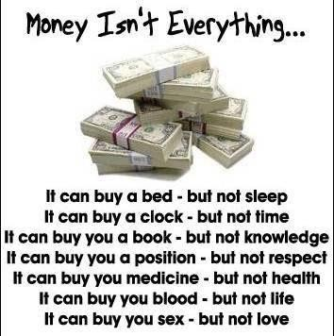
Means of Evaluation. Money allows for the comparison of the value of goods, services and assets. The value of goods and services is expressed in terms of prices and these prices are expressed in terms of money. This allows for different items which are dissimilar, such as a company’s assets, to be added up. Money, thus serves as a ‘unit of account’.

Store of wealth. People and organizations need to be able to use the earnings of one days labour or operation to purchase goods and services in the future. This would mean they would need to store their wealth and that they need a means of saving. Money facilitates the storing of wealth as it can be saved.

VOCABULARY
A.T.M. abbr. Automated Teller Machine;  cash dispenserUK  Banknote(n):  billUS (n).  black market (n). bureau de change ( n). cash ( n).  cash dispenserUK ( n): cashier (n).  coin (n): currency( n). debt (n).  exchange rate (n). foreign exchange( n): hard currency (n). invest( v). investment (n).  legal tender ( n): petty cashUK (n). soft currency (n). speculate (v).  transaction (n). | máy rút tiền  tiền giấy (UK)  tiền giấy  tiền giấy (US)  thị trường chợ đen quầy đổi ngoại tệ tiền mặt  máy rút tiền (UK) thu ngân  tiền xu tiền tệ nợ  tỷ giá hối đoái ngoại tệ  tiền tệ mạnh đầu tư –  sự đầu tư  tiền pháp định quỹ tạp phí tiền tệ yếu  đầu cơ, tích trữ  giao dịch

COMPREHENSION
Answer and make discussion about the following questions
  - What is the importance of money?
  - What are the differences between money and currency?
  - Do you think money is everything? Why and why not?
  - What do you think if the world was no money?

WORD STUDY AND EXERCISES
- Read the explanations and fill in the gaps with the expressions.
Money talks - money gives one the power to get or do what he or she wants
Come into money - If someone comes into money, property or a title, they receive it as a result of the death of a relative
Money doesn't grow on trees- something that you say which means you should be careful how much money you spend because there is only a limited amount.
A money-spinner - a business or product that makes a lot of money for someone.
Throw (your) money around - to often spend money on things that are not necessary.
At all costs - at any expense of time/effort/money
Break even - to have income equal to expenses
Buy (something) for a song - to buy something cheaply
Chip in (money) - to contribute money for something, to pay jointly for something
Feel like a million dollars/bucks - to feel wonderful, to feel well and healthy
In the red - to be unprofitable, to be losing money, to be in debt
  - Although I have been sick for a few weeks I ……………………
  - Cookery books are becoming a real ………………… for the publishing industry.
  - 'Dad, can I have a new bike?' 'We can't afford one…...........you
know.'
  - Everybody in our office …………………. some money to buy a wedding present for our boss.
  - I was able to buy my first house……………………………..
  - She a bit of money when her grandfather died.
  - I'm not surprised she hasn't got any savings. I've never seen anyone
…………like Polly.
  - ………………………… and when I go to a restaurant with my rich uncle we always get a very good table.
  - Our company was able to ………………………. after only six months of operation.
  - The company has been for several months now and
will soon go bankrupt.
  - We must win that game !
- Read the article and fill in the missing word from the box, you can some of the words more than once.
Within, access, in, of, get, make, out, afford, up
Do you keep track 1 ……… your expenses? Do you find it difficult to keep 2 …………. your income? Do you always bargain to get the best price? If you think handling money is a piece 3 cake you must
definitely revise your approach because money does not grow on trees.
There are many ways one can 4……….. rich! You can always wait, provided that you have rich relatives, until your good old soul auntie Rosie deceases and you will unexpectedly come into money. Then, of course you feel like a million dollars because you can 5 …………. anything from Porsche to Armani designer clothes.
Another option is setting 6 ………..your own business but you have to 7 sure it is a money spinner like business online. E-commerce
is both profitable and comfortable as you can work flexi time not leaving your home. Your goods are available to all the customers who have computers with internet 8 and usually no time for shopping in
a mall. To make an payment, you just type 9 ……… your credit card details, or you 10 ……… a bank transfer and you send a confirmation.
However, being an entrepreneur means that you have to break even 11
………. the end. You cannot throw your money around recklessly and without consideration. Once it turns 12 that you are in the red you
may have to fill 13 a couple of forms in a bank to get yourself a
loan.
So remember, you do not have to be rich at all costs! Sometimes you buy something for a song just for the fun 14 ………… going to the flea market, or organize a party where everyone chips in for food and beverages.

UNIT 5: BANK AND BUSINESS
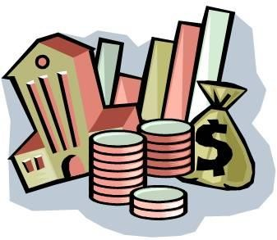

- READING

  - Bank:

Bank and Banking

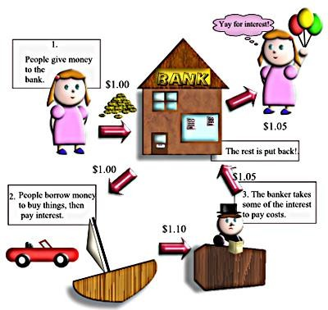
A bank is a financial institution which deals with deposits and advances and other related services. It receives money from those who want to save in the form of deposits and it lends money to those who need it.

  - Banking:
In general terms, the business activity of accepting and safeguarding money owned by other individuals and entities, and then lending out this money in order to earn a profit.

FUNCTIONS OF CENTRAL BANK

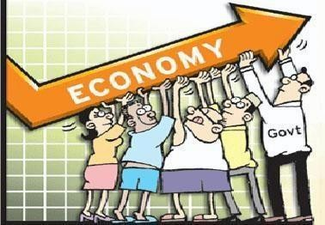

There are four functions of a central bank. The first one is actually to implement monetary policy. There are roughly three ways to do it. First setting interest rate ceilings and floors, which means limiting, upwards or downwards, the fluctuations of the interest rate. The second way to implement monetary policy is simply printing money, or destroying it- coins, banknotes. The third one which is a bit more modern, is those open- market operations, which are simply buying and selling government bonds to and from commercial banks.
So that was the first main task of a central bank. The second one is exchange rate supervision, mainly for floating exchange rates but one should not forget that even for a fixed exchange rate the central bank still has to make sure that it has enough reserves to counteract any upswing or downswing of this exchange rate.
The third main task is the commercial bank surpervision. The commercial banks have enough liquidities, for instance, to avoid any bank run. The bank run is a sort of, kind of panic, a situation in which investors or simple consumers of the banks run to the bank and take the money out because they realize or they think they realize that their bank is not trustworthy any more. And to avoid a sufficient liquidity ratio, for instance.
The fourth main task of the central bank would be to act as a lender of last resort in case, actually, one of these commercial banks goes bankrupt and the investors, the people putting money in the bank, have to get back their money.

VOCABULARY
Balance (n) .  Bank charges (n) Branch (n) CheckbookUS (n) CheckUS (n) .  Credit (n).  Credit card (n).  Current account (n). Debit (n).  Deposit account (n)  Fill inUK (v) Interest(n).  Loan (n). Overdraft ( n). Pay in (v)  Payee (n).  Paying-in slip (n). Standing order (n). Statement (n).  Withdraw (v). [-drew, -drawn  Roughly (adv):  Fluctuation (n): Destroy (v):  Open-market operations: Exchange rate supervision: Floating exchange rate: | số dư tài khoản. phí ngân hàng. chi nhánh  cuốn sổ séc séc thanh toán. khoản nợ  thẻ tín dụng  tài khoản vãng lai / thanh toán ghi nợ  tài khoản tiền gửi (có lãi)  điền thông tin (vào form, phiếu…)  lãi suất  khoản vay (có lãi)  thấu chi  gửi tiền vào tài khoản người được thanh toán biên lai gửi tiền  ủy nhiệm chi  bảng sao kê  rút tiền  khoảng  sự dao động hủy, phá hủy  hoạt động trên thị trường mở giám sát tỉ giá hối đoái  tỉ giá hối đoái thả nổi

Reserve (v): khoản tiền dự trữ

Counteract (n): chống lại
Upswing/downswing (n): chiều hướng tăng/giảm
Liquidity (n): khả năng thanh toán bằng tiền mặt
Bank-run: tình trạng đổ xô đến ngân hàng để rút tiền
Panic (n): sự hoảng sợ, hoang mang
Trustworthy (adj): đáng tin cậy
Sufficient liquidity ratio: tỷ lệ đảm bảo thanh toán bằng tiền mặt

Last resort: giải pháp cuối cùng

COMPREHENSION
  - How many functions of a central bank?
  - What is the first function?
  - Show the ways to implement monetary policy?
  - What is the second function?
  - What is the third main task?
  - What is a bank run?
  - What does the bank do to avoid bank run?
  - What is the fourth main task?

LANGUAGE FOCUS
Relative clause: Who, that, which
We can use a relative clause beginning with who, that or which to describe and define a person or thing. To refer to people, we use who or that. To refer to things, we use which or that.
Example:
  - The accountants who/that advised me were very good.
(The clause who adivised me identifies the accountants)
  - The computer which/that they bought was expensive.
(The clause which they bought indentifies the computer)
Exercise: Choose the best answer in the following sentences.
- His house, for he paid $10,000, is now with $30,000.
  - Who b. where c. which d.that
- The hotel ……………. is near the beach, is the most expensive hotel.
  - Where b. which c.whose d.who
- That’s block cost $20 million to build, has been empty for
years.
  - Who b. which c.where d.whom
- Henry …………… lives about three miles away, was my former teacher.
  - Who b. whose c. which d. whom
- The record ………….. I bought two months ago, was broken yesterday.
  - Who b. which c. what d. when
- The house ………….. was built 20 years ago, is now being converted into a hotel.
  - Who b. when c. where d. that
- The book ………… consists of 4 parts, has been translated into Vietnamese.
  - Which b. on which c.in which d. to which
- He was the first man left the burning building
  - Who b. whom c. which d. whose
- The last person …………….. leaves the room, must turn off the light.
  - Whom b. whose c. who d.which
- The company ……………. imports and exports rice, has gone bankrupt.
  - Who b. whom c. whose d. which

WORD STUDY
Exercise: Complete each sentence with the correct form of the word in capital letter.
  - I sent in my letter of ……………. and they phoned me the next day (APPLY)
  - A ………..… on the new factory is expected soon. (DECIDE)
  - We must ………………. on, electricity, so turn off those light. (ECONOMY)
  - She went to the bank to some money. (WITHDRAW)
  - In an area of high ……………… people are desperate to find jobs (EMPLOY)
  - We are waiting for an ……..……….of his behavior in the meeting. (EXPLAIN)
  - At the moment …is running at 20% (INFLATE)
  - Please let me know if you need any more (INFORM)
  - These shares have given me a good return on my ……….………
(INVEST)
  - We nees somebody with a good working ……….……. of French (KNOW)
More reading texts and exercises in Appendix 3 and 4.

Retail bank
FURTHER READING TYPE OF BANK

A retail bank is a bank that works with consumers, otherwise known as 'retail customers'. Retail banks provide basic banking services to the general public, including:
Checking and savings accounts CDs
Safe deposit boxes
Mortgages and second mortgages Auto loans
Unsecured and revolving loans such as credit cards

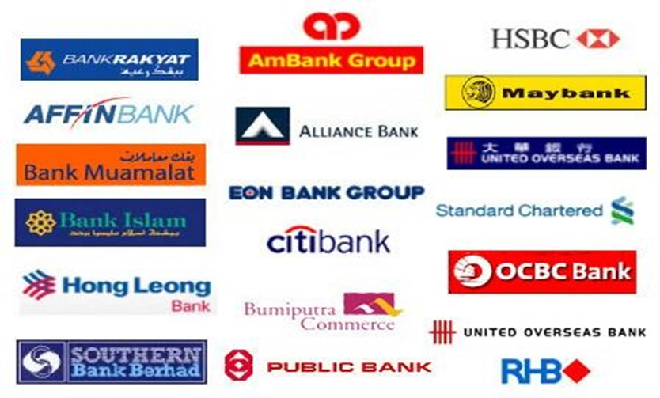

Some famous international banks

Commercial bank
A commercial bank is a bank that works with businesses. Commercial banks handle banking needs for large and small businesses, including:
Basic accounts such as savings and checking Lending money for real and capital purchases Letters of credit
Lockbox service
Payment and transaction processing Foreign exchange

Investment bank
Investment banks help organizations use investment markets.
For example, when a company wants to raise money by issuing stocks or bonds, an investment bank helps them through the process. Investment banks also consult on mergers and acquisitions, among other things.
Investment banks primarily work in the investment markets and do not take customer deposits. However, some large investment banks also serve as commercial banks or retail banks.
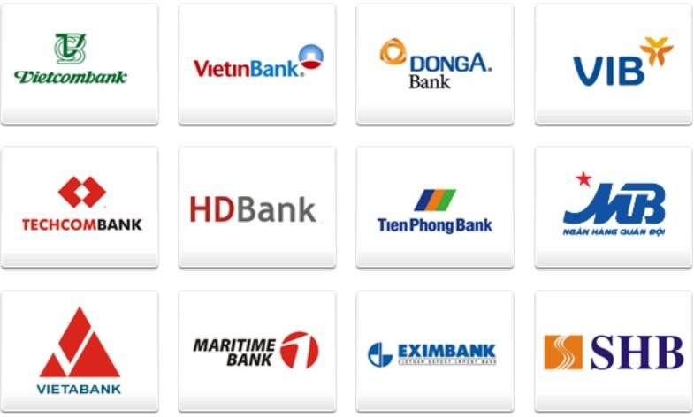

Some famous Vietnamese banks

Central bank
A central bank is an organization responsible for managing banking activity. Within the USA the central bank is the Federal Reserve, or 'the Fed'. Other countries have central banks as well. Their roles are similar, but they may have different objectives.
In the US, the central bank has three primary goals: Conduct monetary policy
Supervise and regulate financial firms Provide financial services
Most consumers do not interact with the central bank. Instead, large financial firms generally work with the central bank in the background.

Credit union
Credit unions are similar to traditional banks in the sense that both institutions offer financial products to customers. However, you have to become a member to use their service (normally, they offer higher interest rate, lower loan or credit card rate and lower fee compare to usual bank).

Online bank
Online banks are banks that you primarily (or exclusively) use on the Internet. Online banks allow you to have more choice and flexibility. You can do things on a computer, and you often get more competitive rates from online banks. They claim that they do not have the overhead and expenses associated with brick-and-mortar banks, so they can pass the savings on to you.

Saving and loan
Savings and Loans (S&L's) are specialized banks created to promote affordable homeownership. After World War II, the US government helped build the Savings and Loans industry by insuring deposits on savings accounts. This encouraged people to save their money, despite federally- regulated low interest rates.

UNIT 6

MARKETING - ANALYSIS OF MARKET OPPORTUNITIES
  - READING
The following definitions were approved by the American Marketing Association Board of Directors: “Marketing is the activity, set of institutions, and processes for creating, communicating, delivering, and exchanging offerings that have value for customers, clients, partners, and society at large.” (Approved October 2007)
Marketing, which is sometimes called distribution, includes all the business activities connected with the movement of goods and services from producers to consumers or users. Marketing is made up, on the one hand, of physical activities such as transporting, storing and selling goods and on the other hand, a series of decisions undertaking any part of the process of moving goods from producer to user. Marketing operations include product planning, buying, storage, pricing, promotion, selling, credit, traffic and marketing research.
The ability to recognize early trends is as important in marketing as knowing the current state of affairs. Producers must know why consumers buy, where and for what purpose. Through market research, the producer tries to predict what the customer will want and, through advertising, attempts to influence the customers to buy.
Marketing operations take up more than half of the customer’s dollar. Every improvement in marketing technique has led to wider distribution of goods in ever-increasing volume. The trend in the US has been to high mass consumption and what has been described as “conspicuous consumption”. The construction of shopping centers has made goods easily available to consumers by providing a wide range of merchandise and plenty of parking facilities.
Definitions of Market Opportunity Analysis
Market Opportunity Analysis using advanced analytical techniques, describes market segment opportunity and predicts future growth.
Product life cycle (PLC)
Marketing concept that, like people and living organisms, goods and services pass through a cradle to grave cycle of progression through their life span. While different products have distinctly different patterns of demand, almost every one of them passes through the stages of introduction, growth, maturity or stagnation, and decline or death.

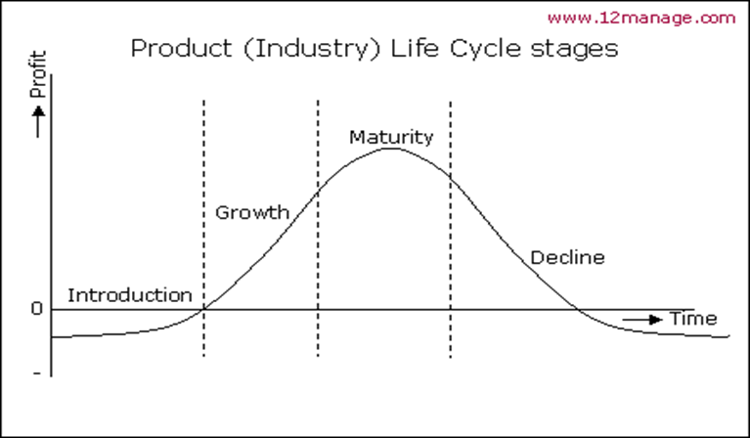

VOCABULARY
Volume (n): Promotion (n):  Mistake (n):  Advertise (v): Advertisement (n): Concept (n):  Human (n):  Affection (n):  Belong (v):  Physical (adj): Warmth(n):  Devote (v):  Satisfy (v):  Create (v):  Stiff (adj):  Survive (v):  Advertise (v) – advertising (n): Market (n):  Market research: Promote (v) – promotion:  Distribute (v) – distribution (n): | khối lượng  đẩy mạnh, xúc tiến, quảng cáo lỗi lầm, nhầm lẫn  quảng cáo sự quảng cáo khái niệm  con người, loài người sự yêu mến, tình cảm thuộc về, sở hữu  vật chất  sự sưởi ấm hiến dâng  thỏa mãn, hài lòng tạo ra  gay găt, rắn chắc tồn tại, sống sót quảng cáo  thị trường  nghiên cứu thị trường, tiếp thị khuếch trương, xúc tiến bán hàng  phân phối
Product planning:  Traffic (n):  Trend (n):  Predict (v):  Consume (v) – consumption (n):  Conspicuous consumption : Merchandise (n): |  | quy hoạch sản phẩm sự lưu thông hàng hóa  khuynh hướng, xu hướng dự đoán trước  sự tiêu thụ  tiêu dùng hiển nhiên hàng hóa

COMPREHENSION
    - How would you define marketing?
    - What two types of activities are associated with marketing?
    - What specific activities come under the heading of marketing?
    - Why do you think producers must be able to predict trends? Can you think of an example when a producer or manufacture did not predict a trend well?
    - How has mass consumption been made possible in the US?

LANGUAGE FOCUS
What and which: fill the gaps in the following sentences by using either
    - He didn’t believe ………..… I said… annoyed me very much.
    - He wasn’t surprised at …………….. he saw because I told him
……………. to expect.
    - He didn’t know the language ……….… made it difficult for him to get a job.
    - Show me …….you’ve got in your hand.
    - Would you know ….to do if you were bitten by a snake?
    - We don’t know ……………..…. Delayed the train, but it went much slower than usual…….. Made us later for our work.
    - I couldn’t remember the number of my own car ………..….. made the police suspicious.
    - You will be punished for ……..you have done.

WORD STUDY
From the list below, select the word that best fills each blank. Use each word only once.
Trend market
research
promote
marketing
advertising
predict
distribution
shopping centers

    - Our market research indicates a new among
people in large cities.
    - ………………. must be completed before product development is started.
    - The producer tries to consumer trends and then tries
to influence them.
    - Another name for marketing is …………
    - The consumer may be influenced into buying a product through
……..................
    - High mass consumption in the US has been made possible by
………………..
    - ………………… operations include product planning and pricing among other things.
    - In order to sell a new product, they have to consider how they want to it.
Check Appendix 5, 6, 7 and 8 for more reading texts, exercises and related word and phrases.

FURTHER READING MARKETING MIX – 4 MARKETING
Marketers use different tools in order to get the desired response from the customers or best satisfy their needs. These tools are known as The Marketing Mix. Marketing Mix is probably the most famous term in marketing.

Marketing Mix
Marketing Mix is a combination of marketing tools that a company uses to satisfy their target customers and achieving organizational goals. McCarthy(1) classified all these marketing tools under four broad categories:
Product Price Place Promotion
These four elements are the basic components of a marketing plan and are collectively called 4 P’s of marketing. 4 P’s pertain more to physical products than services. Below is an illustration for marketing mix
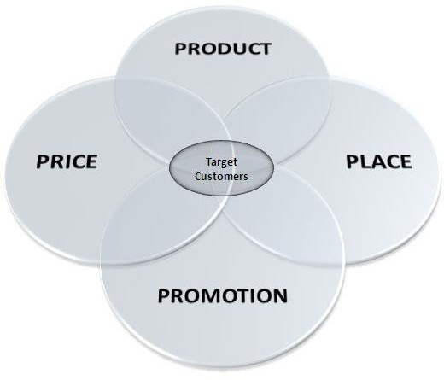
Product
Product is the actual offering by the company to its targeted customers which also includes value added stuff. Product may be tangible (goods) or intangible (services). While formulating the marketing strategy, product decisions include: What to offer?
Brand name Packaging Quality Appearance Functionality Accessories Installation
After sale services Warranty
Price
Price includes the pricing strategy of the company for its products.
How much customer should pay for a product? Pricing strategy not only related to the profit margins but also helps in finding target customers.
Pricing decision also influence the choice of marketing channels. Price decisions include:
Pricing Strategy (Penetration, Skim, etc)
List Price payment period Discounts Financing Credit terms
Using price as a weapon for rivals is as old as mankind. But it’s risky too. Consumers are often sensitive for price, discounts and additional offers. Another aspect of pricing is that expensive products are considered of good quality.
Place (Placement)
It not only includes the place where the product is placed, all those activities performed by the company to ensure the availability of the product tot he targeted customers. Availability of the product at the right place, at the right time and in the right quantity is crucial in placement decisions.
Placement decisions include: Placement Distribution channels Logistics
Inventory
Order processing Market coverage
selection of channel members
Promotion
Promotion includes all communication and selling activities to pursuade future prospects to buy the product. Promotion decisions include:
Advertising Media Types Message Budgets
Sales promotion
Personal selling Public relations Direct marketing
As these costs are huge as compared to product price, So it’s good to perform a break-even analysis before allocating the budget. It helps in determining whether the new customers are worth of promotion cost or not.

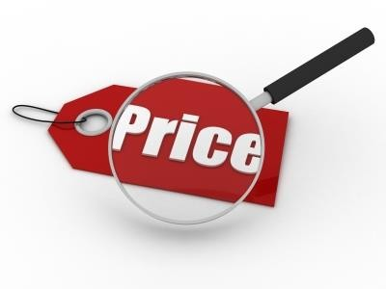
UNIT 7: PRICING

- READING
  - Pricing:
Pricing is the process of determining what a company will receive in exchange for its products. Pricing factors are manufacturing cost, market place, competition, market condition, and quality of product. Pricing is also a key variable in microeconomic price allocation theory. Pricing is a fundamental aspect of financial modeling and is one of the four Ps of the marketing mix. The other three aspects are product, promotion, and place. Price is the only revenue generating element amongst the four Ps, the rest being cost centers.
  - What is good price?
A well chosen price should do three things:
    - Achieve the financial goals of the company (e.g., profitability)
    - Fit the realities of the marketplace (Will customers buy at that price?)
    - Support a product's positioning and be consistent with the other variables in the marketing mix
      - Price is influenced by the type of distribution channel used, the type of promotions used, and the quality of the product
      - Price will usually need to be relatively high if manufacturing is expensive, distribution is exclusive, and the product is supported by extensive advertising and promotional campaigns
      - A low price can be a viable substitute for product quality, effective promotions, or an energetic selling effort by distributors
From the marketer's point of view, an efficient price is a price that is very close to the maximum that customers are prepared to pay. In economic terms, it is a price that shifts most of the consumer surplus to the producer. A good pricing strategy would be the one which could balance between the price floor (the price below which the organization ends up in losses) and the price ceiling (the price beyond which the organization experiences a no demand situation).

VOCABULARY
Tuition (n) : tiền học phí
Rent (n) : tiền thuê nhà Premium (n) : phí bảo hiểm Fee (n) : tiền khám bệnh
Dues (n) : tiền sinh hoạt phí (hội phí)
Retainer (n) : tiền trả trước cho tư vấn, cho luật sư Commission (n) : tiền hoa hồng (trả cho người bán đại lý) Highlight (v) : nhấn mạnh, lưu ý
Ownership (n) : quyền sở hữu View-point (n) : quan điểm Quoted price (n) : giá niêm yết Suppose (v) : giả sử, giả thiết
Discount (n) : giảm giá, chiết khấu Deposit (n) : tiền đặt cọc
Penetrate (v) : thâm nhập, xâm chiếm Compete (v) – competition (n) : cạnh tranh Pricing policy (n): chính sách định giá
Credit terms (n): các điều khoản nợ, điều kiện tín dụng Pure price competition: sự cạnh tranh lành mạnh về giá
Imperfect competition: sự cạnh tranh không hoàn toàn Supply and demand: cung và cầu
Trade in allowance: số tiền các thêm để đổi hàng cũ lấy hàng mới Public utility services (n): dịch vụ công cộng, tiện ích công cộng

READING COMPREHENSION
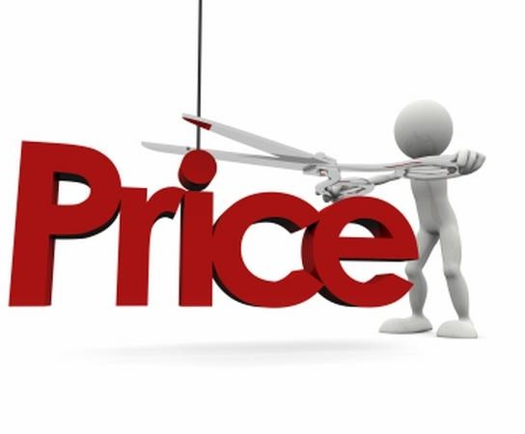
NATURE AND IMPORTANCE OF PRICE
The price paid for goods and services goes by many names. You pay tuition for your education, rent for an apartment, interest on a bank credit card, and a premium for car insurance. Your dentist charges you a fee, professional or social organization charges dues and transportation companies charge a fare. In business a consultant may require a retainer for services rendered, an executive is given a salary, a salesperson receives a commission, and a worker is paid a wage. Of course, what you pay for clothes or haircut is termed a price.

What is the price?
These examples highlight the many varied ways that price plays a part in our daily lives. From a marketing viewpoint, price is the money or other considerations (including other goods and services) exchanged for the ownership or use of a good or service.
For most products and services, money is exchanged, although the amount is not always the same as the list or quoted price. Suppose you decide to buy two indentical Jaguar XJ220 models that are initially scheduled for a 1998 European introduction. The list price is $586,593 for
each. As the quantity discount for buying two Jaguars, you get $7,000 off the list price for each. You are required to put down a deposit of $79,950. However, you agree to pay half down and the other half when the cars are delivered, which results in a financing fee of $3,000 per car. You are allowed $1,000 for your only trade- amounting to $500 of the price of each car.
Applying the “price equation” to your purchase, your price per car is: Price = List price – Discount and Allowances + Extra fees
= $586,593 – (7,000 +500) + $3,000
= $ 582, 903

COMPREHENSION
  - Is tuition a price? Why or why not?
  - In your opinion, is something you exchanged for other things called price?
  - What is a price?
  - Do you agree, for all products and services, money are exchanged?
  - Do prices play an important part in our lives? Why?

LANGUAGE FOCUS
  - Change these sentences into active voice:
- Price is often used to indicate value.
- You are required to put down a deposit of $79,950.
- Money is exchanged for most products and services.
- The practice of exchange goods and services for other goods and services rather than for money is called barter.
- Present simple passive voice:
Notice this sentence from the text:
“Prices are determined in various ways. Notice how the passive voice is formed.
  - We use this room only on special occasions.
  - Banks give investment advice.
  - Companies always borrow money from banks.
  - Banks usually provide credit services.
  - Companies often use the safe deposit boxes.

WORD STUDY
- From the words listed below, select a word tofit each blank space in the sentences. Use each word only once.
Competition volume of sales supply and demand

Trade in allowance Imperfect competition complete

  - In pure competition, the force of operate.
  - He decided to buy his new car at the place where they offer the best
……………….on his old model.
  - Most companies operate in an atmosphere ………………..
  - His company is of course interested in producing the highest
……………….. with the lowest unit cost.
  - is the public goal for most American companies.
  - It is difficult to without sound pricing policy.

- From the list below, select a word to fit each blank space in the passage. Use each word only once.
Willing | market | quarter | because
Three quality | on | relate | goal pricing

Three different objectives …………… (1) to a firm’s profit, usually measured in terms of return on investment (ROI) or return ……………..
- assets. One objective is managing for long run profits, which is followed by many Japanese firms that are …………………..(3) to forgo immediate profit in cars, TV sets, or computers to develop
……………….(4) products that can penetrate competitive
………………..(5) in the future. A maximizing current profit objective, such as during this ……………. (6) or year, is common in many firms
………………..(7) the targets can be set and performance measured quickly. American firms are sometimes criticized for this short-run orientation. A target return objective involves a firm like Du Pont or Exxon setting a ………………….(8) (such as 20 percent) for pretax ROI. These …………………(9) profit objectives have different implications for a firm’s (10) objectives.

FURTHER READING

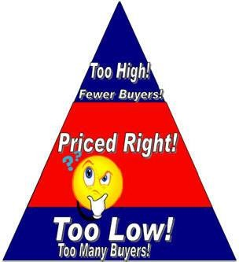
Pricing Methods

The pricing method you select provides direction on how to set your product price. The way you set prices in your business will change over time, for many reasons. As you learn more about your customers and competition, you may decide to change your pricing method. Use changes in the industry or the development stage of your product as an indicator that it’s time to review your pricing strategy.
There are three basic methods to price your product: cost-based pricing
competition-based pricing customer-based pricing
- Cost-based pricing is where the price includes the cost of ingredients and cost of operating the business.
include a profit percentage with product cost add a percentage to an unknown product cost blend of total profit and product cost

Disadvantages of cost-based pricing
Before you select a cost-based pricing option, you should consider the disadvantages. There are two important reasons why cost-based pricing doesn’t work for some businesses:
- Cost-based pricing does not consider how customer demand affects price. Demand for a product will directly affect how much people will pay. If, due to heavy demand, customers believe a product is in short supply, they may be willing to pay more. On the other hand, if demand is very low the customer will look for a discount on the price.
- Competition is not included in cost-based pricing methods. Competition should affect how you price your product. The idea of simply adding a profit level or percentage to a product price will only work in industries with limited competition. In a competitive market, cost-based pricing may encourage competitors to enter the market with a lower price.
- Competition-based pricing is where the price covers costs (cost of raw materials and the cost of operating the business) and is comparable to the competitor’s price.
price is the same as the competition set price to increase customer base seek larger market share through price
Disadvantages of competition-based pricing
  - While competition-based pricing offers advantages; you need to consider the following disadvantages:
  - you may ignore your own production costs if you focus too closely on the prices set by competitors
  - more time is needed to conduct and update market research competitors can easily mimic whatever price you select
- Customer-based pricing, also known as value-based pricing, is a system where the price is based on the customer ‘demand’ or need for the product. If the product is unique or innovative, a value-based price may help create a demand for the product or service.
  - use price to support product image
  - set price to increase product sales
  - design a price range to attract many consumer groups
  - set price to increase volume sales
  - price a bundle of products to reduce inventory or to excite customers
Disadvantages of customer-based pricing
Before you implement a customer-based pricing method, note the following disadvantages. If you are too focused on the customer, you may: ignore production costs forget about the competition.
There are other factors that may affect your pricing strategy. You need to decide how to set both wholesale and retail prices for your product. Volume discounts and rebates must be considered.
As you review each pricing method, think about your business, industry and customer. Before you select a pricing method, be sure you understand the range of options available and their disadvantages and advantages. You may want to blend several pricing methods to suit your business and the type of product(s) you sell.
- Tips for Successful Pricing
Good product prices are important to any successful business. Pricing takes creativity, time, research, good recordkeeping and flexibility. You need to balance the costs of producing a product with competition and the perceptions of your target customer to select the right product price. Follow these tips to ensure greater pricing success.
Be creative
Think of new ways to sell more to existing customers or to attract new customer groups.
Listen to your customer
Make a point of noting customer comments in a journal or file.
Review them periodically to glean new ideas. Do your homework
Keep good notes of how you arrived at a price so you can make similar assumptions in the future.
Boost your records
Good recordkeeping will help you to set a price and to track the performance of your pricing.
Cover the basics
The three basics of pricing are product price, competition and customers. Blend pricing methods to ensure the three basics are in balance. Be flexible
Constantly review both internal and external factors and calculate how a price change would affect the new situation.

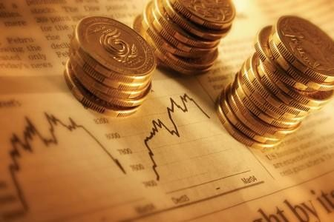
UNIT 8: FINANCE

- READING
Finance is concerned with providing funds to individuals, businesses, and governments. Finance allows these entities to use credit instead of cash to purchase goods and invest in projects. For example, an individual can borrow money from a bank to buy a home. An individual firm can raise money through investors to buy a new factory. Government can issue bonds to raise money for projects.
Finance plays an important role in the economy. As banks, credit unions, and other financial institutions provide credit, they help expand the economy by directing funds from savers to borrowers. For example, a bank acquires large amounts of money from the deposits of individual savers. The bank does not let this money sit idle but instead provides loans to borrowers who might then build a house or expand a business. The savings of millions of people percolate through many financial institutions, spurring economic growth.
A wide variety of financial institutions have different roles in finance and the economy. Some institutions act as an intermediary among consumers, businesses and governments by lending out deposits. Other institutions such as stock exchanges provide a market for existing securities, which include stocks and bonds. Stock exchanges encourage investment because they enable investors to sell their securities when they need arises.
Many aspects of finance are studied individually. Corporate finance centers on how businesses can best raise and spend their funds. Public finance focuses on the financial role of federal, state, and local governments.

VOCABULARY

to be concern with something : entity:  instead of something deposit (n)  financial institutions idle (adj):  securities = stocks :  to enable somebody to do something:  to acquire something:  to percolate through something: to spur somebody something  to arise  to encourage sth/sb to do sth: | liên quan, đề cập đến thực thể  thay vì, thay thế tiền gửi  các định chế tài chính nhàn rỗi (money) chứng khoán  cho phép ai đó làm gì đạt, giành, có được  được biết đến thông qua cái gì khích lệ, khuyến khích, kích thích.  nảy sinh, xuất hiện  khuyến khích, khích lệ cái gì, ai làm gì

- COMPREHENSION
  - What is finance concerned with?
  - What does the term “these entities” in the text refer to?
  - How can an industrial firm raise money?
  - Prove that finance plays an important role in the economy
  - Does bank let money sit idle?
  - Do financial institutions have different roles in finance and the economy?
  - Why do stock exchanges encourage investment?
  - What does corporate finance center on?
  - What does public finance focus on?

LANGUAGE FOCUS
Infinitive of purpose
- Usage
- We use “to + infinitive” to talk about the purpose of doing something (=why someone does something)
  - She telephoned me to invite me to a party.
  - We shouted to warn everyone of the danger.
- We also use “to +infinitive” to say what can be done or must be done with something.
  - It’s usually difficult to find a place to park in the city centre (= a place where you can park)
  - We also use “in order to + infinitive”
  - I’m going to the United States to learn (in order to learn Engligh)
  - Sometimes we have to use so that (not to + infinitive) to talk about the purpose of doing something.
  - Leave early so that you won’t (or don’t) miss the train.
  - We moved to london so that we could visit our friends more often
  - I gave him my address so that he could contact me.
- Use the words in brackets to answer these questions.
  - Why did you go to the bank yesterday? (withdraw some money)
  - Why are you saving money? (build house and travel)
  - Why do you study in this course? (change my job)
  - Why did you hurry? (not want to be late)

WORD STUDY
  - Use the given words, complete the following passage:

In discount | in bulk | on credit | a receipt | services
a refund | a bargain | not worth | a rip-off | a fare

When you buy something in a shop, you usually pay for it outright but sometimes you buy ……………..(1)………………. Sometimes you may be offered ………………..(2)… or a reduction on something
you buy. For example, you might get $10 off perhaps because you are a student. You are often offered a discount if you buy …………
- … It is not usual to haggle about prices in a British shop as
it is in, say, a Turkish market. If you want to return something which you have bought to a shop, you may be given ………….(4)……………., i.e your money will be returned, provided you have …………….(5)…… The money that you pay for …………..(6) ………………, i.e to a school or a lawyer, is usually called a fee or fees. The money paid for a journey is
…………(7)……………..
If you buy something that you feel was very good value, it’s
………….(8) ………………. If you feel that it is definitely ……………
(9)………………. what you paid for it, then you can call it …………….
(10)………………..
  - Make a discussion with your partners about financial career based on the picture below.
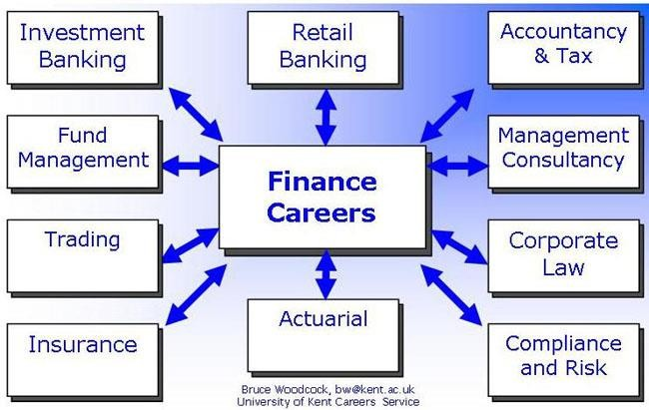

  - Choose the best answer to fill in the blanks – Jobs in finance
- A _ is someone who buys and sells stock. stockbroker
stock-seller
insurance broker
- An insurance broker will help you find the best insurance
at the best price.
politics
policy tax
- An tax consultant is someone who can you on how to pay less tax.
advise advance
advocate
- A tax- (or "IRS auditor" in the USA) is someone who makes sure that you're paying enough taxes.
official inspector
broker
- A company's finance (also known as a CFO) is usually that company's chief accountant.
official
boss director
- A bank is a bank employee who deals directly with most customers.
guard inspector
teller/cashier
- A bank manager is the person responsible for a particular of a bank.
branch building
inspection
- A financial advisor is someone who advises people on how to
their finances. ( = financial affairs)
advise
manage keep
- My always prepares my tax return for me. trader
inspector
accountant
- A venture capitalist is basically . an investor
an accountant a manager

UNIT 9: TAXATION
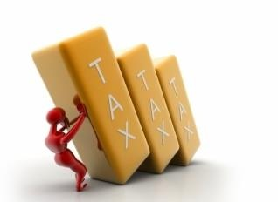
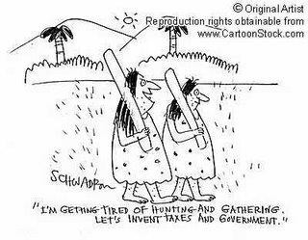
- READING
Taxes may be classified into two groups – direct and indirect taxes. A direct tax is imposed on a person, household, or enterprise with the expectation that taxpayer, will bear the tax burden and not be able to recover it by passing it on to someone else. The leading examples of direct taxes are income taxes and profit taxes.
In industrial market economies the individual income tax, the tax on persons or households, plays an important role in raising revenue an in effecting the distribution of income among income categories. Usually the lowest incomes are now subject to the income tax and incomes above that level are assessed at progressive tax rates, i.e rates that rise as the size of the income grows larger. The purpose of a progressive income tax is to lessen the inequality of incomes that arises from operation of the market system.
Indirect taxes are taxes imposed on consumers of goods and services, or on enterprises with the expectation that the taxes will be passed on to customers in the form of higher prices. Important examples of indirect taxes are excise taxes, which are selective taxes on particular goods or services such as cigarettes or beer, and import duties and various forms of turnover taxes or sales taxes of broad coverage.
All indirect taxes have the function of raising revenue and diverting purchasing power from households and enterprises to the state. But only selective excise taxes and import duties have the function of influencing the composition of output between different commodities and services.

VOCABULARY
Direct and direct taxes: thuế trực thu và thuế gián thu Impose (v): đánh thuế, ấn định/ áp đặt (thuế) Expect (v) – expectation (n): hy vọng, mong đợi Taxpayer (n): người nộp thuế
Bear (v): chịu đựng
Burden (n): gánh nặng, bổn phận, trách nhiệm
Recover (v): lấy lại, giành lại, thu lại, bù lại
Income tax (n): thuế thu nhập
Profit tax (n): thuế thu nhập doanh nghiệp
Industrial (adj): thuộc về công nghiệp
Individual (n): cá nhân
Revenue (n): thu nhập
Effect (v): tác động, ảnh hưởng Distribute (v) – distribution (n): phân phối, phân chia Assess (v): định lượng, định giá Progressive tax rates: các mức thuế lũy tiến Consumer (n): người tiêu dùng
Excise tax (n): thuế hàng hóa
Selective taxes on particular goods or services: thuế hàng hóa và dịch vụ đặc biệt
Import duties: thuế nhập khẩu Purchasing power (n): sức mua Commodity (n): hàng hóa

COMPREHENSION
  - What is a direct tax?
  - Does the direct tax play an important role in the industrial market economies? Why?
  - What is the purpose of a progressive income tax?
  - What are indirect taxes?
  - What is the important role of indirect taxes?
  - Give the examples of direct and indirect taxes?

LANGUAGE FOCUS
Explain how to use these words: much, many, few, fewer, little, less. Now complete the sentences with one of these words above.
  - …………….. people realise how …………… tax they could avoid paying if they studied the tax law.
  - …………… people believe they pay too tax.
  - There is too ………… time and too …………….. problems to talk about irrelevant issues.
  - There isn’t evidence to support these figures.
  - You’ll pay much ………….. tax in the Cayman islands than most places.
  - Very ……………. tax authorities have clear plans for corporation tax in the future.
  - There are many opportunities to avoid tax nowadays.

WORD STUDY
- Select a word to fit each blanks space in the passage.
Use each word only once.
expanditure
create
inflation
Stable needed sense money
households
bycredit

Why are taxes ………………(1) ? They are needed not to raise revenue in the …………….(2) of giving the state ………………. (3) , the state can always get money (4) having the central bank extend
………………(5) to it or by printing money. However, if the state finances a large part of its (6) by printing money or having the
central bank …………….(7) money, there is risk of (8)
because expenditure of ………………..(9) and enterprises and total spending would exceed the value of production at (10) prices.
- Choose the right word to fill in the boxes
a - form (noun)
b - exempt (adjective) c – depreciation
d – unauthorized e - audit (noun) f - tax dispute
g – disclosure h – dividends
i - self-employment income j - tax evasion
- releasing your tax information to a third party ->
- a process to check if what you declared is correct -->
- not paying taxes when one is required to do so -->
- not having to pay taxes -->
- the profits of a company that are distributed among shareholders->
- illegal, not allowed -->
- money that you make working for yourself -->
- a document that you fill out -->
- the decrease in value, over time, of property or assets -->
- a disagreement about how much tax you have to pay -->
3. Choose the word to fill in the blanks
- Many Americans use tax software to complete their tax ………………
returns retainers
resources
- I had to pay taxes. ( = taxes from previous years) ancient
back
previous
- That income will be taxed at a higher . rating
ration
rate

- A 401(k) plan is an employer- sponsored
induced
censored

savings plan.

- You children can be considered your . deductions
exemptions
dependents

- You employer will anything you put into your 401 (k) plan. ( = they will put in the same amount that you do)
even out
equate match
- Here are some examples of filing : single, married filing jointly, married filing separately, etc.
statuses states
statements
- For tax , you may be considered "single", even though you are actually married.
goals purposes
aims
- On tax forms, the most common way to refer to one's husband or wife is " ".
mate spouse
ball-and-chain
- If you have any ( = more, extra) income, you should fill out this form.
extraneous added additional



UNIT 10: INSURANCE
- READING
Throughout human history, unexpected losses have occurred. Such losses would continue to occur whether or not a system of insurance had ever been devised. But through the operation of an insurance system, losses can be predicted before they occur. The predictability of losses is basic to an insurance system’s operations. Because an insurance system allows the cost of losses to be financied and resdistributed in advance.
The first definitionof insurance is the financial one. In this instance, insurance is a financial arrangement that redistributes the costs of unexpected losses.
An insurance system accomplishes the redistribution of the costs of losses by collecting a premium payment from every participant in the system. In exchange for the payment of the premium, the insured receives a promise from the insurance system to be compensated in the event of a loss.
An insurance system is able to operate because all the insureds are willing to substitute a relatively small certain outlay, the insurance premium, for a relatively large uncertain loss. It is generally assumed that most people find the possibility is suffering a large loss unpleasant to contemplate. Therefore, people are willing to pay an insurance premium to be relived of uncertainty about a loss, as well as to be compensated if the
loss occurs. Thus, even if no loss occurs during a year, as will be the case for most insureds, value has still been received in the form of a reduced or eliminated unpleasant mental state, the anxiety about a loss.

VOCABULARY
Insurance (n): sự bảo hiểm, bảo hiểm
Insurer (n): công ty bảo hiểm, người bán bảo hiểm Insured (n): người được bảo hiểm
Occur (v): xảy ra, xuất hiện
Devise (v): đặt ra, tạo ra
Predict (v) dự báo, báo trước – (n) predictability Redistribute (v): tái phân phối
Accomplish (v): hoàn thiện, hoàn thành Loss (n): tổn thất, thiệt hại, mất mát
Premium (n): tiền đóng bảo hiểm, phí bảo hiểm Participant (n): người tham gia
Compensate (v): bồi thường Substitute (v) thay thế, thay đổi Contemplate (v) dự tính, dự định Eliminate (v): loại bỏ
Anxiety (n): sự lo lắng
Mental (adj): tinh thần

COMPREHENSION
  - Through the operation of an insurance system what can people do?
  - What is the first financial definition of insurance?
  - What does an insurance system accomplish?
  - Why is an insurance system able to operate?
  - How many main types of insurance do you know?

LANGUAGE FOCUS
Passive form: Be + Past Participle
“… losses can be predicted before….” “Insurance had ever been devised…”
Exercise: Put the following sentences into the passive
  - John helps Mary.
  - Bill will invite Ann to the party.
  - Tom has opened the door.
  - Workers had built the house.
  - The children can not open the window.

WORD STUDY
  - Look at the first and second paragraph again. The word “redistributes” means:
    - Adds to
    - Reduces
    - Spreads
    - Stops
  - Look at the paragraph 3 again. The word “premium” means:
    - A bonus received by each insured person.
    - An extra payment by an insured person who suffers loss.
    - An amount paid by some insured person only.
    - Cost of insurance to an individual.
  - Look at the fourth paragraph again. The pharse “to be compensated” means:
    - To receive a request for further payment.
    - To receive payment for any loss suffered.
    - To receive more money than the loss suffered.
    - To receive a demand to pay higher premiums.

UNIT 11: MANAGEMENT OF WORKING CAPITAL
- READING
Capital markets are concerned with the purchase and sales of legal instruments that give owners specified rights to a series of future cash flows. These legal instruments are known as financial assets or securities which include bonds, stocks and loans made by financial institution. The original issuer of a security is referred to as a borrower, and the purchaser of a security is referred to as a lender.

Borrowers have an immediate need for cash whereas lenders have an excess of cash. When the borrower issues a security to the lender, both parties benefit. The borrower obtains the current use of cash and the lender obtains a claim to future cash flows
that promises to repay the initial loan as well as to provide a fair rate of profit (in interest).
Transactions between an initial borrower and lender are called primary market transactions. Many financial assets created in the
primary market may be sold by the original lender to other people in what are known as secondary markets. The trading of marketable security in secondary markets has no impact on the original borrower; only the legal owner of the security changes. Examples of formally incorporated secondary markets
include the New York Stock Exchange (NYSE), the American Stock Exchange, and the Tokyo Stock Exchange. Secondary market transactions that do not take place on incorporated exchanges are referred to as over- the-counter (OTC) transactions.
Most securities traded in the secondary markets belong to one of two broad classifications: stocks or bonds.

VOCABULARY
Capital : vốn
Capital market: thị trường vốn
Legal (adj): hợp lý, hợp pháp
Asset: tài sản
Current assets: tài sản lưu động
Fixed assets: tài sản cố định
Securities: chứng khoán
Securities markets (stock exchange): thị trường chứng khoán Transaction: giao dịch
Over – the – counter transaction: giao dịch trên thị trường phi tập trung
Primary market: thị trường sơ cấp Secondary market: thị trường thứ cấp.

COMPREHENSION
- What are capital markets?
- Give examples of some legal instruments transacted in capital markets.
- How do borrowers and lenders get benefits from their transactions in capital markets?
- What’s the difference between primary and secondary markets?
- Define the term “OTC transactions”

LANGUAGE FOCUS
  - Contrast these pairs of sentences using whereas:
Example: Borrowers have an immediate need for cash. Lenders have an excess of cash.
Borrowers have an immediate need for cash whereas lenders have an excess of cash.
In peace time bombs are not in very great demand. In war time their utility is very great.
Some people may refer to save their money and invest it in a secure and profitable scheme. Some may prefer to buy a particular commodity which they have wanted for a long time.
When the price falls, the demand gets higher. The supply decreases as producers ten to produce less.
Many LDCs have obviously derived great benefit from trade. Other LDCs haven’t changed radically their structures of production.
In the 1980s Vietnam had to import rice. Now it is second biggest rice exporting country in the world.

WORD STUDY
  - Make acronyms of letter – names from the groups of names listed below:
Example: The United States of America. The USA
    - British Petroleum.
    - North Atlantic Treaty Organization.
    - The European Economic Community.
    - Association of South East Asian Nations.
    - World Health Organization.
    - The International Monetary Fund
    - The Food and Agricultural Organization.
    - Trans Worlds Airlines.
    - General Agreement on Tariffs and Trade. 10.The United Kingdom.
  - Choose the best word to fill in the blanks – Stock market

- The stock market has been fall
lower
down
for three days straight.

- My stocks are 20% this month. high
up
higher
- I'm hoping for a 10% over the next year. increasing
Increase
increased
- Trading stock is not an ____________________science.
exact
faultless
free from flaws

- When a stock market ( = goes down considerably), many investors lose a lot of money.
clashes smashes
crashes
- My advised me to buy this company's stock.. broker
breaker
brokerage
- The stock decreased in value because many investors were selling it
after the negative financial news came out. off
out
on
- The news had no on the price of the stock. interest
impasse
impact
- These days many investors are (= worried) about the health of the U.S. economy.
scathed uneasy
unscathed
- Online brokers are usually less expensive than their offline
.

counterparts
version counteract

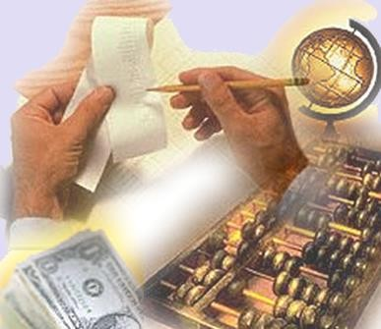
UNIT 12: ACCOUNTING – THE BALANCE SHEET

  - WHAT IS ACCOUNTING?
    - Dialogue between Linda and Mark
L: Hi, Mark. May I ask you some questions about modern accounting?
M: Of course. Go ahead.
L: Could you please explain what accounting is?
M: There are a number of definitions of accounting at present. To some extent, accounting is a system to provide decision makers with information in business economic activities. This system is primarily financial information, stated in monetary terms.
L: Well. What is the main purpose of accounting ?
M: Its main purpose is to provide and report financial information to interested users.
L: Is this financial information important to an organization or a user?
M: Yes. For example, investors need financial data in order to compare prospective investments.
L: I see. Thank you very much.
M: You’re welcome. Please feel free to contact me if you have any questions.
    - Oral drills ; Pair work: practice the following dialogue with your partner A: Could you tell me what accounting is?
B: Certainly. Accounting is an information system that means user, processes and communicates economic activities.
A: In which terms is accounting information expressed?
B: It is expressed in monetary terms.
    - Make “true” or “false” choices
(..............) 1. Accounting is an information system that used in business economic activities.
(. ) 2. Accounting information is used by every non-profit business.
(............) 3. Accounting is one of the fastest growing fields in modern business.
(. ) 4. Computerized accounting systems are popular nowadays.

THE BALANCE SHEET
The financial statement reflecting a company’s solvency is the balance sheet. It follows the accounting equation :
Assets = Liabilities + Owner’s equity Let’s make an example:
The following balance sheet portrays the financial position of Type Well Enterprise Limited on December 31st, 2008

TYPE WELL ENTERPRISE LIMITED
Balance sheet
For the year ended December 31st, 2008
 |  |  | Liabilities
 |  |  | + Owner’s equity
Assets |  | Liabilities
Cash | $ 5,000 | Note payable | $ 4,500
Supplies | $ 800 | Accounts payable | $ 6,000
Building | $ 1,000 | Salaries payable | $ 2,000
Office equipment
Land | $ 8,000 | Owner’s equity
Notes  receivable | $ 3,000 | Balance, December 1st,2008 | $ 4,000
 |  | Net income for December | $ 3,500
 |  | Total owner’s equity | $ 7,500
Total assets | $ 20,000 | Total liabilities and owner’s equity | $ 20,000

Notes:
Is the balance sheet and detailed expression of the accounting
equation ?

VOCABULARY

accounting (n) definition (n) extent (n) decision (n)  business (n) primarily (adv) financial (adj) monetary (adj) term (n)  investor (n)  data(n) plural: datum  prospective(adj) investment(n) summarize (v)  brief (adj)  illustrate(v)  figure(v)  observe(v)  identify (v) measurement (v)  interpret (v)  efficient (adj) computerized |  | sự thanh toán, sự tính toán sự định nghĩa, lời định nghĩa  khu vực; phạm vi; quy mô  sự giải quyết (một vấn đề...); sự phân xử.  việc kinh doanh; việc thương mại  trước hết, đầu tiên; chủ yếu, chính, căn bản (thuộc) tài chính, (về) tài chính  (thuộc) tiền tệ  (ngôn ngữ học) từ, thuật ngữ người đầu tư  số liệu, dữ liệu, dữ kiện  (thuộc) tương lai; về sau, sắp tới  sự đầu tư; vốn đầu tư  tóm tắt; tổng kết  ngắn, vắn tắt, gọn  cung cấp tranh, biểu đồ cho cái gì; minh hoạ  suy nghĩ; tính toán  quan sát, theo dõi  nhận ra, nhận biết, nhận dạng  sự đo lường; phép đo; kích thước; khuôn khổ;  số đo  giải thích, làm sáng tỏ có hiệu lực, có hiệu quả  đưa vào máy tính để làm công việc hoặc cho (cái gì)
 | accountant (n)  chief accountant (n) sheet (n)  income (n) corporation (n) portray (v) heading (n)  contain (v) |  | nhân viên kế toán, người giữ sổ sách kế toán  kế toán trưởng lá, tấm, phiến, tờ lợi tức, thu nhập tập đoàn  miêu tả sinh động đề mục nhỏ; tiêu đề  chứa đựng, bao hàm, gồm có, bao gồm

COMPREHENSION
    - Read and answer the questions
The account functions can summarize in brief. Let’s illustrate them with the following figure
Accounting functions

Observe, identify and measure activities.

Record, classify and summarize mesurments.

Report activities and interpret financial statements

It makes business operations more and more rapid and efficient using computerized accounting system.
  - Answer the following questions
      - What is accounting?
      - How many accounting Functions are there?
      - How does it (computerized accounting system) make business operations?
      - What form is accounting expressed in? 5. What are accounting functions?
Let’s illustrate the account functions.
- Translate the following phrases and sentences into Vietnamese
- the economic activities of a business:
- financial information
- decision makers
- prospective investments
- accounting information
- feel free to do something
- A balance sheet shows the financial position of a business on a specific date.
- Do you think that the balance sheet plays an important part in a company’s transaction?
- Two sides of the balance sheet must always be equal because one side shows the resource of the business and the other shows who supplies the resources.

- Read and answer True (T) or False (F) What is accounting?
Accounting is the system of measuring, describing and interpreting economic activities. At the same time it is the connecting link between decision makers and business operations.
During the twenty- first century, the globalization of the world economy will spur the advance of accounting. Some different forms accounting will appear in specialized fields.
  - Accounting is the system of measuring activities. ………
  - Describing and interpreting economic activities are in the accounting system. ………
  - The globalization of the world economy will lead the advance of accounting. ………
  - Some different forms of accounting will appear in all fields. ………
  - At the different time it is the connecting link between decision makers. ………
Phrases and special terms
- prepare / make up a statement: Chuẩn bị, lập bản báo cáo
- balance sheet: Bản cân đối tài sản, bản tổng kết tài sản
- income statement: Bản báo cáo hoạt động kinh doanh
- statement of cash flow: Bản báo cáo lưu chuyển tiền tệ
- operating activities : Các hoạt động kinh doanh
- ending cash balance: Số dư cuối kỳ của tài khoản tiên mặt
- financial position: Tình hình tài chính
- by the way: Tiện thể, nhân tiện

UNIT 13: THE STOCK EXCHANGE

Look at the picture below, does it show:

The New York Stock Exchange as seen from Wall Street
a) The stock exchange building on the outside?
b) Stock brokers in action?
c) The American flag covering Wall Street?
- READING
The fresher the fish, the better the price at the market. The "stock market" is just that- a huge "market" where stocks are traded by many different vendors. Similar to the way other things are traded- like fish or vegetables at the old-world market, or cows at the cattle auctions- stocks are traded "at auction". Prices are determined by supply and demand- by sellers and buyers willingness to buy or sell at a certain price. As demand goes up, the price goes up, and so on.
Imagine, over 100 years ago, brokers literally shouting, "I have 100 shares of Pacific Railroad for sale, how much will you offer me?" If a broker had an order to buy some stock he would shout "Someone sell me 100 shares of Pacific Railroad! Who has the best price?" You've probably seen some of that happening- in more modern times- in film clips of the Chicago Board of Trade where wheat, corn and pork bellies are bought and sold. Market trading is more organized now. Computers do the shouting.
Brokers arrange for the actual trades (isn't "broker" a funny name for someone that handles your money). A broker is someone who sells stocks for a dealer. Charles Schwab is a dealer. The dealer holds inventories of stocks and sells them through the sales person. The sales guy is the broker or the specialist. If a sell order comes across the computer at an attractive price, the dealer buys (through his agent, the specialist), and adds this stock to his inventory. The brokers, and specialists, using computers, bring the dealers and investors together.
What makes the price of a stock change? Companies are expected to earn profit. If profits increase, the stock price will likely increase. Even if investors think the earnings will increase, the stock price may go up. If good news comes out on a company, the price, and demand for the stock may go up. With bad news, the price and demand may go down. The price of a stock is even more dramatically affected when supply is very high or very low. It is not so uncommon for certain unscrupulous individuals to "create" news or other financial information, for the purpose of duping unsavy investors into creating a demand situation, into which, the unscrupulous-one "sells into" and makes an unfair profit. Investors beware.
There are several different prices:
• Opening Price is the first price paid after trading starts, usually when the stock exchange "opens its trading doors", usually in the morning. Sometimes, opening price is higher or lower than the closing price of the previous day (orders are placed overnight, and after stacking up, affect the demand- and, thus, the opening price.
• Closing Price is opposite- its the price of a stock when the market closes- the price "at the close".
• Ask price is the price you will pay for a stock (and is slightly more than the trading price because it includes a dealer "commission").
• Bid price is what the broker, or agent, will buy your stock for (and is slightly less than the trading price because it includes a dealer "commission").
• Spread is the difference between the bid price and the ask price.
If many buy orders come through the specialist, the price for the stock will be increased. If many sell orders come across the desk, the price will go down. Supply and demand drives stock prices. Lots of orders reduce the spread- thinly traded stocks have a higher spread.
Three Different Stock Exchanges:
There are several organized "exchanges" in the US that make up the stock market. They are the New York Stock Exchange (NYSE), the National Association of Security Dealers Automated Quotes (NASDAQ), and the American Stock Exchange (AMEX). For a company's stock to be "listed", or traded on a particular exchange, it must meet that exchange's requirements of profit, size, employees, and the like.
Penny Stocks:
You get what you pay for- not much. Many new investors are drawn towards the purchase of "penny stocks". Penny stocks, as a group, have little demand in the "market" With penny stock, even when there is good news about a company, who is going to buy the stock from you? Penny stock is rather like Ostridge meat- it may be a good product, but there is no market (demand) for it. The best fishermen sell the best fish.
- VOCABULARY
stock change (n): thị trường/ sàn giao dịch chứng khoán
share: cổ phiếu
stock: cổ phần
securities: chứng khoán
index: chỉ số
Share certificate: chứng chỉ cổ phiếu
Interest: tiền lãi
Interest rate: lãi suất
Dividend: cổ tức
Yield: lợi tức, lợi suất đầu tư (%)
Invest: đầu tư
Investor: nhà đầu tư
Investment: khoản đầu tư
Shareholder: cổ đông
Derivatives: chứng khoán phái sinh
Trading session: phiên giao dịch
Open: mở cửa (phiên)
Close: đóng cửa
Bid: giá bán
Ask: giá mua
Bid-ask spread: chênh lệch giữa giá mua và giá bán
Order: lệnh
Limit order: lệnh giới hạn
Stop order: lệnh dừng
Volatile: biến động, không ổn định
Trading volume: khối lượng giao dịch
Penny Stocks: chứng khoán có mệnh giá nhỏ, giá trị thấp
sell into: Bán giá tăng
auction: đấu giá
commission: tiền hoa hồng

- COMPREHENSION
    - The text is about:
Top of Form
a) Bad behaviour in the markets
b) Expensive prices for goods
c) The structure and organisation of stock markets

2. “The fresher the fish, the better the price at the market” (paragraph 1), does this saying mean...?
Top of Form
a) shares always have same prices
b) prices of shares vary according to their value
c) share prices are equal to fish prices

3. “Computers do the shouting” (paragraph 2), means:
Top of Form
a) Computers shout at users
b) Computers shout from overuse
c) Computers organise prices offered and demanded

4. “Many sell orders come across the desk” (paragraph 5) means that...
Top of Form
a) Sell orders are thrown on the desk
b) Sell orders are offered by the public
c) Sell orders are cancelled
5. Fill in the table with the appropriate information from the text:
Top of Form
Person | Role
Broker
Dealer
Agent
6. What factors negatively affect the stock market? (There could be more than one possible answer)
Top of Form
a) High supply
b) High demand
c) Good market news
d) Political turmoil

LANGUAGE FOCUS

Conditional (type I)
If+ simple present - Will/May +infinitive = this is known as “conditional I”
- “If profits increase, the stock price will likely increase.
- Even if investors think the earnings will increase, the stock price may go up.

Conditional (type II)
If + Simple Past, would + infinitive (this is known as conditional type II)
- If we had more employees, we would work more efficiently.
- If we delivered poor quality, we would not be the leading company in our business.

Conditional (type III)
If + Past Perfect, would + have + past participle = this is known as “conditional type III
- If you had read the paper, you would have seen the advertisement.
- If I had taken the bus, I would have been late.

WORD STUDY
- Complete the following sentences using types of conditional

1. If individuals wish to purchase a stock, they ……………… (place) an order with a brokerage house
2. If employees …………………. (be active), better strategies …………….. (develop)
3. If the manager……………… (be) more flexible, workers ……………… (be) much more at ease.
4. If the company’s strategy …………………… (be) successful, no such crisis …………………………. (emerge).
5. If many sell orders …………………. (present), the prices …………… (go down).
6. If prices…………… (announce) earlier, we ……………. (participate) in the draw.
7. If the bank ………………….. ( warn) customers earlier, the financial disaster …………………….. (avoid).

8. If buy orders ……………….. (come) through specialists, the price for the stock ……………… (increase).


UNIT 14: THE ROLE OF AUDITOR

- READING
An official examination, the audit, is made of the accounts of a business; this is usually done once each year. Independent auditors descend on a company and examine all the company’s accounts for the previous year; this is known, colloquially, as “checking the books”.
The auditors attempt to reconcile all the bank statements, checking them against the invoices and receipts. They check all the company’s stocks; if the value of any of them has decreased during the year, they write down its value to a realistic one – many items depreciate with time and use. Although VAT returns have to be submitted to the Customs and Excise authorities every three months, they are checked again during the audit.
A public company – one of which the shares are quoted on the Stock Exchange – must lodge its accounts in Companies House, where they are available to the public, and to possible investors.
The annual audit is a legal requirement in Britain; many professional firms of accountants only do this work and do not need to undertake any other type of work.
- VOCABULARY
Audit (n): kiểm toán
Year – end nightmare: cơn ác mộng cuối năm Accounts (n): sổ sách
Descend (v): xuống, đến
Colloquially (adv): theo cách nói thông thường Reconcile (v): cân đối
Stock (n): hàng tồn kho
VAT (value added tax): thuế giá trị gia tăng Lodge (v): để ở, gửi ở
Companies House: Sở giao dịch Chứng khoán (ở Anh quốc)

COMPREHENSION
Answer the following questions:
  - What is the audit?
  - What do independent auditors do when they descend on a company?
  - What do auditors attempt to do?
  - Where must a listed company’s accounts to be lodged for the public
  - Is annual audit a legal requirement in the UK?
- LANGUAGE FOCUS
Clause of concession: although +S+V
  - Rewrite the sentences using clause of concession with although.
  - They are expensive. People buy them.
  - The traffic was bad. I arrived on time.
  - I didn’t get the job. I had all the necessary qualifications.
  - I decided to accept the job. The salary was slow.
  - She joined the company only a year ago. She’s already been promoted twice.
- WORD STUDY
    - Match up the terms on the left with the definitions on the right.
Terms | Definitions
- Bookkeeping | - calculating an individual’s or a company’s liability for tax.
- Accounting | B. writing down the details of transactions. (debits and credits)
- Managerial accounting | C. keeping financial records, recording income and expenditure, valuing asset and liabilities, and so on.
- Cost accounting | D. preparing budgets and other financial reports necessary for management.
- Tax accounting | E. inspection and evaluation of accounts by a second set for management.
- Auditing | F. using all available accounting procedures and tricks to disguise the true financial position of a company.
- Creative accounting | G. working out the unit cost of products, including materials, labour and all other expenses.
1______; 2______; 3_____; 4_______; 5________; 6_______; 7 _______

    - Fill in the gaps to complete the passage, choosing from the words or phrases in the box:
Accounts accountancy window dressing bookkeepers audit

I’m Fiona and I’m an accountant. I work in Edinburgh for one of the big …………………..(1) firms. We look at the financial records or…………………(2) of a lot of companies. We work with the accountants of those companies, and the people who work under them: the ……………….. (3) I like my profession: accountancy.
Sometimes we act as auditors: specialist outside accountants who
………………(4) a company’s accounts, that is, we check them at the end of a particular period to see if they give a true and fair view (an accurate and complete picture). An audit can take several days, even for a fairly small company.
When a company’s results are presented in a way that makes them look better than they really are, even if it follows the rules, it may be accused of creative accounting or ……………… (5) Of course, I never do this!

APPENDIX

Appendix 1
Macroeconomic:
What is the importance of macroeconomics?
+ Macroeconomics performance is a central factor affecting the success or failure of nations. Moreover, government can have a major impact on its economic performance through its economic policies through fiscal policy and monetary policy.
What does macroeconomics study?
+ It studies overall economic trends such as employment levels, economic growth and inflation.
What does fiscal policy deal with?
+ Fiscal policy deals with government spending and taxing. What are 4 main areas that macroeconomics focuses on?
+ They are gross national product (GNP), employment, inflation, and the balance of payments.
What are 4 tools of macroeconomics policy?
+ They are fiscal policy, monetary policy, income policy and foreign economic policy.
Microeconomic:
What does microeconomics deal with?
+ It deals with the economic behavior of individual economic agents – mainly house – holds and firms and of particular markets and industries.
What does microeconomics focus on?
+ It focuses on the prices and outputs of particular goods and services and on how markets interact to determine the allocation of scare resources among millions of alternative uses.
Does microeconomics analyze what influences the prices of particular goods?
+ Yes, it does.
In microeconomics what are supply and demand analyses considered to be?
+ They are two of the basic tools of microeconomic analysis.

Appendix 2
Supply and demand
- Give the definition of demand at a given price?
+ The demand for anything, at a given price, is the amount which will be bought at that price.
- What is the difference between demand, desire and need?
+ Need is human’s unlimited desire. The scarcity makes most of needs not be satisfied.
- Give some examples of demand and need.
+ For example, you really want a Mercedes. It’s your need. However, you can’t afford one. Therefore, your demand for a Mercedes is zero. You have enough money to buy a Benz. However you have no intention of buying this kind of car. As a result, your demand for this car is zero.
- What is the law of supply?
+ The law of supply states: in a short-run time period, in a given market, other things being equal, the quantity of an item which is offered for sale varies directly with its price.
- What influences both supply and demand?
+ Price does
- Does the law of supply say that the price is the only thing that changes the supply?
+ No, it doesn’t.
- Why does higher price lead to higher supply?
It is because of profits. If the costs of inputs used to produce goods are fixed / remain stable, higher prices of goods mean higher profits to producers. They will produce more and appeal more business firms to produce goods
- What factors influence supply besides prices?
+ The first factor is technology. Technology is an important factor to improve production, reduce labor costs during the productive process. The second factor is the costs of input (factors of production). If the costs of input are reduce, production costs will be reduced, opportunities to get profits are bigger. As a result, producers tend to produce more goods. The
third factor is tax policies. The fourth factor is the number of producers. The greater the number of producers is, the bigger/larger quantity supplied is.

Appendix 3

Reading text
THE CHANGE IN BANK OF AMERICA

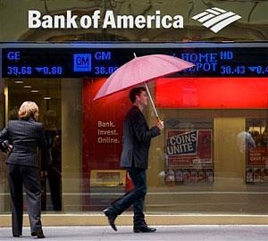

Bank of America Corp (BAC.N) is planning to cut about 300 jobs in its investment banking and capital markets group, as it struggles to rein in costs to make up for weak revenue growth, sources familiar with the situation said on Tuesday.
The layoffs are not nearly as eye-popping as the bank's job cuts in areas like retail banking. Wall Street companies have broadly been looking at cutting jobs recently.
The bank, the second-largest in the United States by assets, is also assigning junior bankers to work with broader groups of companies, the sources said. That move could also lead to more layoffs, the sources said.
The changes for junior bankers are part of the cost-cutting program known as "Project New BAC," which the bank launched last year, the sources said. The program, named for the bank's ticker symbol, is meant to improve profits as a sluggish economy weighs on revenue growth, and new regulations boost compliance costs. The bank is also trying to streamline a company that has grown increasingly bloated after decades of acquisitions. The first phase of the program is expected to cut about 30,000 jobs and $5 billion in annual expenses in consumer and technology areas over the next several years. Plans for the second phase, which covers investment

banking, sales and trading, commercial banking and wealth management, are expected to be finalized in May.
Answer the questions:
- How does this article describe Bank of America's revenue growth?
  - Moderate
  - High
  - Weak
- How do these cuts compare to Bank of America's cuts in retail banking?
  - They're more severe.
  - They're not as severe.
  - They're about the same.
- Why is Bank of America "bloated"?
  - Because they're losing money
  - Because of the junior bankers
  - Because of all the acquisitions they have made
- By how much will the first round of layoffs cut expenses over the next couple of years?
  - $ 5 billion
b. $ 30,000
c. $ 10 billion
- Is Bank of America the largest bank in the United States?
  - Yes
  - No
  - Yes, but it's tied for first place with another bank

Appendix 4
Exercises related to Bank & Banking topic
- Choose the correct word:
- I'd like to an account. open
start
commence
- You don't have any ( = money) in your account. funds
fun
funding
- The bank my husband's credit card because he didn't pay his credit card bills.
reneged
retracted cancelled
- A document which shows all your withdrawals and deposits (usually for one month) is called a "bank "
stapler
statement bill
- What's another way to say "to withdraw"? to make out
to stake out
to take out
- I'd like to some money to my other account. transfer
change
switch
- A cashier's check is a check that's by a bank.
guaranteed
guarantee warrantee
- Another way to say "debit card" is . credit card
plastic card
bank card
- Is there around here somewhere? ( = a cash machine) an electronic machine
an ATM
a money machine

- If you've lost your bank card you can reply
apply/reapply
fill
- Topic for discussion:
for a new one.

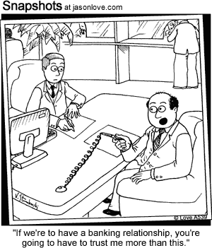
* Give your personal ideas about the relationship between bank and business.

Appendix 5

Basic of Marketing Reading

Marketing, which deals with moving goods from producer to customer, has become important as the volume of competing goods has risen. The marketing goal of producers is to find the right mix of the four Ps: product, price, place and promotion.
But what does the term marketing mean? Many people mistakenly think of it as advertising and selling. Given the number of advertisement column on television, in magazines and offers in and around the shop is not surprising. However, advertising and selling are only two of several marketing functions, and not necessarily the most important ones.
The most basic concept underlying marketing is that of human needs. We have many needs including ones such as affections, knowledge and sense of belonging as well as the physical need for food, warmth and entertainment. A good deal of our lives if devoted to obtaining what will satisfy those needs. Marketing can thus be defined as any human activity, which is directed at satisfying needs and wants by creating and changing goods and value with others. Marketing has become a key factor in the success of many businesses. Today’s companies face stiff competiton and the companies which can best satisfy customer needs are those which will survive and make largest profits.
Comprehension question
Answer the question
  - Why do many people mistakenly think of marketing as advertising and selling?
  - What types of advertising do you know?
  - How would you define marketing?
  - Why is marketing important?
Decide which of the following statements are TRUE or FALSE
- Advertising is a part of marketing
- Selling is the most important function of marketing
- A sense of belonging is a physical need
- Satisfying customer needs is a key to success.

Appendix 6

From AFP

Reading text
SELLING BUDGET CARS IN CHINA

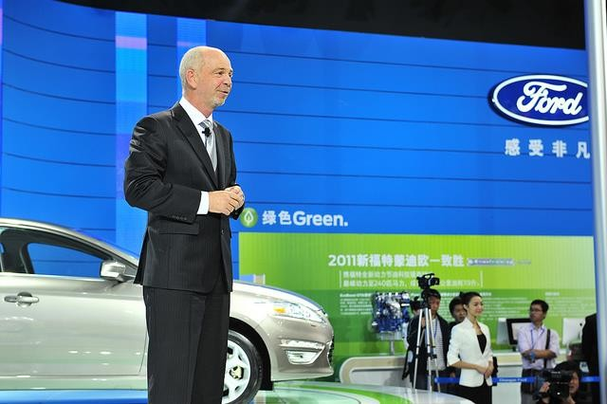

Automakers will race to appeal to budget-conscious Chinese car buyers as the industry expands beyond the wealthy coastal cities in the east, Ford Motor Co's (F.N) Asia chief said on Tuesday.
As they expand more heavily into central and western China, automakers can appeal to price-sensitive consumers by offering multiple vehicles within the same size segment at varying prices, Joe Hinrichs said. "The growth expected the rest of this decade in China is largely to come from the central and western parts of the country which is more value- oriented," he told reporters at Ford's headquarters in Dearborn, Michigan. "You'll need to serve those customers differently," he added.
Ford's plan to introduce 15 new vehicles in China by 2015 began with last month's launch of the new Focus. Hinrichs said last month in Beijing that Ford plans to sell cars priced below the Fiesta, currently their cheapest model in Asia with a price ranging from $12,300 to $17,500.
Ford sales in China rose 24 percent in April to 54,881 vehicles, spurred by strong demand for the Focus.

Ford makes the Fiesta, Focus, Mondeo and other vehicles in China in a three-way tie-up with Chongqing Automobile Co Ltd and Japan's Mazda Motor Corp.
Answer the following questions:
- According to the article, where in China are people more budget- minded?
In the central and western part of the country In Shanghai
In the coastal cities
- Which Ford car is not mentioned in the article? Mustang
Fiesta
Focus
- How many other companies does Ford partner with to make cars in China?
Three One
Two
- According to the article, China's wealthiest cities are . in the central part of the country
in the eastern part of the country
in the western part of the country
- How many new cars does Ford plan to introduce in China over the next 3 years?
10
15
Focus, Fiesta, and Mondeo

Appendix 7
Exercises related to Marketing topic
- Match the words:
a - commercial (n.) b – billboard
c – complimentary d – campaign
e – readership f – slogan
g - press release h – features
i – publicity
j - brand awareness
  - memorable motto or phrase ->
  - a large, square sign used to post advertisements -->
  - a statement (about a product) released to the news media -->
  - an advertisement on TV, the radio, etc. -->
  - the attempt to manage how a public sees a product -->
  - the number of people that read a particular newspaper, magazine, etc. ->
  - a plan of action (to promote a product) -->
  - a measure of how popular a brand is (how many people know it, etc.) ->
  - special characteristics, qualities -->
  - free -->
- Choose the right synonym:
- There has been a drop in sales. = Sales have . decreased
downed increased
- Sales have increased for three years . = Sales have increased for three years in a row.
even
straight
forward
- You have to market these particular attributes. = You have to market these particular .
qualifiers qualifications
qualities
- We shouldn't use the same old strategies. = We should
using the same old strategies. avoid
averse
avert
- Thanks to smart planning, we have another crisis.
= Thanks to smart planning, we have thwarted another crisis. put forth
unveiled
averted
- We shouldn't rule that out as an option. = We should still that an option.
reject
consider contain
- The figures are down from January. = The are down from January.
numbers numerals
mathematics

- Our company has seen 10 years of uninterrupted growth. = Our company has seen 10 years of growth.
sporadic steady stagnant
- We should market this product as being durable and dependable. = We should market this product as being and dependable.
study sturdy
studious
- We need to develop a new strategy. = We need a new . appraisal
approval
approach
- Fill in the blanks
- Cell phone market is at 100% in many European countries. penetration
penalty
penance
- I'm doing an of consumer trends in cellular markets such as Japan.
analysis analyze
analytics
- Every marketer should have an idea of how to build strong . names
ideas
brands
- We plan to this product in the Spring of 2009.
lunch

launch
lynch
- The process of gathering, recording and analyzing of data about customers, competitors and the market is called market .
review
replay research
- Recent market show that there is a considerable

increase in the use of our technology in the banking sector. trends
ideas
trials
- Last year we brought together a team to completely new type of car.
develop a concept make a concept
start a concept

for a

- I don't think we'll have a problem this product. It will almost sell itself.
market
to marketing marketing
- Jane, could you bring me that on the Brazilian biotechnology sector?
rapport
report note
- The ( = statistics/figures) in this report cover three year trends in the manufacturing sector.

matrix metrics mathematics

Appendix 8
Marketing Glossary

1 | brand | n. a particular make of product - to brand v. -  branded adj. – nhãn hiệu
2 | consumer | n. the person who buys and uses a product or service - to consume v. – người tiêu dùng
3 | cost | v. [cost, costed, costed] to estimate the price of making a product - costing n. – chi phí
4 | develop | v. to create a new product or improve an existing one -  product developmentn. – phát triển / phát triển sản phẩm
5 | distribution | n. the delivering of products to end-users, inc.  advertising, storing etc – sự phân phối
6 | end-user | n. the person, customer etc who is the ultimate (and so real) user of a product – người dùng cuối (trong chuỗi  phân phối)
7 | image | n. the concept or perception of a firm or product held by  the general public – hình ảnh/hình tượng (của công ty, của nhãn hiệu…)
8 | label | n. small piece of paper, metal etc on a product giving  information about it – nhãn hàng hóa
9 | launch | v. to introduce a new product, with publicity etc - product  launch n. khai trương/ giới thiệu(sản phẩm mới ra công chúng, thị trường…)
10 | mail order | n. the selling of goods by post - mail-order catalogue n.  bán hàng từ xa (thường qua đường bưu điện) – một dạng phổ biến là mua báo, ấn phẩm, tạp chí.
11 | market research | n. study of consumers' needs & preferences, often for a particular product – nghiên cứu thị trường
12 | packagingUK | n. the wrapping or container for a product – đóng gói sản phẩm
13 | point of sale | n. the place where a product is actually sold to the public  - point-of-sale adj. – quầy thanh toán

14 | product | n. something made to be sold; merchandise [includes  services] - to produce v. – sản phẩm
15 | public  relations | n. creation and maintenance of a good public image -  public relations officer n. – quan hệ công chúng
16 | registered | adj. registered or officially recorded as a trademark -  ® abbr. - to register v. - đăng ký (thường đi kèm với một nhãn hiệu để cho biết nhãn hiệu đó đã được đăng ký với  cơ quan bảo hộ)
17 | sponsor | n. firm supporting an organisation in return for  advertising space - also v .- nhà tài trợ
18 | S.W.O.T. | abbr. Strength, Weaknesses, Opportunities, Threats – viết tắt của Điểm mạnh, Điểm yếu, Cơ hội, Nguy cơ (một  phương pháp kinh điển trong lập kế hoạch kinh doanh)
19 | total product | n. the whole product, inc. name, packaging, instructions, reliability, after-sales etc – sản phẩm trọn gói (bao gồm tất cả linh kiện, chỉ dẫn, dich vụ hậu mãi, bảo hành…cho  sản phẩm đó)
20 | trademark | n. special symbol, design, word etc used to represent a product or firm - " abbr. – thương hiệu (thường là đã  được chính thức đăng ký với cơ quan bảo hộ)

Appendix 9

Reading text PRICING POLICIES

All products and services have prices. Price comparisons can be difficult to make because of consideration of credit terms, delivery, trade-in allowance, guarantees, quality and other forms of service. What price will produce the greatest profit over a long period of time? Too low to cover costs? No other area of marketing operations has been more misunderstood and subject to so much bad practice. Many businesses pursue unsound pricing policies for long periods without becoming aware of it.
Prices are determined in various ways. For example, agricultural prices (cotton, wheat) are decided in large central markets where forces of supply and demand exist. This is pure price competition. Industrial product prices (iron, steel, etc.) are decided by large companies. A few competing sellers control the amount and price of goods sold to large number of buyers. Although competition is the public goal for most businesses in the United States, most operate in imperfect competition. Prices are also set by the government, particularly for public utility services
– railroads, electricity, manufactured gas, bus services, etc.
When demand increases, prices rise, profits expand and new investment is attracted, but we see that there are other factors involved. Prices are related to each other in various ways. Utimately, everything is related in price, since the consumer can buy only so much and must pay for everything out of a particular limited amount of money.
Comprehension question
  - What makes prices comparison difficult?
  - Why would the seller be interested in the price that produces the highest volume of sales at lowest unit cost?
  - What reason can you offer for many businesses following unsound pricing policies?
  - How are agricultural prices decided?
  - How are the most industrial products priced?
  - What is the different between pure and imperfect competition?

Appendix 10

From AFP

Reading text
STARBUCK’S DIFFICULTIES IN EUROPE



Starbucks Corp reported better-than-expected quarterly profit but global sales at established coffee shops fell short of analysts' estimates due to weakness in Europe, sending its shares down five percent in after-hours trade on Thursday.
Sales from cafes open at least 13 months fell 1 percent in the Europe, the Middle East and Africa (EMEA) region during the latest quarter. Analysts polled by Consensus Metrix had expected a 2.2 percent rise in EMEA same-store sales.
Executives attributed the drop to weakness in Europe, which suffered its first decline in same-store sales since 2009.
Sales fell in Ireland and Germany during the fiscal second quarter and were up just slightly in France and the United Kingdom, Starbucks Chief Financial Officer Troy Alstead said.
Europe has been a weak spot for the world's biggest coffee chain. The region is grappling with debt woes and austerity measures and, earlier this week, Britain said its economy had fallen into its second recession since the financial crisis.
"The situation is very, very tough," Chief Executive Howard Schultz said of Europe's economy.
"We will turn the Europe business around in the same way we turned the U.S. business around," Schultz told analysts on a conference call.

Answer the following questions:
- What happened to Starbucks' shares after that their quarterly profits failed to meet analysts' estimates.
They rose by 5%. They plunged by 5%.
they rose by 10%.
- "Quarterly profits" refer to profits during how many months? Three
Four
Six
- According to the article, in which European countries did Starbucks' NOT see a slight increase in sales?
The United Kingdom Ireland
France
- According to the article, are/is to blame for Starbucks' woes in Europe.
Europe's financial troubles
European disdain for American coffee the availability of many other good cafes
- Has Starbucks always struggled in Europe? No
The article doesn't specify. Yes

Appendix 11
Exercise
Fill in the blanks
- Have you seen last month's sales ? figures
figurines
figs
- Sales are by 50% compared to this time last year. up
higher
high
- We'll be looking to hire a sales soon. rap
rope
rep
- In much of the business world, the calendar year is divided into four
. quarts quarters
cubes
- To write up a contract = To a contract drought
draw
draft
- The amount on the ( = an official bill) is higher than what we agreed on.
invoice
draft paper
- Our company offers a wide ( = variety) of software.

assortment
sort assessment
- I work for a company that does outside
external
outdoor

advertising.

- We plan to launch a new sales to attract new customers. company
campaign
comment
- Our customer is made up of mostly middle-aged white men.
basis base collection

Appendix 12
Pricing Glossary
Break-even point – where total revenue equals total costs not including profit. – điểm hòa vốn
Broker – a food broker is a sales agent hired by a producer, processor or manufacturer to encourage sales between a buyer and the seller. – người môi giới
Direct cost – costs that always exist, regardless of how much or how little you sell. They are costs that can be directly traced to producing a product, e.g., raw materials, ingredients, salary, etc. – chi phí trực tiếp (chi phí trực tiếp để sản xuất ra hàng hóa)
Direct marketing – product moving from the farm/processors directly to the consumer and bypassing brokers, distributors or retail channels of trade. – marketing trực tiếp (trực tiếp marketing từ nơi sản xuất đến người tiêu dùng không qua các khâu trung gian)
Distribution channel/market channel – describes the route a product takes to reach the consumer/end-user, e.g., direct market channel, retail channel, etc. – kênh phân phối
Distributor – buys your product and resells it, at a profit, to his account. Distributors offer experience, contacts, and market segments such as gift stores, grocery chains, specialty food stores etc. – nhà phân phối
Economy of scale – the cost advantages and savings a processor gains when more product units are produced, e.g. purchasing raw materials in bulk reduces the input costs. – kinh tế quy mô (thường được hưởng lợi từ việc sản xuất trên quy mô lớn)
Farm gate sales – are sales made directly from the producer to the consumer/end-user, often on site at the farm, e.g. U-pick sales, on-farm sales. – bán hàng trực tiếp (tại nơi làm ra sản phẩm)
Fixed costs – are consistent costs (overhead) that do not change from month to month. These costs occur no matter how many products are produced. Often they are time related, e.g. monthly rent, yearly real estate taxes, annual machinery costs, depreciation, salaries, etc. – chi phí cố định (dù sản xuất ra bao nhiêu sản phẩm chi phí này vẫn cố định, trong thực tế thường không tồn tại pure fixed cost)
Indirect costs – soft costs associated with production, e.g., real estate taxes, administration costs, overhead/lease/rent options, salaries, etc. – chi phí gián tiếp (những chi phí không trực tiếp trong quá trình sản xuất ra hàng hóa)
Input costs – includes direct costs (raw ingredients and material) and indirect costs (overhead, production costs, etc.) to produce a good. – chi phí đầu vào (bao gồm cả chi phí trực tiếp và chi phí gián tiếp)
Market segment – a group of consumers that have the same buying characteristics or have similar needs.
Market share – indicates the size of market one producer/company holds. To calculate market share you need to divide the amount of product you sell into the total market number. – phân khúc thị trường
Marketing mix – the combination of marketing strategies used to sell a product. The four main elements center around four functions, sometimes called the Four Ps: product, price, place (of distribution), and promotion. Non-cash costs – do not involve an outlay of cash e.g. depreciation or amortization. Non-cash costs should be included in a product’s cost. – marketing hỗn hợp (đọc thêm trong bài 6)
Overhead costs – the ongoing expenses of operating a business, e.g., rent, repairs, utilities, insurance, salaries, etc.
- chi phí sản xuất chung (thường được gọi tắt là overhead) Per-unit cost – The cost incurred to produce, store and sell one unit of a product including all fixed costs (e.g., plant and equipment) and all variable costs (e.g., labour, materials, etc.) involved in production. – chi phí trên mỗi đầu sản phẩm
Primary data – detailed research methods such as interviews or actual buying patterns to provide tailored information about the wants and values of your customers. – dữ liệu sơ cấp / ban đầu
Product bundling – is a marketing strategy where several products are for sale as one combined product, e.g., a Saskatoon liquor with a set of crystal glasses. – gói sản phẩm (vd: bán rượu kèm ly, bán xà phòng kèm khăn mặt…)
Product life cycle – a new product progresses through a sequence of stages,
which generally include the introduction, growth, maturity and decline stage. – chu kỳ sống của sản phẩm (đọc thêm bài 6)
Production costs – the total cost of the product including raw materials, labour, overhead, distribution, etc.
Retail prices – the price charged to a consumer. – chi phí sản xuất Secondary data – information from existing sources and materials already researched or reported on by another source. – dữ liệu thứ cấp
Target market – the demographic group of consumers most likely to want or need to buy your product. – thị trường mục tiêu
Variable costs – costs that increase proportionally to the amount produced. As a rule of thumb, variable costs include direct labour, direct material, equipment repairs, fuel costs for distribution, broker fees, marketing expenses, etc. – chi phí biến đổi (biến thiên theo số hàng hóa được sản xuất)
Wholesale prices – the price of a product before a middleman (distributor or broker or agent) or retailer has added on their mark-up fees to the price.
– giá bán buôn
Wholesaler – a third party or firm that buys products from producers and processors to sell to food retailers and foodservice. Their main functions are to purchase, transport, sell, assemble, store and distribute. – người bán buôn

Appendix 13
Exercise – Stock Market
Choose the right word to fill in the blanks
- There was record- trading volume on the New York Stock Exchange this week.
taking destroying
breaking
- This week the bulls gained the upper (= persevered/came out on top).
face hand
level
- Price are fluctuations in the price of a stock. levels
swings
switches
- When a stock market " ", it means it recovers after being down.
rallies rolls
relies
- The recovery raised that the worst might be over. ideas
thoughts
hopes
- A market refers to a period of time when many stocks rise in value.
bull ball
bell
- I own 1,000 of their stock. shares
pieces
papers
- The scandal ( = caused/contributed to) the sell-off.
fooled failed
fueled
- The earnings were higher than , which sent the stock through the roof ( = increased its value dramatically).
accepted expected
escaped
- The stock market was down 400 points, but finished up 50 points. What are some of the reasons for this ?
turnaround turnstile roundabout

Appendix 14
Trường Cao Đẳng nghề Kỹ thuật Công nghệ
- Một số thuật ngữ Kế Toán bằng Tiếng Anh (cơ bản) - st Accounting entry bút toán
Accrued expenses Chi phí phải trả -
Accumulated lũy kế
Advances to employees Tạm ứng –
Assets Tài sản
Assets liquidation thanh lý tài sản
Balance sheet Bảng cân đối kế toán –
Bookkeeper người lập báo cáo
Capital construction xây dựng cơ bản
Cash Tiền mặt
Cash at bank Tiền gửi ngân hàng
Cash in hand Tiền mặt tại quỹ
Cash in transit Tiền đang chuyển
Check and take over nghiệm thu
Current assets Tài sản lưu động và đầu tư ngắn hạn
Current portion of long-term liabilities Nợ dài hạn đến hạn trả
Deferred expenses Chi phí chờ kết chuyển
Deferred revenue Người mua trả tiền trước
Depreciation of fixed assets Hao mòn tài sản cố định hữu hình
Depreciation of leased fixed assets ---- Hao mòn tài sản cố định thuê tài chính
Equity and funds Vốn và quỹ
Exchange rate differences Chênh lệch tỷ giá
Expense mandate ủy nghiệm chi
Expenses for financial activities Chi phí hoạt động tài chính
Extraordinary expenses Chi phí bất thường
Extraordinary income Thu nhập bất thường
Extraordinary profit Lợi nhuận bất thường
Figures in: millions VND Đơn vị tính: triệu đồng
Financial ratios Chỉ số tài chính
Financials Tài chính
Finished goods Thành phẩm tồn kho
Fixed asset costs Nguyên giá tài sản cố định hữu hình
Fixed assets Tài sản cố định
Goods in transit for sale Hàng gửi đi bán
Gross profit Lợi nhuận tổng
Gross revenue Doanh thu tổng
Income from financial activities Thu nhập hoạt động tài chính
Income taxes Thuế thu nhập doanh nghiệp
Intangible fixed asset costs Nguyên giá tài sản cố định vô hình
Intangible fixed assets Tài sản cố định vô hình
Inventory Hàng tồn kho
Investment and development fund Quỹ đầu tư phát triển
Itemize mở tiểu khoản
Liabilities Nợ phải trả
Long-term borrowings Vay dài hạn
Long-term financial assets Các khoản đầu tư tài chính dài hạn
Long-term liabilities Nợ dài hạn
Owners' equity Nguồn vốn chủ sở hữu
Payables to employees Phải trả công nhân viên
Prepaid expenses Chi phí trả trước
Profit before taxes Lợi nhuận trước thuế
Profit from financial activities Lợi nhuận từ hoạt động tài chính
Raw materials Nguyên liệu, vật liệu tồn kho
Receivables Các khoản phải thu
Reconciliation đối chiếu
Reserve fund Quỹ dự trữ
Revenue deductions Các khoản giảm trừ
Sales expenses Chi phí bán hàng
Sales rebates Giảm giá bán hàng
Sales returns Hàng bán bị trả lại
Short-term borrowings Vay ngắn hạn
Short-term liabilities Nợ ngắn hạn
Total assets Tổng cộng tài sản
Total liabilities and owners' equity Tổng cộng nguồn vốn
Welfare and reward fund ---- Quỹ khen thưởng và phúc lợi

- Một số thuật ngữ khác (st):
Types of Accounts Các loại tài khoản kế toán
Account Type 1: Short-term assets Loại tài khoản 1: Tài sản ngắn hạn
Account Type 2: Long-term assets Loại tài khoản 2: Tài sản dài hạn
Account Type 3: Liabilities Loại tài khoản 3: Nợ phải trả
Account Type 4: Equity Loại tài khoản 4: Vốn chủ sở hữu
Account Type 5: Revenue Loại tài khoản 5: Doanh thu
Account Type 6: Production costs, business-----Loại tài khoản 6: Chi phí sản xuất, kinh doanh
Account Type 7: Other income Loại tài khoản 7: Thu nhập khác
Account Type 8: Other expenses Loại tài khoản 8: Chi phí khác
Account Type 9: Determining business results-----Loại tài khoản 9: Xác định kết quả kinh doanh
Account Type 0: Balance sheet accounts------Loại tài khoản 0: Tài khoản ngoài bảng
133 - Deductible VAT Thuế GTGT được khấu trừ
136 - Inter Phải thu nội bộ
- - Property tax deferred Tài sản thuế thu nhập hoãn lại
- - Bonds issued Trái phiếu phát hành
- - Get escrow, long-term deposits Nhận ký cược, ký quỹ dài hạn
347 - Deferred tax payable Thuế thu nhập hoãn lại phải trả
413 - exchange rate differences Chênh lệch tỷ giá hối đoái
414 - Fund Development Quỹ đầu tư phát triển
415 - Fund financial reserve Quỹ dự phòng tài chính
466 - Funds that form of fixed assets Nguồn kinh phí đã hình thành tài
sản cố định
- - Leasehold assets Tài sản thuê ngoài
- - Materials, goods kept for processing-----Vật tư, hàng hóa nhận giữ hộ, nhận gia công
- - Goods deposited deposit, or escrow Hàng hóa nhận bán hộ, nhận
ký gửi, ký cược
- - Bad debts treated Nợ khó đòi đã xử lý
- - Foreign currencies Ngoại tệ các loại
- - Project for public services and- projects Dự án chi sự nghiệp, dự
án

Appendix 15
ACCOUNTING EQUATION
- ACCOUNTING ELEMENTS
  - Dialogue between Betty and Tom
B: - Good morning, Tom. Would you mind explaining accounting elements to me?
T: - Oh, not at all. They are referred to as assets, equities, liabilities, revenues, expenses, profit, etc.
B: - What do assets mean?
T: - Assets are the properties owned by an organization or a person. They may include things such as cash, land, supplies, business equipment, buildings and intangible assets.
B: - I can understand that. Then what about liabilities?
T: - Liabilities are debts owned by a company or creditor’s equity
B: - I see. Then owner’s equity is the net assets of a company or a person. T: - Yes, it is equal to assets minus liabilities.
B: - Sounds interesting. Thanks a lot. T: - You are welcome.
  - Oral drill. Pair work: Practice the following dialogue with your partner: A: - What does the term ‘ Revenue” mean?
B: - Revenue is the inflow of assets ( such as cash ) resulting from the sale of products or the rendering of services to customers.
A: - Well. It is cash received in the process of goods and services rendered. B: - Quite right.
  - Make “true” or “false” choices
…………….(1) Cash is an asset.
…………….(2) Liabilities indicate what the customer owes to the creditor.
…………….(3) Equities belong to those who supply the assets.
…………….(4) If I buy a book for $ 5 from a bookshop. I am the creditor.

ACCOUNTING EQUATION
Read and answer the questions
I think accounting equations includes: Assets , liabilities, owner’s equity.
The basic accounting equation is the following:

why?
Assets = Liabilities + Owner’s Equity.
Total assets always equal the total liabilities and owner’s equity and

Let me make an example: Assume that the Longman Company was

organized at the end of March. It invested $ 200,000 and borrowed $ 50,000 from a bank. Now it has $ 250,000 of assets. In other words, the bank’s equity is $ 50,000. It can be described as ‘ the company’s liabilities’ because the company owns the bank $ 50,000. This is expressed as follows:
Assets = Liabilities + Owner’s Equity.
Well, the dollar amounts of two sides of equation are equal. The basic accounting equation must be in balance.
Questions:
What is the basic accounting equation?
Why are the total assets equal the total liabilities and owner’s equity? Write the basic accounting equation.
2. Put the missing words and numbers:

Assets = Liabilities
+…………….
(1) $ 38,500 | $ 6,400 | $ ……………..
(2) $ 24,000 | $  ……………… | $ 13,000
(3) $ ……………. | $ 5,400 | $ 18,500

VOCABULARY
equation [i'kwei∫n] danh từ phương trình
element ['elimənt] danh từ yếu tố
asset ['æset] danh từ (số nhiều) của cải, tài sản, vật thuộc quyền sở hữu
equity ['ekwiti] danh từ vốn cung cấp cho một doanh nghiệp thông qua việc bán cổ phiếu
giá trị tài sản bị cấm cố (sau khi trừ thuế má)

liability [,laiə'biliti] danh từ (số nhiều) tiền nợ, khoản phải
trả, tiêu sản
revenue ['revənju:] danh từ (số nhiều) tổng thu nhập expense [iks'pens]danh từ (số nhiều) phụ phí, công tác
phí
profit ['prɔfit] danh từ lợi nhuận, lời lãi; tiền lãi, tiền lời
loss [lɔs] danh từ sự thiệt hại, tổn hại, tổn thất, thua lỗ
equipment [i'kwipmənt] danh từ sự trang bị
intangible [in'tændʒəbl] tính từ không thể sờ thấy được
không thể hiểu thấu được, không thể nắm được, mơ hồ
debt [det] danh từ số tiền vay chưa trả; nợ owe [ou] động từ ( to owe somebody
for something; to owe something to somebody) nợ
creditor ['kreditə] danh từ người chủ nợ, người cho vay owner ['ounə] danh từ người sở hữu cái gì; chủ nhân
net [net] danh từ mạng lưới
total ['toutl] tính từ hoàn toàn; toàn bộ; tuyệt đối assume [ə'sju:m] ngoại động từ cho rằng; thừa nhận
express [iks'pres] ngoại động từ biểu lộ, bày tỏ (tình cảm...);
phát biểu ý kiên
balance ['bæləns] danh từ (thương nghiệp) bản đối chiếu
thu chi, bản quyết toán
Phrases and special terms
accounting equation: Phương trình kế toán
accounting element: Yếu tố kế toán
intangible assets: Tài sản vô hình
owner’s equity: Vốn của chủ sở hữu
net assets: Tài sản ròng
as follows: Như sau
in balance: cân bằng

REFERENCES
  - Cao Xuân Thiều, Giáo trình Tiếng Anh chuyên ngành tài chính, NXB Tài chính, Hà Nội, 2006.
  - Ian MacKenzie, English for Business Studies 2nd editon, Cambridge University Press, UK, 2002.
  - P.H.Collin, David York, Adrian Joliffe, Dictionary of Accounting 2nd edition, Peter Collin Publishing, London, 2001.
  - Thomas P.Fitch, Dictionary of Banking term 5th edition, Barron’s Educational Series, USA, 2006.

