Giáo viên: Chu Thị Sơn Trường THCS Yên Sơn
Date of planning: 10- 03- 2025
Date of teaching: 13- 03- 2025
Period 74 Tiết 1 Lớp 8A
UNIT 9: NATURAL DISASTERS
Lesson 6: Skills 2

I. OBJECTIVES
By the end of this lesson, students will be able to:
1. Knowledge:
- Listen and get general and specific about things to do before, during, and after a natural disaster;
- Write instructions about things to do before, during, and after a natural disaster.
2. Core competence:
- Develop communication skills and creativity.
- Be collaborative and supportive in pairwork.
3. Personal qualities
- Feel sympathy for people who are affected by natural disasters and be willing to help them
- Actively join in class activities

II. MATERIALS
- Grade 8 textbook, Unit 9 Skills 2.
- Computer connected to the Internet.
- Projector / TV
- hoclieu.vn

Language analysis
Form | Pronunciation | Meaning | Vietnamese equivalent
1. authority (n) | /ɔːˈθɒrəti/ | a group of people with official responsibility for a particular  area of activity | chính quyền
2. warn (v) | /wɔːn/ | to make someone realise a  possible danger or problem | cảnh báo
3. avoid (v) | /əˈvɔɪd/ | to stay away from someone or something | tránh, tránh xa

Assumption
Anticipated difficulties | Solutions
Students may not have sufficient listening, writing and co-operating skills. | - Play the recording, replay depends on students’ needs.  - Encourage students to work in pairs, in groups so that they can help each other.  - Provide feedback and help if necessary.

III. PROCEDURES
1. WARM-UP (5 mins)
a. Objectives:
- To create an active atmosphere in the class before the lesson.
- To lead into the new lesson.
b. Content:
- Chatting
c. Expected outcomes:
- Ss can talk about what people should do before, during and after a storm.
d. Organisation
TEACHER AND STUDENTS’ ACTIVITIES | CONTENTS
- Teacher shows a picture of a storm and asks Ss what people should do before, during and after a storm.  - Teacher asks Ss to work individually and think of the answers.  - Teacher invites some Ss to share their ideas.  - Teacher gives comments and leads to the new lesson. | 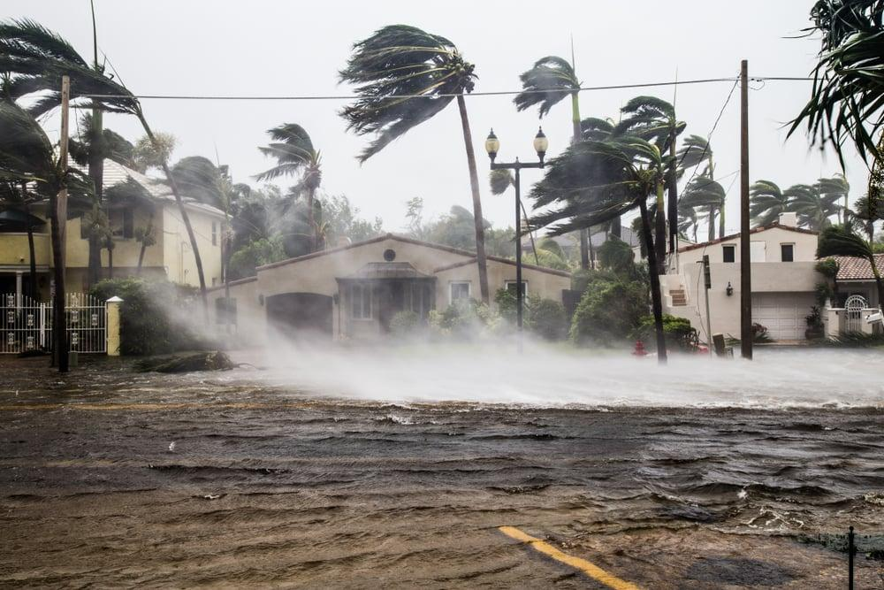
e. Assessment
- Teacher’s feedback.

2. ACTIVITY 1: LISTENING (22 mins)
a. Objectives:
- To introduce new words related to natural disasters.
- To help Ss develop the skill of listening for specific information.
b. Content:
- Vocabulary pre-teach
- Task 1: Work in pairs. Look at the picture and answer the questions.
- Task 2: Listen to a broadcast. Put the activities in the correct column.
- Task 3: Listen again and tick T (True) or F (False) for each sentence.
c. Expected outcomes:
- Ss can l and answer the questions correctly.
- Ss can listen for specific information and do the learning tasks
d. Organisation
TEACHER AND STUDENTS’ ACTIVITIES | CONTENTS
Vocabulary pre-teaching
- Teacher introduces the vocabulary.  - Teacher explains the meaning of the new vocabulary, using pictures and translation.  - Teacher checks students’ understanding with the “Matching” technique. | New words:  1. authority (n) chính quyền  2. warn (v) cảnh báo  3. avoid (v) tránh xa
Task 1: Work in pairs. Look at the picture and answer the questions. (4 mins)
- Teacher asks Ss to work in pairs and look at the pictures carefully.  - Ss look at the pictures and answer the two questions.  - Teacher elicits the answers from Ss.  - Teacher invites some Ss to answer in front of the class. | Suggested answer:  A torch, a mask, a lamp, a whistle, a bottle of water, some medicine, matches, a radio, some plasters, a candle, a multi-purpose knife, some batteries, a blanket.
Task 2: Listen to a broadcast. Put the activities (1 – 6) in the correct column. (7 mins)
- Teacher tells Ss that they are going to listen to a broadcast in which instructions to prepare for a natural disaster are given.  - Teacher has them read the activities 1-6 and try to guess which activities go into which column.  - Teacher invites some Ss to share their answers and write them on the board.  - Teacher has Ss read the activities again and underline the key words.  - Teacher plays the recording and asks Ss to listen and put the activities in the correct columns.  - Ss work in pairs to compare their answers.  - Teacher asks Ss to compare their answers with the ones on the board.  - Teacher confirms whether they are right or wrong, playing the audio again if necessary. | Answer key:  - Before a storm: 2,6  - During a storm: 3,5  - After a storm: 1,4
Task 3. Listen again and tick T (True) or F (False) for each sentence. (7 mins)
- Teacher tells Ss that they are going to listen to the broadcast again and decide if the statements are true or false.  - Without playing the recording again, teacher has Ss read the statements and decide if they are true or false.  - Teacher plays the recording and asks Ss to listen again to check their answers.  - Teacher asks Ss to work in pairs to compare their answers.  - Teacher asks for Ss’ answers and confirms the correct ones. | Answer key:  1. F  2. T  3. F  4. T
e. Assessment
- Teacher corrects the students as a whole class.

3. ACTIVITY 2: WRITING (15 mins)
a. Objectives:
- To brainstorm ideas and make an outline for Ss’ writing.
- To help Ss practise writing instructions about things to do before, during and after a flood.
b. Content:
- Task 4: Work in pairs. Discuss what you should do before, during, and after a flood. Write your ideas in the columns.
- Write instructions (80 - 100 words) about things to do before, during, and after a flood.
c. Expected outcomes:
- Ss can write instructions about things to do before, during, and after a flood.
d. Organisation
TEACHER AND STUDENTS’ ACTIVITIES | CONTENTS
Task 4: Work in pairs. Discuss what you should do before, during, and after a flood. Write your ideas in the columns. (5 mins)
- Teacher asks Ss to work in pairs.  - Ss discuss what they should do before, during and after a flood.  - Ss write their ideas in the columns.  - Teacher has some Ss present their ideas.  - Teacher comments on their answers. |  | 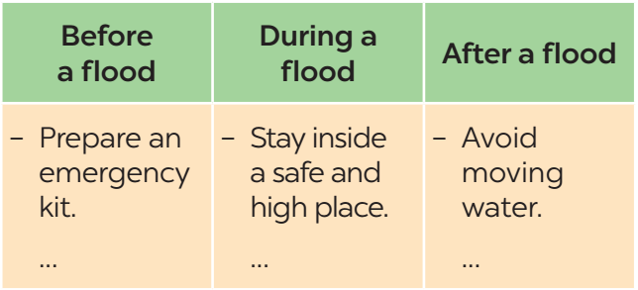
Task 5: Write instructions (80 - 100 words) about things to do before, during, and after a flood. (10 mins)
- Teacher asks Ss to work individually and write their instructions based on their answers in task 4.  - Teacher asks one student to write his/ her answer on the board.  - Other Ss and teacher comment on the writing on the board. |  | Suggested answer:  Here are the things you should do before, during, and after a ﬂood.  Before:  – Prepare an emergency kit with necessary things.  – Build barriers to stop ﬂoodwater from entering the house.  – Move to a higher place if necessary.  During:  – Listen to the radio or television for warnings and information.  – Be careful with ﬂash ﬂooding.  After:  – Avoid moving water.  – Stay away from damaged areas unless the local authority needs your help.  – Listen for local warnings of ﬂash ﬂoods.
e. Assessment
- Teacher gives corrections about spelling and grammar if needed.

4. CONSOLIDATION (3 mins)
a. Wrap-up
- Teacher asks Ss to summarise the main points of the lesson.
b. Homework
- Learn the new words by heart.
- Rewrite the instructions.
- Do exercises in the workbook.
- Prepare for Lesson 7 – Looking back + Project.

