TÀI LIỆU NGHE_PHẦN 1

BÀI 1
SECTION 1 Questions 1-10
You will hear two vetarianary science students called Diana and Tim discussing their work placement and their course modules.
Questions 1-6: First, listen from 1 to 6
Choose the correct letter, A, B or C.
Work experience for veterinary science students

1. What problem did both Diana and Tim have when arranging their work experience?
  - . make initial contact with suitable farms
  - . organising transport to and from the farm
  - . finding a placement for the required length of time
- Tim was pleased to be able to help
  - . a lamb that had a broken leg.
  - . a sheep that was having difficult giving birth.
  - . a newly born lamb that was having trouble feeding.
- Diana says the sheep on her farm
  - . were of various different varieties.
  - . were mainly reared for their meat.
  - . had better quality wool than sheep on the hills.
- What did the students learn about adding supplements to chicken feed?
  - . These should only be given if specially needed.
  - . It is worth paying extra for the most effective ones.
  - . The amount given at one time should be limited.
- What happened when Diana was working with dairy cows?
  - . She identified some cows incorrectly.
  - . She accidentally threw some milk away.
  - . She made a mistake when storing milk.
- What did both farmers mention about vets and farming?
  - . Vets are failing to cope with some aspects of animal health.
  - . There needs to be a fundamental change in the training of vets.
  - . Some jobs could be done by the farmer rather than by a vet.

Questions 7-10
What opinion do the students give about each of the following modules on their veterinary science course?
Choose FOUR answers from the box and write the correct letter, A-F, next to questions 7-10.
Opinions
- Tim found this easier than expected.
- Tim thought this was not very clearly organised.
- Diana may do some further study on this.
- They both found the reading required for this was difficult.
- Tim was shocked at something he learned on this module.
- They were both surprised how little is known about some aspects of this.

Modules on Veterinary Science course
- Medical terminology ……… ………….
- Diet and nutrition ……… ………….
- Animal disease …………… …….
- Wildlife medication ………………….

BÀI 2
Part 2. You will hear an interview with a biology student called Gail Koch, who is spending a year in the rainforest working as a field scientist. For questions 11-15, choose the best answer A, B or C.
11. What does Gail say about being a field scientist?
A. She sometimes fears she will never be a proper one.
B. Being so keen compensates for what she does not know.
C. It can be difficult to do a job that is rarely understood.
12. What does Gail enjoy about her life in the rainforest?
A. the early evenings
B. the varied wildlife
C. the pleasant climate
13. What does Gail find most inspiring about her work?
A. the chance of winning an academic prize
B. the opportunity to contribute to scientific knowledge
C. the hope that she will make a discovery before others do
14. According to Gail, working as a field scientist is
A. a popular career choice.
B. well paid after people have qualified.
C. good preparation for work in other scientific areas.
15. What disadvantage of being at the research station does Gail mention?
A. She sometimes feels she has too much work to get through.
B. She has spent a lot of time trying to make herself more comfortable.
C. She may not be keeping up to date with new developments.

Part 3: You will listen to a talk about Scandinavia. Listen and decide if the following statements are true (T) or false (F). (10 points)
16. The presence of state-controlled monopolies on alcohol in both Norway and Denmark contributes to elevated prices.
17. The Scandinavian nations need substantial taxation to sustain their welfare states.
18. Ikea has been transferred to a parent company in Scandinavia because of lower taxation rates in Sweden.
19. The substantial welfare state of the region is thought to guarantee its financial security, job stability, and equitable economic distribution.
20. Scandinavian citizens receive highly affordable education, access to a free public transportation system, and a well-operating healthcare service.

BÀI 3
Part 2. You will hear a recording about how the food you eat affects your brain . For questions 11-15, decide whether the following statements are true (T) or false (F). Write your answers in the corresponding numbered boxes provided.

YOUR BRAIN ON FOOT
_____11. Each component of the brain has no influence on functioning, development, mood, and energy.
_____12. The fatty acids omegas 3 and 6 can help to lower degenerative brain conditions.
_____13. The food we consume containing proteins and amino acids will affect our feelings and behaviours.
_____14. The human brain, making up about 2% of our body weight, uses up to 12% of our energy resources.
_____15. Having a diet of nutrient-rich foods is crucial for sustained brain power.

Part 3. You will hear a radio interview in which two people – called Randall and Aubrey – are talking about their college roommates. For questions 21-25, choose the answer (A, B, C or D) which fits best according to what you hear.
16. Aubrey lived with roommates _____.
A. during her first year of college B. when she had a room
C. because she got along fine with them D. but they didn’t have fun
17. Her apartment included ____ bedrooms and one bathroom.
A. two B. three C. four D. five
18. One of the things the kitchen lacked was _____.
A. an efficient dishwasher and refrigerator B. sufficient space to store one's food
C. a place where people everyone could eat D. heating and air conditioning
19. Sharing an apartment later on was better for Aubrey because she could ____.
A. prepare her own food B. chose her roommates
C. not step on everyone’s toes D. select the idea location
20. Randall says that living with roommates is an opportunity to learn how to ______.uil
A. build new friendships d new friendships B. budget your money
C. compromise and share D. prepare for your future

BÀI 4
SECTION 2: Questions 11-16
Choose the correct letter A, B or C
11 The most famous view in this park is
A the largest waterfall worldwide.
B the longest river in the world.
C the biggest sub-tropical rainforest in the world.
12 According to the tour guide, what is best to do on top of the mountain?
A having a picnic B taking photos C strolling about
13 What did the tour guide recommend for more experienced walkers?
A the mountain trail B the Bush Track C the Creek Circuit
14 What is mentioned about the transport in the park?
A Bicycles can be hired.
B Trams are available for tourists.
C It is included in the bill.
15 Which activity is provided for adults all year round?
A abseiling B bungee jumping C paragliding
16 What should the visitors do before they go to the restaurant?
A make bookings
B inquire about availability
C collect the meal ticket at the reception

Questions 17-20: Label the plan below. Write the correct letter, A-I, next to
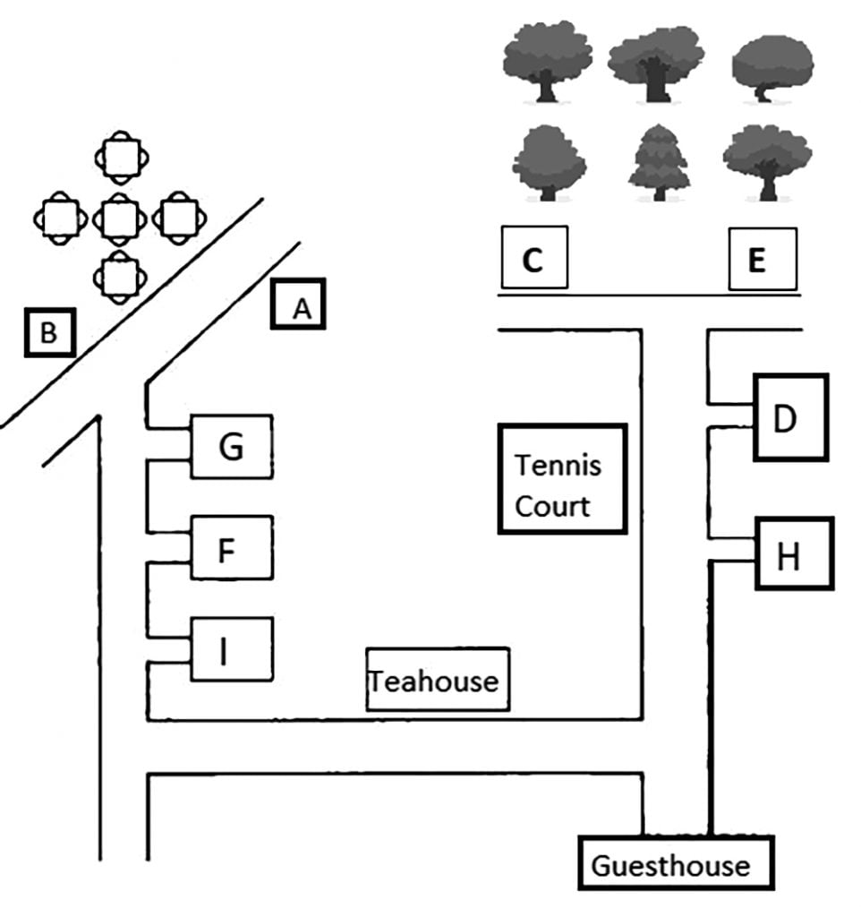
17 Campsite __________
18 Business Centre __________
19 Museum __________
20 Café __________

BÀI 5
SECTION 2: Questions 11 – 20

Part 1. You hear a guidance counselor talking to a group of students. First you have sometime to look at question 11 to 14. Listen carefully and answer question 11 to 14.
QUESTION 11 -14 : Which counselor should you see? Write the correct letter, A, B or C

A. Louise | B. Tony Denby | C. Naomi Flynn
11. if it is your first time seeing a counselor ______
12. if you are unable to see a counselor during normal office hours ______
13. if you do not have an appointment ______
14. if your concerns are related to anxiety ______

Part 2. You will hear part of an interview with the astronaut Charles Duke, who is talking about his trip to the moon. For questions 11-16, choose the answer (А, В, C or D) which fits best according to what you hear.
15. How did Charles feel about space travel as a boy?
A. He thought it was unlikely to happen. B. He regarded it as more than science fiction.
C. He was fascinated by the idea of it. D. He showed no particular interest in it.
16. What did Charles consider to be the hardest part of the training?
A. feeling trapped in the heavy spacesuit
B. endlessly practising the lunar surface landing
C. constantly being afraid of making a mistake
D. being unable to move his arms and hands
17. What was Charles’s reaction when he first found out he was going to the moon?
A. He realised he had to be cautious. B. He felt proud to be given the opportunity.
C. He tried to control his excitement. D. He reflected on his chances of survival.

18. How did the crew feel when they had landed on the moon?
A. They felt as if they were coming home.
B. They realised they had achieved something special.
C. They were afraid of what they might find on the surface.
D. They were worried about how they would take off again.
19. What feature of the moon made the greatest impact on Charles?
A. the brightness of the moon B. the vastness of the sky
C. the loneliness of the place D. the absence of any stars
20. What does Charles feel was the most memorable part of his mission?
A. nearly falling into a crater B. walking on the moon’s surface
C. seeing things never seen before D. holding a piece of the moon

BÀI 6
Questions 11-15. Choose the correct letter, A, B or C
Changes in Barford over the last 50 years
11. In Shona’s opinion, why do fewer people use buses in Barford these days?
A. The buses are old and uncomfortable
B. Fares have gone up too much.
C. There are not so many bus routes.
12. What change in the road network is known to have benefited the town most?
A. the construction of a bypass
B. the development of cycle paths
C. the banning of car from certain street
13. What is the problem affected shopping in the town centre?
A. lack of parking space
B. lack of major retailers
C. lack of restaurants and café
14. What does Shona say about medical facilities in Barford?
A. There is no hospital.
B. New medical pratices are planned.
C. The number of dentists is too low.
15. The largest number of people are employed in
A. manufacturing.
B. services.
C. education.

Questions 16-20. Choose FIVE answers from the box and write the correct answer, A-G, next to Questions 16-20
What is planned for each of the following facilities?
Plans  A. It will move to a new location.  B. it will have its opening hours extended.  C. It will be refurbished.  D. It will be used for a different purpose.  E. It will have its opening hours reduced.  F. It will have new management.  G. It will be expanded | Facilities  16. railway station car park ______  17. cinema ______  18. indoor market ______  19. library ______  20. nature reserve ______

BÀI 7
Part 2. For questions 1-5, listen to a talk about a presentation and decide whether these statements are True (T) or False (F). (1 point)
______1. The students chose to talk about John Chapman because he was relevant to their topic.
______2. The students recorded their sources of information on their laptops.
______3. The tutor does not understand whether apples grew in America before Europeans arrived.
______4. The audience was particularly interested to hear about the cultivation of apples in Kazakhstan.
______5. The students will present their follow-up work on the department website only.
Part 3: Listen to a speech by Sam about the mystery of sleep. For questions 1-5, choose the answer (A, B, C or D) which best fits what you hear. ( 1 point)
1. The author mentioned that sleep deprivation can lead to _____________.
A. the fatigue in working B. the unclear sight
C. the possibility of dancing D. the precise directions
2. The similarity in both humans and animals is ______________.
A. feeling unsafe whenever sleep away from home
B. the ability not to sleep in few weeks or months
C. the mechanism of both sides of brain
D. the likeliness to suffer from ill effects
3. According to the talker, brain is refilled in case ________________.
A. we have a dream B. our sleep was controlled
C. protein and cholesterol are damaged D. we get into sleep-like state
4. The short definition of REM sleep is _________________.
A. the stage that we recall the nostalgic memories
B. the stage that we have the eccentric dream
C. the stage that information is amalgamated into long-term storage
D. the stage that make people to remember all what they’ve learned
5. Which tips for a better sleep are NOT MENTIONED in the speech?
A. The time that we should go to bed and get up is alike.
B. We need to hit the sack before 1:00 PM.
C. The temperature in the room should be hold moderately.
D. Stay away from alcohol.

BÀI 8

PART 2: 11-20

Questions 11-14: You will hear part of a podcast for visitors to the popular holiday region called the Treloar Valley. Choose the correct letter, A, B or C.
11. The Treloar Valley passenger ferry________________.
A. usually starts services in April.
B. departs at the same time each day.
C. is the main means of transport for local villagers.
12. What does the speaker say about the river cruise?
A. It can be combined with a train journey.
B. It’s unsuitable for people who have walking difficulties.
C. The return journey takes up to four hours.
13. What information is given about train services in the area?
A. Trains run non-stop between Calton and Plymouth.
B. One section of the rail track is raised.
C. Bookings can be made by telephone or the Internet.

14. The ‘Rover’ bus ticket_________________.
A. can be used for up to five journeys a day.
B. is valid for weekend travel only.
C. has recently gone down in price.

Questions 15-20: Label the map below.
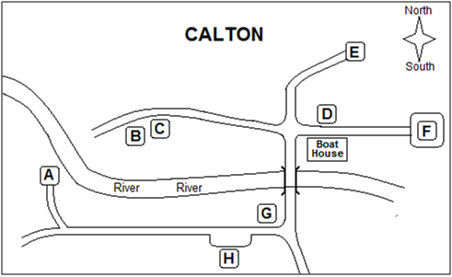
Write the correct letter, A-H, next to questions 15-20.
15___________ Bus stop
16___________ Car park
17___________ Museum
18___________ Mill
19___________ Potter’s studio
20___________ Café

BÀI 9
PART 2: Questions 11–20
Questions 11 and 12: Choose TWO letters, A–E.
Which TWO warnings does Dan give about picking mushrooms? ______________
A Don’t pick more than one variety of mushroom at a time.
B Don’t pick mushrooms near busy roads.
C Don’t eat mushrooms given to you.
D Don’t eat mushrooms while picking them.
E Don’t pick old mushrooms.

Questions 13 and 14: Choose TWO letters, A–E.
Which TWO ideas about wild mushrooms does Dan say are correct?_____________
A Mushrooms should always be peeled before eating.
B Mushrooms eaten by animals may be unsafe.
C Cooking destroys toxins in mushrooms.
D Brightly coloured mushrooms can be edible.
E All poisonous mushrooms have a bad smell.
Questions 15–20: Choose the correct letter, A, B, or C.
- What advice does Dan give about picking mushrooms in parks?
A. Choose wooded areas. B. Don’t disturb wildlife. C. Get there early.
- Dan says it is a good idea for beginners to
A. use a mushroom app. B. join a group. C. take a reference book.

- What does Dan say is important for conservation?
A. selecting only fully grown mushrooms
B. picking a limited amount of mushrooms
C. avoiding areas where rare mushroom species grow

Questions 18-20: Decide whether the following statements are True (T) or False (F).
- According to Dan, some varieties of wild mushrooms are in decline because there is a decrease in building developments locally.
- Dan says that when storing mushrooms, people should keep them in the fridge for at least two days.
- There are many different recipes with new varieties of mushrooms.

BÀI 10

Part 2. For questions 11-15, you will hear a part of the talk given by a member of staff in a hospital. Listen and choose the best answer to each question.
11. How many patients does the hospital consult every year?
A. 3,000. B. 5,000. C. 11,000.
12. When can patients meet the female doctor?
A. On weekday mornings. B. Three days a week. C. Only on Mondays and Fridays.
13. Who is the expert on treating hearing loss?
A. Mr. Roberts. B. Mr Green. C. Mr. Edwards.
14. Where are patients recommended to buy their medicine?
A. The supermarket in the town.
B. Pharmacies nearby the city centre.
C. The health care's pharmacy.
15. What will the patients be asked about whether they are willing to do?
A. Letting one student attend the consultation.
B. Asking postgraduate students to do treatment.
C. Meeting students in group discussion.

Part 3. For questions 16-20, you will hear a conversation about “the hair of the dog”. Listen and decide whether the following statements are True (T) or False (F).

______16. Rob had a hangover because he drank alcohol while watching football at the pub.
______17. Finn suggested that Rob drink water to cure his hangover.
______18. Feifei initially thought "the hair of the dog" referred to cutting Fido's hair to cure Rob's hangover.
______19. The phrase "the hair of the dog" comes from a modern medical recommendation.
______20. Rob decided to only drink coffee after his hangover and refused Finn's offer for another beer.

