WEEK: 18 | Period 54: UNIT 7: TRAFFIC  Lesson 1: GETTING STARTED
I. OBJECTIVES
By the end of the lesson, students are expected to achieve the following objectives:
1. Knowledge:
*Vocabulary:
- Vocabulary to talk about about Traffic; means of transport : cycle (v), traffic jam (n.phr.), cross the road (v.phr.), rush hour (n.phr.), teach- taught;
* Pronunciation:
- Pronounce the new words correctly: cycle (v) , traffic jam (n.phr.) , cross the road (v.phr.), rush hour (n.phr.), teach- taught;
* Grammar:
- Use it to indicate distance;
- Use should/shouldn't,
2. Competencies:
a. General competencies:
- Group work and independent working, pair work, linguistic competence, cooperative learning and communicative competence.
- Develop communication skills and enhance awareness of preserving the culture
- Be co-operative and supportive in pair work and teamwork.
- Actively join in class activities.
b. Specific competencies:
- use words related to the topic Traffic;
- Asking and answering questions about means of transport
- pronounce the sounds /ai/ and /ei/ correctly;
- read for general and specific information about traffic
- talk about traffic in the area;
c. Digital competencies:
1.1TC1b
- Students can browse to some websites as: hoclieu.vn, loigiaihay.com, Vietjack.com to get information about the topic and self-study.
6.2 TC1a
- Students can use Chatgpt, Gemini to get explanations about any problem of the topic effectively.
5.3 TC1a
- Students can
+ use Canva to make flashcards of Vocabulary, a poster of the Topic
+ use Napkin to make a Mindmap of Grammar of the Topic.
+ use Google AI studio with Live function to practice Speaking.
+ use Powerpoint, Gamma, Video creator apps to make a presentation of the Topic
3. Qualities:
- Develop awareness of travelling in town/city
- Be concerned to the local traffic
- Develop self-study skills.
- Ss have the good attitude to working in groups, individual work, and pairwork, cooperative learning and working.
The disabled students can be supported by T and other Ss.
II. TEACHING AIDS:
- Teacher: Grade 7 textbook, Projector / TV.....
- Students: Textbook, workbook…
- Computer connected to the Internet.
- Hoclieu.vn
III. PROCEDURE:
1. Activity 1. WARM UP ( 3’- 5’)
*) Objectives:
- To create an active atmosphere in the class before the lesson;
- To lead into the new unit.
*) Organisation: Teacher’s instructions …
Teacher’s & Student’s activities | Contents
+ Greeting  + Miming game  * Teacher gives instructions  - Ask Ss in groups,  - One of the students in the group go to the board.  - Teacher secretly show 1 picture of a mean of transport to that student. He/She has to mime the picture and the other has to guess. Of course the other groups will also be allowed to guess.  - take turns go to the board until finish all the pictures.  - Teacher checks and corrects if Ss pronounce the words incorrectly.  OR: Teacher (T) asks Ss some questions about the previous lessons,  - T may introduce some warm-up activities to create a friendly and relaxed atmosphere to inspire Ss to warm up to the subject and new class…  - T encourages Ss to talk in English as much as possible  + Lead to the unit Traffic.  - Ask Ss to open their book to page 72 - 73 and introduce what they are going to study….  The disabled students can be supported by T and other Ss. | + Greeting  + Miming game  - T_Ss.  + Students (Ss) listen and learn how to do the tasks.  - Work in groups  - Open the book and write the tittle of the lesson.  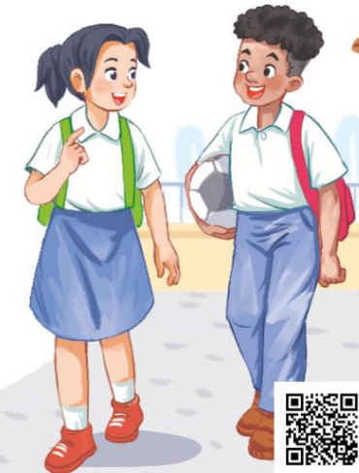
2. ACTIVITY 2: PRESENTATION ( 12’- 15’)
Task 1:
*) Objectives:
- To set the context for the introductory conversation;
- To introduce the topic of the unit.
*) Organisation: Teacher’s instructions.
Teacher’s & Student’s activities | Content
1. Listen and read: (Ex 1, p. 72)  *Teach vocabulary:  + Teacher uses different techniques to teach vocab (situation, realia, translation.)  + Teacher introduces the vocabulary by:  - providing the pictures  - eliciting the definition of the words  + Teacher do the “Rub out and remember” checking technique.  + Teacher checks students’ pronunciation and gives feedback.  - Teacher reveals that these words will appear in the reading text and asks students to open their textbook to discover further.  - T may begin to ask Ss questions: How do you go to school every day? On foot? By bicycle? By bus? On your parents' motorbike?... Which means of transport is fastest? Which means is safest? Which means do you like (most)? (Why?) What do you see on the way to school every day?...  - Set the context for the listening and reading: Ask Ss to look at the title of the conversation and the picture. Ask them some questions like: What do you think they are talking about?  - Then ask Ss to look at the title / the picture and guess what the conversation between Lan and Mark might be about.  - Play the recording twice for Ss to listen and read along (they may read silently or aloud).  - Have some pairs of Ss read the conversation aloud.  - Ask Ss what Lan and Mark are talking about. Now confirm the correct answer. (They are talking about the traffic, the means of transport, etc.)  - Have Ss say the words in the text that they think are related to the topic of the unit. Have them pronounce the words containing the sounds /ai/ and /ei/. Quickly write the words on the board.  - Check their pronunciation, if necessary.  The disabled students can be supported by T and other Ss. | 1. Listen and read:  - T_Ss  * Listen to the teacher’s instructions carefully and do the tasks  *Vocabulary  - cycle (v) /ˈsaɪkl/: đạp xe  - traffic jam (n.phr.) /ˈtræfɪk dʒæm/: tắc đường  - cross the road (v.phr.) /krɒs ðə rəʊd/: băng qua đường  - rush hour (n.phr.) /ˈrʌʃ aʊə(r)/: giờ cao điểm  - crowded (adj) Đông đúc  - teach- taught (v) Dạy học (past tense)
  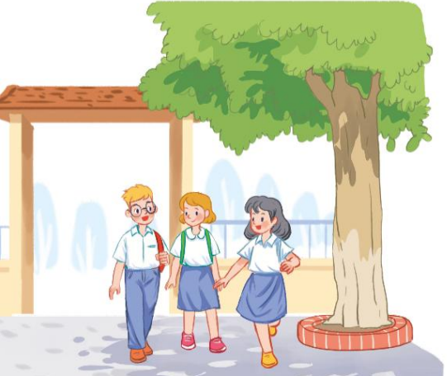
3. ACTIVITY 3: PRACTICE ( 15’)
Task 2:
*) Objectives: To help Ss understand some details of the conversation.
*) Organisation:
Teacher’s & Student’s activities | Content
2. Read the conversation again and choose the correct answer.  - Have Ss read the questions and the options without reading the conversation. Explain that they focus on some details of the conversation.  - Have Ss read the conversation again and circle the correct answers (A, B, or C) individually.  - Check their answers and explain if necessary.  The disabled students can be supported by T and other Ss. | 2. Read the conversation again and choose the correct answer.  - T_Ss  - Work individually.  - Give the answers  * Key: 1. A 2. B 3. C
Task 3:
*) Objectives: To help Ss further understand the text;
*) Organisation :
3. Write one word from the conversation to complete each sentence.  - To acquaint Ss with the grammar points and new vocabulary of the unit.  - Ask Ss to read the sentences and find the words in the conversation to fill in the gaps. If Ss find it difficult to do the task, ask them to read the conversation again and find the information in it.  - Go around and offer help, if needed.  - Allow Ss to share answers before discussing as a class. Write the correct answers on the board.  - If there is time, call on some Ss to read the sentences.  - Check the answers as a class.  The disabled students can be supported by T and other Ss. | 3. Write one word from the conversation to complete each sentence.  - T_ Ss  - Listen to the instructions clearly  - Ss to work individually.  * Key:  1. cycled 2. should  3. jams 4. How  5. crowded
Task 4:
*) Objectives: To help Ss revise and develop the vocabulary about means of transport.
*) Organisation:
4. Look at the pictures and write a word under each.  - Have Ss work in pairs and write the means of transport under the right pictures. Then T lets Ss read each word correctly. Check and correct their pronunciation.  - For more able students, let them ask and answer questions about how they use these means of transport:  Example:  A: Do you ride a bike to school?  B: Yes, I do.  A: Do you ever travel by plane?  B: No, never/not yet.  - Check the answers as a class.  The disabled students can attend this activity. | 4. Look at the pictures and write a word under each.  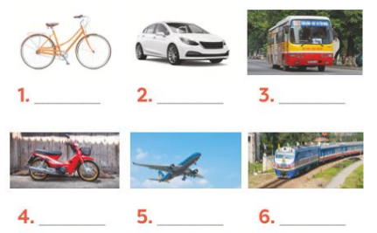  - T_ Ss. Work individually.  - Ss do the tasks  * Key:  1. bicycle / bike  2. car  3. bus  4. motorbike  5. plane  6. train  7. boat  8. ship
4. ACTIVITY 4: PRODUCTION( 8’)
Task 5:
*) Objectives: To help Ss revise some vocabulary related to traffic and practise asking and answering questions about means of transport.
*) Organisation:
Teacher’s & Student’s activities | Content
5. GAME: Find someone who … Write your friends’ names in the blanks. Then report to the class.  - Let Ss stand up and go round the class to ask everyone these questions:  + Do you (usually) walk to school/go to school by bus...?  - Yes, I do / No, I don’t.  - Ask Ss to take notes, and then have some of them report their results to the class.  Example: I've asked 8 students in class. Two of them walk to school every day. Three of them never go to school by bus....  - T may need to explain to Ss:  + traffic:  + the vehicles that are on a road at a particular time  + the movement of people or goods from one place to another  + transport: Carrying people or goods from one place to another using vehicles  means of transport: type of vehicle used for transporting people or goods  + how: Used to ask about means of transport  - T goes round to help weaker Ss.  The disabled students can attend this activity. | 5. GAME: Find someone who … Write your friends’ names in the blanks. Then report to the class.  + Listen to the instructions carefully and do the tasks.  s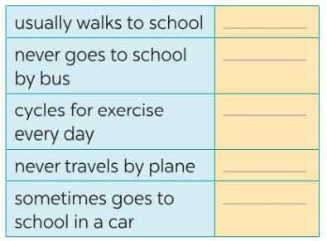  Example:  - Do you usually walk to school?  - Yes, I do/ No, I don’t  ** Report it.  * Example:  I've asked 8 students in class. Two of them walk to school every day. Three of them never go to school by bus....
5. CONSOLIDATION (2’)
a. Wrap up
- Ask one or two Ss to tell the class what they have learnt.
- Ask Ss to say some words / phrases and grammar points they remember from the lesson. Tell Ss that they will learn these language points in the following lessons.
b. Homework
- Do more exercises in workbook.
- Prepare new lesson: Lesson 2: A CLOSER LOOK _1
T helps the disabled students to revise the previous lesson and prepare the next lesson.
========================================================

