Giáo án lớp 1
UNIT 15 : AT THE FOOTBALL MATCH
Lesson 2

I. OBJECTIVES:
- By the end of the lesson, students will be able to:
+ Say the letter F/f and the words face, father, foot and football
+ Listen and identify the words face, father, foot and football.
+ Trace the letter F/f and complete the words ___ather, ___oot, ___ootball,
___ ace.
1. Knowledge/ Language focus:
- Vocabulary: face, father, foot and football
- Sound: /f/
2. Skills:
Listening, writing and speaking.
3. Quality /Attitude:
Actively participate in activities with their classmates in pairs, groups or class. Educate Ss to become studious and obedient students; love something at the football match.
4. Competences:
SS can develop some competences:
- Communicative and collaborative competence: work in pairs/groups, role play: work in pairs/groups, role play: work in pairs/groups, role play
- Problem-solving competence: observing, collecting and analyzing information
- Self studying and self - control competence: remembering, recalling and guessing words/phrases
- Creative competence, linguistic competence: giving ideas, changing information, giving comments, critical thinking.
II. TEACHING AIDS / MATERIALS:
Pictures, Textbooks, computer, projector, pictures, recording…
III. METHODS:
Communicative language teaching, contextual teaching and learning, total physical response, games activities teaching, Model-Action-Talk, teaching methods by visual, direction method, audiolingual method.
IV. PROCEDURE:
Teacher’s activities | Students’ activities
Activity 1:Warm up:5’  *Aim: help ss to be eager and happy to begin the new lesson.  *Procedure:  - Invite a few Ss to point to the picture/poster and pronounce the sound of the letter F/ f and say the words face, father, foot and football  Activity 2. Listen and chant:10’  *Aim: help Ss to read the chant with some words: face, football, father.  *Procedure:  - Have Ss look at the chant and say .  Draw Ss’ attention to the first verse and explain its meaning. Check comprehension.  - Play the recording of the first verse for Ss to listen and to get familiarized with the tune, saying Listen to the first line, please!  - Then have them listen again and repeat the verse, line by line, individually and in chorus.  - Follow the same procedure with the second verse. Correct pronunciation, if necessary. Show them how to chant and clap hands.  - Play the recording all the way through again for Ss to listen and do choral and individual repetition, Then play the recording for them to listen and repeat until they feel confident.  - Put the class into two groups to practise chanting and clapping. Each group should sing one verse of the chant.  - Encourage some Ss to go to the front of the class to chant and clap their hands. The rest of the class may clap along to the rhythm. If they chanted well.  *Outcome: read the chant with some words: face, football, father.  Activity 3. Listen and tick :7’  *Aim: help Ss to improve listening skill with some words foot, father.  *Procedure:  - Have Ss look at the pictures and say what they can see. Draw Ss’ attention to the boxes next to the letters a and b. Check comprehension.  - Invite some Ss to point to the pictures and say the words in front of the class, saying Point to the pictures and say the words, please! E.g. 1a: a face, 1b: a foot.  - Play the recording for Ss to listen and tick the box.  - Let SS to listen again and check .  *Outcome: improve listening skill with some words, foot, father.  Activity 4. Look and trace.10’  *Aim: help Ss to look and trace with the sound of the letter F/f.  *Procedure:  - Have Ss look at the letter F (upper case) and f (lower case). Ask Ss to make sure if they recognize the two forms of the letter.  - Tell Ss to trace the letter F /f. T can demonstrate by air tracing or tracing the broken lines of the letter F /f. on the board.  - Then let Ss do the tracing. Give further support to those Ss who find it difficult to do the task.  - Check the results of Ss’ tracing and give feedback. Ask Ss to work in pairs and swap their answers. Give Ss time to work. Go around and offer help, if necessary.  - Ask some Ss to show what they have done.  - With a better class, write the letter F /f. in broken lines on the board and invite some Ss to trace them.  *Outcome: look and trace with the sound of the letter F/f.  Activity 5.Consolidation: 2’  Asking Ps to focus on sounds and vocabulary again.  Activity 6.Homelink: 1’  Practice more at home.  Prepare the new lesson. | - SS point and say.  - SS look and listen.  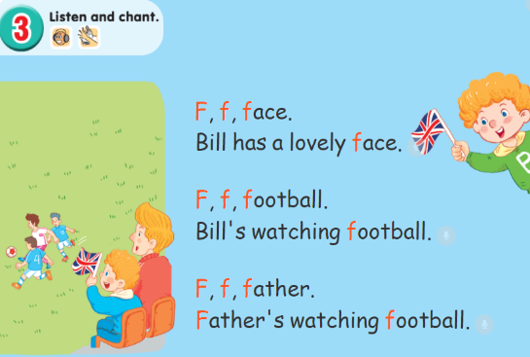  - SS listen.  - Ss listen and repeat.  - SS listen and chant.  - Ss listen and repeat.  - SS practice chanting and clapping.  -SS chant in front of the class.  - SS look and listen.  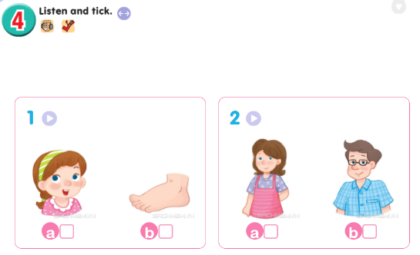  - SS point and say.  - Ss listen and tick.  - Ss listen and check.  *Key: 1.b 2. b  - SS look and listen.  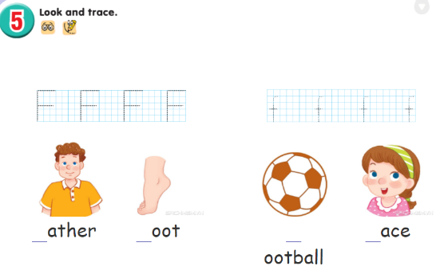  - SS trace.  - SS check.  - SS show.  - SS listen.  - SS listen and take note.
V. COMMENT
……………………………………………………………………………………
……………………………………………………………………………………

Giáo án lớp2
UNIT 15: IN THE CLOTHES SHOP
Lesson 2

I. OBJECTIVES:
By the end of the lesson, students will be able to: correctly pronounce the words shirts, shoes, shorts.
1. Knowledge/ Language focus:
- Sound / ∫/
- Vocabulary: review
2. Skills:
Listening, writing and speaking.
3. Quality /Attitude:
Actively participate in activities with their classmates in pairs, groups or class. Educate Ss to become studious and obedient students; love something relates to the clothes shop.
4. Competences:
SS can develop some competences:
- Communicative and collaborative competence: work in pairs/groups, role play
- Problem-solving competence: observing, collecting and analyzing information
- Self studying and self - control competence: remembering, recalling and guessing words/phrases.
- Creative competence, linguistic competence: giving ideas, changing information, giving comments, critical thinking.
II. TEACHING AIDS / MATERIALS:
Pictures, textbook, computer, projector, pictures, recording…
III. METHODS:
Communicative language teaching, contextual teaching and learning, total physical response, games activities teaching, Model-Action-Talk, teaching methods by visual, direction method, audiolingual method.
IV. PROCEDURE:
Teacher’s activities | Students’ activities
Activity 1.Warm- up: Check-up:5’  *Aims: to help ss remember the words that they have learned in lesson 1.  *Procedure:  - T asks ss to say the letter and the sound they learnt in lesson 1(sh, / ∫/  Say “Open your book page 66 and look at lesson 2”  Activity 2. Listen and chant:10’  * Aims: to correctly pronounce the words shirts, shoes, shorts.  *Procedure:  - Have ss look at the chant on p. 66 in their books and draw ss’ attention to the first line and explain its meaning. Ask them to pay attention to the letter sh and the words: shirts, shoes, shorts. Check comprehension.  - Play the recording of the first verse for Ss to listen and to get familiarized with the tune.  - Play the recording again, ask ss to listen and repeat the first line. Then play the recording for them to listen and repeat until they feel confident.  - Follow the same Procedure: with the other verse. Show ss how to chant and clap their hands. Correct pronunciation, if necessary.  - Play the recording all the way through. Ask ss to listen and repeat the chant individually and in chorus. Give further support to those ss who find it difficult to do the task.  - Select some ss to the front of the class to chant and clap their hands. The rest of the class may sing the chant along and clap their hands.  Activity 3. Listen and tick: 8’  *Aims: to recognize the words shirts, shoes, shorts  *Procedure:  - Have Ss look at two pictures and say what they can see. Draw ss’ attention to the boxes next to the letters a and b. Check comprehension.  - Encourage some ss to point to the pictures and say the words in front of the class. E.g. 1a: shirts, 1b: shorts  - Play the recording for ss to listen and tick the box.  - Let ss to listen again and check.  -T gets feedback.  shoes, shorts  Activity 4. Write and say:9’  * Aims: to write the letter sh, complete and say the words: shirts, shoes, shorts  *Procedure:  - Have Ss look at the letter sh.  - Then let ss write the letter. Then find out the missing letter to complete the correct word. Give further support to those Ss who find it difficult to do the task.  - Check the results of ss’ tracing and give feedback. Ask ss to work in pairs and swap their answers. Give ss time to work. Go around and offer help, if necessary.  - Ask some ss to show what they have done.  *Outcome: Ss can write the letter sh, complete and say the words: shirts, shoes, shorts  Activity 5. Consolidation: 2’  - T tells ss about the main content of the lesson.  - T tells ss about the educational Aims of the lessons.  Activity 6. Home link: 1’  - Practice more at home.  - Prepare for the next lesson. | - SS say the letter and the sound.  - SS open their book.  - Look at the picture and listen.  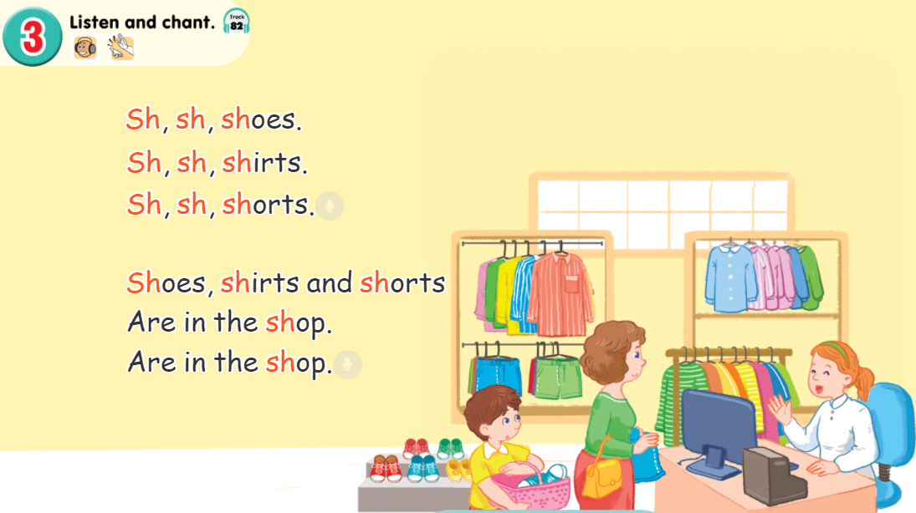  - Ss listen and repeat.  - SS listen and chant.  - SS chant.  - SS chant in front of the class.  - Look at the picture and describe it.  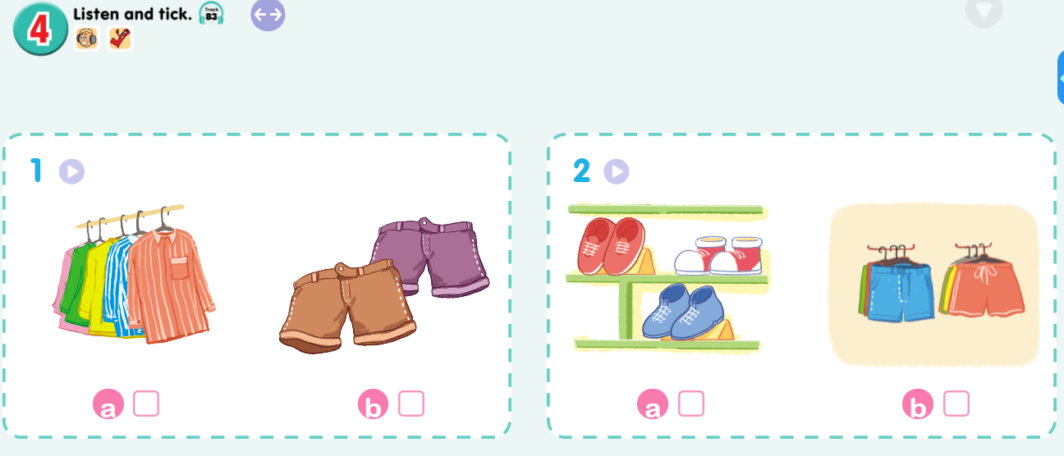  - Point and say  - SS listen and do the task.  - Ss look and listen.  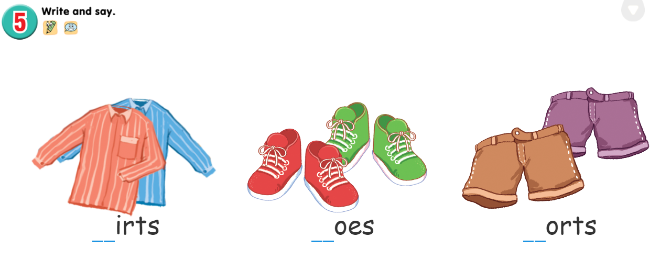  - Ss listen.  - SS do the task.  - Check in pairs.  - Ss show their work.  - SS listen.  - SS listen and take note.

V. COMMENT
……………………………………………………………………………………
……………………………………………………………………………………
……………………………………………………………………………………

