WEEK 01
GRADE 4(Khối 4)
Period 1 (Tiết 1)
Làm quen với Chương trình và sách giáo khoa Tiếng Anh 4 và các tài liệu bổ trợ liên quan trên mạng
I Objectives: (Mục tiêu)
By the end of the lesson, Ss will be able to:
1. Knowledge (Kiến thức)
- Use the allocation in their study (at school + at home) and basic classroom language.
2. Skills (Kĩ năng)
- Speaking and listening.
3. Attitude (Thái độ)
- Be confident in communicating with friends/ teachers.
- Love people and be polite when communicating
Actively participate in activities with their classmates in pairs, groups or class. Educate Ss to become studious and obedient students, who love learning English.
- Honesty, patience and friendliness.
4. Competence development (Phát triển năng lực)
- Co-operation (ready to help friends in pair work/group work).
- Self-study (can perform individual tasks and solve problems by themselves.) Communicative and interactive skill
- Use language to greet and respond to greetings formally.
II. Teaching aids (Đồ dùng dạy học)
- Teacher: Teaching plan, English 4, pictures, board, Laptop, TV, CD rom….
- Pupils: Pupil’s book, workbook, notebook, school things………...
III. Procedures (Tiến trình)
Steps | Teacher’s activities | Students’ activities
I.Warm up: Khởi động 5’ | *Aims: to create a friendly and active atmosphere in the class to begin the lesson.  *Procedure:  - Greet the class and introduce yourself, saying: Hello. I’m Ms Hoa.  - Encourage Ss to say their names  - Sing a song | - Greet and introduce  - Ss greet and say their names  - Listen, and sing the song in the chorus
II. New lesson  Bài mới  1. Presentation (10’) | *Aims: Ss will be able to know about the program and English 4 textbook  *Procedure:  - Introduce the subject  + “English 4” has 3 books. (Two student books and one exercise book)  - Introduce the student’s book and workbook.  - Say the main contents  There are 20 Units, each Unit has 3 lessons  Lesson 1:  - Look, listen and repeat  - Listen, point and say  - Let’s talk  - Listen and circle/ tick/ number  - Look, complete/ match and read  - Let’s sing/play  Lesson 2:  - Look, listen and repeat  - Listen, point and say  - Let’s talk  - Listen and number/ tick  - Look, complete and read.  - Let’s sing/ play  Lesson 3:  - Listen and repeat  - Listen and circle/ tick  - Let’s chant  - Read and match/ circle/ compete/ write the answer/tick True/ False.  - Let’s write  - Project  After 5 Units has a Review and extension activities. | - Listen to the teacher  - Listen to the teacher
2. Practice (10’) | *Aims: Ss will be able to know and do action about classroom languages.  *Procedure:  - Say and model some classroom languages  + Open/ close your books, please!  + Stand up/ Sit down, please!  + Be quiet/ Don’t talk, please!  + Pick up your pen  + Put your pen down  + Raise your hands  + Go to the board  + Look  + Complete  + Let’s play  + Ask/ answer the question  + Work in pairs/groups  + …. | - Listen to the teacher  - Look and do action
3. Production (8’) | *Aims: Ss will be able to sing and dance a song.  *Procedure:  - Sing and model the “Hello” song | - Listen to the song through the tape.  - Listen and repeat sentence by sentence linking the action.  - Sing all the text and link the action in the chorus.  - Work in groups (two groups) to sing
III. Homework.  (2’) | - Practice more at home.  - Prepare for “Starter” | - Listen to the teacher.
*Supplement (Bổ sung)
- Ss can listen to some keywords in the recording and read for specific information
- Most Ss can pronounce the words correctly and practice quickly.
- Class: …………….
+ Ss (HSKT) can take part in some class activities (tham gia các hoạt động của lớp)
+ Ss (HSKT) can listen and understand some words in the lesson.
IV. Điều chỉnh sau tiết dạy (nếu có)
............................................................................................................................................................................................................................................................................................
____________________________________________________________________
Period 2 (Tiết 2)
STARTER: A. Hello again!
I Objectives: (Mục tiêu)
By the end of the lesson, Ss will be able to:
1. Knowledge (Kiến thức)
- Revise some competencies learned in Grade 3
- Greeting, introducing themselves and introducing each other.
- Talking about activities in the classroom.
- Talking about outdoor activities.
- Vocabulary: Review
2. Skills (Kĩ năng)
- Speaking and listening.
3. Attitude (Thái độ)
- Kindness: Help partners to complete learning tasks.
- Honesty: tell the truth about feelings and emotions.
- Be confident in communicating with friends/ teachers.
- Love people and be polite when communicating
4. Competence development (Phát triển năng lực)
- Co-operation (ready to help friends in pair work/group work).
- Self-study (can perform individual tasks and solve problems by themselves.)
- Oral communication: introduce themselves
- Sociability: Talk to each other and say good words to others.
- Use language to greet and respond to greetings formally.
II. Teaching aids (Đồ dùng dạy học)
- Teacher: Teaching plan, English 4, pictures, board, Laptop, TV, website hoclieu.vn CD rom….
- Pupils: Pupil’s book, workbook, notebook, school things………...
III. Procedures (Tiến trình)
Steps | Teacher’s activities | Students’ activities
I. Warm-up:  Khởi động (3’) | Sing a song: Hello song  *Aims: to create a friendly and active atmosphere in the class to begin the lesson.  *Procedure:  - Show the song on the screen.  https://www.youtube.com/watch?v=tVlcKp3bWH8  - Ask pupils to listen and sing the song.  - Say “Open your book on page 7” and look at “Starter, Hello again!”. | Sing the song in chorus.  - Ss listen and open their books.
II. New lesson  Bài mới  1. Let’s sing  10’ | *Aims: Ss will be able to sing the song “Hello. How are you?” with the correct pronunciation, rhythm and melody.  *Procedure:  - Draw pupils’ attention to the lyrics of the song.  - Have pupils read the verses of the lyrics.  - Have pupils listen to the verses, check comprehension, drawing their attention to the pronunciation, rhythm and melody.  + Minh meets and greets Lucy on the first day of school.  + Nam introduces Mary and Mai.  - Listen to and practice singing the song, line by line while clapping their hands.  - Ask pupils to listen to and sing the whole song while clapping their hands.  - Invite a few groups to the front of the class to sing the song. | - Look at the board and listen.  - Ss listen and read.  -Ss listen and answer  -Ss listen again and repeat.  -Ss listen and sing the whole song.  -Ss sing in front of the class.
2. Listen and tick - 10’ | *Aims: Ss will be able to listen and understand a short text in which Ms. Hoa greets the characters in the classroom and ticks the correct pictures.  *Procedure:  - Draw pupils’ attention to the characters and check comprehension.  + Who is he/she?  + Where is he/she?  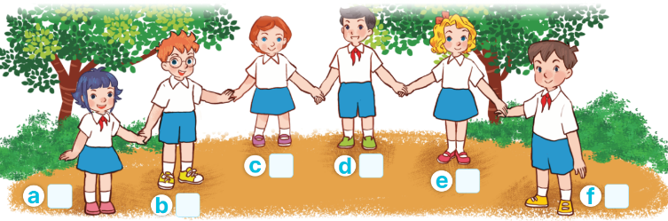  - Play the recording all the way through.  - Play the recording and tick the pictures.  - Tell pupils to swap their books with their partners, then check answers together as a class.  - Have Ss to listen and repeat in chorus, sentence by sentence. Correct their pronunciation where necessary.  Key: f (Minh); b (Ben); a (Linh); c (Lucy) | -Look at the screen and listen.  - Ss look, listen and answer.  -Ss listen to the tape and tick  -Ss listen again and check themselves  - Ss swap their books with their partners and check answers.  - Ss listen and repeat in chorus
3. Let’s play  10’ | *Aims: Ss will be able to spell some words learned in Grade 3 by playing the game “Spelling Bee”.  *Procedure:  - Before playing the game, have pupils look at the English alphabet and sing The Alphabet song or spell the letters of the song.  - Tell pupils that they are going to spell some words they have learned.  - Explain how to play the game. Check comprehension and give feedback.  - Write the words on a piece of paper or on the board.  - Call a group of four pupils to the front of the class.  - Give the piece of paper to one of the group members and ask him/her to say one word (ex: friend). The other members spell the word (ex: F-R-I-E-N-D). The pupil who correctly spells the word first gets one point or star.  - The pupil who has the most points or stars at the end of the game wins. | Ss look and sing a song.  -Ss listen and note.  -Ss listen and remember  -Ss listen  -Ss go to the board and play the game.  - Ss play the game  -Ss get the point or star.
* Consolidation | *Aims: Ss will be able to consolidate and wrap up the content of the lesson.  *Procedure:  - T asks ss to answer the following questions:  + What have you learned from the lesson today?  - Review the song.  - Learn the song. | - Ss listen and answer.
III. Homework (2’) | - Prepare the new lesson: B. Classroom activities. | - Ss listen and pay attention.
*Supplement (Bổ sung)
- Ss can listen to some keywords in the recording and read for specific information
- Most Ss can pronounce the words correctly and practice quickly.
- Class …….
+ Ss (HSKT) can take part in some class activities (tham gia các hoạt động của lớp)
+ Ss (HSKT) can listen and understand some words in the lesson.
IV. Điều chỉnh sau tiết dạy (nếu có)
............................................................................................................................................................................................................................................................................................
Period 3(Tiết 3)
STARTER: B. Classroom activities
I Objectives: (Mục tiêu)
By the end of the lesson, Ss will be able to:
1. Knowledge (Kiến thức)
- Revise some competencies learned in Grade 3:
- Greeting, introducing themselves and introducing each other.
- Talking about activities in the classroom.
- Talking about outdoor activities.
- Vocabulary: Review
2. Skills (Kĩ năng)
- Speaking and listening.
3. Attitude (Thái độ)
- Be confident in communicating with friends/ teachers.
- Love people and be polite when communicating
- Kindness: Help partners to complete learning tasks.
- Leadership: Collaborate with teachers to enhance language skills.
4. Competence development (Phát triển năng lực)
- Co-operation (ready to help friends in pair work/group work).
- Self-study (can perform individual tasks and solve problems by themselves.) Communicative and interactive skill
- Use language to greet and respond to greetings formally.
II. Teaching aids (Đồ dùng dạy học)
- Teacher: Teacher’s guide Page 12,13, audio Track 3,4,5, website hoclieu.vn, posters, laptop, pictures, textbook, lesson plan, TV or projector.
- Students: Pupil’s book Page 8, notebooks, workbooks, school things.
III. Procedures (Tiến trình)

Steps | Teacher’s activities | Students’ activities
I.Warm up Khởi động (3’) | Sing a song: Stand up sit down  *Aims: to create a friendly and active atmosphere in the class to begin the lesson.  *Procedure:  - Show the song on the screen.  https://www.youtube.com/watch?v=DiXMZJi_2NU  - Ask pupils to listen, sing, and dance the song.  - Say “Open your book to page 8” and look at “Starter, Classroom activities”. | - Sing and dance the song in chorus.  - Ss listen and open their books.
II. New lesson  1. Let’s chant  5’ | *Aims: Ss will be able to say the chant with the correct rhythm and pronunciation  *Procedure:  - Have pupils read the chant and elicit its meaning. Check comprehension.    - Play the recording for pupils to listen to and repeat the chant, line by line.  - Draw their attention to the rhythm and pronunciation.  - Play the recording all the way through for pupils to chant and clap.  - Invite a few groups of pupils to listen to and repeat the chant in front of the class.  - Praise them to encourage their performance. | -Look at the chant and read.  -Ss listen and repeat.  -Ss listen and pay attention  -Ss listen and repeat  -Ss perform the chant in front of the class  - Ss listen.
2. Listen and number  5’ | *Aims: Ss will be able to listen to and understand four sentences describing what the characters are doing in the classroom at break time and number the correct pictures.  *Procedure:  - Draw pupils’ attention to the pictures and ask and answer the questions:  + Who are they?  +What are they doing?  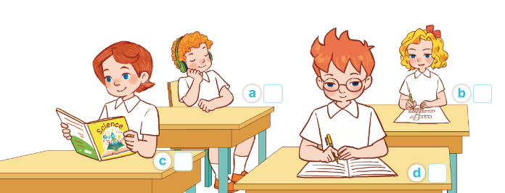  - Play the recording all the way through for pupils to listen and familiarise themselves with the speaker’s voice.  - Play the recording again for pupils to listen and number the pictures.  - Get pupils to swap books with a partner to check their answers before checking as a class.  - Check the correct answer and give feedback.  - Play the recording, sentence by sentence, for pupils to listen and repeat in chorus.  Key: 1.a 2.c 3.d 4.b | -Look at the pictures and answer  -Ss listen to the tape  - Ss listen again and write the number  -Ss swap books with the partner and check.  -Ss check the answer together.  - Ss listen and repeat, sentence by sentence.
3. Listen and act out 4’ | *Aims: Ss will be able to listen and understand a chant with seven sentences describing what the characters usually do in the classroom and act out the chant.  *Procedure:  - Draw pupils’ attention to the picture and answer the question:  + Who are they?  + What are they doing?  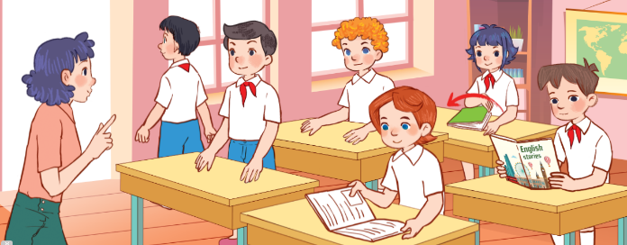  - Play the recording all the way through for pupils to listen and familiarise themselves with the speaker’s voice.  - Play the recording again for pupils to listen and point at the pictures  - Give pupils listen to the recording, line by line, and act out.  - Invite a group to listen and act out in front of the class.  - Play the recording, line by line, for pupils to listen and repeat in chorus. | -Ss listen and answer  -Ss listen and pay attention  -Ss listen again and point at the pictures  -Ss listen again and act out.  -Ss listen and act out in front of the class  -Ss listen and repeat.
*Consolidation  1’ | *Aims: Ss will be able to consolidate and wrap up the content of the lesson.  *Procedure:  - T asks ss to answer the following questions: + What have you learned from the lesson today?  - T reviews the classroom activities. | -Ss answer the questions  - Ss listen
III. Home-link (1’) | - Learn the classroom activities.  - Prepare the new lesson: C.Outdoor activities | -Ss listen
*Supplement (Bổ sung)
- Ss can listen to some keywords in the recording and read for specific information
- Most Ss can pronounce the words correctly.
- Class: ………………..
+ Ss (HSKT) can take part in some class activities (tham gia các hoạt động của lớp)
+ Ss (HSKT) can listen and understand some words in the lesson.
IV. Điều chỉnh sau tiết dạy (nếu có)
............................................................................................................................................................................................................................................................................................
..............................................................................................................................................
____________________________________________________________________
Period 4 (Tiết 4)
STARTER: C. Outdoor activites
I Objectives: (Mục tiêu)
By the end of the lesson, Ss will be able to:
1. Knowledge (Kiến thức)
Revise some competencies learned in Grade 3:
- Greeting, introducing themselves and introducing each other.
- Talking about activities in the classroom.
- Talking about outdoor activities.
- Vocabulary: Review
2. Skills (Kĩ năng)
- Listening, speaking and reading.
3. Attitude (Thái độ)
- Be confident in communicating with friends/ teachers.
- Love people and be polite when communicating
- Honesty: tell the truth about feelings and emotions.
- Responsibility: appreciate kindness
4. Competence development (Phát triển năng lực)
- Co-operation (ready to help friends in pair work/group work).
- Self-study (can perform individual tasks and solve problems by themselves.) Communicative and interactive skill
- Oral communication: let’s play and say.
- Sociability: talk to each other and say good words to others.
II. Teaching aids (Đồ dùng dạy học)
- Teacher: Teacher’s guide Page 14, 15, website hoclieu.vn, posters, laptop, pictures, textbook, lesson plan, TV, or projector.
- Students: Pupil’s book Page 9, notebooks, workbooks, school things.
III. Procedures (Tiến trình)
Steps | Teacher’s activities | Students’ activities
I.Warm up Khởi động (3’) | Sing a song: What are you doing?  *Aims: to create a friendly and active atmosphere in the class to begin the lesson.  *Procedure:  - Show the song on the screen.  https://www.youtube.com/watch?v=HrHqq8xJiU4  - Ask pupils to listen, sing, and dance the song.  - Say “Open your book to page 9” and look at “Starter, Outdoor activities”. | - Sing and dance the song in chorus.  - Ss listen and open their books.
II. New lesson  1. Let’s play  5’ | *Aims: Ss will be able to practice the names of outdoor activities by playing the “Miming game”  *Procedure:  - Elicit the language that pupils need to talk about break time activities.  + Ex: What are they doing?  They’re…………..(swimming, running, singing, skating, skipping).  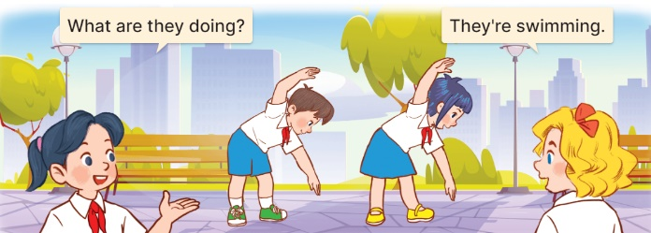  - Explain how the game is played:  + Two pupils mime the action of an activity.  + One pupil asks What are they doing?  + And the other pupils guess the action and answer.  - Divide the class into groups of five to play the game.  - The team that guesses the correct answer first gets one point or star.  - The team with the most points or stars is the winner | - Ss listen and answer  -Ss listen and pay attention  -Ss play the game  -Ss play the game  -Ss listen
2. Follow the lines and say  5’ | *Aims: Ss will be able to match the pupils with the pictures and talk about their hobbies.  *Procedure:  - Tell pupils the goal of the activity and explain that they should follow the lines to match the pupils with the pictures, point to the pupils, and say what their hobbies are.  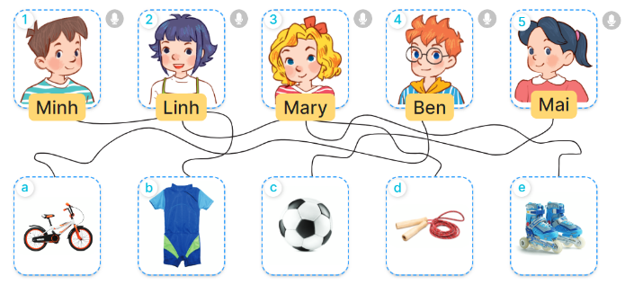  - Do the first picture as an example:  + First, have pupils look at Minh and the line to Picture b (a swimsuit).  + Then have them say: “Look at Minh. His hobby is swimming”.  - Set a time limit for pupils to do the activity independently. Go around the classroom and offer help if necessary.  - Get pupils to swap books with a partner and check their answers.  - Check the answers together.  - Invite some pupils to look at the task they have done and talk about pupils’ hobbies in front of the class. | -Ss look and pay attention  -Ss look at the picture and the line  -Ss look and say  -Ss do the task  -Ss swap books together  - Ss check the answer  -Ss say about the pictures
3. Read and act out 4’ | *Aims: Ss will be able to read the chant aloud and act out with the help of the lyrics and picture cues.  *Procedure:  - Have pupils look at the first picture to identify the meaning of the first two lines.    - Get pupils to read aloud the first line and jump up. Then have them read the second line aloud and jump up high.  - Give pupils a time limit to read the first verse and act out in pairs or groups.  - Go around the classroom and give further support to pupils who find it difficult to do the task.  - Repeat with the second and third verses of the chant.  - When pupils are familiar with the verses and actions, ask them to read the whole chant aloud and act out.  - Invite a few groups to the front of the class to say the chant and act out. | -Ss look t the picture and answer.  - Ss read and act out  -Ss read and act out in pairs  - Ss work in pairs  -Ss listen and repeat  -Ss read and act out the whole chant  -Ss say the chant and act out in front of the class.
*Consolidation  1’ | *Aims: Ss will be able to consolidate and wrap up the content of the lesson.  *Procedure:  - T asks ss to answer the following questions:  + What have you learned from the lesson today?  - T reviews the outdoor activities. | -Ss answer the questions  - Ss listen
III. Home-link (1’) | - Learn the outdoor activities by heart  - Prepare the new lesson: Unit 1: My friends- Lesson 1. | -Ss listen
*Supplement (Bổ sung)
- Ss can listen to some keywords in the recording and read for specific information
- Most Ss can pronounce the words correctly.
- Class: …………………
+ Ss (HSKT) can take part in some class activities (tham gia các hoạt động của lớp)
+ Ss (HSKT) can listen and understand some words in the lesson.
IV. Điều chỉnh sau tiết dạy (nếu có)
............................................................................................................................................................................................................................................................................................
____________________________________________________________________
_______________________________________________________________________
Sao Đỏ, ngày ……. tháng 09 năm 2024

NGƯỜI LẬP  Nguyễn Thị Thu Hòa | NGƯỜI KIỂM TRA | BAN LÃNH ĐẠO

