Exercise 1: Write the words

|  |  |  |  |
| --- | --- | --- | --- |
| Peacock | swinging | elephant | counting |
| monkey | climbing | tiger | horse |

|  |  |  |  |
| --- | --- | --- | --- |
| https://bestflashcard.com/images/vocabulary/english/sgk-tieng-anh-3-global-success-unit-20/elephant.PNG | https://bestflashcard.com/images/vocabulary/english/sgk-tieng-anh-3-global-success-unit-20/counting.PNG | https://bestflashcard.com/images/vocabulary/english/sgk-tieng-anh-3-global-success-unit-20/monkey.PNG | https://bestflashcard.com/images/vocabulary/english/sgk-tieng-anh-3-global-success-unit-20/climbing.PNG |
| ………………….. | ……………………. | ……………………. | …………………….. |
| https://bestflashcard.com/images/vocabulary/english/sgk-tieng-anh-3-global-success-unit-20/horse.PNG | https://bestflashcard.com/images/vocabulary/english/sgk-tieng-anh-3-global-success-unit-20/tiger.PNG | https://bestflashcard.com/images/vocabulary/english/sgk-tieng-anh-3-global-success-unit-20/peacock.PNG | https://bestflashcard.com/images/vocabulary/english/sgk-tieng-anh-3-global-success-unit-20/swinging.PNG |
| …………………… | ………………….. | …………………….. | …………………….. |

Exercise 2. Look and answer

|  |  |  |
| --- | --- | --- |
| Káº¿t quáº£ hÃ¬nh áº£nh cho monkey ' clipart | https://bestflashcard.com/images/vocabulary/english/sgk-tieng-anh-3-global-success-unit-20/elephant.PNG | https://bestflashcard.com/images/vocabulary/english/sgk-tieng-anh-3-global-success-unit-20/peacock.PNG |
| What animal is it? | What animal is it? | What animal is it? |
| *It’s a………………………….* | *……………………………….* | *……………………………….* |
| https://bestflashcard.com/images/vocabulary/english/sgk-tieng-anh-3-global-success-unit-20/tiger.PNG | https://bestflashcard.com/images/vocabulary/english/sgk-tieng-anh-3-global-success-unit-20/horse.PNG | Red Parrot Clip Art Free PNG Image｜Illustoon |
| What animal is it? | What animal is it? | What animal is it? |
| *……………………………….* | *……………………………….* | *……………………………….* |

Exercise 3: Look, read and match

|  |  |  |
| --- | --- | --- |
| 1. I can see a monkey. |  | https://bestflashcard.com/images/vocabulary/english/sgk-tieng-anh-3-global-success-unit-20/horse.PNG |
| 1. I can see a horse. |  | https://bestflashcard.com/images/vocabulary/english/sgk-tieng-anh-3-global-success-unit-20/tiger.PNG |
| 1. I can see an elephant. |  | https://bestflashcard.com/images/vocabulary/english/sgk-tieng-anh-3-global-success-unit-20/peacock.PNG |
| 1. I can see a tiger. |  | Káº¿t quáº£ hÃ¬nh áº£nh cho monkey ' clipart |
| e) I can see a parrot. |  | https://bestflashcard.com/images/vocabulary/english/sgk-tieng-anh-3-global-success-unit-20/elephant.PNG |
| f) I can see a peacock. |  | Red Parrot Clip Art Free PNG Image｜Illustoon |

Exercise 4: Look and circle the right sentence.

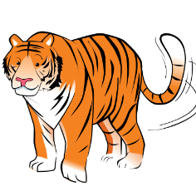

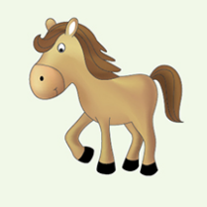

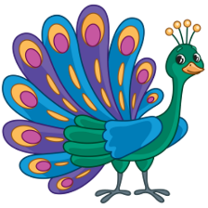

a) I can see a parrot. a) I can see a horse. a) I can see an elephant.

b) I can see a peacock. b) I can see a monkey. b) I can see a tiger.

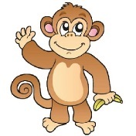

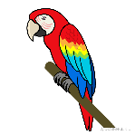

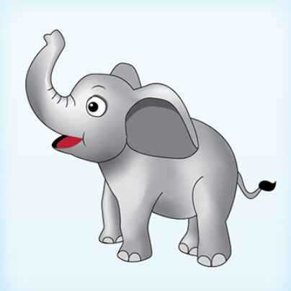

a) I can see a horse. a) I can see a parrot. a) I can see a peacock.

b) I can see an elephant. b) I can see a tiger. b) I can see a monkey.

Exercise 5: Look and write







a) What can you see? b) What can you see? c) What can you see?

*…………………………….. …………………………….. ……………………………..*







d) What can you see? e) What can you see? f) What can you see?

*…………………………….. …………………………….. ……………………………..*

Exercise 6: Put the words in the correct order

|  |  |  |
| --- | --- | --- |
| https://bestflashcard.com/images/vocabulary/english/sgk-tieng-anh-3-global-success-unit-20/tiger.PNG | https://bestflashcard.com/images/vocabulary/english/sgk-tieng-anh-3-global-success-unit-20/peacock.PNG | https://bestflashcard.com/images/vocabulary/english/sgk-tieng-anh-3-global-success-unit-20/horse.PNG |
| a) tiger – a – can – see- I | b) a– see – peacock – I – can | c) see – can – a – I – horse |
| *…………………………………….* | *…………………………………….* | *……………………………………* |
| Red Parrot Clip Art Free PNG Image｜Illustoon | Káº¿t quáº£ hÃ¬nh áº£nh cho monkey ' clipart | https://bestflashcard.com/images/vocabulary/english/sgk-tieng-anh-3-global-success-unit-20/elephant.PNG |
| d) parrot – a – I – see - can | e) I – see – a - can – monkey | f) I – elephant – see – can - an |
| *…………………………………….* | *……………………………………* | *……………………………………* |

Exercise 7.Write

|  |  |
| --- | --- |
| Yes , it is. | No, it isn’t |

|  |  |  |
| --- | --- | --- |
| Káº¿t quáº£ hÃ¬nh áº£nh cho monkey ' clipart | https://bestflashcard.com/images/vocabulary/english/sgk-tieng-anh-3-global-success-unit-20/tiger.PNG | https://bestflashcard.com/images/vocabulary/english/sgk-tieng-anh-3-global-success-unit-20/horse.PNG |
| Is it a mokey? | Is it an elephant? | Is it horse ? |
| *……………………………* | *……………………………* | *……………………………* |
| Red Parrot Clip Art Free PNG Image｜Illustoon | https://bestflashcard.com/images/vocabulary/english/sgk-tieng-anh-3-global-success-unit-20/elephant.PNG | https://bestflashcard.com/images/vocabulary/english/sgk-tieng-anh-3-global-success-unit-20/peacock.PNG |
| Is it a peacock ? | Is it a tiger? | Is it a peacock? |
| *……………………………* | *……………………………* | *……………………………* |

Exercise 8.Look and write

|  |  |  |
| --- | --- | --- |
| https://bestflashcard.com/images/vocabulary/english/sgk-tieng-anh-3-global-success-unit-20/counting.PNG | https://bestflashcard.com/images/vocabulary/english/sgk-tieng-anh-3-global-success-unit-20/dancing.PNG | https://bestflashcard.com/images/vocabulary/english/sgk-tieng-anh-3-global-success-unit-20/climbing.PNG |
| What is the parrot doing ? | What is the elephant doing ? | What is the tiger doing? |
| *………………………………….* | *…………………………………* | *…………………………………* |
| Peacock Dancing Cartoon Clipart Vector - FriendlyStock | Swinging Monkey Royalty Free SVG, Cliparts, Vectors, And Stock  Illustration. Image 24304775. | Funny Cartoon Parrot Singing Royalty Free SVG, Cliparts, Vectors, And Stock  Illustration. Image 60374844. |
| What is the peacock doing? | What is the monkey doing? | What is the parrot doing? |
| *…………………………………* | *…………………………………* | *…………………………………* |
| Káº¿t quáº£ hÃ¬nh áº£nh cho parrot    flying clipart | A Single Cartoon Fish Swimming Underwater. Royalty Free SVG, Cliparts,  Vectors, And Stock Illustration. Image 41695186. | Vector Illustration Of Cartoon Baby Monkey Climbing Tree Branch Royalty  Free SVG, Cliparts, Vectors, And Stock Illustration. Image 123303478. |
| What is the parrot doing? | What is the fish doing? | What is the monkey doing? |
| *…………………………………* | *…………………………………* | *…………………………………* |

Exercise 9. Rewrite the right sentences:

|  |  |  |
| --- | --- | --- |
| 4,853 Singing Bird Stock Vector Illustration and Royalty Free Singing Bird  Clipart | The bird is flying. | -> ……………………………. |
| https://bestflashcard.com/images/vocabulary/english/sgk-tieng-anh-3-global-success-unit-20/climbing.PNG | The tiger is running. | -> ……………………………. |
| Káº¿t quáº£ hÃ¬nh áº£nh cho elephant walk clipart | The elephant is dancing. | -> ……………………………. |
| A cute blue bird flying - Clipart World | The bird is walking | -> ……………………………. |
| Tiger Clipart Clipart - tiger-walking-graphic-image-clipart - Classroom  Clipart | The tiger is climbing. | -> ……………………………. |
| Cartoon Horse Running Isolated On White Stock Vector (Royalty Free)  690505621 | Shutterstock | The horse is walking | -> ……………………………. |
| Run Tiger Cartoon Character Stock Illustration - Illustration of toon,  wild: 71896786 | The tiger is walking | -> ……………………………. |

Exercise 10. Look and write:

|  |  |
| --- | --- |
| Yes, it is. | No, it isn’t |

|  |  |  |
| --- | --- | --- |
| Káº¿t quáº£ hÃ¬nh áº£nh cho elephant walk clipart | Vector Illustration Of Cartoon Baby Monkey Climbing Tree Branch Royalty  Free SVG, Cliparts, Vectors, And Stock Illustration. Image 123303478. | http://sr.photos2.fotosearch.com/bthumb/IMZ/IMZ013/cof1932.jpg |
| Is the elephant walking ? | Is the monkey swinging? | Is the bird singing? |
| *……………………………………* | *……………………………………* | *…………………………………* |
| Funny Cartoon Parrot Singing Royalty Free SVG, Cliparts, Vectors, And Stock  Illustration. Image 60374844. | Horse Walking Cartoon Clipart Vector - FriendlyStock | Swinging Monkey Royalty Free SVG, Cliparts, Vectors, And Stock  Illustration. Image 24304775. |
| Is the parrot flying? | Is the horse running ? | Is the monkey swinging? |
| *……………………………………* | *……………………………………* | *…………………………………* |
| Goldfish Swimming Stock Illustrations – 3,307 Goldfish Swimming Stock  Illustrations, Vectors & Clipart - Dreamstime | Elephant Dance Stock Illustrations – 611 Elephant Dance Stock  Illustrations, Vectors & Clipart - Dreamstime | Red Parrot Clip Art Free PNG Image｜Illustoon |
| Is the goldfish swimming? | Is the elephant dancing ? | Is the parrot singing ? |
| *……………………………………* | *……………………………………* | *………………………………* |

Exercise 11. Put the words in the correct order to make sentences

|  |  |  |
| --- | --- | --- |
| Káº¿t quáº£ hÃ¬nh áº£nh cho parrot    flying clipart | Horse Walking Cartoon Clipart Vector - FriendlyStock | Vector Illustration Of Cartoon Baby Monkey Climbing Tree Branch Royalty  Free SVG, Cliparts, Vectors, And Stock Illustration. Image 123303478. |
| flying/The /parrot/is | horse/The/ walking/is/ | climbing/The /monkey/is |
| *…………………………………* | *…………………………………* | *…………………………………* |
| Funny Cartoon Parrot Singing Royalty Free SVG, Cliparts, Vectors, And Stock  Illustration. Image 60374844. | HÃ¬nh áº£nh cÃ³ liÃªn quan | Káº¿t quáº£ hÃ¬nh áº£nh cho elephant walk clipart |
| singing/The/parrot/is | swimming./The/fish/is | walking/The/ is/elephant/ |
| *…………………………………* | *…………………………………* | *…………………………………* |
| Cartoon Horse Running Isolated On White Stock Vector (Royalty Free)  690505621 | Shutterstock | Swinging Monkey Royalty Free SVG, Cliparts, Vectors, And Stock  Illustration. Image 24304775. | C:\Users\Silvia\Documents\minhas imagens\ILUSTRAÇÕES\CLIPART\ATIVIDADES\a atividades animais\Anoiper1007.gif |
| horse/The/running/is | swinging/The /monkey/is | The/reading/is/ a /book/parrot |
| *…………………………………* | *…………………………………* | *…………………………………* |
| A cute blue bird flying - Clipart World | Orange Cat Climbing Trees Picture And HD Photos | Free Download On Lovepik | https://bestflashcard.com/images/vocabulary/english/sgk-tieng-anh-3-global-success-unit-20/counting.PNG |
| flying/The/bird/is | /cat/The/climbing/is | is/The/ counting/ parrot |
| *…………………………………* | *…………………………………* | *…………………………………* |

Exercise 12: Read and fill in the blanks.

a) Is the duck swimming? Yes, *………………*

b) What is the horse ……………… ? It’s running.

c) Is the monkey climbing? No, …………..

d) What …………..the tiger doing? It’s walking

f) .................is the horse doing? It’s running.

g) What……………you see? I can see a peacock.

h) What is the peacock doing? It……………dancing.

i) What can you see? I can…….. a tiger.

j) What is the elephant doing? …………………walking

k) What do you see? I see …………… elephant.

l) What is the tiger…………………….? It’s running.

m) What can you see? I can see ……………. monkey

Exercise 13: Read and match.

|  |  |  |
| --- | --- | --- |
| 1. Is the horse running? | 1. The monkey is swinging. |  |
| 1. What is the monkey doing? | 1. Yes, it is. |  |
| 1. What animals do you like? | 1. I can see a peacock. |  |
| 1. Do you like monkeys? | 1. Yes, it is dancing. |  |
| 1. What can you see? | 1. No, I don’t. I like parrots. |  |
| 1. Is the tiger walking? | 1. I like elephants. |  |
| 1. Is the peacock dancing? | 1. I see six monkeys. |  |
| 1. How many monkeys can you see? | 1. No, the tiger is climbing. |  |
| 1. Where are the tigers? | 1. It’s flying. |  |
| 10) What is parrot doing? | 1. They’re there. |  |

Exercise 14: Write questions for the underlined parts.

A) The cat is running. B) The duck is swimming in the pond.

*…………………………………………. ……………………………………………..*

C) No, the tiger is walking. D) The bird is singing. *…………………………………………. ……………………………………………..*

E) The monkey is climbing. F) The parrot is counting.

*…………………………………………. ……………………………………………..*

G) I can see a peacock. H) The horse is running.

*…………………………………………. ……………………………………………..*

I) My sister is skipping. J) There are seven peacocks in the zoo.

*…………………………………………. ……………………………………………..*

K) The dog is running. L) I can see four elephants in the zoo.

*…………………………………………. ……………………………………………..*

M) I’m watching TV. N) He is singing

*…………………………………………. ……………………………………………..*

Exercise 15: Circle the odd one out.

|  |  |  |  |  |
| --- | --- | --- | --- | --- |
|  | 1. monkey | 1. dog | 1. elephant | 1. tiger |
|  | 1. swing | 1. run | 1. climb | 1. horse |
|  | a) walk | b) climbing | c) running | d) counting |
|  | a) How many | b) Do | c) What | d) Where |
|  | a) basketball | b) football | c) tiger | d) chess |
|  | a) trucks | b) cars | c) kite | d)planes |
|  | a) basketball | b) badminton | c) volleyball | d) play |
|  | a) big | b) new | c) peacock | d) old |
|  | a) fly | b) swim | c) walk | d) small |
|  | a) This | b) am | c) is | d) are |

Exercise 16: Find the mistakes and correct them.

|  |  |
| --- | --- |
| 1. What animals see can you? | *……………………………………………….* |
| 1. The monkey are swinging. | *……………………………………………….* |
| 1. Is the horse runing? Yes, it is. | *……………………………………………….* |
| 1. What the tiger doing? It’s running. | *……………………………………………….* |
| 1. I can see three monkey. | *……………………………………………….* |
| 1. There is a elephant in the zoo. | *……………………………………………….* |
| 1. I can see a parrot big. | *……………………………………………….* |
| 1. What is the horse do? | *……………………………………………….* |

Exercise 17: Look, read and tick (✓) or cross (🗶)

|  |  |
| --- | --- |
|  | a) A dog is playing with a ball.  b) Two dolphins are swimming  and one is jumping.  c) The woman in the blue T-shirt  has longer hair than the woman in  red T-shirt.  d) The weather is wet and we can  see a rainbow.  e) The boy who is wearing a hat  is eating a sandwich.  f) A man is giving some fish to  two cats.  g) A woman with grey hair is  pointing to an elephant.  h) The elephant is jumping. |

Exercise 18: Look , read and answer these questions.

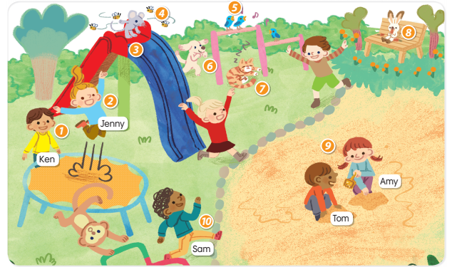

1)What is Ken doing? 2) What is Jenny doing?

He’s standing.  *…………………………………………*

3) What is the mouse doing? 4) What are the bees doing?

*………………………………………… …………………………………………*

5) What are the birds doing? 6) What is the dog doing?

*………………………………………… …………………………………………*

7) What is the cat doing? 8) What is the rabbit doing?

*………………………………………… …………………………………………*

9) What are Tom and Amy doing? 10) What is Sam doing?

*………………………………………… …………………………………………*

11) Is there a monkey in the playground?

*…………………………………………*

Listening:

Part 1: Listen and number the picture. There is one example:

















1

Part 2: Listen and circle, there is one example:

1.

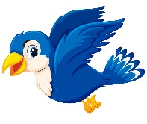

A B

2.

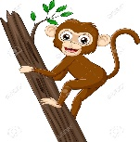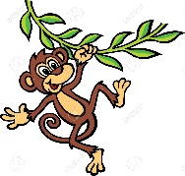

A B

3.

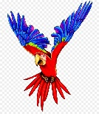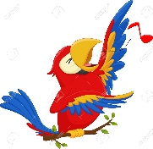

A B

4.

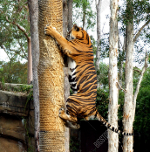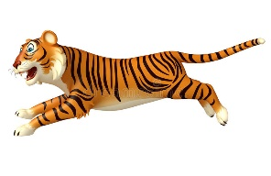

A B

5.

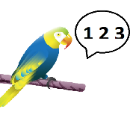

A B

6.

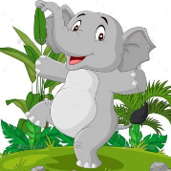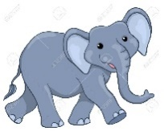

A B

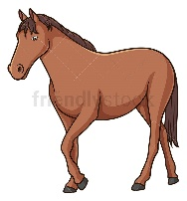7. 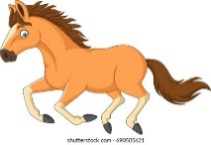

A B

8.



A B

9.

 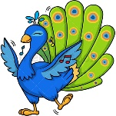

A B