Exercise 1: Write the words:
listening to music | singing | writing | drawing a picture
playing basketball | watching TV | dancing | reading

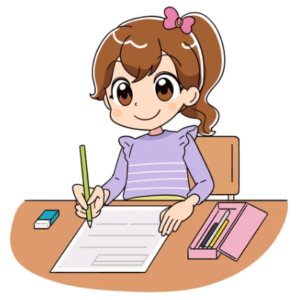 |  |  | 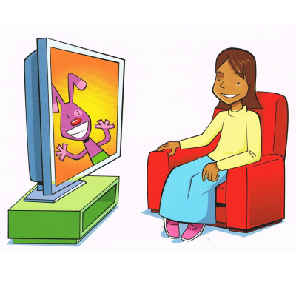
…………………. | …………………. | …………………. | ………………….
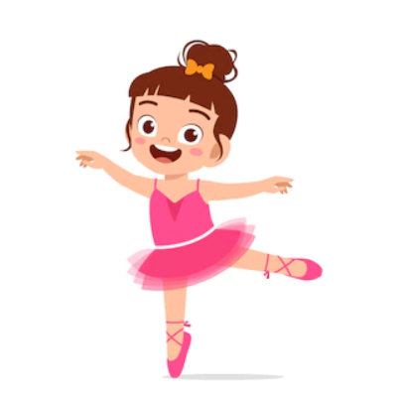 | 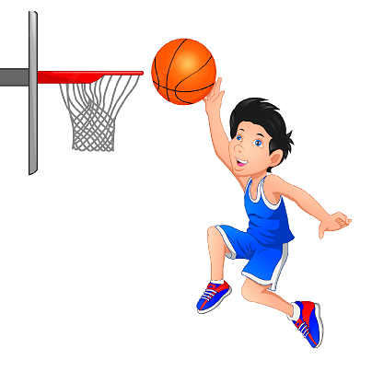 |  | 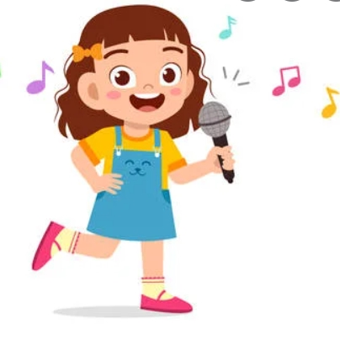
…………………. | …………………. | …………………. | ………………….

Exercise 2. Read and number

- I’m listening to music. | - I’m writing.
- I’m singing. | - I’m drawing a picture.
- I’m reading. | - I’m dancing.
- I’m playing basketball. | - I’m watching TV
Exercise 3 :Look and circle the right sentence.
1. I’m writing.
2. I’m watching.
3. I’m drawing a picture.
1. I’m reading.
2. I’m dancing.
3. I’m writing.
1. I’m watching TV.
2. I’m playing basketball.
3. I’m writing.
1. I’m singing.
2. I’m listening to music.
3. I’m dancing.
1. I’m writing.
2. I’m reading.
3. I’m drawing a picture.
1. I’m singing.
2. I’m reading.
3. I’m watching TV.
1. I’m listening to music.
2. I’m playing basketball.
3. I’m drawing a picture.
1. I’m reading.
2. I’m singing.
3. I’m dancing.

Exercise 4: Answer the questions:
- What are you doing? | - What are you doing? |  | - What are you doing?
……………………………….. | ……………………………….. |  | ………………………………..
- What are you doing? | - What are you doing? |  | - What are you doing?
……………………………….. | ……………………………….. |  | ………………………………..
g. What are you doing? |  | h. What are you doing?
…………………………………….. |  | ….………………………………..
 |  | 
i. What are you doing? |  | k. What are you doing?
…………………………………….. |  | ….………………………………..
Exercise 5. Write the answers:
Yes, I am. | No, I am not.

Are you listening to music? | Are you singing ? | Are you dancing?
……………………………….. | ……………………………….. | ………………………………..
Are you watching TV? | Are you reading? | Are you singing ?
……………………………….. | ……………………………….. | ………………………………..
Are you reading? | Are you playing football? | Are you listening to music ?
……………………………….. | ……………………………….. | ………………………………..
Are you writing? | Are you dancing | Are you writing?
……………………………….. | ……………………………….. | ………………………………..
Are you playing basketball? | Are you reading | Are you singing?
……………………………….. | ……………………………….. | ………………………………..
Exercise 6: Answer the questions
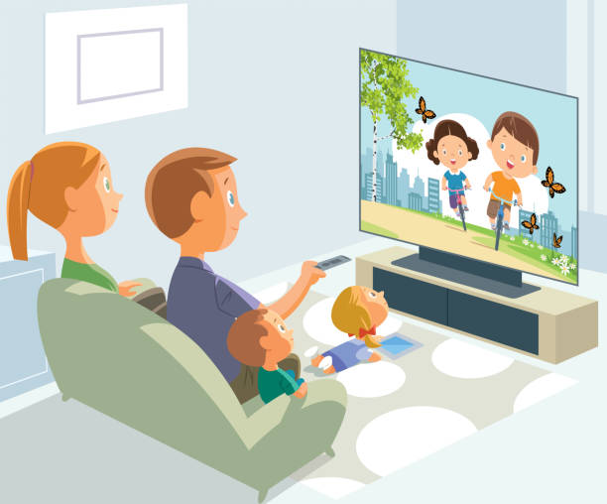 | 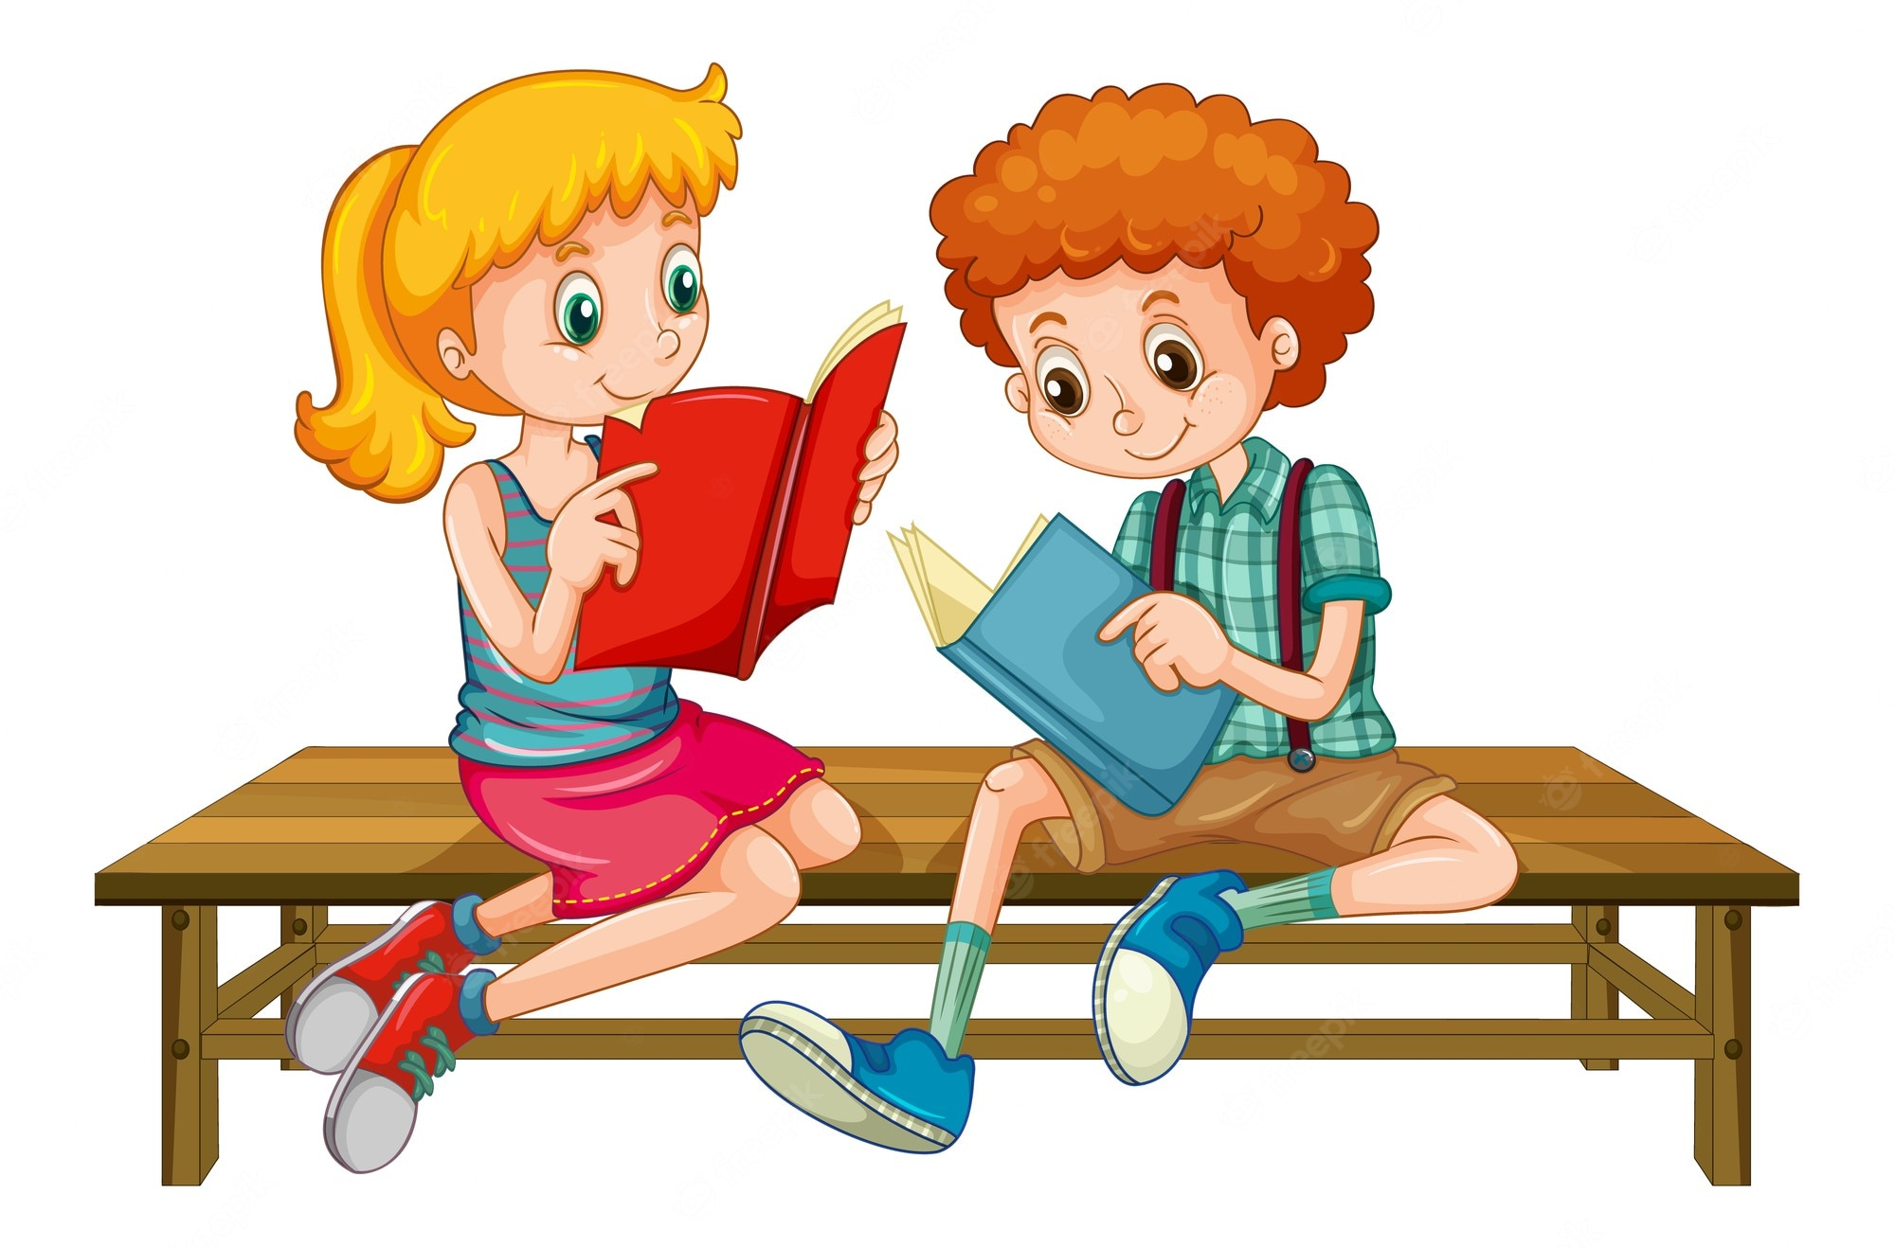 |  | 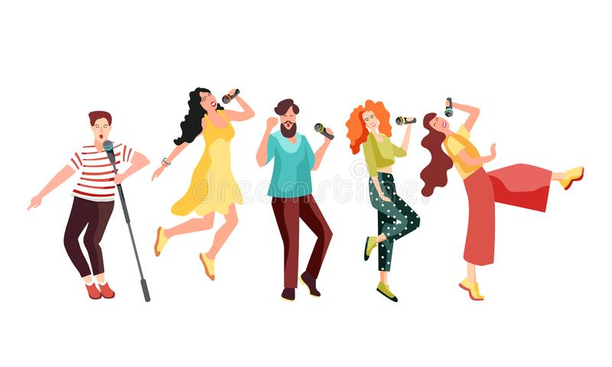
What are they doing? | What are they doing? |  | What are they doing?
………………………………………………….. | ………………………………………………….. |  | …………………………………………………..
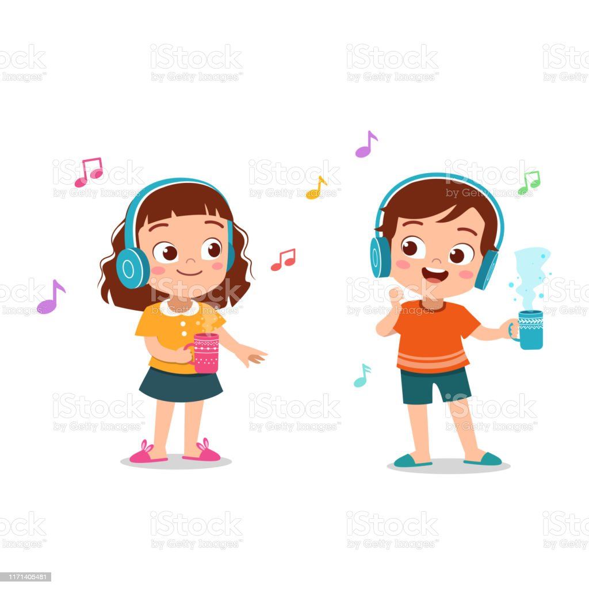 | 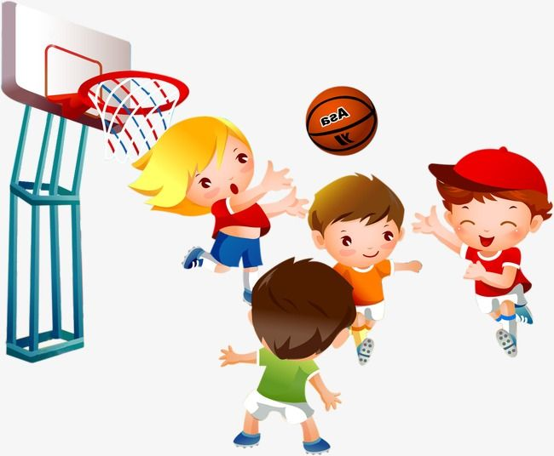 |  | 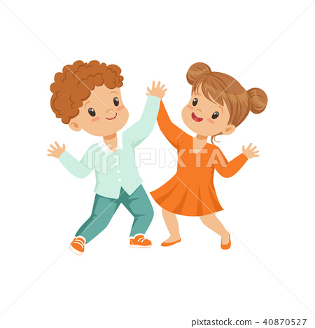
What are they doing? | What are they doing? |  | What are they doing?
………………………………………………….. | ………………………………………………….. |  | …………………………………………………..
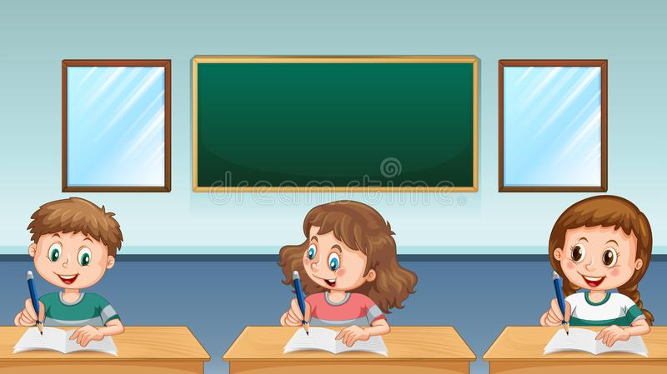 |  | 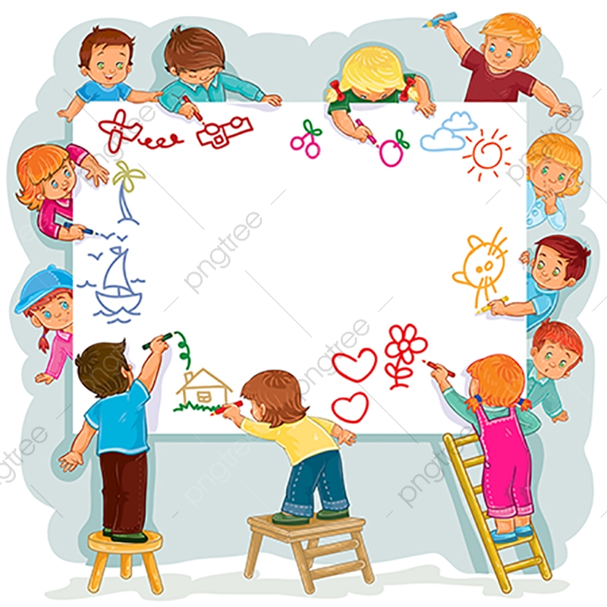
What are they doing? |  | What are they doing?
………………………………………………….. |  | …………………………………………………..
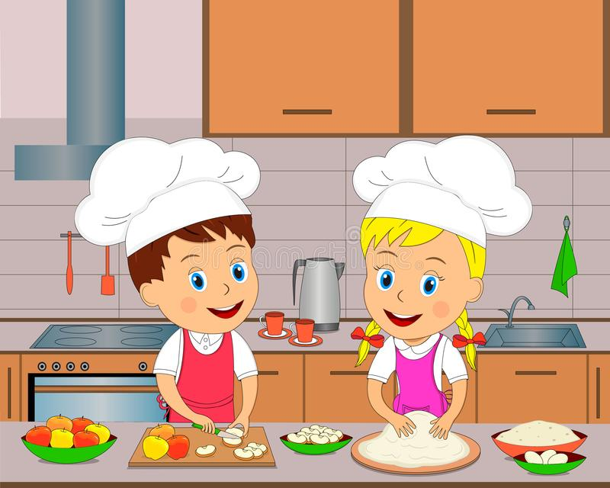 |  | 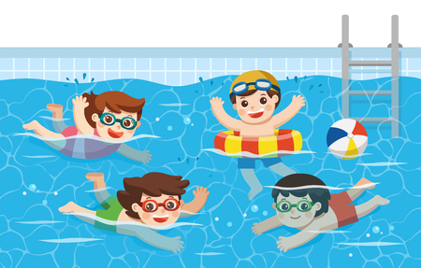
What are they doing? |  | What are they doing?
………………………………………………….. |  | …………………………………………………..

Exercise 7: Writing the sentences, using I’m…….. – They ‘re……..
…………………………………. | …………………………………. | ………………………………….
…………………………………. | …………………………………. | ………………………………….
…………………………………. | …………………………………. | ………………………………….
…………………………………. | …………………………………. | ………………………………….
…………………………………. | …………………………………. | ………………………………….
Exercise 8: Complete the sentences.
a) What are you doing ? …………am reading.
b) ………………… you doing ? I’m writing.
c) What are they doing? They ............ playing basketball.
d) What are you …………? I’m singing.
e) Are you watching TV ? Yes, …………am.
f) …………are they doing ? They are reading in the bedroom.
g) What are they doing? ……………..are dancing.
i) What are you doing? I’m……………………to music.
k) What are you doing? I’m ……………….a picture.
Exercise 9: Make questions for these answers.
A) I’m listening to music.
…………………………………………………………………………
B) Yes, I am watching TV.
………………………………………………………………………………………
C) They are playing badminton.
………………………………………………………………………………………
D) No, I’m reading.
………………………………………………………………………………………
E) Lucy and Mary are drawing a picture.
………………………………………………………………………………………
F) I have two cars.
………………………………………………………………………………………
G) My trucks are on the bed.
………………………………………………………………………………………
H) They have six golfish.
………………………………………………………………………………………
I) Yes, I have two parrots.
………………………………………………………………………………………
Exercise 10: Write the words in the correct order.
a) drawing – I – a – am – picture.
…………………………………………………………….
b) listening – music – to – They’re
…………………………………………………………….
c) TV – watching – am – I
…………………………………………………………….
d) singing – are – They – and – dancing
…………………………………………………………….
e) am – in – cooking – the – I – kitchen
…………………………………………………………….
f) in – reading – bedroom – are – the – They
…………………………………………………………….
g) Ben – basketball – and – are – Bill – playing
…………………………………………………………….
h) writing – I – am
…………………………………………………………….
11.Read and circle
a. My father ______________ a big cat.
- have | - has | - is
b.________________ they watching TV? No , they aren’t .
- Am | - is | - Are
c. I am _____________ in my bedroom.
- read | - reading | - to read
d. Are you writing? Yes , I _____________ .
- am not | - is | - am
e. What are you _________________. I’m cooking
- doing | - do | - to do
f. Are you swimming? No, I _____________.
- am | - am not | - not
g. What are they doing? ____________ are listening to music.
- I | - He | - They
h. Are they making a sandcastle? Yes, they _____________.
- am | - is | - are
i._________ Lisa and Lily playing chess? Yes, they are.
- Are | - Is | - Am
l. What are they doing ? They ___________ playing volleyball.
- are | - is | - am

Exercise 12: Find and correct the mistake:
- She have a new train
She has a new train.
- I’m listen to music.
………………………………………………………………….
- What is you doing? I’m watching TV
………………………………………………………………….
4. They are cook in the kitchen .
………………………………………………………………….
5. What are you do? I’m reading.
………………………………………………………………….
6. What are you doing? I’m listening music.
………………………………………………………………….
7. I’m read in library.
………………………………………………………………….
8. Are you drawing a picture? No, I not.
………………………………………………………………….
9. What are you doing? I playing basketball.
………………………………………………………………

Exercise 13: Odd one out:
- drawing | - play | - writing | - reading
- volleyball | - basketball | - playing | - football
- He | - I | - They | - have
- watch | - writing | - sing | - dance
- like | - cat | - dog | - goldfish
- truck | - kite | - plane | - singing
- classroom | - swimming | - library | - art room
- is | - am | - are | - an
- speak | - doll | - play | - swim
- meat | - rice | - chicken | - school
- singing | - kitchen | - bedroom | - bathroom

Listening:
Part 1: Listen and number the picture, there is one example:

1

Part 2: Listen and write. There is one example:
1. Ben | listening to music
2. Anna | ………………………………………………………….
3. Lucy | ………………………………………………………….
4. Jill | ………………………………………………………….
5. Mary | ………………………………………………………….
6. Mai | ………………………………………………………….
7. Linh | ………………………………………………………….
8. Jim | ………………………………………………………….

