Exercise 1: Look and write

|  |  |  |  |  |
| --- | --- | --- | --- | --- |
| kite | train | plane | truck | car |
| doll | toy | bus | teddy bear | ship |

|  |  |  |  |  |
| --- | --- | --- | --- | --- |
| https://bestflashcard.com/images/vocabulary/english/sgk-tieng-anh-3-global-success-unit-17/truck.PNG | https://bestflashcard.com/images/vocabulary/english/sgk-tieng-anh-3-global-success-unit-17/plane.PNG | https://bestflashcard.com/images/vocabulary/english/sgk-tieng-anh-3-global-success-unit-17/ship.PNG | https://bestflashcard.com/images/vocabulary/english/sgk-tieng-anh-3-global-success-unit-17/kite.PNG | https://bestflashcard.com/images/vocabulary/english/sgk-tieng-anh-3-global-success-unit-17/car.PNG |
| ………………. | ………………. | ………………. | ………………. | ………………. |
| https://bestflashcard.com/images/vocabulary/english/sgk-tieng-anh-3-global-success-unit-17/teddy-bear.PNG | https://bestflashcard.com/images/vocabulary/english/sgk-tieng-anh-3-global-success-unit-17/train.PNG | https://bestflashcard.com/images/vocabulary/english/sgk-tieng-anh-3-global-success-unit-17/toy.PNG | https://bestflashcard.com/images/vocabulary/english/sgk-tieng-anh-3-global-success-unit-17/bus.PNG | Doll Clipart Free Download - Clipart World |
| ………………. | ………………. | ………………. | ………………. | ………………. |

Exercise 2: Circle the right sentence.

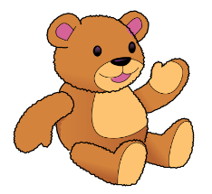

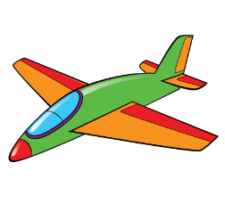

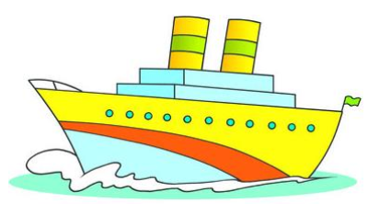

a) I have a kite. a) I have a ship. a) I have a bus.

b) I have a plane. b) I have a truck. b) I have a teddy bear.

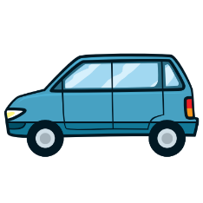

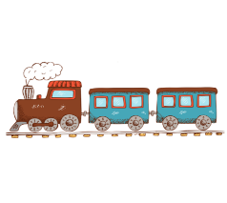



a) I have a car. a) I have a train. a) I have a train.

b) I have a kite. b) I have a bus. b) I have a car.

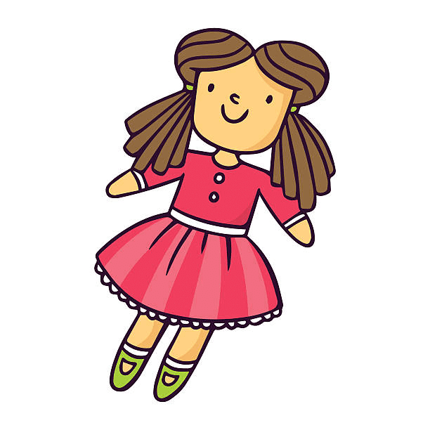

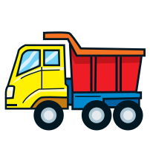



a) I have a teddy bear. a) I have a truck. a) I have a doll.

b) I have a bus. b) I have a plane. b) I have a teddy bear.

Exercise 3: Complete the sentences and match

|  |  |
| --- | --- |
| Have | Has |

|  |  |  |
| --- | --- | --- |
| 1. She ………. a plane. |  | https://bestflashcard.com/images/vocabulary/english/sgk-tieng-anh-3-global-success-unit-17/car.PNG |
| 2. I …………. a truck. | https://bestflashcard.com/images/vocabulary/english/sgk-tieng-anh-3-global-success-unit-17/kite.PNG |
| 3. Ben ……….a car. | https://bestflashcard.com/images/vocabulary/english/sgk-tieng-anh-3-global-success-unit-17/ship.PNG |
| 4. He …………a teddy bear. | https://bestflashcard.com/images/vocabulary/english/sgk-tieng-anh-3-global-success-unit-17/truck.PNG |
| 5. They………..a bus. | Doll Clipart Free Download - Clipart World |
| 6. My sister………….a kite. | https://bestflashcard.com/images/vocabulary/english/sgk-tieng-anh-3-global-success-unit-17/plane.PNG |
| 7. Jack and Peter …………..a ship. | https://bestflashcard.com/images/vocabulary/english/sgk-tieng-anh-3-global-success-unit-17/bus.PNG |
| 8. My brother……….a train. | https://bestflashcard.com/images/vocabulary/english/sgk-tieng-anh-3-global-success-unit-17/teddy-bear.PNG |
| 9. She…………..a doll. |  | https://bestflashcard.com/images/vocabulary/english/sgk-tieng-anh-3-global-success-unit-17/train.PNG |

Exercise 4: Look and write, using ***have- has***

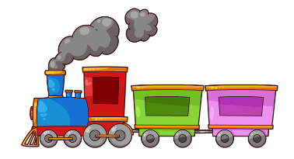



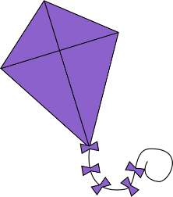



4. Jim

1. Lucy

2. Bill and Tom

3. Mary

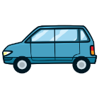

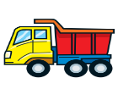



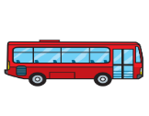

7. My brother

8. My sister

5. My friends

6. I





6. My sisters

7. They

1. Lucy ***has*** a plane.

2. ……………………………………………………..

3. ……………………………………………………..

4. ……………………………………………………..

5. ……………………………………………………..

6. ……………………………………………………..

7. ……………………………………………………..

8. ……………………………………………………..

9. ……………………………………………………..

Exercise 5: Look at the number of toys, write: ***She/ He has …. – They have….***

|  |  |  |  |
| --- | --- | --- | --- |
| Illustration Of Cartoon Boy With Train Toy Royalty Free SVG, Cliparts,  Vectors, And Stock Illustration. Image 16835039. | 1. He has a train | Kid girls share toy bear unfortunate illustration. Illustration of a kid  girl sharing and giving her teddy bear toy to a less | CanStock | 2. ……………………………… |
| 85 Background Of Girl Flying Kite Illustrations & Clip Art - iStock | 3. …………………………….. | Little boy playing toy cars illustration. | CanStock | 4.…………………………….. |
| 64 Boy Toy Truck Illustrations & Clip Art - iStock | 5. …………………………….. | Preschool Red Hair Boy and African American Girl Kids Playing with Wooden  Bricks and Blocks Together in Kindergarten Stock Vector - Illustration of  cute, kinder: 174668514 | 6. …………………………….. |
| Download Dolls Clip Art - Girl Playing With Dolls Clipart - Full Size PNG  Image - PNGkit | 7. …………………………….. | Boys playing with toy cars stock vector. Illustration of infancy - 107108148 | 8. …………………………….. |
| Baby Girl with Teddy Bear stock vector. Illustration of innocence - 25438598 | 9. …………………………….. | Little Boy With Toy Airplane Royalty Free Cliparts, Vectors, And Stock  Illustration. Image 89018803. | 10. …………………………….. |
| Premium Vector | Cartoon little boy playing bus and airplane toys | 11. …………………………….. | Happy girl cartoon character holding a toy ship Vector Image | 12. …………………………….. |
| Small Cute Girl Running And Playing Kite Stock Illustration - Download  Image Now - iStock | 13. …………………………….. | Premium Vector | Scene with children repairing toy boat together | 14. …………………………….. |

Exercise 6: Find the mistakes and correct them.

|  |  |  |
| --- | --- | --- |
| Premium Vector | A boy happy play with the grey teddy bear | Girl Playing with Remote Controlled Car Stock Vector - Illustration of  person, clipart: 82186854 | Illustration Of Cute Boy And Girl Playing With Their Toys Cars Red Hair Boy  Shows And Shares His Toy Cars To His Africanamerican Friend Stock  Illustration - Download Image Now - iStock |
| 1. **She** has a teddy bear. | 1. She have a car. | 1. They has three cars. |
| He has a teddy bear. | *…………………………* | *………………………..* |
| Pin on Clip art Kids | Boy and girl flying kite Royalty Free Vector Image | Boy plays with a toy car stock illustration. Illustration of drawing -  17641207 |
| d. He has a planes. | e. He have a kite. | f. They has a truck. |
| *…………………………..* | *………………………..* | *…………………………..* |
| Premium Vector | Cartoon little boy playing bus and airplane toys | Kids Playing Kites Stock Illustration - Download Image Now - iStock | kids playing on ship 521095 Vector Art at Vecteezy |
| g. He has a plane and a kite. | They have four kite. | h. They have a truck. |
| *………………………………*  .. | *……………………………*  .. | *……………………………*  .. |
| Child That Plays Stock Illustration 77131237 | Shutterstock | Vector illustration of a girl holding her rag doll Stock Vector Image & Art  - Alamy | Vector Illustration Little Boy Rolling His Car Truck Print, Cartoon,  Illustration, Baby PNG and Vector with Transparent Background for Free  Download |
| i. He has a yellow car. | k. He has a doll. | l. He has some trucks. |
| *……………………………..*  .. | *…………………………….*  .. | *…………………………….*  .. |

Exercise 7: Read and Tick **(√ )** or cross **(** **X )**

|  |  |
| --- | --- |
| Hello. I’m Mary. I’m seven years old. I have many toys. I have two big kites. I like flying kites. I have two trains, they’re blue. I have four teddy bears, they’re brown. I have a small car and a blue ship. My plane is orange and blue, it’s new. I have a truck, it’s old. I have two dolls, they’re pink. I love my toys. | Toys Stock Illustrations – 105,322 Toys Stock Illustrations, Vectors &  Clipart - DreamstimeKids Toys Clip Art Set – Daily Art Hub – Free Clip Art Everyday |

1. What is her name?

..................................................................

1. How old is she?

..................................................................

1. How many kites does she have?

..................................................................

1. What color are the kites?

..................................................................

1. How many train does she have?

..................................................................

1. Are the trains red?

..................................................................

1. How many teddy bears does she have?

..................................................................

1. What color are the teddy bears?

..................................................................

1. How many cars does she have?

..................................................................

10- Is her car big or small?

..................................................................

11- How many ships does she have?

..................................................................

12- Is the ship yellow?

..................................................................

13- How many planes does she have?

..................................................................

14- What color is the plane?

..................................................................

15- Is the plane new?

..................................................................

16- How many trucks does she have?

..................................................................

17- Is the truck new or old?

..................................................................

18- How many toys does she have?

..................................................................

Exercise 8: Read and match

|  |  |
| --- | --- |
| 1. Where is the cat? | 1. Yes, I do. I have two kites. |
| 1. What is this? | 1. The cat is on the table. |
| 1. How many goldfish do you have ? | 1. They’re on the bed. |
| 1. Is the train on the chair ? | 1. No, it isn’t. It’s small. |
| 1. Where are the cars ? | 1. I have five goldfish. |
| 1. Do you have any kites ? | 1. Yes, it is. |
| 1. What is his job ? | 1. They have three parrots. |
| 1. Are your trucks in the living room? | 1. He’s a worker. |
| 1. Is your ship big? | 1. It’s a train. |
| 1. How many parrots do they have? | 10) No, they are in the bedroom. |

Exercise 9: Write about your friends:

|  |  |  |  |
| --- | --- | --- | --- |
|  | **School things** | **Toys** | **Pets** |
| **Phong** | Four colorful pens stock illustration. Illustration of shine - 11341597Erasers stock photo. Image of school, closeup, deleting - 36792016Pencil Clipart | EtsyBuy eBoot 2 Pieces Plastic Color Ruler Straight Ruler Math Rulers 12  Inches, Pink and Blue Online in Indonesia. B07B48S1NDSchool Bag Clip Art Backpack Illlustration Vector Stock Vector -  Illustration of artistic, isolated: 198347690 | Three Cute Teddy Bears Illustration Royalty Free SVG, Cliparts, Vectors,  And Stock Illustration. Image 93264907.bus londres red clipart | Clipart Panda - Free Clipart ImagesAmazon.com: Wonder Wheels by Battat – Dump Truck, Tow Truck, Cement Truck – Toy  Truck Combo Set for Toddlers Age 1 & Up (3 Pc) – 100% Recyclable , Yellow :  Toys & GamesKite Clipart Illustration Vector Isolated Stock Vector - Illustration of  clip, kites: 201382873Red Car and Blue Car Illustration Stock Vector - Illustration of auto,  front: 41038115 | Illustration of cute red kitten Stock Vector Image by ©Dazdraperma  #10315605483 Birds clip art ideas | clip art, art, birdsNotice to All Dog Owners - Town of Fulton |
| This is my friend. His name is Phong. He has one school bag, two pencils, two rulers, three erasers and four pens. | He has…………………….  ………………………………  ………………………………  ………………………………  ……………………………… | ……………………………  …………………………  ……………………………  ……………………………  …………………………… |
| **Lan and Mai** | Eraser Cartoon Images – Browse 14,309 Stock Photos, Vectors, and Video |  Adobe Stock2,765 Three Rulers Stock Photos, Pictures & Royalty-Free Images - iStockVector Set Of Pen And Mechanical Pencil Royalty Free SVG, Cliparts,  Vectors, And Stock Illustration. Image 93164000.Pack of Yellow Pencils - Some with Erasers on the Back End Stock  Illustration - Illustration of erasers, pack: 161212214Clip Art Illustration School Bag Free Content, PNG, 800x732px, School,  Area, Backpack, Bag, Classroom Download Free | Toy dump truck plastic car in bright colors Vector ImageTwo Airplanes With Blue And White Colors Illustration Royalty Free SVG,  Cliparts, Vectors, And Stock Illustration. Image 93436556.Cartoon Boat on White Background. a Toy Ship for Children. Colorful Vector  Illustration for Kids. Stock Vector - Illustration of steamer, background:  104062901Dolls Stock Illustrations – 5,490 Dolls Stock Illustrations, Vectors &  Clipart - DreamstimeSet of Four Cute Toy Multicoloured Cars Stock Vector - Illustration of  cute, ride: 187371744 | Kitty Clipart Pet Cat - Cat Png Clip Art PNG Image | Transparent PNG Free  Download on SeekPNGTwo Cartoon Dachshunds Stock Illustration - Download Image Now - iStockGoldfish Bowl Clipart Stock Illustrations – 114 Goldfish Bowl Clipart Stock  Illustrations, Vectors & Clipart - Dreamstime |
| ………………………………  ………………………………  ………………………………  ………………………………  ……………………………… | ………………………………  ………………………………  ………………………………  ………………………………  ……………………………… | ……………………………  ……………………………  ……………………………  ……………………………  …………………………… |
| **Chi** | Pen Clip Vector Art, Writing, Signature, Exam PNG and Vector with  Transparent Background for Free DownloadGreen Pencil and Eraser clipart. Free download transparent .PNG | CreazillaHand Drawn Cartoon School Bag Illustration, Backpack Clipart, School Bag,  Color Schoolbag PNG Transparent Clipart Image and PSD File for Free Downloadhand drawn children school bag png transparent - Clipart WorldVector Cartoon Single Ruler on White Background Stock Vector - Illustration  of isolated, centimeters: 90515880 | Clipart Teddy Bear free images - Clipart WorldTrain Clipart Images – Browse 47,533 Stock Photos, Vectors, and Video |  Adobe StockCute Clipart Borders Clipart Source - Kites Clip Art Transparent PNG -  432x432 - Free Download on NicePNG11,424 Toy Boat Cliparts, Stock Vector and Royalty Free Toy Boat  IllustrationsElliyana's Game Design Blog!: Aeroplane Design | Cartoon airplane, Airplane  crafts, Infant activities | Parrot clipart free - Clipart WorldTwo Valentine dogs | Stock vector | Colourbox |
| ………………………………  ………………………………  ………………………………  ………………………………  ……………………………… | ………………………………  ………………………………  ………………………………  ………………………………  ……………………………… | ……………………………  ……………………………  ……………………………  ……………………………  …………………………… |
| **My brothers** | 4 Packs Plastic Straight Rulers Plastic Ruler Measuring Tool For Student  School Office - Buy Plastic Ruler Measuring Tool For Student School  Office,4 Packs Plastic Straight Rulers,Measuring Tool For Student School  OfficePens Stock Illustrations – 10,838 Pens Stock Illustrations, Vectors &  Clipart - DreamstimeClose View Two Erasers 3d Render Stock Illustration 140057731 | ShutterstockPencil Clipart Pen - Pencils Clipart Png, Transparent Png -  910x720(#601602) - PngFindPurple School Bag Hand Drawn Illustration, School Bag Clipart, Purple School  Bag, Creative School Bag PNG Transparent Clipart Image and PSD File for  Free DownloadBack-to-School Braces Basics | School bags, Clip art, Kids learning  activities | Reading Triumphs Level 1 Unit 4.3 - QuizizzTwo Toys Car Trucks Isolated On Stock Photo 223733338 | Shutterstock  Boat Stock Photography Royalty-free Toy - Toy Boat Clipart Png, Transparent  Png is free transparent png image. Download and use it … | Free toys, Toy  boat, Clip art  Aeroplane Clipart, Airplane Clipart Png, Clipart, Airplane Vector PNG  Transparent Clipart Image and PSD File for Free Download | Aviao desenho,  Caminhão desenho infantil, Desenhar caricaturas de rostosDolls stock illustration. Illustration of small, handmade - 122461452 | Set of three cute rabbits 608085 Vector Art at VecteezyPremium Vector | Cute cat cartoon. cat clipart vector illustrationAquarium PNG |
| ………………………………  ………………………………  ………………………………  ………………………………  ……………………………… | ………………………………  ………………………………  ………………………………  ………………………………  ……………………………… | ……………………………  ……………………………  ……………………………  ……………………………  …………………………… |

Exercise 10: Put the words in the correct order

a) I – two – have – birds.

I have two birds.

b) blue – She – a – has – ship.

*………………………………………………………………………….*

c) Tony – three – cats – small – has.

*………………………………………………………………………….*

d) Peter – five - Ben – cars – have – and

*………………………………………………………………………….*

e) ten– They – goldfish - have

*………………………………………………………………………….*

f) Rose – dolls – new – has - two

*………………………………………………………………………….*

g) brown – your – Is – teddy bear?

*………………………………………………………………………….*

h) dogs – How – have – many- do – you?

*………………………………………………………………………….*

h) rabbit – have – any – hair – you?

*………………………………………………………………………….*

i) father – My – parrot – a – has – big.

*………………………………………………………………………….*

j) red – a – has – Alice – truck.

*………………………………………………………………………….*

k) small – and – They – planes – a – have – ship – three.

*………………………………………………………………………….*

l) is – his – What – have – color – train.

*………………………………………………………………………….*

Exercise 11: Look and write

|  |  |
| --- | --- |
| have | has |

a) I *……………….* four teddy bears. b) Tony and Ben *………….* many toys.

c) She *……………* a plane. d) Anna *…………..*some goldfish.

e) Rosy *……………* two kites. e) Lily *……………….* a small cat.

f) My father *…………….* a big dog. f) My brother …………..two new ships.

g) My sisters *……………*some dolls. g) My grandma *……………*a parrot.

h) She *……………*a newbus. i) John*……………….* a green car.

Listening:

Part 1: Listen and complete the following sentences:

1. I have a ……………...

2. (a)……………... has a (b)……………... kite.

3. My (a)……………...has a (b)……………... and a (c)……………....

4. (a)……………... have two (b)……………....

5. He has a (a)……………... doll and a red (b)……………....

6. She has a (a)……………... and three (b)……………...

7. Lucy has a (a)……………... (b)……………....

8. They have two (a)……………... dolls and a (b)……………... (c)……………....

Part 2: Listen and number the picture. There is one example:

|  |  |
| --- | --- |
| https://bestflashcard.com/images/vocabulary/english/sgk-tieng-anh-3-global-success-unit-17/bus.PNGBlue Toy Train Engine and Three Train Cars clipart. Free download  transparent .PNG | Creazilla | https://bestflashcard.com/images/vocabulary/english/sgk-tieng-anh-3-global-success-unit-17/car.PNGFree Red Car Cliparthttps://bestflashcard.com/images/vocabulary/english/sgk-tieng-anh-3-global-success-unit-17/car.PNG |
| https://s.sachmem.vn/public/sm-quizz/icons/checkbox-default.png | https://s.sachmem.vn/public/sm-quizz/icons/checkbox-default.png |
| Doll Clipart Free Download - Clipart Worldhttps://bestflashcard.com/images/vocabulary/english/sgk-tieng-anh-3-global-success-unit-17/teddy-bear.PNG | https://bestflashcard.com/images/vocabulary/english/sgk-tieng-anh-3-global-success-unit-17/kite.PNGhttps://bestflashcard.com/images/vocabulary/english/sgk-tieng-anh-3-global-success-unit-17/kite.PNGhttps://bestflashcard.com/images/vocabulary/english/sgk-tieng-anh-3-global-success-unit-17/ship.PNG |
| https://s.sachmem.vn/public/sm-quizz/icons/checkbox-default.png | https://s.sachmem.vn/public/sm-quizz/icons/checkbox-default.png |
| https://bestflashcard.com/images/vocabulary/english/sgk-tieng-anh-3-global-success-unit-17/bus.PNGhttps://bestflashcard.com/images/vocabulary/english/sgk-tieng-anh-3-global-success-unit-17/truck.PNGhttps://bestflashcard.com/images/vocabulary/english/sgk-tieng-anh-3-global-success-unit-17/truck.PNG | Doll Clipart Free Download - Clipart WorldDoll Clipart Free Download - Clipart WorldIcons Clipart Airplane - Airplane Clipart Icon, HD Png Download ,  Transparent Png Image - PNGitem |
| https://s.sachmem.vn/public/sm-quizz/icons/checkbox-default.png | https://s.sachmem.vn/public/sm-quizz/icons/checkbox-default.png |
| https://bestflashcard.com/images/vocabulary/english/sgk-tieng-anh-3-global-success-unit-17/car.PNGhttps://bestflashcard.com/images/vocabulary/english/sgk-tieng-anh-3-global-success-unit-17/kite.PNG | Icons Clipart Airplane - Airplane Clipart Icon, HD Png Download ,  Transparent Png Image - PNGitemhttps://bestflashcard.com/images/vocabulary/english/sgk-tieng-anh-3-global-success-unit-17/plane.PNGFree Red Car Clipart |
| 1 | https://s.sachmem.vn/public/sm-quizz/icons/checkbox-default.png |