Exercise 1: Write the words

|  |  |  |  |  |
| --- | --- | --- | --- | --- |
| new | room | small | desk | pillow |
| window | bed | old | big | door |

|  |  |  |  |
| --- | --- | --- | --- |
| https://bestflashcard.com/images/vocabulary/english/sgk-tieng-anh-3-global-success-unit-14/bed.PNG | https://bestflashcard.com/images/vocabulary/english/sgk-tieng-anh-3-global-success-unit-14/small.PNG | https://bestflashcard.com/images/vocabulary/english/sgk-tieng-anh-3-global-success-unit-14/old.PNG | https://bestflashcard.com/images/vocabulary/english/sgk-tieng-anh-3-global-success-unit-14/window.PNG |
| ……………………….. | ……………………….. | ……………………….. | ……………………….. |
| https://bestflashcard.com/images/vocabulary/english/sgk-tieng-anh-3-global-success-unit-14/new.PNG | An empty room interior 418708 Vector Art at Vecteezy | Pillow clipart image - Clipart World | https://bestflashcard.com/images/vocabulary/english/sgk-tieng-anh-3-global-success-unit-14/desk.PNG |
| ……………………….. | ……………………….. | ……………………….. | ……………………….. |
| https://bestflashcard.com/images/vocabulary/english/sgk-tieng-anh-3-global-success-unit-14/big.PNG | | https://bestflashcard.com/images/vocabulary/english/sgk-tieng-anh-3-global-success-unit-14/door.PNG | |
| ……………………….. | | ……………………….. | |

Exercise 2: Look and write, using ***There is - There are***

|  |  |
| --- | --- |
| https://bestflashcard.com/images/vocabulary/english/sgk-tieng-anh-3-global-success-unit-14/desk.PNG | https://bestflashcard.com/images/vocabulary/english/sgk-tieng-anh-3-global-success-unit-14/desk.PNGhttps://bestflashcard.com/images/vocabulary/english/sgk-tieng-anh-3-global-success-unit-14/desk.PNG |
| There is a desk. | There are two desks. |
| https://bestflashcard.com/images/vocabulary/english/sgk-tieng-anh-3-global-success-unit-14/window.PNG | https://bestflashcard.com/images/vocabulary/english/sgk-tieng-anh-3-global-success-unit-14/window.PNGhttps://bestflashcard.com/images/vocabulary/english/sgk-tieng-anh-3-global-success-unit-14/window.PNGhttps://bestflashcard.com/images/vocabulary/english/sgk-tieng-anh-3-global-success-unit-14/window.PNG |
| a) ………………………………………. | b)………………………………………… |
| An empty room interior 418708 Vector Art at VecteezyAn empty room interior 418708 Vector Art at Vecteezy | An empty room interior 418708 Vector Art at Vecteezy |
| …………………………………………………………………. | ………………………………………………………………… |
| Pillow clipart image - Clipart World  c) | d) |
| ………………………………………………………………… | ………………………………………………………………… |
| https://bestflashcard.com/images/vocabulary/english/sgk-tieng-anh-3-global-success-unit-14/door.PNGhttps://bestflashcard.com/images/vocabulary/english/sgk-tieng-anh-3-global-success-unit-14/door.PNG | https://bestflashcard.com/images/vocabulary/english/sgk-tieng-anh-3-global-success-unit-14/door.PNG |
| ………………………………………………………………… | ………………………………………………………………… |
| https://bestflashcard.com/images/vocabulary/english/sgk-tieng-anh-3-global-success-unit-14/bed.PNG | https://bestflashcard.com/images/vocabulary/english/sgk-tieng-anh-3-global-success-unit-14/bed.PNGhttps://bestflashcard.com/images/vocabulary/english/sgk-tieng-anh-3-global-success-unit-14/bed.PNG |
| ………………………………………………………………… | ………………………………………………………………… |
| Student Chair | Team building activities, Student chair, Team buildingStudent Chair | Team building activities, Student chair, Team buildingStudent Chair | Team building activities, Student chair, Team buildingStudent Chair | Team building activities, Student chair, Team building | Student Chair | Team building activities, Student chair, Team building |
| ………………………………………………………………… | ………………………………………………………………… |
| Clipart Png Lamp - Clip Art Table Lamp, Transparent Png , Transparent Png  Image - PNGitem | Clipart Png Lamp - Clip Art Table Lamp, Transparent Png , Transparent Png  Image - PNGitemClipart Png Lamp - Clip Art Table Lamp, Transparent Png , Transparent Png  Image - PNGitemClipart Png Lamp - Clip Art Table Lamp, Transparent Png , Transparent Png  Image - PNGitem |
| ………………………………………………………………… | ………………………………………………………………… |

Exercise 3: Write the sentences:

|  |  |  |
| --- | --- | --- |
| Hình ảnh có liên quanHình ảnh có liên quan | | https://bestflashcard.com/images/vocabulary/english/sgk-tieng-anh-3-global-success-unit-14/bed.PNGhttps://bestflashcard.com/images/vocabulary/english/sgk-tieng-anh-3-global-success-unit-14/bed.PNG |
| chair/ big   * The chair is big. | | bed/ small   * ………………………………………. |
| https://bestflashcard.com/images/vocabulary/english/sgk-tieng-anh-3-global-success-unit-14/new.PNG | | Window clipart. Free download transparent .PNG | CreazillaWindow clipart. Free download transparent .PNG | Creazilla |
| school bag/ new   * …………………………………….. | | Window/ big   * ………………………………………………….. |
| Door Clipart Stock Illustrations – 9,670 Door Clipart Stock Illustrations,  Vectors & Clipart - DreamstimeDoor Clipart Stock Illustrations – 9,670 Door Clipart Stock Illustrations,  Vectors & Clipart - Dreamstime | | https://bestflashcard.com/images/vocabulary/english/sgk-tieng-anh-3-global-success-unit-14/old.PNG |
| door/ small   * ……………………………………………….. | | school bag/ old   * ………………………………………. |
| Old lamp png images | PNGEgg | | Big Pink Erasers Bulk For Children Stationery - Buy Eraser,Pencil  Eraser,Rubber Eraser Product on Alibaba.com |
| lamp/ old   * …………………………………………………………….. | | eraser/ pink   * ……………………………………….. |
| 15 Ruler Clipart Png For Free Download On Mbtskoudsalg - Ruler Clipart |  Full Size PNG Download | SeekPNG | | Cartoon Old Wooden Chair Royalty Free SVG, Cliparts, Vectors, And Stock  Illustration. Image 25593231.Over The Chair Clipart - Chair Clipart Transparent Transparent PNG -  5534x8175 - Free Download on NicePNG |
| ruler/ yellow   * ……………………………………………………………… | | chair/ old   * ……………………………………………………… |
| Coffee Table clipart. Free download transparent .PNG | CreazillaCoffee Table clipart. Free download transparent .PNG | Creazilla | Vector Cartoon Interior Of Cozy Hotel Bedroom With Furniture - Double Bed,  Carpet And Terrace. Living Apartment Of Tropical Resort With Big Window,  Green Plants. Summer Rest. Colorful Background. Royalty Free Cliparts,Teen room. small bedroom for kids student apartment inside of house modern  interior vector cartoon. illustration of interior | CanStock | |
| table/ small   * ……………………………………………. | bedroom/ big   * …………………………………………… | |
| Blue Pen Doodle Style Illustration Stock Illustration - Download Image Now  - iStock | | School Desk png download - 2619*3064 - Free Transparent Desk png Download.  - CleanPNG / KissPNG |
| pen/ blue   * ……………………………………………………… | | desk/ old   * …………………………………………………………. |

Exercise 4: Circle the correct answer.

|  |  |
| --- | --- |
| Lamp clipart png picture - Clipart World | **There is**/ **There are** a lamp. |
| https://bestflashcard.com/images/vocabulary/english/sgk-tieng-anh-3-global-success-unit-14/bed.PNGhttps://bestflashcard.com/images/vocabulary/english/sgk-tieng-anh-3-global-success-unit-14/bed.PNGhttps://bestflashcard.com/images/vocabulary/english/sgk-tieng-anh-3-global-success-unit-14/bed.PNG | **There is**/ **There are** three beds. |
| Hình ảnh có liên quanHình ảnh có liên quan | **There is**/ **There are** two chairs. |
| https://bestflashcard.com/images/vocabulary/english/sgk-tieng-anh-3-global-success-unit-14/door.PNG | How many doors are there?  **There is**/ **There are** a door. |
| Window clipart. Free download transparent .PNG | CreazillaWindow clipart. Free download transparent .PNG | Creazilla | How many windows are there?  **There is**/ **There are** two windows . |
|  | How many pillows are there?  **There is**/ **There are** four pillows. |
| Coffee Table Wiki Fandom - Table Clipart, HD Png Download , Transparent Png  Image - PNGitem | How many tables are there?  **There is** / **There are** **a table**. |
| Set of Six Colored Ballpoint Pens with Buttons and Metal Stock Vector -  Illustration of colored, color: 105761995 | How many pens are there?  **There is** / **There are** six pens. |
| 5+ Kitchen Clipart - Preview : Kitchen Vector Ar | HDClipartAll | How many kitchens are there?  **There is** / **There are** a kitchen. |
| Desk clipart 1 - Clipart WorldDesk clipart 1 - Clipart WorldDesk clipart 1 - Clipart World | How many desks are there?  **There is** / **There are** three desks. |

Exercise 5: Write ***there is/ there are***

1*. ……………………………….* a chair.

2. *……………………………….* four bedrooms.

3. *……………………………….* a school bag.

4. *……………………………….* two tables.

5. *……………………………….* three lamps.

6. *……………………………….* two beds.

7. *……………………………….* a ruler.

8. *……………………………….* two bathrooms.

9. *……………………………….* eight pens

10. *……………………………….* a door.

11. *……………………………….* seventeen pencils.

12. *……………………………….* a living room.

13. *……………………………….* five desks.

Exercise 6: Make questions for these answer

a) There is a bed in the bedroom.

How many beds are there in the bedroom?

b) There are two pillows on the bed.

*………………………………………………………………………………………..*

c) There is a lamp on the table.

*………………………………………………………………………………………..*

d) There are four books in the school bag.

*………………………………………………………………………………………..*

e) There is a table in the living room.

*………………………………………………………………………………………..*

f) There are four bedrooms on my house.

*………………………………………………………………………………………..*

g) There are three windows in the bedroom.

*………………………………………………………………………………………..*

h) There is a desk in the bedroom.

*………………………………………………………………………………………..*

i) There are five chairs in the kitchen.

*………………………………………………………………………………………..*

j) There is a kitchen in the house.

*………………………………………………………………………………………..*

k) There are two bathrooms in the house.

*………………………………………………………………………………………..*

l) There are nine pencils in the pencil case.

*………………………………………………………………………………………..*

m) There is an eraser on the desk.

*………………………………………………………………………………………..*

Exercise 7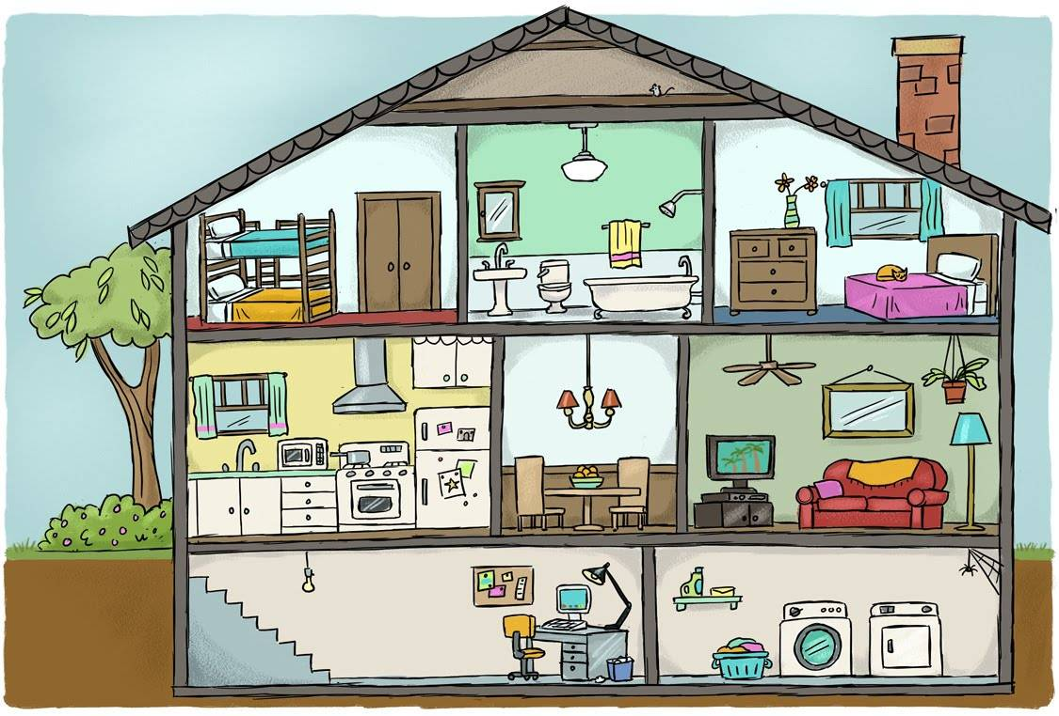: Answer the questions:

1. How many bedrooms are there in the house?

…………………………………………………………………………..

1. How many bathrooms are there in the house?

…………………………………………………………………………..

1. How many kitchens are there in the house?

…………………………………………………………………………..

1. How many living rooms are there in the house?

…………………………………………………………………………..

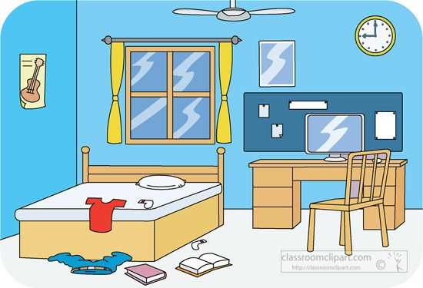

1. How many windows are the in the bedroom?

………………………………………………………………….

1. How many desks are there in the bedroom?

………………………………………………………………….

1. How many chairs are there in the bedroom?

………………………………………………………………….

1. How many beds are there in the bedroom?

………………………………………………………………….

1. How many books are there on the floor?

…………………………………………………………….......

10. How many pillows are there on the bed?

………………………………………………………………….

Exercise 8: Make and answer questions, using ***How many, there is, there are***



1. book

* ………………………………………………………………………..

……………………………………………………………………….

1. notebook

* ……………………………………………………………………….

……………………………………………………………………….

1. eraser

* ……………………………………………………………………….

……………………………………………………………………….

1. ruler

* ……………………………………………………………………….

……………………………………………………………………….

1. school bag

* ……………………………………………………………………….

……………………………………………………………………….

1. pencil

* ……………………………………………………………………….

……………………………………………………………………….

Exercise 9: Complete the sentences, using ***It’s - They’re***

|  |  |  |
| --- | --- | --- |
| Clipart bed Stock Vectors, Images & Vector Art | Shutterstock | 0. bed/bedroom/ big  -> There is a bed in the bedroom. **It’s** big.  1. lamp/ bedroom/ new  ->…………………………………………………………………….  2. pillow/bed/ green  ->……………………………………………………………………. | |
| Vector flat illustration of Modern Kitchen Interior Empty No People House  Room with kitchen furniture, table, chairs and cooking table Stock Vector  Image & Art - Alamy | 3. table/ kitchen/ yellow  ->………………………………………………………………….  4. chair/ kitchen/ orange  ->……………………………………………………………………. | |
| Premium Photo | Vintage lamp in the attic. old lamp on the table | 5. lamp/ table/ old.  ->……………………………………………………………………. | |
| PREPOSITION | Baamboozle | 6. School bag/ desk/ new  -> …………………………………………………………………… | |
| Classroom objects and indefinite article in French | Classroom, Teaching  french, French | | 7. book/ desk/ green  -> ……………………………………………………  8. ruler/ desk/ red  -> ………………………………………………….  9. pencil/ desk/ orange  -> ………………………………………………….  10. pencil case/ desk/ orange.  -> ………………………………………………… |
| Premium Vector | Bedroom scene with two windows | | 11. window/ bedroom/ small  -> ………………………………………………………………………..  12. lamp/ bedroom/ big  -> ………………………………………………………………………. |
| Living Room Furniture In Bright Colors On White Background. Blue Sofa With  Table, Stands, Lamps, Carpet, Porcelain Set, Soft Chairs In Room With Large  Window. Outside Spring Trees. Flat Cartoon Vector Royalty | | 13. table/ living room/ small  -> ……………………………………………………  14. window/ living room/ big  -> …………………………………………………… |

Exercise 10: Read the text and answer the questions:

My name is Ben. I’m eight years old. I like swimming. There are four people in my family. My father is a doctor, my mother is a nurse, my sister is a student, and I’m a student too. My house is new. There are four bedrooms, they’re small. There is a living room. it’s big. There are three bathrooms, they’re small. There is a kitchen, it’s big. My bedroom is blue. There is a bed in my bedroom, it’s small. There are two chairs and one desk. They’re old. There is a window in my bedroom, it’s new. I love my bedroom.

1. How old is Ben?

……………………………………………...........................................

1. What is his hobby?

……………………………………………...........................................

1. How many people are there in his family?

……………………………………………...........................................

1. Is his father a doctor?

……………………………………………...........................................

1. Is his mother a cook?

……………………………………………...........................................

1. What is his job?

……………………………………………...........................................

1. Is his house new?

……………………………………………...........................................

1. How many rooms are there in his house?

……………………………………………...........................................

1. How many bedrooms are there in his house?

……………………………………………...........................................

10. Are the bedrooms big?

……………………………………………...........................................

11. How many bathrooms are there in his house? How are they?

….……………………………………………………………………………..

1. What color is his bedroom?

……………………………………………………………………………….

1. How many chairs are there in his bedroom?

……………………………………………………………………………….

1. Is the bed big?

……………………………………………………………………………….

1. How many windows are there in his bedroom?

………………………………………………………………………………

Exercise 11: Put the words in the correct order

a) There – a bed – is – in – the bedroom.

*………………………………………………………………………………………….*

b) two – the bed – There are – pillows – on

*………………………………………………………………………………………….*

c) a table – There – living room – is – the – in

*………………………………………………………………………………………….*

d) are – There – ten – books – the – on – desk

*………………………………………………………………………………………….*

e) There – in – the kitchen – are – five chairs

*………………………………………………………………………………………….*

f) How many – the – lamps – in - are – there – bedroom?

*………………………………………………………………………………………….*

g) is – The – big – door.

………………………………………………………………………………………….

h) new – My – is – house.

Listening:

Part 1: Listen and circle. There is one example:

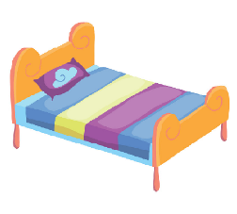1.

A B

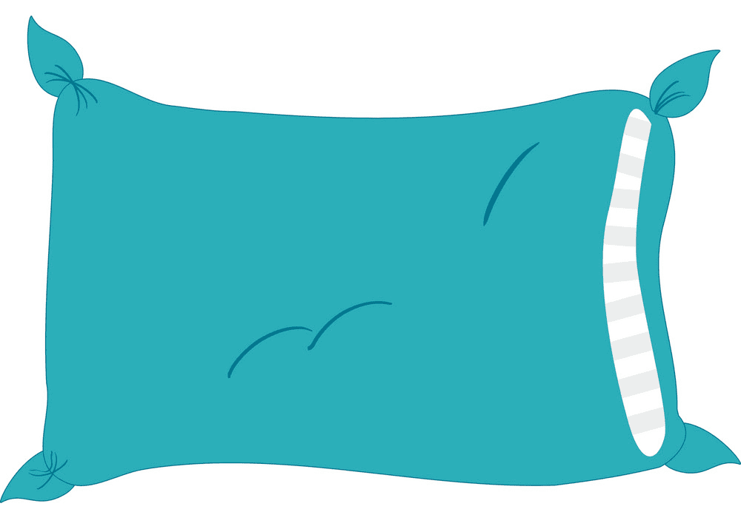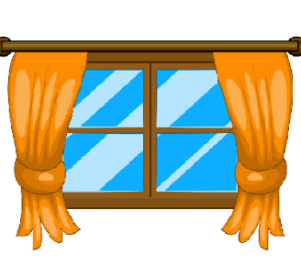2.

A B

3.

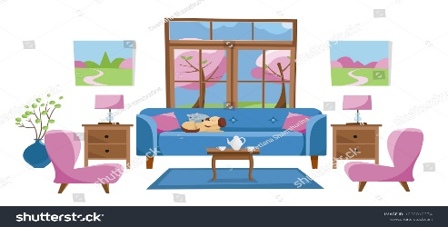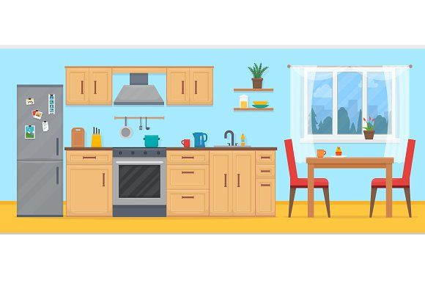

A B

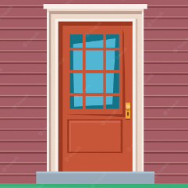4.

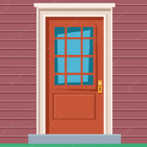

A B

5.

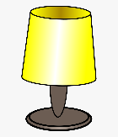 

A B

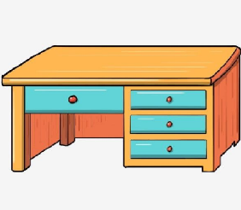6.

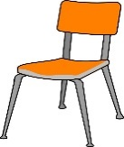

A B

Part 2: Listen and tick https://s.sachmem.vn/public/sm-quizz/icons/checkbox-tick.png or cross https://s.sachmem.vn/public/sm-quizz/icons/checkbox-cross.png. There are two examples

|  |  |
| --- | --- |
| Hình ảnh có liên quanHình ảnh có liên quan | https://bestflashcard.com/images/vocabulary/english/sgk-tieng-anh-3-global-success-unit-14/bed.PNGhttps://bestflashcard.com/images/vocabulary/english/sgk-tieng-anh-3-global-success-unit-14/bed.PNG |
| https://s.sachmem.vn/public/sm-quizz/icons/checkbox-cross.png1. | https://s.sachmem.vn/public/sm-quizz/icons/checkbox-tick.png2. |
| https://bestflashcard.com/images/vocabulary/english/sgk-tieng-anh-3-global-success-unit-14/new.PNG | Window clipart. Free download transparent .PNG | CreazillaWindow clipart. Free download transparent .PNG | Creazilla |
| https://s.sachmem.vn/public/sm-quizz/icons/checkbox-default.png3. | https://s.sachmem.vn/public/sm-quizz/icons/checkbox-default.png 4. |
| Door Clipart Stock Illustrations – 9,670 Door Clipart Stock Illustrations,  Vectors & Clipart - DreamstimeDoor Clipart Stock Illustrations – 9,670 Door Clipart Stock Illustrations,  Vectors & Clipart - Dreamstime | School Desk png download - 2619*3064 - Free Transparent Desk png Download.  - CleanPNG / KissPNG |
| https://s.sachmem.vn/public/sm-quizz/icons/checkbox-default.png5. | https://s.sachmem.vn/public/sm-quizz/icons/checkbox-default.png6. |
| Old lamp png images | PNGEgg | Pillow clipart image - Clipart World |
| https://s.sachmem.vn/public/sm-quizz/icons/checkbox-default.png 7. | https://s.sachmem.vn/public/sm-quizz/icons/checkbox-default.png8. |
| Coffee Table clipart. Free download transparent .PNG | CreazillaCoffee Table clipart. Free download transparent .PNG | Creazilla | Cartoon Old Wooden Chair Royalty Free SVG, Cliparts, Vectors, And Stock  Illustration. Image 25593231.Over The Chair Clipart - Chair Clipart Transparent Transparent PNG -  5534x8175 - Free Download on NicePNG |
| https://s.sachmem.vn/public/sm-quizz/icons/checkbox-default.png9. | https://s.sachmem.vn/public/sm-quizz/icons/checkbox-default.png10. |