Exercise 1: Look and write

|  |  |  |  |  |
| --- | --- | --- | --- | --- |
| green | red | blue | yellow | color |
| black | orange | white | brown |

|  |  |  |  |  |  |  |  |
| --- | --- | --- | --- | --- | --- | --- | --- |
| Brown Splat Svg Clip Arts - Pink Paint Splatter Clipart, HD Png Download -  kindpng |  | | Káº¿t quáº£ hÃ¬nh áº£nh cho black   clipart | |  | |  |
| *………………* | *………………* | | *………………* | | *………………* | | *………………* |
|  | | Orange Splash Ink Clip Art Icon - Orange Paint Splash Clipart PNG Image |  Transparent PNG Free Download on SeekPNG | | Káº¿t quáº£ hÃ¬nh áº£nh cho white  clipart | |  | |
| ………………… | | ………………… | | ………………… | | ………………… | |

Exercise 2: Put the words in the correct order

  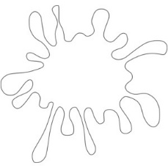

a) black – It – is b) It – blue – is c) is – It - white

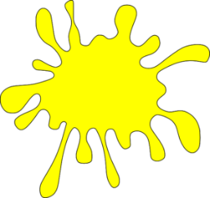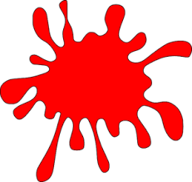 It is black *……………………………… ………………………………*



d) is – It – green e) It – red – is f) yellow – is - It

*…………………………… ……………………………… ………………………………*

Exercise 3: Look and write

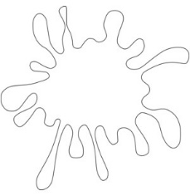

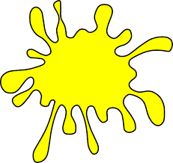

a) What color is it? b) What color is it? c) What color is it? d) What color is it?

*…………………… …………………….. …………………….. …………………….*

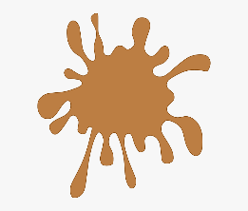*.*

e) What color is it? f) What color is it? g) What color is it? h) What color is it?

……………………… ………………….. ………………….. …………………

Exercise 4: Look and write:

|  |  |
| --- | --- |
| Yes, it is. | No, it isn’t. |

   

a) Is it red? b) Is it red? c) Is it blue? d) Is it yellow?

*………………….. ………………….. ………………….. …………………..*

Exercise 5: Look, read and write the missing letters





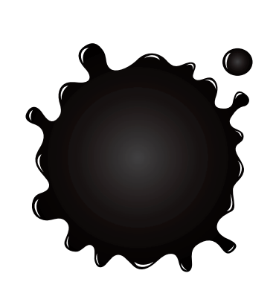

bl _ _ _

y_l_o_

g_ _en



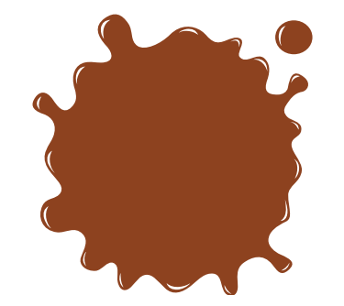



_r_n_e

r_d

_ _ own

Exercise 6: Make and answer the questions, there is an example:

|  |  |  |  |
| --- | --- | --- | --- |
| Transparent Broken Pencil Png - Pencil Emoji Black And White, Png Download  - kindpng | Pink and blue eraser Images, Stock Photos & Vectors | Shutterstock | Japanese Red School Bag for Elementary School Students Stock Vector -  Illustration of elementary, freshman: 119855802 | Brown Pencil Clipart, HD Png Download - kindpng |
| - What color is the pen?  - It’s black. | ……………………..  .……………………. | .……………………..  ……………………… | .……………………. |
| Openbook Orange Covers Round Clip Art At Clker - Orange Open Book Clip Art  - Free Transparent PNG Clipart Images Download | Vector Cartoon Single Ruler on White Background Stock Vector - Illustration  of doodle, education: 90515886 | Notebook Clipart Black and White 4 - Clipart World | Pencil case icon outline style Royalty Free Vector Image |
| ……………………..  .……………………. | ……………………..  .……………………. | ……………………..  .……………………. | ……………………..  .……………………. |

Exercise 7: Write the school thing and the color

|  |  |
| --- | --- |
| Book Vector Drawing Illustration Graphics Free Hq Image - Vector Book  Cartoon Png Clipart (#5235532) - PinClipart | I have a……………………………..  It’s ………………………………….. |
| Stationery Supplies Realistic Orange Pencil, Children S Stationery, Pencil  Without Rubber PNG Transparent Clipart Image and PSD File for Free Download | …………………………………………  ………………………………………… |
| Ruler Clip Art at Clker.com - vector clip art online, royalty free & public  domain | …………………………………………  ………………………………………… |
| Yellow Backpack, Illustration, Vector On White Background. Royalty Free  SVG, Cliparts, Vectors, And Stock Illustration. Image 152541801. | …………………………………………  ………………………………………… |
| Blue Pencil Case Icon, Isometric 3d Style Stock Illustration - Illustration  of construction, materials: 125892722 | …………………………………………  ………………………………………… |
| Black Notepad Clip Art at Clker.com - vector clip art online, royalty free  & public domain | …………………………………………  ………………………………………… |
| Eraser coloring page - Coloringcrew.com | …………………………………………  ………………………………………… |
| Green Pen Clip Art - Green Pen Vector Image | …………………………………………  ………………………………………… |

Exercise 8: Read and color.

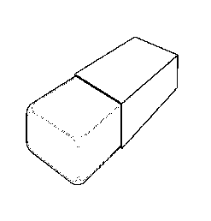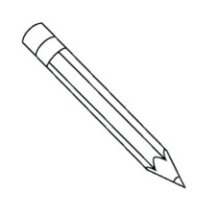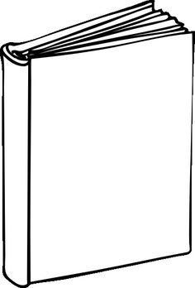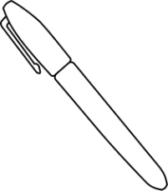

It’s a **black** book.

It’s a **blue** eraser.

It’s a **green** pen.

It’s a **brown** pencil.

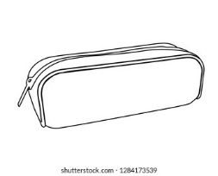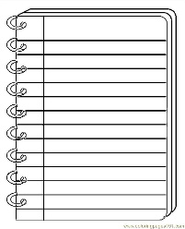

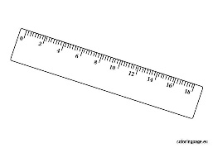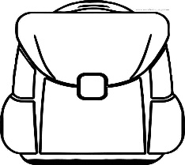

It’s a **yellow**

notebook

notebook pen.

It’s a **green** pen.

It’s an

**orange** eraser pen.

It’s a **red** school bag.

Exercise 9: Read and match

|  |  |  |
| --- | --- | --- |
| 1. What color is it? | 1. Yes, you can. |  |
| 1. Do you have a ruler? | 1. It’s green. |  |
| 1. How old are you ? | 1. Let’s go to the art room. |  |
| 1. May I come in ? | 1. Yes, I do. |  |
| 1. I like drawing. | 1. It’s a nose. |  |
| 1. What’s your hobby ? | 1. I’m ten years old. |  |
| 1. What’s this ? | 1. I like swimming. |  |

Exercise 10: Write the school things and color

|  |  |  |  |
| --- | --- | --- | --- |
| Bright Blue Backpack. School Bag. Rucksack with Small Pockets and Metal  Clasp. Cartoon Vector Design Stock Vector - Illustration of icon,  adventure: 137376042Bright Blue Backpack. School Bag. Rucksack with Small Pockets and Metal  Clasp. Cartoon Vector Design Stock Vector - Illustration of icon,  adventure: 137376042 | Free Pencil Mock Up Vectors, 1,000+ Images in AI, EPS format | Page 7 | Kawaii Christmas png images | PNGWingKawaii Christmas png images | PNGWingKawaii Christmas png images | PNGWing | Book Clip Art, PNG, 929x1280px, Book, Book Discussion Club, Brown, Drawing,  Free Content Download FreeBook Clip Art, PNG, 929x1280px, Book, Book Discussion Club, Brown, Drawing,  Free Content Download FreeBook Clip Art, PNG, 929x1280px, Book, Book Discussion Club, Brown, Drawing,  Free Content Download FreeBook Clip Art, PNG, 929x1280px, Book, Book Discussion Club, Brown, Drawing,  Free Content Download Free |
| What color are they?  They’re blue. | ………………………  ……………………… | ………………………  ……………………… | ………………………  ……………………… |
| Set Of Black Pens And Pencils Isolated On White, Vector Illustration  Royalty Free Cliparts, Vectors, And Stock Illustration. Image 16646773. | green pencil case Cheaper Than Retail Price> Buy Clothing, Accessories and  lifestyle products for women & men -green pencil case Cheaper Than Retail Price> Buy Clothing, Accessories and  lifestyle products for women & men -green pencil case Cheaper Than Retail Price> Buy Clothing, Accessories and  lifestyle products for women & men -green pencil case Cheaper Than Retail Price> Buy Clothing, Accessories and  lifestyle products for women & men -green pencil case Cheaper Than Retail Price> Buy Clothing, Accessories and  lifestyle products for women & men -green pencil case Cheaper Than Retail Price> Buy Clothing, Accessories and  lifestyle products for women & men -green pencil case Cheaper Than Retail Price> Buy Clothing, Accessories and  lifestyle products for women & men - | Ruler coloring page | February math, Coloring pages, First day of schoolRuler coloring page | February math, Coloring pages, First day of schoolRuler coloring page | February math, Coloring pages, First day of schoolRuler coloring page | February math, Coloring pages, First day of schoolRuler coloring page | February math, Coloring pages, First day of schoolRuler coloring page | February math, Coloring pages, First day of schoolRuler coloring page | February math, Coloring pages, First day of schoolRuler coloring page | February math, Coloring pages, First day of school | Yellow Book PNG - old-yellow-book yellow-book-club-invite caterpilar-with- yellow-book yellow-book-dancing yellow-book-vector yellow-book-symbols  yellow-book-cartoon yellow-book-logo yellow-book-maps yellow-book-template  yellow-book-worksheets ...Yellow Book PNG - old-yellow-book yellow-book-club-invite caterpilar-with- yellow-book yellow-book-dancing yellow-book-vector yellow-book-symbols  yellow-book-cartoon yellow-book-logo yellow-book-maps yellow-book-template  yellow-book-worksheets ...Yellow Book PNG - old-yellow-book yellow-book-club-invite caterpilar-with- yellow-book yellow-book-dancing yellow-book-vector yellow-book-symbols  yellow-book-cartoon yellow-book-logo yellow-book-maps yellow-book-template  yellow-book-worksheets ...Yellow Book PNG - old-yellow-book yellow-book-club-invite caterpilar-with- yellow-book yellow-book-dancing yellow-book-vector yellow-book-symbols  yellow-book-cartoon yellow-book-logo yellow-book-maps yellow-book-template  yellow-book-worksheets ...Yellow Book PNG - old-yellow-book yellow-book-club-invite caterpilar-with- yellow-book yellow-book-dancing yellow-book-vector yellow-book-symbols  yellow-book-cartoon yellow-book-logo yellow-book-maps yellow-book-template  yellow-book-worksheets ...Yellow Book PNG - old-yellow-book yellow-book-club-invite caterpilar-with- yellow-book yellow-book-dancing yellow-book-vector yellow-book-symbols  yellow-book-cartoon yellow-book-logo yellow-book-maps yellow-book-template  yellow-book-worksheets ... |
| ………………………  ……………………… | ………………………  ……………………… | ………………………  ……………………… | ………………………  ……………………… |

Exercise 11: Circle:

1. I have a pen. ***It’s/ They’re*** blue.

2. I have four pencils. ***It’s/ They’re*** brown.

3. I have a school bag. ***It’s/ They’re*** red.

4. Mai: I have three pencil cases.

Minh: What color ***is it/ are they***? ***It’s/ they’re*** green.

5. It’ a book***. It’s/ they’re*** black.

6. What color ***is/ are*** they?

7. What color ***is/ are*** the rulers

9. What color ***is/ are*** your eraser?

10. What color are they? ***It’s/ They’re*** white.

11. ***What/ How*** color is it?

12: My school bag ***is/ are*** orange.

13. My pencils ***is/ are*** brown.

14. This ***is/ are*** my notebook.

Exercise 12: Look and write:

|  |  |
| --- | --- |
| Set Of Black Pens And Pencils Isolated On White, Vector Illustration  Royalty Free Cliparts, Vectors, And Stock Illustration. Image 16646773. | I have five pens. They’re black.   * My pens are black |
| Kawaii Christmas png images | PNGWing | ……………………………………………………  …………………………………………………… |
| Bright Blue Backpack. School Bag. Rucksack with Small Pockets and Metal  Clasp. Cartoon Vector Design Stock Vector - Illustration of icon,  adventure: 137376042Bright Blue Backpack. School Bag. Rucksack with Small Pockets and Metal  Clasp. Cartoon Vector Design Stock Vector - Illustration of icon,  adventure: 137376042 | ……………………………………………………  …………………………………………………… |
| green pencil case Cheaper Than Retail Price> Buy Clothing, Accessories and  lifestyle products for women & men - | ……………………………………………………  …………………………………………………… |
| Free Pencil Mock Up Vectors, 1,000+ Images in AI, EPS format | Page 7 | ……………………………………………………  …………………………………………………… |
| Yellow Book PNG - old-yellow-book yellow-book-club-invite caterpilar-with- yellow-book yellow-book-dancing yellow-book-vector yellow-book-symbols  yellow-book-cartoon yellow-book-logo yellow-book-maps yellow-book-template  yellow-book-worksheets ... | ……………………………………………………  …………………………………………………… |
| Book Clip Art, PNG, 929x1280px, Book, Book Discussion Club, Brown, Drawing,  Free Content Download FreeBook Clip Art, PNG, 929x1280px, Book, Book Discussion Club, Brown, Drawing,  Free Content Download Free | ……………………………………………………  …………………………………………………… |
| Ruler Clip Art at Clker.com - vector clip art online, royalty free & public  domain | ……………………………………………………  …………………………………………………… |

Exercise 13: Odd one out

|  |  |  |  |
| --- | --- | --- | --- |
| a) book | b) flower | c) rubber | d) pencil |
| a) red | b) green | c) light blue | d) eight |
| a) boy | b) father | c) mother | d) grandfather |
| a) sit down | b) stand up | c) open your book | d) ruler |
| a) He | b) She | c) his | d) I |
| a) nine | b) black | c) six | d) five |
| a) blue | b) yellow | c) ear | d) gray |
| a) like | b) cooking | c) running | d) walking |
| a) computer room | b) painting | c) art room | d) classroom |

Listening:

Part 1: Listen, number and color. There is one example:

|  |  |  |  |
| --- | --- | --- | --- |
| Ruler coloring page | February math, Coloring pages, First day of school | Pencil case Images, Stock Photos & Vectors | Shutterstock | Notebook 12 Coloring Page for Kids - Free School Printable Coloring Pages  Online for Kids - ColoringPages101.com | Coloring Pages for Kids | Randoseru Firm Sided Backpack clipart. Free download transparent .PNG |  Creazilla |
|  |  |  | 1 |
| Káº¿t quáº£ hÃ¬nh áº£nh cho pencil   clipart black and white | Káº¿t quáº£ hÃ¬nh áº£nh cho book  clipart black and white | Káº¿t quáº£ hÃ¬nh áº£nh cho eraser clipart black and white | Káº¿t quáº£ hÃ¬nh áº£nh cho pen clipart black and white |
|  |  |  |  |

Part 2: Listen and complete the sentences. There is one example:

1. I have a pen. It’s black

2. I have (a)……………………. pencils. They’re (b) …………………….

3. I have a (a)……………………..It’s (b) …………………….

4. I have three (a)……………………..They’re (b) …………………….

5. Do you have a (a)………………….?

Yes, I do. I have four. They are (b)………………….

6. I have a (a)……………………. school bag. What color is your school bag?

It’ (b)…………………….

7. I have six books. They are(a) …………………….and(b) …………………….

8. Is your (a)…………………….red?

No, it isn’t. It’s (b)……………………..