Exercise 1: Look and write

|  |  |  |  |  |  |  |  |
| --- | --- | --- | --- | --- | --- | --- | --- |
| eraser | pen | School bag | book | Pencil case | notebook | ruler | pencil |

|  |  |  |  |
| --- | --- | --- | --- |
| Kết quả hình ảnh cho pen   clipart | Hình ảnh có liên quan |  | Kết quả hình ảnh cho pencil clipart |
| .……………………. | .……………………. | .……………………. | .……………………. |
| Book Vector Drawing Illustration Graphics Free Hq Image - Vector Book  Cartoon Png Clipart (#5235532) - PinClipart | Vector Cartoon Single Ruler on White Background Stock Vector - Illustration  of doodle, education: 90515886 | Notebook clipart transparent 4 - Clipart World | Pencil Case Clipart Student Pencil Case, Pencil Case Clipart, Childrens  Pencil Box, Pencil Case Clip Art PNG Transparent Clipart Image and PSD File  for Free Download |
| .……………………. | .……………………. | .……………………. | .……………………. |

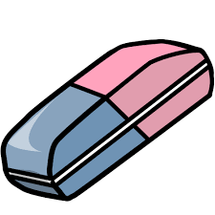Exercise 2: Look and write the missing letters.

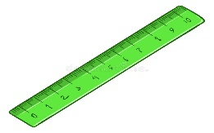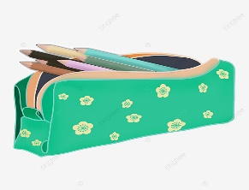

P_nc_l c_s_e

B_o_

er_se_

R_l_r

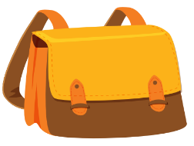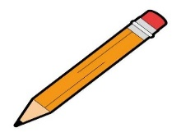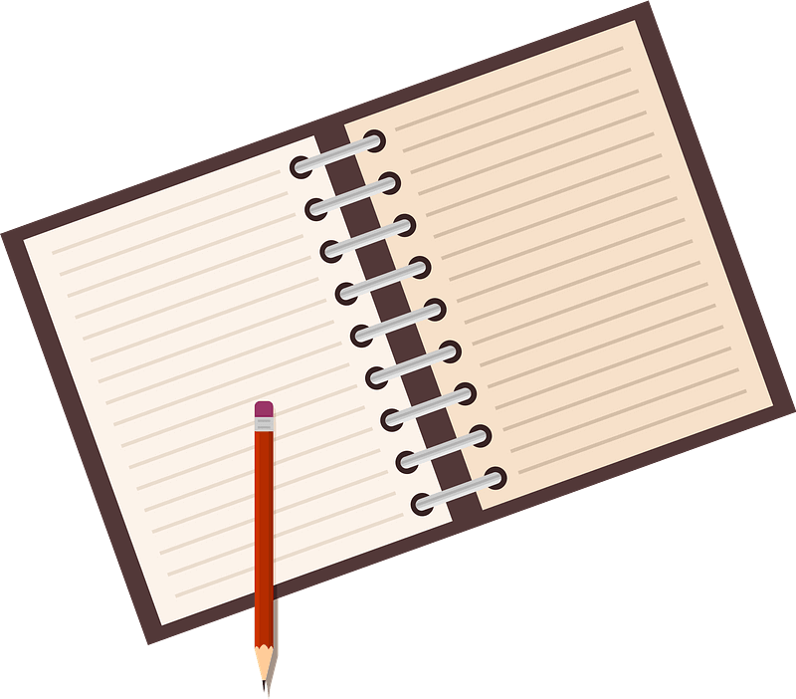

_e_

P_n_il

n_t_boo_

S_ho__ b_g

# Exercise 3: Rearrange the letters to make a word

|  |  |  |  |  |  |  |
| --- | --- | --- | --- | --- | --- | --- |
| Kết quả hình ảnh cho pencil clipart | Book Vector Drawing Illustration Graphics Free Hq Image - Vector Book  Cartoon Png Clipart (#5235532) - PinClipart | | Hình ảnh có liên quan | | | Vector Cartoon Single Ruler on White Background Stock Vector - Illustration  of doodle, education: 90515886 |
| P/n/e | b/o/k/o | | r/e/a/e/r/s | | | l/r/e/r/u |
|  |  | |  | | |  |
| Notebook clipart transparent 4 - Clipart World | | Pencil Case Clipart Student Pencil Case, Pencil Case Clipart, Childrens  Pencil Box, Pencil Case Clip Art PNG Transparent Clipart Image and PSD File  for Free Download | | Kết quả hình ảnh cho pen   clipart |  | |
| o/n/o/k/e/b/ot | | e/p/c/l/n/i e/c/s/a | | e/p/n | h/s/o/l/c/o a/g/b | |
|  | |  | |  |  | |

Exercise 4: Look and write

|  |  |
| --- | --- |
| Yes, it is. | No, it isn’t. |

****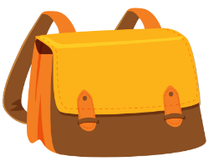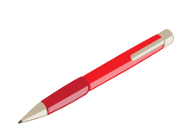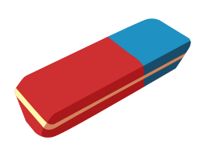

a) Is this an eraser? b) Is this a pen? c) Is this a pencil? d) Is this a notebook?

*…………………… ……………………… ………………… ……………………..*

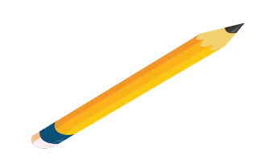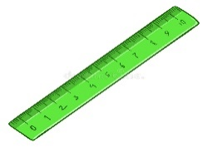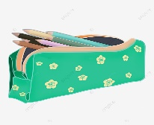

e) Is this a school bag? f) Is this a book? g) Is this a pen? h) Is this a ruler?

*………………………… ………………… ……………………… ……………………..*

# Exercise 5: Look and write:

|  |  |  |  |
| --- | --- | --- | --- |
|  | Notebook clipart transparent 4 - Clipart World | Kết quả hình ảnh cho pencil clipart | Pencil Case Clipart Student Pencil Case, Pencil Case Clipart, Childrens  Pencil Box, Pencil Case Clip Art PNG Transparent Clipart Image and PSD File  for Free Download |
| I have a school bag | …………………….. | ……………………… | …………………….. |
| Book Vector Drawing Illustration Graphics Free Hq Image - Vector Book  Cartoon Png Clipart (#5235532) - PinClipart | Vector Cartoon Single Ruler on White Background Stock Vector - Illustration  of doodle, education: 90515886 | Hình ảnh có liên quan | Kết quả hình ảnh cho pen   clipart |
| ……………………….. | ……………………… | ………………………. | ……………………… |

Exercise 6: Put the words in the correct order to make sentences.



a) ruler – I – have – a b) eraser – I – have – an c) I – a – pen - have

*………………………………… ………………………………… …………………………………*

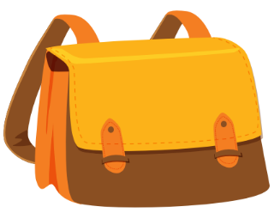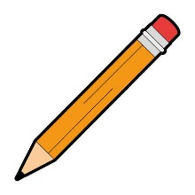

d) I – a – book – have e) pen – a – I – have f) school bag – a – I – have

*………………………………… ………………………………… …………………………………*

g) a – I – notebook – have h) pencil case – a – have – I

………………………………. …………………………….

Exercise 7: Look and write:

|  |  |
| --- | --- |
| Yes, I do | No , I don’t |

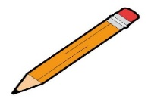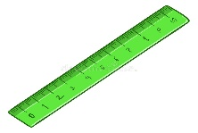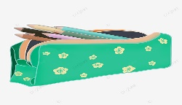

a) Do you have a ruler? b) Do you have a pencil? c) Do you have a pencil case?

# No, I don’t*. ………………………. ………………………….*

# Hình ảnh có liên quanKết quả hình ảnh cho pen clipartNotebook clipart transparent 4 - Clipart World

# d) Do you have a notebook? e) Do you have an eraser? f) Do you have a pen?

# *……………………………. …………………………. ………………………….*

# Book Vector Drawing Illustration Graphics Free Hq Image - Vector Book Cartoon Png Clipart (#5235532) - PinClipart

# g) Do you have a school bag? h) Do you have a book?

# ………………………………… ……………………………

# Kết quả hình ảnh cho pen clipartNotebook clipart transparent 4 - Clipart WorldVector Cartoon Single Ruler on White Background Stock Vector - Illustration of doodle, education: 90515886Exercise 8: Read and tick ✓ or cross 🗶

# 

# Kết quả hình ảnh cho pencil cliparta) I have a pencil. b) I have book. c) I have a ruler.

# Book Vector Drawing Illustration Graphics Free Hq Image - Vector Book Cartoon Png Clipart (#5235532) - PinClipart

# Hình ảnh có liên quand) I have a pen. e) I have pencil. f) I have a noteboook.

# Pencil Case Clipart Student Pencil Case, Pencil Case Clipart, Childrens Pencil Box, Pencil Case Clip Art PNG Transparent Clipart Image and PSD File for Free Download

# g) I have a school bag. h) I have an eraser

Exercise 9: Look and circle

|  |  |  |  |
| --- | --- | --- | --- |
| 1) | It’s a *ruler* / *book.* | Nose - Vector Illustration Royalty Free Cliparts, Vectors, And Stock  Illustration. Image 18464628. 6) | It’s a *nose* / *mouth* |
| Kết quả hình ảnh cho pencil clipart2) | It’s a *pen/ pencil*. | 7) | It’s a *pencil* / *book* |
| 3) | It’s a *pencil case / school bag* | 8) | I have a *ruler / pen* |
| 4) | It’s a *book / school bag.* | Stickman Kids Teacher Music Instruments Room - Stock Illustration  [48883345] - PIXTA9) | It’s the *music room /art room* |
| Hình ảnh có liên quan5) | It’s *an /a* eraser | Notebook clipart transparent 4 - Clipart World10) | It’s a *pencil* *case / notebook*. |
| 3,893 Girl Singing Illustrations & Clip Art - iStock11) | I like *drawing / singing* | 1,707 Kids Swimming Clipart Illustrations & Clip Art - iStock12) | I like *swimming/ running* |
| Pencil Case Clipart Student Pencil Case, Pencil Case Clipart, Childrens  Pencil Box, Pencil Case Clip Art PNG Transparent Clipart Image and PSD File  for Free Download13) | I have a *pen/ pencil case* | Happy Classroom clipart - Clipart World14) | It’s our *classroom/ computer room* |

Exercise 10: Look and write

|  |  |
| --- | --- |
| Kết quả hình ảnh cho pen   clipartHình ảnh có liên quanPencil Case Clipart Student Pencil Case, Pencil Case Clipart, Childrens  Pencil Box, Pencil Case Clip Art PNG Transparent Clipart Image and PSD File  for Free Download  Free Red Cross Clipart, Download Free Red Cross Clipart png images, Free  ClipArts on Clipart LibraryFree Red Cross Clipart, Download Free Red Cross Clipart png images, Free  ClipArts on Clipart LibraryRed Cross Mark Clipart Tickclip - Red Tick Clip Art PNG Image | Transparent  PNG Free Download on SeekPNG | Book Vector Drawing Illustration Graphics Free Hq Image - Vector Book  Cartoon Png Clipart (#5235532) - PinClipartPencil Case Clipart Student Pencil Case, Pencil Case Clipart, Childrens  Pencil Box, Pencil Case Clip Art PNG Transparent Clipart Image and PSD File  for Free Download  Free Red Cross Clipart, Download Free Red Cross Clipart png images, Free  ClipArts on Clipart LibraryRed Cross Mark Clipart Tickclip - Red Tick Clip Art PNG Image | Transparent  PNG Free Download on SeekPNGFree Red Cross Clipart, Download Free Red Cross Clipart png images, Free  ClipArts on Clipart Library |
| Do you have a pen?  ……………………………. | Do you have a book?  ………………………………. |
| Free Red Cross Clipart, Download Free Red Cross Clipart png images, Free  ClipArts on Clipart LibraryRed Cross Mark Clipart Tickclip - Red Tick Clip Art PNG Image | Transparent  PNG Free Download on SeekPNGFree Red Cross Clipart, Download Free Red Cross Clipart png images, Free  ClipArts on Clipart LibraryKết quả hình ảnh cho pen   clipartVector Cartoon Single Ruler on White Background Stock Vector - Illustration  of doodle, education: 90515886Hình ảnh có liên quan | Free Red Cross Clipart, Download Free Red Cross Clipart png images, Free  ClipArts on Clipart LibraryKết quả hình ảnh cho pencil clipartFree Red Cross Clipart, Download Free Red Cross Clipart png images, Free  ClipArts on Clipart LibraryRed Cross Mark Clipart Tickclip - Red Tick Clip Art PNG Image | Transparent  PNG Free Download on SeekPNGPencil Case Clipart Student Pencil Case, Pencil Case Clipart, Childrens  Pencil Box, Pencil Case Clip Art PNG Transparent Clipart Image and PSD File  for Free DownloadBook Vector Drawing Illustration Graphics Free Hq Image - Vector Book  Cartoon Png Clipart (#5235532) - PinClipart |
| Do you have a ruler?  ………………………….... | Do you have a pencil case?  ………………………………... |
| Red Cross Mark Clipart Tickclip - Red Tick Clip Art PNG Image | Transparent  PNG Free Download on SeekPNGBook Vector Drawing Illustration Graphics Free Hq Image - Vector Book  Cartoon Png Clipart (#5235532) - PinClipartRed Cross Mark Clipart Tickclip - Red Tick Clip Art PNG Image | Transparent  PNG Free Download on SeekPNGPencil Case Clipart Student Pencil Case, Pencil Case Clipart, Childrens  Pencil Box, Pencil Case Clip Art PNG Transparent Clipart Image and PSD File  for Free DownloadFree Red Cross Clipart, Download Free Red Cross Clipart png images, Free  ClipArts on Clipart Library | Free Red Cross Clipart, Download Free Red Cross Clipart png images, Free  ClipArts on Clipart LibraryFree Red Cross Clipart, Download Free Red Cross Clipart png images, Free  ClipArts on Clipart LibraryRed Cross Mark Clipart Tickclip - Red Tick Clip Art PNG Image | Transparent  PNG Free Download on SeekPNGNotebook clipart transparent 4 - Clipart WorldHình ảnh có liên quanVector Cartoon Single Ruler on White Background Stock Vector - Illustration  of doodle, education: 90515886 |
| Do you have a school bag?  ………………………………. | Do you have an eraser?  ……………………………… |

# Exercise 11: Odd-One-Out

|  |  |  |  |
| --- | --- | --- | --- |
| a. apple | b. banana | c. mango | d. bear |
| a. bird | b. hippo | c. notebook | đ. tiger |
| 1. Nose | 1. mouth | 1. swimming | 1. eye |
| a. school bag | b. fine | 1. pen | 1. ruler |
| 1. speak | b. art room | 1. classroom | c. music room |
| 1. green | 1. red | 1. blue | 1. one |
| 1. Lucy | 1. teacher | 1. Bill | 1. Mary |
| a. eraser | 1. running | 1. singing | d. painting |

## Exercise 12: Put the words in the correct order to make sentences.

a) a – is – hand – It.

*………………………………………………………………………*

b) I – a- have – pen

*………………………………………………………………………*

c) cooking – like - I

*………………………………………………………………………*

d) art room – is – our - It

*………………………………………………………………………*

e) a – you – Do – have- ruler?

*………………………………………………………………………*

f) I – pencil – a – have

*………………………………………………………………………*

g) name – My – Ben – is

*………………………………………………………………………*

h) Do – have – an– you - eraser?

*………………………………………………………………………*

i) go – the – Let’s– playground - to

*………………………………………………………………………*

j) down – I – sit – My?

*………………………………………………………………………*

k) book – Open – your

*………………………………………………………………………*

l) school – Is – our – it?

*………………………………………………………………………*

m) pen – That – my – is

*………………………………………………………………………*

Listening:

Part 1: Listen and tick https://s.sachmem.vn/public/sm-quizz/icons/checkbox-tick.png or cross https://s.sachmem.vn/public/sm-quizz/icons/checkbox-cross.png. There are two examples.

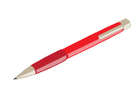https://s.sachmem.vn/public/sm-quizz/icons/checkbox-tick.pnghttps://s.sachmem.vn/public/sm-quizz/icons/checkbox-cross.png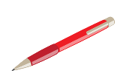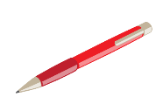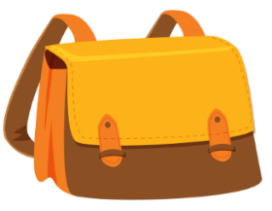1. 2.

3. 4.



https://s.sachmem.vn/public/sm-quizz/icons/checkbox-default.pnghttps://s.sachmem.vn/public/sm-quizz/icons/checkbox-default.png

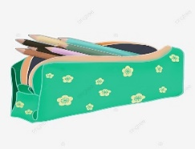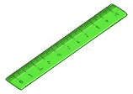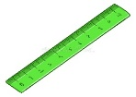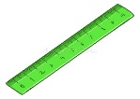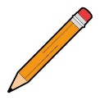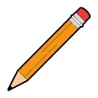5. 6.

https://s.sachmem.vn/public/sm-quizz/icons/checkbox-default.png

https://s.sachmem.vn/public/sm-quizz/icons/checkbox-default.png

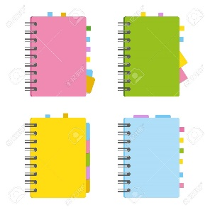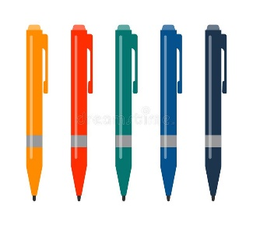7. 8.

https://s.sachmem.vn/public/sm-quizz/icons/checkbox-default.png

https://s.sachmem.vn/public/sm-quizz/icons/checkbox-default.png

9. 10.

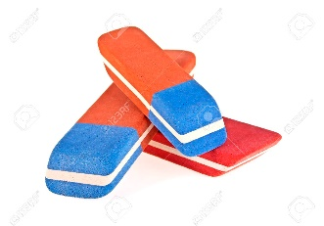

https://s.sachmem.vn/public/sm-quizz/icons/checkbox-default.pnghttps://s.sachmem.vn/public/sm-quizz/icons/checkbox-default.png

Part 2: Listen and circle, there is one example:

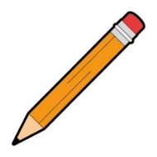1. I have a pencil.

A B

2.

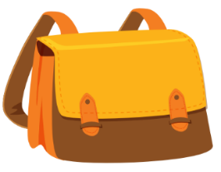

A B

3.

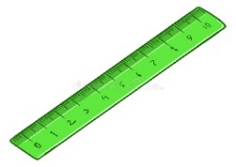

A B

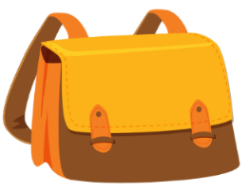4.



A B

5.



A B

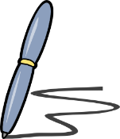6.

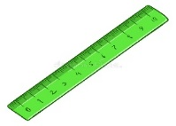

A B

7.

A B

8.

A B