Exercise 1: Look and write

|  |  |  |  |
| --- | --- | --- | --- |
| Computer room | Art room | Music room | classroom |
| playground | school | gym | library |

|  |  |  |  |
| --- | --- | --- | --- |
| Kids Drawing in Art Class. Vector Art Education Stock Vector - Illustration  of artistic, paint: 189426736 | Park Playground clipart png images - Clipart World | Vở bài tập Tiếng Anh 3 - UNIT 7 That's my school - WORD CHECK - A. Read and  match. | Sách Mềm | Classroom with Green Board and Desks PNG Clipart Image​ | Gallery  Yopriceville - High-Quality Free Images and Transparent PNG Clipart |
| ………………….. | ………………….. | ………………….. | ………………….. |
| Gym Clipart | Hacer ejercicio, Gimnasio, Ejercicios | 2,152 Music Instructor Illustrations & Clip Art - iStock | Happy kids go to school Clipart | +1,566,198 clip arts | Group of School Kids Studying in Library Illustration Stock Vector -  Illustration of education, young: 138054543 |
| ………………….. | ………………….. | ………………….. | ………………….. |

Exercise 2: Look and read. Put a tick (✓) or cross (🗶) in the box.

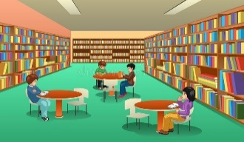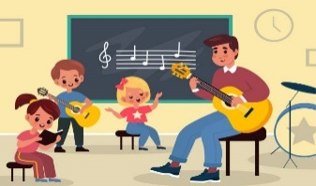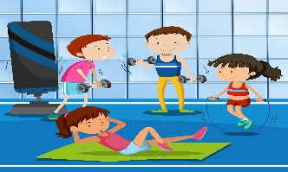

a) It’s our art room. b) It’s our music room. c) It’s our computer room

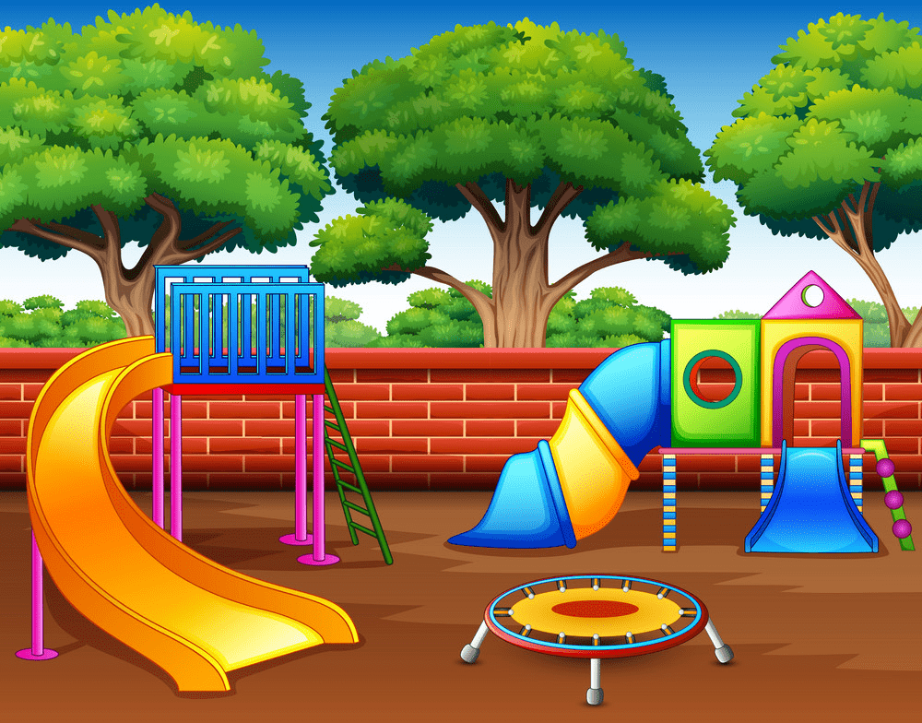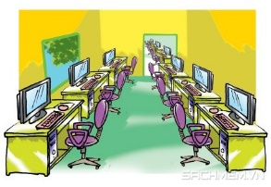



d) It’s our school. e) It’s our class room. f) It’s our playground.

Exercise 3: Look and write. There is an example.

|  |  |
| --- | --- |
| Yes, it is. | No, it isn’t. |

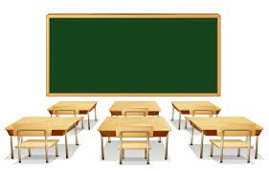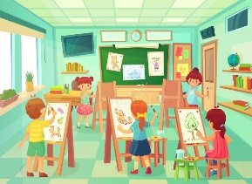





a) Is this our school? b) …………………………….? c) ………………………….?

Yes, it is. *……………………… ………………………*

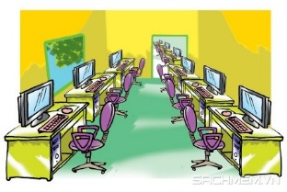





d) …………………………? e) ……………………… ? f) ………………………….. ?

*……………………… ……………………… ………………………*





g) ………………………….. ? h) ………………………….. ?

*……………………… ……………………..*

Exercise 4: Look and write the missing letters



C_mp_te_ roo_

_ym

P_a_gro_nd

Li_ra_y





_u_ic _oom

S_h_o_

A_t r_om

Cl_ss_ro_m

Exercise 5: Look at the pictures and complete the sentences.

|  |  |
| --- | --- |
| Kids Drawing in Art Class. Vector Art Education Stock Vector - Illustration  of artistic, paint: 189426736 | a) Let’s go to the art room. |
| 2,152 Music Instructor Illustrations & Clip Art - iStock | b) *………………………*………… |
| Group of School Kids Studying in Library Illustration Stock Vector -  Illustration of education, young: 138054543 | c) ………….. *…………………….* |
| Classroom with Green Board and Desks PNG Clipart Image​ | Gallery  Yopriceville - High-Quality Free Images and Transparent PNG Clipart | d) *………………………*……... |
| Park Playground clipart png images - Clipart World | e)……………………………… |
| Gym Clipart | Hacer ejercicio, Gimnasio, Ejercicios | f) ……………………………… |
| Happy kids go to school Clipart | +1,566,198 clip arts | g) ……………………………… |
| Vở bài tập Tiếng Anh 3 - UNIT 7 That's my school - WORD CHECK - A. Read and  match. | Sách Mềm | h) ……………………………… |

Exercise 6**:** Put the words in correct order:

1. the/ that/ computer/ Is / room/?

🡪………………………………………………………………….

2. the/ library/ This/ is/.

🡪………………………………………………………………….

3. my/ is/ school/That.

🡪………………………………………………………………….

4. That/ music/ the/ room/ is/.

🡪………………………………………………………………….

5. to/ Let’s/ the/ gym/go

🡪………………………………………………………………….

6. my/ is/ This/ friend/ new/.

🡪………………………………………………………………….

7. classroom/ is/ our/ It

🡪………………………………………………………………….

8. this/ playground/ Is/ our?

🡪………………………………………………………………….

Exercise 6**:** Write and match:

|  |  |
| --- | --- |
| I like reading | 🡪 Let’s go to the…………… |
| I like drawing | 🡪 ……………………………… |
| I like singing | 🡪 ……………………………… |
| I like dancing | 🡪 ……………………………… |
| I like painting | 🡪 ……………………………… |
| I like sliding | 🡪 ……………………………… |

Exercise 7. Odd one out

|  |  |  |  |
| --- | --- | --- | --- |
| 1. black | 1. eye | 1. pink | 1. blue |
| 1. dancing | 1. cooking | 1. swimming | 1. library |
| 1. mouth | 1. nose | 1. ear | 1. friend |
| 1. teacher | 1. two | 1. six | 1. nine |
| 1. classroom | 1. art room | 1. face | 1. music room |

Exercise 8: Look and circle the correct words

|  |  |  |  |
| --- | --- | --- | --- |
| 2,152 Music Instructor Illustrations & Clip Art - iStock | Kids Drawing in Art Class. Vector Art Education Stock Vector - Illustration  of artistic, paint: 189426736 | Vở bài tập Tiếng Anh 3 - UNIT 7 That's my school - WORD CHECK - A. Read and  match. | Sách Mềm | Gym Clipart | Hacer ejercicio, Gimnasio, Ejercicios |
| a) classroom  b) music room  c) art room | a) art room  b) computer room  c) gym | a) library  b) playground  c) computer room | a) playground  b) gym  c) classroom |

Exercise 9: Look and circle

|  |  |  |  |
| --- | --- | --- | --- |
| Classroom with Green Board and Desks PNG Clipart Image​ | Gallery  Yopriceville - High-Quality Free Images and Transparent PNG Clipart | It’s our *computer room* / *class room.* | Park Playground clipart png images - Clipart World | It’s our *gym/ playgroud* |
| Happy kids go to school Clipart | +1,566,198 clip arts | It’s our *school / playground* | Group of School Kids Studying in Library Illustration Stock Vector -  Illustration of education, young: 138054543 | It’s our music *room/ library* |

Exercise 10: Rewrite the right sentences:

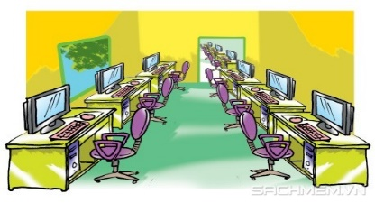

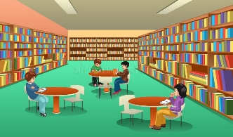

A) Let’s go to the art room. B) Let’s go to the classroom.

*🡪………………………… 🡪………………………….*

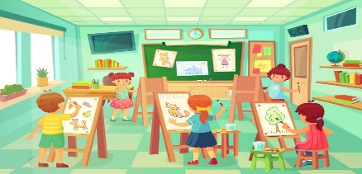

C) Let’s go to the computer room. D) Let’s go to the music room.

*🡪…………………………………….. 🡪………………………………….*

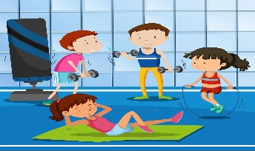

E) Let’s go to the art room. F) Let’s go to the playground.

🡪…………………………………….. 🡪…………………………………….

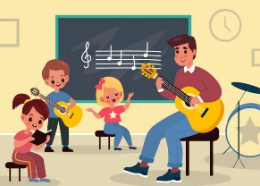

G) Let’s go to the library. H) Let’s go to the gym

🡪……………………………………… 🡪……………………………………..

Listening:

Part 1: Listen and draw line, there is one example:

|  |  |  |
| --- | --- | --- |
| 1. |  | Vở bài tập Tiếng Anh 3 - UNIT 7 That's my school - WORD CHECK - A. Read and  match. | Sách Mềm  a. |
| 2. | Kids Drawing in Art Class. Vector Art Education Stock Vector - Illustration  of artistic, paint: 189426736  b. |
| 3. | Park Playground clipart png images - Clipart Worldc. |
| 4. | Gym Clipart | Hacer ejercicio, Gimnasio, Ejerciciosd. |
| 5. | Group of School Kids Studying in Library Illustration Stock Vector -  Illustration of education, young: 138054543e. |
| 6. | 2,152 Music Instructor Illustrations & Clip Art - iStockf. |
| 7. | Classroom with Green Board and Desks PNG Clipart Image​ | Gallery  Yopriceville - High-Quality Free Images and Transparent PNG Clipartg. |
| 8. |  | Happy kids go to school Clipart | +1,566,198 clip arts  h. |

Part 2: Listen and tick. The first sentence is done for you.

1.



|  |  |
| --- | --- |
| A. https://s.sachmem.vn/public/sm-quizz/icons/checkbox-tick.png | B. https://s.sachmem.vn/public/sm-quizz/icons/checkbox-default.png |

2.

|  |  |
| --- | --- |
| A. https://s.sachmem.vn/public/sm-quizz/icons/checkbox-default.png | B. https://s.sachmem.vn/public/sm-quizz/icons/checkbox-default.png |

3.

|  |  |
| --- | --- |
| A. https://s.sachmem.vn/public/sm-quizz/icons/checkbox-default.png | B. https://s.sachmem.vn/public/sm-quizz/icons/checkbox-default.png |

4.

|  |  |
| --- | --- |
| A. https://s.sachmem.vn/public/sm-quizz/icons/checkbox-default.png | B. https://s.sachmem.vn/public/sm-quizz/icons/checkbox-default.png |

5. 

|  |  |
| --- | --- |
| A. https://s.sachmem.vn/public/sm-quizz/icons/checkbox-default.png | B. https://s.sachmem.vn/public/sm-quizz/icons/checkbox-default.png |

6.



|  |  |
| --- | --- |
| A. https://s.sachmem.vn/public/sm-quizz/icons/checkbox-default.png | B. https://s.sachmem.vn/public/sm-quizz/icons/checkbox-default.png |

7.



|  |  |
| --- | --- |
| A. https://s.sachmem.vn/public/sm-quizz/icons/checkbox-default.png | B. https://s.sachmem.vn/public/sm-quizz/icons/checkbox-default.png |

8.



|  |  |
| --- | --- |
| A. https://s.sachmem.vn/public/sm-quizz/icons/checkbox-default.png | B. https://s.sachmem.vn/public/sm-quizz/icons/checkbox-default.png |