Exercise1.Look and write
swimming | running | dancing | singing
drawing | cooking | walking | painting

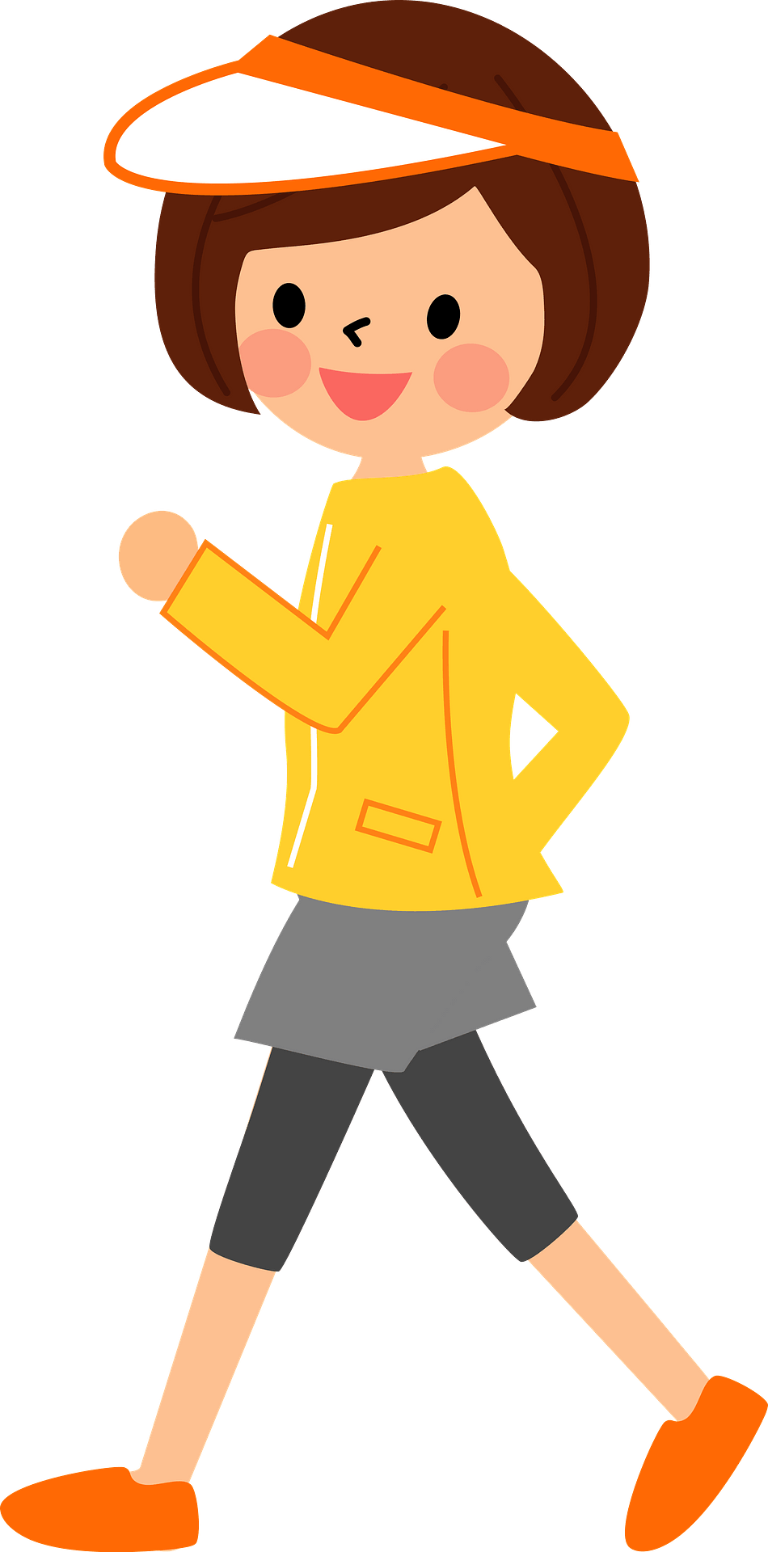 | 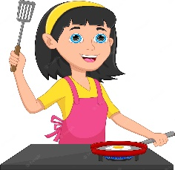 | 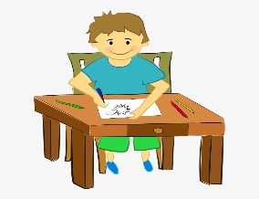 | 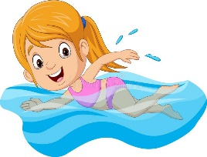
………………………… | ………………………… | ………………………… | …………………………
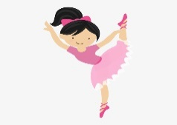 | 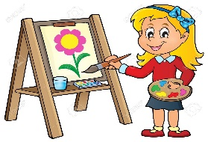 | 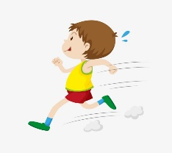 | 
………………………… | ………………………… | ………………………… | …………………………
Exercise 2. Look and answer the questions.
 | 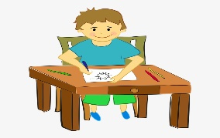
What’s your hobby? | What’s your hobby?
It’s singing. | ……………………………………..
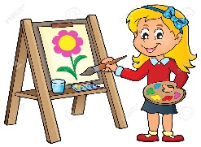
What’s your hobby? | What’s your hobby?
…………………………………….. | ……………………………………..
 | 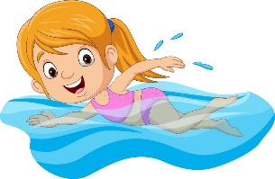
What’s your hobby? | What’s your hobby?
…………………………………….. | ……………………………………..
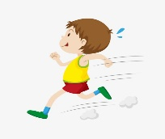
What’s your hobby? | What’s your hobby?
…………………………………….. | ……………………………………..

Exercise 3: Answer questions about you.
1. What’s your name? ________________________________________
2. How old are you? __________________________________________
3. How are you today?_________________________________________
4. Which class are you in? _____________________________________

5. What’s your hobby? __________________________________________
6. What’s your favourite color? __________________________________________ Exercise 4. Look and write:
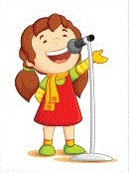 | singing | I like singing.
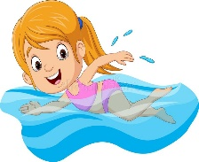 | _________________ | ______________________________
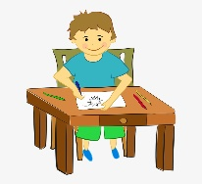 | _________________ | ______________________________
 | _________________ | ______________________________
 | _________________ | ______________________________
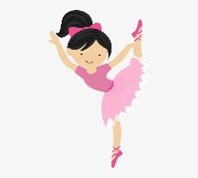 | _________________ | ______________________________
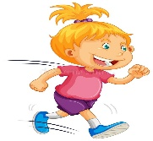 | _________________ | ______________________________
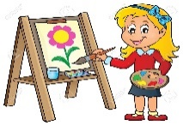 | _________________ | ______________________________
Exercise 5: One of the two sentences is right. Decide which one
I like walking
I like swimming
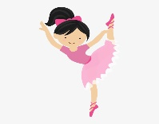 | I like running.  I like dancing.
I like drawing.
I like cooking.
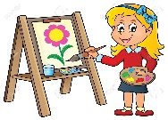 | I like painting.  I like singing.
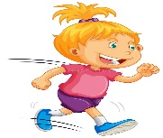 | I like cooking.  I like running.
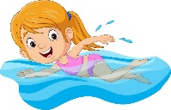 | I like walking.  I like swimming.
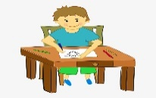 | I like drawing.  I like swimming
 | I like walking  I like singing
Exercise 6. Make and answer the question.
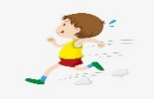  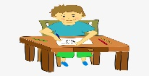   | 
What’s your hobby?  It’s running. | ………………………………..  ………………………………..
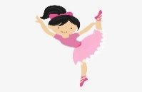 | 
………………………………..  ……………………………….. | ………………………………..  ………………………………..
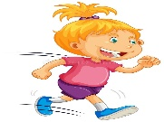 | 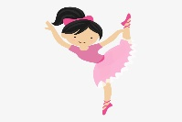
………………………………..  ……………………………….. | ………………………………..  ………………………………..
………………………………..  ……………………………….. | ………………………………..  ………………………………...
Exercise 7. Look and write.
I kike……………………. |  | 
……………………………………… | cooking | swimming
……………………………………… | walking | painting
……………………………………… | drawing | cooking
……………………………………… | running | dancing
……………………………………… | swimming | walking
……………………………………… | painting | running
……………………………………… | singing | drawing
Exercise 8: Odd one out
1. A. nose B. mouth C. hand D. painting
2. A. green B. black C. yellow D. color
3. A. is B. are C. am D. eye
4. A. morning B. swimming C. cooking D. dancing
5. A. running B. friend C. teacher D. mother
6. A. two B. three C. nine D. Hello
7. A. book B. car C. kite D. ball
Exercise 9: Put the words in the correct order
a) like – I – painting
…………………………………………………………………………..
b) hobby - What – your – is?
…………………………………………………………………………..
c) and – swimming – like – singing - I
…………………………………………………………………………..
d) is – cooking– It
…………………………………………………………………………..
e) is – nose – It – a
…………………………………………………………………………..
f) is - John– name- My
…………………………………………………………………………..
g) your – Open – eyes
…………………………………………………………………………..

h) is - teacher– my- That
…………………………………………………………………………..
i) this- friend- Is- your?
…………………………………………………………………………..
Exercise 10: Make questions for the sentences:
a) It’s an eye.
…………………………………………………………………..
b) My name is Mai.
…………………………………………………………………..
c) I like walking.
…………………………………………………………………..
d) I’m nine years old.
…………………………………………………………………..
e) I’m fine. Thank you.
…………………………………………………………………..
f) It’s singing.
…………………………………………………………………..
g) Yes, this is my teacher.
…………………………………………………………………..
Listening:
Part 1: Listen and complete the following sentences, sentence 1 is done for you.
1. My name is Ben. I like singing.
2. Hi, I’m Bill. I like ………………………..
3. - what is your hobby?
- I like (a) ………………………... What’s your hobby?
- It’s (b) ………………………..
4. Hello, my name is Mai. I like ………………………...
5. Hi, I’m Marry. I’m (a) ……………… years old. I like (b) ………………………...
6. I don’t like (a) ……………………….., I like (b) ………………………..
7. Hello. My name is Lucy. I like ………………………....
Part 2: Listen and circle, there is one example:
1. A B | 2. A B
3. A B | 4. A B
5. A B | 6. A B
7. A B | 8. A B

