Exercise 1: Look and write
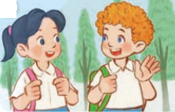 | 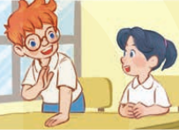 | 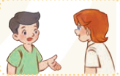
- Hi. …………Bill, What’s your ……………?  - ……………….name’s Mai | - Hello. My……….is Ben, ……….……your name?  - My name’s …………….. | - ………., I’m Nam, what’s ………name?  - …… name’s……..
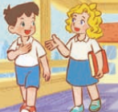 | 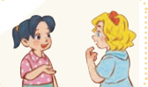 | 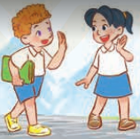
- Hello. ……………Mary.  …………..your…………?  - ……………………………Minh. | - ………. My………is Mai.  What’…………………………?  -………..name’s…………….. | - ……………bye, Mai.  -………………., Bill.

Exercise 2: Put the words in the correct order
a) name- My- Mai- is.
…………………………………………………………………….
b) your- What- is- name?
…………………………………………………………………….
c) Do- spell- name- you- your- How?
…………………………………………………………………….
d) you- How- are?
…………………………………………………………………….
e) you- fine- Thank
…………………………………………………………………….
f) am- Lucy- Hi- I
…………………………………………………………………….

Exercise 3: Look, read and complete:
8
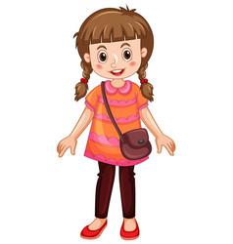
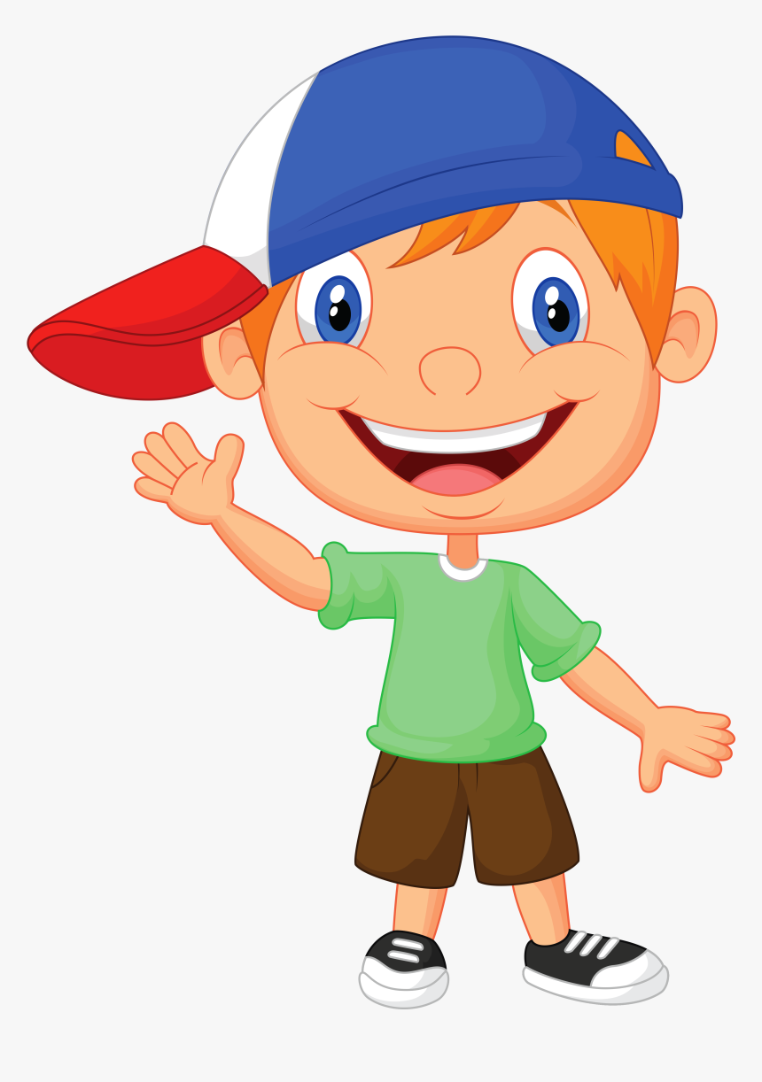
7

10
a) How old are you? b) How old are you? d) …………… are you?
I am ……………. years old. I am seven ……………. I am …… years old.
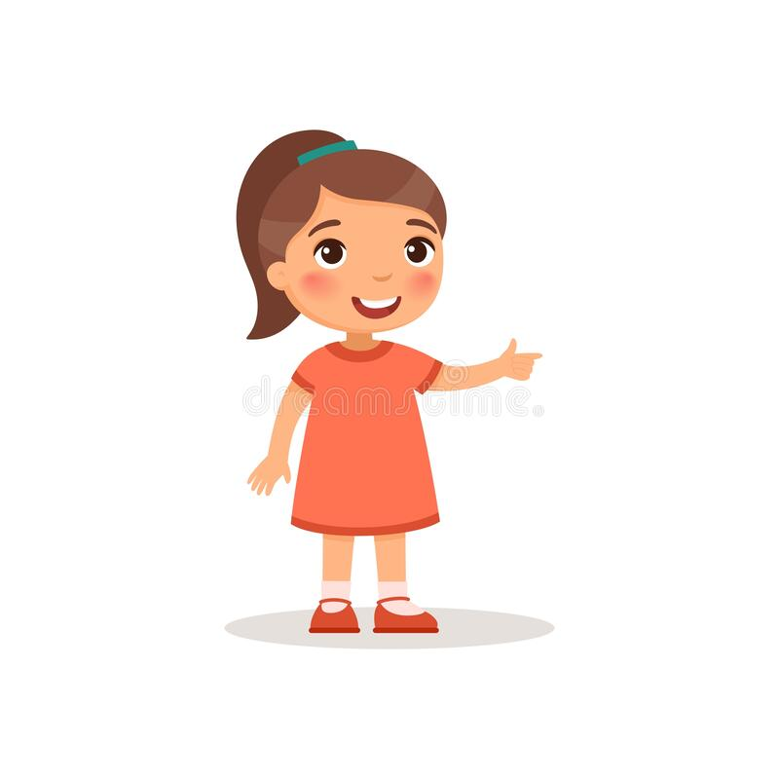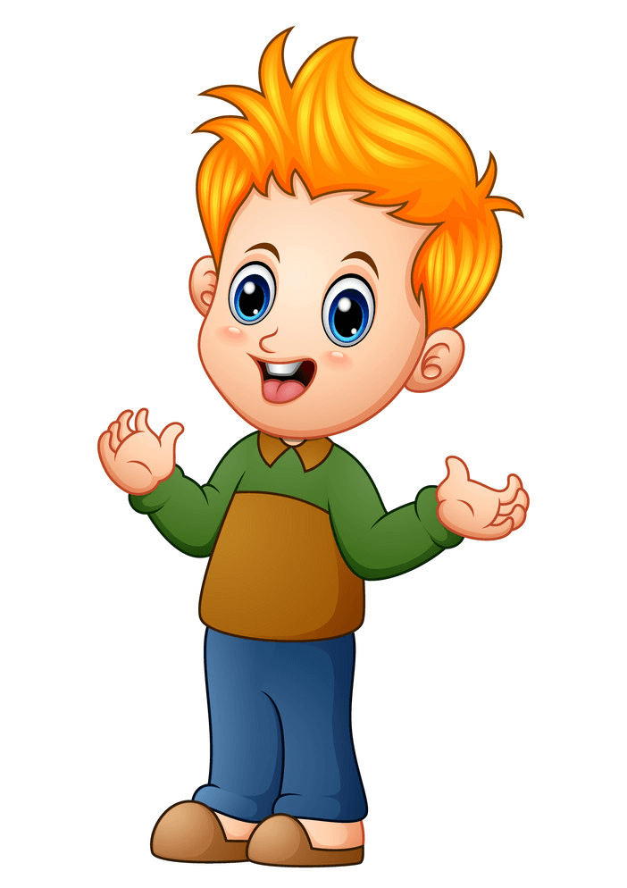
6
9
7
d) How old are you? e) How old ……. you? f) ……. old are you?
……… six years old. I am ………… years old. I am ……. years old.

Exercise 4: Choose correct answer:
1. How _________ you?
A. am B. is C. are D. it
2. Good bye. ______ you later.
A. What B. See C. How D. Are
3. __________. I am Ben
A. Hello B. Good-bye C. It D. You
4. Good bye. See you __________.
A. later B. late C. How D. Are
5. ___________ your name?
A. Hello B. Good-bye C. What D. What’s
6. What’s your name?
- I’m fine, thanks B. My name’s Mary C. Thank you
7. How are you?
- I’m fine, thanks B. yes, please. C. I’m nine years old

Exercise 5: Match (A) with ( B)
A B
1. What’s your name? | a) I like blue.
2. How old are you? | b) I’m fine , thank you.
3. What color is it? | c) I’m seven years old.
4. How are you? | d) It’s red.
5. What color do you like? | e) My favorite toy is a teddy bear.
6. What is this? | f) My name is Bill.
7. What is your favorite toy? | g) It’s a ball.

Exercise 6: Circle the odd one out
 | a) Mai | b) Ben | c) Mary | d) name
 | a) old | b) six | c) nine | d) seven
 | a) red | b) book | c) pink | d) blue
 | a) book | b) yellow | c) pen | d) pencil
 | a) dog | b) cat | c) fish | d) ball
 | a) dad | b) mom | c) Lucy | d) sister
Exercise 7: Make questions for these answers
a) My name is Lucy.
c) I’m seven years old.
d) It’s pink.
Exercise 8: Complete the sentence:
- …………..old are you?
- What’s …………… name?
- How……………..you ?
- Hi, Nam. I ……….. Lucy.
- Nice to …………… you.
- Hi, my name…………Ben.
- Hi, …………name is Minh.
- I am ………….., thank you.
- My…………. is Mary.
10.I am seven …………….. old.

Exercise 9: Look at the pictures and write:

 | 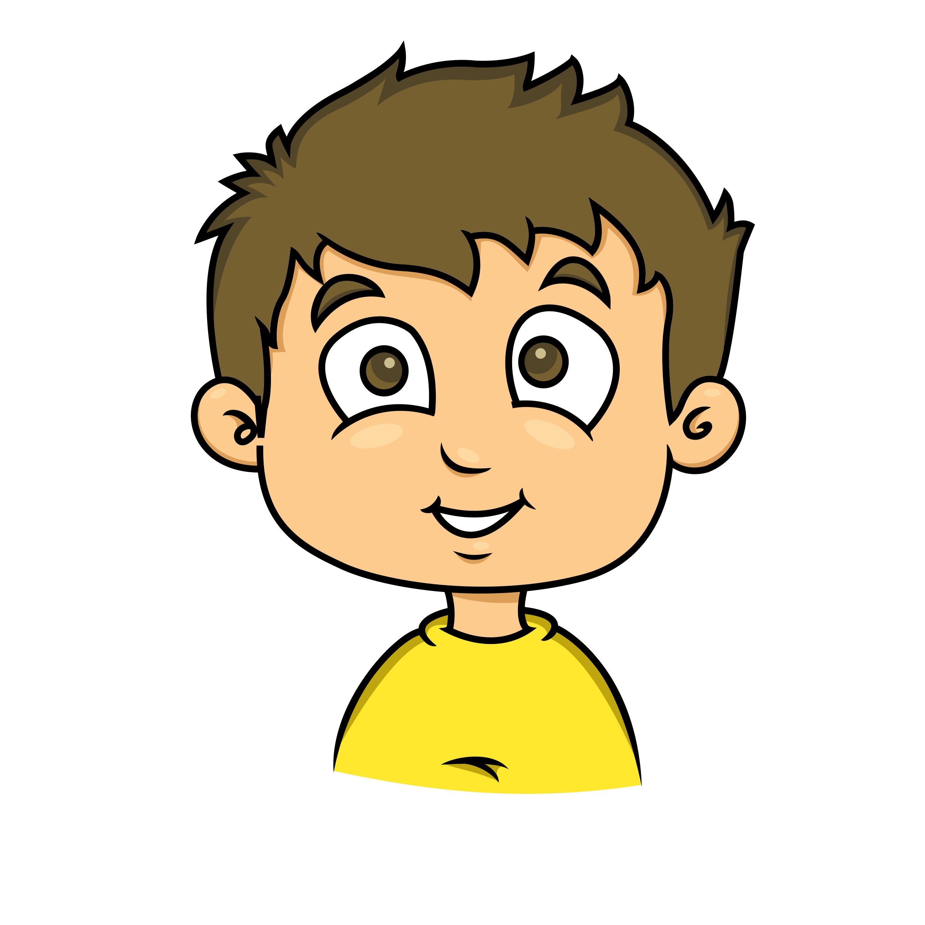 |  | 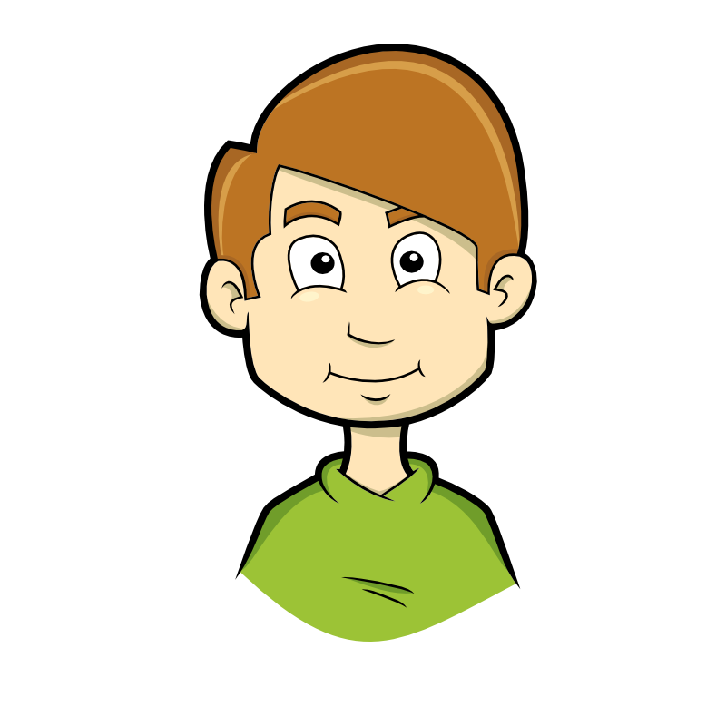 | 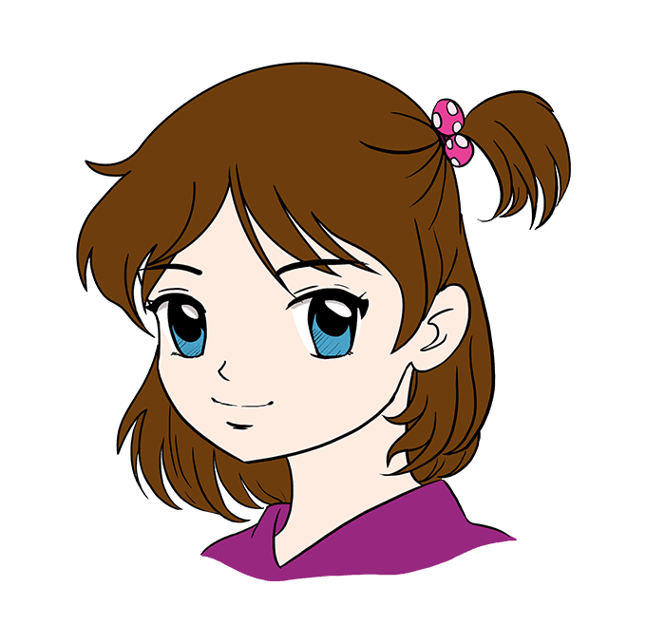
Peter(8) | Alex(7) | Lisa(9) | Tony(10) | Anna(8)

1. My name’s Peter. I’m eight years old.
2……………………………………………………………….
3……………………………………………………………….
4……………………………………………………………….
5……………………………………………………………….
Exercise 10: Look and read. Put a tick (✓) or cross (✗) in the box.
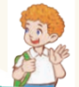
a) My name’s Ben. b) I’m Linh.

c) My name’s Lan. d) My name is Mary.

e) I’m Nam. f) My name is Minh.

g) My name’s Mary. h) His name is Minh.
LISTENING:
Part 1: Listen and draw line, there is one example:
  a. |  | 1
  b. |  | 2
  c. |  | 3
  d. |  | 4
  e. |  | 5
  f. |  | 6
Part 2: Listen and write a name or a number, there is one example:
1. six
2. ………………………………………
3. ………………………………………
4. ………………………………………
5. ………………………………………
6. ………………………………………

