Exercise 1 Look and write

|  |  |  |  |
| --- | --- | --- | --- |
| Kate | kitten | bike | kite |

|  |  |  |  |
| --- | --- | --- | --- |
|  |  |  |  |
| *…………………….* | *…………………….* | *…………………….* | *…………………….* |

Exercise 2 Look and write the missing letters

|  |  |  |  |
| --- | --- | --- | --- |
|  |  |  |  |
| _ _ tten | ki _ _ | bi _ _ | _ _ ate |

Exercise 3 Look and match

|  |  |  |
| --- | --- | --- |
| 1. She is Kate. |  |  |
| 1. She’s riding a bike. |  |  |
| 1. I can see a kitten. |  |  |
| 1. I can see a kite. |  |  |

Exercise 4 Read and circle the correct words

|  |  |
| --- | --- |
| Hình ảnh có liên quan | Hình ảnh có liên quan |
| a) She is **singing** / **swimming**. | b) He’s **flying** / **fly** a kite. |
| Hình ảnh có liên quan | Hình ảnh có liên quan |
| c) She’s riding a **bike** /**car.** | d) He’s **sing** / **singing.** |
| Hình ảnh có liên quan | Kết quả hình ảnh cho play with kitten clipart |
| ê) **He** / **She** is reading a book. | f) He’s playing with a **kitten** / **rabbit.** |

Exercise 5 Put the words in the correct order

a) see –– I – can – Kate

*………………………………………………………………….*

b) She – a bike – is – riding.

*………………………………………………………………….*

c) Kate – a kite – flying - is

*………………………………………………………………….*

d) kitten – The – is – playing – a leaf - with

*………………………………………………………………….*

e) He – a book – is - reading

*………………………………………………………………….*

Exercise 6 Look and tick (✓) or cross (🗶)

  

a) I can see Kate. a) She’s singing. c) He’s swimming.

 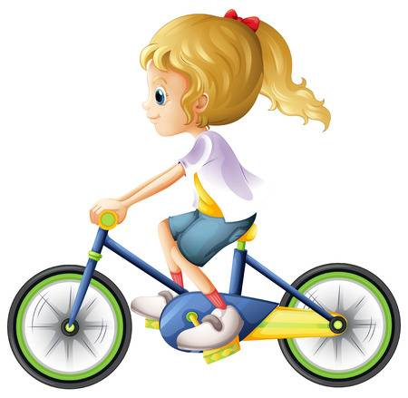 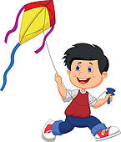

d) She’s running. e) She’s riding a bike. f) He’s flying a kite.

Exercise 7 Read and complete the sentences

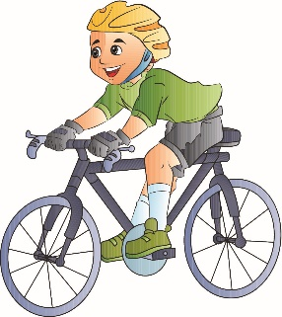  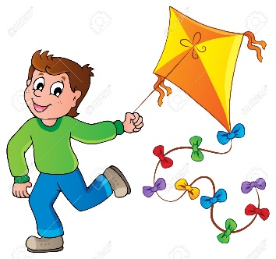

a) He’s *……………* a bike. b) *………* is singing. c) He’s flying a *………*

  

d) She *………….* singing. e) He is *……………….* f) I’m*……………..*

Exercise 8 Look at each picture . Circle the letter that makes the beginning sound

|  |  |  |
| --- | --- | --- |
|  |  |  |
| w t u | k l m | t f w |
|  |  |  |
| u t r | r s w | w r t |
| Kết quả hình ảnh cho pizza clipart |  |  |
| n o p | u v w | k l m |

Exercise 9 Circle the odd one out :

|  |  |
| --- | --- |
| 1.  R | a. b.  c. |
| 2.  P | a.  b.  c. Kết quả hình ảnh cho pasta clipart |
| 3.  W | a.  b.  c. |
| 4.  K | a.  b.  c. |