Exercise 1 Look and write

|  |  |  |  |
| --- | --- | --- | --- |
| sand | sail | singing | sea |

|  |  |  |  |
| --- | --- | --- | --- |
|  |  |  |  |
| *…………………….* | *…………………….* | *…………………….* | *…………………….* |

Exercise 2 Look and write the missing letters

|  |  |  |  |
| --- | --- | --- | --- |
|  |  |  |  |
| s _ _ | _ _ nging | sa _ _ | _ _ il |

Exercise 3 Look and match

|  |  |  |
| --- | --- | --- |
| 1. I can see the sea. |  |  |
| 1. I’m singing. |  |  |
| 1. I can see the sand. |  |  |
| 1. I can see a sail |  |  |

Exercise 4 Read and circle the correct words

|  |  |
| --- | --- |
| Hình ảnh có liên quan |  |
| a) She is **singing** / **swimming**. | b) They are **singing** /**swimming**. |
| Kết quả hình ảnh cho sunny  cartoon |  |
| c) It’s **sunny / rainy** | d) Look at the **lake** / **sand** |
| Kết quả hình ảnh cho sky cartoon |  |
| ê) Look at the **sky / sun.** | f) Look at the **sand / sea.** |

Exercise 5 Put the words in the correct order

a) see – sea – I – can – the

*………………………………………………………………….*

b) I – sail – can – see – a

*………………………………………………………………….*

c) the – I – can – see – sand

*………………………………………………………………….*

d) They – singing – are – the – sand - on

*………………………………………………………………….*

e) Look – the – at – sky

*………………………………………………………………….*

f) sun – Look – at – the

*………………………………………………………………….*

Exercise 6 Look and tick (✓) or cross (🗶)

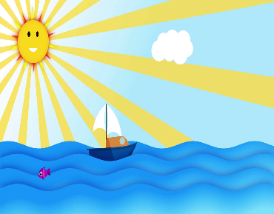  

a) Look at the river. a) Look at the sun. c) I can see a sail.

  

d) She’s running. e) He’s swimming. f) I can the sand.

Exercise 7 Circle the r’s :

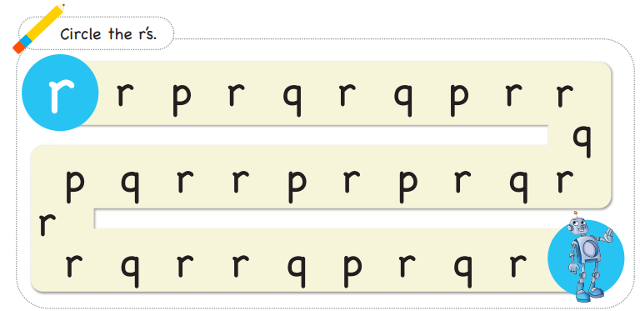

Exercise 8 Look at each picture . Circle the letter that makes the beginning sound

|  |  |  |
| --- | --- | --- |
|  | Hình ảnh có liên quan |  |
| w t u | w f p | t f w |
|  |  |  |
| u t r | r s w | w r t |
| Kết quả hình ảnh cho pizza clipart |  |  |
| n o p | u v w | r s w |

Exercise 9 Color by number

|  |  |
| --- | --- |
|  | 1 = green  1= blue  3= purple  4= grey  5= pink  6 = orange |