Exercise 1 Look and write

|  |  |  |  |
| --- | --- | --- | --- |
| rabbit | river | road | rainbow |

|  |  |  |  |
| --- | --- | --- | --- |
|  |  |  |  |
| *…………………….* | *…………………….* | *…………………….* | *…………………….* |

Exercise 2 Look and write the missing letters

|  |  |  |  |
| --- | --- | --- | --- |
|  |  |  |  |
| rain _ _ _ | _ _ _ d | ra _ _ _ _ | ri _ _ _ |

Exercise 3 Look and match

|  |  |  |
| --- | --- | --- |
| 1. I can see a road. |  |  |
| 1. I can see a rabbit. |  |  |
| 1. I can a rainbow. |  |  |
| 1. I can see a river. |  |  |

Exercise 4 Read and write

|  |  |  |
| --- | --- | --- |
| sky | road | rabbit |

1. I can see a rainbow across the *…………………..*
2. Can you see a river near the *…………………..*
3. Can you see a *…………………..* in the field.

Exercise 5 Look and tick (✓) or cross (🗶)

  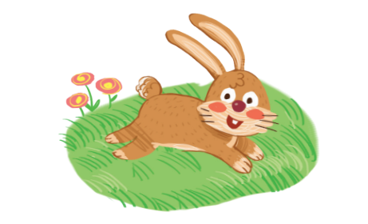

a) I can see a road. b) I can see a rainbow. c) I can see a rabbit.

  

d) I can see a river. e) I can see a present. e) I can see a desk.

 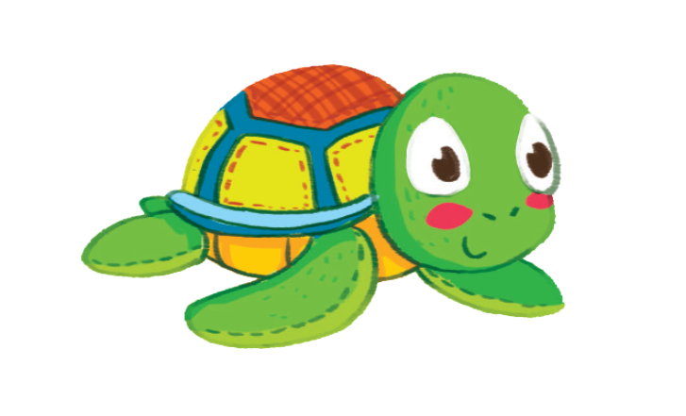 

f) I can see a flag. g) I can see a tiger. h) I can see a leaf.

Exercise 6 Put the words in the correct order

a) can – I – see – a – road.

*……………………………………………………………………*

b) I – a – river – can – see

*……………………………………………………………………*

e) rainbow – I – can – see – a

*……………………………………………………………………*

f) a – see – can- robot – I

*……………………………………………………………………*

g) rabbit – I – can – see – a

*……………………………………………………………………*

h) window – I – can – see – a

*……………………………………………………………………*

i) flag – can – see – I – a

*……………………………………………………………………*

Exercise 7 Look and write

|  |  |
| --- | --- |
| Yes, I can. | No , I can’t |

|  |  |  |
| --- | --- | --- |
|  |  |  |
| 1. Can you see a river ? | 1. Can you see a desk ? | 1. Can you see a rabbit ? |
|  |  |  |
|  |  |  |
| 1. Can you see a road ? | 1. Can you see a turtle ? | 1. Can you see a rainbow ? |
|  |  |  |

Exercise 8 Circle the odd one out :

|  |  |
| --- | --- |
| 1.  R | a. b.  c. |
| 2.  P | a.  b.  c. Kết quả hình ảnh cho pasta clipart |
| 3.  W | a.  b.  c. |
| 4.  F | a.  b. Kết quả hình ảnh cho flag clipart c. |

Exercise 9 Look at each picture . Circle the letter that makes the beginning sound

|  |  |  |
| --- | --- | --- |
|  | Hình ảnh có liên quan |  |
| w t u | w f p | t f w |
|  |  |  |
| u t r | f n l | w r t |
| Kết quả hình ảnh cho pizza clipart |  |  |
| n o p | u v w | f g h |