Exercise 1 Look and write

|  |  |  |  |
| --- | --- | --- | --- |
| washing | window | Wendy | water |

|  |  |  |  |
| --- | --- | --- | --- |
|  |  |  |  |
| *………………………….* | *………………………….* | *………………………….* | *………………………….* |

Exercise 2 Look and match

|  |  |  |
| --- | --- | --- |
| 1. Look at the window. |  |  |
| 1. I can see Windy. |  |  |
| 1. Look at the white cat . |  | Hình ảnh có liên quan |
| 1. He’s washing the window. |  |  |
| 1. I can see water. |  |  |

Exercise 3 Read and circle the correct words

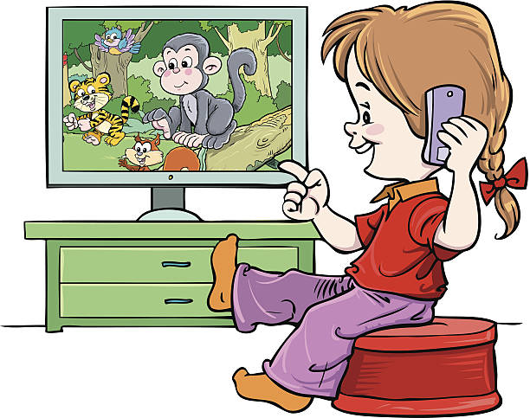 

a)She’s **washing** / **watching** TV. b) He’s washing his **hands** / **foot.**



c) She’s next to the **window** /**water.** d) I can see **Tony/ Wendy.**

Exercise 4 Put the words in the correct order

a) can – Wendy – I

*………………………………………………….*

b) I – a window – can – see

*………………………………………………….*

c) water – I – can – see

*………………………………………………….*

d) Look – the – white cat – at

*………………………………………………….*

e) He’s – the – window – washing

*………………………………………………….*

f) football – My father’s – watching

*………………………………………………….*

Exercise 5 Look and tick (✓) or cross (🗶)

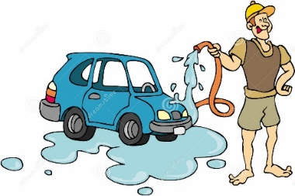 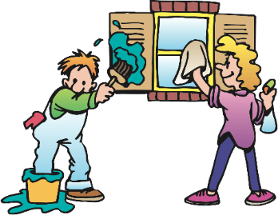

a) He’s washing the window. b) They’re washing the window. 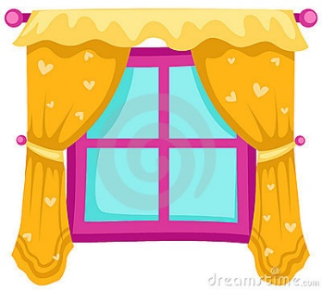 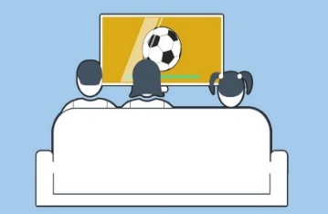

c) Look at the flag . d) They’re watching football.

Exercise 6 Look at each picture . Circle the letter that makes the beginning sound

|  |  |  |
| --- | --- | --- |
|  | Kết quả hình ảnh cho NOODLES clipart |  |
| s t u | m n o | l m n |
|  |  | HÃ¬nh áº£nh cÃ³ liÃªn quan |
| u v w | f g h | g h i |
| Kết quả hình ảnh cho flag clipart |  |  |
| e m f | e f g | u v w |

Exercise 7 Circle the odd one out

|  |  |
| --- | --- |
| 1.  Gg | a. Káº¿t quáº£ hÃ¬nh áº£nh cho goat  clipart b. c. HÃ¬nh áº£nh cÃ³ liÃªn quan |
| 2.  Hh | a. Kết quả hình ảnh cho NOODLES clipart b.  c. |
| 3.  Mm | a. Kết quả hình ảnh cho monkey clipart b. Hình ảnh có liên quan c. |
| 4.  Ll | a.  b.  c. |
| 5.  Nn | a.  b. Kết quả hình ảnh cho NOODLES clipart c. |
| 6.  Tt | a.  b.  c. |
| 7.  Ww | a. Kết quả hình ảnh cho NOODLES clipart b. Káº¿t quáº£ hÃ¬nh áº£nh cho window. clipart c. |
| 8.  Ff | a.  b.  c. Káº¿t quáº£ hÃ¬nh áº£nh cho goat  clipart |