Exercise 1 Look and write
foot | father | football | face | flag

 | 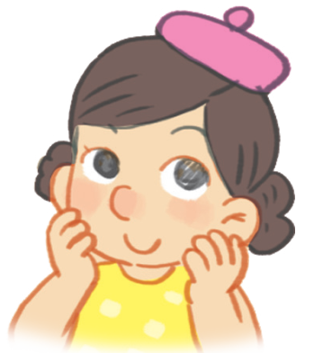 | 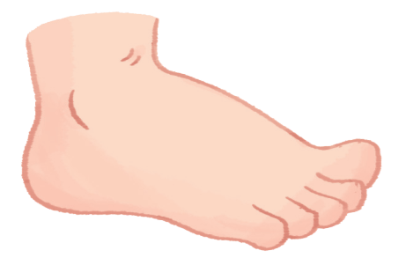 |  | 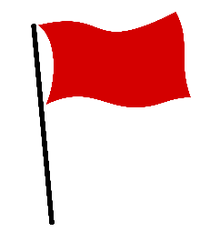
………………… | ……………………. | ……………………. | ……………………. | …………………….

Exercise 2 Look and circle the correct words
 | 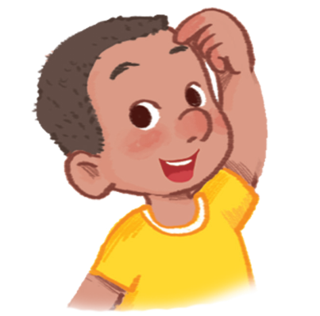 | 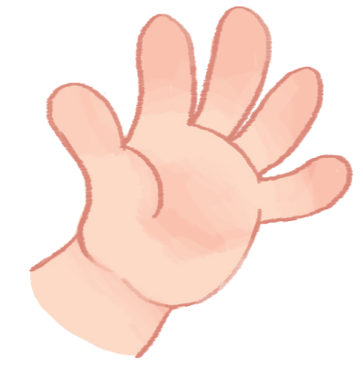
a) father  b) foot  c) football | a) head  b) hair  c) face | a) face  b) foot  c) hand
 | 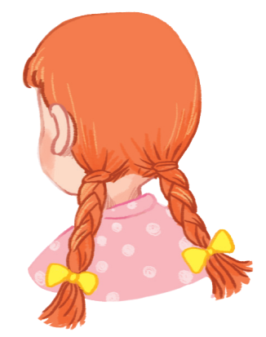
a) flag  b) father  c) foot | a) hair  b) hand  c) foot | a) foot  b) football  c) face

Exercise 3 Look and tick ( ) or cross ()
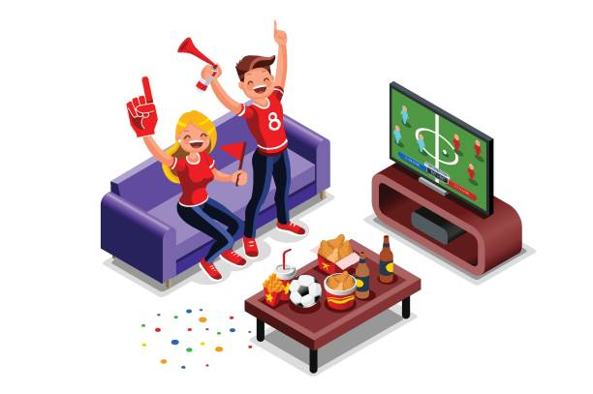 | 
- They’re watching football. | - He’s holding a flag. | - Touch your head.
 | 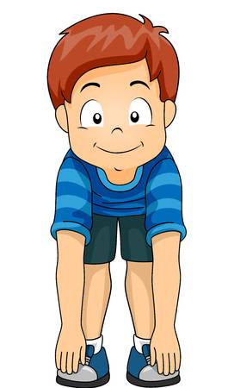 | 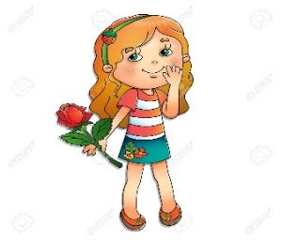
- Touch your face. | - Touch your foot. | f) She’s holding a flower.
Exercise 4 Look at the pictures and complete the sentences
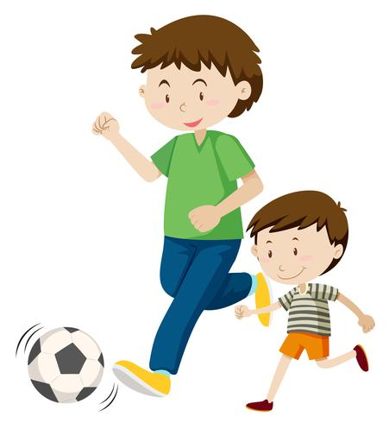
a) My father’s playing ………………. | b) Touch your………………. | c) Touch your………………
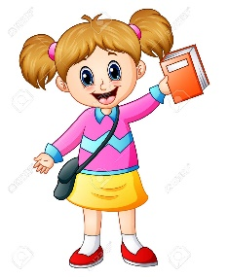 | 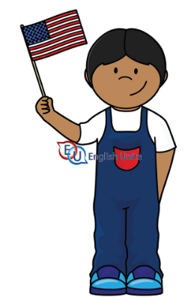
d) She’s holding a ………………. | e) He’s ………………. flag. | f) Touch your……………….
Exercise 5 Put the words in the correct order
a) mother – The – has – face – a – lovely
……………………………………………………………………………
b) watching – is – The – father – football
……………………………………………………………………………
c) Touch – face – your
……………………………………………………………………………
d) Nick’s – a flag – holding
……………………………………………………………………………
e) foot – Touch – your
……………………………………………………………………………
f) is – my – This – face
……………………………………………………………………………
g) a book – holding – Tony’s
……………………………………………………………………………
Exercise 6 Look and circle the correct words.
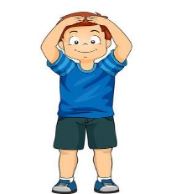 | a) Touch your head/face. | 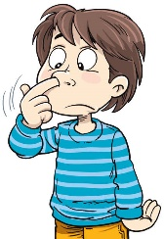 | b) Touch your hand/ nose.
 | c) Touch your head /foot. |  | d) She’s holding a book/ball.
 | e) He’s holding a car /flag. |  | f) She’s holding a book/flag
Exercise 7 Look at each picture . Circle the letter that makes the beginning sound
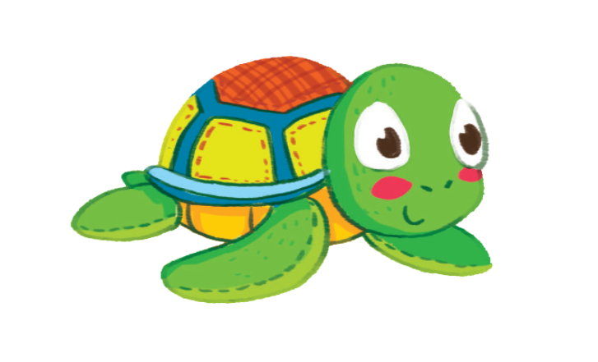 |  | 
s t u | m n o | l m n
 | 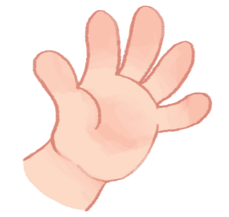
e f g | f g h | g h i
 | 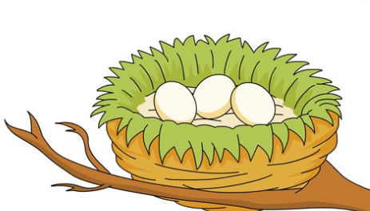 | 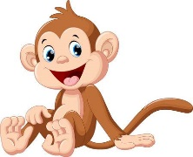
e m f | e f g | m n o
Exercise 8 Circle the right pictures :
Nn |  | 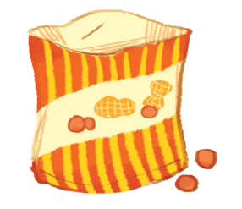
Tt |  |  | 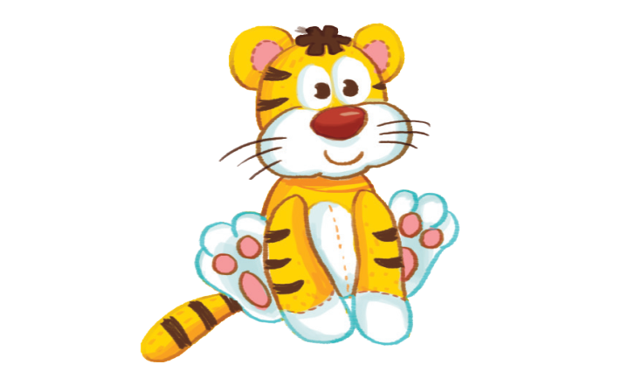
Ff

